Vastu/Nashik/03/2023833/30490/46262
22/24-455-RPV
Date: 05.08.2023

To, `
The Branch Manager,
Bank of Baroda
Regional Office Nashik Road Branch

BSNL Building, Datta Mandir Road, Nashik Road,
Nashik -422 101, State - Maharashtra, Country - India.

Sub: Vetting of Extra Amenities

Sir,

With reference to above subject, we have evaluated the Extra Amenities for Residential Flat No. 204, 2nd Floor, "Ishwar Pratishtha 4 Apartment", Survey No. 17 / 3 / 1 to 6 / 17 / 4, Plot No. 1, Near GPS 99 Restaurant, Pujya Sri Sri Ravishankar, Sawata Mali Road, Vidhate Nagar, Village - Wadala, Taluka & District - Nashik, PIN Code – 422 214, State – Maharashtra, Country – India belongs to Mr. Yashodip Rajendra Chaudhari.

We have verified the rates quoted as per current market rates. Details of work and Extra Amenities considered as per copy of Agreement for Extra Amenities issued by Mr. Yashodip Rajendra Chaudhari (First Party) and M/s. Tarun Construction (Second Party) received on dated 06.12.2023. The Extra Amenities amount is Rs.10,00,000/- ( Rupees Ten Lakh Only)

The said Cost Vetting Certificate is valid upto next 6 months Only.

Thanking you

Sincerely yours

Manoj B. Chalikwar
Registered Valuer
Chartered Engineer (India)
Reg. No. CAT-I-F-1763
Reg. No. IBBI/RV/07/2018/10366
BOB Empanelment No.: ZO:MZ:ADV:46:941
Encl: Valuation report.

Agreement for Extra Amenities
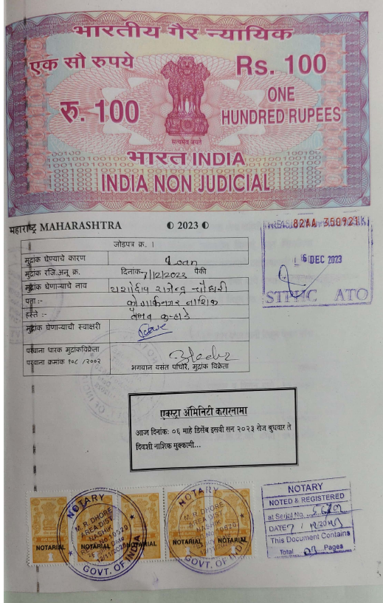
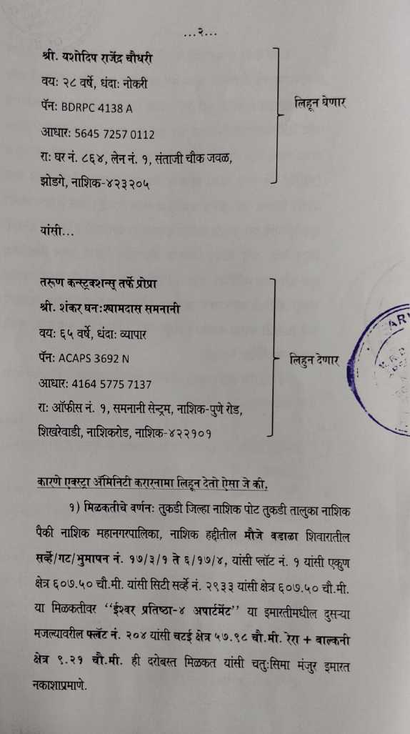

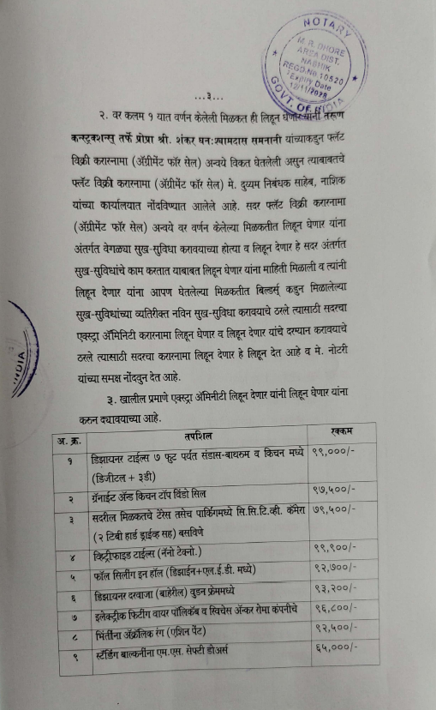
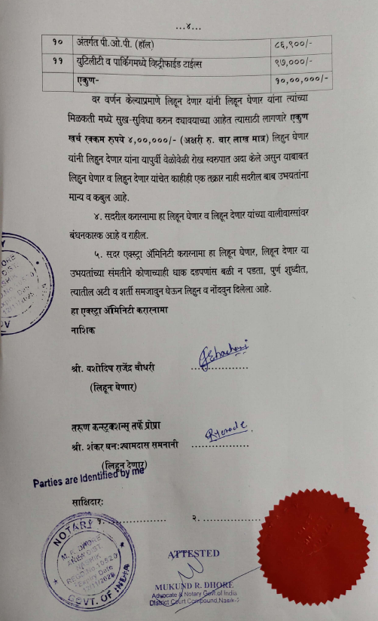

The Extra Amenities amount is Rs.10,00,000/- ( Rupees Ten Lakh Only. )

