Valuation Report of the Immovable Property

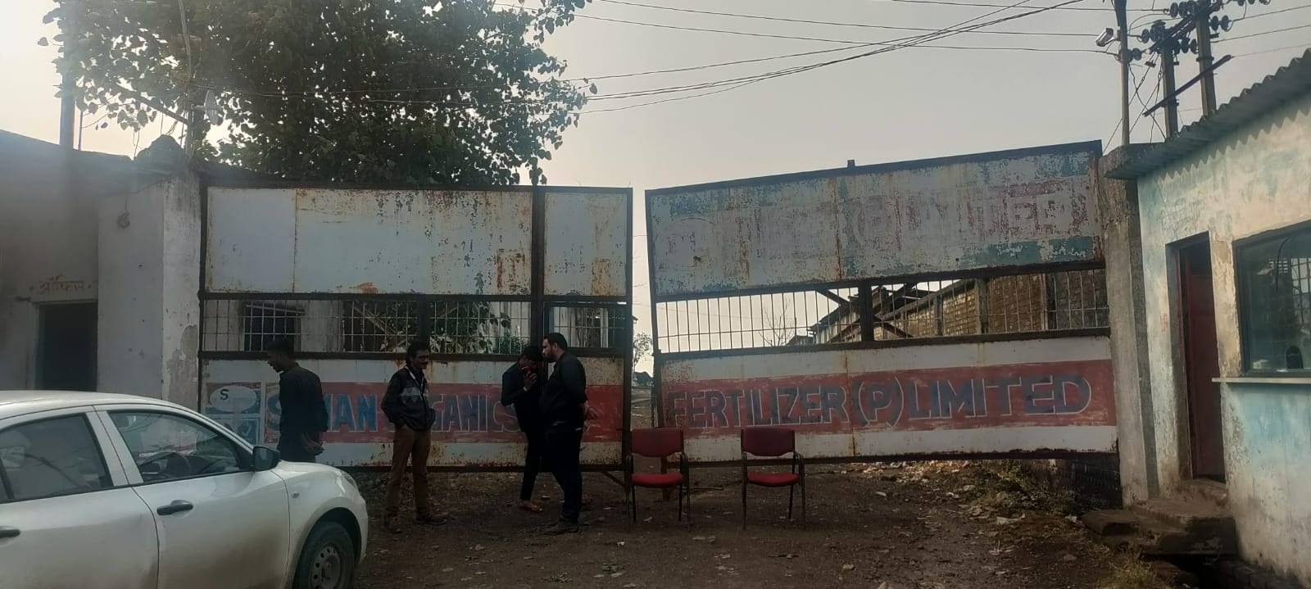

Details of the property under consideration:

Name of Owner: Shri. Ravindra S/o Shri. Motiram Choudhary

Industrial Land & Building bearing Survey No. 92/1 & 93/2, Pansemal Road
Gram Baljhiri, Tehsil Pansemal, District Badwani, PIN – 455 111,
State – Madhya Pradesh, Country – India

Longitude Latitude: 21°38’57.4”N 74°41’47.7”E

Valuation Done for:

Valuation Done for:
State Bank of India
SARB INDORE
5, Yeshwant Niwas Road, Indore 452003 Country – India.

INDEX
Particulars Page No.

1. VALUATION OPINION REPORT 3
2. VALUATION REPORT (IN RESPECT OF LAND AND FACTORY BUILDING) 4
3. TOTAL ABSTRACT OF THE ENTIRE PROPERTY 11
4. JUSTIFICATION FOR PRICE /RATE 12
5. ACTUAL SITE PHOTOGRAPHS 13
6. ROUTE MAP OF THE PROPERTY 16
7. DECLARATION-CUM-UNDERTAKING 19
8. ASSUMPTIONS, DISCLAIMERS, LIMITATIONS & QUALIFICATIONS 22
9. ASSUMPTIONS, CAVEATS, LIMITATION AND DISCLAIMERS 24
10. MODEL CODE OF CONDUCT FOR VALUERS 25

Vastu/Indore/12/2023/00523/43502
12/11-110-BSA
Date: 13.12.2023

VALUATION OPINION REPORT

This is to certify that the Industrial Land & Building bearing Survey No. 92/1 & 93/2, Pansemal Road, Gram Baljhiri, Tehsil Pansemal, District Badwani, PIN – 455 111, State – Madhya Pradesh, Country – India belongs to Shri. Ravindra S/o Shri. Motiram Choudhary.

Boundaries of the property.
North | : | Owner Land
South | : | Land of Krishnakanth
East | : | Road
West | : | Land of Dayaram
Considering various parameters recorded, existing economic scenario, and the information that is available with reference to the development of neighborhood and method selected for valuation, we are of the opinion that, the property premises can be assessed and valued for SARFAESI Securitisation and Reconstruction of Financial Assets and Enforcement of Security Interest Act, 2002 purpose at

Particulars | Fair Market Value In (₹) | Realizable Value In (₹) | Distress Sale Value In (₹) | Insurable Value In  (₹)
Industrial Land & Building | 83,27,124/- | 70,78,055/- | 58,28,987/- | 41,42,108 /-
The valuation of the property is based on the documents produced by the concerned. Legal aspects have not been taken into consideration while preparing this valuation report.

Hence certified.

Sharadkumar B. Chalikwar
Govt. Reg. Valuer
Chartered Engineer (India)
Reg. No. IBBI/RV/07/2019/11744
Reg. No. (N) CCIT/1-14/52/2008-09
SBI Empanelment No.: TCC/ 2022-23/1121/SV/1

Vastukala Consultants (I) Pvt. Ltd.
106, 1st Floor, Gold Star Tower, Opp. Treasure Island Mall, M.G. Road, Indore – 452 001

To,
The Branch Manager,
State Bank of India
SARB INDORE
5, Yeshwant Niwas Road, Indore 452003, Country – India.

VALUATION REPORT (IN RESPECT OF LAND AND BUILDING)
I | General
1. | Purpose for which the valuation is made |  | : | As per the request from State Bank of India, SARB INDORE Branch, To assess fair market value of the property for SARFAESI Securitisation and Reconstruction of Financial Assets and Enforcement of Security Interest Act, 2002 purpose.
2. | a) | Date of inspection | : | 01.12.2023
 | b) | Date on which the valuation is made | : | 13.12.2023
3. | Copy of List of documents produced for perusal
- Sale Deed, Registration No. A1/650 dated 31.07.2007 between Shri. Rameshchandra S/o Balusa (the Seller) AND Shri. Ravindra S/o Shri. Motiram Choudhary (the Purchaser) – Agricultural Land
- Diversion Order No. 28/A – 2 / 2007-08 dated 12.03.2008 issued by Court Sub Divisional Officer (Revenue) Sub Division, Sendhwa, District Badwani
- Diversion Order No. 2/A – 21 / 06-07 dated 15.05.2007 Singed by Collector Named of Arun Tiwari, District Badwani.
4. | Name of the owner(s) and his / their address (es) with Phone no. (details of share of each owner in case of joint ownership) |  | : | Shri. Ravindra S/o Shri. Motiram Choudhary  Address: Industrial Land & Building bearing Survey No. 92/1 & 93/2, Pansemal Road, Gram Baljhiri, Tehsil Pansemal, District Badwani, PIN – 455 111, State – Madhya Pradesh, Country – India.  Contact Person:  Mr. Indore (Banker)  Contact No. +91 96176 35035
5. | Brief description of the property (Including Leasehold / freehold etc.) |  | :
The immovable property comprises of Industrial land and factory building thereof. The property is located in a developing area having good infrastructure, well connected by road and train. It is located at 1.5 KM. travelling distance from Pansemal Bus Stand.

Nearest Landmark: Modal School Baljhiri Pansemal.

Land:
Total Land Area as per Sale Deed / Diversion Order as below
Survey Number | Area in Hectare | Area in Sq. M.
92/1 | 0.365 | 3,650.00
93/2 | 0.849 | 8,490.00
Total | 1.214 | 12,140.00

As per Sale Deed / Diversion Order, the land area of Survey No. 92/1 & 93/2 is 12,140.00 Sq. M., which is considered for the purpose of valuation. The land has been diverted for Industrial purpose.

Structure:
The land consists of Industrial Structure of roofing and Partly Colour Sheet roofing. It is Ground Floor Structure. The Ancillary Structures consist of Labour Quarters, Office Room, Godown, Working Area. All are ground floor Colour Sheet roofing, Framed Structure.

As Per Site Inspection, the structure area is as below which is considered for valuation-

Particulars | Area in Sq. M.
Tin Shed Working Area | 2,504.18
3 Godown | 723.71
Office | 193.98
Labour Room | 326.64
Total | 3,748.51

6. | Location of property |  | :
 | a) | Plot No. / Survey No. | : | Survey No. 92/1 & 93/2
 | b) | Door No. | : | Patwari Halka No. 11
 | c) | C.T.S. No. / Village | : | Gram Baljhiri
 | d) | Ward / Taluka | : | Tehsil - Pansemal
 | e) | Mandal / District | : | District – Badwani
7. | Postal address of the property |  | : | Industrial Land & Building bearing Survey No. 92/1 & 93/2, Pansemal Road, Gram Baljhiri, Tehsil Pansemal, District Badwani, PIN – 455 111, State – Madhya Pradesh, Country – India.
8. | City / Town |  | : | Badwani
 | Residential area |  | : | No
 | Commercial area |  | : | No
 | Industrial area |  | : | Yes
9. | Classification of the area |  | :
 | i) High / Middle / Poor |  | : | Middle Class
 | ii) Urban / Semi Urban / Rural |  | : | Semi - Urban
10. | Coming under Corporation limit / Village Panchayat / Municipality |  | : | Gram Panchayat Baljhiri, Tehsil Pansemal, District Badwani
11. | Whether covered under any State / Central Govt. enactments (e.g., Urban Land Ceiling Act) or notified under agency area/ scheduled area / cantonment area |  | : | No
12. | In Case it is Agricultural land, any conversion to house site plots is contemplated |  | : | Yes
13. | Boundaries of the property |  |  | As per Site Inspection | As per Document
 | North |  |  | Owner Land | Land of Naago Gobraya
 | South |  |  | Land of Krishnakanth | Land of Krishna S/o Keshav teli
 | East |  |  | Road | Road
 | West |  |  | Land of Dayaram | Remaining Land of Seller
14.1 | Dimensions of the site |  | :
 |  |  |  | A  As per the Deed |  | B  Actuals
 | North |  | : | The land is Rectangular in shape
 | South |  | :
 | East |  | :
 | West |  | :
14.2 | Latitude, Longitude & Co-ordinates of property |  | : | 21°38’57.4”N 74°41’47.7”E
14. | Extent of the site |  | : | Plot area = 12,140.00 Sq. M.  (As per Sale Deed / Diversion Order)  As per Site Inspection, considered area of Industrial Structure is as below –
  Particulars | Area in Sq. M.
  Tin Shed Working Area | 2,504.18
  3 Godown | 723.71
  Office | 193.98
  Labour Room | 326.64
  Total | 3,748.51
15. | Extent of the site considered for Valuation (least of 14A& 14B) |  | :
16 | Whether occupied by the owner / tenant? If occupied by tenant since how long? Rent received per month. |  | : | Vacant and under Owner’s possession
II | CHARACTERSTICS OF THE SITE
 | Classification of locality |  | : | Middle class
 | Development of surrounding areas |  | : | Developing
 | Possibility of frequent flooding/ sub-merging |  | : | No
 | Feasibility to the Civic amenities like School, Hospital, Bus Stop, Market etc. |  | : | All available near by
 | Level of land with topographical conditions |  | : | Plain
 | Shape of land |  | : | Rectangular
 | Type of use to which it can be put |  | : | Industrial purpose
 | Any usage restriction |  | : | Industrial
 | Is plot in town planning approved layout? |  | : | No
 | Corner plot or intermittent plot? |  | : | Intermittent
 | Road facilities |  | : | Yes
 | Type of road available at present |  | : | R.C.C. Road
 | Width of road – is it below 12 meter or more than 20 ft. |  | : | It is more than 20 ft.
 | Is it a Land – Locked land? |  | : | No
 | Water potentiality |  | : | Municipal Water Supply
 | Underground sewerage system |  | : | Connected to Municipal Sewerage lines
 | Is Power supply is available in the site |  | : | Yes
 | Advantages of the site |  | : | Located in developing Industrial Area
 | Special remarks, if any like threat of acquisition of land for publics service purposes, road widening or applicability of CRZ provisions etc. (Distance from sea-cost / tidal level must be incorporated) |  | : | No
Part – A (Valuation of land)
1 | Size of plot |  | : | Plot area = 12,140.00 Sq. M.  (As per Sale Deed / Diversion Order)
 | North & South |  | : | -
 | East & West |  | : | -
2 | Total extent of the plot |  | : | Plot area = 12,140.00 Sq. M.  (As per Sale Deed / Diversion Order)
3 | Prevailing market rate (Along with details / reference of at least two latest deals / transactions with respect to adjacent properties in the areas) |  | : | Online Price Indicators for Similar properties were not available. we have derived rates from the local market survey done by our Site engineer.
4 | Ready Reckoner rate from Government Portal |  | : | ₹ 1,100/- per Sq. M.
 | In case of variation of 20% or more in the valuation proposed by the valuer and the Guideline value provided in the State Govt. notification or Income Tax Gazette justification on variation has to be given. |  | : | It is a foregone conclusion that market value is always more than RR prices. As the RR rates are fixed by respective state governments for computing stamp duty / regn. Fees. Thus, the rates differ from place to place and location. Amenities per se as evident from the fact that even RR rates decided by Govt. differ.
5 | Assessed / adopted rate of valuation of Land |  | : | ₹ 400/- per Sq. M.
6 | Estimated value of land |  | : | ₹ 48,56,000/-
Part – B (Valuation of Building)
1 | Technical details of the building |  | :
 | - Type of Building (Residential / Commercial / Industrial) |  | : | Industrial
 | - Type of construction (Load bearing / RCC / Steel Framed) |  | : | Load bearing / M.S. Structure / Composite Structure
 | - Year of construction |  | : | 2007 (As per Site Information)
 | - Number of floors and height of each floor including basement, if any |  | : | Factory Building - Ground Floor
 | - Plinth area floor-wise |  | : | As per Brief Description
 | - Condition of the building |  | :
 | - Exterior – Excellent, Good, Normal, Poor |  | : | Normal
 | - Interior – Excellent, Good, Normal, Poor |  | : | Normal
 | - Date of issue and validity of layout of approved map |  | : | Approved Building Plan is not Provided, which is verified
 | - Approved map / plan issuing authority |  | :
 | - Whether genuineness or authenticity of approved map / plan is verified |  | :
 | - Any other comments by our empaneled valuers on authentic of approved plan |  | : | No

Specifications of construction (floor-wise) in respect of

Sr.  No. | Description
 | Foundation | : | Open Foundation
 | Basement | : | No
 | Superstructure | : | Brick Masonry Wall
 | Joinery / Doors & Windows (Please furnish details about size of frames, shutters, glazing, fitting etc. and specify the species of timber | : | MS rolling shutters and wooden door frame with flush shutters and Aluminium framed glass fixed and openable type and sliding windows
 | RCC Works | : | RCC Slab, Columns, Beams
 | Plastering | : | Cement Plastering + Neeru Finish
 | Flooring, Skirting, dado | : | Partly Kota Stone and Partly P.C.C. flooring
 | Special finish as marble, granite, wooden paneling, grills etc. | : | Normal
 | Roofing including weatherproof course | : | - C. Sheet / G. I. Sheet roofing
 | Drainage | : | Connected to Public Sewerage System
2. | Compound Wall | :
 | Height | : | Provided rounded the boundary of land with 8’ height
 | Length | : | Provided rounded the boundary of land with 8’ height
 | Type of construction | : | Provided rounded the boundary of land with 8’ height
3. | Electrical installation | :
 | Type of wiring | : | Industrial type wiring
 | Class of fittings (superior / ordinary / poor) | : | Ordinary
 | Number of light points | : | Provided as per requirement
 | Fan points | : | Provided as per requirement
 | Spare plug points | : | Provided as per requirement
 | Any other item | : | -
4. | Plumbing installation
 | - No. of water closets and their type | : | Provided as per requirement
 | - No. of wash basins | : | Provided as per requirement
 | - No. of urinals | : | Provided as per requirement
 | - No. of bathtubs | : | Provided as per requirement
 | - Water meters, taps etc. | : | Provided as per requirement
 | - Any other fixtures | : | Provided as per requirement

Part – C (Extra Items) |  | : | Amount in ₹
 | Portico | : | Included in the Cost of Construction
 | Ornamental front door | : | Included in the Cost of Construction
 | Sit out / Verandah with steel grills | : | Included in the Cost of Construction
 | Overhead water tank | : | Included in the Cost of Construction
 | Extra steel / collapsible gates | : | Included in the Cost of Construction
 | Total

Part – D (Amenities) |  | : | Amount in ₹
 | Wardrobes | : | Included in the Cost of Construction
 | Glazed tiles | : | Included in the Cost of Construction
 | Extra sinks and bathtub | : | Included in the Cost of Construction
 | Marble / ceramic tiles flooring | : | Included in the Cost of Construction
 | Interior decorations | : | Included in the Cost of Construction
 | Architectural elevation works |  | Included in the Cost of Construction
 | Paneling works |  | Included in the Cost of Construction
 | Aluminum works |  | Included in the Cost of Construction
 | Aluminum handrails |  | Included in the Cost of Construction
 | False ceiling |  | Included in the Cost of Construction
 | Total |  | Included in the Cost of Construction

Part – E (Miscellaneous) |  | : | Amount in ₹
 | Separate toilet room | : | Included in the Cost of Construction
 | Separate lumber room | : | Included in the Cost of Construction
 | Separate water tank / sump | : | Included in the Cost of Construction
 | Trees, gardening | : | Included in the Cost of Construction
 | Total |  | Included in the Cost of Construction

Part – F (Services) |  | : | Amount in ₹
 | Water supply arrangements | : | Included in the Cost of Construction
 | Drainage arrangements | : | Included in the Cost of Construction
 | Compound wall | : | Included in the Cost of Construction
 | C.B. deposits, fittings etc. | : | Included in the Cost of Construction
 | Pavement |  | Included in the Cost of Construction
 | Total |  | Included in the Cost of Construction

Government Value

Particulars | Area in Sq. M. | Rate in ₹ | Value in ₹
Land | 12,140.00 | 1,100/- | 1,33,54,000/-
Structure | As per valuation table |  | 34,71,124/-
Total |  |  | 1,68,25,124/-

Structure
Floor | Total BUA Area in  Sq. M. | Year Of Const | Total Life of Structure | Replacement Rate (`) | Age Of Build. | Final Rate (`) | Final Value (`)
Factory Building Tin Shed Structure | 3,748.51 | 2007 | 60 | 1,300/- | 16 | 926/- | 34,71,124/-

TOTAL ABSTRACT OF THE ENTIRE PROPERTY

Part - A | Land |  | ₹ 48,56,000/-
Part - B | Buildings |  | ₹ 34,71,124/-
 | Land Development |  | ₹ 16,00,000/-
Part – C | Extra Items |  | -
Part – D | Amenities |  | -
Part - E | Miscellaneous |  | -
Part - F | Services |  | -
 | Fair Market Value In (`) |  | ₹ 83,27,124/-
 | Realizable Value In (`) |  | ₹ 70,78,055/-
 | Distress Sale Value In (`) |  | ₹ 58,28,987/-
 | Insurable Value In (`) |  | ₹ 41,42,108 /-
Remarks | Approved Building Plan Not Provided

JUSTIFICATION FOR PRICE /RATE
The Market Value of the property is based on facts of markets discovered by us during our enquiries, however the government rate value in this case is less than the market value arrived by us. We are of the opinion that the value arrive by us will prove to be correct if an Auction of the subject property is carried out. As far as Market Value in Index II / Property Documents is concerned, it is not possible to comment on same, may be government rates are fixed by sampling during same point of time in part and whereas, Market values change every month.

In most of the cases the actual deal amount or Transaction value is not reflected in Index II / Property Documents because of various Market practices. As Valuer, we always try to give a value which is correct reflection of actual transaction value irrespective of any factors in market.
Method of Valuation / Approach

- The cost approach is a Real Property Valuation method which considers the value of a property as the cost of the land plus the replacement cost of the building (construction costs) minus the physical and functional depreciation.
- This approach is most commonly used for real estate properties that are not easily sold like schools, hospitals, government buildings and above type of property.
- Land cost can be estimated using the Sales Comparison Approach by studying recent sales of land close to the subject property, and these sales should be comparable in size and location with subject property.
- There are different ways to estimate replacement costs, the most common being finding out the cost to build a square foot of comparable properties multiplied by the total square footage of the building. The cost approach is commonly used for Industrial purpose, Industrial Building and properties mentioned above.
- As the property is an Industrial land and building thereof, we have adopted Cost approach / Land and Building Method for the purpose of valuation. The Price for similar type of property in the nearby vicinity is in the range of
₹ 350/- to 450/- per Sq. M. for land Considering the rate with attached report, current market conditions, demand and supply position, Land size, location, sustained demand for industrial building / Plot, all round development of industrial and commercial application in the locality etc.
- We estimate 400/- per Sq. M. for Land with appropriate cost of construction for valuation.

The saleability of the property is: Normal
Likely rental values in future in: N.A.
Any likely income it may generate: N.A.

ACTUAL SITE PHOTOGRAPHS
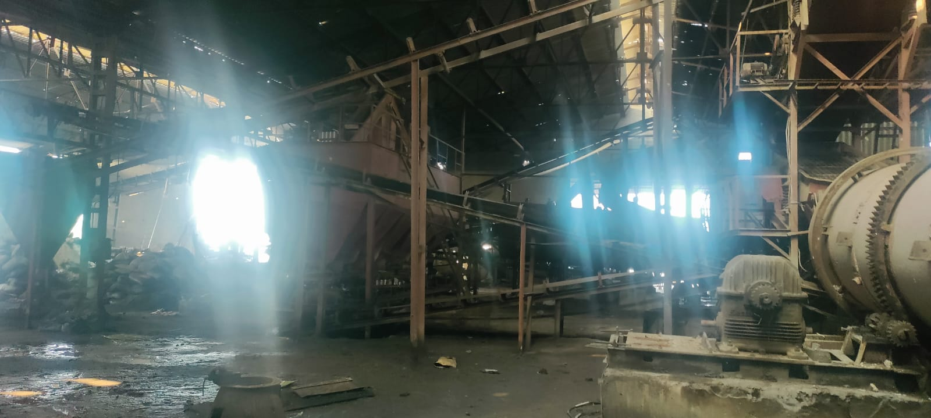
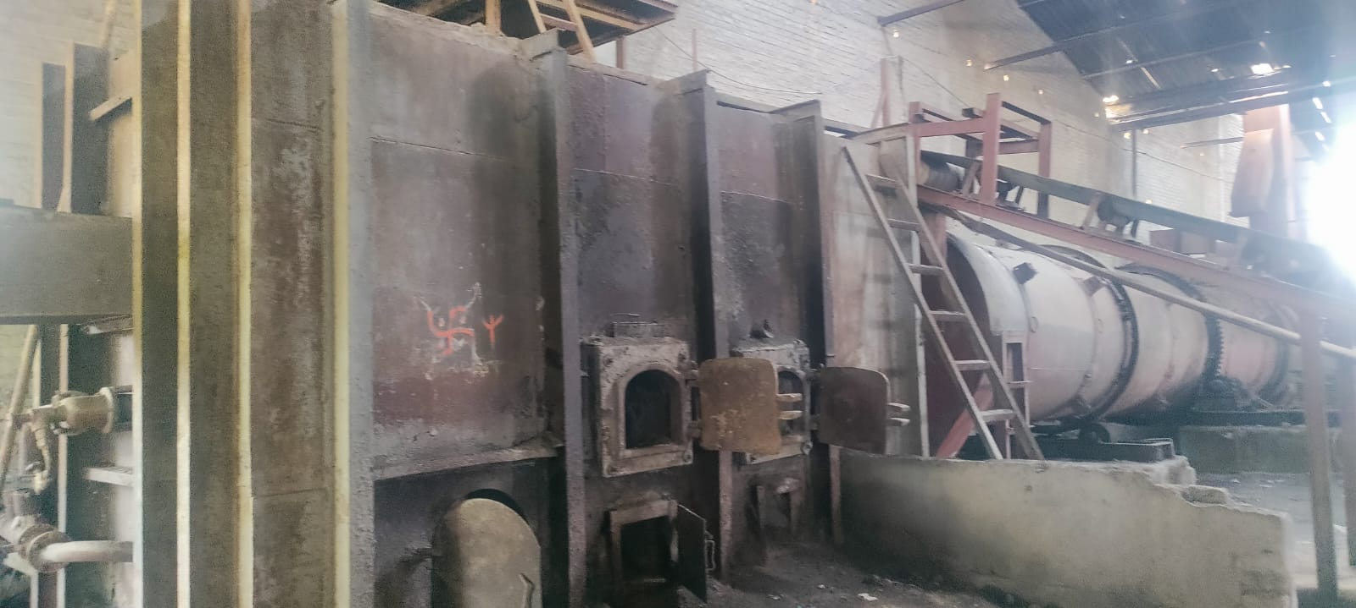
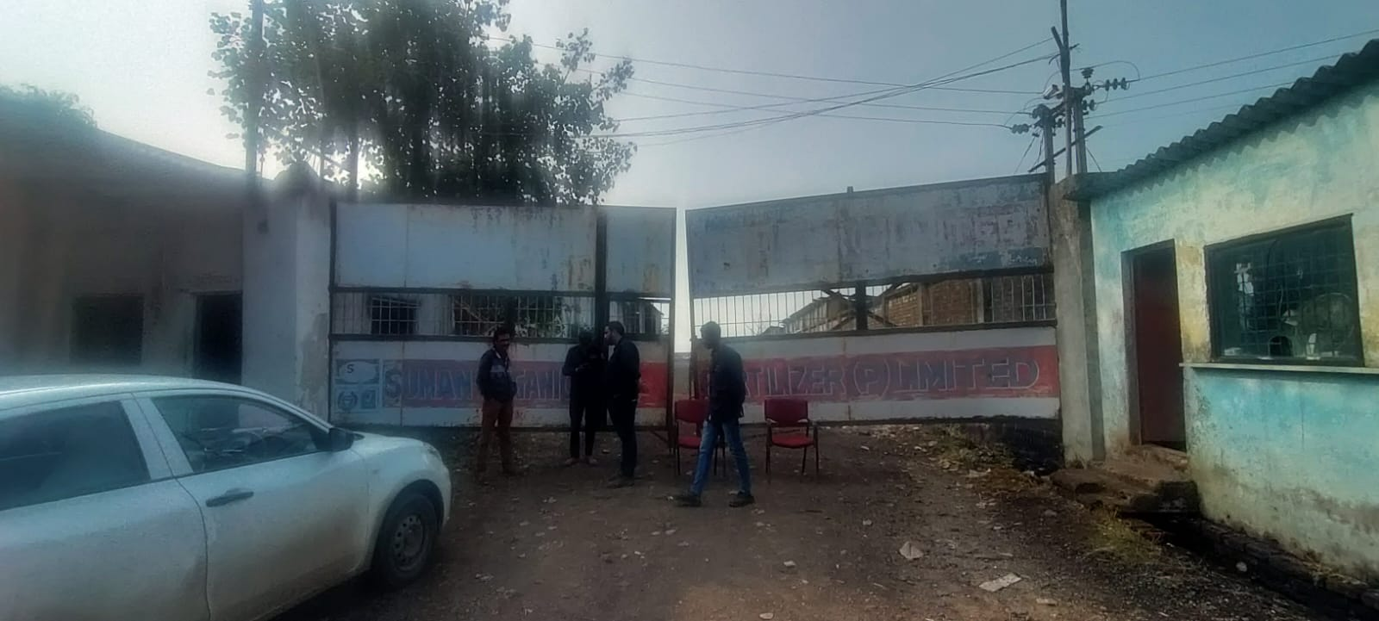

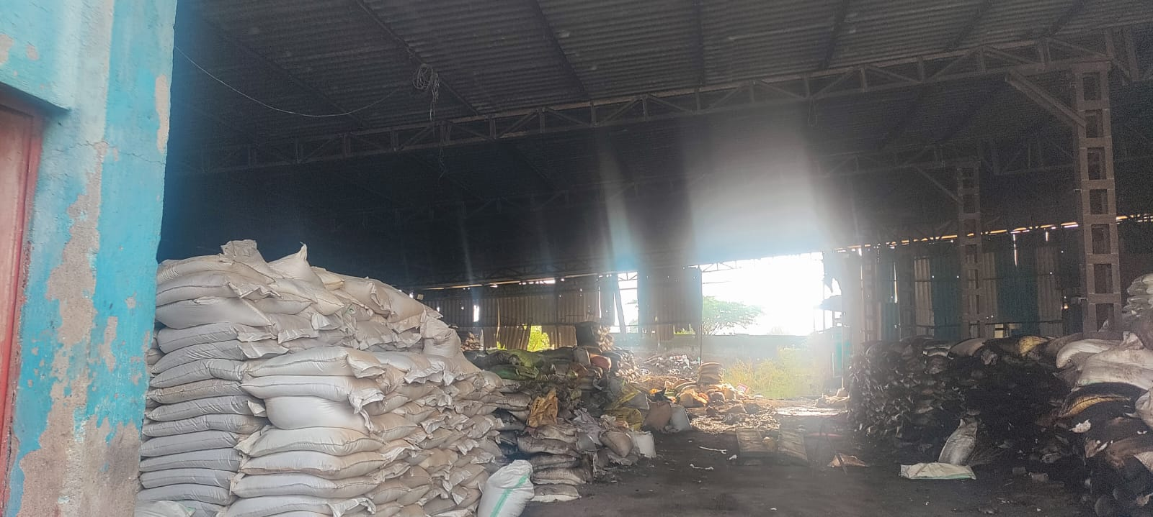
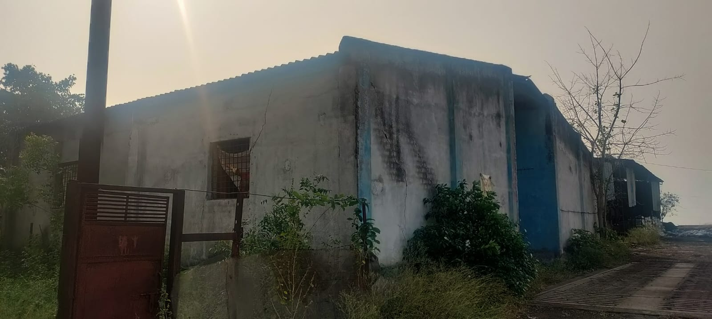

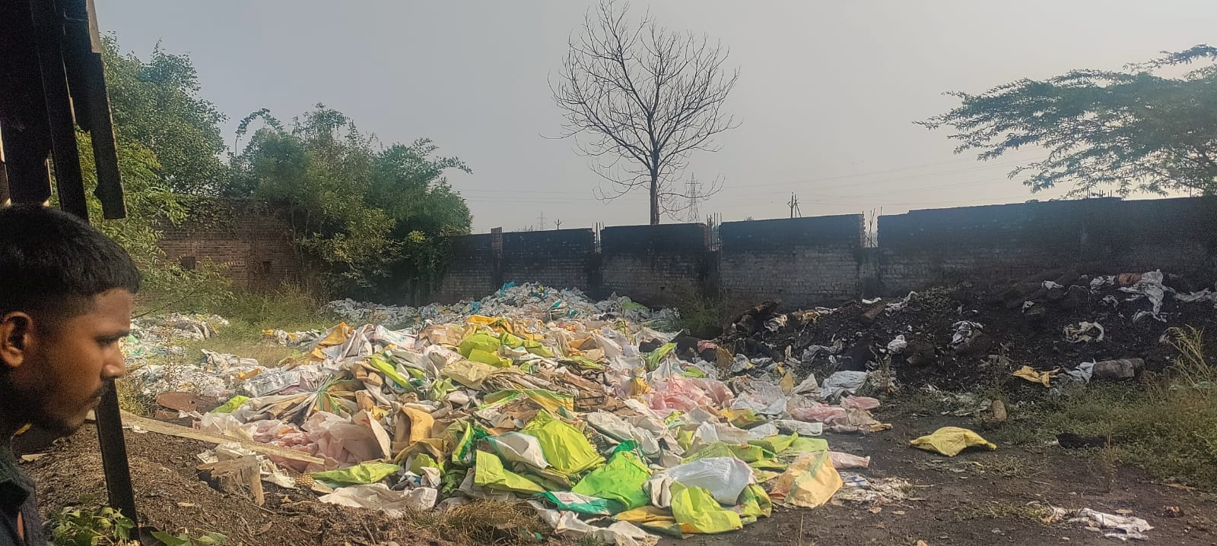
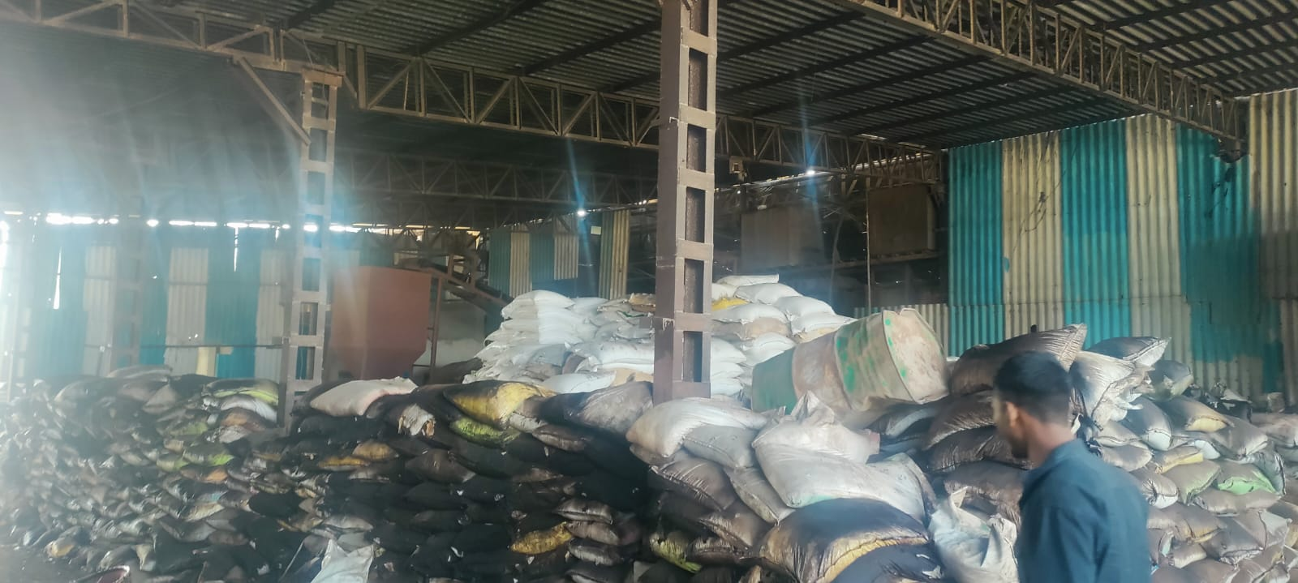

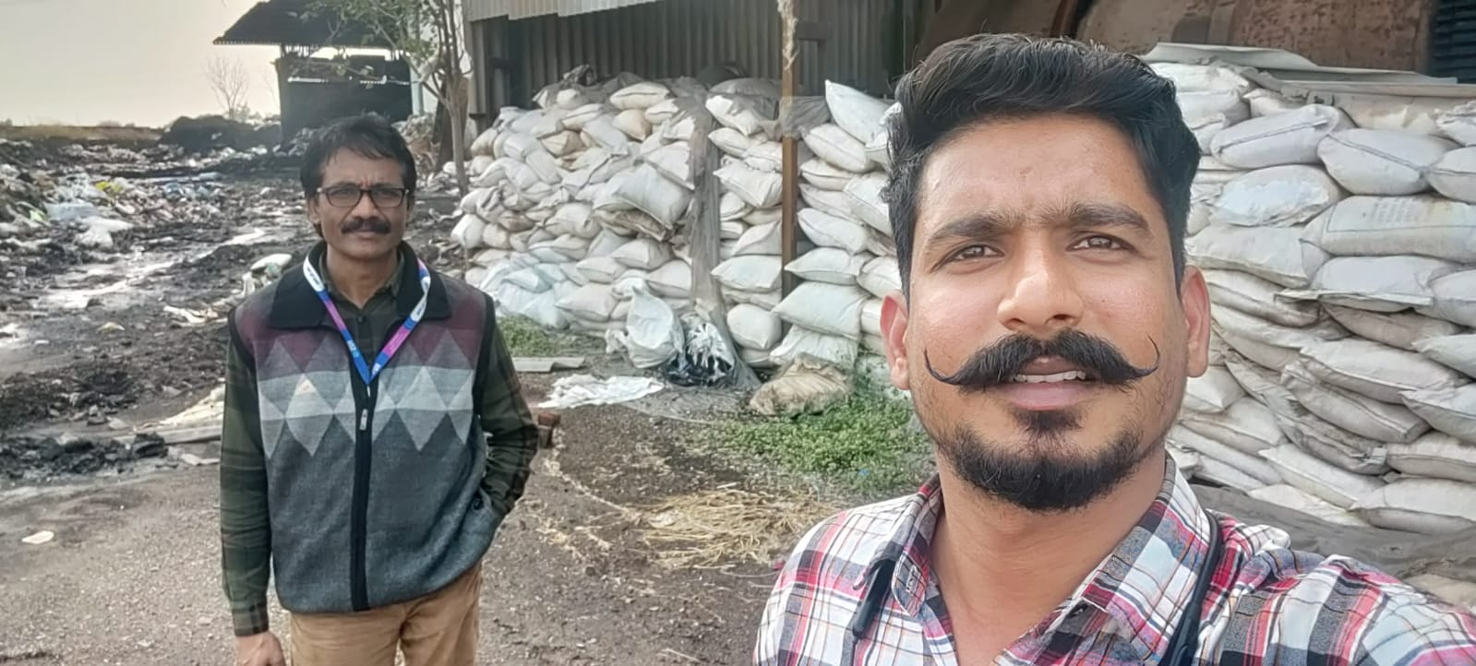

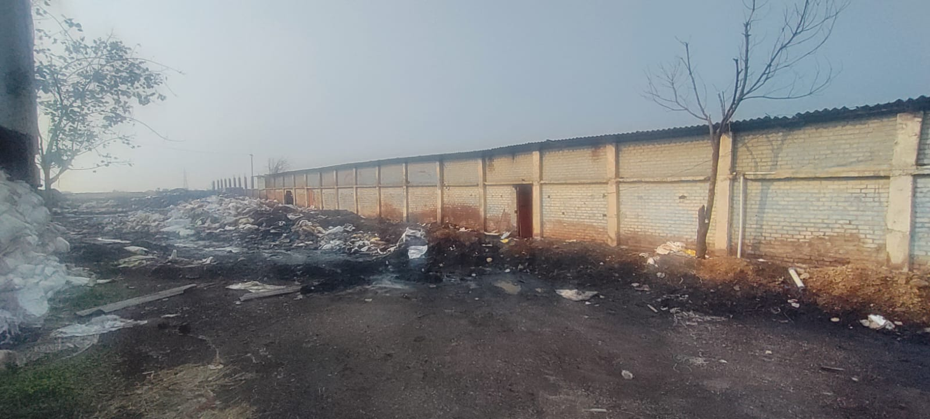

ROUTE MAP OF THE PROPERTY
Site u/r
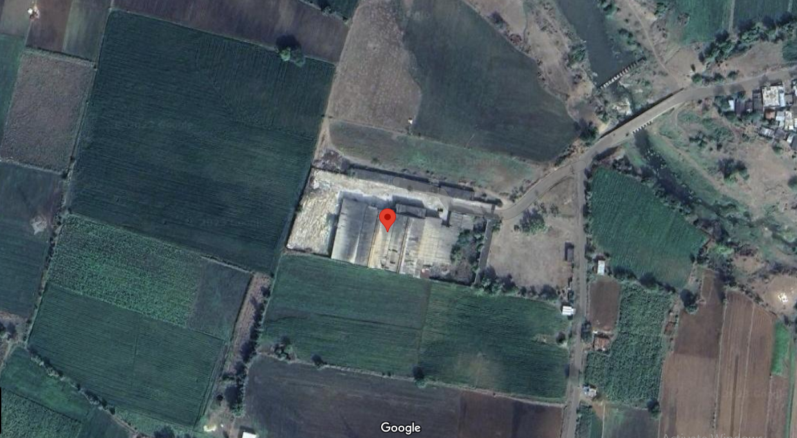

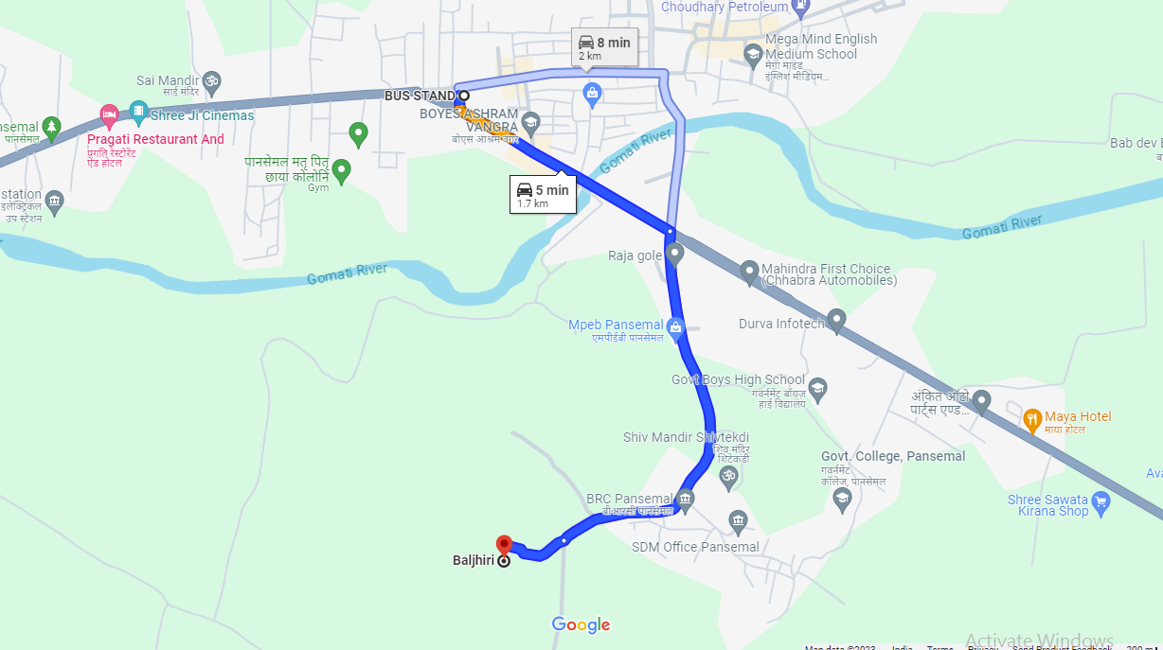

Longitude Latitude: 21°38’57.4”N 74°41’47.7”E
Note: The Blue line shows the route to site from nearest railway station (Pansemal Bus Stand –1.7 KM.)

READY RECKONER RATE
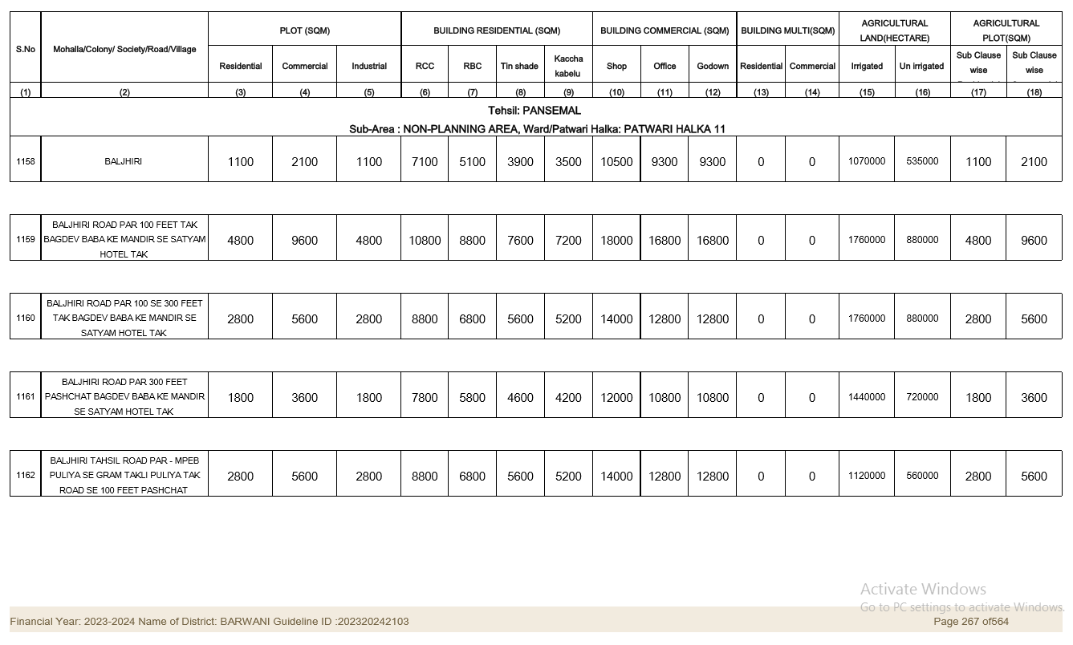

As a result of my appraisal and analysis, it is my considered opinion that the Fair Market Value for this particular above property in the prevailing condition with aforesaid specification is ₹83,27,124/- (Rupees Eighty Three Lakh Twenty Seven Thousand One Hundred Twenty Four Only). The Realizable Value of the above property is ₹70,78,055/- (Rupees Seventy Lakh Seventy Eight Thousand Fifty Five Only). The Distress Sale is ₹58,28,987/- (Rupees Fifty Eight Lakh Twenty Eight Thousand Nine Hundred Eighty Seven Only).

Place: Indore
Date: 13.12.2023

Sharadkumar B. Chalikwar
Govt. Reg. Valuer
Chartered Engineer (India)
Reg. No. IBBI/RV/07/2019/11744
Reg. No. (N) CCIT/1-14/52/2008-09
SBI Empanelment No.: TCC/ 2022-23/1121/SV/1

The undersigned has inspected the property detailed in the Valuation Report dated _______________________

on ____________________. We are satisfied that the fair and reasonable market value of the property is

`_________________________ (Rupees ________________________________________________________

________________________________________only).

Date
Signature
(Name & Designation of the Inspecting Official/s)

Countersigned
(BRANCH MANAGER)

Enclosures
 | Declaration-cum-undertaking from the valuer (Annexure- IV) | Attached
 | Model code of conduct for valuer - (Annexure - V) | Attached
(Annexure-IV)

DECLARATION-CUM-UNDERTAKING

I, Sharadkumar Chalikwar son of Shri. Baburao Chalikwar do hereby solemnly affirm and state that:

- I am a citizen of India.
- I will not undertake valuation of any assets in which I have a direct or indirect interest or become so interested at any time during a period of three years prior to my appointment as valuer or three years after the valuation of assets was conducted by me.
- The information furnished in my valuation report dated 13.12.2023 is true and correct to the best of my knowledge and belief and I have made an impartial and true valuation of the property.
- I/ my authorized representative has personally inspected the property on 01.12.2023. The work is not sub - contracted to any other valuer and carried out by myself.
- Valuation report is submitted in the format as prescribed by the bank.
- I have not been depanelled / delisted by any other bank and in case any such depanelment by other banks during my empanelment with you, I will inform you within 3 days of such depanelment.
- I have not been removed / dismissed from service / employment earlier.
- I have not been convicted of any offence and sentenced to a term of imprisonment.
- I have not been found guilty of misconduct in my professional capacity.
- I have not been declared to be unsound mind.
- I am not an undischarged bankrupt or has not applied to be adjudicated as a bankrupt.
- I am not an undischarged insolvent.
- I have not been levied a penalty under section 271J of Income-tax Act, 1961 (43 of 1961) and time limit for filing appeal before Commissioner of Income-tax (Appeals) or Income-tax Appellate Tribunal, as the case may has expired, or such penalty has been confirmed by Income-tax Appellate Tribunal, and five years have not elapsed after levy of such penalty.
- My PAN Card number as applicable is AEAPC0117Q.
- I undertake to keep you informed of any events or happenings which would make me ineligible for empanelment as a valuer.
- I have not concealed or suppressed any material information, facts and records and I have made a complete and full disclosure.
- I have read the Handbook on Policy, Standards and procedure for Real Estate Valuation, 2011 of the IBA and this report is in conformity to the "Standards" enshrined for valuation in the Part - B of the above handbook to the best of my ability.
- I have read the International Valuation Standards (IVS) and the report submitted to the Bank for the respective asset class is in conformity to the "Standards" as enshrined for valuation in the IVS in "General Standards" and "Asset Standards" as applicable. The valuation report is submitted in the prescribed format of the bank.
- I abide by the Model Code of Conduct for empanelment of valuer in the Bank. (Annexure V - A signed copy of same to be taken and kept along with this declaration).
- I am registered under Section 34 AB of the Wealth Tax Act, 1957.
- I am valuer registered with Insolvency & Bankruptcy Board of India (IBBI).
- My CIBIL Score and credit worthiness is as per Bank's guidelines.
- I am Chairman & Managing Director of the company, who is competent to sign this valuation report.
- I will undertake the valuation work on receipt of Letter of Engagement generated from the system (i.e., LLMS / LOS) only.
- Further, I hereby provide the following information.
Sr. No. | Particulars | Valuer comment
1 | Background information of the asset being valued; | The property is in the name of Shri. Ravindra S/o Shri. Motiram Choudhary, as per Sale Deed, Registration No. 2785 dated 15.03.2013.
2 | Purpose of valuation and appointing authority | As per the request from State Bank of India, SARB INDORE Branch Stressed Assets Management Branch Fort To assess fair market value of the property for SARFAESI Securitisation and Reconstruction of Financial Assets and Enforcement of Security Interest Act, 2002 purpose.
3 | Identity of the Valuer and any other experts involved in the valuation; | Sharadkumar B. Chalikwar – Regd. Valuer  Umang Patel - Regd. Valuer  Dinesh Kanere – Regional Technical Manager  Somesh Nahar – Valuation Engineer  Akhilesh Yadav – Technical Manager  Jayaraja Acharya- Technical Officer
4 | Disclosure of Valuer interest or conflict, if any; | We have no interest, either direct or indirect, in the property valued. Further to state that we do not have relation or any connection with property owner / applicant directly or indirectly. Further to state that we are an independent Valuer and in no way related to property owner / applicant
5 | Date of appointment, valuation date and date of report; | Date of Appointment – 01.12.2023  Valuation Date – 13.12.2023  Date of Report – 13.12.2023
6 | Inspections and/or investigations undertaken; | Physical Inspection done on 01.12.2023
7 | Nature and sources of the information used or relied upon; | - Market Survey at the time of site visit  - Ready Reckoner rates / Circle rates  - Enquiries with Real estate consultants  - Existing data of Valuation assignments carried out by us
8 | Procedures adopted in carrying out the valuation and valuation standards followed; | Cost Approach (For building construction)  Comparative Sales Method (For Land component)
9 | Restrictions on use of the report, if any; | This valuation is for the use of the party to whom it is addressed and for no other purpose. No responsibility is accepted to any third party who may use or rely on the whole or any part of this valuation. The valuer has no pecuniary interest that would conflict with the proper valuation of the property.
10 | Major factors that were taken into account during the valuation. | Current market conditions, demand and supply position, industrial land size, location, sustained demand for industrial land, all round development of industrial application in the locality etc.
11 | Major factors that were taken into account during the valuation. | Nil
12 | Caveats, limitations, and disclaimers to the extent they explain or elucidate the limitations faced by valuer, which shall not be for the purpose of limiting his responsibility for the valuation report. | Attached

ASSUMPTIONS, DISCLAIMERS, LIMITATIONS & QUALIFICATIONS

Value Subject to Change
The subject appraisal exercise is based on prevailing market dynamics as on 13th December 2023 and does not take into account any unforeseeable developments which could impact the same in the future.
Our Investigations
We are not engaged to carry out all possible investigations in relation to the subject property. Where in our report we identify certain limitations to our investigations, this is to enable the reliant party to instruct further investigations where considered appropriate or where we recommend as necessary prior to reliance. Vastukala Consultants India Pvt. Ltd. (VCIPL) is not liable for any loss occasioned by a decision not to conduct further investigations.
Assumptions
Assumptions are a necessary part of undertaking valuations. VCIPL adopts assumptions for the purpose of providing valuation advise because some matters are not capable of accurate calculations or fall outside the scope of our expertise, or out instructions. The reliant party accepts that the valuation contains certain specific assumptions and acknowledge and accept the risk of that if any of the assumptions adopted in the valuation are incorrect, then this may have an effect on the valuation.
Information Supplied by Others
The appraisal is based on the information provided by the client. The same has been assumed to be correct and has been used for appraisal exercise. Where it is stated in the report that another party has supplied information to VCIPL, this information is believed to be reliable but VCIPL can accept no responsibility if this should prove not to be so.
Future Matters
To the extent that the valuation includes any statement as to a future matter, that statement is provided as an estimate and/or opinion based on the information known to VCIPL at the date of this document. VCIPL does not warrant that such statements are accurate or correct.
Map and Plans
Any sketch, plan or map in this report is included to assist the reader while visualizing the property and assume no responsibility in connection with such matters.
Site Details
Based on inputs received from Client's representative and site visit conducted, we understand that the subject property is admeasuring Plot Area = 12,140.00 Sq. M. and Structure thereof. The property is owned by Shri. Ravindra S/o Shri. Motiram Choudhary. It is Vacant and under owner’s possession. VCIPL has assumed that the subject property is free from any encroachment and is available as on the date of the appraisal.
Property Title
Based on our discussion with the Client, we understand that the property is in the name of Shri. Ravindra S/o Shri. Motiram Choudhary. For the purpose of this appraisal exercise, we have assumed that the subject property has a clear title and is free from any encumbrances, disputes and claims. VCIPL has made no further enquiries with the relevant local authorities in this regard and does not certify the property as having a clear and marketable title. Further, no legal advice regarding the title and ownership of the subject property has been obtained for the purpose of this appraisal exercise. It has been assumed that the title deeds are clear and marketable.
Environmental Conditions
We have assumed that the subject property is not contaminated and is not adversely affected by any existing or proposed environmental law and any processes which are carried out on the property are regulated by environmental legislation and are properly licensed by the appropriate authorities.
Town Planning
The permissible land use, zoning, achievable FSI, area statement adopted for purpose of this valuation is based on the information provided by the Client's representative and the same has been adopted for this valuation purpose. VCIPL has assumed the same to be correct and permissible. VCIPL has not validated the same from any authority.
Area
Based on the documents, we understand that the subject property is contiguous land parcel admeasuring Plot Area = 12,140.00 Sq. M. and Structure thereof.
Condition & Repair
In the absence of any information to the contrary, we have assumed that there are no abnormal ground conditions, nor archaeological remains present which might adversely affect the current or future occupation, development or value of the property. The property is free from rat, infestation, structural or latent defect. No currently known deleterious or hazardous materials or suspect techniques will be used in the construction of or subsequent alteration or additions to the property and comments made in the property details do not purport to express an opinion about, or advise upon, the condition of uninspected parts and should not be taken as making an implied representation or statement about such parts.
Valuation Methodology
For the purpose of this valuation exercise, the valuation methodology used is cost approach.
The cost approach is a Real Property Valuation method which considers the value of a property as the cost of the land plus the replacement cost of the building (construction costs) minus the physical and functional depreciation.
This approach is most commonly used for real estate properties that are not easily sold like schools, hospitals, government buildings and above type of property.
Land cost can be estimated using the Sales Comparison Approach by studying recent sales of land close to the subject property, and these sales should be comparable in size and location with subject property.
There are different ways to estimate replacement costs, the most common being finding out the cost to build a square foot of comparable properties multiplied by the total square footage of the building. The cost approach is commonly used for Industrial purpose, Industrial Building and properties mentioned above.
Where reliance has been placed upon external sources of information in applying the valuation methodologies, unless otherwise specifically instructed by Client and/or stated in the valuation, VCIPL has not independently verified that information and VCIPL does not advise nor accept it as reliable. The person or entity to whom the report is addressed acknowledges and accepts the risk that if any of the unverified information in the valuation is incorrect, then this may have an effect on the valuation.
Not a Structural Survey
We state that this is a valuation report and not a structural survey.
Other
All measurements, areas and ages quoted in our report are approximate.
Legal
We have not made any allowances with respect to any existing or proposed local legislation relating to taxation on realization of the sale value of the subject property. VCIPL is not required to give testimony or to appear in court by reason of this appraisal report, with reference to the property in question, unless arrangement has been made thereof. Further, no legal advice on any aspects has been obtained for the purpose of this appraisal exercise.
Property specific assumptions
Based on inputs received from the client and site visit conducted, we understand that the subject property is tenant occupied admeasuring Plot Area = 12,140.00 Sq. M. and Structure thereof.

ASSUMPTIONS, CAVEATS, LIMITATION AND DISCLAIMERS
- We assume no responsibility for matters of legal nature affecting the property appraised or the title thereto, nor do we render our opinion as to the title, which is assumed to be good and marketable.
- The property is valued as though under responsible ownership.
- It is assumed that the property is free of liens and encumbrances.
- It is assumed that there are no hidden or unapparent conditions of the subsoil or structure that would render it more or less valuable. No responsibility is assumed for such conditions or for engineering that might be required to discover such factors.
- There is no direct/ indirect interest in the property valued.
- The rates for valuation of the property are in accordance with the Govt. approved rates and prevailing market rates.
(Annexure - V)

MODEL CODE OF CONDUCT FOR VALUERS

Integrity and Fairness
- A valuer shall, in the conduct of his/its business, follow high standards of integrity and fairness in all his/its dealings with his/its clients and other valuers.
- A valuer shall maintain integrity by being honest, straightforward, and forthright in all professional relationships.
- A valuer shall endeavour to ensure that he/it provides true and adequate information and shall not misrepresent any facts or situations.
- A valuer shall refrain from being involved in any action that would bring disrepute to the profession.
- A valuer shall keep public interest foremost while delivering his services.
Professional Competence and Due Care
- A valuer shall render at all times high standards of service, exercise due diligence, ensure proper care and exercise independent professional judgment.
- A valuer shall carry out professional services in accordance with the relevant technical and professional standards that may be specified from time to time.
- A valuer shall continuously maintain professional knowledge and skill to provide competent professional service based on up-to-date developments in practice, prevailing regulations / guidelines and techniques.
- In the preparation of a valuation report, the valuer shall not disclaim liability for his/its expertise or deny his/its duty of care, except to the extent that the assumptions are based on statements of fact provided by the company or its auditors or consultants or information available in public domain and not generated by the valuer.
- A valuer shall not carry out any instruction of the client insofar as they are incompatible with the requirements of integrity, objectivity and independence.
- A valuer shall clearly state to his client the services that he would be competent to provide and the services for which he would be relying on other valuers or professionals or for which the client can have a separate arrangement with other valuers.
Independence and Disclosure of Interest
- A valuer shall act with objectivity in his/its professional dealings by ensuring that his/its decisions are made without the presence of any bias, conflict of interest, coercion, or undue influence of any party, whether directly connected to the valuation assignment or not.
- A valuer shall not take up an assignment if he/it or any of his/its relatives or associates is not independent in terms of association to the company.
- A valuer shall maintain complete independence in his/its professional relationships and shall conduct the valuation independent of external influences.
- A valuer shall wherever necessary disclose to the clients, possible sources of conflicts of duties and interests, while providing unbiased services.
- A valuer shall not deal in securities of any subject company after any time when he/it first becomes aware of the possibility of his / its association with the valuation, and in accordance with the Securities and Exchange Board of India (Prohibition of Insider Trading)Regulations,2015 or till the time the valuation report becomes public, whichever is earlier.
- A valuer shall not indulge in "mandate snatching" or offering "convenience valuations" in order to cater to a company or client's needs.
- As an independent valuer, the valuer shall not charge success fee.
- In any fairness opinion or independent expert opinion submitted by a valuer, if there has been a prior engagement in an unconnected transaction, the valuer shall declare the association with the company during the last five years.
Confidentiality
- A valuer shall not use or divulge to other clients or any other party any confidential information about the subject company, which has come to his / its knowledge without proper and specific authority or unless there is a legal or professional right or duty to disclose.
Information Management
- A valuer shall ensure that he/ it maintains written contemporaneous records for any decision taken, the reasons for taking the decision, and the information and evidence in support of such decision. This shall be maintained so as to sufficiently enable a reasonable person to take a view on the appropriateness of his /its decisions and actions.
- A valuer shall appear, co-operate and be available for inspections and investigations carried out by the authority, any person authorised by the authority, the registered valuers organisation with which he/it is registered or any other statutory regulatory body.
- A valuer shall provide all information and records as may be required by the authority, the Tribunal, Appellate Tribunal, the registered valuers organisation with which he/it is registered, or any other statutory regulatory body.
- A valuer while respecting the confidentiality of information acquired during the course of performing professional services, shall maintain proper working papers for a period of three years or such longer period as required in its contract for a specific valuation, for production before a regulatory authority or for a peer review. In the event of a pending case before the Tribunal or Appellate Tribunal, the record shall be maintained till the disposal of the case.

Gifts and hospitality:
- A valuer or his / its relative shall not accept gifts or hospitality which undermines or affects his independence as a valuer.
- Explanation: For the purposes of this code the term 'relative' shall have the same meaning as defined in clause (77) of Section 2 of the Companies Act, 2020.
- A valuer shall not offer gifts or hospitality or a financial or any other advantage to a public servant or any other person with a view to obtain or retain work for himself / itself, or to obtain or retain an advantage in the conduct of profession for himself / itself.
Remuneration and Costs.
- A valuer shall provide services for remuneration which is charged in a transparent manner, is a reasonable reflection of the work necessarily and properly undertaken, and is not inconsistent with the applicable rules.
- A valuer shall not accept any fees or charges other than those which are disclosed in a written contract with the person to whom he would be rendering service.
Occupation, employability and restrictions.
- A valuer shall refrain from accepting too many assignments, if he/it is unlikely to be able to devote adequate time to each of his/ its assignments.
- A valuer shall not conduct business which in the opinion of the authority or the registered valuer organisation discredits the profession.
Miscellaneous
- A valuer shall refrain from undertaking to review the work of another valuer of the same client except under written orders from the bank or housing finance institutions and with knowledge of the concerned valuer.
- A valuer shall follow this code as amended or revised from time to time.

Sharadkumar B. Chalikwar
Govt. Reg. Valuer
Chartered Engineer (India)
Reg. No. IBBI/RV/07/2019/11744
Reg. No. (N) CCIT/1-14/52/2008-09
SBI Empanelment No.: TCC/ 2022-23/1121/SV/1

