Valuation Report of the Immovable Property

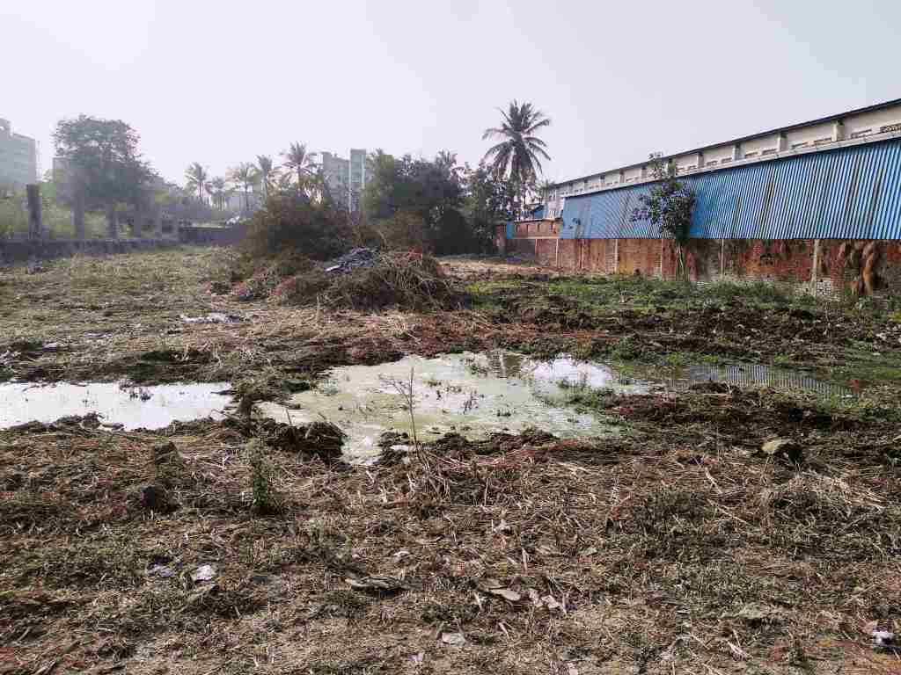

**Details of the property under consideration:**

Name of Owner: **M/s. Ritrishi Multipap Pvt. Ltd.**

Industrial Plot No.19, Survey No. 130, Village - Palghar and Palghar Nagar Parishad, Taluka - Palghar,

District - Palghar, PIN - 401 404, State - Maharashtra, Country – India

# Latitude Longitude - 19°42'53.7"N 72°46'00.7"E

# 

**Valuation Done for:**

**Cosmos Bank**

# MRO-A1, Vile Parle (East) Branch

# Pratik Avenue, 1st Floor, Opp. Shivsagar Hotel, Nehru Road, Vile Parle (East), Mumbai - 400 057,

# State – Maharashtra, Country – India

Vastu/Mumbai/01/2024/5462/2301706

21/2-331-JABS Date: 15.01.2024

# VALUATION OPINION REPORT

The property Industrial Plot No.19, Survey No. 130, Village - Palghar and Palghar Nagar Parishad, Taluka - Palghar, District - Plghar, PIN - 401 404, State - Maharashtra, Country – India belongs to **M/s. Ritrishi Multipap Pvt. Ltd.**

**Boundaries of the property.**

|  |  |  |  |
| --- | --- | --- | --- |
| **Building** | : | **As per actual site** | **As per Documents** |
| North | : | Mindbinders Company Pvt. Ltd. | Details not available |
| South | : | Open Plot | Details not available |
| East | : | Railway Line | Details not available |
| West | : | Open Plot | Details not available |

Considering various parameters recorded, existing economic scenario, and the information that is available with reference to the development of neighborhood and method selected for valuation, we are of the opinion that, the property premises can be assessed and valued for banking purpose for –

|  |  |  |  |
| --- | --- | --- | --- |
| **Particulars** | **Fair Market Value In (₹)** | **Realizable Value In (₹)** | **Distress Sale Value In (₹)** |
| Industrial Plot | 2,26,43,500.00 | 2,03,79,150.00 | 1,81,14,800.00 |

The valuation of the property is based on the documents produced by the concern. Legal aspects have not been taken into considerations while preparing this valuation report.

Hence certified

## Manoj B. Chalikwar

## Registered Valuer

## Chartered Engineer (India)

## Reg. No. CAT-I-F-1763

## Cosmos Emp. No. H.O./Credit/67/2019-20

Encl. Valuation Report

Valuation Report of Industrial Plot No.19, Survey No. 130, Village - Palghar and Palghar Nagar Parishad, Taluka - Palghar, District - Palghar, PIN - 401 404, State – Maharashtra, Country – India.

*Form 0-1*

*(See Rule 8 D)*

REPORT OF VALUATION OF IMMOVABLE PROPERTY (OTHER THAN AGRICULTURAL LANDS, PLANTATIONS, FORESTS, MINES AND QUARRIES)

GENERAL:

|  |  |  |  |
| --- | --- | --- | --- |
| 1 | Purpose for which the valuation is made | | To assess the Fair Market Value as on 15.01.2024 for Bank Loan Purpose |
| 2 | Date of inspection | | 10.01.2024 |
|  | Name of the owner/ owners | | **M/s. Ritrishi Multipap Pvt. Ltd.** |
| 4 | If the property is under joint ownership / co-ownership, share of each such owner. Are the shares undivided? | | Private Limited Company Ownership |
| 5 | Brief description of the property | | **Address:** Industrial Plot No.19, Survey No. 130, Village - Palghar and Palghar Nagar Parishad, Taluka - Palghar, District - Palghar, PIN - 401 404, State – Maharashtra, Country – India.  **Contact Person:**  Mr. Rishi S. Mundhra (Owner)  Contact No. +91 9082782089  **Landmark:** Near Dhawale Hospital |
| 6 | Location, street, ward no | | Boisar – Palghar Road, Near ML Dhawale Memorial Trust, Village - Palghar and Palghar Nagar Parishad, Taluka - Palghar, District – Palghar |
| 7 | Survey/ Plot no. of land | | Industrial Plot No.19, Survey No. 130 |
| 8 | Is the property situated in residential/ commercial/ mixed area/ industrial area? | | Industrial Area |
| 9 | Classification of locality-high class/ middle class/poor class | | Middle Class |
| 10 | Proximity to civic amenities like schools, Hospitals, Offices, market, cinemas etc. | | All the amenities are available in the vicinity |
| 11 | Means and proximity to surface communication by which the locality is served | | Served by Buses, Taxies, Auto and Private cars |
|  | *LAND* | |  |
| 12 | Area of land supported by documentary proof. Shape, dimension and physical features | | Land Area – 1,969.00 Sq. M.  (Area as per Deed of conveyance) |
| 13 | Roads, Streets or lanes on which the land is abutting | | Boisar – Palghar Road |
| 14 | If freehold or leasehold land | | Freehold |
| 15 | If leasehold, the name of Lessor/lessee, nature of lease, date of commencement and termination of lease and terms of renewal of lease. | | N. A. |
| (i) Initial premium | |
| (ii) Ground rent payable per annum | |
| (iii) Unearned increase payable to the Lessor in the event of sale or transfer | |
| 16 | Is there any restriction covenant in regard to use of land? If so attach a copy of the covenant. | | Industrial |
| 17 | Are there any agreements of easements? If so, attach a copy of the covenant | | Information not available |
| 18 | Does the land fall in an area included in any Town Planning Scheme or any Development Plan of Government or any statutory body? If so, give Particulars. | | Information not available |
| 19 | Has any contribution been made towards development or is any demand for such contribution still outstanding? | | Information not available |
| 20 | Has the whole or part of the land been notified for acquisition by government or any statutory body? Give date of the notification. | | No |
| 21 | Attach a dimensioned site plan | | Copy of Approved Site Plan not available for our verification. |
|  | *IMPROVEMENT* | |  |
| 22 | Attach plans and elevations of all structures standing on the land and a lay-out plan. | | Not applicable, being valuation of open plot only |
| 23 | Furnish technical details of the building on a separate sheet (The Annexure to this form may be used) | | Not applicable, being valuation of open plot only |
| 24 | Is the building owner occupied/tenanted/both? | | Open plot in the name of /s. Ritrishi Multipap Pvt. Ltd. |
|  | If the property owner occupied, specify portion and extent of area under owner-occupation | | N.A. |
| 25 | What is the Floor Space Index permissible and Percentage actually utilized? | | N.A. |
| 26 | *RENTS* | |  |
|  | (i) | Names of tenants/ lessees/ licensees, etc. | N.A. |
|  | (ii) | Portions in their occupation | N.A. |
|  | (iii) | Monthly or annual rent/ compensation / license fee, etc. paid by each | N.A. |
|  | (iv) | Gross amount received for the whole property | N.A. |
| 27 | Are any of the occupants related to, or close to business associates of the owner? | | N. A. |
| 28 | Is separate amount being recovered for the use of fixtures, like fans, geysers, refrigerators, cooking ranges, built-in wardrobes, etc. or for services charges? If so, give details | | N. A. |
| 29 | Give details of the water and electricity charges, if any, to be borne by the owner | | N. A. |
| 30 | Has the tenant to bear the whole or part of the cost repairs and maintenance? Give particulars | | N. A. |
| 31 | If a lift is installed, who is to bear the cost of maintenance and operation- owner or tenant? | | N. A. |
| 32 | If a pump is installed, who is to bear the cost of maintenance and operation- owner or tenant? | | N. A. |
| 33 | Who has to bear the cost of electricity charges for lighting of common space like entrance hall, stairs, passage, compound, etc. owner or tenant? | | N. A. |
| 34 | What is the amount of property tax? Who is to bear it? Give details with documentary proof | | N. A. |
| 35 | Is the building insured? If so, give the policy no., amount for which it is insured and the annual premium | | N. A. |
| 36 | Is any dispute between landlord and tenant regarding rent pending in a court of rent? | | N. A. |
| 37 | Has any standard rent been fixed for the premises under any law relating to the control of rent? | | N. A. |
|  | *SALES* | |  |
| 38 | Give instances of sales of immovable property in the locality on a separate sheet, indicating the Name and address of the property, registration No., sale price and area of land sold. | | As per sub registrar of assurance records |
| 39 | Land rate adopted in this valuation | | ` 11,500.00 per Sq. M. |
| 40 | If sale instances are not available or not relied up on, the basis of arriving at the land rate | | Online Price Indicators, Location, development of surrounding area, type of land and construction, construction specifications, age of building, condition of the premises & building, facilities provided and its prevailing market rate. |
|  | *COST OF CONSTRUCTION* | |  |
| 41 | Year of commencement of construction and year of completion | | N.A. |
| 42 | What was the method of construction, by contract / By employing Labour directly / both? | | N.A. |
| 43 | For items of work done on contract, produce copies of agreements | | N.A. |
| 44 | For items of work done by engaging Labour directly, give basic rates of materials and Labour supported by documentary proof. | | N.A. |
|  | **Remark**: The land is demarcated by compound wall except front portion. | | |

*PART II- VALUATION*

GENERAL:

Under the instruction of Cosmos Bank, MRO-A1, Vile Parle (East) Branch to assess fair market value as on 15.01.2024 for Industrial Plot No.19, Survey No. 130, Village - Palghar and Palghar Nagar Parishad, Taluka - Palghar, District - Palghar, State – Maharashtra, Country – India belongs to **M/s. Ritrishi Multipap Pvt. Ltd.**

**We are in receipt of the following documents:**

|  |  |
| --- | --- |
| 1 | Copy of 7/12 Revenue Extract, Plot No. 19, Survey No. 130 of Village Palghar,Taluka - Palghar, District - Thane |
| 2 | Copy of Deed of Conveyance dated 16.08.2007 between Shri. Chandrakant Nilkanth Dandekar, Shri. Vinayak Nilkanth Dandekar, Shri. Keshav Nilkanth Dandekar, Shri. Dinkar Nilkanth Dandekar, Smt. Madhavi Suresh Dandekar, Shri. Rohit Suresh Dandekar, Smt. Tanuja Suresh Dandekar, Smt. Rohini Suresh Dandekar, Smt. Deepshri Milind Bhalerao, Shri. Gajanan Shridhar Kelakar, Smt. Kusum Vinayak Vad & Smt. Vimal Madhusudan Dandekar (Vendors) AND M/s. Ritrishi Multipap Pvt. Ltd., through its Director Mr. Rishi Shankarlal Mundhra (Purchaser) |
| 3 | Copy of No Objection Certificate No. P.N.P / B.B / 64 / 2006-2007 dated 20.03.2007 issued by Palghar Nagarparishad, Palghar |

**LOCATION:**

The said building is located at bearing Plot No.19, Survey No. 130, Village - Palghar and Palghar Nagar Parishad, Taluka - Palghar, District - Palghar. The property falls in Industrial Zone. It is at a travelling distance of 3.2 km. travelling distance from Palghar railway station.

**Valuation as on 15th January 2024:**

1. **Land Valuation:**

|  |  |  |  |
| --- | --- | --- | --- |
| **Fair Market Value** |  | | |
| A) Plot | **Area in Sq. M.** | **Rate in `** | **Fair Market Value in `** |
| 1,969.00 | 11,500/- | **2,26,43,500/-** |

1. **Valuation of Structures.**

The Built-up area of the building : **Not applicable, being valuation of open plot only**

**Deduct Depreciation:**

Year of Construction of the building : N.A.

Expected total life of building : N.A.

Age of the building as on 2024 : N.A.

Cost of Construction : N.A.

Depreciation : N.A.

Amount of depreciation : N.A.

**Depreciated cost of construction** : N.A.

**Government Value:**

|  |  |  |  |
| --- | --- | --- | --- |
| **Particulars** | **Area in Sq. M.** | **Rate in `** | **Value in `** |
| Plot | 1,969.00 | 4,500/- | 88,60,500/- |
| **Total** |  |  | **88,60,500/-** |

**TOTAL VALUE OF THE PROPERTY:**

|  |  |
| --- | --- |
| **Particulars** | **Value (`)** |
| **Land** | 2,26,43,500.00 |
| **Land Development** | - |
| **Building** | - |
| **Fair Market Value** | **2,26,43,500.00** |
| **Realizable Value** | **2,03,79,150.00** |
| **Distress Sale Value** | **1,81,14,800.00** |
| **Insurable value**  **(Depreciated Cost of Construction** | **-** |

Taking into consideration above said facts, we can evaluate the value of Industrial Plot No.19, Survey No. 130, Village - Palghar and Palghar Nagar Parishad, Taluka - Palghar, District - Thane, PIN - 401 404, State - Maharashtra, Country – India for this particular purpose at **` 2,26,43,500.00 (Rupees Two Crore Twenty Six Lakh Forty Three Thousand Five Hundred Only)** as on **15th January 2024.**

**NOTES**

1. I, Manoj B. Chalikwar with my experience and ability to judgment I am of the considered opinion that the fair market value of the property as on 15th January 2024 is ` 2,26,43,500.00 (Rupees Two Crore Twenty Six Lakh Forty Three Thousand Five Hundred Only). Value varies with time and purpose and hence this value should not be referred for any purpose other than mentioned in this report.
2. This valuation is done on the basis of information, which the valuer has obtained by information provided by the client about the premises and location of the surrounding area and also prevailing rates in the surrounding area, and further subject to document as mentioned in valuation report.
3. This valuer should not be held responsible for authentication of documents, clear title and other such related matters. For that purpose, Latest Legal Opinion should be sought.

*PART III- DECLARATION*

I hereby declare that

* + 1. The information furnished in part I is true and correct to the best of my knowledge and belief;
    2. I have no direct or indirect interest in the property valued:

ANNEXURE TO FORM 0-1

Technical details Building

|  |  |  |
| --- | --- | --- |
| 1. | No. of floors and height of each floor | Not applicable, being valuation of open plot only |
| 2. | Plinth area floor wise as per IS- 1225 | - |
| 3 | Year of construction | - |
| 4 | Estimated future life | - |
| 5 | Type of construction- load bearing walls/RCC frame/ steel frame | - |
| 6 | Type of foundations | - |
| 7 | Walls | - |
| 8 | Partitions | - |
| 9 | Doors and Windows | - |
| 10 | Flooring | - |
| 11 | Finishing | - |
| 12 | Roofing and terracing | RCC, G.I. & ACC sheet roof |
| 13 | Special architectural or decorative features, if any | - |
| 14 | |  |  | | --- | --- | | (i) | Internal wiring – surface or conduit | | (ii) | Class of fittings: Superior/ Ordinary/ Poor. | | - |
| 15 | Sanitary installations   |  |  | | --- | --- | | (i) | No. of water closets | | (ii) | No. of lavatory basins | | (iii) | No. of urinals | | (iv) | No. of sinks |   Class of fittings: Superior colored / superior white/ordinary. | - |
| 16 | Compound wall  Height and length  Type of construction | - |
| 17 | No. of lifts and capacity | - |
| 18 | Underground sump – capacity and type of construction | - |
| 19 | Over-head tank Location, capacity Type of construction | - |
| 20 | Pumps- no. and their horse power | - |
| 21 | Roads and paving within the compound approximate area and type of paving | Kachha Road |
| 22 | Sewage disposal – whereas connected to public sewers, if septic tanks provided, no. and capacity | - |
| 23 | General Remarks |  |
|  |  | |

**Actual site photographs**

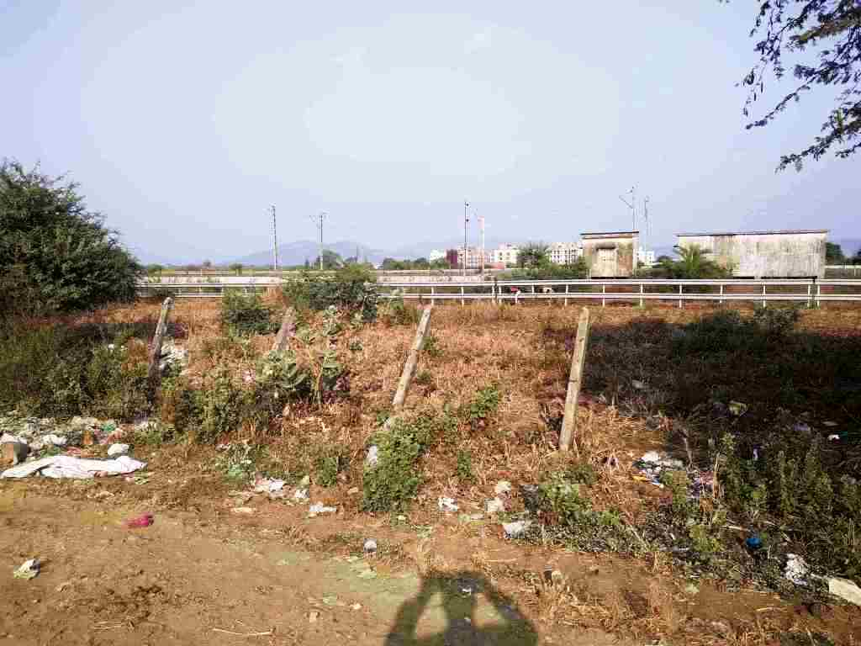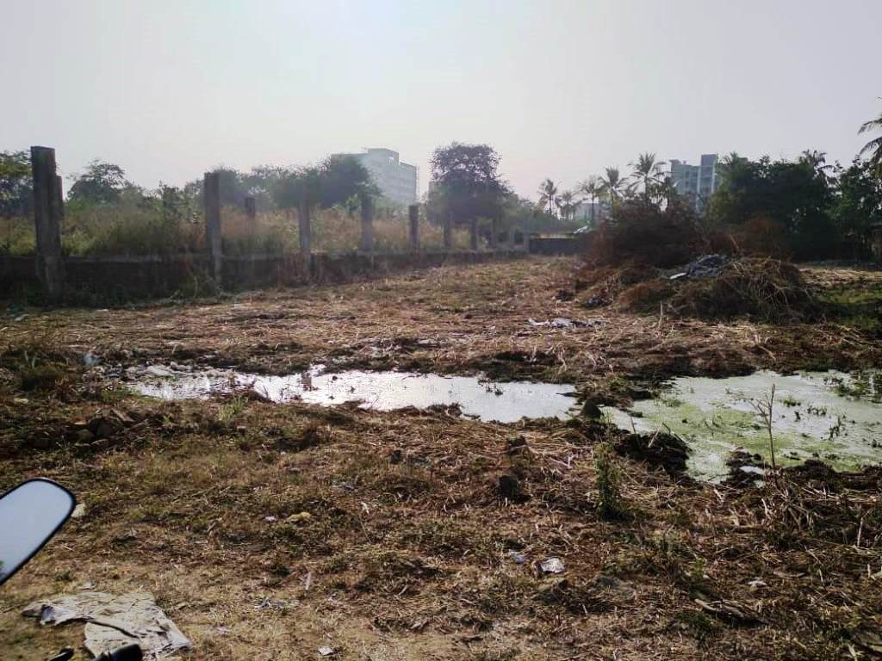

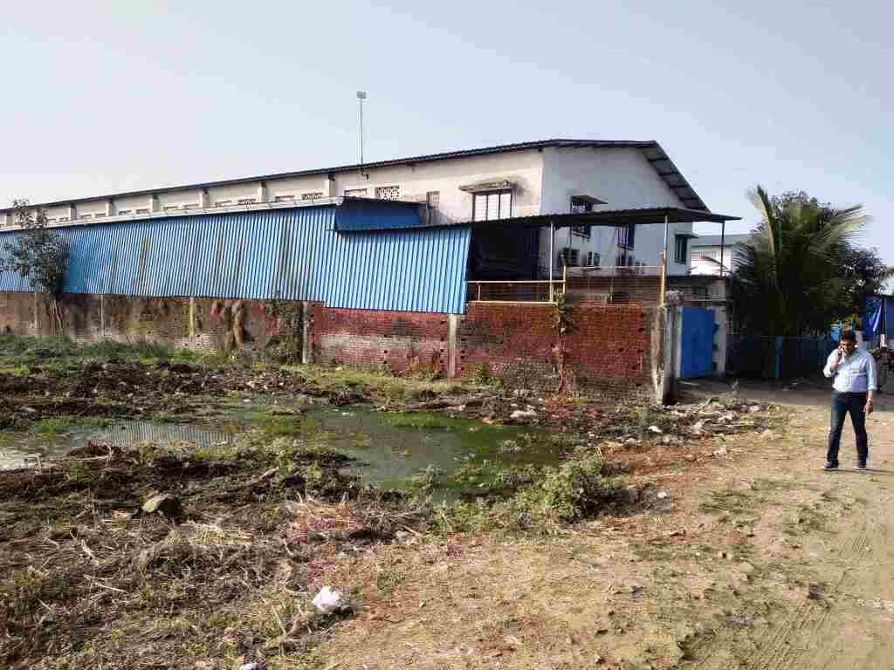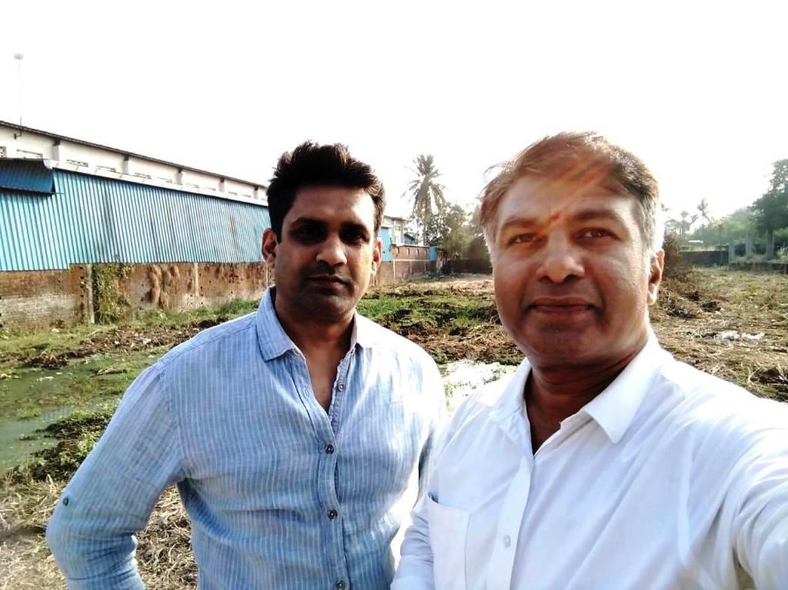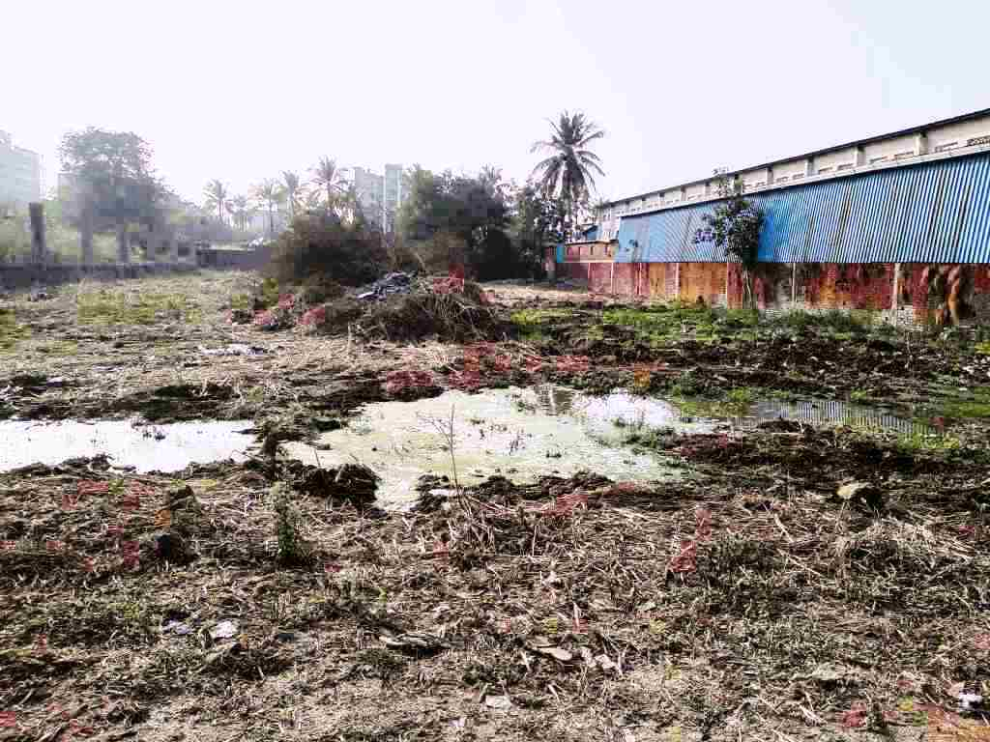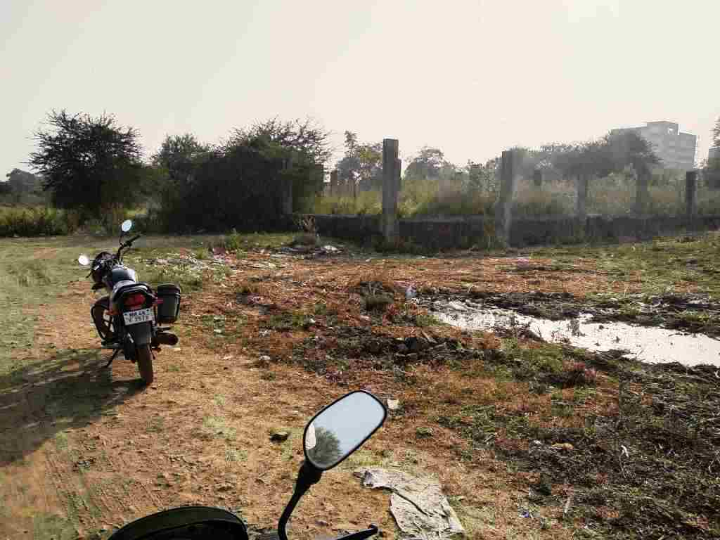1

**Route Map of the property**

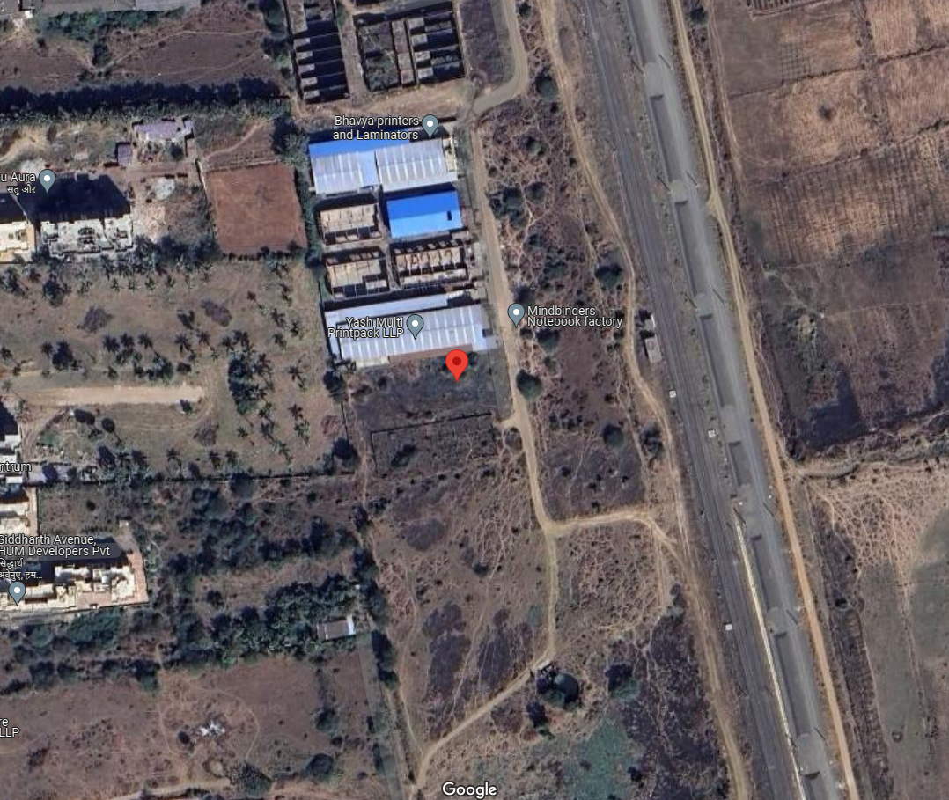**Site u/r**

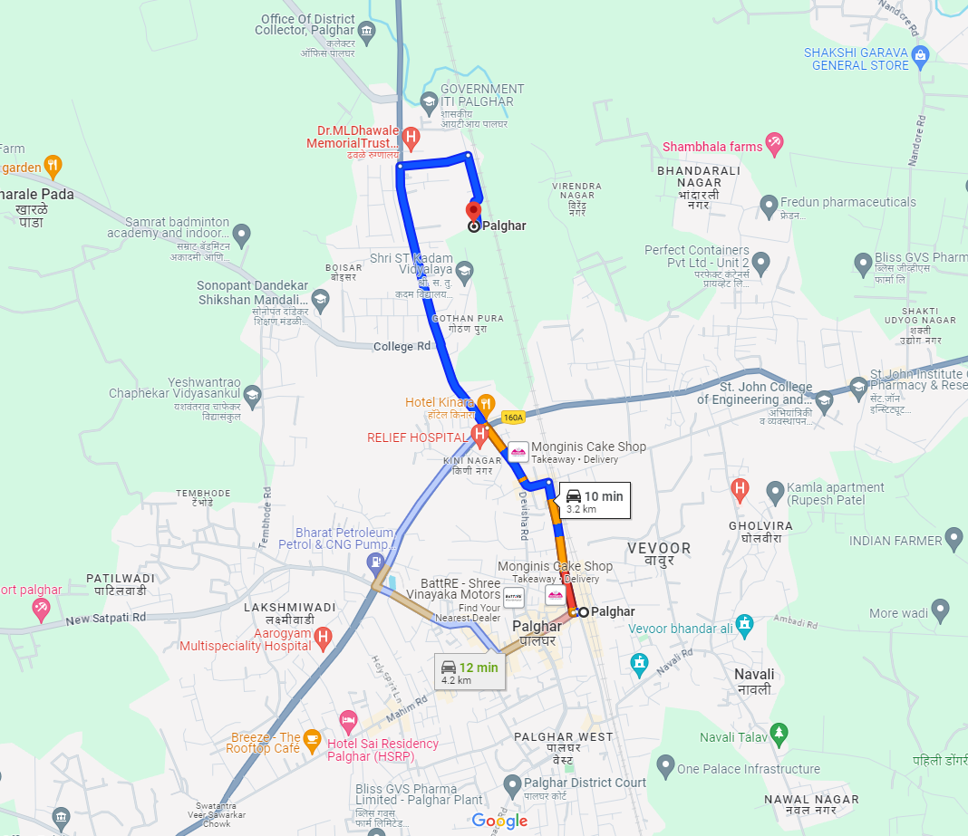

# Latitude Longitude - 19°42'53.7"N 72°46'00.7"E

**Note:** The Blue line shows the route to site from nearest Metro station (Palghar – 3.2 km)

**READY RECKONER RATE**

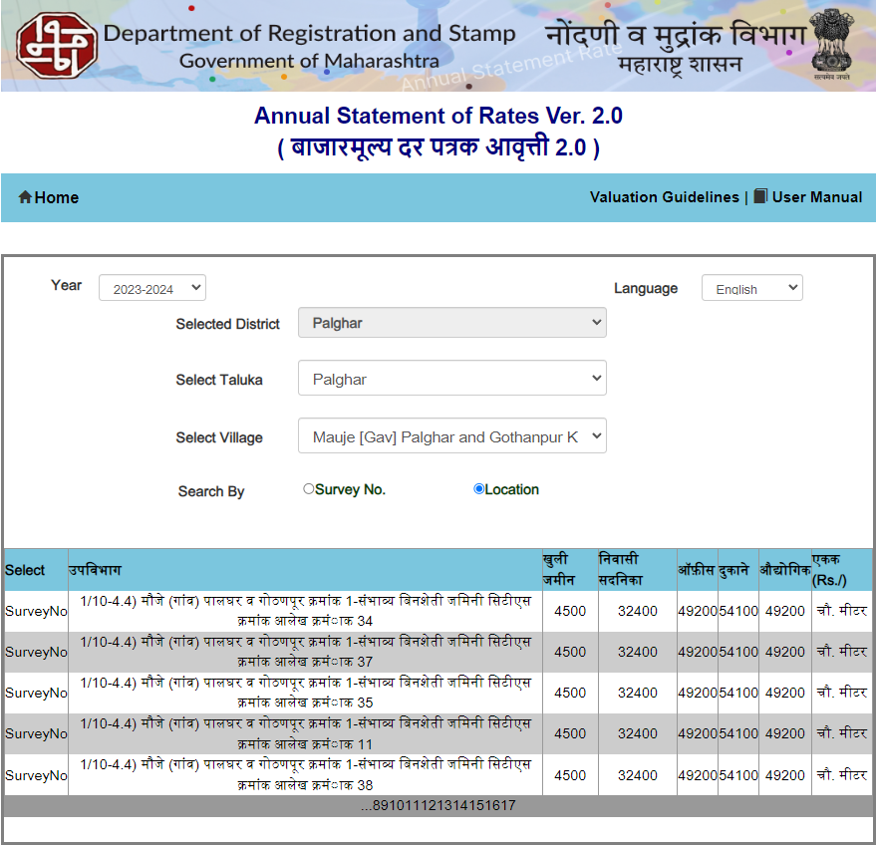

**Price Indicators**

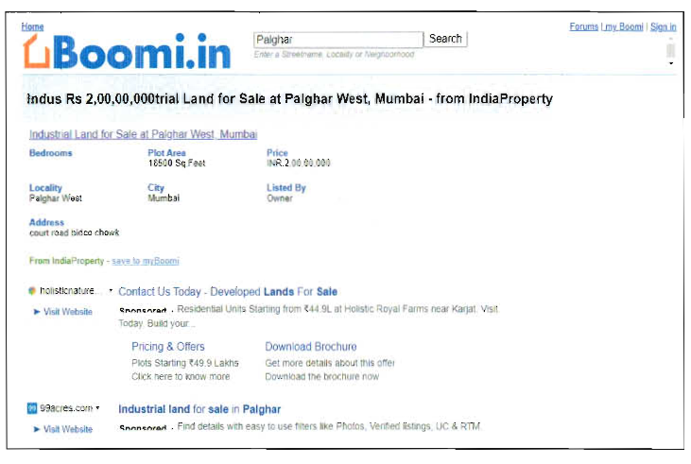

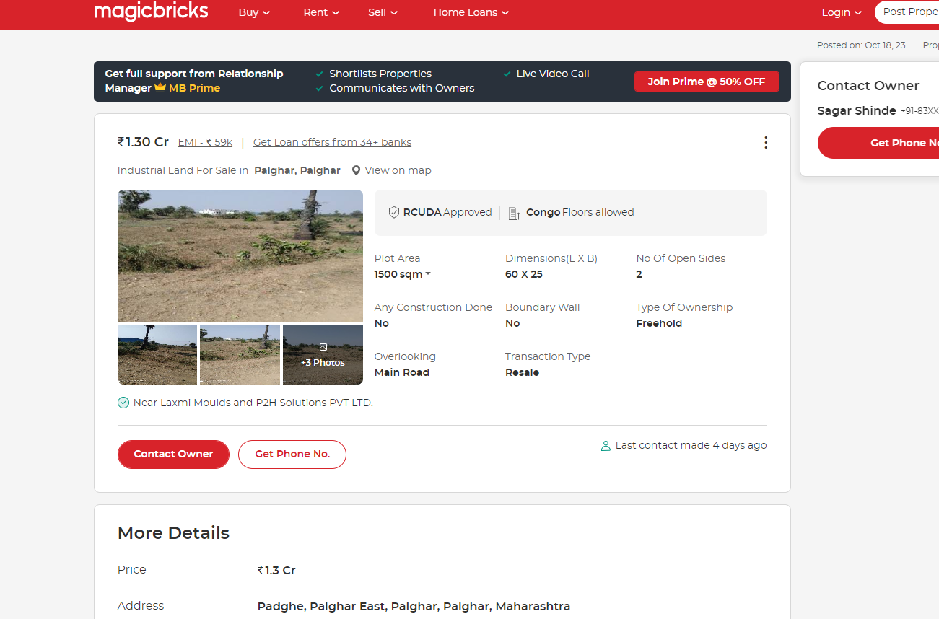

**DEFINITION OF VALUE FOR THIS SPECIFIC PURPOSE**

This exercise is to assess **Fair Market Value** of the property under reference as on **15th January 2024.**

The term **Fair Market Value** is defined as

*“The most probable price, as of a specified date, in cash, terms equivalent to cash, or in other precisely revealed terms for which the specified property rights would sell after reasonable exposure in a competitive market under all conditions requisite to a fair sale, with the buyer and seller each acting prudently knowledgeably and for self-interest assuming that neither is under undue duress”.*

Fundamental assumptions and conditions presumed in this definition are:

1. Buyer and seller are motivated by self-interest.

2. Buyer and seller are well informed and are acting prudently.

3. The property is exposed for a reasonable time on the open market.

4. Payment is made in cash or equivalent or in specified financing terms.

#### UNDER LYING ASSUMPTIONS

1. We assume no responsibility for matters of legal nature affecting the property appraised or the title thereto, nor do we render our opinion as to the title, which is assumed to be good and marketable.

2. The property is valued as though under responsible ownership.

3. It is assumed that the property is free of liens and encumbrances.

4. It is assumed that there are no hidden or unapparent conditions of the subsoil or structure that would render it more or less valuable. No responsibility is assumed for such conditions or for engineering that might be required to discover such factors.

5. There is no direct/ indirect interest in the property valued

6. The rates for valuation of the property are in accordance with the Govt. approved rates and prevailing market rates.

##### DECLARATION OF PROFESSIONAL FEES CHARGED

We hereby declare that, our professional fees are not contingent upon the valuation findings. However, if the statute AND/OR clients demands that, the fees should be charged on the percentage of assessed value then, with the full knowledge of the AND/OR end user, it is being charged accordingly.

# VALUATION OF THE PROPERTY PREMISES

Considering various parameters recorded herein above, existing economic scenario, and the information that is available with reference to the development of neighborhood and method selected for valuation, we are of the opinion that, the property premises can be assessed and valued for banking purpose as on day for ` 2,26,43,500.00 (Rupees Two Crore Twenty Six Lakh Forty Three Thousand Five Hundred Only).

## Manoj B. Chalikwar

## Registered Valuer

## Chartered Engineer (India)

## Reg. No. CAT-I-F-1763

## Cosmos Emp. No. H.O./Credit/67/2019-20