Vastu/Nashik/12/2023/005376/2303783
01/12-12-RPBS
Date: 01.12.2023

To, `
The Branch Manager,
Bank of Baroda
Regional Office Nashik Road Branch
BSNL Building, Datta Mandir Road, Nashik Road,
Nashik -422 101, State - Maharashtra, Country - India.

Sub: Vetting of Extra Amenities

Sir,

With reference to above subject, we have evaluated the Extra Amenities for Residential Flat No. 17, Sixth ^{Floor}, B - Wing, " Laxmi Avenue ", Survey No. 6/ 3/ 1 + 6/ 2/ A, Plot No. 40+41, CTS. No. 8185/18 to 8185/20, Near Parksyde Business Avenue, Pandav Nagari, Pathardi Road, Village - Pathardi, Taluka & District - Nashik, PIN Code – 422009, State – Maharashtra, Country – India belongs to Name of Owner: Mr. Rohit Vijayrao Saindane & Mrs. Pratibha Vijayrao Saindane.

We have verified the rates quoted as per current market rates. Details of work and Extra Amenities considered as per copy of Agreement for Extra Amenities issued by Mr. Rohit Vijayrao Saindane & Mrs. Pratibha Vijayrao Saindane (First Part) and Shri. Vishal Tulshiram Kendhe (Second Part) received on dated 30.11.2023. The Extra Amenities amount is Rs.6,00,000/- (Rupees Six Lakh Only)

The said Cost Vetting Certificate is valid upto next 6 months Only.

Thanking you

Sincerely yours

Manoj B. Chalikwar
Registered Valuer
Chartered Engineer (India)
Reg. No. CAT-I-F-1763
Reg. No. IBBI/RV/07/2018/10366
BOB Empanelment No.: ZO:MZ:ADV:46:941
Encl: Valuation report.

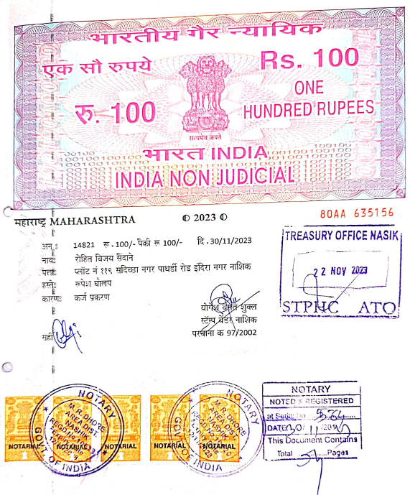
Agreement for Extra Amenities
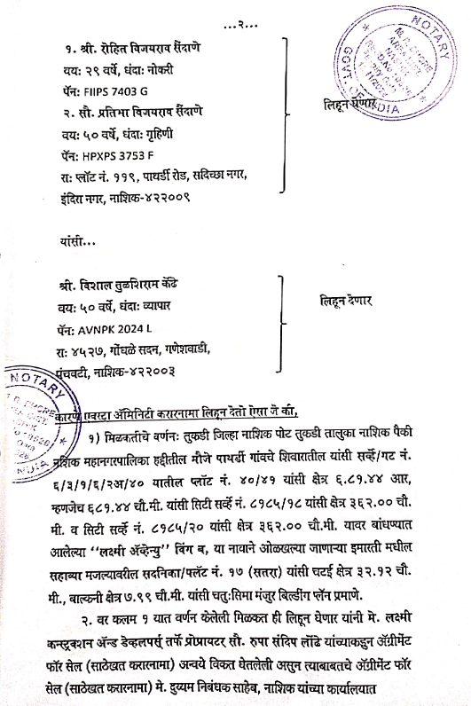

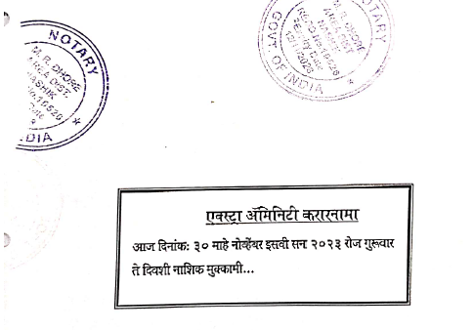

Agreement for Extra Amenities
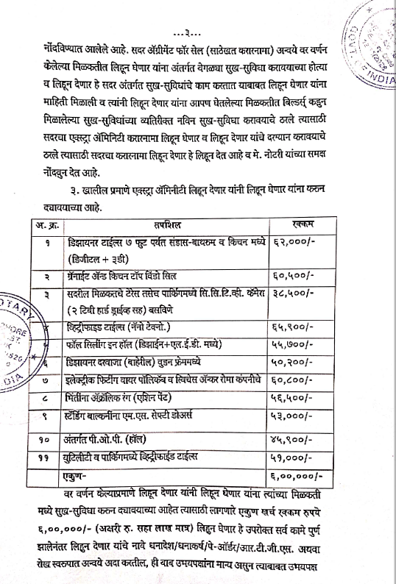
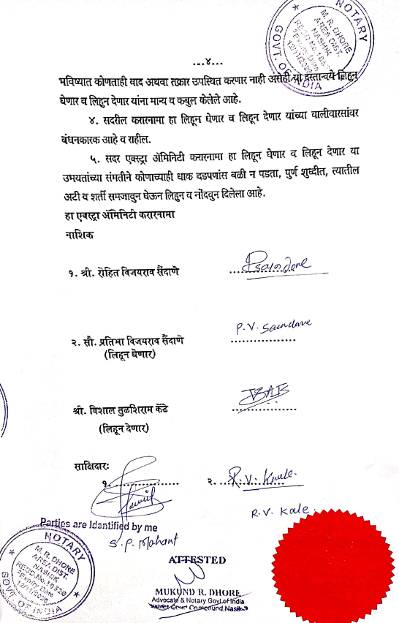

The Extra Amenities amount is Rs.6,00,000/- (Rupees Six Lakh Only.)

