Vastu/Nashik/12/2023833/2303787
02/2-16-CCBS-CCBS
Date: 02.12.2023

To, `
The Branch Manager,
Bank of Baroda
Regional Office Nashik Road Branch
BSNL Building, Datta Mandir Road, Nashik Road,
Nashik -422 101, State - Maharashtra, Country - India.

Sub: Vetting of Extra Amenities

Sir,

With reference to above subject, we have evaluated the Extra Amenities for Residential Row Bungalow No.2, Parking + First + Second Floor, " Shubham Row Bungalow",Survey No.908/3/25, Plot No.25, Near Saikrupa Hospital, Mauli Nagar, Dnyaneshwar Nagar,Village – Nashik, Taluka – Nashik, District - Nashik, PIN Code – 422 010, State – Maharashtra, Country – India belongs to Shri.Shubham Mukund Musale Name of Proposed Purchaser: Shri.Namdeo Khanderao Aaghav & Sau.Shobha Namdeo Aaghav & Shri.Yogeshwar Namdeo Aaghav & Shri.Rameshwar Namdeo Aaghav

We have verified the rates quoted as per current market rates. Details of work and Extra Amenities considered as per copy of Agreement for Extra Amenities issued by Shri.Namdeo Khanderao Aaghav & Sau.Shobha Namdeo Aaghav & Shri.Yogeshwar Namdeo Aaghav & Shri.Rameshwar Namdeo Aaghav (First Part) and Shri.Suresh Baburao Jadhav (Second Part) received on dated 29.11.2023. The Extra Amenities amount is Rs.2,00,000/- (Rupees Two Lakh Only)

The said Cost Vetting Certificate is valid upto next 6 months Only.

Thanking you

Sincerely yours

Sharadkumar B. Chalikwar
Govt. Reg. Valuer
Chartered Engineer (India)
Reg. No. (N) CCIT/1-14/52/2008-09
Encl: Valuation report.
.

.
Agreement for Extra Amenities

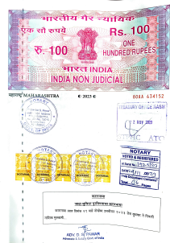

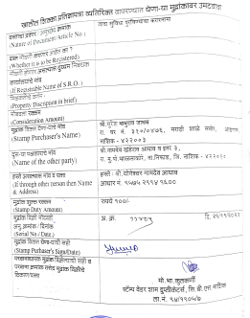

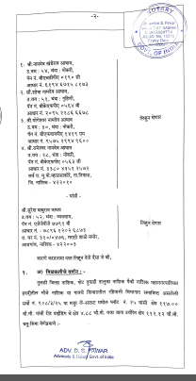
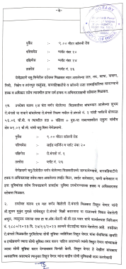

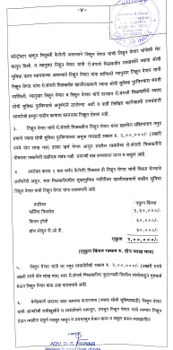
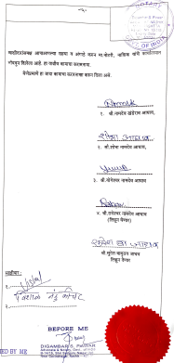
Agreement for Extra Amenities

The Extra Amenities amount is is Rs.2,00,000/- (Rupees Two Lakh Only)

