COST VETTING REPORT
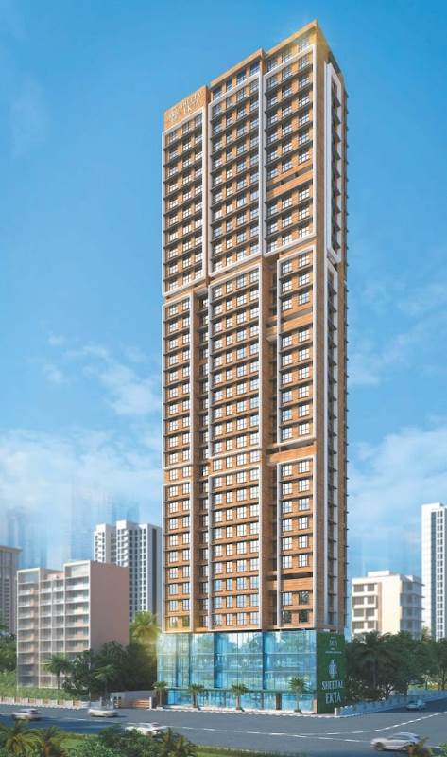

Details of the property under consideration:

Name of Project: "Sheetal Ekta"

"Sheetal Ekta", Proposed Redevelopment of existing building No. 18 – A & B, known as Dindoshi Ekta CHSL on Plot bearing S. No. 31 & 39, CTS. No. 110(pt.) & 146 (pt.), Shivdham Complex, Gen. A. K. Vaidya Marg, Village – Dindoshi, Malad (East), Mumbai – 400 097, State – Maharashtra, Country – India

Latitude Longitude: 19°10'32.1"N 72°51'40.3"E

Valuation Done for:
State Bank of India
SME Chembur Branch
Unit No. 11, Building No. 11, Ground Floor, Corporate Park, Sion Trombay Road,
Chembur, Mumbai, Pin Code – 400 071, State - Maharashtra, Country – India.

Vastu/SBI/Mumbai/09/2023/3697/2302505
12/10-149-PY
Date: 18.09.2023

To,
The Branch Manager,
State Bank of India
SME Chembur Branch
Unit No. 11, Building No. 11,
Ground Floor, Corporate Park,
Sion Trombay Road, Chembur,
Mumbai, Pin Code – 400 071,
State - Maharashtra, Country – India.

Sub: Cost Vetting Report for "Sheetal Ekta" at Malad (East) Mumbai, Pin Code – 400 097.

Ref: As per your mail dated 01.12.2023

Dear Sir,
In accordance with your letter of engagement as stated above, we enclose our Report on Cost Vetting for "Sheetal Ekta", Proposed Redevelopment of existing building No. 18 – A & B, known as Dindoshi Ekta CHSL on Plot bearing S. No. 31 & 39, CTS. No. 110(pt.) & 146 (pt.), Shivdham Complex, Gen. A. K. Vaidya Marg, Village – Dindoshi, Malad (East), Mumbai – 400 097, State – Maharashtra, Country – India.
M/s. DGS Township Pvt. Ltd., making a difference requires consistent effort and a commitment to quality. DGS Group have been committed to constructing architectural landmarks that redefine the Mumbai skyline. Over the years, they have garnered a reputation for delivering exceptional properties and world-class infrastructure, with an enhanced focus on affordable housing and sustainable growth. Their dedication to innovation, integrity, and quality shows in every project they undertake. From conception to completion, they develop each of their unique projects with passion, creativity, and expertise. They strive to add to the alluring landscape of the thriving city of dreams, Mumbai. When looking to construct an enduring, excellent structure, trusting the skills and efficiency of the DGS team.
M/s. DGS Township Pvt. Ltd. is proposing redevelopment of existing building No. 18 – A & B, known as Dindoshi Ekta CHSL on Plot bearing S. No. 31 & 39, CTS. No. 110(pt.) & 146 (pt.), Shivdham Complex, Gen. A. K. Vaidya Marg, Village – Dindoshi, Malad (East), Mumbai – 400 097, State – Maharashtra, Country – India. Project is comprising Commercial cum Residential of Rehab cum Sale Building.
Commercial cum Residential of Rehab cum Sale Building is proposed of Basement + Ground Floor + 1st to 33rd Upper Floors with total RERA carpet area of 92,490.42 Sq. Ft. which consists 2 BHK, Offices and Shops units with 73 nos. of Sell flats, 48 Tenant Flats, 4 Security to Society Flats, 4 Sell Offices, 9 Tenant Offices & 4 Tenant Shops providing with Fitness Centre, Society Office, & Other Amenities.
In this regard, SBI, SME Chembur Branch, Unit No. 11, Building No. 11, Ground Floor, Corporate Park, Sion Trombay Road, Chembur, Mumbai, Pin Code – 400 071, has approached Vastukala Consultants (I) Pvt. Ltd. (VCIPL) to conduct a Cost Vetting of the said project.
Our analysis of the cost vetting is enclosed in this report. This Report forms an integral whole and cannot be split in parts. The outcome of the report/ study can only lead to proper conclusions if the Report as a whole is taken into account.
The information used by Vastukala Consultants (I) Pvt. Ltd. (VCIPL) in preparing this report has been obtained from a variety of sources and other relevant documents provided by the client & bank. As agreed, we have performed our cost vetting exercise with the data available related to the business, considering the market prospects and projections. Our results are dependent on documents provided by client & bank, the underlying assumptions, which has been analyzed at a broader level by VCIPL while assessing their reasonableness.
Total Project Cost for the completion of Project will be ` 116.48 Cr.

For Vastukala Consultants (I) Pvt. Ltd.

Manoj B. Chalikwar
Registered Valuer
Chartered Engineer (India)
Reg. No. IBBI / RV / 07/2018/10366
Reg. No. CAT-I-F-1763
SBI Empanelment No.: SME/TCC/2021-22/86/3
About the Project:
Proposed Redevelopment of existing building No. 18 – A & B, known as Dindoshi Ekta CHSL on Plot bearing S. No. 31 & 39, CTS. No. 110(pt.) & 146 (pt.), Shivdham Complex, Gen. A. K. Vaidya Marg, Village – Dindoshi, Malad (East), Mumbai – 400 097. It is about 2.60 Km. travelling distance from Malad (East) Railway station.

Area Statement as per Approved Plan
A | AREA STATEMENT
1 | Area of the plot (As per MHADA NOC & Demarcation) | 1,128.58
2 | Deduction for
a | Road Set back area | 34.25
b | Proposed Road | -
c | Any reservation | -
d | % Amenity space as per DCR 56 / 57 (Sub plot) | -
e | Other
 | Total ( a + b + c + d + e) | 34.25
3 | Balance Area of the plot (1 – 2) | 1,094.33
4 | Deduction for 15% recreational ground | -
 | 10% Amenity space (If deductible for IND)
5 | Net Area of Plot (3 – 4) | 1,094.33
6 | Additions for FSI purpose
2a | 100% for DP Road
2b | 100% for Set – back | 34.25
 | Total (2a + 2b) | 34.25
7 | Total Area (5 + 6) | 1,128.58
8 | FSI Permissible | 3.00
9 | - Permissible Floor Area (7 X 8) | 3,385.74
 | - Additional Layout FSI | 3,760.00
 | Total Permissible Area 9 (i) + 9 (ii) | 7,145.74
10 | Proposed Built up Area | 6,436.21
11 | Excess Balcony Area taken in floor space index | N.A.
12 | Total Proposed Area (10 + 11) | 6,436.21
B | Details of FSI Availed as per DCR 35 (4)
1 | Fungible Built up area component proposed vide DCR 35 (4) for purely residential = OR < (D(i) X 0.35) | 172.82
2 | Fungible Built up area component proposed vide DCR 35 (4) for non – residential = OR < (12 X 0.20) | 615.34
3 | Total Fungible Built up area vide DCR 35 (4) | 788.16
4 | Total BUA proposed including fungible compensatory area (12 + B(3)) | 7,224.37
5 | Permissible fungible area | 2,501.00
C | Prorata shares as per MHADA
1 | Prorata share as per letter No. CO/MB/REE/NOC/F-337/84 X 40 = 3,360 M. | 3,760.00
2 | Total Gross Built up area permissible | 9,646.74
3 | Total Gross Built up area proposed | 7,224.37
4 | No. CO/MB/REF/NOC/F-337/1047/2019
D | Tenement Statement
i | Total Gross Built up area proposed | 7,224.37
ii | Less Deduction of Non – Residential area (Shop, etc.) | 1,799.71
iii | Area available for tenements | 5,424.66
iv | FSI consumed on net holding | -
v | Fungible FSI consumed on net holding | -
vi | Tenements permissible | 381 nos.
vii | Tenements proposed | 60 nos.
viii | Tenements existing
 | Total Tenements on the plot
E | Parking Statement
i | Parking required by regulations for | 51 nos.
 | Car / Scooter / Motor cycle | As per area statement
 | Outsiders (visitors) | As per area statement
ii | Covered garages permissible | As per area statement
iii | Covered garages provided | As per area statement
 | Car | As per area statement
 | Scooter / Motor Cycle | As per area statement
 | Outsiders (visitors) | As per area statement
iv | Total Parking Provided | 77 nos.
F | Transport Vehicles parking
i | Spaces for transport vehicles parking required by regulations
ii | Total no. of transport vehicles parking spaces provided

Area Statement as per Concession Drawing Plan
A | AREA STATEMENT
1 | Area of the plot (As per MHADA NOC & Demarcation) | 1,128.58
2 | Deduction for
a | Road Set back area | 34.25
b | Proposed Road | -
c | Any reservation | -
d | % Amenity space as per DCR 56 / 57 (Sub plot) | -
e | Other
 | Total ( a + b + c + d + e) | 34.25
3 | Balance Area of the plot (1 – 2) | 1,094.33
4 | Deduction for 15% recreational ground | -
 | 10% Amenity space (If deductible for IND)
5 | Net Area of Plot (3 – 4) | 1,094.33
6 | Additions for FSI purpose
2a | 100% for DP Road
2b | 100% for Set – back | 34.25
 | Total (2a + 2b) | 34.25
7 | Total Area (5 + 6) | 1,128.58
8 | FSI Permissible | 3.00
9 | - FSI credit available by development right (restricted to % of the balance area vide 3 above) | -
 | Additions for FSI purpose
 | - 33% as per DCR 32 (2754.57 X 33%)
 | - External TDR (As per App. VII – B) (67%)
 | - Other
 | Total
10 | - Permissible Floor Area (7 X 8) + 9 | 3,385.74
 | - Additional Layout FSI | 3,760.00
 | Total Permissible Area 10 (i) + 10 (ii) | 7,145.74
11 | Proposed Built up Area | 7,120.51
 | - Existing Floor Area | N.A.
12 | Excess Balcony Area taken in floor space index | N.A.
13 | Total Proposed Area (10 + 11 + 12)
B | Details of FSI Availed as per DCR 35 (4)
1 | Fungible Built up area component proposed vide DCR 35 (4) for purely residential = OR < (D(i) X 0.35) | 2,124.31
2 | Fungible Built up area component proposed vide DCR 35 (4) for non – residential = OR < (12 X 0.20) | 367.87
3 | Total Fungible Built up area vide DCR 35 (4) | 2,492.18
4 | Total BUA proposed including fungible compensatory area (12 + B(3)) | 9,612.69
C | Prorata shares as per MHADA
1 | Prorata share as per letter No. CO/MB/REE/NOC/F-337/84 X 40 = 3,360 M. | 3,760.00
2 | Total Gross Built up area permissible | 13,372.69
3 | Total Gross Built up area proposed | 9,612.69
4 | No. CO/MB/REF/NOC/F-337/1047/2019
D | Tenement Statement
i | Total Gross Built up area proposed | 9,612.69
ii | Less Deduction of Non – Residential area (Shop, etc.) | 1,418.94
iii | Area available for tenements | 8,193.75
iv | FSI consumed on net holding | -
v | Fungible FSI consumed on net holding | -
vi | Tenements permissible | 381 nos.
vii | Tenements proposed | 125 nos.
viii | Tenements existing
 | Total Tenements on the plot
E | Parking Statement
i | Parking required by regulations for | 79 nos.
 | Car / Scooter / Motor cycle | As per area statement
 | Outsiders (visitors) | As per area statement
ii | Covered garages permissible | As per area statement
iii | Covered garages provided | As per area statement
 | Car | As per area statement
 | Scooter / Motor Cycle | As per area statement
 | Outsiders (visitors) | As per area statement
iv | Total Parking Provided | 111 nos.
F | Transport Vehicles parking
i | Spaces for transport vehicles parking required by regulations
ii | Total no. of transport vehicles parking spaces provided

Construction Area as per Approved Plan for Rehab cum Sale Building

Sr. No. | Floor | Built Up Area in Sq. M. | Staircase Area in Sq. M. | Other Area in Sq. M. | Total Construction Area in Sq. M.
1 | Basement Floor | 217.91 | 131.22 | 89.61 | 438.74
2 | Ground Floor | 265.24 | 131.22 | 89.61 | 486.07
3 | 1st Floor | 311.93 | 112.53 | 89.61 | 514.07
4 | 2nd Floor | 311.93 | 112.53 | 89.61 | 514.07
5 | 3rd Floor | 311.93 | 112.53 | 89.61 | 514.07
6 | 4th Floor | 253.76 | 115.71 | 89.61 | 459.08
7 | 5th Floor | 253.76 | 115.71 | 89.61 | 459.08
8 | 6th Floor | 191.71 | 115.71 | 158.22 | 465.64
9 | 7th Floor | 253.76 | 115.71 | 89.61 | 459.08
10 | 8th Floor | 253.76 | 115.71 | 89.61 | 459.08
11 | 9th Floor | 253.76 | 115.71 | 89.61 | 459.08
12 | 10th Floor | 253.76 | 115.71 | 89.61 | 459.08
13 | 11th Floor | 253.76 | 115.71 | 89.61 | 459.08
14 | 12th Floor | 253.76 | 115.71 | 89.61 | 459.08
15 | 13th Floor | 191.71 | 115.71 | 158.22 | 465.64
16 | 14th Floor | 253.76 | 115.71 | 89.61 | 459.08
17 | 15th Floor | 253.76 | 115.71 | 89.61 | 459.08
18 | 16th Floor | 253.76 | 115.71 | 89.61 | 459.08
19 | 17th Floor | 253.76 | 115.71 | 89.61 | 459.08
20 | 18th Floor | 253.76 | 115.71 | 89.61 | 459.08
21 | 19th Floor | 253.76 | 115.71 | 89.61 | 459.08
22 | 20th Floor | 183.31 | 115.69 | 169.19 | 468.19
23 | 21st Floor | 253.76 | 115.71 | 89.61 | 459.08
24 | 22nd Floor | 253.76 | 115.71 | 89.61 | 459.08
25 | 23rd Floor | 253.76 | 115.71 | 89.61 | 459.08
26 | 24th Floor | 346.03 | 114.42 | - | 460.45
27 | 25th Floor | 346.03 | 114.42 | - | 460.45
28 | 26th Floor | 346.03 | 114.42 | - | 460.45
29 | 27th Floor | 257.62 | 114.39 | 95.97 | 467.98
30 | 28th Floor | 347.94 | 114.39 | - | 462.33
31 | 29th Floor | 347.94 | 114.39 | - | 462.33
32 | 30th Floor | 347.94 | 114.39 | - | 462.33
33 | 31st Floor | 347.94 | 114.39 | - | 462.33
34 | 32nd Floor | 347.94 | 114.39 | - | 462.33
35 | 33rd Floor | 277.69 | 114.39 | 67.57 | 459.65
36 | Terrace / OHT | - | 114.39 | - | 114.39
TOTAL |  | 9,612.69 | 4,172.59 | 2,620.51 | 16,405.79
No. of Stack Car Parking |  |  |  |  | 111 Nos.

Project Cost
Sr. No. | Particulars | Total Estimated Amount in ` | Total Estimated Amount  in ` Cr.
1 | Land Cost
 | Acquisition Cost of Land or Development Rights, and Legal Cost. | 1,56,47,420.00 | 1.56
 | Rent to Tenants, Lease premium, Lease Rent, interest cost incurred or payable on Land Cost | 14,71,11,560.00 | 14.71
 | Amount of Premium payable to obtain development rights, FSI, additional FSI, fungible area, and any other incentive under DCR from Local Authority or State Government or any Statutory Authority. | 27,72,60,604.00 | 27.73
 | Acquisition cost of TDR (if any) | - | -
2 | Cost of Construction
 | Estimated construction cost of rehab cum sale building including site development and infrastructure for the same. | 57,22,82,410.00 | 57.23
 | On site expenditure for development of entire project excluding cost of construction as per(i) above,
a. | Architect Fees & Consultant fees | 1,14,45,648.00 | 1.14
b. | Admin Cost includes salaries, site overheads, development works, cost of services (including water, electricity, sewerage, drainage, layout roads etc.), cost of machineries and equipment including its hire and maintenance cost, consumables etc. All costs directly incurred to complete the construction of the entire phase of the project registered. | 2,86,14,121.00 | 2.86
c. | Marketing Cost | 2,75,20,165.00 | 2.75
3 | Interest during the Project | 8,49,00,000.00 | 8.49
4. | Contingency Charges | - | -
 | GRAND TOTAL: | 116,47,81,928.00 | 116.48

Manoj B. Chalikwar
Registered Valuer
Chartered Engineer (India)
Reg. No. IBBI / RV / 07/2018/10366
Reg. No. CAT-I-F-1763
SBI Empanelment No.: SME/TCC/2021-22/86/3

Comments on each element of Cost of Project: -
- Land Cost:
As per Present Ready Reckoner rate the Project Land Value is ` 7.47 Cr. considering Land Rate @ ` 68,240.00 per Sq. M. & Net Plot Area of 1,094.33 Sq. M.
As per document purchase cost of land & stamp duty cost is ` 1,56,47,420.00 i.e., ` 1.56 Cr. which is 1.34% of Total Project Cost.
Sr. No. | Agreement Name | Date | Particulars | Total Cost in ` | Incurred Cost in `
1 | Development Agreement | 3/27/2019 | Stamp Duty | 1,44,97,980.00 | 1,44,97,980.00
2 | Development Agreement | 3/27/2019 | Reg. Fees | 30,000.00 | 30,000.00
3 | Development Agreement | 3/27/2019 | Reg. Fees | 2,000.00 | 2,000.00
4 | Rectification Cum Supplementary Deed | 4/29/2022 | Stamp Duty | 10,86,200.00 | 10,86,200.00
5 | Rectification Cum Supplementary Deed | 4/29/2022 | Reg. Fees | 30,000.00 | 30,000.00
6 | Special Power of Attorney | 3/27/2021 | Stamp Duty | 500.00 | 500.00
7 | Special Power of Attorney | 3/27/2021 | Reg. Fees | 740.00 | 740.00
 | TOTAL |  |  | 1,56,47,420.00 | 1,56,47,420.00

- Payment Payable to Rehab Tenants (Rent Cost):
Since it is a having some redevelopment flat from the date of shifting of 61 Tenants till handing over their respective new flats as per the Tenant Agreement. Further the rent keeps on increasing as per agreement. The existing Tenants has to be given total rental of ` 14,71,11,560.00 i.e., ` 14.71 Cr. Builder has paid ` 7.90 Cr. which is 12.63 % of Total Project Cost.
Existing Tenants Carpet Area & Rent per month for Flat are as follows:
Sr. No | Particulars | Commercial Shops | Commercial Offices | Residential Flat | Total | Units
1 | No. of Tenants | 4.00 | 9.00 | 48.00 | 61.00 | Nos.
2 | Rent per tenant per month for April 23 to Feb 24 | 110,000.00 | 50,000.00 | 40,000.00 |  | Rupees
3 | Rent per year for April 23 to Feb 24 | 4,840,000.00 | 4,950,000.00 | 21,120,000.00 | 30,910,000.00 | Rupees
4 | Rent per tenants per month for March 24 to Jan 25 | 121,000.00 | 55,000.00 | 44,000.00 |  | Rupees
5 | Rent per year for March 24 to Jan 25 | 5,324,000.00 | 5,445,000.00 | 23,232,000.00 | 34,001,000.00 | Rupees
6 | Rent per tenants per month for Feb 25 to March 25 | 133,100.00 | 60,500.00 | - |  | Rupees
7 | Rent per year for Feb 25 to March 25 | 1,064,800.00 | 1,089,000.00 | - | 2,153,800.00 | Rupees
8 | Rent per tenants per month for Feb 25 to Dec 25 | - | - | 48,400.00 |  | Rupees
9 | Rent per year for Feb 25 to Dec 25 | - | - | 25,555,200.00 | 25,555,200.00 | Rupees
10 | Rent per tenants per month for Jan 26 to Mar 26 | - | - | 53,240.00 |  | Rupees
11 | Rent per year for Jan 26 to Mar 26 | - | - | 7,666,560.00 | 7,666,560.00 | Rupees
12 | Corpus Fund per Tenant | 800,000.00 | 700,000.00 | 700,000.00 |  | Rupees
13 | Total Corpus Fund | 3,200,000.00 | 6,300,000.00 | 33,600,000.00 | 43,100,000.00 | Rupees
14 | Shifting Charges per Tenant | 15,000.00 | 15,000.00 | 15,000.00 |  | Rupees
15 | Total Shifting Charges | 60,000.00 | 135,000.00 | 720,000.00 | 915,000.00 | Rupees
16 | Brokerage Cost | 440,000.00 | 450,000.00 | 1,920,000.00 | 2,810,000.00 | Rupees
17 | Total Rent Cost (3 + 5 + 7 + 9 + 11 + 13 + 15 + 16) | 1,49,28,800.00 | 1,83,69,000.00 | 11,38,13,760.00 | 14,71,11,560.00 | Rupees

- Building Cost of Construction for Rehab cum Sale Building:
Construction Area of Rehab cum Sale Building = 16,405.79 Sq. M. i.e., 1,76,591.93 Sq. Ft.
No. of Stack Car Parking = 111 Nos.
Total estimated cost for construction of Building (includes cost of RCC work, manpower, lift, material, painting, finishing work, site development, etc.) is ` 49,21,73,724.00 i.e., ` 49.22 Cr. which comes ` 30,000.00 per Sq. M. on construction area for building, cost for deep excavation & shore piling is ` 2,46,08,686.00 i.e., ` 2.46 Cr. which comes 5% of cost of construction of building and cost for stack parking is ` 5,55,00,000.00 i.e., ` 5.55 Cr. which comes ` 5,00,000.00 per stack parking.
Hence, total construction cost (Cost of construction of building + Cost of deep excavation & shore piling + Cost of stack parking) (` 49,21,73,724.00 + ` 2,46,08,686.00 + ` 5,55,00,000.00) = ` 57,22,82,410.00 i.e., ` 57.23 Cr.
The total construction area is 16,405.79 Sq. M. i.e., 1,76,591.93 Sq. Ft., projected cost of ` 57.23 Cr is 49.13% of total project cost
VCIPL opinion the construction cost of 30,000/- Per Sq. M. which is in line with Market-Trend.
Particulars | Rate per Sq. Ft.
Excavation Work | 1500.00
Total RCC Work | 15000.00
Final Finishing Work | 7500.00
Other Work | 6000.00
Cost of Construction | 30000.00
Deep Excavation & Shore Piling Cost | 5% of construction cost of building
Stack Car Parking Cost | 5,00,000.00 per parking

- Approval Charges:
The Total Approval Cost (Fungible Cost & Development Cess Premium & TDR Cost) as per architect letter will be ` 27,72,60,604.00 i.e., ` 27.73 Cr. which is 23.80% of Total Project Cost. Builder has paid ` 11.63 Cr.
Sr. No. | Particulars | Total Cost in ` | Incurred Cost in `
1 | Water Deposit Charges | 100,000.00 | 100,000.00
2 | FSI (1st Installment) | 39,709,360.00 | 39,709,360.00
3 | Scrutiny Fees | 18,000.00 | 18,000.00
4 | Debris Removal | 6,600.00 | 6,600.00
5 | Layout Approval Fees | 40,000.00 | 40,000.00
6 | Development Cess | 6,679,141.00 | 6,679,141.00
7 | Development Cess | 16,697,851.00 | 16,697,851.00
8 | Scrutiny Fees | 1,517,200.00 | 1,517,200.00
9 | Deposit | 77,800.00 | 77,800.00
10 | Debris Deposit | 45,000.00 | 45,000.00
11 | Development Charges | 25,594,200.00 | 25,594,200.00
12 | Open Space Deficiency charges | 678,120.00 | 678,120.00
13 | AVS Deficiency | 933,500.00 | 933,500.00
14 | Open Space Deficiency for parkin tower | 24,700.00 | 24,700.00
15 | Labour Welfare Cess | 2,185,400.00 | 2,185,400.00
16 | Department charges | 2,679,500.00 | 2,679,500.00
17 | Misc. Development charges | 2,584,234.00 | 2,584,234.00
18 | Infrastructure Charges | 16,697,851.00 | 16,697,851.00
19 | FSI Deferment scheme | 129,253,966.80 | -
20 | Scrutiny Fees | 960,700.00 | -
21 | IOA Deposit | 26,000.00 | -
22 | 50% Fungible Premium MHADA | 11,915,840.00 | -
23 | 30% Fungible Premium Dharavi | 7,149,504.00 | -
24 | 20% Fungible Premium MSRDC | 4,766,336.00 | -
25 | Staircase, Lift, Lobby area, Premium | 6,919,800.00 | -
Total |  | 277,260,603.80 | 116,268,457.00
As per information & challan provided by developer.

- Architect Cost, RCC & Other Professional Charges:
The total Architect charges of ` 1,14,45,648.00 i.e., ` 1.14 Cr. is 2.0% of total construction cost building & it is on lower side because developer have their inhouse team for professional work.
The professional charge consists of Architect & Legal which in lower side than the market trend which is in the range of 2% - 5% of Total Construction cost of the project.

- Administrative Expenses:
Salaries, site overheads, development works, cost of services (including water, electricity, sewerage, drainage, layout roads etc.), cost of machineries and equipment including its hire and maintenance cost, consumables etc. All costs directly incurred to complete the construction of the entire phase of the project registered is estimated 5% of total construction cost Building which comes to ` 2,86,14,121.00 i.e., ` 2.86 Cr.
The admin charges which in market is in the range of 3% - 5% of Total Construction cost of the project.

- Marketing Expenses:
Marketing costs directly incurred to complete the construction of the entire phase of the project registered is estimated at 2% of total Sale income from the project which comes to ` 2,75,20,165.00 i.e., ` 2.75 Cr.
The marketing charge consists of brokerage & commission which in market is in the range of 1% - 3% of Total Sale income of the property.

- Interest Costs:
The Interest cost for the term loan is ` 8,49,00,000.00 i.e., ` 8.49 Cr., which is 7.29% of total project cost.
As per information provided by the client.

Observation and Construction: -
Total estimated cost of project i.e., ` 116,47,81,928.00 (Rupees One Hundred Sixteen Crore Forty – Seven Lakh Eighty – One Thousand Nine Hundred Twenty – Eighty Only) i.e., ` 116.48 Cr. is fair & reasonable.
The project cost is including land premium payable to concern authorities, Fungible FSI Premium, Cost of Construction of rehab & Sale Building, on site expenses including admin & marketing expenses, premiums / charges to be paid to competent authority and Bank interest, etc. we have not independently verified interest cost hence not consider in cost vetting.
As per present sanctioned building plan, permissible built-up area on the said plot is 7,224.37 Sq. M. The rehab cum sale building is presently approved for Basement + Ground Floor + 1st 18th Upper Floors only. The Developer has submitted the concession drawing plan to the competent authority for utilization of total permissible Built-up area and fungible FSI. The rehab cum sale building is presently sanctioned for Basement + Ground Floor + 1st to 33rd Upper Floors only. Estimated cost of entire project of 33rd upper floors is considered.
Total estimated cost of construction of Rehab cum Sales building is ` 49,21,73,724.00 i.e., ` 49.22 Cr. which comes ` 30,000.00 per Sq. M. on construction area for building, cost for deep excavation & shore piling is ` 2,46,08,686.00 i.e., ` 2.46 Cr. which comes 5% of cost of construction of building and cost for stack parking is ` 5,55,00,000.00 i.e., ` 5.55 Cr. which comes ` 5,00,000.00 per stack parking. Hence, total construction cost (Cost of construction of building + Cost of deep excavation & shore piling + Cost of stack parking) (` 49,21,73,724.00 + ` 2,46,08,686.00 + ` 5,55,00,000.00) = ` 57,22,82,410.00 i.e., ` 57.23 Cr., which is fair & reasonable considering the present status of project, type & quality of construction & specification of the building materials to be used, height of the structure, amenities to be provided in proposed building.

Assumptions & Remarks-
- The adequacy of Engineering / Structural design is beyond the scope of our assignment.
- Estimated project completion date is 31/05/2027. The cost is certified based on the assumptions that the project will be completed within time frame. Few assumptions are made regarding inflation & cost rise etc. during construction period.

Photo copy of following document is provided to us & this report should be read along with it:
- Copy of Developer Agreement dated 27.03.2021 between M/s. Dindoshi Ekta Co-operative Housing Society Ltd. (The Society) and M/s. DGS Township Pvt. Ltd. (The Developers) through registered agreement vide No. BRL-9-4567-2021 dated 27.03.2021.
- Copy of Deed of Rectification cum Supplementary Agreement dated 29.04.2022 between M/s. Dindoshi Ekta Co-operative Housing Society Ltd. (The Owner) and M/s. DGS Township Pvt. Ltd. (The Developers) through registered agreement vide No. BLR-9-7335-2022 dated 29.04.2022.
- Copy of Special Power of Attorney through registered agreement vide No. BLR-9-12120-2021 dated 24.09.2021, M/s. Dindoshi Ekta Co-operative Housing Society Ltd. (The Society/ Executants) appoints Mr. Surajdev D. Shukla director of M/s. DGS Township Pvt. Ltd.
- Copy of Intimation of Approval (IOA) Letter No. MH / EE / B. P. Cell / GM / MHADA – 61 / 1216 / 2022 dated 23.12.2022 issued by Maharashtra Housing and Area Development Authority (MHADA).
- Copy of Approved Plan No. MHADA – 61 / 1216 / 2022 dated 23.12.2022 issued by Maharashtra Housing and Area Development Authority (MHADA).
Approved upto: Basement + Ground Floor + 1st to 18th Upper Floors
- Copy of Building Concession Plan dated 30.07.2022 issued by Maharashtra Housing and Area Development Authority (MHADA).
Sanctioned Upto: Basement + Ground Floor + 1st to 33rd Upper Floors
- Copy of 1st Commencement Certificate No. MH/EE/(BP)/GM/MHADA-61/1216/2023/CC/1/New dated 22.05.2023 valid upto 21.05.2024 issued by Maharashtra Housing and Area Development Authority (MHADA).
(This CC is endorsed for the work for Top of Plinth level (i.e., height upto 0.30. mts AGL) as per approved IOA dated 23.12.2022)
- Copy of 2nd Further Commencement Certificate No. MH/EE/(BP)/GM/MHADA-61/1216/2023/FCC/1/New dated 20.09.2023 valid upto 21.05.2024 issued by Maharashtra Housing and Area Development Authority (MHADA).
(This CC is Further extended upto Top of 8th upper floor i.e., for building comprising of Basement for Shops with separate internal staircase from above shops + Ground Floor for Shops and parking tower system for Car – Parks + 1st to 3rd floor Offices (Rehab & Sales) + Service Floor (Between 3rd & 4th Floor and) + 4th Floor to 8th Floor for residential users having BUA adm. 3,585.01 Sq. M. with height 33.25 M. as per last approved IOA plans issued vide / no. MH/EE/(B.P.) Cell/GM/MHADA – 61/1216/2022 dated 23.12.2022)
- Copy of Fire NOC Certificate No. FB/HR/R-4/81 dated 14.07.2022 issued Municipal Corporation of Greater Mumbai, Mumbai Fire Brigade.
- Copy of No Objection Certificate for Height Clearance NOC ID No. JUHU/WEST/B/010523/735495 dated 30.01.2023 valid upto 29.01.2031 issued by Airports Authority of India.
- Copy of Geotechnical Investigation Report dated April 2023 issued by M/s. Geocon International Pvt. Ltd.
- Copy of CA Certificate dated 17.12.2023 issued by M/s. Rajpurohit & Tiwari Chartered Accountants.
- Copy of RERA Certificate No. P51800051884 dated 07.07.2023 issued by Maharashtra Real Estate Regulatory Authority (MAHRERA).
- Copy of Sewerage NOC Certificate No. Dy.CWE/SP/125/P/N dated 08.02.2023 issued by Municipal Corporation of Greater Mumbai, Chief Engineer (Sewerage Project).
- Copy of Hydraulic NOC Certificate No. HE/744/EEWW (P & R)/NOC dated 27.01.2023 issued by Municipal Corporation of Greater Mumbai, Hydraulic Engineer’s Department.

Actual Site Photographs
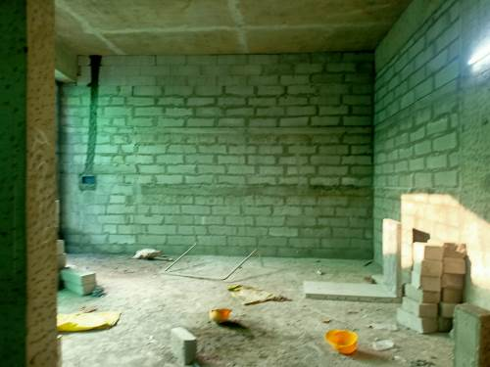
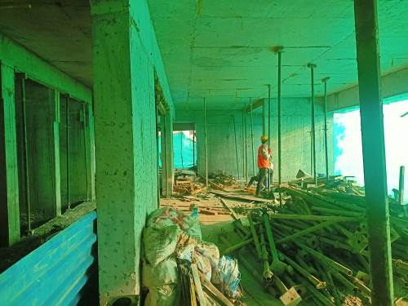
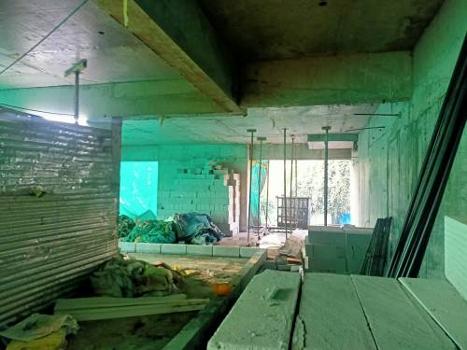
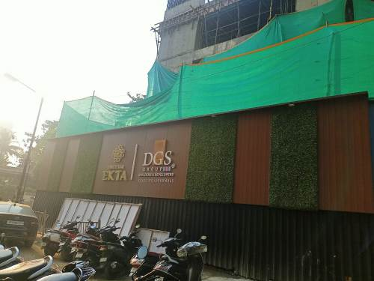
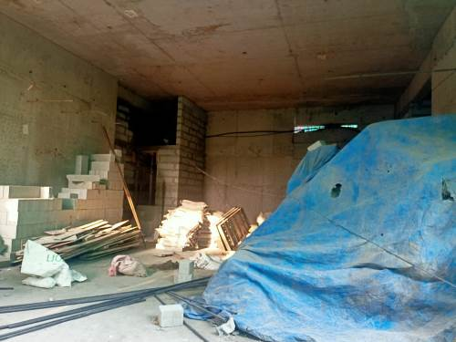

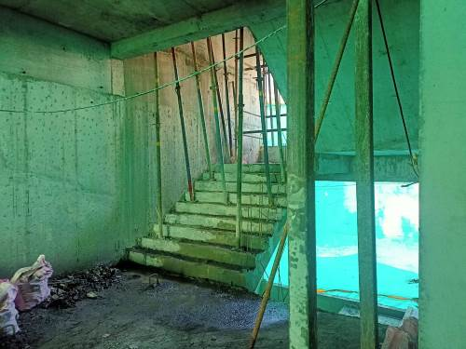
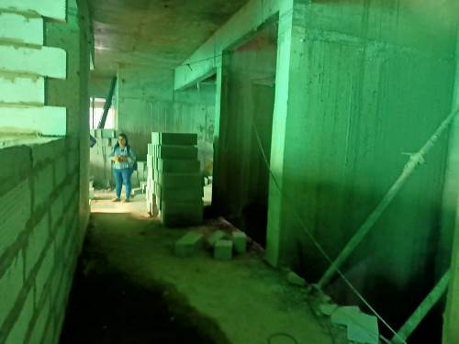
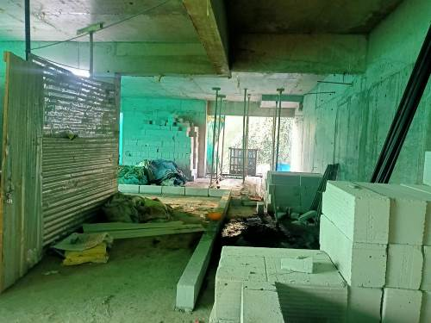
Actual Site Photographs
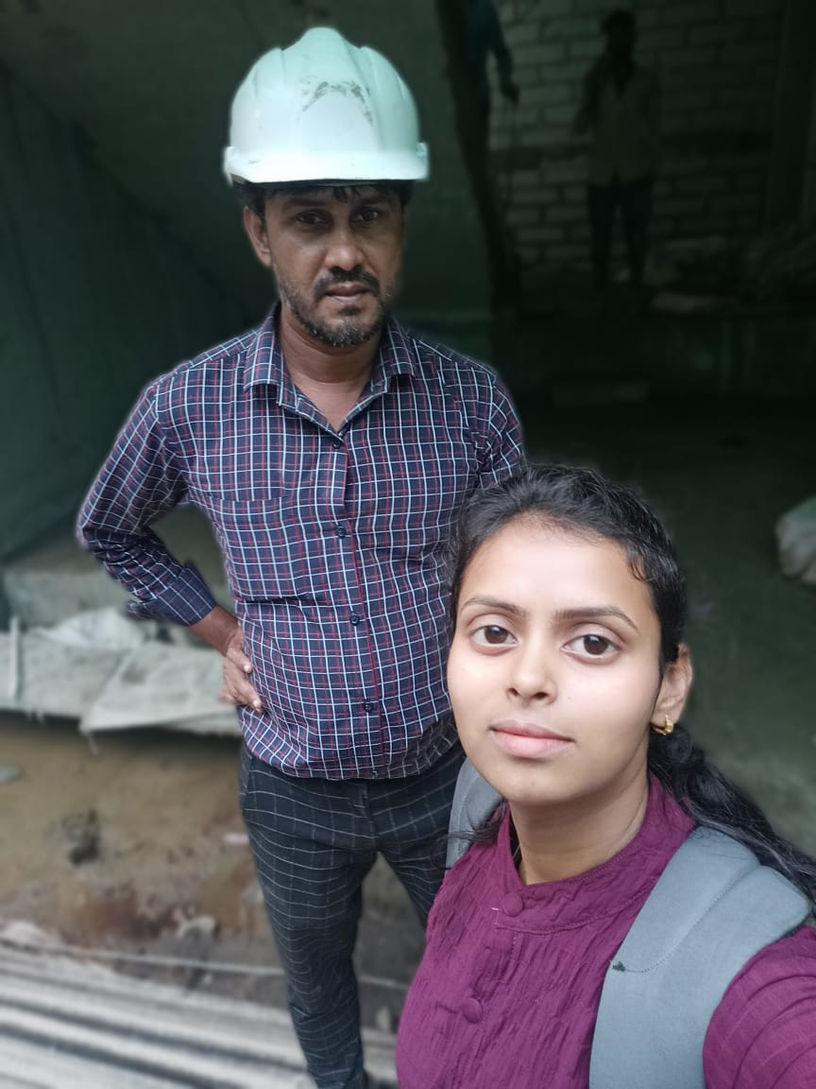
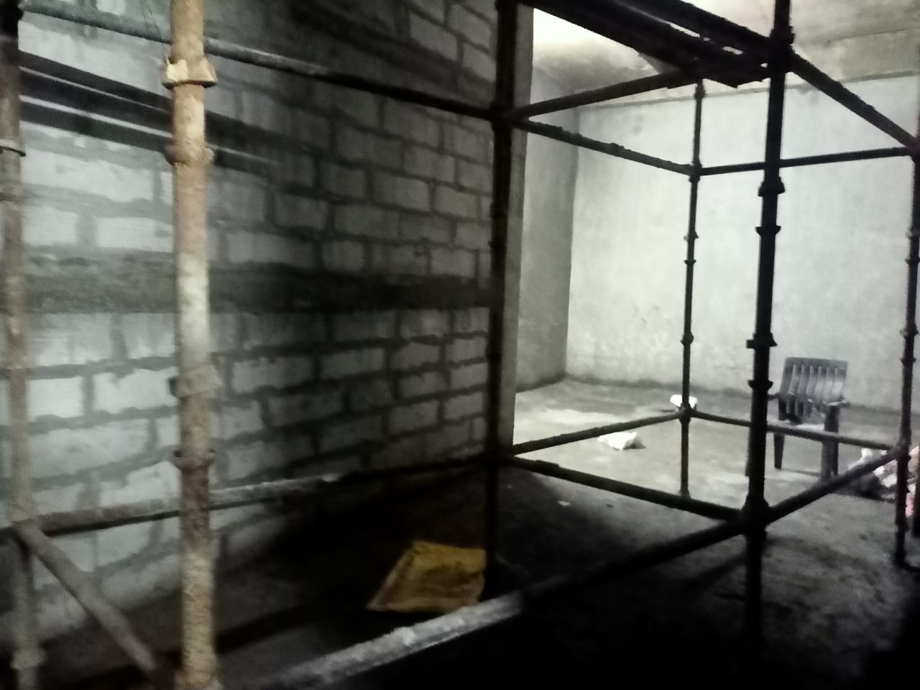
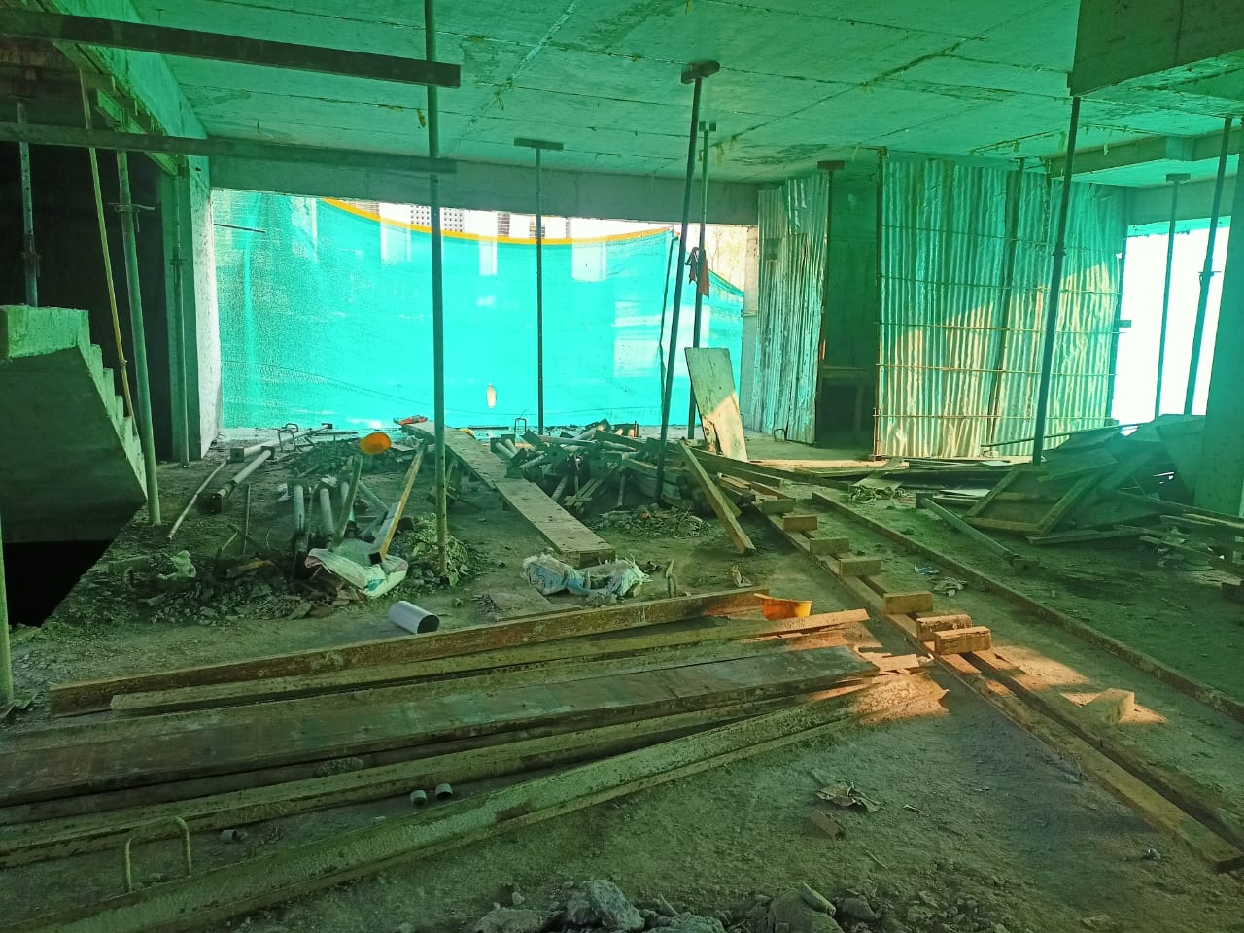
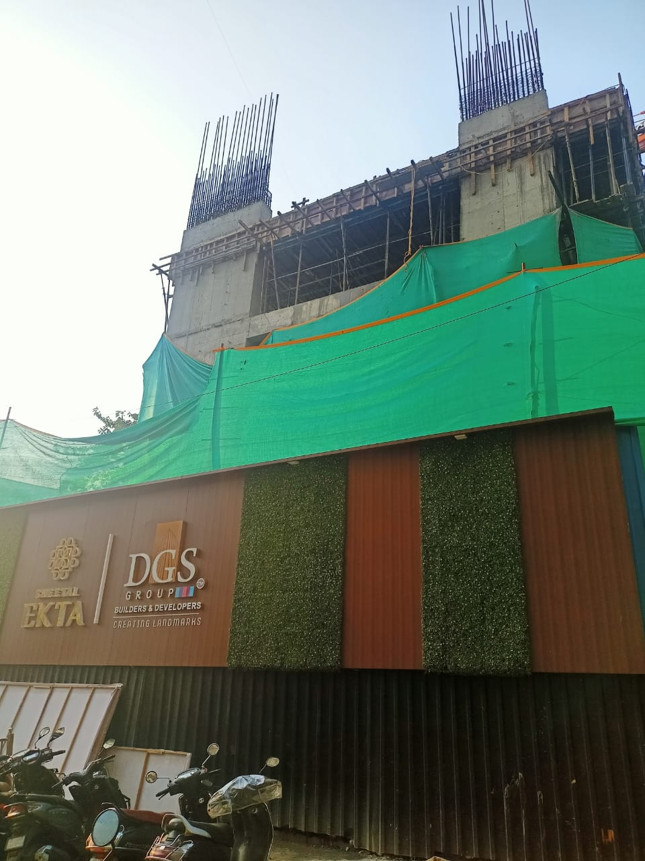
Route Map of the property
Site u/r
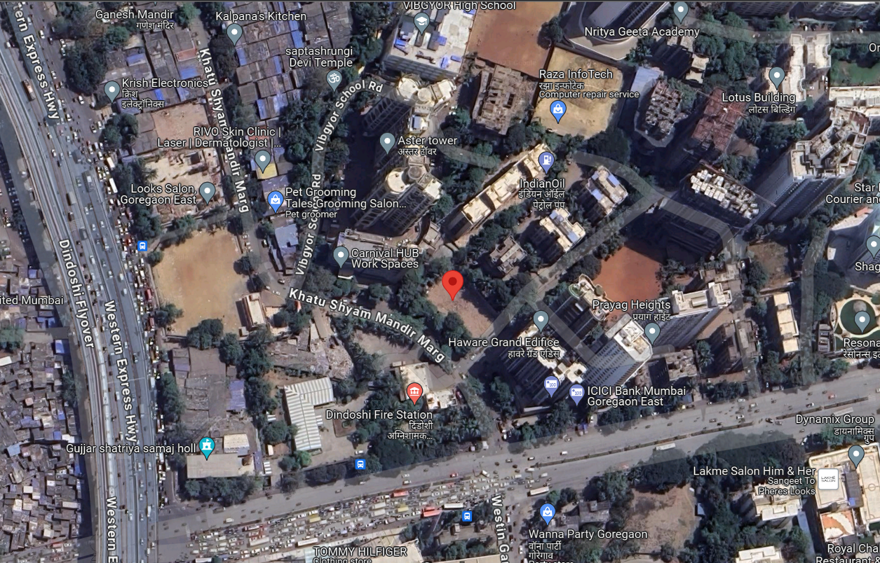

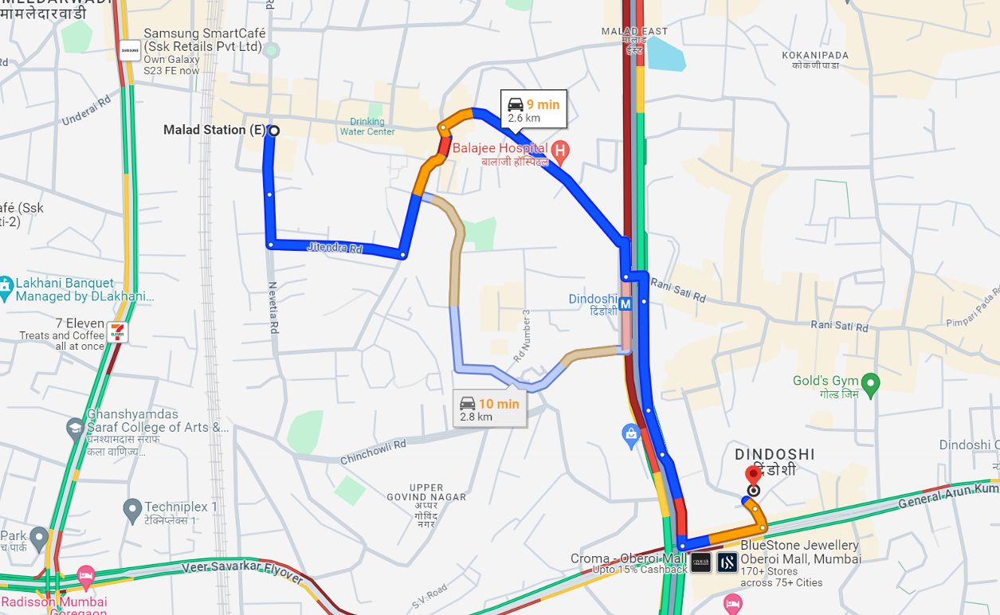

Latitude Longitude: 19°10'32.1"N 72°51'40.3"E
Note: The Blue line shows the route to site from nearest railway station (Malad – 2.60 Km.)

