Vastu/Nashik/01/2023/28773/4459903/06-13-RYVDate: 30.11.2023

**Structural Stability Report**

Residential Flat No. 06,Third Floor, **" Makrand Apartment "**, Survey No. 102/ 1/ 1/ 2K, Plot No. 22 + 23B, C.T.S. No. 5869/ 2/ 19, Near Yashwant Hospital, Dindori Naka, Peth Road, Panchavati, Village – Nashik, Taluka & District - Nashik, PIN Code – 422 003, State – Maharashtra, Country – India. belongs to **Name of Proposed Purchaser: Mr. Ghanshyam Bhanudas Nerkar. & Name of Owner: Smt. Rajani Bhagwan Khairnar.**

This is to certify that on visual inspection, it appears that the structure of **" Makrand Apartment "**is in normal condition and the future life can be reasonably takes under normal condition and with proper periodic repairs & maintenance is about 34years.

**General Information**:

|  |  |  |
| --- | --- | --- |
| **A.** | **Introduction** | |
| 1 | Name of Building | **" Makrand Apartment "** |
| 2 | Property Address | Residential Flat No. 06,Third Floor, **" Makrand Apartment "**, Survey No. 102/ 1/ 1/ 2K, Plot No. 22 + 23B, C.T.S. No. 5869/ 2/ 19, Near Yashwant Hospital, Dindori Naka, Peth Road, Panchavati, Village – Nashik, Taluka & District - Nashik, PIN Code – 422 003, State – Maharashtra, Country – India. |
| 3 | Type of Building | Flat No. 06 |
| 4 | No. of Floors | Ground + 3 Upper Floors |
| 5 | Whether stilt / podium / open parking provided | Open Parking |
| 6 | Type of Construction | R.C.C. Framed Structure |
| 7 | Type of Foundation | R.C.C. Footing |
| 8 | Thickness of the External Walls | 6’ thick brick walls both sides plastered |
| 9 | Type of Compound | Brick Masonry Walls |
| 10 | Year of Construction | 1997 (As per Full Occupancy Certificate) |
| 11 | Present age of building | 26years |
| 12 | Residual age of the building | 34years Subject to proper, preventive periodic maintenance & structural repairs. |
| 13 | No. of Flats | 2Flats On Third Floor |
| 14 | Methodology adopted | As per visual site inspection |

|  |  |  |
| --- | --- | --- |
| **B.** | **External Observation of the Building** | |
| 1 | Plaster | Normal |
| 2 | Chajjas | Normal |
| 3 | Plumbing | Normal |
| 4 | Cracks on the external walls | Not Found |
| 5 | Filling cracks on the external walls | Not Found |
| 6 | Cracks on columns & beams | Not Found |
| 7 | Vegetation | Not Found |
| 8 | Leakages of water in the drainage pipes or water pipes | Not Found |
| 9 | Dampness external in the wall due to leakages | Found |
| 10 | Any other observation about the condition of external side of the building | The external condition of the structure is in Normal condition |
| **C** | **Internal Observation of the common areas of the building and captioned premises** | |
| 1 | Beams (Cracks & Leakages) | Not found |
| 2 | Columns (Cracks & Leakages) | Not found |
| 3 | Ceiling (Cracks & Leakages) | found |
| 4 | Leakages inside the property | Not Found |
| 5 | Painting inside the property | Normal |
| 6 | Maintenance of staircase & cracks | Normal |

|  |  |  |
| --- | --- | --- |
| **D** | **Common Observation** | |
| 1 | Structural Audit of the Building Under Bye – Laws No. 77 of the Model Bye Laws (Co-Operative Societies Act / Rules) | As per bye Laws No. 77 of Co-Op. Societies bye Laws under the Act the society shall conduct a Structural Audit of the building of the society as follows |
| 2 | Remark | - |

|  |  |
| --- | --- |
| **E** | **Conclusion** |
| The captioned Flat is having Third floor which are constructed in year 1997 (As per Full Occupancy Certificate). Estimated future life under present circumstances is about 34years’ subject to proper, preventive periodic maintenance & structural repairs.  The inspection dated 29.11.2023 reveals no structural damage or deterioration to the building. The building as well as the property is maintained in normal condition & will stand future life subject to proper, preventive periodic maintenance & Average structural repairs.  Our Observations about the structure are given above.  The above assessment is based on visual inspection only. | |

**Sharadkumar B. Chalikwar**

Govt. Reg. Valuer

Chartered Engineer (India)

Reg. No. (N) CCIT/1-14/52/2008-09

Encl: Valuation report.

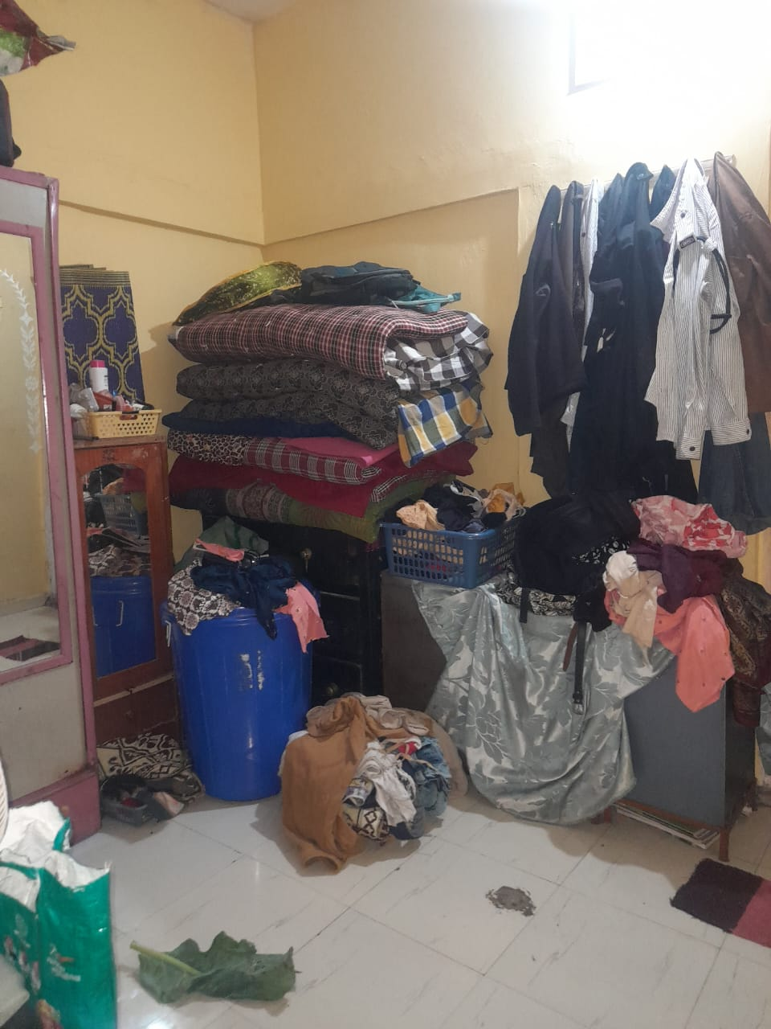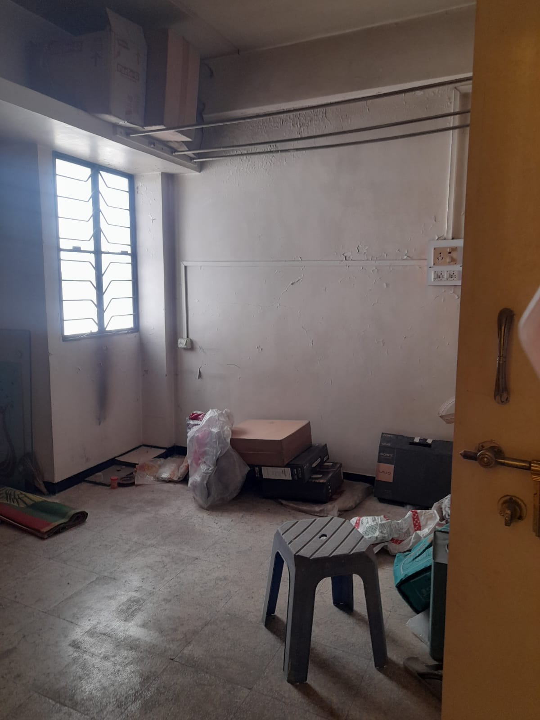**Actual site Photographs**

