Vastu/Nashik/11/005324/ 2303729
29/15-425 -RYBS
Date: 29.11.2023

To,
The Branch Manager,
Union Bank of India
Gangapur Road Branch
Shree Ganesh Avenue, Chunchale Road,
Nashik - 422 013, State – Maharashtra, Country – India

Sub: Vetting of Extra Amenities

Sir,

With reference to above subject, we have evaluated the Extra Amenities for Residential Flat No. 103, First Floor, " Green Residency ", Survey No. 501/ 2 to 15/ 1/ 1/ B+501/ 2 to 15/ 1/ 1/ 29 Final Plot No. 25, Plot No. 3, TP Scheme No. II, Behind Leva Samaj Kalyan Mandal, Fatema Manzil Hirve Nagar, Wadala Pathardi Road, Village – Nashik, Taluka & District - Nashik, PIN Code – 422 011,State – Maharashtra, Country – India. belongs to Name of Proposed Purchaser: Mr. Shabbir Ameer Tamboli & Mr. Danish Shabbir Tamboli. Name of Owner: M/s. Green Life Developers.

We have verified the rates quoted as per current market rates. Details of Extra Amenities considered as per copy of Extra Amenities Agreement between Mr. Shabbir Ameer Tamboli (First Party). Mr. Mohamad Imtiyaz Ansari (Second Party) received on dated 29.11.2023. The Extra Amenities amount is Rs. 2,50,000/- (Rupees Two Lakh Fifty Thousand Only)

The said Cost Vetting Certificate is valid upto next 6 months Only.

Thanking you

Sincerely yours

Sharadkumar B. Chalikwar
Govt. Reg. Valuer
Chartered Engineer (India)
Reg. No. (N) CCIT/1-14/52/2008-09

Agreement for Extra Work
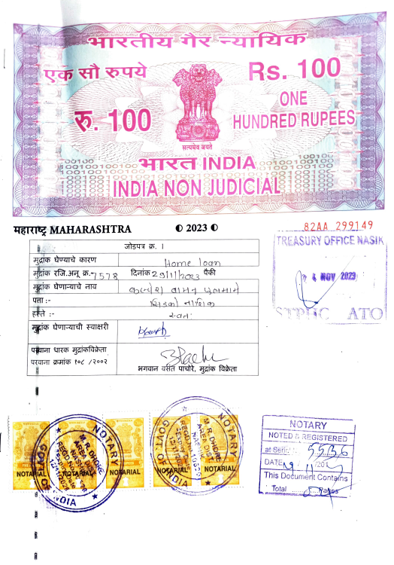
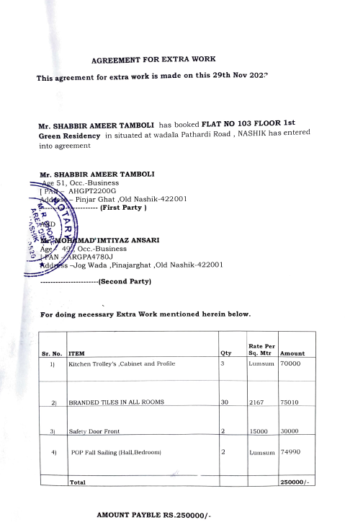

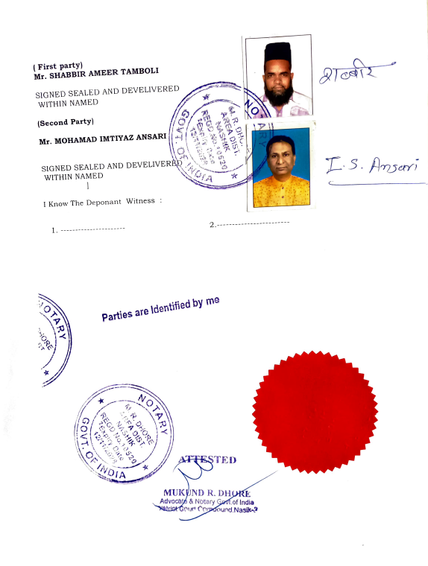

The Extra Amenities amount is Rs. 2,50,000/- (Rupees Two Lakh Fifty Thousand Only)

