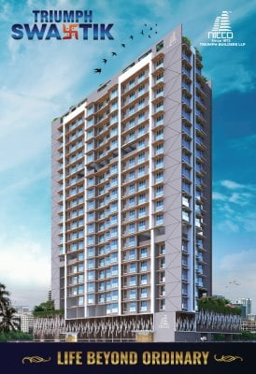2nd LENDERS INDEPENDENT ENGINEER REPORT

**Details of the property under consideration:**

**Name of Project: Triumph Swastik**

**"Triumph Swastik", Proposed Redevelopment of building named Four Enns CHSL on plot bearing**

**CTS 33/8, Village – Chinchavali, Sunder Nagar, S. V. Road, Malad West, Mumbai – 400 064,**

**State – Maharashtra, Country – India**

**Latitude Longitude: 19°10'35.0"N 72°50'38.7"E**

Valuation Prepared for:

State Bank of India

SME Chembur Branch

Unit No. 11, Building No. 11, Ground Floor, Corporate Park, Sion Trombay Road,

Chembur, Mumbai, Pin Code – 400 071, State - Maharashtra, Country – India

Vastu/SBI/Mumbai/11/2023/5307/2303716

29/02-412-PY

Date: - 29.11.2023

SECOND LENDERS INDEPENDENT ENGINEER REPORT

**To,**

**State Bank of India**

SME Chembur Branch

Unit No. 11, Building No. 11,

Ground Floor, Corporate Park,

Sion Trombay Road, Chembur,

Mumbai, Pin Code – 400 071,

State - Maharashtra, Country – India

Subject: Construction of Proposed Redevelopment of building named Four Enns CHSL on plot bearing CTS 33/8, Village – Chinchavali, Sunder Nagar, S. V. Road, Malad West, Mumbai – 400 064, State – Maharashtra, Country – India.

**Ref:** You’re Request for Lenders Independent Engineer Report of under Construction Building.

**Dear Sir,**

**The Construction work as per approved plan was in progress during the site visit on 05th October 2023. Total expenditure occurred as on 30/09/2023 on this project by M/s. Triumph Builders LLP is ` 60.17 Cr. & as per CA Certificate actual total expenditure occurred as on 30/09/2023 is ` 58.35 Cr. Hence, release of Balance Amount as requested by M/s. Triumph Builders LLP is hereby recommended.**

**DECLARATION**

1. The information furnished in the report is based on our 2nd site visit Dated 05/10/2023 & Document Provided by Client.
2. Vastukala 1st LIE Report of the project dated 08/05/2023.
3. I have no direct and indirect interest in the property examined for report.
4. I have not been found guilty of misconduct in my professional capacity.

**Sharadkumar B. Chalikwar**

Govt. Reg. Valuer

Chartered Engineer (India)

Reg. No. (N) CCIT/1-14/52/2008-09

Encl.: LIE report

# Purpose & Methodology

• State Bank of India Banks and financial institutions require monitoring & an independent review of the progress of the sanctioned projects

**VCIPL** undertakes such study to independently review the progress of the project and put forward a comprehensive analysis

# Advantages:

* Assurance on present practices
* Identification of risk
* Analyzing the performance of third parties
* Recommendations

# The Methodology

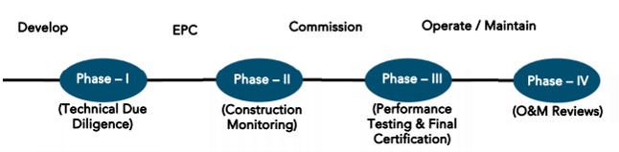

**SECOND LENDERS INDEPENDENT ENGINEER REPORT**

**OF**

**"TRIUMPH SWASTIK"**

**"Triumph Swastik",** Proposed Redevelopment of building named Four Enns CHSL on plot bearing

CTS 33/8, Village – Chinchavali, Sunder Nagar, S. V. Road, Malad West, Mumbai – 400 064,

State – Maharashtra, Country – India

**Latitude Longitude: 19°10'35.0"N 72°50'38.7"E**

**NAME OF DEVELOPER: M/s. Triumph Builders LLP**

|  |
| --- |
| Pursuant to instructions from State of India, SME Chembur Branch, Chembur we have duly visited, inspected, surveyed & assessed the above said property on **05th October 2023** to determine the fair & reasonable market value of the said property/project as on Quarter ending **30th September 2023** for LIE purpose.  **1. Location Details:**  Proposed Redevelopment of building named Four Enns CHSL on plot bearing CTS 33/8, Village – Chinchavali, Sunder Nagar, S. V. Road, Malad West, Mumbai – 400 064. It is about 1.6 Km. travelling distance from Malad Railway station. Surface transport to the property is by buses, taxis & private vehicles. The property is in developed locality. All the amenities like shops, banks, hotels, markets, schools, hospitals, etc. are all available in the surrounding locality. The area is higher middle class & developed. |

**2. Developer Details:**

|  |  |
| --- | --- |
| **Name of builder** | **M/s. Triumph Builders LLP** |
| **Project Rera Registration Number** | **P51800035067** |
| **Registered office address** | Office at G-B, Shiv Chhaya CHS Ltd, Sir M V Road, Andheri East, Mumbai – 400 069, State – Maharashtra, Country – India |
| **Contact details** | **Contact Person:**  Mrs. Mona Mehta  Mobile No. 7977952834 |
| **E – mail ID and website** |  |

**3. Boundaries of the Property:**

|  |  |
| --- | --- |
| **Direction** | **Particulars** |
| **On or towards North** | Sundar Nagar Road |
| **On or towards South** | ONGC Colony |
| **On or towards East** | Internal Road |
| **On or towards West** | Durga Mata Mandir & Sundar Nagar Garden |

# Introduction

**As per Information on site M/s. Triumph Builders LLP** has acquired land by Developer Agreement dated 25.10.2021 vide registered No. BRL-1-14109 dated 16.11.2021 admeasuring **area is 3,172.30 Sq. M.** bearing **CTS No. 33/8.** For the Proposed Residential Building.

# Area Statement:

# Land:

|  |  |  |
| --- | --- | --- |
| **Date** | **Particular** | **Area in Sq. M.** |
| 25.10.2021 | CTS No. 33/8 | 3,172.30 |
| TOTAL | | 3,172.30 |

1. Copy of Developer Agreement dated 25.10.2021 between M/s. Four Enns CHSL (The Society) and M/s. Triumph Builders LLP (The Developers) registered vide No. BRL-1-14109 dated 16.11.2021.

# Building Area:

| **Sr. No.** | **Particulars** | **Area in Sq. M.** |
| --- | --- | --- |
| **1** | Area of Plot CTS Nos. 182C, 182D & 182E | 3,172.30 |
|  | a)      Area of reservation in plot | - |
|  | b)      Area of road set back | - |
|  | c)      Area of DP Road | - |
| **2** | Deduction for |  |
| **A** | For reservation / road area to be handed over to MCGM (100%) |  |
|  | a) Road set back / widening area (Regulation No. 16) | - |
|  | b) Proposed D. P. Road area (Regulation No. 16) | - |
|  | c) Reservation area (plot) to be handed over to (Regulation No. 17) | - |
|  | Total Area Under Road / Reservation | - |
| **B** | For amenity area to be handed over to MCGM |  |
|  | a) Area of amenity plot as per dcr 14(a) | - |
|  | b) Area of amenity plot as per dcr 14(b) | - |
|  | c) Area of amenity plot as per dcr 35 | - |
|  | Total Amenity Area | - |
| **3** | Total Deduction | - |
| **4** | Balance Area of Plot | 3,172.30 |
| **5** | Plot area under development | 3,172.30 |
| **6** | Zonal (Basic) FSI (0.50 or 0.75 or 1 or 1.33) | 1.00 |
| **7** | Permissible Built-Up Area |  |
|  | a)   Permissible built-up area as per zonal (basic) FSI | 3,172.30 |
|  | b)   Permissible built-up area as per regulation 30(c) (protected development) | 3,337.29 |
|  | (3337.29 – 3172.30 = 205.60) |  |
|  | Permissible Built-up Area (7a or 7b above, whichever is more) | 3,337.29 |
| **8** | Built-up Equal to area of land handed over as per regulation 30(A) |  |
|  | a) Additional BUA for 2(A)(c)(I) & 2(B) above within the cap of “admissible TDR” as per table no. 12 on balance plot 200%for set back | - |
|  | b) Additional BUA in case of 2(A)(c)(I) as per regulation 17(1) note 20(vii) & (viii) as per are policy on remaining plot. (Y% as per table no. 5 of regulation 17(1) | - |
| **9** | Total Area Land Handed Over As per Regulation 30(A) Additional / Incentive BUA Within the CAP of admissible TDR as per table 12 on balance plot | - |
|  | a) In Lieu of cost of construction of amenities building as per regulation 30 (A) (3) (b) | - |
|  | b) 50% of rehab component as per reg. 33 (7)(A) | - |
|  | C) 15% of commercial & 10 sq.mt per rehab tenement as per reg.33(7)(b) (0.00 x 15% = 0.00 sq. mt. & 10 sq. mt. x 66 Nos. of tenements = 660.00 sq.mt | 660.00 |
|  | Total Additional BUA / Incentive Area | - |
| **10** | BUA due to admissible FSI on payment of premium as per table No. 12 of regulation No. 30 (A) [Sr. no. 5 x 50%] Restriction To | 1,586.15 |
| **11** | BUA due to admissible TDR as per table No. 12 of regulation No. 30 (A) & 32 [by restricting area utilized beyond zonal fsi no. 7(b), 8 (a) & 9 above | - |
|  | a) General TDR [{Sr No. 5x50% or 70% or 100%) x 50% or 80% max] | 950.61 |
|  | b) Slum TDR [ Sr. No. 5 x 50% or 70% or 90% or 100%) x 50%- or 20%-min DRC NO.- SRA/ /CONST. DT. | 445.01 |
|  | Total TDR | 1395.62 |
| **12** | Permissible Built-Up Area (7+8+9+10+11) | 6,979.06 |
| **13** | Proposed Built Up Area | - |
|  | Residential | 6,979.06 |
|  | Non-Residential | - |
|  | Total Proposed Built Up Area | 6,979.06 |
| **14** | TDR Generated if any as per regulation 30(A) AND 32 for unutilized BUA on plot | - |
| **15** | Fungible Compensatory Area as per Regulation No. 31(3) |  |
|  | a. i) Permi Fungible Compensatory area for rehab comp. w/ocharging premium | - |
|  | Residential | 1,018.86 |
|  | Non-Residential | - |
|  | a. ii) Fungible Compensatory area for rehab comp. w/o charging premium | 1,018.86 |
|  | b. i) Permissible fungible compensatory area by changing premium (Residential) | - |
|  | Residential | 1,423.41 |
|  | Non-Residential | - |
|  | b. ii) Fungible Compensatory area availed on payment of premium | 1,423.41 |
| **16** | Total Built Up Area Proposed Including Area [13 + 15(a) (ii) + 15(b) (ii)] | 9,421.33 |
| **17** | FSI Consumed on plot [13 + 4] | 2.20 |
| **B** | **TENEMENT STATEMENT** |  |
|  | a) Proposed Area (item a 17) | 9,421.33 |
|  | b) Less Deduction of nonresidential area | - |
|  | c) Area available for tenements (a-b) | 9,421.33 |
|  | d) Tenements Permissible as per (450 + hectare) | 424 Nos. |
|  | e) Tenements Proposed | 124 Nos. |
|  | f) Tenements existing | - |
|  | Total Tenements proposed (e + f) | 142 Nos. |
| **D** | **PARKING ATATEMENT** |  |
|  | a) Total Parking Required | 142 Nos |
|  | b) Total Parking Proposed | 194 Nos |
| **E** | **TRANSPORT VEHICLES PARKING STATEMENT** | - |
|  | a) Transport Vehicles parking required | - |
|  | b) Transport Vehicles Parking Proposed | - |

# List of Approvals:

1. Copy of Approved Plan No. P-8594/2021/(33/8)/P/S Ward/Chinchavali-P/SM dated 31.12.2021 issued by Municipal Corporation of Greater Mumbai.

**Approved upto: Wing A & B: Stilt Floor + 1st & 2nd (Part) Podium Floor + 2nd (Part) to 16th (Part) Upper Residential Floor**

1. Copy of 1st Amended Approved Plan No. P-8594/2021/(33/8)/P/S Ward/Chinchavali-P/S dated 05.12.2022 issued by Municipal Corporation of Greater Mumbai.

**Approved upto: Wing A & B: Stilt Floor + 1st & 2nd (Part) Podium Floor + 2nd (Part) to 18th Upper Residential Floor**

1. Copy of 2nd Amended Approved Plan No. P-8594/2021/(33/8)/P/S Ward/Chinchavali-P/S dated 21.03.2023 issued by Municipal Corporation of Greater Mumbai.

**Approved upto: Wing A & B: Stilt Floor + 1st & 2nd (Part) Podium Floor + 2nd (Part) to 19th Upper Residential Floor**

1. Copy of 1st Commencement Certificate No. P-8594/2021/(33/8)/P/S Ward/Chinchavali-P/S/CC/1/New dated 07.04.2022 valid till 06.04.2023 issued by Municipal Corporation of Greater Mumbai.

**(This CC is endorsed for the work upto Plinth Level of Wing A & B)**

1. Copy of 2nd Commencement Certificate No. P-8594/2021/(33/8)/P/S Ward/Chinchavali-P/S/CC/1/New dated 07.04.2022 valid till 06.04.2023 issued by Municipal Corporation of Greater Mumbai.

**(This CC is endorsed for the work upto Stilt Floor + 1st to 14th Upper Residential Floor of Wing A & B except podium extension beyond building line)**

1. Copy of 3rd Commencement Certificate No. P-8594/2021/(33/8)/P/S Ward/Chinchavali-P/S/FCC/1/Amend dated 13.04.2023 valid till 06.04.2024 issued by Municipal Corporation of Greater Mumbai.

**(This CC is endorsed for the work upto Stilt Floor + 1st & 2nd (Part) & 3rd (Part) Podium Floor + 2nd (Part), 3rd (Part) to 19th Upper Residential Floor of Wing A & B except podium extension beyond building line)**

1. Copy of 4th Commencement Certificate No. P-8594/2021/(33/8)/P/S Ward/Chinchavali-P/S/FCC/2/Amend dated 21.08.2023 valid till 06.04.2024 issued by Municipal Corporation of Greater Mumbai.

**(This CC is endorsed for the Part Podium portion shown in red colur hatch marked ABCD on plinth plan upto top of 2nd podium as per last approved plan beyond building line)**

# LEVEL OF COMPLETION:

# Rehab cum Sales Building (Wing A & B)

| Sr. No | Floor No. | Construction Area in Sq. M. | Completed Area in Sq. M. | % of work completed | Work Completion as on 1st LIE Report | Work Completion as on 05.10.2023 |
| --- | --- | --- | --- | --- | --- | --- |
| 1 | Excavation & Shore Piling | | | 100% | Work is Completed |  |
| 2 | Ground Floor | 1,099.72 | 685.20 | 50% | Slab Work is completed | Slab Work is completed |
| 3 | 1st Floor | 1,738.00 | 685.20 | 20% | Slab Work is completed | Slab Work is completed |
| 4 | 2nd Floor | 2,084.05 | 685.20 | 20% | Slab Work is completed | Slab Work is completed |
| 5 | 3rd Floor | 1,844.99 | 685.20 | 20% | Slab Work is completed | Slab Work is completed |
| 6 | 4th Floor | 685.20 | 685.20 | 60% | Slab Work & Blockwork is completed | Slab Work, block work, plaster work, Gypsum work, kitchen platform, toilet dadoing & electrification work is completed |
| 7 | 5th Floor | 685.20 | 685.20 | 60% | Slab Work & Blockwork is completed | Slab Work, block work, plaster work, Gypsum work, kitchen platform, toilet dadoing & electrification work is completed |
| 8 | 6th Floor | 694.83 | 694.83 | 60% | Slab Work & Blockwork is completed | Slab Work, block work, plaster work, Gypsum work, kitchen platform, toilet dadoing & electrification work is completed |
| 9 | 7th Floor | 713.10 | 713.10 | 60% | Slab Work & Blockwork is completed | Slab Work, block work, plaster work, Gypsum work, kitchen platform, toilet dadoing & electrification work is completed |
| 10 | 8th Floor | 726.60 | 726.60 | 50% | Slab Work is completed | Slab Work, block work, plaster work, Gypsum work, kitchen platform, toilet dadoing & electrification work is completed |
| 11 | 9th Floor | 728.42 | 728.42 | 50% | Slab Work is completed | Slab Work, block work, plaster work, Gypsum work, kitchen platform, toilet dadoing & electrification work is completed |
| 12 | 10th Floor | 728.42 | 728.42 | 50% | Slab Work is completed | Slab Work, block work, plaster work, Gypsum work & electrification work is completed |
| 13 | 11th Floor | 728.42 | 728.42 | 50% | Slab Work is completed | Slab Work, block work, plaster work & electrification work is completed |
| 14 | 12th Floor | 731.60 | 731.60 |  |  | Slab Work, block work, plaster work & electrification work is completed |
| 15 | 13th Floor | 737.99 | 737.99 |  |  | Slab Work & block work is completed |
| 16 | 14th Floor | 747.09 | 747.09 |  |  | Slab Work & block work is completed |
| 17 | 15th Floor | 744.38 | 744.38 |  |  | Slab Work is completed |
| 18 | 16th Floor | 744.38 | 744.38 |  |  | Slab Work is completed |
| 19 | 17th Floor | 744.38 | 744.38 |  |  | Slab Work is completed |
| 20 | 18th Floor | 744.38 | 744.38 |  |  | Slab Work is completed |
| 21 | 19th Floor | 744.38 | 744.38 |  |  | Slab Work is completed |
| 22 | Terrace Floor | 135.36 |  |  |  |  |
| Total | | **18,530.89** | **14,369.57** | **48.89%** |  |  |
| As per previous 1st LIE Report | | **18,530.89** | **8,430.99** | **25.94%** |  |  |
| Difference | | **-** | **5,938.58** | **22.95%** |  |  |

# Details of the Project as Financed By SBI:

# Project Cost: (as per C.A. Certificate)

|  |  |  |  |  |
| --- | --- | --- | --- | --- |
| **Particulars** | **Estimated Cost (in Cr.)** | **Incurred Cost (In Cr.) 30.09.2023 by M/s. Varma & Associates** | **Incurred Cost (In Cr.) 31.03.2023 by M/s. Varma & Associates** | **Net** |
| Land Cost | 1.35 | 2.17 | 2.17 | - |
| Rent Cost | 10.45 | 5.05 | 3.98 | 1.07 |
| Construction cost of Building | 55.59 | 25.94 | 17.12 | 8.82 |
| Premium Cost / FSI / GOM Charges / fees / security Deposits | 16.14 | 16.22 | 16.21 | 0.01 |
| Architect Cost, RCC & Other Professional Cost | 2.78 | 0.17 | 0.04 | 0.13 |
| Administrative Cost | 2.22 | 2.00 | 1.74 | 0.26 |
| Marketing Cost | 2.58 | 4.87 | 4.28 | 0.59 |
| Interest Cost | 6.38 | 1.93 | 0.94 | 0.99 |
| **Total** | **97.50** | **58.35** | **46.48** | **11.87** |

* **The Builder has incurred about 5.05 Cr. Rent Cost, 25.94 Cr. as construction cost, 2.00 Cr. for admin cost, 4.87 Cr. for marketing cost & 1.93 Cr. for interest cost in last quarter till 30.09.2023 as per C.A. certificate issued by M/s. Varma & Associates dated 13.10.2023.**

# Project Cost: (as per Bills):

|  |  |  |  |
| --- | --- | --- | --- |
| **Particulars** | **Incurred Cost (in Cr.)** | | **Net** |
| **30.09.2023 as per Bill (Inclusive GST)** | **31.03.2023 as per Bill (Inclusive GST)** |
| Land Cost | 1.35 | 1.35 | - |
| Rent Cost | 5.05 | 3.98 | 1.08 |
| Construction cost of Building | 27.67 | 16.61 | 11.06 |
| Premium Cost / FSI / GOM Charges / fees / security Deposits | 15.91 | 15.91 | - |
| Architect Cost, RCC & Other Professional Cost | 0.27 | 0.11 | 0.16 |
| Administrative Cost | 1.04 | 0.94 | 0.10 |
| Marketing Cost | 6.94 | 6.45 | 0.50 |
| Interest Cost | 1.93 | 0.94 | 0.99 |
| **Total** | **60.17** | **46.28** | **13.89** |

Note:

# Land Cost:

|  |  |  |  |  |
| --- | --- | --- | --- | --- |
| Sr. No. | Date | Description | Total Cost in ` | Incurred Cost in ` |
| 1 | 16.11.2021 | Stamp Duty | 1,34,70,000.00 | 1,34,70,000.00 |
| 2 | Reg. Fees | 30,000.00 | 30,000.00 |
| 3 | 8,380.00 | 8,380.00 |
| 4 | 100.00 | 100.00 |
| Total | | | **1,35,08,480.00** | **1,35,08,480.00** |

As per developer agreement.

|  |  |  |  |  |  |  |
| --- | --- | --- | --- | --- | --- | --- |
| **Summary of Bills** | | | | | | |
| **Sr. No.** | **Particulars** | **Amount in `**  **(till 30.09.2023)** | **Amount in ` (in Cr.)** | **Amount in `**  **(till 31.03.2023)** | **Amount in ` (in Cr.)** | **Net** |
| **1** | Construction Cost | 27,66,93,008.00 | 27.67 | 16,60,64,201.00 | 16.61 | 11.06 |
| **2** | Rent Cost | 5,05,11,750.00 | 5.05 | 3,97,50,000.00 | 3.98 | 1.08 |
| **3** | Premium Cost / FSI / GOM Charges / fees / security Deposits | 15,91,26,279.00 | 15.91 | 15,90,98,789.00 | 15.91 | - |
| **4** | Professional Cost | 27,32,312.00 | 0.27 | 11,39,566.00 | 0.11 | 0.16 |
| **5** | Administrative Cost | 1,03,97,112.00 | 1.04 | 93,98,448.00 | 0.94 | 0.10 |
| **6** | Marketing Cost | 6,94,43,657.00 | 6.94 | 6,44,85,935.00 | 6.45 | 0.50 |
| **TOTAL** | | **56,89,04,118.00** | **56.89** | **43,99,36,939.00** | **43.99** | **12.90** |

Note: Bills were provided by the client up to 30.09.2023

# Interest Cost:

|  |  |  |  |  |  |  |
| --- | --- | --- | --- | --- | --- | --- |
| **Sr. No** | **Particulars** | **Estimate Amount in `** | **Incurred Amount in ` (till 30.09.2023)** | **Incurred Amount in ` (till 31.03.2023)** | **Difference in `** | **Balance Amount in `** |
| **1** | Interest Cost | 10,25,00,000.00 | 1,93,13,135.00 | 93,58,703.00 | 99,54,432.00 | 8,31,86,865.00 |
| **TOTAL** | | **10,25,00,000.00** | **1,93,13,135.00** | **93,58,703.00** | **99,54,432.00** | **8,31,86,865.00** |

Interest Cost is based on discussion with the client.

# Cost of Construction as on 05th October 2023:

|  |  |  |  |  |  |  |
| --- | --- | --- | --- | --- | --- | --- |
| Plinth Area Calculation | | | | | | |
| Floors | **Construction Area in Sq. M.** | **Completed Area in Sq. M.** | **Rate per Sq. M.** | **Full Value after completion** | **Percentage of work completed** | **Actual Expenditure till date in `** |
| Ground Floor | 1,099.72 | 685.20 | 30,000.00 | 3,29,91,600.00 | 50% | 1,64,95,800.00 |
| 1st Floor | 1,738.00 | 685.20 | 30,000.00 | 5,21,40,000.00 | 20% | 1,04,28,000.00 |
| 2nd Floor | 2,084.05 | 685.20 | 30,000.00 | 6,25,21,500.00 | 20% | 1,25,04,300.00 |
| 3rd Floor | 1,844.99 | 685.20 | 30,000.00 | 5,53,49,700.00 | 20% | 1,10,69,940.00 |
| 4th Floor | 685.20 | 685.20 | 30,000.00 | 2,05,56,000.00 | 72% | 1,48,00,320.00 |
| 5th Floor | 685.20 | 685.20 | 30,000.00 | 2,05,56,000.00 | 72% | 1,48,00,320.00 |
| 6th Floor | 694.83 | 694.83 | 30,000.00 | 2,08,44,900.00 | 72% | 1,50,08,328.00 |
| 7th Floor | 713.10 | 713.10 | 30,000.00 | 2,13,93,000.00 | 72% | 1,54,02,960.00 |
| 8th Floor | 726.60 | 726.60 | 30,000.00 | 2,17,98,000.00 | 72% | 1,56,94,560.00 |
| 9th Floor | 728.42 | 728.42 | 30,000.00 | 2,18,52,600.00 | 72% | 1,57,33,872.00 |
| 10th Floor | 728.42 | 728.42 | 30,000.00 | 2,18,52,600.00 | 72% | 1,57,33,872.00 |
| 11th Floor | 728.42 | 728.42 | 30,000.00 | 2,18,52,600.00 | 72% | 1,57,33,872.00 |
| 12th Floor | 731.60 | 731.60 | 30,000.00 | 2,19,48,000.00 | 72% | 1,58,02,560.00 |
| 13th Floor | 737.99 | 737.99 | 30,000.00 | 2,21,39,700.00 | 60% | 1,32,83,820.00 |
| 14th Floor | 747.09 | 747.09 | 30,000.00 | 2,24,12,700.00 | 60% | 1,34,47,620.00 |
| 15th Floor | 744.38 | 744.38 | 30,000.00 | 2,23,31,400.00 | 50% | 1,11,65,700.00 |
| 16th Floor | 744.38 | 744.38 | 30,000.00 | 2,23,31,400.00 | 50% | 1,11,65,700.00 |
| 17th Floor | 744.38 | 744.38 | 30,000.00 | 2,23,31,400.00 | 50% | 1,11,65,700.00 |
| 18th Floor | 744.38 | 744.38 | 30,000.00 | 2,23,31,400.00 | 50% | 1,11,65,700.00 |
| 19th Floor | 744.38 | 744.38 | 30,000.00 | 2,23,31,400.00 | 50% | 1,11,65,700.00 |
| Terrace & OHT | 135.36 |  | 30,000.00 | 40,60,800.00 | 0% | - |
| TOTAL | **18,530.89** | **14,369.57** |  | **55,59,26,700.00** | **48.89%** | **27,17,68,644.00** |
| As per previous  1st LIE Report | **18,530.89** | **8,430.99** |  | **55,59,26,700.00** | **25.94%** | **14,41,85,880.00** |
| Difference | **-** | **5,938.58** |  | **-** |  | **12,75,82,764.00** |

##### Note: Details of work completed is as per site visit dated 05.10.2023 but report is prepared for 30th September quarter 2023.

|  |  |  |  |  |  |
| --- | --- | --- | --- | --- | --- |
| **Particulars** | **Estimated Cost**  **(In Cr.)** | **Incurred Cost (in Cr.)** | | | **Net** |
| **Issued dated 28.04.2023 till 31.03.2023 as per CA** | **As per Bills upto 30.09.2023** | **As per Bills upto 31.03.2023** |
| Land Cost | 1.35 | 2.17 | 1.35 | 1.35 | - |
| Rent Cost | 10.45 | 5.05 | 5.05 | 3.98 | 1.08 |
| Construction cost of Building | 55.59 | 25.94 | 27.67 | 16.61 | 11.06 |
| Premium Cost / FSI / GOM Charges / fees / security Deposits | 16.14 | 16.22 | 15.91 | 15.91 | - |
| Architect Cost, RCC & Other Professional Cost | 2.78 | 0.17 | 0.27 | 0.11 | 0.16 |
| Administrative Cost | 2.22 | 2.00 | 1.04 | 0.94 | 0.10 |
| Marketing Cost | 2.58 | 4.87 | 6.94 | 6.45 | 0.50 |
| Interest Cost | 6.38 | 1.93 | 1.93 | 0.94 | 0.99 |
| **Total** | **97.50** | **58.35** | **60.17** | **46.28** | **13.89** |

Note:

As CA as not considered unpaid bill for the calulation but we have considered unpaid bill of amount 1.82 Cr. which is considered in the construction cost header.

We have considered Other Expenses, Printing & Stationery, and Water Bills cost is consider in on-site expenditure cost header but CA has considered them in cost of construction header .

We have considered Stamp Duty, Registration Charges and Brokerage against of sale flat are cosnidered in marketing cost header.

As per plinth area, calculation the work completed is up to 48.89% of total work, which comes to ` 27.18 Cr. However, company has incurred cost of ` 27.67 Cr. till 30.09.2023 as per bill inclusive of the material on site.

# Comparison of Cost incurred on dated 30.09.2023 & 31.03.2023

|  |  |  |  |  |
| --- | --- | --- | --- | --- |
| Particulars | 31.03.2023 as per Bill | 31.03.2023 as per Bill | Net | % of net amount |
| Land Cost | 1.35 | 1.35 | - | 0.00% |
| Rent Cost | 5.05 | 3.98 | 1.08 | 1.79% |
| Construction cost of Building | 27.67 | 16.61 | 11.06 | 18.38% |
| Premium Cost / FSI / GOM Charges / fees / security Deposits | 15.91 | 15.91 | - | 0.00% |
| Architect Cost, RCC & Other Professional Cost | 0.27 | 0.11 | 0.16 | 0.27% |
| Administrative Cost | 1.04 | 0.94 | 0.10 | 0.17% |
| Marketing Cost | 6.94 | 6.45 | 0.50 | 0.83% |
| Interest Cost | 1.93 | 0.94 | 0.99 | 1.65% |
| Total | **60.17** | **46.28** | **13.89** | **23.08%** |

# % of Fund Utilised till 30th September 2023

|  |  |  |  |  |
| --- | --- | --- | --- | --- |
| Particulars | Estimated Project Cost  (in Cr.) | Incurred cost as on 31.03.2022 | % of Incurred Cost | % of Estimated Project Cost |
| Land Cost | 1.35 | 1.35 | 100.00% | 1.39% |
| Rent Cost | 10.45 | 5.05 | 48.32% | 5.18% |
| Construction cost of Building | 55.59 | 27.67 | 49.77% | 28.38% |
| Premium Cost / FSI / GOM Charges / fees / security Deposits | 16.14 | 15.91 | 98.62% | 16.32% |
| Architect Cost, RCC & Other Professional Cost | 2.78 | 0.27 | 9.83% | 0.28% |
| Administrative Cost | 2.22 | 1.04 | 46.76% | 1.07% |
| Marketing Cost | 2.58 | 6.94 | 268.67% | 7.12% |
| Interest Cost | 6.38 | 1.93 | 30.25% | 1.98% |
| Total | **97.50** | **60.17** | **61.71%** | **61.71%** |

Based on above Calculation it is found that total Project cost incurred is 61.71% of the Total Project Cost.

# Means of Finance:

|  |  |  |
| --- | --- | --- |
| **Sr. No.** | **Particulars** | **Exp. Cumulative (Cr.)** |
|  | Equity share capital / Quassi Loan from Promoter | 0.47 |
|  | Unsecured Loan Amount | 5.93 |
|  | Sales (Advance from customer) | 34.47 |
|  | Bank Laon Amount | 17.48 |
|  | **Total** | **58.35** |

The Details of the Means of Finance are provided by Client as on 30.09.2023.

# Mandatory Arrangements:

|  |  |  |
| --- | --- | --- |
| **Sr. No.** | **Particulars** | **Status** |
|  | Rainwater Harvesting | To be executed after RCC Structure |
|  | Firefighting System | To be executed after RCC Structure |
|  | Solid Waste Management | To be executed after RCC Structure |

# Quality of Construction:

|  |  |  |
| --- | --- | --- |
| **Sr. No.** | **Particulars** | **Status** |
|  | Soundness of Structures | Executing as per approved Structural Design |
|  | Look of Structures | Good |
|  | Quality of Material Used | Good |
|  | Safety Measures for Construction/labour | Taken Care by Contractor |

# Schedule V/s. Actual Progress:

| Activity | Date of Implementation | Date of Completion | Status |
| --- | --- | --- | --- |
| Land |  |  | Completed |
| Development of Land |  |  | Completed |
| Foundation Work |  |  | Completed |
| Ground Floor Slab |  |  | Slab work is Completed |
| 1st Floor Slab |  |  | 40% Slab work is Completed |
| 2nd Floor Slab |  |  | 40% Slab work is Completed |
| 3rd Floor Slab |  |  | 40% Slab work is Completed |
| 4th Floor Slab |  |  | Slab work is Completed |
| 5th Floor Slab |  |  | Slab work is Completed |
| 6th Floor Slab |  |  | Slab work is Completed |
| 7th Floor Slab |  |  | Slab work is Completed |
| 8th Floor Slab |  |  | Slab work is Completed |
| 9th Floor Slab |  |  | Slab work is Completed |
| 10th Floor Slab |  |  | Slab work is Completed |
| 11th Floor Slab |  |  | Slab work is Completed |
| 12th Floor Slab |  |  | Slab work is Completed |
| 13th Floor Slab |  |  | Slab work is Completed |
| 14th Floor Slab |  |  | Slab work is Completed |
| 15th Floor Slab |  |  | Slab work is Completed |
| 16th Floor Slab |  |  | Slab work is Completed |
| 17th Floor Slab |  |  | Slab work is Completed |
| 18th Floor Slab |  |  | Slab work is Completed |
| 19th Floor Slab |  |  | Slab work is Completed |
| Block work / Internal Plaster work |  |  | 4th to 14th floor blockwork is completed, 4th to 12th floor internal plaster work is completed |
| Terrace Parapet wall / Overhead water tank / Lift Machine room / compound wall / External Plaster work |  |  | 4th to 12th floor external plaster work is completed |
| Electric Work |  |  |  |
| Water Proofing |  |  |  |
| Plumbing Work |  |  |  |
| Tiling / Marble Flooring |  |  |  |
| Door Frames |  |  | Door frame work is in progress |
| Window Installation |  |  |  |
| Staircase Flooring |  |  |  |
| Staircase Railing |  |  |  |
| Refuge Area Flooring |  |  |  |
| Internal Painting |  |  |  |
| External Painting |  |  |  |
| Lift Work |  |  |  |
| Fire Fighting Installation |  |  |  |
| Stack Parking |  |  |  |
| CP Fitting & Sanitary Work |  |  |  |
| Final Finishing & Fitting |  |  |  |

# Action initiated to complete the project in time:

**For Rehab cum Sales Building:** 19th Floor Slab work is completed, till 14th floor blockwork is completed.

# Comments related to cost overrun if any:

The cost of Sales Building is ` 97.50 Cr.

# Balance investment required for completion of project:

We opinion amount of **` 37.33 Cr.** Will be required to complete the Project.

# Mandatory Approval Status:

| **Sr. No.** | **Particulars** | **Name of Department** | **Status** | **Order Details** |
| --- | --- | --- | --- | --- |
| **1** | IOD of Building | Municipal Corporation of Greater Mumbai (MCGM) | Obtained and available at site | P-8594/2021/(33/8)/P/S Ward/Chinchavali-P/SM dated 31.12.2021 |
| **1A** | 1st Amended | Municipal Corporation of Greater Mumbai (MCGM) | Obtained and available at site | P-8594/2021/(33/8)/P/S Ward/Chinchavali-P/S dated 05.12.2022 |
| **1B** | 2nd Amended | Municipal Corporation of Greater Mumbai (MCGM) | Obtained and available at site | P-8594/2021/(33/8)/P/S Ward/Chinchavali-P/S dated 21.03.2023 |
| **2A** | First C.C. | Municipal Corporation of Greater Mumbai (MCGM) | Obtained and available at site | P-8594/2021/(33/8)/P/S Ward/Chinchavali-P/S/CC/1/New dated 07.04.2022 valid till 06.04.2023. This CC is endorsed for the work upto Plinth Level of wing A & B |
| **2B** | Second C.C. | Municipal Corporation of Greater Mumbai (MCGM) | Obtained and available at site | P-8594/2021/(33/8)/P/S Ward/Chinchavali-P/S/CC/1/New dated 07.04.2022 valid till 06.04.2023. This CC is endorsed for the work upto Stilt Floor + 1st to 14th Upper Residential Floor of Wing A & B except podium extension beyond building line |
| **2C** | Third C.C. | Municipal Corporation of Greater Mumbai (MCGM) | Obtained and available at site | P-8594/2021/(33/8)/P/S Ward/Chinchavali-P/S/FCC/1/Amend dated 13.04.2023 valid till 06.04.2024. This CC is endorsed for the work upto Stilt Floor + 1st & 2nd (Part) & 3rd (Part) Podium Floor + 2nd (Part), 3rd (Part) to 19th Upper Residential Floor of Wing A & B except podium extension beyond building line |
| **2D** | Fourth C.C. | Municipal Corporation of Greater Mumbai (MCGM) | Obtained and available at site | P-8594/2021/(33/8)/P/S Ward/Chinchavali-P/S/FCC/2/Amend dated 21.08.2023 valid till 06.04.2024. This CC is endorsed for the Part Podium portion shown in red colur hatch marked ABCD on plinth plan upto top of 2nd podium as per last approved plan beyond building line. |
| **2E** | Fifth C.C. | Municipal Corporation of Greater Mumbai (MCGM) | Pending |  |
| **3B** | Occupancy | Municipal Corporation of Greater Mumbai (MCGM) | Pending (Project is not completed) |  |

# Status Insurance Coverage:

Information not provided

# Assumptions & Remarks:

* The adequacy of Engineering / Structural design is beyond the scope of our assignment.
* Estimated project completion date is 31/12/2025 for Rehab cum Sales Building respectively. The cost is certified based on the assumptions that the project will be completed within period. Few assumptions were made regarding inflation & cost rise etc. during construction period.

**Sharadkumar B. Chalikwar**

Govt. Reg. Valuer

Chartered Engineer (India)

Reg. No. (N) CCIT/1-14/52/2008

**About the Project:**

|  |  |  |
| --- | --- | --- |
| **1. Introduction** | |  |
| a) | Project Name  (With Address & Phone Nos.) | **"Triumph Swastik",** Proposed Redevelopment of building named Four Enns CHSL on plot bearing CTS 33/8, Village – Chinchavali, Sunder Nagar, S. V. Road, Malad West, Mumbai – 400 064, State – Maharashtra, Country – India  Contact Person:  Mrs. Mona Mehta  Mobile No. 79779 52834 |
| b) | Purpose of Valuation | As per request from State Bank of India, SME Chembur Branch to assess fair market value of the Project for LIE purpose. |
| c) | Date of Inspection of Property | 05.10.2023 |
| d) | Date of LIE Report | 29.11.2023 |
| e) | Name of the Developer of Property  (in case of developer built properties) | M/s. Triumph Builders LLP  Office at G-B, Shiv Chhaya CHS Ltd, Sir M V Road, Andheri East, Mumbai – 400 069, State – Maharashtra, Country – India |
| **2. Physical Characteristics of the Property** | | |
| a) | Location of the Property | **"Triumph Swastik",** Proposed Redevelopment of building named Four Enns CHSL on plot bearing CTS 33/8, Village – Chinchavali, Sunder Nagar, S. V. Road, Malad West, Mumbai – 400 064, State – Maharashtra, Country – India |
| Brief description of the property |  |
|  | **TYPE OF THE BUILDING**   1. **Rehab cum Sales Building (Wing A & B)**  |  |  | | --- | --- | | No. of Floors | Stilt Floor + 1st & 2nd (Part) Podium Floor + 2nd (Part) to 19th Upper Residential Floor | | Building type | Residential Sale building |   Rehab cum Sales Building work is given on contract based for RCC contract. Developer has grant to the contractor do the work of construction and completion includes Concrete work, Reinforcement work, Masonry, Internal Plaster, External Plaster and other miscellaneous work such as repairing, joints b/w concrete and masonry surface, etc. Bill must be paid on measurement of construction area exclusive of Steel, Cement & other construction material.  Lift & lift installation contract is not finalized till now.  Firefighting work contract is not finalized.  **PROPOSED DATE OF COMPLETION & FUTURE LIFE:**  Expected completion date as per RERA is 31st December 2025  **ABOUT PROJECT:**  Triumph Swastik is ideally connected to the best the city has to offer, with all modern ammenties. Zero wastage flats. The magnificent Triumph Swastik that is smartly located in Malad West, Mumbai is a well-planned project. The prices for this diligently designed Triumph Swastik project are offered in the Rs. 1. 60 Cr - 2. 58 Cr range. This project encompasses over 56 units.  This Residential property ensures to cater to the modern needs of all residents. The residential dwellings are in Under Construction state. Flat are the kind of units available in this project. The residential units offered are spacious and available in different sizes as 2 BHK Flat (658. 0 Sq. Ft. - 675. 0 Sq. Ft.), 3 BHK Flat (913. 0 Sq. Ft. - 913. 0 Sq. Ft.). The residential project features 2 remarkable towers with well-planned units. 01 May 2022 is the project's launch date. The year and month of possession of this flat is 01 June 2025.  Triumph Swastik is a high-quality yet affordable residential project by Triumph Builders LLP. Subscribe to a fine living with amenities such as Skydeck, High Ceiling, Earth quake resistant, Private Terrace/Garden, Park, Conference Room, AC in each room, Meditation Area, Aerobics Room, Lift at Triumph Swastik. Enjoy the luxury of living with all modern conveniences in Triumph Swastik.  The project focuses on one sense of open space to create a perfect living space. Each home is open to let the positive vibes come in, with impressive views of lush greenery. Every convenience you need is close at hand. Opulent and Efficient, Triumph Swastik is a place that is filled up with tranquillity and calmness. The homes have everything for your convenience and promise a luxurious yet comfortable lifestyle. Feel the essence of freshness inside the house and indulge into a peaceful gathering with your loved ones. | |
|  | Nearby landmark | Near Durga Mata Mandir |
| Postal Address of the Property | **"Triumph Swastik",** Proposed Redevelopment of building named Four Enns CHSL on plot bearing CTS 33/8, Village – Chinchavali, Sunder Nagar, S. V. Road, Malad West, Mumbai – 400 064, State – Maharashtra, Country – India |
|  | Area of the plot/land  (Supported by a plan) | Plot Area: 3,172.30 Sq. M. |
| Type of Land: Solid, Rocky, Marsh land, reclaimed land, Water-logged, Land locked. | Solid land |
|  | Independent access/approach to the property etc. | Yes |
| Google Map Location of the Property with a neighborhood layout map | Provided |
|  | Details of roads abutting the property | North Side - 24 M wide road  East Side - 12 M wide road |
| Description of adjoining property | Located in Higher Middle-class locality |
| Plot No. Survey No. | CTS No. 33/8, |
| Ward/Village/Taluka | Village – Chinchavali, Taluka – Borivali |
| Sub-Registry/Block | Mumbai Suburban |
| District | District - Mumbai Suburban |
| b) | **Boundaries of the Plot** |  |
|  | |  |  |  |  | | --- | --- | --- | --- | |  | **As per Agreement** | **As per RERA Certificate** | **Actual** | | **North** | 44 ft. wide Municipal Road | 13.20 Road | Sundar Nagar Road | | **South** | Plot No. 16 / CTS No. 33/11 | CTS No. 33/11 | ONGC Colony | | **East** | 30 ft. wide Colony Road | 9.15 Road | Internal Road | | **West** | Sunder Nagar Udyan | CTS No. 33/7 | Durga Mata Mandir & Sundar Nagar Garden | | |

|  |  |
| --- | --- |
| **4. Document Details and Legal Aspects of Property:** | |
| a) | Ownership Documents (**Building Permission, Commencement Certificate & Status of Plan)** |
|  | Sale Deed, Gift Deed, Lease Deed |
| 1. Copy of Developer Agreement dated 25.10.2021 between M/s. Four Enns CHSL (The Society) and M/s. Triumph Builders LLP (The Developers) registered vide No. BRL-1-14109 dated 16.11.2021. |
| 1. Copy of Power of Attorney dated 24.10.2021 |
| 1. Copy of Legal Title Report dated 12.04.2022 issued by M/s. Mehta & Co. |
| 1. Copy of Property Tax |
| 1. Copy of Approved Plan No. P-8594/2021/(33/8)/P/S Ward/Chinchavali-P/SM dated 31.12.2021 issued by Municipal Corporation of Greater Mumbai   **Approved upto: Wing A & B: Stilt Floor + 1st & 2nd (Part) Podium Floor + 2nd (Part) to 16th (Part) Upper Residential Floor** |
| 1. Copy of Commencement Certificate No. P-8594/2021/(33/8)/P/S Ward/Chinchavali-P/S/CC/1/New dated 07.04.2022 valid till 06.04.2023 issued by Municipal Corporation of Greater Mumbai.   **(This CC is endorsed for the work upto Plinth Level of Wing A & B)** |
| 1. Copy of Concession Drawing Plan No. P-8594/2021/(33/8)/P/S Ward/Chinchavali-P/SM dated 03.12.2021 issued by Municipal Corporation of Greater Mumbai   **Approved upto: Wing A & B: Stilt Floor + 1st & 2nd (Part) Podium Floor + 2nd (Part) to 19th Upper Residential Floor** |
| 1. Copy of 1st Amended Approved Plan No. P-8594/2021/(33/8)/P/S Ward/Chinchavali-P/S dated 05.12.2022 issued by Municipal Corporation of Greater Mumbai.   **Approved upto: Wing A & B: Stilt Floor + 1st & 2nd (Part) Podium Floor + 2nd (Part) to 18th Upper Residential Floor** |
| 1. Copy of 2nd Amended Approved Plan No. P-8594/2021/(33/8)/P/S Ward/Chinchavali-P/S dated 21.03.2023 issued by Municipal Corporation of Greater Mumbai.   **Approved upto: Wing A & B: Stilt Floor + 1st & 2nd (Part) Podium Floor + 2nd (Part) to 19th Upper Residential Floor** |
| 1. Copy of 2nd Commencement Certificate No. P-8594/2021/(33/8)/P/S Ward/Chinchavali-P/S/CC/1/New dated 07.04.2022 valid till 06.04.2023 issued by Municipal Corporation of Greater Mumbai.   **(This CC is endorsed for the work upto Stilt Floor + 1st to 14th Upper Residential Floor of Wing A & B except podium extension beyond building line)** |
| 1. Copy of 3rd Commencement Certificate No. P-8594/2021/(33/8)/P/S Ward/Chinchavali-P/S/FCC/1/Amend dated 13.04.2023 valid till 06.04.2024 issued by Municipal Corporation of Greater Mumbai.   **(This CC is endorsed for the work upto Stilt Floor + 1st & 2nd (Part) & 3rd (Part) Podium Floor + 2nd (Part), 3rd (Part) to 19th Upper Residential Floor of Wing A & B except podium extension beyond building line)** |
| 1. Copy of CA Certificate dated 11.05.2022 issued by M/s. Varma & Associates |
| 1. Copy of RERA Certificate No. P51800035067 dated 04.05.2022 issued by Maharashtra Real Estate Regulatory Authority. |
| 1. Copy of Sale of TDR (FSI) dated 11.10.2022 between M/s. Enclave Hospitality Pvt. Ltd. (The Transferor) and M/s. Triumph Builders LLP (The Transferee). |
| 1. Copy of Sale of TDR (FSI) dated 07.10.2022 between M/s. K, Patel & Co. (The Transferor / The Developer) and M/s. Triumph Builders LLP (The Transferee / The Purchaser). |
| 1. Copy of Sale of TDR (FSI) dated 07.10.2022 between M/s. New World Landmark LLP (The Transferor) and M/s. Triumph Builders LLP (The Transferee). |
| 1. Copy of CA Certificate dated 28.04.2023 issued by M/s. Varma & Associates |
| 1. Copy of Bills upto 31.03.2023 |
| b) | **Documents verified for present LIE report** |
|  | 1. Copy of CA Certificate dated 13.10.2023 issued by M/s. Varma & Associates |
| 1. Copy of Bills from 01.04.2023 to 30.09.2023 |
| 1. Copy of 4th Commencement Certificate No. P-8594/2021/(33/8)/P/S Ward/Chinchavali-P/S/FCC/2/Amend dated 21.08.2023 valid till 06.04.2024 issued by Municipal Corporation of Greater Mumbai.   **(This CC is endorsed for the Part Podium portion shown in red colur hatch marked ABCD on plinth plan upto top of 2nd podium as per last approved plan beyond building line)** |

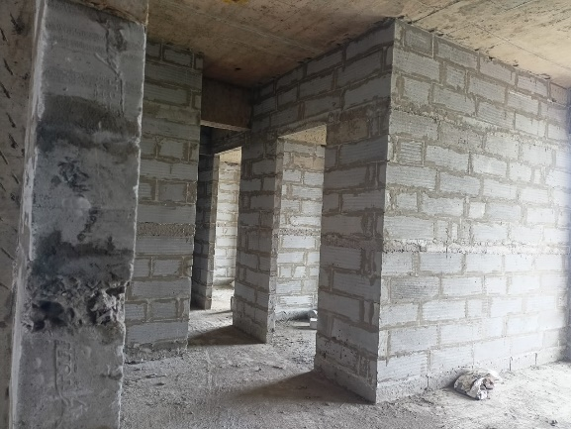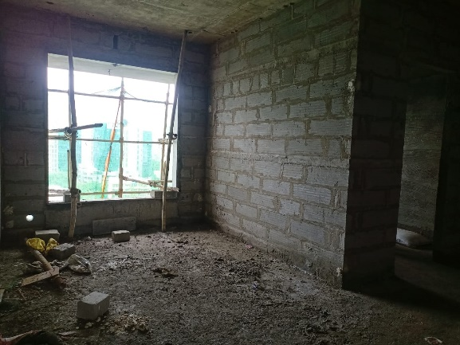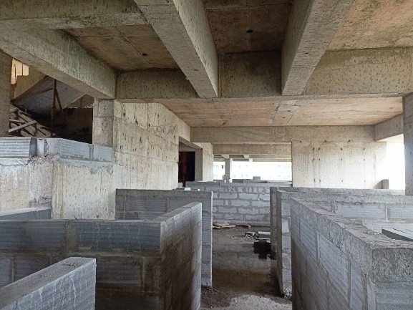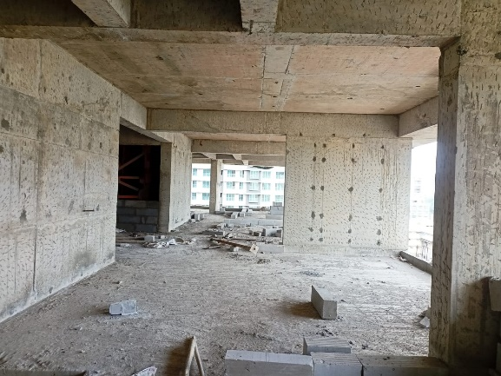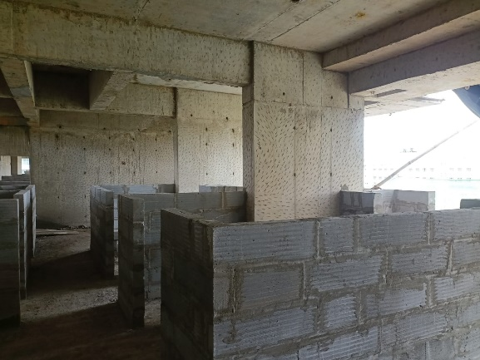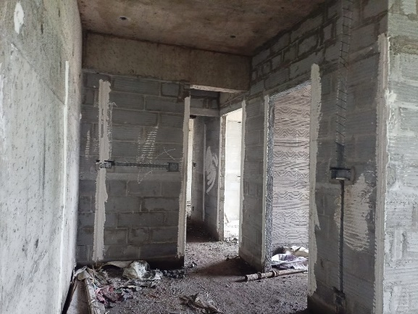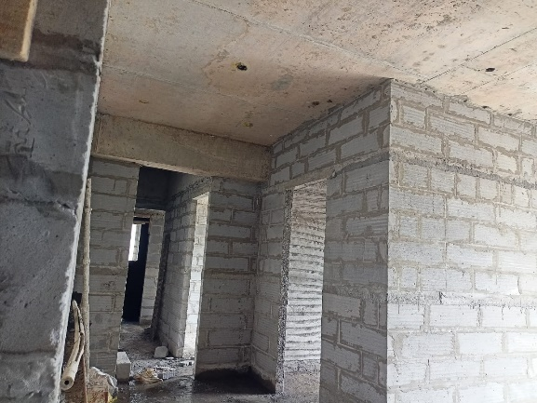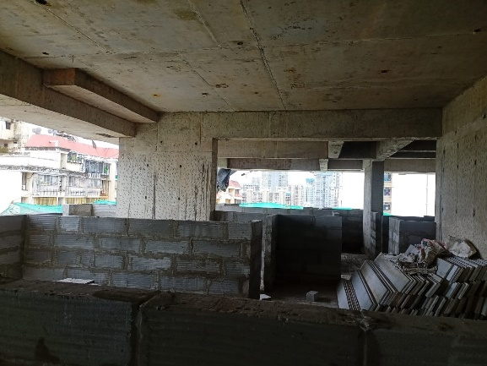**Actual Site Photographs As on 05.10.2023**

**Actual Site Photographs As on 05.10.2023**

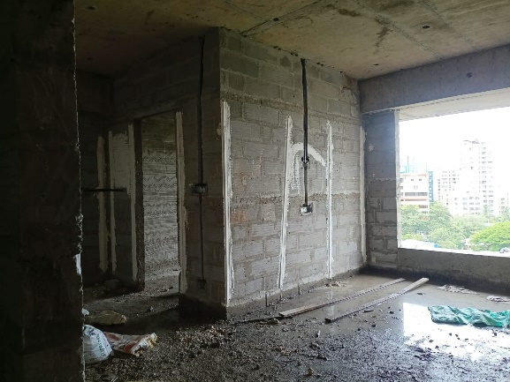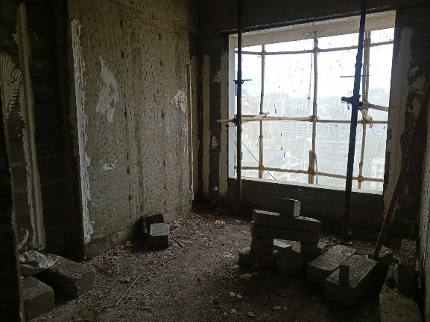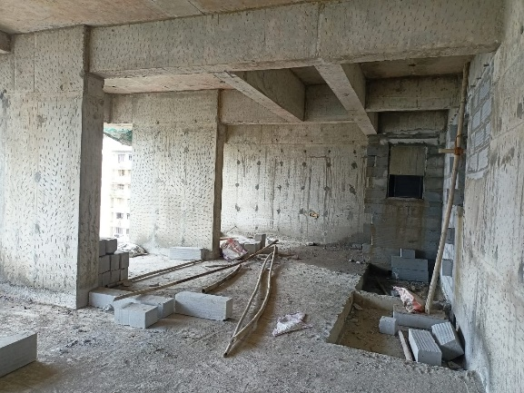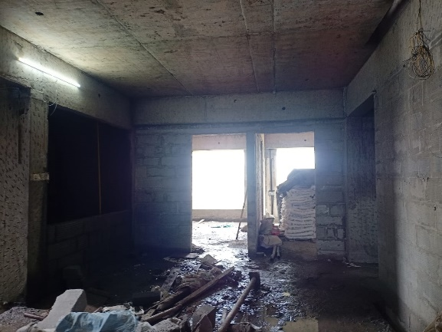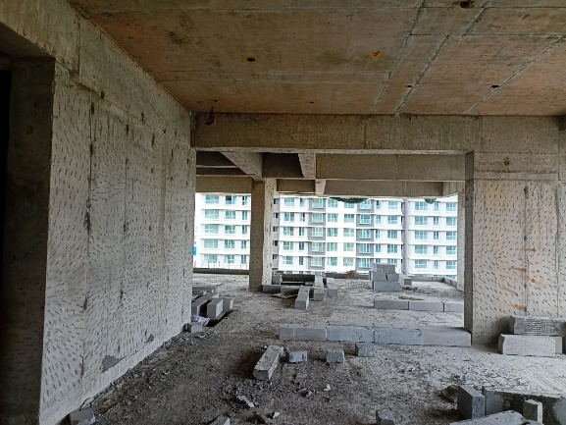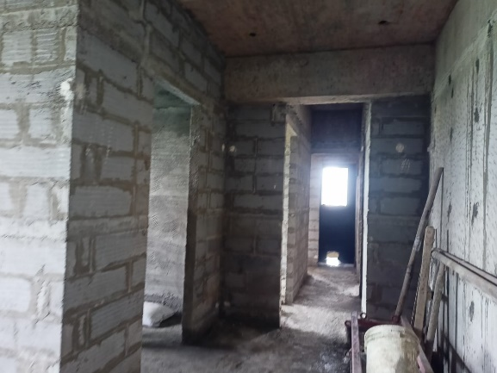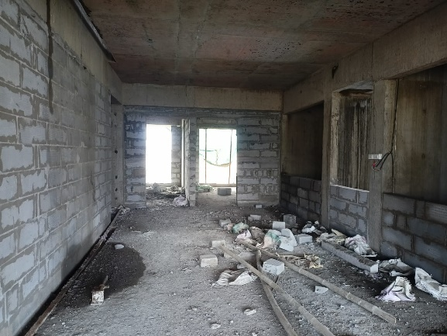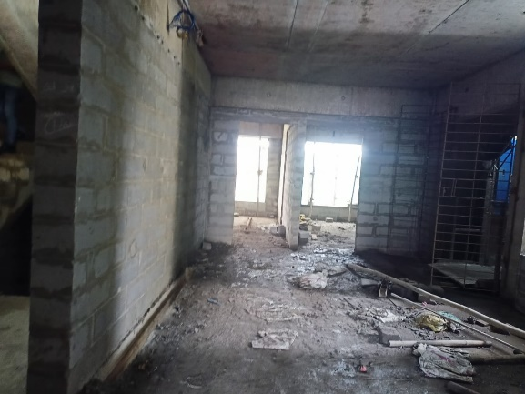

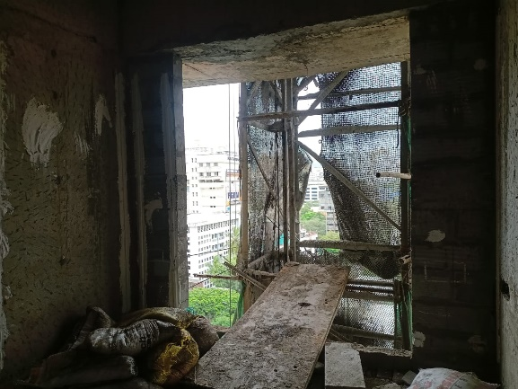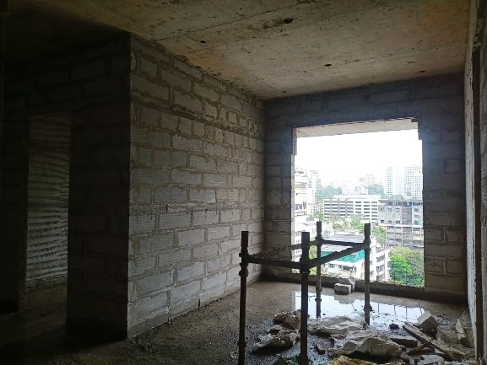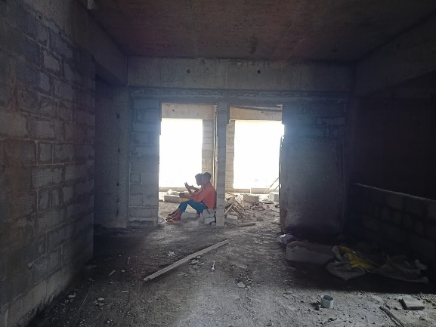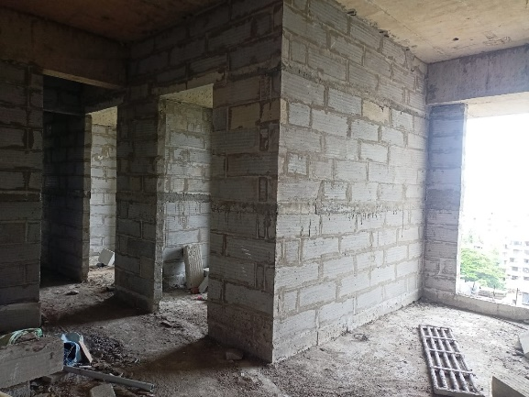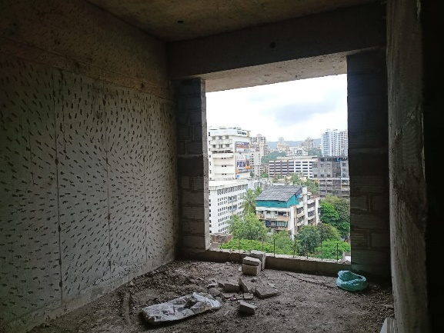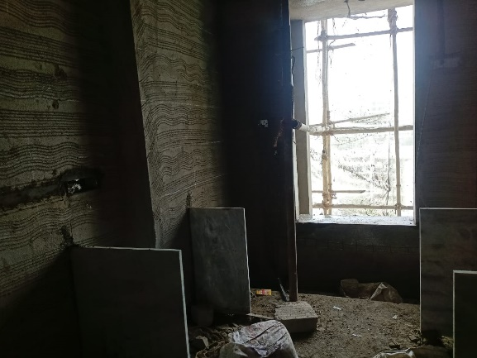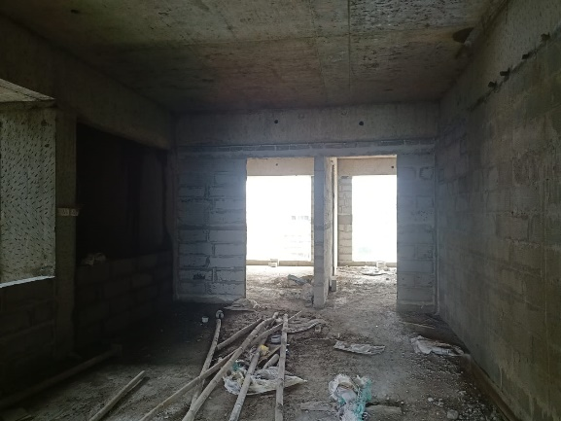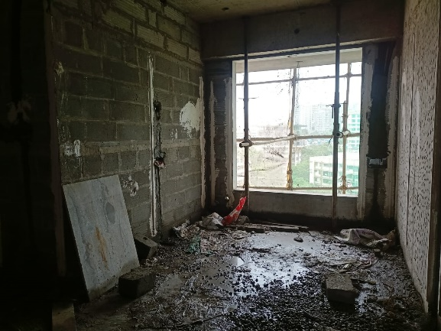**Actual Site Photographs As on 05.10.2023**

**Actual Site Photographs As on 05.10.2023**

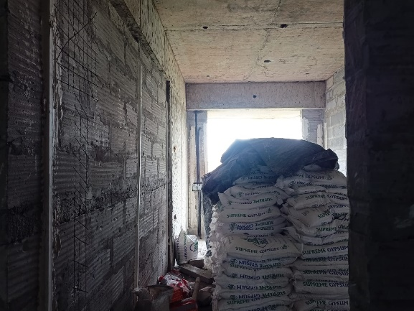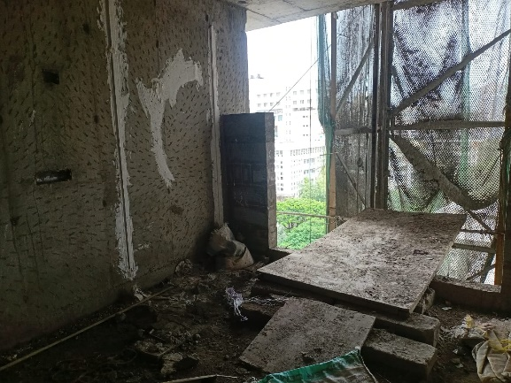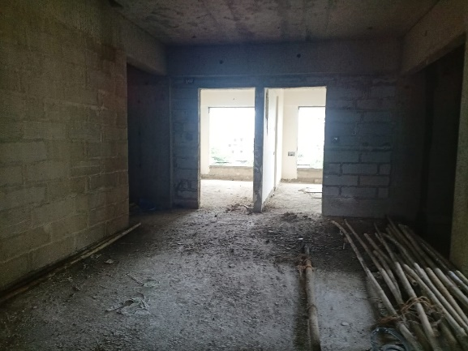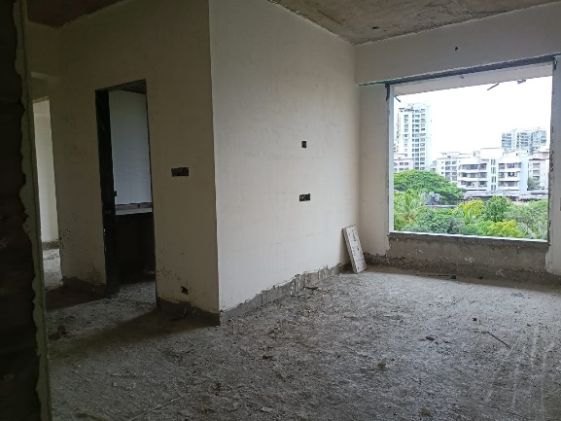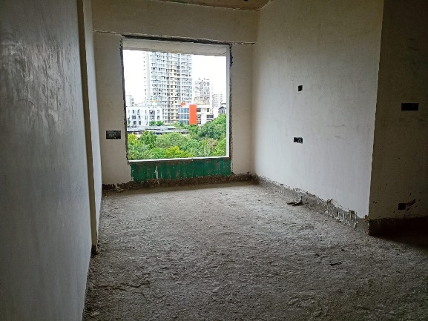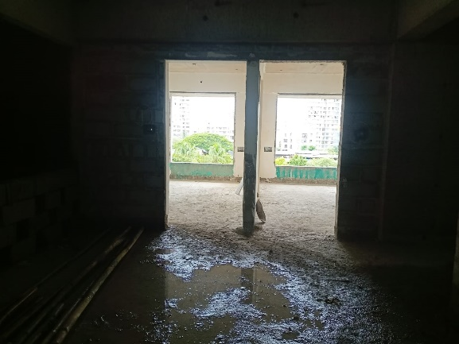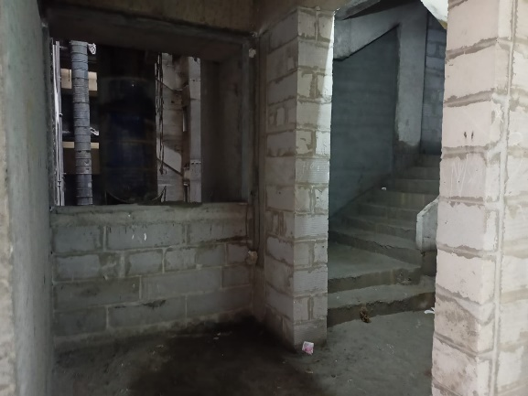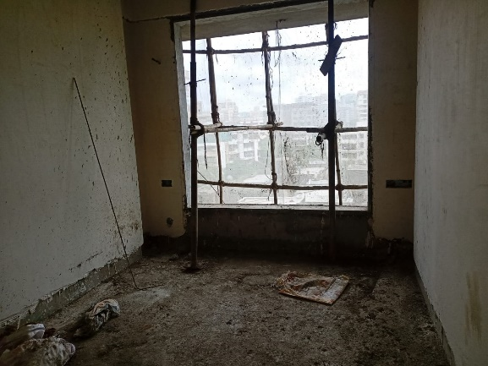

**Actual Site Photographs As on 05.10.2023**

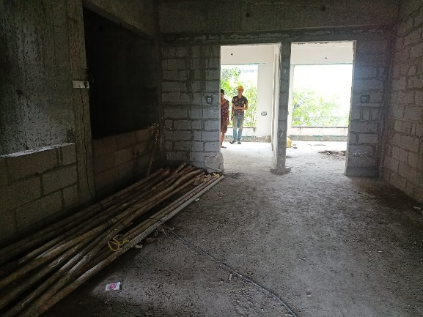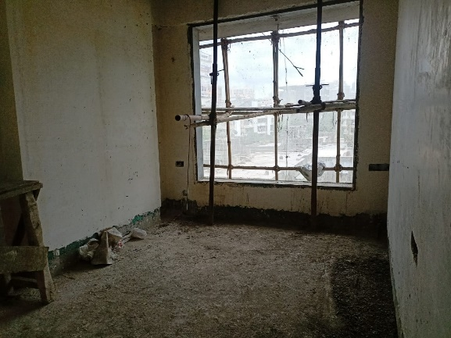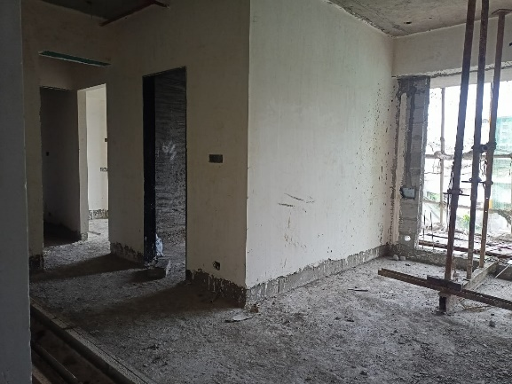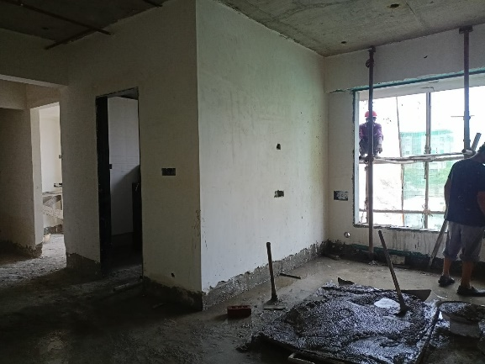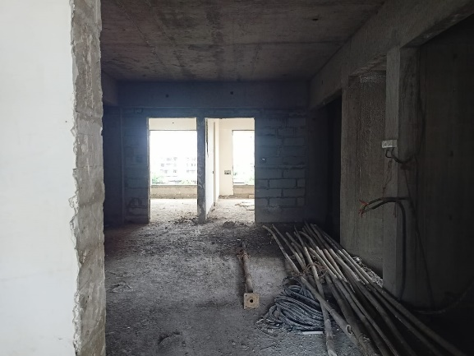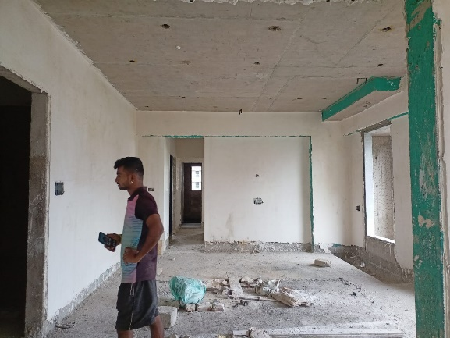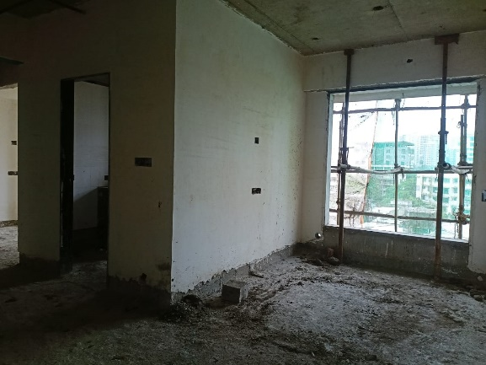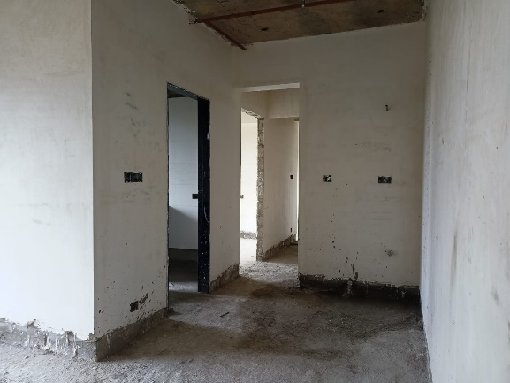

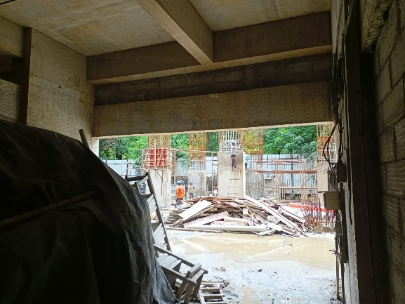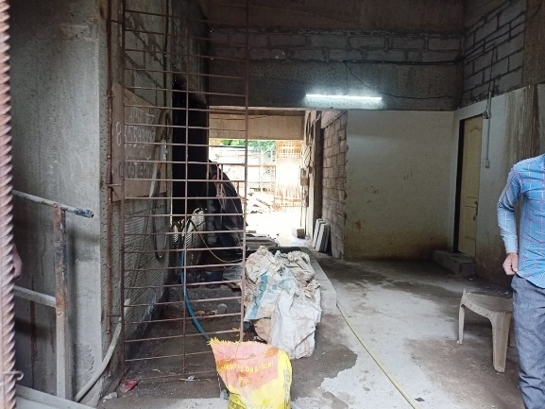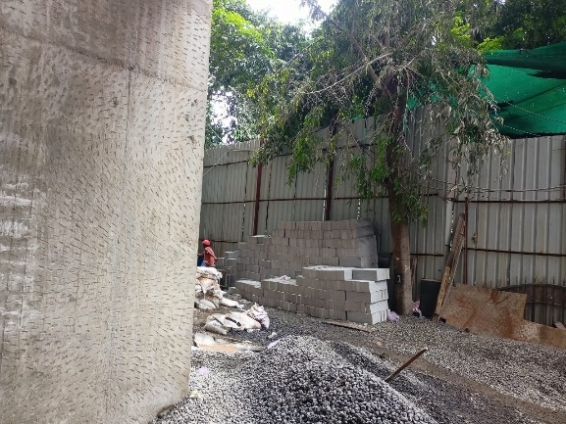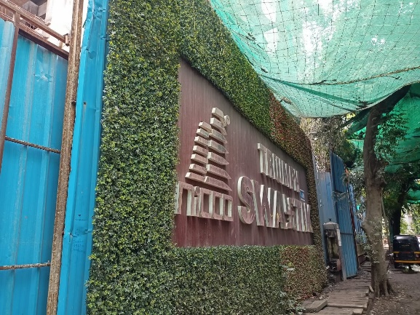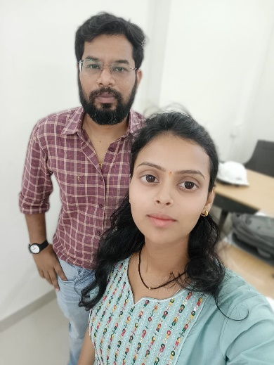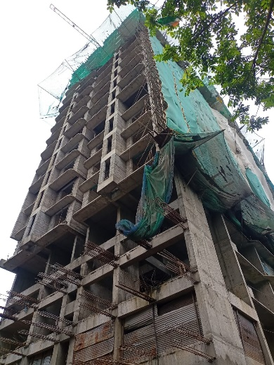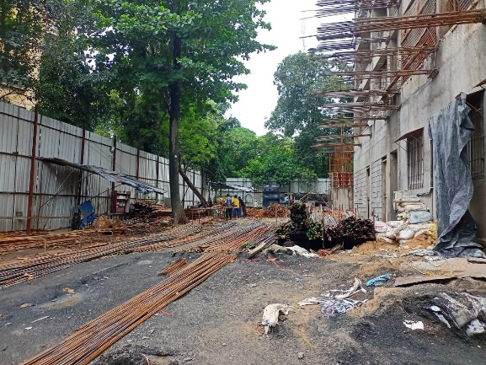**Actual Site Photographs As on 05.10.2023**



**Route Map of the property**

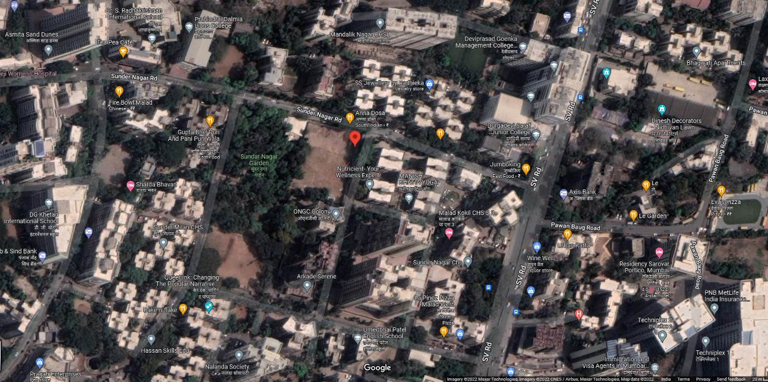**Site u/r**

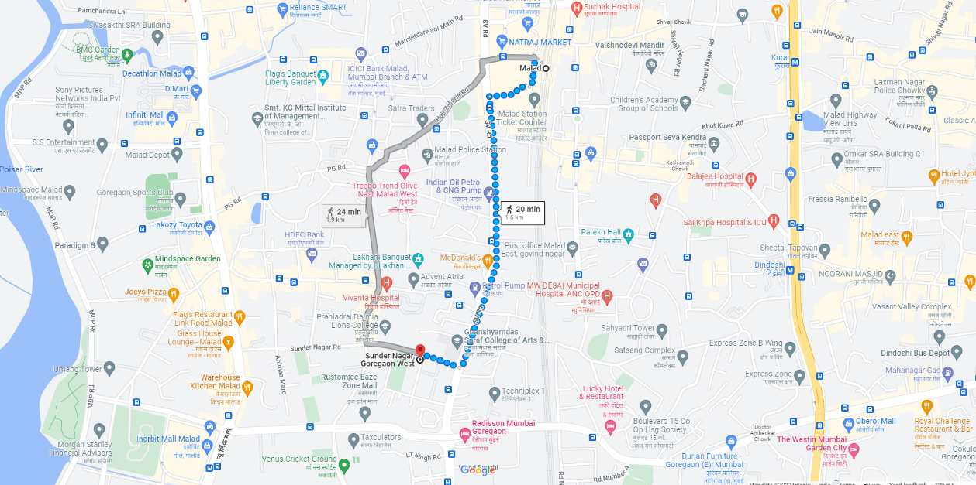

## Latitude Longitude: 19°10'35.0"N 72°50'38.7"E

Note: The Blue line shows the route to site from nearest railway station (Malad – 1.60 Km.)

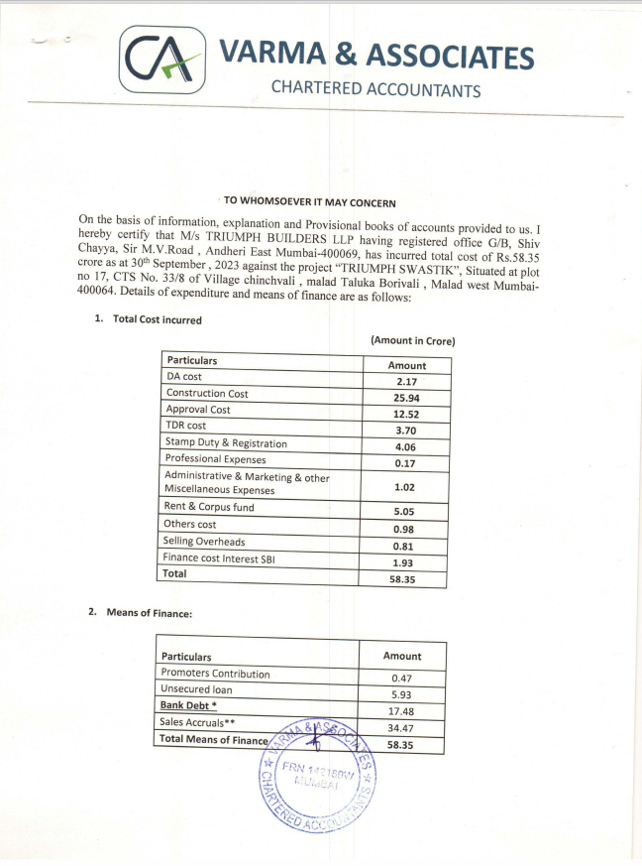**CA Certificate Dated 13.10.2022 till 30.09.2023**

**CA Certificate Dated 13.10.2022 till 30.09.2023**

