Vastu/Nashik/03/2023833/30490/46262
22/24-455-RPV
Date: 24.11.2023

To, `
The Branch Manager,
Bank of Baroda
Regional Office Nashik Road Branch
BSNL Building, Datta Mandir Road, Nashik Road,
Nashik -422 101, State - Maharashtra, Country - India.

Sub: Vetting of Extra Amenities

Sir,

With reference to above subject, we have evaluated the Extra Amenities for Residential Flat No.704, Seventh Floor, A-Wing "Vivanta Residency", Survey No.163/1/40, Plot No.1, Near Adumber Banquet Lawns, Ayodhya Nagari, Meri - Rasbihari Link Road, Village – Nashik , Taluka- Nashik, District - Nashik, PIN Code – 422 003, State – Maharashtra, Country – India belongs to Sau. Jayashri Dasharath Morade.

We have verified the rates quoted as per current market rates. Details of work and Extra Amenities considered as per copy of Agreement for Extra Amenities issued by Sau. Jayashri Dasharath Morade (First Part) and M/s. Pavilius Group (Second Part) received on dated 22.11.2023. The Extra Amenities amount is Rs.5,00,000/- ( Rupees Five Lakh Only. )

The said Cost Vetting Certificate is valid upto next 6 months Only.

Thanking you

Sincerely yours

Manoj B. Chalikwar
Registered Valuer
Chartered Engineer (India)
Reg. No. CAT-I-F-1763
Reg. No. IBBI/RV/07/2018/10366
BOB Empanelment No.: ZO:MZ:ADV:46:941
Encl: Valuation report.

Agreement for Extra Amenities
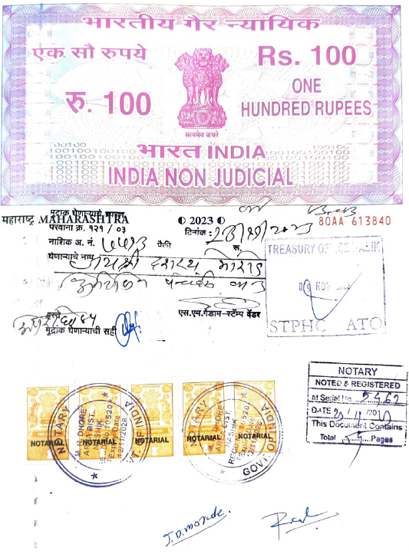
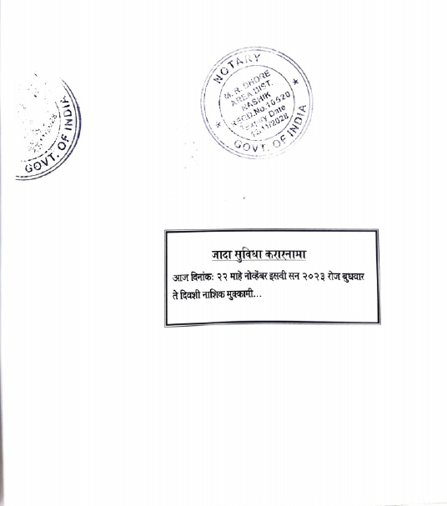

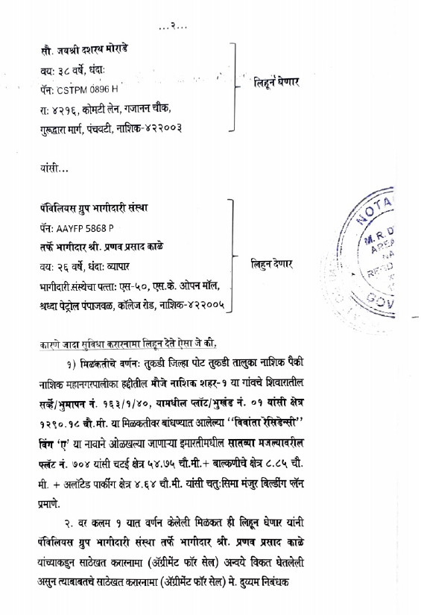

Agreement for Extra Amenities
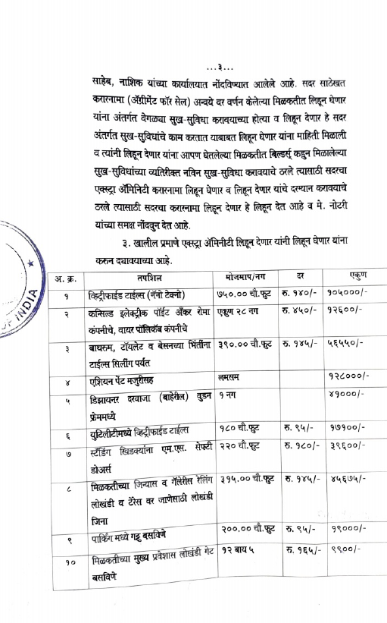
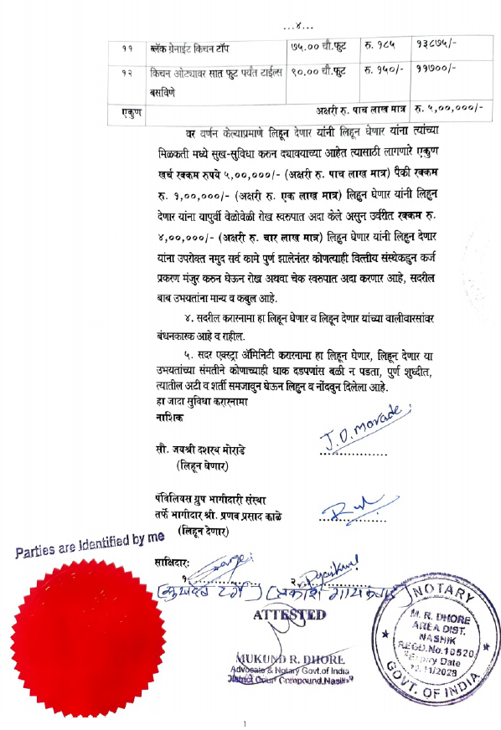

The Extra Amenities amount is Rs.5,00,000/- ( Rupees Five Lakh Only. )

