**Name of Owner: M/s. Krushna Cotex Private Limited**

**Plant Location: - Gat No. 27, Village-Dahiwad, Taluka-Shipur, District Dhule, PIN Code-425 405, State- Maharashtra, County-India.**

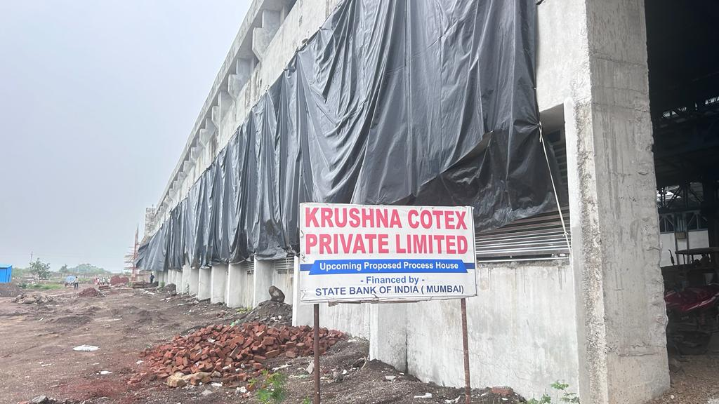

**Report Prepared For**

**State Bank of India**

**Industrial Finance Branch, Andheri**

**102, Natraj, 194, Sir. M.V Road, W.E Highway-Metro Junction, Andheri (E )**

**Mumbai – 400 069, State – Maharashtra, Country – India**

**INDEX**

|  |  |  |
| --- | --- | --- |
| CHAPTER | NAME | PAGE NO. |
| 1 | **PREAMBLE** | **03** |
| 2 | **ASSIGNMENT OVERVIEW** | **04** |
| 3 | **ABOUT COMPANY & THE PROJECT** | **07** |
| 4 | **PROJECT EXECUTION** | **33** |
| 5 | **PHOTOGRAPHS** | **37** |
| 6 | **NOTES, LIMITATIONS, DISCLAIMERS & CAVEATS** | **46** |
| 7 | **SUMMARY** | **48** |
| 8 | **OPINION** | **52** |

1. **PREAMBLE**

**State of India**, Industrial Finance Branch, Andheri, 102, Natraj, 194, Sir. M.V Road, W.E Highway-Metro Junction, Andheri (E ), Mumbai – 400 069, State – Maharashtra, Country – India has appointed **M/s Vastukala Consultants (I) Pvt. Ltd. (VCIPL)** as Lender’s Independent Engineers for inspection and monitoring the progress of proposed processing and made ups Unit with approx. 60 000 meters/day fabric processing and 5,000 sets/day sheeting sets facility of   
Rs. 191.71 Crores by **M/s Krushna Cotex Private Limited,** (hereinafter referred to as either “KCPL or “the borrower” or “the company”) on behalf of lenders. **M/s Krushna Cotex Private Limited** is the borrower and the project is financed by State Bank of India as per the table mentioned below: -

**(Rs in Cr)**

| S. No | Particular | Proposed |
| --- | --- | --- |
| 1 | Term Loan from State of India, IFB-Andheri (E ) Branch | 123.00 |
| 2 | Promoters Contribution | 68.71 |
|  | **Total** | **191.71** |

Pursuant to instructions from Relationship Manager of **State of India**, Industrial Finance Branch, Andheri, 102, Natraj, 194, Sir. M.V Road, W.E Highway-Metro Junction, Andheri (E ), Mumbai – 400 069, State – Maharashtra, Country – India, as appointment of Lender’s Independent Engineer, our Engineer visited the project site of proposed processing and made ups Unit with approx. 60 000 meters/day fabric processing and 5,000 sets/day sheeting sets facility at Gat No. 27, Village-Dahiwad, Taluka-Shipur, District Dhule, PIN Code-425 405, State- Maharashtra, County-India on 26.09.2023 with a view to ascertain and certify the quantity and amount of work progressively undertaken by the borrower.

1. **ASSIGNMENT OVERVIEW**

#### 2.1 NATURE OF ASSIGNMENT

To review the status of the proposed processing and made ups Unit with approx. 60 000 meters/day fabric processing and 5,000 sets/day sheeting sets facility at Gat No. 27, Village-Dahiwad, Taluka-Shipur, District Dhule, PIN Code-425 405, State- Maharashtra, County-India on behalf of **State of India**, Industrial Finance Branch, Andheri, 102, Natraj, 194, Sir. M.V Road, W.E Highway-Metro Junction, Andheri (E ), Mumbai – 400 069, State – Maharashtra, Country – India (Lender’s).

#### 2.2 SCOPE OF WORK: -

#### The scope of work is under: -

* Executive Summary, Brief Profile/ Basic information of the applicant Company.
* Periodic Progress Monitoring Report.
* Financial Progress.
* Project Cost, Means of Finance details and Expenses.
* Bank related details.
* Physical Progress.
* Site Visit.
* Present Physical Status of the Project.
* Building & Civil Work
* Status of Plant & Machinery and Miscellaneous Fixed Assets.
* Verification of Invoice/ Purchase Orders.
* Details of Plant & Machinery Installed.
* Statutory Approvals for the Projects
* Monitoring of obtainment of the statutory approvals, clearances from appropriate authorities.
* Monitoring of the actuals with the timelines initially set for different stages of implementation for monitoring the time over run if any.
* Verification of the invoices and validation of the rates/commercial terms and conditions thereof vis-a-viz the original projections.
* Environmental Clearances.

#### 2.3 DATE OF VISIT: -

* VCIPL’s Engineer has visited the project site 1st time on 26.09.2023.

#### 2.4 DOCUMENTS PROVIDED FOR VALUATION: -

The following documents were perused during the said assignment:

* Letter for Commercial Advance-Sanction of Credit Facilities issued by **State of India**, Industrial Finance Branch, Andheri, 102, Natraj, 194, Sir. M.V Road, W.E Highway-Metro Junction, Andheri (E ), Mumbai – 400 069, State – Maharashtra, Country – India vide Letter No. SBI/IFB/AND/AMT III/2022-23/28 dated 02.05.2022.
* TEV Report prepared by M/s. Kakode Associates Consulting Pvt. Ltd. dated January 2022.
* Articles of Association.
* Memorandum of Association.
* PO for Processing Machines Unloading, Erection, Machine piping issued to Enaky Engineering, Mumbai vid Ref. PO No. KCPL/23-24/15 dated 28.06.2023.
* PO for Erection of Thermic Fluid Heater Parts issued to Konark Fabtech India Pvt. Ltd., Nashik vid Ref. PO No. KCPL/23-24/16 dated 03.08.2023.
* Agreement to Lease dated 24.03.2022 made between M/s. Deesan Infrastructure Pvt. Ltd. (“the Lessor”) and M/s. Krushna Cotex Pvt. Ltd. (“the Lessee”) for Let out space admeasuring 10,999.00 Sq. M to the Lessee on lease for the lease rent for the period of 29 year.
* Provisional Balance Sheet as at 31.03.2023.
* Implementation Schedule.
* Certificate of Incorporation.
* Company’s PAN Card.
* Sanction Letter for technical estimate & load for New-HT Power supply of Contract demand of 1765 KVA and connected load of 1412 kW under 1.3% Norm. Charges under DDF Scheme issued by superintending Engineer, MSEDCL, Dhule Circle dated 30.01.2023.
* Process House Site Plan.
* Project Details.
* Machinery List.
* Bank account Statement.
* CA Certificate for cost incurred till 30.09.2023 signed by M/s. Vijay M. Rathi, Chartered Accountant, Dhule dated 27.10.2023.
* Power Load calculation.
* Ledger Abstract.
* Consent to Establish under Section 25 of the Water (Prevention & Control of Pollution) Act, 1974 & under Section 21 of the Air (Prevention & Control of Pollution) Act, 1981 and Authorization under Rule 6 and Rule 18(7) of the Hazardous & Other Wastes (Management & Transboundary Movement) Rules 2016 issued by Maharashtra Pollution Control Board for a period up to commissioning of the unit or up to 5 year whichever is earlier dated 12.09.2023.
* NOC Stipulating fire protection and fire fighting issued by Malegaon Municipal Corporation dated 09.10.2023.
* Tax Invoice and Bill of Entry.

#### 2.5 METHODOLOGY ADOPTED

* LIE visit to the project site 1st time on 16.07.2023.
* Perusal of documents and information provided by the Company.
* Physical verification of the project site with the following executives of the Company: -
* Mr. Abhishek Srivastava, Project Head of KCPL.
* Mr. Sujeet Lodh, Manage-Engineering of KCPL.
* Explanations and information given by the following executives of the Company,
* Mr. Abhishek Srivastava, Project Head of KCPL.
* Mr. Girish Rathod, Executive-Accounts & Finance of KCPL.
* Examinations of documents provided by the Company.
* Selective photographs of the project site are enclosed.
* Finalization of LIE Report.

1. **ABOUT COMPANY & THE PROJECT**

#### 3.1. ABOUT COMPANY: -

**M/s. Krushna Cotex Private Limited (“KCPL” or “Company”)** is a Private Limited Company incorporated on 30th March 2007. It is classified as non-govt. Company and is registered at Registrar of Companies, Mumbai. KCPL's Corporate Identification Number is (CIN) U17200MH2007PTC169431 and its registration number is 169431. Its registered address is 4-A Vikas Centre, 104 S V Road, Santacruz (W), Mumbai- 400 054.

KCPL is a part of Deesan Group that has fully integrated unit with State-of-the-art facilities. They are manufacturing Cotton Yarn, Woven fabric, Knitted Fabric, Cotton Fabric, made ups, Terry Towels and Garments. KCPL is expanding their existing unit with latest processing made ups which will enhance the existing facilities.

KCPL proposes to processing and made ups Unit with approx. 60 000 meters/day fabric processing and 5,000 sets/day sheeting sets facility at Gat No. 27, Village-Dahiwad, Taluka-Shipur, District Dhule, PIN Code-425 405, State- Maharashtra, County-India. Shirpur is well connected by road, rail and air transportation with all major cities in India has proximal connectivity to ports like Mumbai.

KCPL had made Agreement to Lease dated 24.03.2022 with M/s. Deesan Infrastructure Pvt. Ltd. (“the Lessor”) for Let out space admeasuring 10,999.00 Sq. M to the Lessee on lease for the lease rent for the period of 29 year.

**3.2. GENERAL INFORMATION: -**

| Particular | Details |
| --- | --- |
| CIN | U17200MH2007PTC169431 |
| Company / LLP Name | Krushna Cotex Private Limited |
| ROC Code | RoC-Mumbai |
| Registration Number | 169431 |
| Company Category | Company limited by Shares |
| Company Sub Category | Non-govt company |
| Class of Company | Private |
| Authorised Capital(Rs) | 150,000,000 |
| Paid up Capital(Rs) | 73,757,220 |
| Date of Incorporation | 30/03/2007 |
| Registered Address | 4-A Vikas Centre 104 S V Road Santacruz (W), Mumbai-400 054 |
| Email Id | amol@krushnacotex.in |

**3.3 ABOUT DIRECTORS OF THE COMPANY:-**

The present director of the company are as under:-

**1. Mrs Jayshree Amrish Patel**

Mrs. Jayshree Amrish Patel wife of Mr. Amrish Rasiklal Patel aged 66 years residence at Kushal Bunglow No 1 Pallavi beach angle, Opp Military campus, Ruia Park, Juhu, Mumbai 400049. She is associated as director in KCPL since 2007 and having more than 20 years of expertise in Textile Manufacturing Business. She is qualified graduate and having a good knowledge of Terry Towel division and grey fabric Manufacturing.

**2. Mrs Hiral Chintan Patel**

Mrs. Hiral Chintan Patel wife of Mr. Chintan Amrish Patel aged 43 years residence at Kushal Bunglow No 1 Pallavi beach angle, Opp Military campus, Ruia Park, Juhu, Mumbai 400049. She is associated as director in KCPL since 2007 and having more than 12 years of expertise in Textile Manufacturing Business. She is qualified graduate and having a good knowledge of Terry Towel division and grey fabric Manufacturing.

**3. Ms. Kruti Bhupesh Patel**

Ms. Kruti Bhupesh Patel wife of Mr. Bhupesh Patel aged 57 years residence at Chintan Bunglow, 9th Road, Plot No 72 Nutan Laxmi Society, Juhu Mumbai 400058. She is associated as director in KCPL since 2007 and having more than 14 Years of expertise in Textile Manufacturing Business. She is qualified graduate and having a good knowledge of Terry Towel division and grey fabric Manufacturing

**4. Mr. Babubhai Naik:-**

Mr. Babubhai Naik aged 68 years is associated as director in KCPL since 2018 and having more than 25 Years of expertise in Textile Manufacturing Business. He is from IIM Ahmedabad and having an expertise knowledge of Textile industry

**5. Ms. Ketki Mukesh Patel:-**

Ms. Ketki Mukesh Patel wife of Late Mr Mukesh Rasiklal Patel aged 63 years residence at Samriddhi Bunglow Plot no 72 9th Road, Nutan Laxmi CHS, Juhu Mumbai 400049. She is associated as director in KCPL since 2007 and having more than 14 Years of expertise in Textile Manufacturing Business. She is qualified graduate and having a good knowledge of Terry Towel division and grey fabric Manufacturing

**2. Smt. Ruchika Agarwal**

Smt. Ruchika Agarwal is also a commerce graduate from Rajasthan. She will be assisting   
Shri. Sorabh Agarwal in the accounts and administration.

**3.4. SHAREHOLDING PATTERN: -**

| S No. | Name of Shareholder | Class of Share | No of Shares | % of Shareholding |
| --- | --- | --- | --- | --- |
| 1 | Ashish Nanda | Non-convertible Preference Shares | 7,81,250 | 19.8% |
| 2 | Shirpur Construction Pvt. Ltd. | Equity Shares | 6,25,000 | 15.8% |
| 3 | Hiral Chintan Patel | Equity Shares | 4,45,166 | 11.3% |
| 4 | Deesan Tex Fab Pvt. Ltd. | Equity Shares | 4,10,266 | 10.4% |
| 5 | Bhupesh Rasiklal Patel | Equity Shares | 3,60,000 | 9.1% |
| 6 | Rima Tapan Patel | Equity Shares | 3,60,000 | 9.1% |
| 7 | Tapan Mukesh Patel | Equity Shares | 3,60,000 | 9.1% |
| 8 | Ketki Mukesh Patel | Equity Shares | 2,09,800 | 5.3% |
| 9 | Jayshree Amrish Patel | Equity Shares | 1,32,000 | 3.3% |
| 10 | Kruti Bhupesh Patel | Equity Shares | 78,500 | 2.0% |
| 11 | Alkaben Desai | Equity Shares | 69,200 | 1.8% |
| 12 | Enpak Motors Pvt. Ltd. | Equity Shares | 24,600 | 0.6% |
| 13 | Solaris Tex Pvt. Ltd. | Equity Shares | 14,700 | 0.4% |
| 14 | Sneha Cottons Pvt. Ltd. | Equity Shares | 11,900 | 0.3% |
| 15 | Narendra Agrawal | Equity Shares | 10,000 | 0.3% |
| 16 | Surekha Eknath Mahajan | Equity Shares | 10,000 | 0.3% |
| 17 | Crest Textiles Pvt. Ltd. | Equity Shares | 8,200 | 0.2% |
| 18 | Sanskriti Tex Fab Pvt. Ltd. | Equity Shares | 8,000 | 0.2% |
| 19 | Subhyog Garments Pvt. Ltd. | Equity Shares | 8,000 | 0.2% |
| 20 | Tarini Garments Pvt. Ltd. | Equity Shares | 8,000 | 0.2% |
| 21 | Riddhi Tex Fab Pvt. Ltd. | Equity Shares | 7,600 | 0.2% |
| 22 | Shirpur Tex Fab Pvt. Ltd. | Equity Shares | 7,000 | 0.2% |
| 23 | Urja Textiles Pvt. Ltd. | Equity Shares | 3,400 | 0.1% |
|  |  | **Total** | **39,52,582** | **100%** |

**3.5) ABOUT THE PROJECT**

M/s Krushna Cotex Private Limited (KCPL) was incorporated on 30th March 2007, as a private limited company with the objective of manufacturing of all kinds of Yarn. Textiles, readymade garments, furnishing fabrics etc. KCPL is currently engaged in manufacturing of Terry towels which are further sold in domestic as well as international markets. The company has proposed to setup a new unit for processing of fabric and manufacturing of made ups.

KCPL is part of Deesan Group of Companies. Deesan group was started by Mr. Amrish Rasiklal Patel in 1998 with an objective to develop Shirpur. The group is engaged into various activities such as manufacturing of textiles, Education, Agro Products, Textile Parks, and construction activities.

In the textile segment, the group is engaged in manufacturing of wide range of textile products such as Cotton yarn (grey/dyed), Knitted Fabric, Woven Fabric, Cotton Fabric, made ups, Terry Towels, Garments etc. Currently, the group has 1200 smaller width looms producing around 10 million meters per annum of shirting/dress material. 350 Wider width looms producing around 2.5 million meters per annum. Apart from this, the group also has 66 terry towel looms producing around 8400 metric tonne per annum. There are around 238 companies within the group.

KCPL is currently engaged in manufacturing of home textiles such as terry towel and has an installed capacity of 500 tonnes per month. The current product range of the company includes, wash towels, Hand towels, Bathmat and Bath Towels in various sizes. The promoters are now expanding its business activities further into home textiles in form of made ups unit.

The proposed manufacturing facility of KCPL has Fabric processing capacity of 60,000 metres fabric per day and made ups capacity of 5.000 sheeting sets per day. The company shall manufacture 5 types of made ups, namely. Twin, Full, Queen, King and Cal-King. All the types of bedding shall consist of Flat sheets, Fitted sheets and 2 Pillow Covers. However, the sizes of the made up shall defer based on the bedding type.

KCPL proposed expansion project comprises of the setting up a processing and made ups Unit with approx 60 000 meters/day fabric processing and 5 000 sets/day sheeting sets. Adequate storage and handling facilities are provided for the materials required for the production.

The fabric processed shall be partly captively consumed for manufacturing of made ups and the balance processed fabric shall be sold. The company is planning to Export the products manufactured in the new unit.

**LOCATION:-**

The project shall be located at Gat No 27, Village-Dahiwad, Taluka-Shipur, District-Dhule, Maharashtra, which is in an integrated textile park developed by M/s Deesan Infrastructure Private Limited (DIPL). DIPL has leased 118350 sq. ft (i.e. 10999 Sq. M) of the said land to KCPL for 29 years.

**LOCATION ADVANTAGES –**

The integrated textile park developed by DIPL aims to provide favourable infrastructure for the textile manufacturers like water connection, power connection and other facilities catering to the textile industry required for uninterrupted operations. The raw material (cotton) is widely available in the region and is further supported by government programs. Since the region is a hub for textile industry, skilled labours are available in abundance. The region is well connected by transportation with all major cities in India. The land location is suitable for operating the proposed manufacturing facility and infrastructure like Roads, Power, Water. Transportation, etc together with skilled/semi-skilled labour, etc are easily manageable due to the presence of the Textile Park by DIPL. The Google Location for the same is as under:-

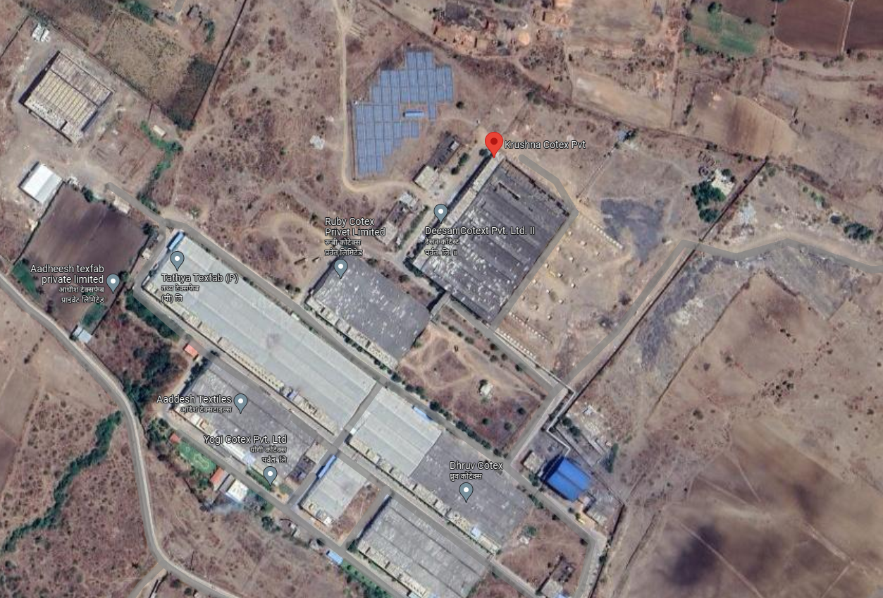

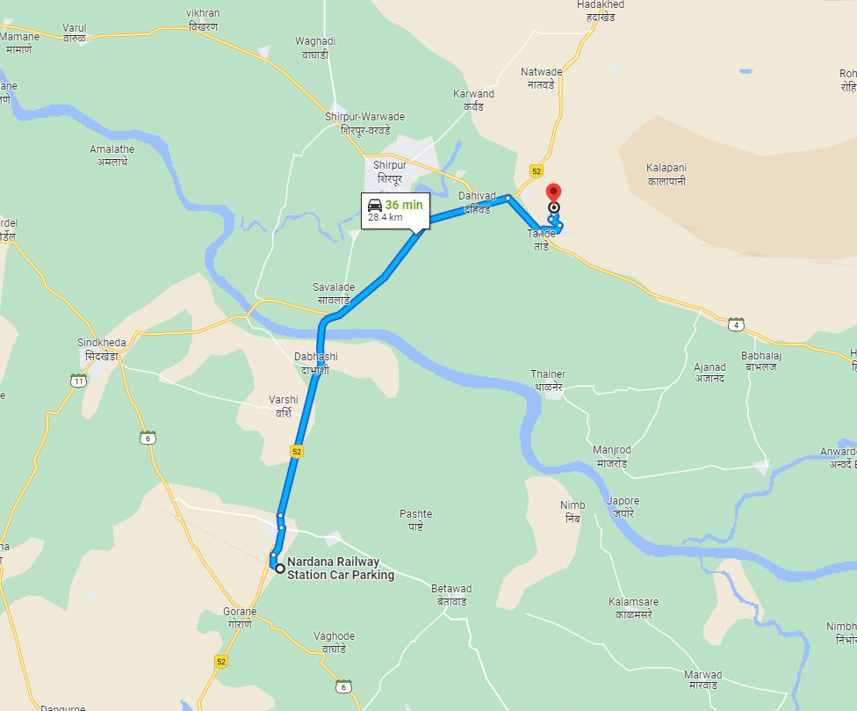

**Longitude Latitude: 21°20'02.0"N 74°57'23.6"E**

**Note:** The Blue line shows the route to site from nearest railway station (Nardana – 28.4 KM.)

KCPL intends to complete the project within 24 months and commencement of the commercial operations is expected by April 2024.

The technologies as proposed to be utilized by the company for the project are internationally well-established technologies for manufacturing of KCPL product. All the equipment shall be of high quality and based on latest technology.

The company would require 1,200 cubic meter of water per day which would be fulfilled from the existing Textile Park.

The project is expected to start commercial operations in April 2024. As per TEV Report Building required for the proposed project is developed on DIPL on land admeasuring 118350 sq. ft (i.e. 10999 Sq. M) of the said land is leased to KCPL by DIPL for 29 years. As per revised Plan provided by the Company, the Built-up area for Building is as under:-

| S No. | Name of Building | Floor | Size (M) | Area (Sq. M.) |
| --- | --- | --- | --- | --- |
| **A** | **Area Used by M/s. Deesan Cotext Pvt. Ltd. II** |  |  |  |
| 1 | Existing Building - Plant Area | G | 41.63 X 88.25 | 3,673.85 |
| 2 | Existing Building - Plant Area | G | 42.60 X 88.25 | 3,759.45 |
| 3 | Existing Building - Plant Area | 1st | 42.60 X 88.25 | 3,759.45 |
| 4 | Existing Building – Office Area | G | 84.23 X 12.98 | 1,093.31 |
| 5 | Existing Building – Office Area | 1st | 84.23 X 12.98 | 1,093.31 |
|  |  |  | **Total (A)** | **13,379.36** |
| **B** | **Area to be used by KCPL** |  |  |  |
| 1 | Existing Building - Plant Area | Ground | 63 X 88.25 | 5,559.75 |
| 2 | Existing Building – Office Area | G | 63 X 12.98 | 817.74 |
| 3 | Existing Building – Office Area | 1st | 63 X 12.98 | 817.74 |
| 4 | Proposed Building-Plant Area | Ground | 147.23 X 68.25 | 10,048.45 |
| 5 | Proposed Building-Office & Lab Area | Ground | 147.23 X 6.75 | 993.80 |
| 6 | Proposed Building-Office & Lab Area | 1st | 142.03 X 6.75 | 958.70 |
| 7 | Substation | G | 11 X 6.23 | 68.53 |
| 8 | Pump Room | G | 10.12 X 18.21 | 184.29 |
|  |  |  | **Total (B)** | **19,449.00** |
|  |  |  | **Total (A+B)** | **32,828.36** |

**Note:-**

* As per Plan the Ground Coverage for KCPL proposed project is 17,672.56 Sq. M., however the Company has provided the lease deed of Land admeasuring 10,999 Sq. M. Company should provide the Lease deed for the additional Land.
* Construction of Proposed Building is in progress. The Plint work and beam work is completed. The Cost of Building is in the scope of DIPL.

The foundation for the machinery and related finishing work will be undertaken by KCPL subsequently The utilities needed for the proposed project are as under

1 Water Treatment Plant

2 Effluent Treatment Plant

3 Boiler For Steam Generation

4 Firefighting hydrant system

5 Electrical Distribution

The promoters plan to subscribe to two government subsidies as follows

**Power Subsidy**

As per the New Textile Policy, Maharashtra government will provide the power subsidy benefit to Textile sector A subsidy of Rs 2 per unit will be given to textile sector unit to avail power subsidy benefits After getting this document verified from the power sector department, the subsidy benefit will be reflected in the power bill and will be availed by the manufacturer on a monthly basis.

**Capital Subsidy**

The Amended Technology Upgradation Fund Scheme (has been notified by the Ministry of Textiles. In order to promote ease of doing business in the country and achieve the vision of generating employment and promoting exports through “Make in India” with “Zero effect and Zero defect” in manufacturing, it has been decided that the government would provide credit linked capital Investment Subsidy (under Amended Technology Upgradation Fund Scheme (ATUFS).

The Scheme would facilitate augmenting of investment, productivity, quality, employment, exports along with import substitution in the textile industry It will also indirectly promote investment in textile machinery (having benchmark technology) manufacturing.

Technology Upgradation means induction of new machinery by an entity engaged in the textile industry with state of art technology as specified annually by the Technical Advisory cum Monitoring Committee (Technology lower than the specified one will not be treated as Technology Upgradation. Capital Investment Subsidy (means the subsidy at prescribed rate on credit linked Capital Investment to an entity engaged in textile sector on technology upgradation which will be determined on the basic cost’ of the specified machinery after its installation and commissioning. ‘Basic cost’ means cost of machinery excluding taxes, duties and any other charges

To avail this Capital Subsidy benefit, the company will have to file the application thru online portal to DIC department. Government will release the funds as per there schedule to the respective loan account of the Company. This capital subsidy funds will be adjusted against the loan taken by the company.

Total estimated project cost is Rs. 191.71 Crores as indicated in table provided below for ready reference.

| S. No | Particular of Project | Estimated Project Cost (₹ in Crores) |
| --- | --- | --- |
| 1. | Buildings (Machine Foundation) | 3.00 |
| 2. | Plant & Machinery | 130.38 |
| 3. | Other Fixed Asset | 19.35 |
| 4. | Preliminary/ Pre-Operative Expenses | 3.23 |
| 5. | Contingencies (5% of total cost excluding IDC and Promotors contribution for Working Capital | 7.80 |
| 6. | Interest During Construction (IDC) | 13.03 |
| 7. | Promotors contribution for Working Capital | 14.92 |
|  | **Total** | **191.71** |

**NOTE:-**

* Land and Building is leased from DIPL. Cost of Land and Buildings is in the Scope of DIPL, therefor the same is not considered in the project cost.
* Under the head of Building on machinery foundation is considered.
* The TEV has vetted the costs. As per TEV report, the costs considered for the civil works, plant machinery, etc. for the proposed project seems reasonable Overall. As per TEV Report total project cost is estimated at Rs. 191.71 Crores which is reasonable and in line with industry standards.

**MEANS OF FINANCE**

| S. No | Particular of Project | Cost (₹ in Crores) |
| --- | --- | --- |
| 1. | Term Loan | 123.00 |
| 2. | Promoter Capital | 68.71 |
|  | **Total** | **191.71** |

**OBSERVATIONS:-**

* The total cost of the proposed project is Rs. 191.71 crore to be funded by equity of Rs. 68.71 crore and term loan of Rs. 123.00 crores. The debt-to-equity ratio of th project would be 1.79 times. KCPL is also seeking non-fund-based limits (CAPEX letter of credit) of Rs. 109.43 crore as a sublimit of the rupee term loan.
* **State of India**, Industrial Finance Branch, Andheri has sanction a Term Loan of Rs. 123.00 Crores to KCPL vide Letter for Commercial Advance-Sanction of Credit Facilities Letter No. SBI/IFB/AND/AMT III/2022-23/28 dated 02.05.2022.

**3.6) LEASED LAND FOR THE PROJECT:-**

The project is expected to start commercial operations in April 2024. As per TEV Report Building required for the proposed project is developed on DIPL on land admeasuring 118350 sq. ft (i.e. 10999 Sq. M) of the said land is leased to KCPL by DIPL for 29 years.

**Note:-**

* As per Plan the Ground Coverage for KCPL proposed project is 17,672.56 Sq. M., however the Company has provided the lease deed of Land admeasuring 10,999 Sq. M. Company should provide the Lease deed for the additional Land.

**3.7) LEASED BUILDINGS FOR THE MANUFACTURING PROJECT: -**

. As per revised Plan provided by the Company, the Built-up area for Building is as under:-

| S No. | Name of Building | Floor | Size (M) | Area (Sq. M.) |
| --- | --- | --- | --- | --- |
| **A** | **Area Used by M/s. Deesan Cotext Pvt. Ltd. II** |  |  |  |
| 1 | Existing Building - Plant Area | G | 41.63 X 88.25 | 3,673.85 |
| 2 | Existing Building - Plant Area | G | 42.60 X 88.25 | 3,759.45 |
| 3 | Existing Building - Plant Area | 1st | 42.60 X 88.25 | 3,759.45 |
| 4 | Existing Building – Office Area | G | 84.23 X 12.98 | 1,093.31 |
| 5 | Existing Building – Office Area | 1st | 84.23 X 12.98 | 1,093.31 |
|  |  |  | **Total (A)** | **13,379.36** |
| **B** | **Area to be used by KCPL** |  |  |  |
| 1 | Existing Building - Plant Area | Ground | 63 X 88.25 | 5,559.75 |
| 2 | Existing Building – Office Area | G | 63 X 12.98 | 817.74 |
| 3 | Existing Building – Office Area | 1st | 63 X 12.98 | 817.74 |
| 4 | Proposed Building-Plant Area | Ground | 147.23 X 68.25 | 10,048.45 |
| 5 | Proposed Building-Office & Lab Area | Ground | 147.23 X 6.75 | 993.80 |
| 6 | Proposed Building-Office & Lab Area | 1st | 142.03 X 6.75 | 958.70 |
| 7 | Substation | G | 11 X 6.23 | 68.53 |
| 8 | Pump Room | G | 10.12 X 18.21 | 184.29 |
|  |  |  | **Total (B)** | **19,449.00** |
|  |  |  | **Total (A+B)** | **32,828.36** |

**Note:-**

* As per Plan the Ground Coverage for KCPL proposed project is 17,672.56 Sq. M., however the Company has provided the lease deed of Land admeasuring 10,999 Sq. M. Company should provide the Lease deed for the additional Land.
* Construction of Proposed Building is in progress. The Plint work and beam work is completed. The Cost of Building is in the scope of DIPL.

**3.8) BUILDING:-**

Under the head of Building on machinery foundation is considered. The Cost for the same is   
Rs. 3.00 Crores. Breakup for the same is as under:-

| S. No. | Brief Description | Unit | Rate (Rs.) | Qty. | | | Amount (Rs.) | | |
| --- | --- | --- | --- | --- | --- | --- | --- | --- | --- |
| Process House. | Elect. Sub Station | Total | Process House. | Elect. Sub Station | Total |
| **I** |  |  |  |  |  |  |  |  |  |
| **A** | **Excavation and Filling** | |  |  |  |  |  |  |  |
| 1 | Excavation in all types of ordinary and hard soils, hard murrum, sand including removal of boulders of all sizes if any, upto a depth of 2.00 mts. By mechanical means. | Cu.m. | 111 | 4,242 | 200 | 4,442 | 4,70,862 | 22,200 | 4,93,062 |
| 2 | Do-do as above item no. P01.01 but for depth bet. 2.0mt. & 3.0mt.Detpth | Cu.m. | 124 | 300 | 100 | 400 | 37,200 | 12,400 | 49,600 |
| 3 | Disposal of surplus excavated material ( carting away) | Cu.m. | 106 | 1,061 | 0 | 1,061 | 1,12,413 | - | 1,12,413 |
| 4 | Providing & filling with murrum (contractors earth) for all depths | Cu.m. | 331 | 1,061 | 50 | 1,061 | 3,51,026 | 16,550 | 3,67,576 |
| 5 | Filling/backfiilling with available excavated murrum / hard soil/ ordinary soil. (Owner’s earth) | Cu.m. | 120 | 3,182 | 150 | 3,332 | 3,81,780 | 18,000 | 3,99,780 |
| **B** | **Hardcore and Soling** |  |  |  |  |  |  |  |  |
| 1 | hardcore strata 150 mm thk. | Sqm | 261 | 100 | 20 | 120 | 26,100 | 5,220 | 31,320 |
| 2 | 230 mm thk. Rubble soling (contractor’s rubble) | Sqm | 347 | 125 | 160 | 285 | 43,375 | 55,520 | 98,895 |
| 3 | 180 mm thk. Metal soling in two layers | Sqm | 366 | 4,242 | 50 | 4,292 | 15,52,572 | 18,300 | 15,70,872 |
| **C** | **Masonry up to Plinth** | | |  |  |  |  |  |  |
| 1 | fly ash brick masonry 230mm or more than 230mm thick, straight or curved in length | cu.m. | 3829 | 0 | 9 | 9 | - | 34,461 | 34,461 |
| **D** | **Plain Cement Concrete** | | |  |  |  |  |  |  |
| 1 | M15 plain cement concrete in foundation / floor bedding | cu.m. | 2134 | 300 | 22 | 322 | 6,40,200 | 46,948 | 6,87,148 |
| 2 | M10 plain cement concrete | cu.m. | 2312 | 25 | 10 | 35 | 57,800 | 23,120 | 80,920 |
| **E** | **Plastering up to Plinth** | | |  |  |  |  |  |  |
| 1 | Internal plaster on walls | Sqm | 299 | 0 | 40 | 40 | - | 11,960 | 11,960 |
| 2 | Sand faced plaster two coats (incl. Polypropylene fibers) | Sqm | 368 | 0 | 51 | 51 | - | 18,768 | 18,768 |
| 3 | Polyethylene sheet | Sqm | 39 | 0 | 160 | 160 | - | 6,240 | 6,240 |
|  |  |  |  |  |  | **Total (I)** | **36,73,328** | **2,89,687** | **39,63,015** |
| **II** | **Reinforced cement concrete (M30) in foundation and plinth at all levels and positions** | | | | | | | | |
| 1 | a) for Cast in Situ or | Cu.m. | 2114 | 900 | 50 | 950 | 19,02,600 | 1,05,700 | 20,08,300 |
|  | Walls (any shape) any thickness straight or curved |  |  |  |  |  |  |  |  |
| 2 | a) for Cast in Situ or | Cu.m. | 2233 | 30 | 9 | 39 | 66,990 | 20,097 | 87,087 |
| 3 | for all types of Slabs plain or sloping of any thickness at all levels and positions. |  |  |  |  |  |  |  |  |
| 4 | a) for Cast in Situ or | Cu.m. | 2233 | 25 |  | 25 | 55,825 | - | 55,825 |
|  | Trimix flooring (vaccume dewaterd concrete). |  |  |  |  |  |  |  |  |
| 5 | a) 150mm thick | SQM | 434 | 4,261 | 140 | 4400.66 | 18,49,126 | 60,760 | 19,09,886 |
| 6 | Providing and Adding Hard topping @ 5 Kgs/ Sqm of approved manufacturer. | SQM | 67 | 4,261 | 140 | 4400.66 | 2,85,464 | 9,380 | 2,94,844 |
|  |  |  |  |  |  | **Total (II)** | **41,60,006** | **1,95,937** | **43,55,943** |
| **III** | **Reinforcement** |  |  |  |  |  |  |  |  |
| 1 | TOR (fe 415 /fe500) reinforcement sail or tisco | M.T. | 8860 | 102 | 22 | 124 | 9,03,720 | 1,94,920 | 10,98,640 |
|  |  |  |  |  |  | **Total (III)** | **9,03,720** | **1,94,920** | **10,98,640** |
| **IV** | **Structural Steel** |  |  |  |  |  |  |  |  |
| 1 | Structural steel | M.T. | 74567 | 2 | 1 | 3 | 1,49,134 | 74,567 | 2,23,701 |
| 2 | A) M.S. Nozing Angles, Plates, Hooks, Structural inserts, Gratings over Trenchs, etc. | M.T. | 80126 | 1.5 | 0.3 | 1.8 | 1,20,189 | 24,038 | 1,44,227 |
| 3 | B) M.S. Pipe sleeves | M.T. | 91356 | 0.5 | 0.15 | 0.65 | 45,678 | 13,703 | 59,381 |
| 4 | Fixing MS holding down bolts of various diameter ranging from 12mm to 50mm including nuts washers, sleeves etc. in concrete or masonry with approved non shrink grouting compound of approved manufacturer, scaffolding etc. as per drawing and as directed etc. complete. (Bolt with Tam Plate will be supplied by Client). | Kg. | 138 | 3,000 |  | 3000 | 4,14,000 | - | 4,14,000 |
| 5 | Chequered plates 6 / 8mm thk. | M.t. | 74219 | 0 | 2 | 2 | - | 1,48,438 | 1,48,438 |
| 6 | M. S. Railing | Rmt. | 420 | 25 |  | 25 | 10,500 | - | 10,500 |
|  |  |  |  |  |  | Total (IV) | 7,39,501 | 2,60,746 | 10,00,247 |
| V | Miscellaneous Works In R.C.C. |  |  |  |  |  |  |  |  |
| 1 | forming pockets upto 500mm depth | No. | 449 | 125 |  | 125 | 56,125 | - | 56,125 |
| 2 | Non shrink grouting | Cu.m. | 55027 | 4.25 |  | 4.25 | 2,33,865 | - | 2,33,865 |
| 3 | Using Roffe bond repair polymer | Litre | 359 | 500 | 50 | 550 | 1,79,500 | 17,950 | 1,97,450 |
| 4 | PVC SLEEVES | No. | 365 | 50 | 10 | 60 | 18,250 | 3,650 | 21,900 |
| 5 | 8mm to 12mm dia | No. | 124 | 10 |  | 10 | 1,240 | - | 1,240 |
| 6 | 16mm dia | No. | 247 | 5 |  | 5 | 1,235 | - | 1,235 |
| 7 | 20mm dia | No. | 562 | 5 |  | 5 | 2,810 | - | 2,810 |
| 8 | 25mm dia | No. | 674 | 4 |  | 4 | 2,696 | - | 2,696 |
| 9 | 32mm dia | No. | 758 | 2 |  | 2 | 1,516 | - | 1,516 |
|  |  |  |  |  |  | **Total (V)** | **4,97,237** | **21,600** | **5,18,837** |
| VI | Cement | Nos. | 343 | 18,360 | 3,960 |  | 62,97,480 | 13,58,280 | 76,55,760 |
| VII | Reinforced Steel | MT | 55000 | 102 | 22 |  | 56,10,000 | 12,10,000 | 68,20,000 |
| **Total (I to VII)** | | | | | | | **2,18,81,272** | **35,31,170** | **2,54,12,442** |
| **18% GST** | | | | | | | **39,38,629** | **6,35,611** | **45,74,240** |
| **Total including GST** | | | | | | | **2,58,19,900** | **41,66,781** | **2,99,86,681** |

**3.9) PLANT & MACHINERY FOR THE PROJECT:-**

The plant & machinery includes both imported as well as indigenous machineries. The total cost of plant & machinery is estimated at Rs. 130.38 Crores. The cost of imported plant and machinery is estimated at Rs. 126.30 Crores (inclusive of GST, C&F+ Erection Expenses) and cost of indigenous plant and machinery is estimated around 4.08 Crores inclusive of taxes.

**Breakup of Imported Plant & Machinery is as under:-**

|  |  |  |  |  |  |  |  |  |  |
| --- | --- | --- | --- | --- | --- | --- | --- | --- | --- |
| S. No. | Description | Make | Currency | No of Units/Set | Basic Price in FC | Total Basic Price Rs. Lakhs | GST@ 18.00 % in Rs. Lakhs | Transport, Insurance, Erection, Etc.@2.00 % in Rs. Lakhs | Total Price Lakh Rs. |
| 1 | Singeing & Desizing Machine - Wider Width | Osthoff | Euro | 1 | 6,69,500 | 578 | 104 | 12 | 693 |
| 2 | Continuous Desize wash Scouring and bleaching | Benninger | Euro | 1 | 27,65,859 | 2,387 | 430 | 48 | 2,864 |
| 3 | Automatic Fabric Mercerizing Machine - Wider | Benninger | Euro | 1 | 22,61,674 | 1,952 | 351 | 39 | 2,342 |
| 4 | E - Control range | Monforts | Euro | 1 | 13,59,600 | 1,173 | 211 | 23 | 1,408 |
| 5 | Pad Steam Dyeing Range | Benninger | Euro | 1 | 17,86,432 | 1,542 | 278 | 31 | 1,850 |
| 6 | Cold Pad Batch | Benninger | Euro | 1 | 3,63,590 | 314 | 56 | 6 | 377 |
| 7 | Washing Range - Wider Width | Benninger | Euro | 1 | 15,45,000 | 1,333 | 240 | 27 | 1,600 |
| 8 | Multi Chamber Stenter - 8 Chamber - Wider Width | Monforts | USD | 1 | 5,41,780 | 413 | 74 | 8 | 495 |
| 9 | Sanforizing machine - Wider Width | Monforts | Euro | 1 | 5,12,997 | 443 | 80 | 9 | 531 |
| 10 | Calendaring Machine - Wider Width | Guarneri Technology | Euro | 1 | 3,91,400 | 338 | 61 | 7 | 405 |
| 12 | Weft Straightner | Mahlo | Euro | 1 | 61,800 | 53 | 10 | 1 | 64 |
|  |  |  |  |  | **Total** | **10,525** | **1,895** | **211** | **12,630** |

**OBSERVATIONS:-**

* The Company has considered GST of 18% for Imported Machinery, we are at opinion that the GST on Imported machinery should not be applicable.
* Company has not considered the Cost of 10 Chamber Stenter, 2 sets Fong's PLC based Package Dyeing Machine, Rotary Screen Printing Machine, Automatic Dosing System, Laser Engraver, Continuous Steaming Plant Type VPM.
* Company has not provided the details for all PO/WO.

**Breakup of Indigenous Plant & Machinery is as under: -**

|  |  |  |  |  |  |  |  |
| --- | --- | --- | --- | --- | --- | --- | --- |
| S. No. | Description | Make | No of Units | Price in Rs. Lakhs | GST @ 18.00 % in Rs. Lakhs | Transport, Insurance, Erection, Etc. @ 2.00 % in Rs. Lakhs | Grand Total in Rs. Lakhs |
| 1 | Grey Batching machine | Almac | 1 | 8.69 | 1.56 | 0.17 | 10.43 |
| 2 | Fabric rolling/Plating Machine | Monti | 1 | 4.44 | 0.80 | 0.09 | 5.33 |
| 3 | Jumbo Jigger for Bleaching |  |  | - | - | - | - |
| a | No of 500 Kg Jiggers | Yamuna | 1 | 20.25 | 3.65 | 0.41 | 24.30 |
| b | No of 1000 Kg Jiggers | Yamuna | 1 | 24.75 | 4.46 | 0.50 | 29.70 |
| 4 | Cylinder Drying - 16 Cly | Yamuna | 4 | 166.20 | 29.92 | 3.32 | 199.44 |
| 5 | Grey Fabric Inspections Machine | Almac | 7 | 31.11 | 5.60 | 0.62 | 37.33 |
| 6 | Finished Fabric Inspection Machine | Almac | 4 | 17.78 | 3.20 | 0.36 | 21.33 |
| 7 | Cutting Tables |  | 2 | 3.00 | 0.54 | 0.06 | 3.60 |
| 8 | Stitching machines |  | 170 | 63.75 | 11.48 | 1.28 | 76.50 |
|  |  |  | **Total** | **339.96** | **61.19** | **6.80** | **407.96** |

The cost of Plant & Machinery is as under:-

| S No. | Description of Machinery | Estimated Project Cost  (Rs. in Crores) |
| --- | --- | --- |
| 1 | Imported Machinery | 126.30 |
| 2 | Indigenous Machinery | 4.08 |
|  | **Total** | **130.38** |

**OBSERVATIONS:-**

* The Company has finalized the machines for the project. However, change of supplier may take place while making final deal with the supplier. The status of plant & machinery is discussed in next section.
* Company has not provided the total PO/WO.

**3.10) OTHER FIXED ASSET: -**

The Other Fixed Asset includes both imported as well as indigenous machineries. The total cost of Other Fixed Asset is estimated at Rs. 19.35 Crores. The cost of imported Other Fixed Asset is estimated at Rs. 5.02 Crores (inclusive of GST, C&F+ Erection Expenses) and cost of indigenous Other Fixed Asset is estimated around 14.33 Crores inclusive of taxes.

**Breakup of Imported Other Fixed Assets is as under:-**

|  |  |  |  |  |  |  |  |  |
| --- | --- | --- | --- | --- | --- | --- | --- | --- |
| S. No. | Description | Make | Currency | No of Units/Set | Total Basic Price Rs. Lakhs | **GST@ 18.00 % in Rs. Lakhs** | Transport, Insurance, Erection, Etc.@2.00 % in Rs. Lakhs | Total Price Lakh Rs. |
| **A** | **Lab Colour dispensing system** |  |  |  |  |  |  |  |
| 1 | Lab Colour dispensing system | Data colour | USD | 1 | 23.44 | 4.22 | 0.47 | 28.13 |
| 2 | Spectrophotometer | Data colour | USD | 1 | 21.55 | 3.88 | 0.43 | 25.86 |
| 3 | Ahiba Lab Dyeing Equipment | Data colour | USD | 1 | 8.01 | 1.44 | 0.16 | 9.61 |
|  |  |  |  | **Total (A)** | **53.00** | **9.54** | **1.06** | **63.60** |
| **B** | **Other Lab Equipment** |  |  |  |  |  |  |  |
| 4 | Light Booth | Mathis | CHF | 1 | 4.05 | 0.73 | 0.08 | 4.87 |
| 5 | Dye bath analysis system for Pad- dyeing processes | Mathis | CHF | 1 | 29.14 | 5.24 | 0.58 | 34.96 |
| 6 | Washing unit for textile samples | Mathis | CHF | 1 | 75.98 | 13.68 | 1.52 | 91.17 |
| 7 | Beaker Dyeing apparatus - 12 beaker | Mathis | CHF | 1 | 16.10 | 2.90 | 0.32 | 19.31 |
| 8 | Beaker Dyeing apparatus - 24 beaker | Mathis | CHF | 1 | 20.70 | 3.73 | 0.41 | 24.84 |
| 9 | Laboratory Steamer | Mathis | CHF | 1 | 63.40 | 11.41 | 1.27 | 76.08 |
| 10 | MATHIS 2-Roll Laboratory Padder horizontal or vertical Type HVF 350 mm, table model | Mathis | CHF | 1 | 28.74 | 5.17 | 0.57 | 34.48 |
| 11 | Laboratory Drying, Condensation and Fixation Apparatus | Mathis | CHF | 1 | 60.61 | 10.91 | 1.21 | 72.73 |
| 12 | MATHIS LABDRYER Laboratory Dryer Type | Mathis | CHF | 1 | 34.29 | 6.17 | 0.69 | 41.15 |
| 13 | MATHIS Mini Pad-Steam-Unit Type TPS 350 mm | Mathis | CHF | 1 | 32.00 | 5.76 | 0.64 | 38.40 |
|  |  |  |  | **Total (B)** | **365.00** | **65.70** | **7.30** | **438.00** |
|  |  |  | **Total (A+B)** | | **418.00** | **75.24** | **8.36** | **501.60** |

**OBSERVATIONS:-**

* The Company has considered GST of 18% for Imported Other Fixed Assets, we are at opinion that the GST on Imported machinery should not be applicable.
* Company has not provided the total PO/WO.

**Breakup of Indigenous Other Fixed Assets is as under: -**

| S. No. | Items | Make | No of Units | Total Cost Rs. Lakh | GST @ 18.00% | Transport, Insurance, Erection, Etc. @ 2.00 % | Grand Total in Rs. Lakhs |
| --- | --- | --- | --- | --- | --- | --- | --- |
| 1 | Ventilation for Production Unit |  | 1 | 16.00 | 3.00 | 3.20 | 19.00 |
| 2 | Electrical Installations |  | 1 | 202.00 | 36.00 | 4.05 | 243.00 |
| 3 | Steam Piping ( Unit is length in meter) |  | 1400 | 202.00 | 36.00 | 4.03 | 242.00 |
| 4 | Condensate piping( Unit is length in meter) |  | 1400 | 56.00 | 10.00 | 1.12 | 67.00 |
| 5 | Thermic Fluid Piping (Unit is length in meter) |  | 700 | 101.00 | 18.00 | 2.02 | 121.00 |
| 6 | Water piping ( Unit is length in meter) |  | 700 | 25.00 | 5.00 | 0.50 | 30.00 |
| 7 | Air piping ( Unit is length in meter) |  | 700 | 25.00 | 5.00 | 0.50 | 30.00 |
| 8 | Gas Piping |  | 100 | 10.00 | 2.00 | 0.19 | 12.00 |
| 9 | Accessories |  | 1 | 12.00 | 2.00 | 0.24 | 14.00 |
| **10** | **Lab Equipment** |  |  |  |  |  |  |
| a | Spectrophotometer | Konica | 1 | 7.88 | 1.42 | 0.16 | 9.45 |
| b | Martindale Abrasion Tester | MAG | 1 | 1.39 | 0.25 | 0.03 | 1.67 |
| c | Martindale Abrasion cum pilling tester | MAG | 1 | 2.02 | 0.36 | 0.04 | 2.42 |
| d | Colour matching booth as per American Buys | MAG | 1 | 0.74 | 0.13 | 0.01 | 0.89 |
| e | Spray Rating Tester | MAG | 1 | 0.16 | 0.03 | 0.00 | 0.20 |
| f | GSM Cutter | MAG | 1 | 0.19 | 0.03 | 0.00 | 0.23 |
| g | Crocometer | MAG | 1 | 0.35 | 0.06 | 0.01 | 0.42 |
| h | Washing Fastness Tester | MAG | 1 | 1.48 | 0.27 | 0.03 | 1.77 |
| i | Light Fastness Tester - MBTL | MAG | 1 | 1.60 | 0.29 | 0.03 | 1.92 |
| j | Drape Meter | MAG | 1 | 0.29 | 0.05 | 0.01 | 0.35 |
| k | Perspiration Tester | MAG | 1 | 0.13 | 0.02 | 0.00 | 0.15 |
| l | Colour Matching Cabinet | MAG | 1 | 0.39 | 0.07 | 0.01 | 0.47 |
| m | Grading scale for Staining (ISO) | MAG | 1 | 0.11 | 0.02 | 0.00 | 0.13 |
| n | Grading scale for colour fastness (ISO) | MAG | 1 | 0.11 | 0.02 | 0.00 | 0.13 |
| o | Grading scale for Staining (AATCC) | MAG | 1 | 0.36 | 0.06 | 0.01 | 0.43 |
| p | Grading scale for colour fastness (AATCC) | MAG | 1 | 0.36 | 0.06 | 0.01 | 0.43 |
| q | Hot Air Oven – Digital | MAG | 1 | 0.43 | 0.08 | 0.01 | 0.52 |
| r | Flammability Tester | Paramount | 1 | 0.67 | 0.12 | 0.01 | 0.81 |
| s | Thickness Tester Digital | Paramount | 1 | 0.21 | 0.04 | 0.00 | 0.25 |
| t | ThermoStirer | Paramount | 1 | 0.10 | 0.02 | 0.00 | 0.12 |
| u | Digital Moisture Meter | MAG | 1 | 0.18 | 0.03 | 0.00 | 0.21 |
| v | Tachometer | MAG | 1 | 0.25 | 0.04 | 0.00 | 0.30 |
| w | Sublimation Tester | MAG | 1 | 0.74 | 0.13 | 0.01 | 0.89 |
| x | Microscope (600 x) | Paramount | 1 | 0.67 | 0.12 | 0.01 | 0.81 |
| y | Digital Microscope (1500 x) | Paramount | 1 | 1.86 | 0.33 | 0.04 | 2.23 |
| z | Lab Vacuum pump | Paramount | 1 | 0.30 | 0.05 | 0.01 | 0.36 |
| aa | Themo hygrometer | Paramount | 1 | 0.03 | 0.01 | 0.00 | 0.03 |
| ab | Water Bath – 6 Pots | Paramount | 1 | 0.26 | 0.05 | 0.01 | 0.31 |
| ac | Incubator | Paramount | 1 | 0.37 | 0.07 | 0.01 | 0.44 |
| ad | Laundrometer (550 ml x 8 Jars) | Paramount | 1 | 1.02 | 0.18 | 0.02 | 1.23 |
| ae | Shrinkage Measuring Template & Scale – Universal | MAG | 1 | 0.13 | 0.02 | 0.00 | 0.15 |
| **11** | **Material handling Equipment** |  |  |  |  |  |  |
| a | Batching Trollies |  | 24 | 3.85 | 0.69 | 0.08 | 4.61 |
| b | Packed roll carrying Trollies |  | 2 | 0.32 | 0.06 | 0.01 | 0.38 |
| c | Dispatch goods carrying Trollies |  | 20 | 3.20 | 0.58 | 0.06 | 3.85 |
| d | Pullers |  | 2 | 0.16 | 0.03 | 0.00 | 0.19 |
| e | Lifting Truck |  | 2 | 32.00 | 5.76 | 0.64 | 38.40 |
| f | A - Frames - 3200 mm | Texway | 120 | 96.13 | 17.30 | 1.92 | 115.35 |
| g | Wrapping & Packing | Texway | 1 | 3.32 | 0.60 | 0.07 | 3.99 |
| h | Slow Rotating Station | Menzel | 2 | 14.34 | 2.58 | 0.29 | 17.21 |
| 12 | Storage Racking System |  | 1 | 60.00 | 11.00 | 1.20 | 72.00 |
| 13 | Storage tank fuel caustic soda, hydrogen peroxide |  | 1 | 10.00 | 2.00 | 0.19 | 12.00 |
| 14 | Weighing equipment |  | 1 | 2.00 | - | 0.03 | 2.00 |
| 15 | Chiller |  | 1 | 4.00 | 1.00 | 0.08 | 5.00 |
| 16 | Caustic Recovery Plant | Unitop | 1 | 136.00 | 25.00 | 2.73 | 164.00 |
| 17 | Caustic Recovery Plant - Client Scope |  | 1 | 28.00 | 5.00 | 0.56 | 34.00 |
| 18 | Furniture & Fixtures |  | 1 | 8.00 | 1.00 | 0.16 | 10.00 |
| 19 | Office Equipment |  | 1 | 8.00 | 1.00 | 0.16 | 10.00 |
| 20 | Computers with software |  | 1 | 8.00 | 1.00 | 0.16 | 10.00 |
| 21 | Air Conditioners for Office |  | 1 | 8.00 | 1.00 | 0.16 | 10.00 |
| 22 | Air Conditioners for R&D Lab |  | 1 | 4.00 | 1.00 | 0.08 | 5.00 |
| 23 | Fire Fighting Equipment |  | 1 | 83.00 | 15.00 | 1.65 | 99.00 |
| 24 | Vehicles |  | 1 | 9.00 | 2.00 | 0.18 | 11.00 |
|  |  |  | **Total** | **1,195.07** | **215.05** | **26.75** | **1,433.42** |

The cost of Other Fixed Assets is as under:-

| S No. | Description of Machinery | Estimated Project Cost  (Rs. in Crores) |
| --- | --- | --- |
| 1 | Imported Other Fixed Assets | 5.02 |
| 2 | Indigenous Other Fixed Assets | 14.33 |
|  | **Total** | **19.35** |

**OBSERVATIONS:-**

* The Company has finalized the Other Fixed Assets for the project. However, change of supplier may take place while making final deal with the supplier. The status of plant & machinery is discussed in next section.
* 16.5 TPH Boiler and Vertical Thermopac /Bagasse Cost is not considered in the Project.
* Company has not provided the total PO/WO.

**3.11) PRE-OPERATIVE EXPENDITURE: -**

Preoperative expenditure for the proposed project estimated by the company is Rs. 3.23 Croess and the break-up of the same is as under: -

|  |  |  |
| --- | --- | --- |
| S. No. | Description | Amount Rs. Lakh |
| 1 | Legal Charges | 8.33 |
| 2 | Company Formation Expenses | 5.00 |
| 3 | Establishment and Project Man. Expenses. | 8.33 |
| 4 | Rent, Rate and Taxes | 5.00 |
| 5 | Communication Cost | 3.33 |
| 6 | Travelling Expenses | 16.67 |
| 7 | Bank Loan Processing Fees @ .5 % on Loan | 62.03 |
| 8 | L.C. Charges @ 1. % of Foreign Exchange | 129.13 |
| 9 | Insurance During Construction Period | 48.18 |
| 10 | Training & Start up Expenses (Trial Runs) | 20.00 |
| 11 | Engineering / Consultants Fees. | 16.86 |
|  | **Total** | 322.86 |

**3.12) CONTINGENCY: -**

The cost estimate is based on the budgetary quotations for most of the capital Equipments and no major change in the cost is expected. Considering these factors, provision for contingency has been estimated at @5% of Project Cost of Building, Cost of Plant & Machinery, Other Fixed Assets and Preliminary/ Pre-Operative Expenses (i.e., Rs. 3.00 Crores+ Rs. 130.38 Crores + Rs. 19.35 Crores + 3.23 Crores = Rs. 155.96 Crores). Therefore, the estimated cost for contingency is Rs. 7.80 Crores.

**3.13) SOFT COST: -**

The Soft Cost consist of Interest During Construction (IDC) and Promotors contribution. The Breakup for the same is as under:-

| S No. | Machine Name | Total Value (₹ in Crs) |
| --- | --- | --- |
| 1. | Interest During Construction (IDC) | 13.03 |
| 2. | Promotors contribution for Working Capital | 14.92 |
|  | **Total** | **27.95** |

**3.14) POWER & WATER REQUIREMENT: -**

The total connected load for the company would be around 2,713 KW and the contract demand would be 1765 KVA. The power breakup is as given under:

| S. No | Machine | Vendor | Installed Power (kW) |
| --- | --- | --- | --- |
| 1 | Singe + Deszie range | Osthoff | 51 |
| 2 | Bleaching Range | Benninger | 267.3 |
| 3 | Mercerising Range | Benninger | 244.8 |
| 4 | Drying Range | Radiant | 33 |
| 5 | Sueding Machine | Lafer | 46 |
| 6 | Pad Dry | Monforts | 157 |
| 7 | Cold Pad Batch | Benninger | 36.9 |
| 8 | Pad Steam Range | Benninger | 173.7 |
| 9 | Rotary Printing | Zimmer | 148.5 |
| 10 | Sample printing | Zimmer | 39.6 |
| 11 | Digital Printing | Reggiani | 61 |
| 12 | Loop Ager | Salvade | 14 |
| 13 | Print Washer | Menzel | 70 |
| 14 | Stenter 8C | Monfongs | 229 |
| 15 | Stenter 10 C | Monfongs | 263 |
| 16 | Sanforise | Monfongs | 75 |
| 17 | Jigger | Bhatt | 40 |
| 18 | Caustic Recovery Plant | Korting | 11 |
| 19 | Greige Preparation |  | 10 |
| 20 | Inspection&Packing |  | 35 |
| 21 | Dye/Chem Preparation | ColorService | 41 |
| 22 | Print Kitchen | Embee | 60 |
| 23 | Print Engraving | SPG | 15 |
| 24 | Screen Preparation | Stovec | 9 |
| 25 | Strike Off Section | AKB | 15 |
| 26 | QA Lab |  | 50 |
| 27 | Dyeing Lab- Dispenser | ColorService | 6 |
| 28 | Dyeing Lab-Mathis | Mathis | 50 |
| 29 | Rotating Station |  | 14.8 |
| 30 | Boiler | IBL | 171 |
| 31 | TFH | Thermax | 60 |
| 32 | Compressor |  | 75 |
| 33 | Tank farm- ch+water pump |  | 40 |
| 34 | Chiller |  | 30 |
| 35 | WTP |  | 70 |
|  |  |  | 2713 |

| S No. | Machine / Building Name | Unit | Load |
| --- | --- | --- | --- |
| 1 | Total Connected load | KW | 2,713 |
| 2 | Total connected Load ON Transformer | KW | 2,713 |
| 3 | Considering U.F 70%, i.e 0.70 | KW | 1,898.82 |
| 4 | Considering 0.90% Power Factor | KVA | 1,708.94 |
| 5 | Therefore for 1,708.94 KVA Contract Demand | KVA | 1,765 |

**Observations:-**

* KCPL has applied for the 1765 KVA (Contact Demand) and received the sanction letter Sanctioning of New contract demand 1765 KVA and connected load 1412 KW under 1.3% Norm. Charges under DDF Scheme issued by superintending Engineer, MSEDCL, Dhule Circle dated 30.01.2023.. This will meet the requirement of the company.
* Water will be supplied by Textile Park.

**3.15) STATUTORY CLEARANCES AND APPROVALS: -**

Status of Approvals and clearances is as under: -

| S. No. | Approvals / Certifications | Approving / Sanctioning Authority | Status |
| --- | --- | --- | --- |
| 1 | Consent to Establish | Maharashtra State Pollution Board | Received |
| 2 | Udhyam Aadhar | Ministry of MSME | Received |
| 3 | Approved Building Plan | Malegaon Municipal Corporation | Received |
| 4 | GST Registration | Ministry of CBIC | Received |
| 5 | PF/ESIC Registration | Ministry of Labour and Employment | Received |
| 6 | Boiler Certificate | Directory of Steam Boiler | Not required at this state. Will be required before commercial Production |
| 7 | Consent to Operate | Maharashtra State Pollution Board | Not required at this state. Will be required before commercial Production |
| 8 | Factory Clearance | Maharashtra Factory Rules | Pending. This is provided once workers are hired at the factory before the commencement of operations. |
| 9 | Electricity Load Approval | MSEDCL | Received |
| 10 | Provisional Fire NOC | Malegaon Municipal Corporation | Received |
| 11 | Final Fire NOC | Malegaon Municipal Corporation | Not required at this state. Will be required before commercial Production |

**OBSERVATIONS: -**

* The borrowers to undertake an Erection All Risk Policy for the project to provide coverage against any physical loss/damage caused due to construction work, installation of machinery, etc.

**3.16) IMPLEMENTATION SCHEDULE: -**

Implementation Schedule for the Proposed Project is as under:-

| S. No. | Activity | Date |
| --- | --- | --- |
| 1 | LC Opening for Imported Machinery | March to June-2022 |
| 2 | Civil Work Flooring | 30.11.2022 |
| 3 | Plant & Machinery | 01.01.2023 |
| 4 | Erection and Installation | 31.10.2023 |
| 5 | Trail Production Phase | 01.11.2023 to 31.03.2024 |
| 6 | Commercial Production Start | 01.04.2024 |

**OBSERVATIONS: -**

* The progress of the project is slow as per original Commercial production date. Company should expedite the execution of the project.

**3.16) INSURANCE: -**

Company has not provided the insurance policy.

**OBSERVATIONS: -**

* Company should to undertake an Erection All Risk Policy and Contractor all risk policy for the project to provide coverage against any physical loss/damage caused due to construction work, installation of machinery, etc.

1. **PROJECT EXECUTION**

#### 4.1) SITE SETUP: -

The project site setup is as under: -

| S. No | Particular | Status as on LIE 1st Visit |
| --- | --- | --- |
| 1 | Power | Available for construction |
| 2 | Water | Available for construction |
| 3 | Project Team | Available |
| 4 | Timing | 8.00 a.m to 6.00 p.m |
| 5 | Project Office Setup | Furniture and office Equipments etc. |
| 6 | Staff | Recruitment ongoing |
| 7 | Lighting | Flood Lights |
| 8 | Labour Camp | Available |
| 9 | Canteen | Available |

**OBSERVATIONS:-**

The site setup is satisfactory. The photographs of site setup are provided for ready reference in Photograph Section.

#### 4.2) COST OF THE PROJECT: -

Total estimated project cost is Rs. 191.71 Crores as indicated in table provided below for ready reference.

| S. No | Particular of Project | Estimated Project Cost (₹ in Crores) |
| --- | --- | --- |
| 1. | Buildings (Machine Foundation) | 3.00 |
| 2. | Plant & Machinery | 130.38 |
| 3. | Other Fixed Asset | 19.35 |
| 4. | Preliminary/ Pre-Operative Expenses | 3.23 |
| 5. | Contingencies (5% of total cost excluding IDC and Promotors contribution for Working Capital | 7.80 |
| 6. | Interest During Construction (IDC) | 13.03 |
| 7. | Promotors contribution for Working Capital | 14.92 |
|  | **Total** | **191.71** |

**NOTE:-**

* Land and Building is leased from DIPL. Cost of Land and Buildings is in the Scope of DIPL, therefor the same is not considered in the project cost.
* Under the head of Building on machinery foundation is considered.
* The TEV has vetted the costs. As per TEV report, the costs considered for the civil works, plant machinery, etc. for the proposed project seems reasonable Overall. As per TEV Report total project cost is estimated at Rs. 191.71 Crores which is reasonable and in line with industry standards.

**MEANS OF FINANCE**

| S. No | Particular of Project | Cost (₹ in Crores) |
| --- | --- | --- |
| 1. | Term Loan | 123.00 |
| 2. | Promoter Capital | 68.71 |
|  | **Total** | **191.71** |

#### 4.3) EXPENDITURE ON PROJECT: -

The expenditure on Cost on Project as on 30.09.2023 as per CA Certificate is as under: -

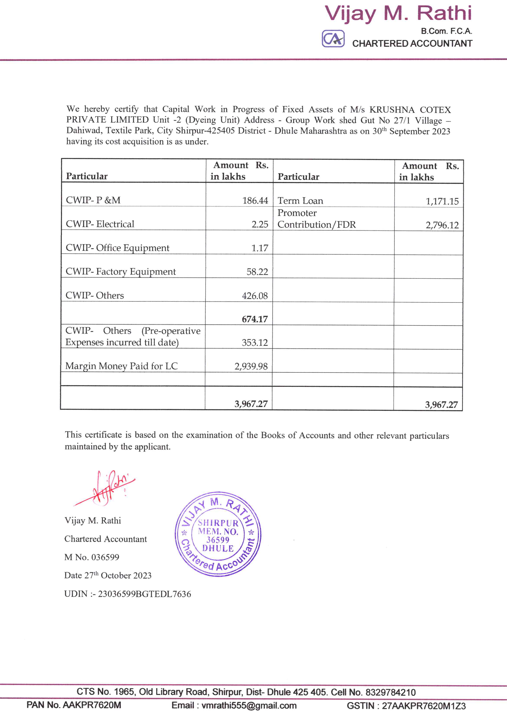

**OBSERVATIONS: -**

* The Total Cost incurred for the proposed project as per CA Certificate is Rs. 3,967.27 Lakhs.
* Company has provided the Ledger abstract for CWIP-P&M, Electrical, Office Equipment, Factory Equipment, Other and Other (Pre-operative Expenses incurred till date).
* Company has not provided the detail for Margin money paid for LC.

#### 4.4) SUMMARY OF TOTAL COST INCURRED TOWARDS PROJECT: -

Cost incurred towards Project Heat as per LIE is as under:-

|  |  |  |  |
| --- | --- | --- | --- |
| S. No | Particular of Project | Estimated Project Cost  (₹ in Crores) | Cost incurred till 30.09.2023  (₹ in Crores) |
| 1 | Buildings | 3.00 | 2.27 |
| 2 | Plant & Machinery | 130.38 | 33.26 |
| 3 | Other Fixed Asset | 19.35 | 0.62 |
| 4 | Preliminary/ Pre-Operative Expenses | 3.23 | 2.82 |
| 5 | Contingencies (5% of total cost excluding IDC and Promotors contribution for Working Capital | 7.80 | - |
| 6 | Interest During Construction (IDC) | 13.03 | 0.71 |
| 7 | Promotors contribution for Working Capital | 14.92 | - |
|  | **Total** | **191.71** | **39.67** |

**OBSERVATIONS: -**

* Proposed Factory Shed is under Construction.
* Foundation of Print Washer is 90% Completed and Pad Steam Machine is 70% Completed.
* The Major Cost incurred towards Plant & Machinery for Margine Money Paid for LC for Imported Machinery.
* Pad Steam Dyeing Range and Cold Pad Batch of Benninger make are arrived and Kept at site in packed condition.

1. **PHOTOGRAPHS**

|  |  |
| --- | --- |
|  |  |
|  |  |
|  |  |
|  |  |
|  |  |
|  |  |
|  |  |
|  |  |
|  |  |
|  |  |
|  |  |
|  |  |
|  |  |
|  |  |
|  |  |
|  |  |
|  |  |
|  |  |
|  |  |
|  |  |
|  |  |
|  |  |
|  |  |
|  |  |
|  |  |
|  |  |
|  |  |
|  |  |
|  |  |
|  |  |
|  |  |
|  |  |
|  |  |
|  |  |
|  |  |
|  |  |

1. **NOTES, LIMITATIONS, DISCLAIMERS & CAVEATS**

#### Notes, Limitations, Disclaimers & Caveats forms important part of the report.

* The Lender’s independent engineer report is made to review the progress of project activities and to prepare the detail report outlining all activities completed along with the status.
* Our Engineer has visited the project site of on 26.09.2023 with a view to ascertain and certify the quantity and amount of work progressively undertaken by the borrower.
* LIE progress report is based on the physical verification of the site on 26.09.2023, invoices provided, discussions held with the Directors of the Company and information and explanation given & documents provided. Accordingly, the percentage of work of completion of project activities is worked out. The photographs are enclosed.
* The Company has provided the necessary documents. LIE has referred the same for preparation of report.
* During the date and time of our visit to the project site, the execution of project activities like construction of Building, Foundation Work, Drainage and Road was going on and it can be clearly seen from the photographs enclosed.
* The Credit details in other bank accounts are not verified by us and we have relied on documents issued by the party.
* Our report does not cover verification of ownership, title clearance, or legality and subject to adequacy of engineering / structural design.
* Our report does not cover verification of ownership, title clearance, or legality and subject to adequacy of engineering / structural design. The report is delayed as compared with the visit date because of delay in receipt of documents.
* It should be noted that VCIPL’s project progress assessments are based upon the facts and evidence available at the time of assessment and the documents provided. The lenders should do the progress assessment from time to time.
* The legal documents pertaining to the ownership of the properties has been referred to on its face value and that is presumed that Bank /financer have got the same verified through its legal counsel. We do not certify the veracity of the documents. This report does not certify valid or legal or marketable title of any of the parties over the property. Our report does not cover verification of ownership, title clearance, or legality and subject to adequacy of engineering / structural design.
* Our report is only for the use of the party to whom it is addressed, and no responsibility is accepted to any third party for the whole or any part of its contents.
* It is presumed that the soft copies of documents are taken from the originals duly tested and verified at the party’s end.
* The progress report is made based on our visit, information furnished, discussions, documents made available at the time of visit. We presume optimistically that the project assessed by us will be a top success project. In case on a future date if the project does not come up to an expectation of the lenders and borrowers, due to various factors i.e., socio, economic and political factors in this region and country, any decrease in projections, profits, non-repayment of regular installments of loan and interest thereon, the VCIPL should not be held responsible on a future date. The market scenario in India at particular and the whole world at large is at volatile trend since last many months and future cannot be anticipated as of date.
* Our report should be read along with disclaimers. We have given our opinion as the percentage of work completion of the project as on date of visit to the project site.

1. **SUMMARY**

#### 7.1) WORK COMPLETION FOR THE PROJECT: -

Location wise the progress of the project is as under: -

| S. No. | Activities | % of Work Completion |
| --- | --- | --- |
|  | **Project Documentation** |  |
| 1 | Detailed Project Report | 100% |
|  | **Statutory Clearances** |  |
| 2 | Building Plan (initial approval) | 80% |
| 3 | Pollution Control Board - Consent to establish | 100% |
| 4 | Pollution Control Board - Consent to operate | 0% |
| 5 | Power Sanction | 100% |
| 6 | Insurance | 0% |
| 7 | Bank Loan Sanction | 100% |
| 8 | Disbursement – Term loan (Fund + non-Fund) | 6% |
| 9 | Environment Clearance | 0% |
| 10 | Boiler Certificate | 0% |
| 11 | Fire NOC |  |
| 12 | Factory License |  |
|  | **Site Setup** |  |
| 13 | Office setup at Site | 80% |
| 14 | Recruitment | Ongoing |
|  | **Leasehold Building** |  |
|  | **Existing Building** |  |
| 15 | Foundation | 100% |
| 16 | Flooring Work | 50% |
| 17 | Brick Work | 100% |
| 18 | Roof | 80% |
| 19 | Finishing | 80% |
|  | **Proposed Factory Building** |  |
| 20 | Foundation | 100% |
| 21 | Flooring Work | 0% |
| 22 | Brick Work | 0% |
| 23 | Roof | 0% |
| 24 | Finishing | 0% |
|  | **Sub Station** |  |
| 25 | Foundation | 20% |
| 26 | Flooring Work | 0% |
| 27 | Brick Work | 0% |
| 28 | Roof | 0% |
| 29 | Finishing | 0% |
|  | **Pump House** |  |
| 30 | Foundation | 20% |
| 31 | Flooring Work | 0% |
| 32 | Brick Work | 0% |
| 33 | Roof | 0% |
| 34 | Finishing | 0% |
|  | **Boiler House** |  |
| 35 | Foundation | 20% |
| 36 | Flooring Work | 0% |
| 37 | Brick Work | 0% |
| 38 | Roof | 0% |
| 39 | Finishing | 0% |
|  | **Imported Plant & Machinery** |  |
| 40 | Vendor Selection | 100% |
| 41 | Purchase Order/ Contract | 25% |
| 42 | Delivery | 17% |
| 43 | Erection | 0% |
| 44 | Installation | 0% |
| 45 | Electrification | 0% |
| 46 | Trials & Commissioning | 0% |
|  | **Indigenous Plant & Machinery** |  |
| 47 | Vendor Selection | 100% |
| 48 | Purchase Order/ Contract | 10% |
| 49 | Delivery | 0% |
| 50 | Erection | 0% |
| 51 | Installation | 0% |
| 52 | Electrification | 0% |
| 53 | Trials & Commissioning | 0% |
|  | **Other Fixed Asset** |  |
| 54 | Vendor Selection | 100% |
| 55 | Purchase Order/ Contract | 10% |
| 56 | Delivery | 0% |
| 57 | Erection | 0% |
| 58 | Installation | 0% |
| 59 | Electrification | 0% |
| 60 | Trials & Commissioning | 0% |
|  | **Electrical Fittings** |  |
| 61 | Vendor Selection | 100% |
| 62 | Purchase Order/ Contract | 0% |
| 63 | Delivery | 0% |
| 64 | Erection | 0% |
| 65 | Installation | 0% |
| 66 | Electrification | 0% |
| 67 | Trials & Commissioning | 0% |
|  | **Total Work Completed** | **15%** |

#### 7.2) DRAW DOWN SCHEDULE: -

The estimated draw down schedule is as under: -

**(Rs. in Crores)**

|  |  |  |
| --- | --- | --- |
| S. No. | Disbursement till | Total |
|  | Project Cost |  |
| 1 | 30.06.2022 | 95.00 |
| 2 | 30.09.2022 | 7.27 |
| 3 | 31.03.2023 | 8.00 |
| 4 | 31.03.2024 | 12.73 |
|  | **Total** | **54.27** |

**OBSERVATIONS: -**

* Company has not provided the revised Draw Down Schedule.

1. **OPINION**

Based on the physical inspection and verification of project site, information and explanation given to us and the documents referred by us; we are of the opinion that the progress of proposed processing and made ups Unit with approx. 60 000 meters/day fabric processing and 5,000 sets/day sheeting sets facility at Gat No. 27, Village-Dahiwad, Taluka-Shipur, District Dhule, PIN Code-425 405, State- Maharashtra, County-India belonging to **M/s. Krushna Cotex Private Limited** is 15 % completed as per our information provided by the party, observation made during LIE 1st visit to the project site on 26.09.2023 subject to observations made in the main report.

**Date:-22.11.2023**

**Place:- Mumbai**

**For Vastukala Consultants (I) Pvt. Ltd.**

|  |
| --- |
| **Umang A Patel** |
| **Registered Valuer**  **Chartered Engineer (India)**  **Reg. No. IBBI/RV/04/2019/10803** |