Vastu/Nashik/11/2023/005149/2303572
21/15-268-CCBS
Date: 21.11.2023

To,
The Branch Manager,
Punjab National Bank

Canada Corner Branch

Shop No.2,3,4 Prestige Point, Opp. Vasant Market, Canada Corner
Nashik – 422 005, State – Maharashtra, Country – India.

Sub: Vetting of Extra Work Amenities

Sir,

With reference to above subject, we have evaluated the Extra Work Amenities for Residential Flat No. 602, Sixth Floor, " Nilkanth Heights Apartment ", Survey No.324/2A/1/2/2B, Plot No.26+27+28, Near Gajanan Garden, Prashant Nagar, Pathardi Phata, Village – Pathardi, Taluka & District - Nashik, PIN Code – 422 010, State – Maharashtra, Country – India belongs to Mr.Pradip Sukhdev Shejul

We have verified the rates quoted as per current market rates. Details of Extra Work Amenities considered as per copy of Extra Work Amenities Agreement between Mr.Pradip Sukhdev Shejul (Claiming Party ) M/s.Vinayak Infra to Partner Mr.Ashokbhai Batukbhai Aadroja (Executing Party) received on dated 09.11.2023. The Extra Work Amenities Agreement amount is Rs. 2,80,000/- (Rupees Two Lakh Eighty Thousand Only.)

Note:1) The said Cost Vetting Certificate is valid upto next 6 months Only.

Thanking you

Sincerely yours

Sharadkumar B. Chalikwar
Govt. Reg. Valuer
Chartered Engineer (India)
Reg. No. (N) CCIT/1-14/52/2008-09
PNB Empanelment No. ZO:SAMD:1138
Encl: Vetting report

Extra Amenities Work Notarized Agreement

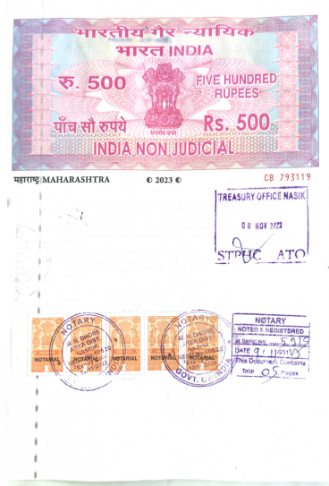
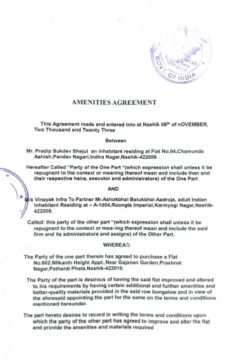

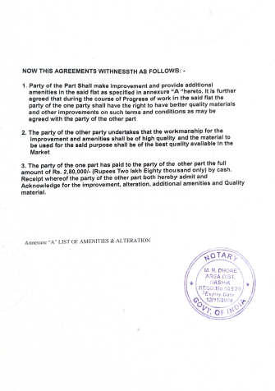
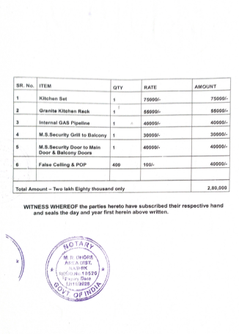

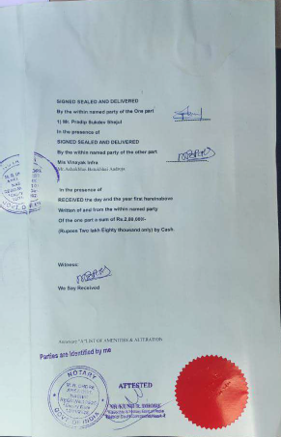

The Extra Work Amenities Agreement amount is Rs. 2,80,000/- (Rupees Two Lakh Eighty Thousand Only.)

