Valuation Report of the Immovable Property
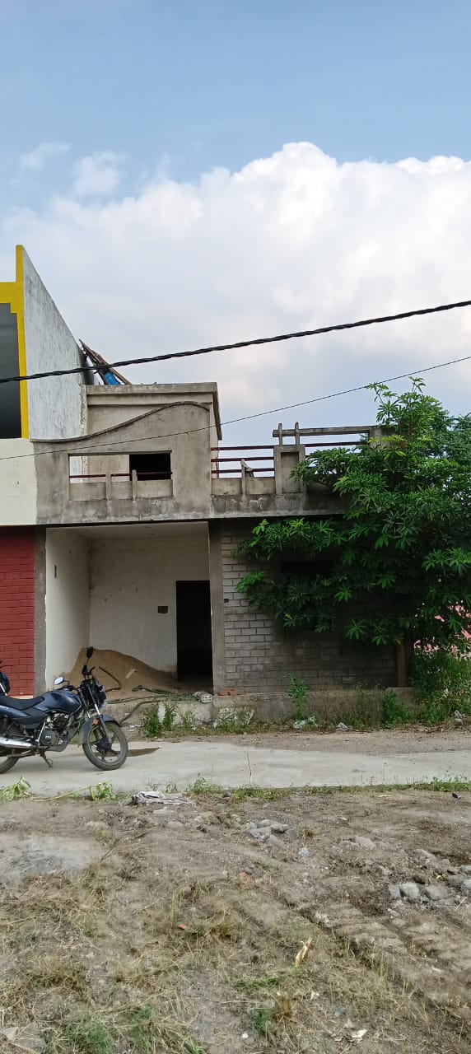

Details of the property under consideration:

Name of Owner: Shri. Hemant Lunawat S/o Shri. Narendra Lunawat

Residential House on Plot No. B-125, “Shri Adinath Avenue”, Narayan Road,
Gram Tajpura, Tehsil Mahidpur, District Ujjain, PIN – 456 443,
State – Madhya Pradesh, Country – India

Latitude Longitude - 23°28’44.5”N 75°39’13.8”E

Valuation Done for:

MAS FINANCIAL SERVICE LTD
(M.P. / CG )- Agriculture & Fes Business (Sme Loan & Lap)
Princess business sky park, Opposite C21 Mall, Indore, PIN – 452 011,
State – Madhya Pradesh, Country – India

Vastu/Indore/11/2023/31110/2300782
09/11-393-BSA
Date: 25.05.2023

VALUATION OPINION REPORT

The Property bearing Residential House on Plot No. B-125, “Shri Adinath Avenue”, Narayan Road, Gram Tajpura, Tehsil Mahidpur, District Ujjain, PIN – 456 443, State – Madhya Pradesh, Country – India belongs to Shri. Hemant Lunawat S/o Shri. Narendra Lunawat.

Boundaries of the property:
Boundaries | :
North | : | Other House
South | : | Open Plot
East | : | Other Plot
West | : | Colony Road

Considering various parameters recorded herein above, existing economic scenario, and the information that is available with reference to the development of neighborhood and method selected for valuation, we are of the opinion that, the property premises can be assessed and valued for this particular purpose as follows -

Particulars | : | Full Value after completion  (`) (A + B1) | Proportionate Value as on Today (`)  (A + B2)
Fair Market Value | : | 27,60,000/- | 24,15,000/-
Realizable Value | : | 24,84,000/- | 21,73,500/-
Distress Sale Value | : | 22,08,000/- | 19,32,000/-

The valuation of the property is based on the documents produced by the concern. Legal aspects have not been taken into considerations while preparing this valuation report.

Hence certified

Manoj B. Chalikwar

Registered Valuer

Chartered Engineer (India)

Reg. No. IBBI / RV / 07/2018/10366
Reg. No. CAT-I-F-1763
Encl: Valuation report

VALUATION REPORT IN RESPECT OF IMMOVABLE PROPERTY

1. | Date of Inspection | : | 20.04.2023
2. | Purpose of valuation | : | As per request from Bank of Maharashtra, Annapurna Indore Branch to assess Fair Market Value of the property under reference for Banking purpose.
3. | Name and address of the Valuer. | : | Sharadkumar B. Chalikwar  Vastukala Consultants (I) Pvt. Ltd.  106, 1st Floor, Gold Star Tower, Opp. Treasure Island Mall, M.G. Road, Indore – 452 001
4. | Copy Of Documents Handed Over to The Valuer by The Bank | : | - Sale Deed E- Registration No. MP43202220A1065010 Dated 25.01.2020 between Shri. Dilip Malviya S/o Shri. Babulal Malviya (the Seller) AND Shri. Hemant Lunawat S/o Shri. Narendra Lunawat (the Purchaser).  - Approved Plan No. Pancha/Q/2023 dated 07.10.2023 issued by Gram Panchayat Bhimakheda, Singed by Sarpanch & Sachiv.
5. | Details of enquiries made/ visited to govt. Offices for arriving fair market value. | : | Market analysis and as per sub-registrar value.
6. | Factors for determining its market value. | : | Location, development of surrounding area, facilities provided and its prevailing market rate.
7. | Any Critical Aspects Associated with Property | : | No
8. | Present/Expected Income from the property | : | N.A.
 | Property Details: | :
9. | Name(s) of the Owner and Postal address of the property under consideration. | : | Shri. Hemant Lunawat S/o Shri. Narendra Lunawat
 |  | : | Residential House on Plot No. B-125, “Shri Adinath Avenue”, Narayan Road, Gram Tajpura, Tehsil Mahidpur, District Ujjain, PIN – 456 443, State – Madhya Pradesh, Country – India.  Contact Person:  Mr. Hemant Lunawat (Owner)  Contact No. +91 98270 93132
10. | If the property is under joint ownership/ co-ownership share of each such owner/ are the share is undivided. | : | Sole Ownership
11. | Brief description of the property:  The immovable property comprising of freehold Residential Land and building thereof. The property is located in a developed area having basic infrastructure, well connected by road and train. It is located at 20.2 KM. travelling distance from Mahidpur Junction Railway station.  Land:  As per diversion order, the land area is 85.50 Sq. M. i.e. 920.00 Sq. Ft., which is considered for valuation.  Structure:  The property consists of under construction Commercial building of Ground floors. It is a R.C.C. Framed Structure with RCC beams, columns, slabs and RCC staircase is proposed for access to the upper floors.  At present, the building is under construction. The work completion status is as below –  The composition of the building as per Site inspection is as below -  As per site inspection, Total Built up Area is as below.  The composition of the building as per Approved Plan is as below -  As per approved plan, the area statement is as below.
  RCC Footing / Foundation | Completed | RCC Plinth | Completed
  RCC Work | Completed | Internal Brick Work | Completed
  External Brick Work | Completed | Internal plastering | Completed
  External plastering | Completed | Passage, Staircase & Lobby development | Completed
  Total Work Completed | 75%
  Floor | Composition
  Ground | Kitchen + Hall + 2 Room + Wash Area + Toilet
  Particulars | Sq. Ft.
  Ground Floor | 5,031.00
  First Floor | 4,250.00
  Second Floor | 2,855.00
  Total Area | 12,136.00
  Floor | Composition
  Ground | Kitchen + Porch + 2 Room + 2 Toilet
  Particulars | i.e. in Sq. Ft.
  Total Plot Area | 920.00
  Proposed BUA on Ground Floor | 920.00
12. | Location of the property. (C.T.S. No., Survey No., Hissa No., Plot No., etc.). | : | Survey No. 126/1 EEE /3,
13. | Boundaries of the property | : | As per Actual at Site |  | As per Sale Deed
13. | North | : | Other House |  | Plot No. 126
13. | South | : | Open Plot |  | Plot No. 124
13. | East | : | Other Plot |  | Boundary
13. | West | : | Colony Road |  | Colony Road
14. | Route map | : | Enclosed
15. | Any specific identification marks | : | Nearby Dhanlaxmi Honda
16. | Whether covered under Corporation/ Panchayat/ Municipality. | : | Nagar Palika Nigam Mahidpur
17. | Whether covered under any land ceiling of State/ Central Government. | : | No
18. | Is the land freehold/ leasehold? | : | Freehold
19. | Are there any restrictive covenants in regard to use of Land? If so attach a copy of the covenant. | : | -
20. | Type of the property- Whether | :
 | Residential | : | No
 | Industrial | : | No
 | Commercial | : | Yes
 | Institutional | : | No
 | Government | : | No
 | Non – Government | : | No
 | Other (Specify) | : | N.A.
21. | In case of Agricultural land
 | Any conversion to House site is obtained | : | N.A.
 | Whether the land is dry or wet. | : | N.A.
 | Availability of irrigation facilities | : | N.A.
 | Type of crops grown | : | N.A.
 | Annual yield or income. | : | N.A.
22. | Year of acquisition/ purchase. | : | Sale Deed E- Registration No. MP43202220A1065010 Dated 25.01.2020
23. | Whether the property is occupied by owner or tenant. If occupied by tenant since how long he is staying, and the amount of rent being paid. | : | Under Construction Building
24. | Classification of the site. | :
 | a. Population group. | : | Urban
 | b. High/ Middle/ Poor class | : | Middle class
 | c. Residential/ nonresidential. | : | Non-residential
 | d. Development of surrounding area. | : | Developed
 | e. Possibility of any threat to the property. (Floods, calamities etc.). | : | No
25. | Proximity of civic amenities.  (Like school, hospital, bus stop, market etc.). | : | All available nearby
26. | Level of the land (Plain, rock etc.) | : | Plain
27. | Terrain of the Land. | : | Leveled
28. | Shape of the land (Square/ rectangle etc.). | : | Irregular
29. | Type of use to which it can be put (for construction of house, factory etc.). | : | Commercial
30. | Any usage restrictions on the property. | : | No.
31. | Whether the plot is under town planning approved layout? | : | Yes
32. | Whether the building is intermittent or corner? | : | Corner
33. | Whether any road facility is available? | : | Yes
34. | Type of road available (B.T. / Cement Road etc.). | : | Kacha Road
35. | Front Width of the Road? | : | More than 20 ft.
36. | Source of water & water potentiality. | : | Good
37. | Type of Sewerage System. | : | Connected to Municipal Sewerage System
38. | Availability of power supply. | : | Yes
39. | Advantages of the site. | : | Located in developed Commercial area
40. | Disadvantages of the site. | : | No
41. | Give instances of sales of immovable property in the locality on a separate sheet, indicating the name & address of the property, registration No. sale price and area of land sold. | : | As per Sub-Registrar of Assurance records
 | Valuation of the property:
42. | 1) Dimensions of the plot | : | -
43. | 2) Total area of the plot | : | 920.00 Sq. Ft.  (As Per Diversion Order)
44. | 3) Prevailing Market Rate/Price trend of the Property in the locality/city from property search sites viz magickbricks.com, 99acres.com, makaan.com etc. if available | : | ` 1,000/- to ` 2,000/- per Sq. Ft. for Residential Land
45. | 4) Government Rate obtained from the online government records of Land | : | ` 7,200/- per Sq. M.  i.e., ` 669/- per Sq. Ft.
46. | Building |  | ` 1,500/- per Sq. Ft. on Built-up Area
B) Structure

Floor |  | Built-up Area | Year Of Const. | Total Life of Structure | Replacement Rate | Full Value after completion | Work Completed | Proportionate value as on date
 |  | (Sq. Ft.) |  | (Yrs.) | (`) | (`) (B1) | % | (`) (B2)
Residential |  | 920.00 | Under Construction | 60 | 1,500/- | 13,80,000/- | 75 | 10,35,000/-
 | Total |  |  |  |  | 13,80,000/- |  | 10,35,000/-

47. | - Government Value
 | Particulars | : | Area in Sq. Ft. | Rate in ` |  | Value in `
 | Plot | : | 920.00 | 669/- |  | 40,14,000/-
 | Structure |  | As per valuation table |  |  | 13,80,000/-
 | Total |  |  |  |  | 2,22,18,000/-
 | 5) Assessed/ adopted rate of valuation. |  | ` 1,500.00 per Sq. Ft. for Residential Land
48. | - Fair Market Value
 | Particulars | : | Area in Sq. Ft. | Rate in ` |  | Value in `
 | Full Value after completion
 | A) Plot |  | 920.00 | 1,500/- |  | 13,80,000/-
 | B1) Building |  | As per valuation table |  |  | 13,80,000/-
 | Total Full Value (A + B1) |  |  |  |  | 27,60,000/-
 | Proportionate Value as on today
 | A) Plot |  | 920.00 | 1,500/- |  | 13,80,000/-
 | B2) Building |  | As per valuation table |  |  | 10,35,000/-
 | Total Proportionate Value (A+B2) |  |  |  |  | 24,15,000/-
 | a. Technical details of the Plot:
49. | Type of Plot (Residential/ Commercial/ Industrial). | : | Residential Land
50. | Year of construction. | : | The building is under construction.
51. | Future life of the property. | : | Future Life – 60 Years (After completion) subject to proper, preventive periodic maintenance & structural Repairs.
52. | No. of floors and height of each floor including basement. | : | Ground floors
53. | Plinth area of each floor | : | As per approved plan, the area statement is as below.
  Particulars | i.e. in Sq. Ft.
  Total Plot Area | 920.00
  Proposed BUA on Ground Floor | 920.00
54. | Type of construction.  (Load bearing/ R.C.C. / Steel framed). |  | RCC framed structure
 | Condition of the building. | :
55. | External (excellent/ good/ normal/ poor). | : | N.A., the building is under construction
56. | Internal (excellent/ good/ normal/ poor). | : | N.A., the building is under construction
 | Remarks: | :
57. | b. Specifications of Construction:
 | Foundation. | : | R.C.C
 | Basement. | : | N.A.
 | Superstructure. | : | R.C.C. frame work with 9" thick B. B. Masonry for external walls. 6" Thk. B.B. Masonry for internal walls
 | Joinery/ Doors & Windows. | : | Existing for ground floor and proposed for 1st to 2nd floor - Wooden framed glass openable type windows, Teak Wood door frames with solid flush shutters
 | RCC work. | : | Footings, Columns, Beams, Slab
 | Plastering. | : | Existing for ground floor and proposed for 1st to 2nd floor - Cement plastering
 | Flooring, Skirting. | : | Existing for ground floor and proposed for 1st to 2nd floor – Vitrified tiles flooring
 | Kitchen Pantry Platform | : | No
 | Whether any weather proof course is provided. | : | R.C.C. Slab
 | Drainage. | : | Connected to Municipal Sewerage System
 | Compound wall (Height, length and type of construction). | : | R.C.C
 | Electric installation (Type of wire, Class of fittings) | : | Existing for ground floor and Proposed for 1st to 2nd floor -Concealed wiring
 | Plumbing installation (No. of water closets & wash basins etc.) | : | Existing for ground floor and Proposed for 1st to 2nd floor - Concealed plumbing
 | Bore well. | : | No
 | Wardrobes, if any. | : | No
 | Development of open area | : | Yes

 | Summary of Valuation | : | Full Value after completion  (`) (A + B1) | Proportionate Value as on Today (`)  (A + B2)
 | Total Value of the Property | : | ` 27,60,000/- | ` 24,15,000/-
 | Realizable Value | : | ` 24,84,000/- | `21,73,500/-
 | Forced/ Distress Sale value. | : | ` 22,08,000/- | `19,32,000/-
 | Insurable value of the property  (Full Replacement Cost (13,80,000/-) – Subsoil structure cost (15%) | : | ` 11,73,000 /-
 | Remarks
1,

Justification for price /rate
The Market Value of the property is based on facts of markets discovered by us during our enquiries, however the government rate value in this case is less than the market value arrived by us. We are of the opinion that the value arrive by us will prove to be correct if an Auction of the subject property is carried out. As far as Market Value in Index II is concerned, it is not possible to comment on same, may be government rates are fixed by sampling during same point of time in part and whereas, Market values change every month.
In most of the cases the actual deal amount or Transaction value is not reflected in Index II because of various Market practices. As Valuer, we always try to give a value which is correct reflection of actual transaction value irrespective of any factors in market.

Actual site photographs
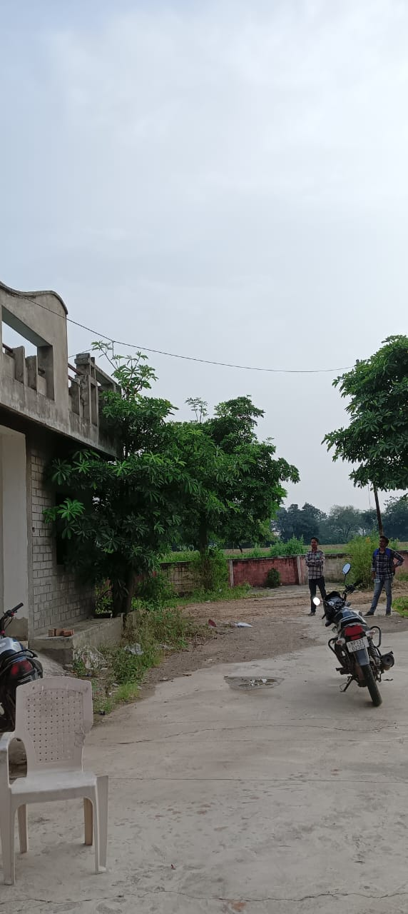
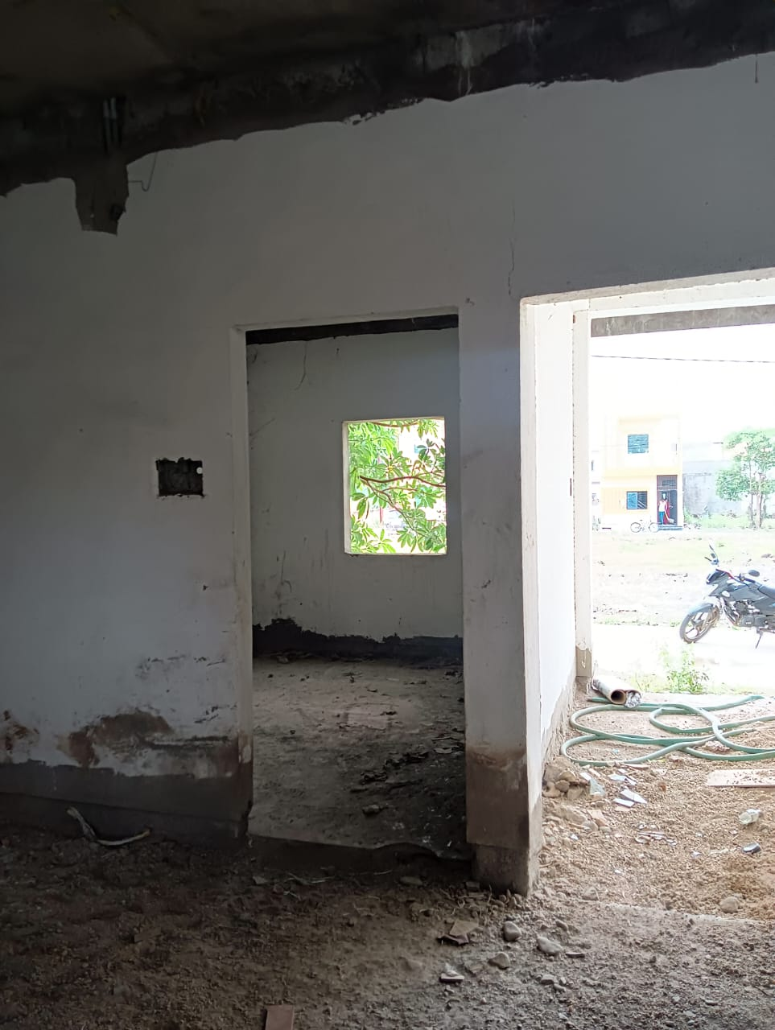
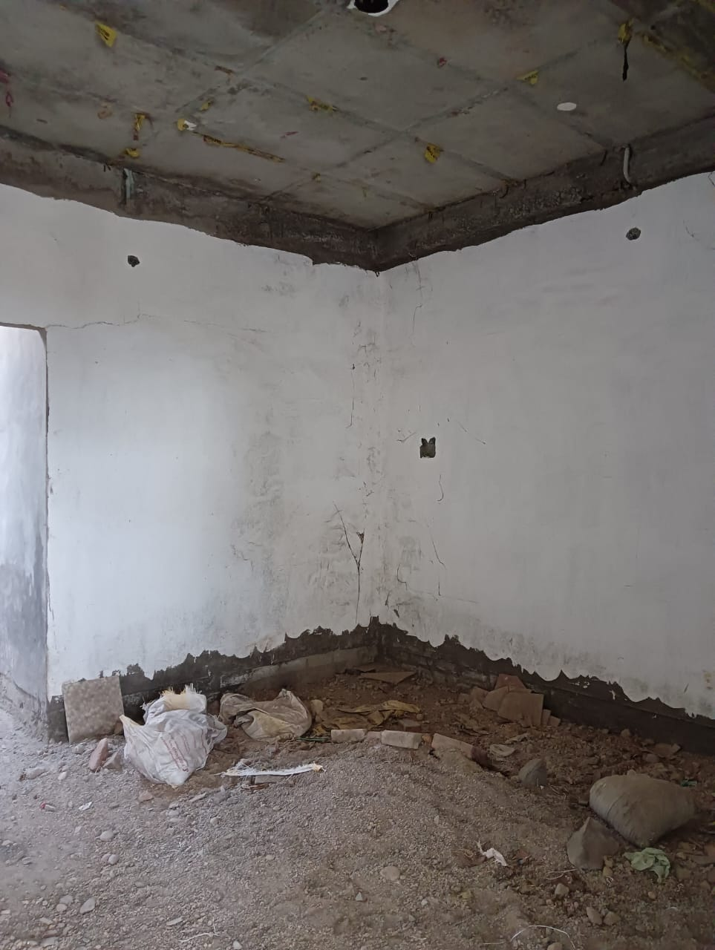
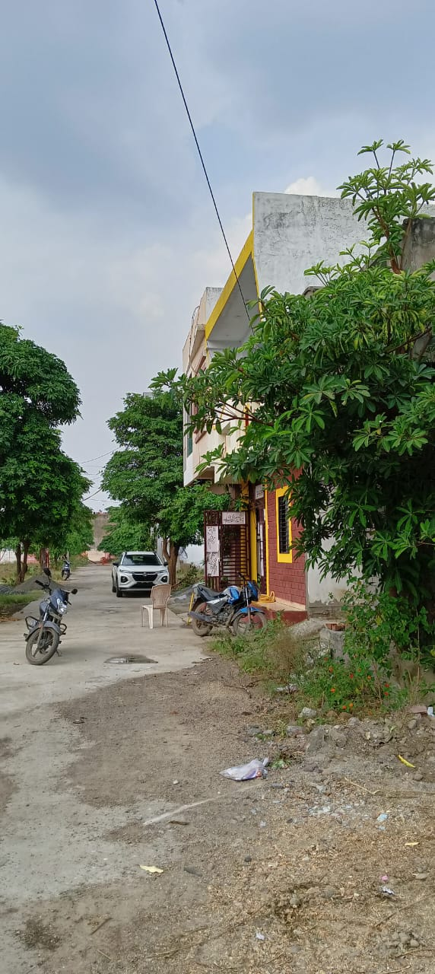

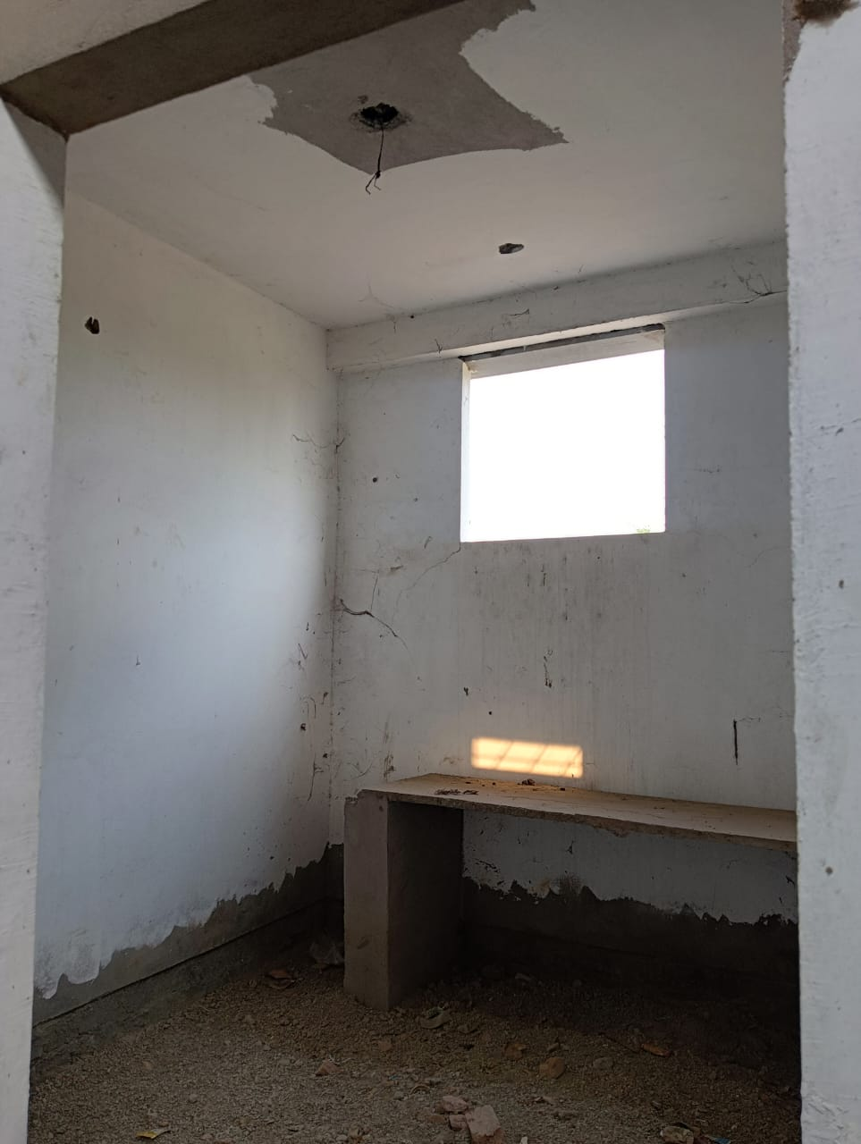
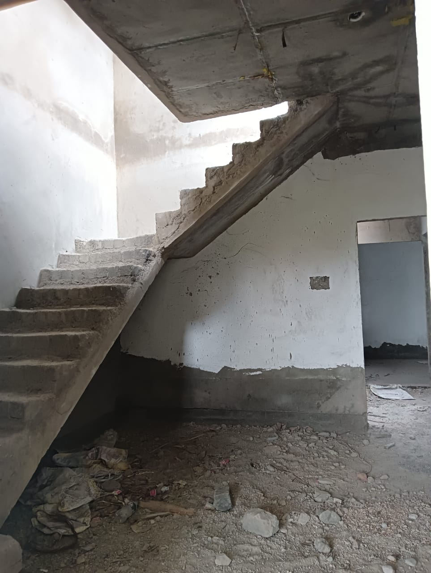
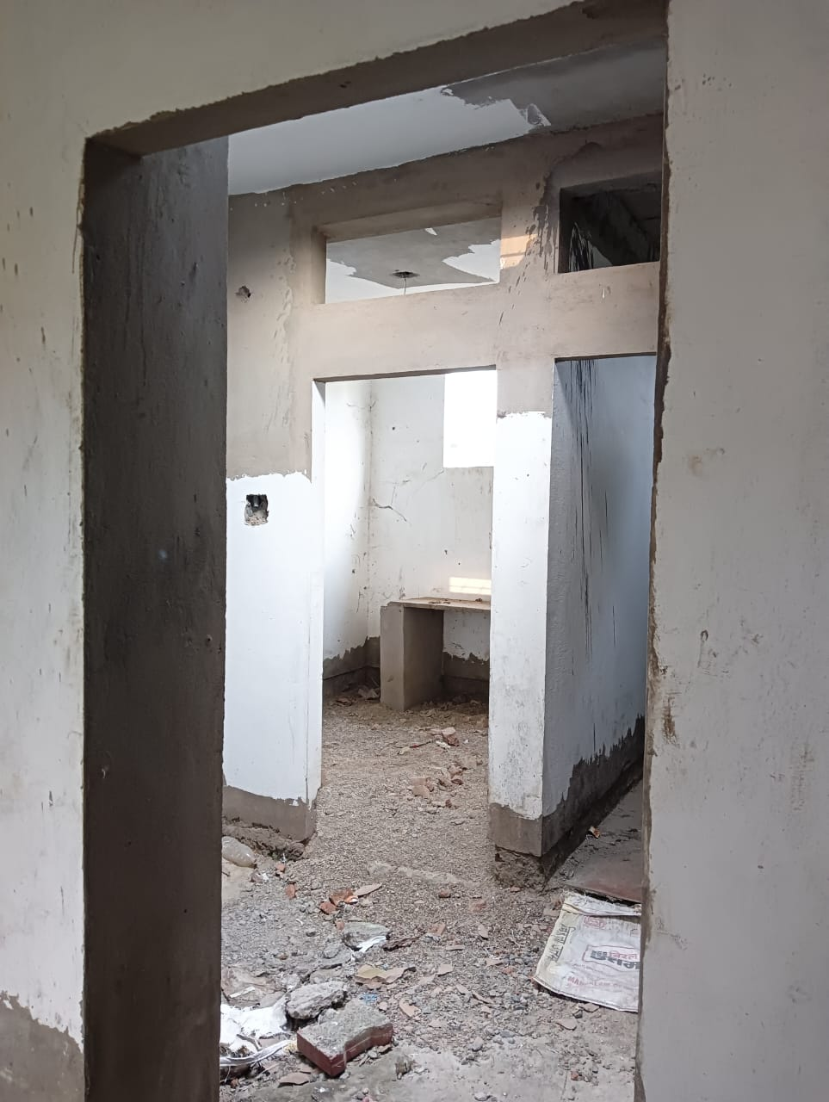

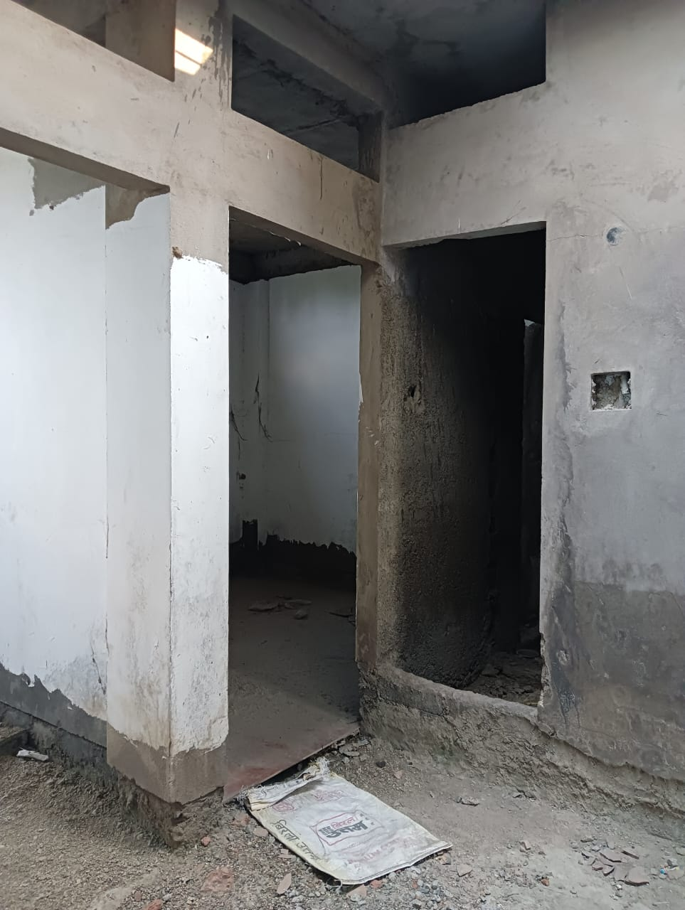


Route Map of the property
Site u/r
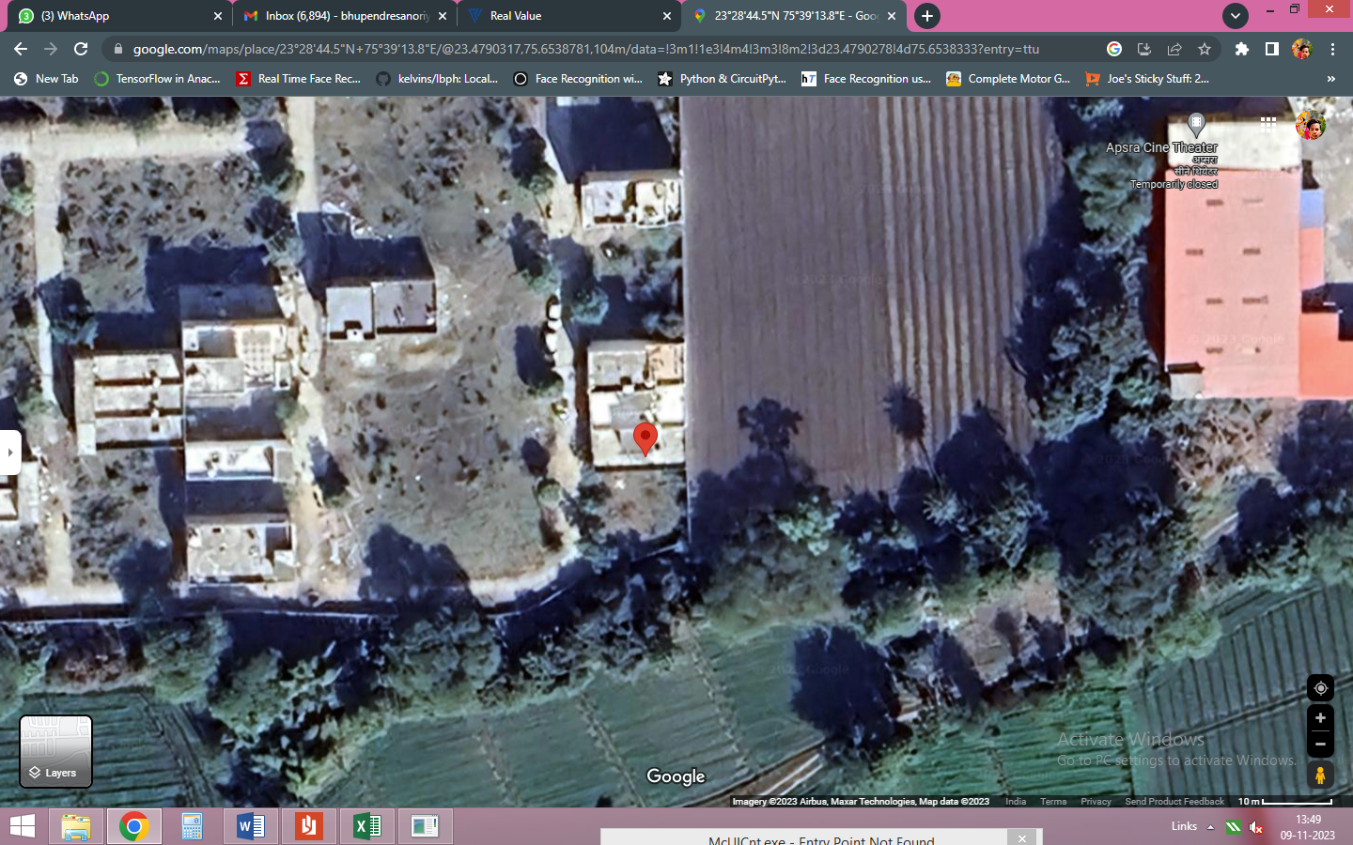

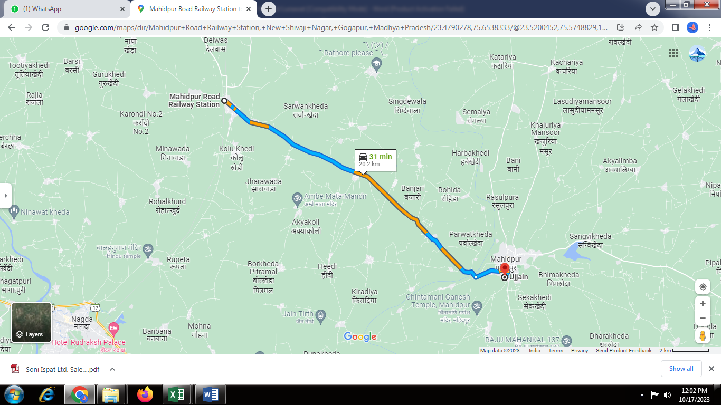

Latitude Longitude - 23°28’44.5”N 75°39’13.8”E
Note: The Blue line shows the route to site from nearest railway station (Mahidpur– 20.2 KM.)

Government Guideline Rate
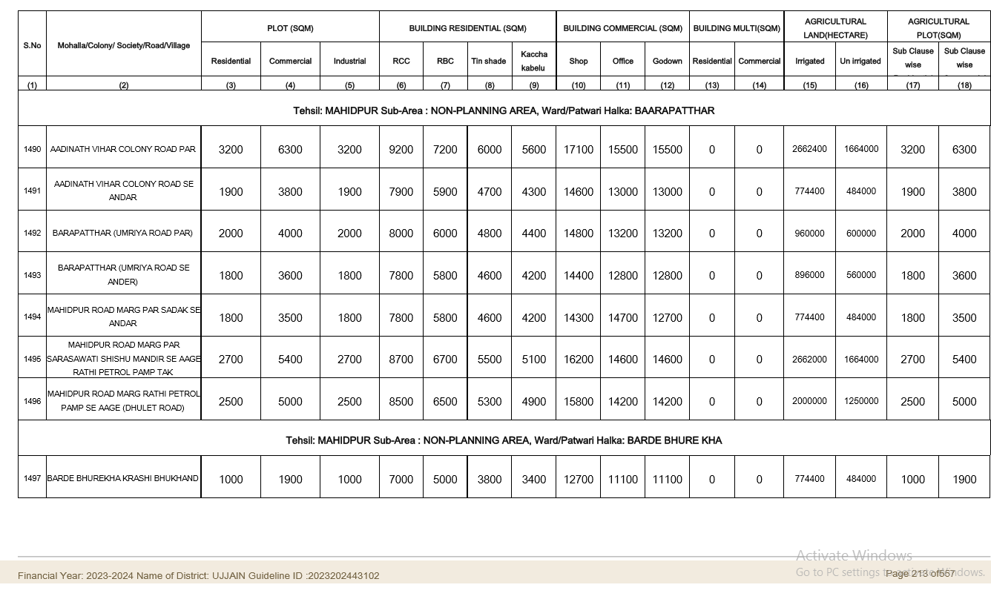

Price Indicator
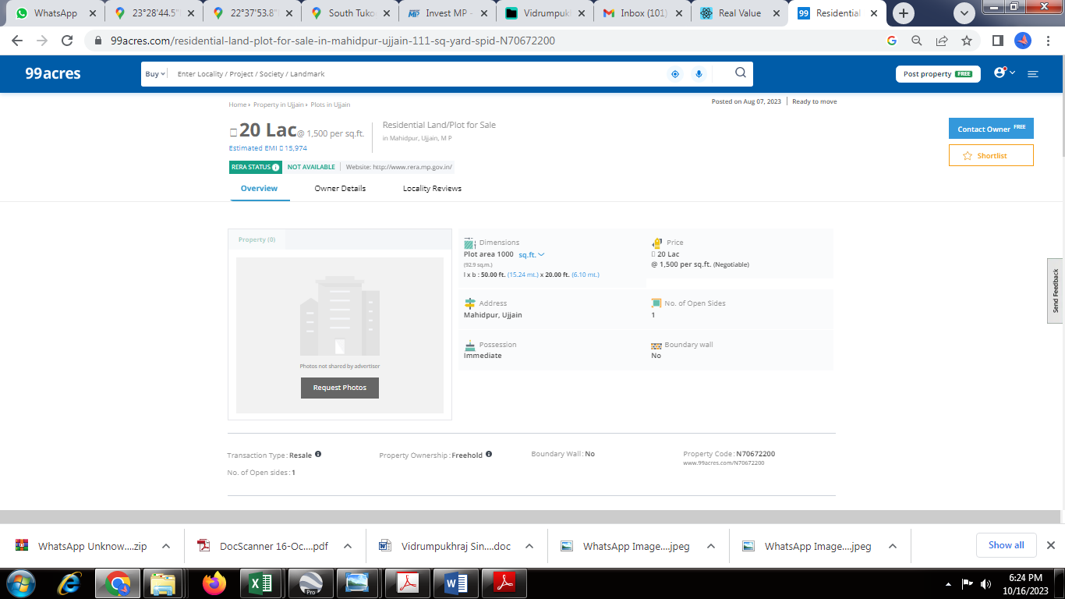

DEFINITION OF VALUE FOR THIS SPECIFIC PURPOSE

This exercise is to assess Fair Market Value of the property under reference for purpose as on 25th November 2023.

The term Fair Market Value is defined as

"The most probable price, as of a specified date, in cash, terms equivalent to cash, or in other precisely revealed terms for which the specified property rights would sell after reasonable exposure in a competitive market under all conditions requisite to a fair sale, with the buyer and seller each acting prudently knowledgeably and for self-interest assuming that neither is under undue duress"

Fundamental assumptions and conditions presumed in this definition are:

- Buyer and seller are motivated by self-interest.

- Buyer and seller are well informed and are acting prudently.

- The property is exposed for a reasonable time on the open market.

- Payment is made in cash or equivalent or in specified financing terms.

ASSUMPTIONS, CAVEATS, LIMITATION AND DISCLAIMERS
- We assume no responsibility for matters of legal nature affecting the property appraised or the title thereto, nor do we render our opinion as to the title, which is assumed to be good and marketable.
- The property is valued as though under responsible ownership.
- It is assumed that there are no hidden or unapparent conditions of the subsoil or structure that would render it more or less valuable. No responsibility is assumed for such conditions or for engineering that might be required to discover such factors.
- There is no direct/ indirect interest in the property valued.
- The rates for valuation of the property are in accordance with the Govt. approved rates and prevailing market rates.

Manoj B. Chalikwar

Registered Valuer

Chartered Engineer (India)

Reg. No. IBBI / RV / 07/2018/10366
Reg. No. CAT-I-F-1763

Encl: Valuation report

