Valuation Report of Vehicle
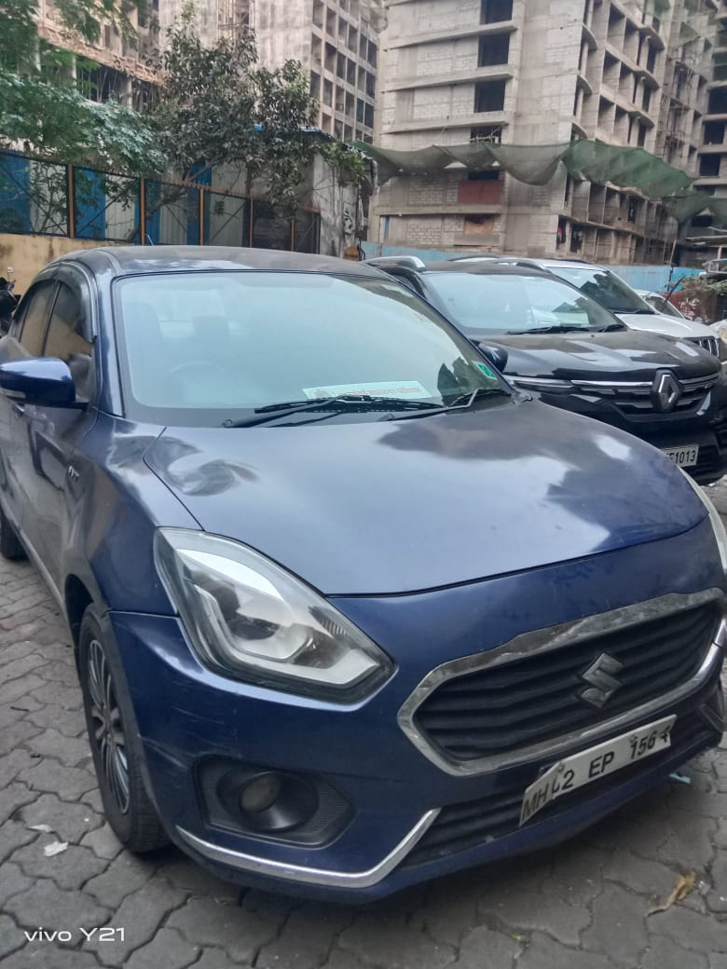

Details of the property under consideration:
Name of Owner: Mr. Mukesh Vaikunthlal Mehta
Vehicle inspected at Jai Laxmi Complex, Gamdevi Road, Gamdevi, Gamdevi Road, Damodar Park, Ghatkopar (West), Mumbai – 400 086, State- Maharashtra, Country- India.

Valuation Done for:

Bank of India
Vileparle west Branch

377, Smit Kiran Building, S.V. Road, Vileparle (West), Mumbai – 400056, State -Maharashtra, Country – India.

Vastukala Consultants (I) Pvt. Ltd.
Mumbai • Delhi NCR • Indore • Aurangabad • Nanded
Raipur • Jaipur • Ahmedabad • Rajkot • Thane • Nashik
INDEX
Contents Page No.
1. Valuation Report of Vehicle 1
1. VALUATION OPINION REPORT 3
2. VALUATION REPORT [IN RESPECT OF VEHICLE] 4
3. VALUATION RATIONALE 6
4. DOCUMENTS REFERRED: - 10
5. VALUATION 10
6. DECLARATION 11
7. UNDERTAKING 12
8. PHOTOGRAPHS 13
9. ASSUMPTIONS, CAVEATS, LIMITATION AND DISCLAIMERS 16
10. DEFINITION OF VALUE FOR THIS SPECIFIC PURPOSE 18
11. VALUATION OF VEHICLE 19

Vastu/Mumbai /11/2023/5022/2303538
20/3-234-APU
Date: 20.11.2023

VALUATION OPINION REPORT
This is to certify that the Vehicle inspected at Vehicle inspected at Jai Laxmi Complex, Gamdevi Road, Gamdevi, Gamdevi Road, Damodar Park, Ghatkopar (West), Mumbai – 400 086, State- Maharashtra, Country- India belongs to Mr. Mukesh Vaikunthlal Mehta. (As per RC Book).
Considering various parameters recorded, existing economic scenario, and the information that is available with reference to the industrial scenario and method selected for valuation, we are of the opinion that, the assets can be assessed and valued for particular purpose at:
Particulars | Fair Market Value in (Rs.) | Realizable Value in (Rs.) | Distress Sale Value (Rs.)
Vehicle  (Maruti Dzire ZXI / AGS / Maruti Dzire ZXI + AMT)  Reg. No. MH02EP1564 | 4,75,000 | 4,04,000 | 3,33,000
Hence certified.
For Vastukala Consultants (I) Pvt. Ltd.

Umang Ashwin Patel
Regd. Valuer
Chartered Engineer (India)
Reg. No. IBBI/RV/04/2019/10803

VALUATION REPORT [IN RESPECT OF VEHICLE]
To,
The Branch Manager,
Bank of India
Vileparle west Branch
377, Smit Kiran Building, S.V. Road, Vileparle (West), Mumbai – 400056, State -Maharashtra, Country – India.
- GENERAL INFORMATION:
1. | Borrower’s Name and Address | : | Mr. Mukesh Vaikunthlal Mehta.  Address.: A-102, 1st Floor, Zee Tulsi Niwas Co-Op. Hsg. Soc. Ltd.", Dadabhai Cross Road No. 3, Near Flyover, Vile Parle (West), Mumbai – 400 056, State- Maharashtra, Country- India
2. | Purpose for which valuation is made | : | To ascertain the Present Fair Market Value for Banking Purpose
3. | a) Date on which Inspection is made | : | 16.11.2023
3. | b) Date of Report | : | 17.11.2023
4. | Name of the owner/(s) | : | Mr. Mukesh Vaikunthlal Mehta.  (As per RC Book)
5. | Nature of Vehicle valued (Make)  Type of Vehicle (e.g.)  {Motor Cycle, Scooters, Three Wheelers, Motor Cars, Buses, Lorries, Tractors} | : | Light Motor Vehicle– (Maruti Dzire ZXI / AGS / Maruti Dzire ZXI + AMT) Reg. No. MH02EP1564  Body type: RIGID (Passenger Car)  No. of Cylinder: 04  No. of Tyres: 04  Seating Capacity: 05 (including driver).
6. | Details of the LMV Vehicle valued. | :
a. | Year of Manufacture |  | 05/2017
b. | Registration No. & Date |  | Reg. No. MH02EP1564 Dated: 02.06.2017
c. | Chassis No. of Vehicle |  | MA3CZF63SHE104838
d. | Engine No. |  | K12MN1985560
e. | CC |  | 1197 CC
f. | Unladen Weight |  | 895 Kg
g. | Laden Weight |  | 1315 Kg
h. | Model |  | Maruti Dzire ZXI / AGS / Maruti Dzire ZXI + AMT
i. | Colour |  | Prme Oxford Blue
j. | Fuel used |  | Petrol
k. | Emission norms |  | Bharat Stage IV
7. | Details about the Vehicle purchased.
7. | Date of Purchase |  | Details not Available
7. | Purchase Value |  | Details not Available
7. | Name of the Supplier |  | Details not Available
8. | Whether a second-hand vehicle or new Vehicle? | : | The Vehicle is Second hand and registered as on 02.06.2017.
9. | What is the condition of Vehicle? | : | Good
10. | - Tyres |  | Good Condition
10. | - Doors (with or without dent) |  | Good Condition
10. | - Colour |  | Good Condition
10. | - Glasses |  | Good Condition
10. | - Battery |  | Good Condition
10. | - Any other Damages |  | Minor dent on body.
10. | - Body |  | The body of Vehicle is in good condition.
10. | Accessories attached to the vehicle | : | As per standard fitting
11. | Odometer Reading | : | 46392 KM
12. | Whether any damage is done to the Vehicle? If serious damage gives details with approx. depreciation for the same in valuation. | : | No serious damages observed
13. | IDV as on the date of valuation. | : | Details Not Available
14. | Place where the Vehicle is valued? | : | Jai Laxmi Complex, Gamdevi Road, Gamdevi, Gamdevi Road, Damodar Park, Ghatkopar (West), Mumbai – 400 086, State- Maharashtra, Country- India.
15. | Name of the owner in case of second Vehicle? | : | Not applicable
16. | Whether R.C. Book is verified regarding any previous hypothecation charge (Financer) on the vehicle? | : | Details not provided
17. | Whether Vehicle is properly Vehicle?  Name of the Insurance Company  Policy No.  Valid up to  Type of Cover | : | Party has provided Insurance policy which was expired on 27.10.2022.
18. | Single user or Multiple User | : | Single user
19. | Estimated life of vehicle | : | Estimated balance life of this type of private vehicle is 9 Yrs. subject to proper maintenance and servicing of the vehicle.
20. | Method of Valuation |  | Market Comparison Method is used for Calculation FMV on the basis of following factors: -  - On Road Price  - Sale Instance  - Visual observation  - Condition of the vehicle  - Age of the vehicle  - Current mileage vehicle travelled.

VALUATION RATIONALE

3.1 Methodologies

3.1.1 Market Approach
As per Ind AS 113: Appendix A, it is defined as a valuation technique that uses prices and other relevant information generated by market transactions involving identical or comparable (i.e. similar) assets, liabilities or a group of assets and liabilities.
In order to compare the subject of the valuation with the price of the other tangible asset interests, Valuers adopt generally accepted and appropriate units of comparison that are considered by participants, dependent upon the type of asset being valued.
As per IVS 400 differences that should be considered in valuing tangible asset interests include, but are not limited to:
- The type of interest providing the price evidence and the type of interest being valued,
- The respective locations,
- The respective configuration,
- The circumstances under which the price was determined, and the basis of value required,
- The effective date of the price evidence and the valuation date, and market conditions at the time of the relevant transactions and how they differ from conditions at the valuation date.
Direct Sales Comparison Method is the most common method under the Market Approach for Plant and Machinery Valuation. The basic fundamental for this method is on the assumption that an informed purchaser would not pay more for an item than the cost of acquiring an existing one with the same utility. This method is preferred when valuing plant and machinery for which there is a known and active secondary market. In applying it under the ‘in-situ’ premise, an allowance then is made to reflect the cost of delivery, installation taxes, fees and duties known as indirect or additional costs.
Comparable Match Method is other method under market approach for plant and machinery valuation. This technique establishes values based on the analysis of similar (but not identical) assets using some measure of utility (size, capacity, year manufactured, etc.) as the basis of comparison. The main difference from direct sales comparison method is that the comparisons may not be similar in terms of model and year built, but has other similarities such as capacity, brand acceptance or same country of origin. Hence, appropriate adjustments have to be made on the comparable before the value of asset can be derived.

3.1.2 Income Approach
It is defined as valuation technique that convert future amounts (e.g., cash flows or income and expenses) to a single current (i.e., discounted) amount. The fair value measurement is determined on the basis of the value indicated by current market expectations about future amounts.
The income approach is defined in the International Glossary of Business Valuation Terms as
“A general way of determining a value indication of a business, business ownership interest, security or intangible asset using one or more methods that converts anticipated economic benefits into a present single amount.”
The development of a yield or discount rate should be influenced by the objective of the valuation. For example:
- If the objective of the valuation is to establish the value to a particular owner or potential owner based on their own investment criteria, the rate used may reflect their required rate of return or their weighted average cost of capital, and
- If the objective of the valuation is to establish the market value, the discount rate may be derived from observation of the returns implicit in the price paid for tangible asset interests traded in the market between participants or from hypothetical participant’s required rates or return. When a discount rate is based on an analysis of market transactions, Valuers should also follow the guidance contained in IVS 105 Valuation Approaches and Methods.

Two methods are typically used to value machinery and equipment using the income approach, Direct Capitalization Method and Discounted Cash Flow Method.
Direct Capitalization Method involves capitalizing a ‘normalized’ single year net income estimated by an appropriate market-based yield. It capitalizes a projected cash flow into perpetuity and the capitalization rate that is calculated has no changes.
Discounted Cash Flow Method is a multiple period model. Using this method, future cash flows from the asset are forecasted using market stated assumptions as well as future capital and operational expenditures projected by the company. This method allows for the explicit modelling of income and expense associated with the assets. These future financial benefits are then discounted to a present-day value at an appropriate discount rate taking into account return on investment and risk.

3.1.3 Cost Approach
The cost approach is commonly adopted method for plant and equipment, particularly in the case of individual assets that are specialised or special-use facilities. In cost approach appraisal, the market price for the asset is equal to the cost, less depreciation. It yields the most accurate market value when the asset is new.
Replacement Cost New is the cost of obtaining an alternative asset of equivalent utility; this can either be a modern equivalent providing the same functionality or the cost of reproducing an exact replica of the subject asset. After concluding on a replacement cost, the value should be adjusted to reflect the impact on value of physical, functional, technological and economic obsolescence on value. In any event, adjustments made to any particular replacement cost should be designed to produce the same cost as the modern equivalent asset from an output and utility point of view. In addition, other applicable direct & indirect cost applicable in the current market conditions will be factored to arrive at current RCN for the machineries.
Reproduction Cost New Method is appropriate in circumstances where the cost of a modern equivalent asset is greater than the cost of recreating a replica of the subject asset or the utility offered by the subject asset could only be provided by a replica rather than a modern equivalent.
Under Indexing Method, a ratio multiplier based on applicable index of a particular category of assets in comparison to the similar index at the time of procurement/ acquisition of asset is computed. The ratio multiplier is computed from Wholesale Price Index (WPI) published by Reserve Bank of India for various categories of assets. This multiplier is then applied to historical cost to estimate the current replacement cost of the assets. Under this scenario, capitalized values in the fixed register would typically involve all direct and indirect costs and thus, no extra costs will be factored to estimate current replacement cost.

3.2 Other terminologies used

3.2.1 Depreciated Replacement Cost
In regard to the Appraisal and Guidance Notes issued by the International Valuation Standards Council (IVSC) in which the Depreciated Replacement Cost is defined as:
“The current cost of replacing an asset with its modern equivalent asset less deductions for physical deterioration and all relevant forms of obsolescence and optimization.”
Under Cost Approach, the fair value of the Plant & Machinery component will be assessed through ‘Depreciated Replacement Cost’ (DRC) Method. In this approach, the Current Replacement Cost of the assets (given the current condition of the asset) is evaluated after giving regards to parameters such as Make, Model, Capacity, Technical specification, Types of process, construction specifications, age of the Machinery, Country of origin, etc. and the same has been depreciated based on parameters such as age, physical condition of the components, remaining useful life, technical obsolescence, etc. of individual components.

3.2.2 Total Economic/ Physical life
The total economic life of the assets has been considered on the basis of economic life prescribed for various categories under Schedule II, Part C of Indian Companies Act, 2013 and Useful life of machines catalogue published by American Society of Appraisers (ASA). Wherever the age of machineries had exceeded the prescribed total economic life, typically future/ balance physical life will be adopted on the basis of physical/ working condition of the assets. It is to be noted that estimated future physical life of the machineries is based on the visual/ physical observation of the valuer as of date of inspection and no technical evaluation regarding the durability of machineries has been undertaken.

3.2.3 Scrap & Salvage Value
Salvage value is the estimated amount that an asset is worth at the end of its useful life. It is also known as scrap value or residual value and is used while determining the depreciation of an asset.

3.2.4 In-situ & ex-situ value
Under In-situ value, the assets will remain in their existing place and location (In-Situ) following the completion of sale. In-situ value is typically assessed in the case of assessment of Fair Value on ‘going concern’ basis. In this scenario, the prospective buyer for the unit would comprehend the requirement of necessary industrial infrastructure (including other indirect costs that are typically allowed for capitalization) that is required for the operations of the industry.
Under Ex-situ value, the assets will be removed from their existing location following the completion of sale and this typically utilized in the case of assessment of Liquidation Value or Forced Sale Value. In this scenario, adjustments are required to exclude necessary costs & charges such as foundation costs, decommissioning costs, etc.

3.3 Factors affecting the value

3.3.1 General factors
The value of P&E starts with the inspection. This is done to ascertain the condition of the plant and also to determine if the information provided to them is usable and related to the subject assets being valued. The factors generally considered during inspection are:

Asset related
- The asset’s technical specification
- The remaining useful, economic or effective life, considering both preventive and predictive maintenance
- The asset’s condition including maintenance history
- Any functional, physical or technological obsolescence
- Additional costs associated with additional equipment, transport, installation and commissioning etc.

Environment related
- The location in relation to the source of raw material and market for the product
- The impact of any environmental or other legislation that either restricts utilization or imposes additional operation or decommissioning costs
- Licenses to operate machineries which produce or utilize radioactive substances or toxic wastes and that may be restricted in certain countries.

Economy related
- The actual or potential profitability of the asset based on comparison of operating costs with earnings or potential earnings
- The demand for the product manufactured by the plant with regard to both macro and micro- economic factors could impact on demand
- The potential for the asset to be put to a more valuable use than the current use (i.e. HABU)

3.3.3 Factors related to imported assets
For assessing Current Replacement Cost of imported Machineries (if any), I have adopted the current price (vide replacement cost method or index method using producer price index issued by central bank of respective country) of the machineries along with prevailing currency exchange rate, duties, freight charges, commissioning costs, etc.

3.3.4 Factors related to used assets
The methodologies and approaches specified above are equitably used in the case of transferred assets. Replacement cost of second-hand machineries/ transferred equipment is assessed after taking proper consideration to the actual year of manufacturing of the plant and machineries, country of origin, actual invoice or Historic cost, etc. It is to be noted that the details related to the same has been availed from the Client as well as based on my best effort basis.

3.4 Methodology adopted
As stated earlier, the fair value of Vehicle has been estimated through Market Approach (Sales Comparison Method).

DOCUMENTS REFERRED: -
Client has provided the Copy of following documents/ Information.
- RC Book of Vehicle.

VALUATION
- Based on sale instance the prevailing market rate for the said type of Vehicle is in the range of Rs. 4,50,000/- to Rs. 5,00,000/-
- Based on various factors like On Road Price, Sale Instance, Visual observation, Condition of the vehicle, Age of the vehicle, Current mileage, odometer reading, the fair Market Value is work out to be Rs. 4,75,000.

Particulars | Fair Market Value in (Rs.) | Realizable Value in (Rs.) | Distress Sale Value (Rs.)
Vehicle  (Maruti Dzire ZXI / AGS / Maruti Dzire ZXI + AMT)  Reg. No. MH02EP1564 | 4,75,000 | 4,04,000 | 3,33,000

DECLARATION
For preparation of valuation report we have relied upon following information provided to us by the company / Bank and other various sources as well as our data bank:
- Observations made by us during physical inspection of said Vehicle on November 16th, 2023.
- The valuation of the Vehicle available at the said location is worked out by ‘as is where is basis’. After considering various factors like On Road Price, Sale Instance, Visual observation, Condition of the vehicle, Age of the vehicle, Current mileage, odometer reading.
- The maintenance up-keep and the present condition of the said machinery is considered while estimating the present realizable value for the particular Vehicle.
- Information available on internet on the subject matter.
- Our engineer inspected the Vehicle on November 16th, 2023. and has taken photographs of said Vehicle which are attached to this report. Technical changes/obsolescence are not considered while preparing this report.

UNDERTAKING
Vehicle inspected at Varu Enclave Tower, Phoolpada Road, Opp. Yashwant Co-Op. Hsg. Soc. Ltd., RJ Nagar, Virar (East), District - Palghar, PIN Code – 401 305, State- Maharashtra, Country- India belongs to Mr. Mukesh Vaikunthlal Mehta. (As per RC Book) per our detailed appraisal and analysis is amounting to:
Particulars | Fair Market Value in (Rs.) | Realizable Value in (Rs.) | Distress Sale Value (Rs.)
Vehicle  (Maruti Dzire ZXI / AGS / Maruti Dzire ZXI + AMT)  Reg. No. MH02EP1564 | 4,75,000 | 4,04,000 | 3,33,000

This should be considered as true and fair.

The information given in this report is correct and true and I have no direct and indirect interest in the asset valued.

Our engineer inspected the Vehicle on 16.11.2023.

above Vehicle is found to be in running condition. I have exercised due diligence in furnishing the above information.
Place: Mumbai
Date: 17.11.2023

For Vastukala Consultants (I) Pvt. Ltd.

Umang Ashwin Patel
Regd. Valuer
Chartered Engineer (India)
Reg. No. IBBI/RV/04/2019/10803

PHOTOGRAPHS
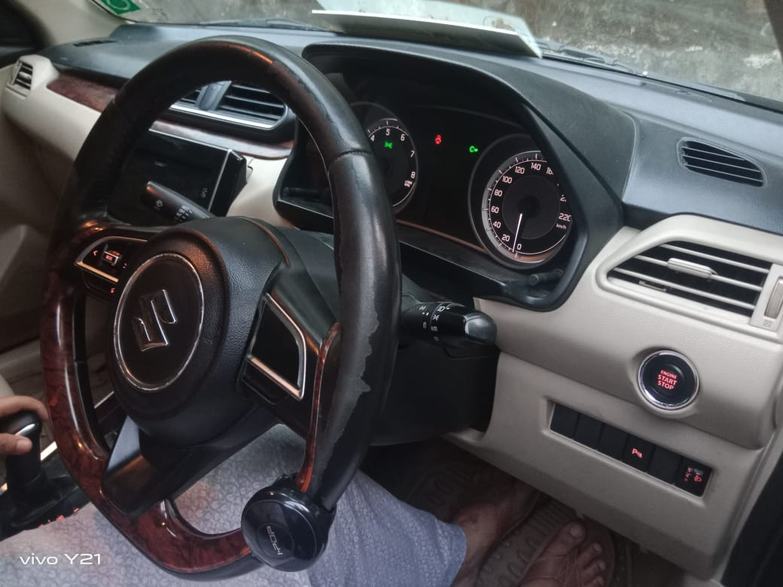
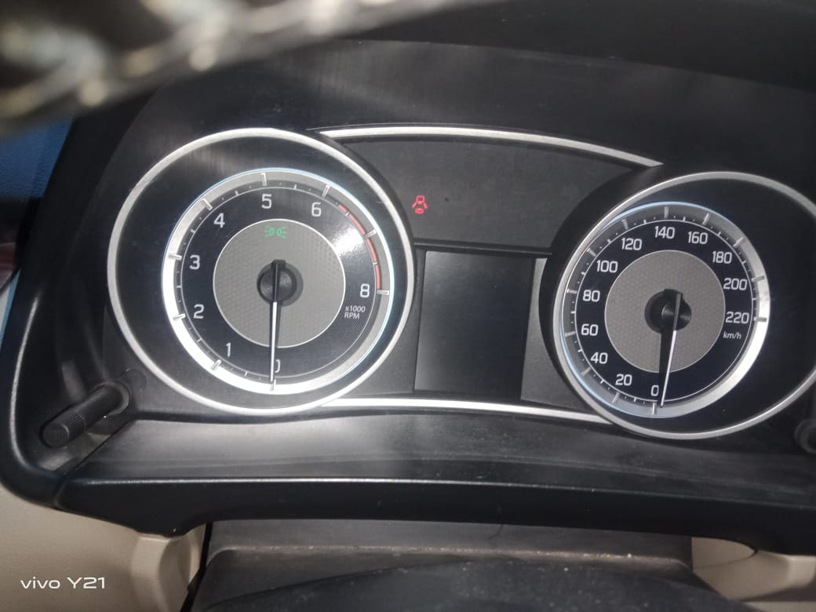

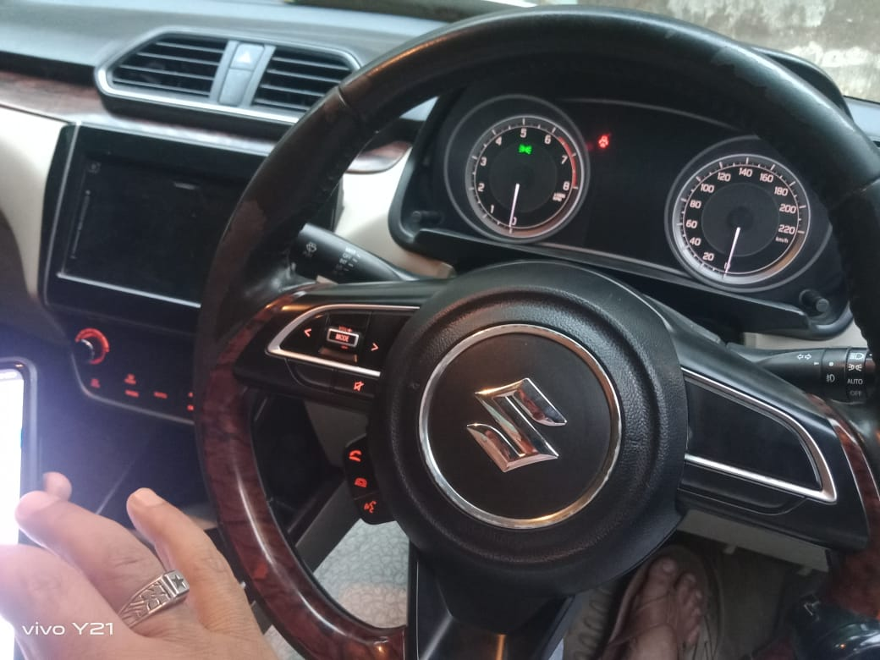
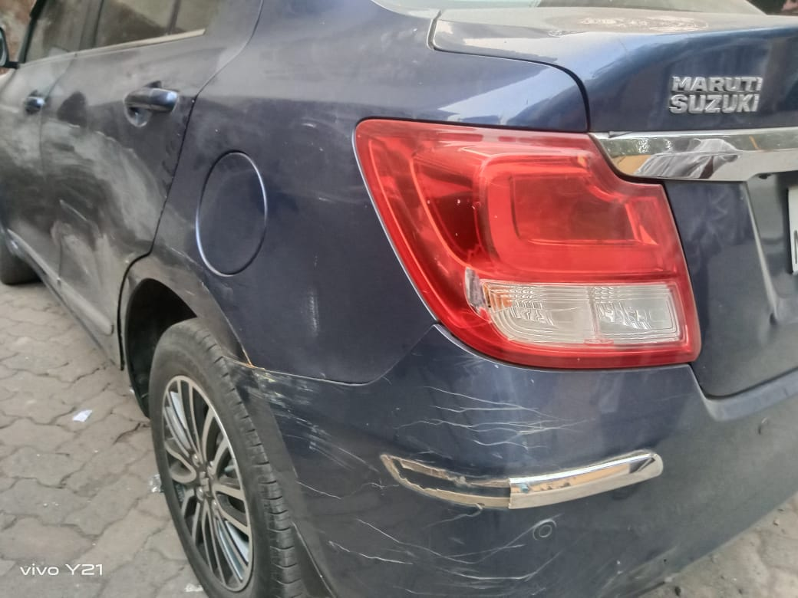

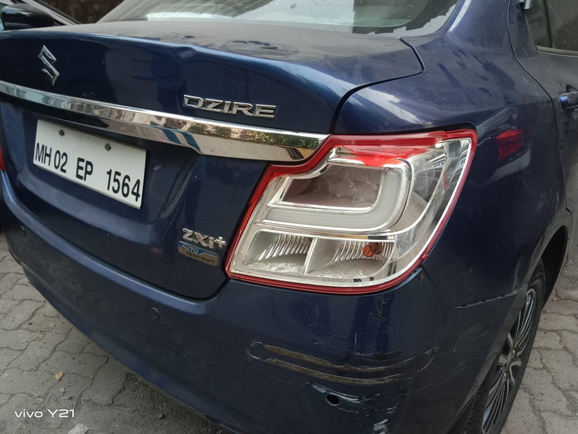
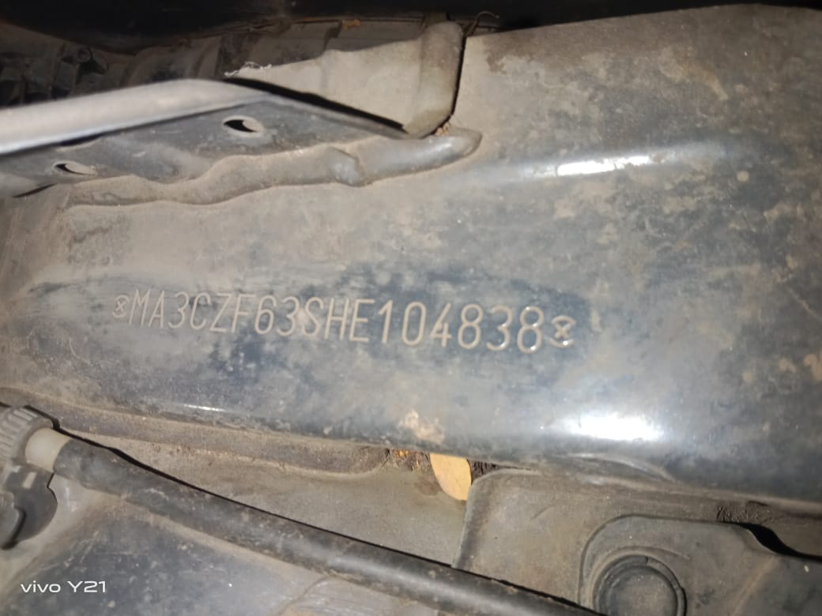

PHOTOGRAPHS

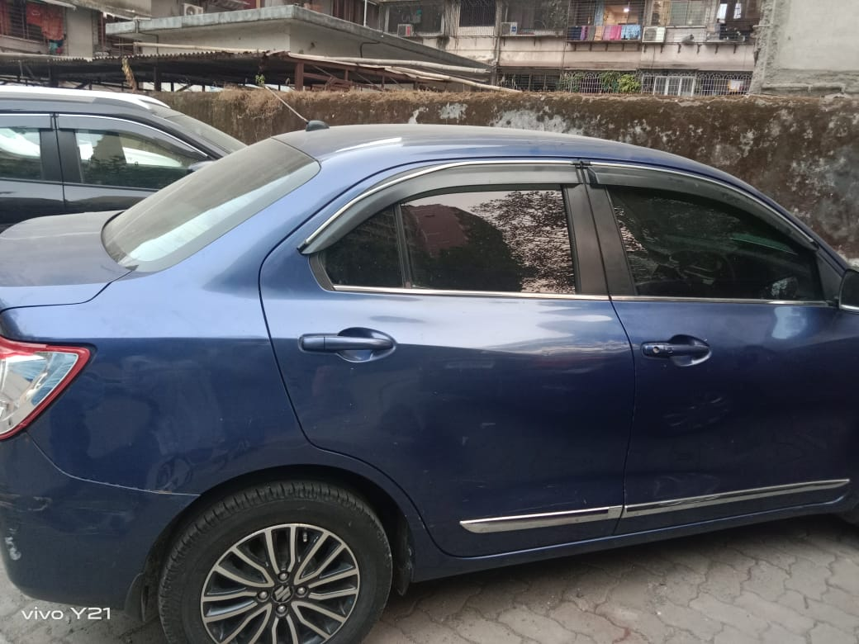
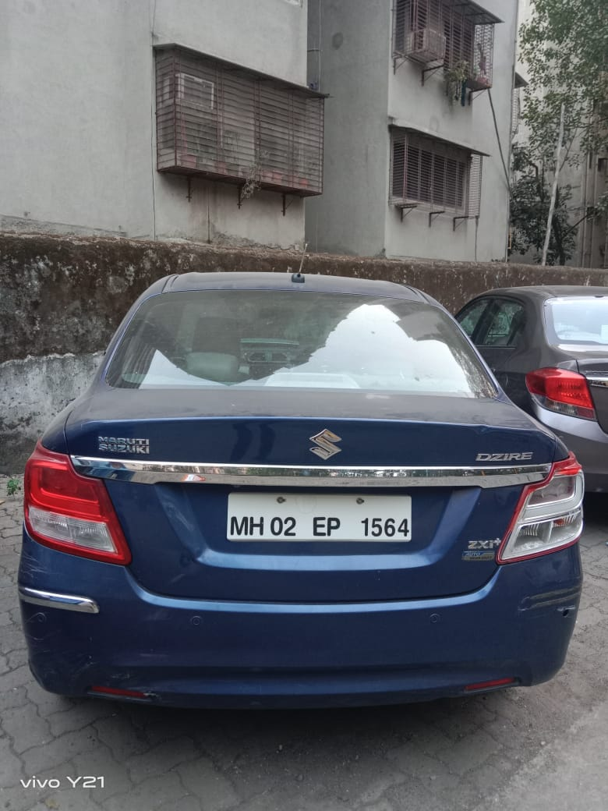

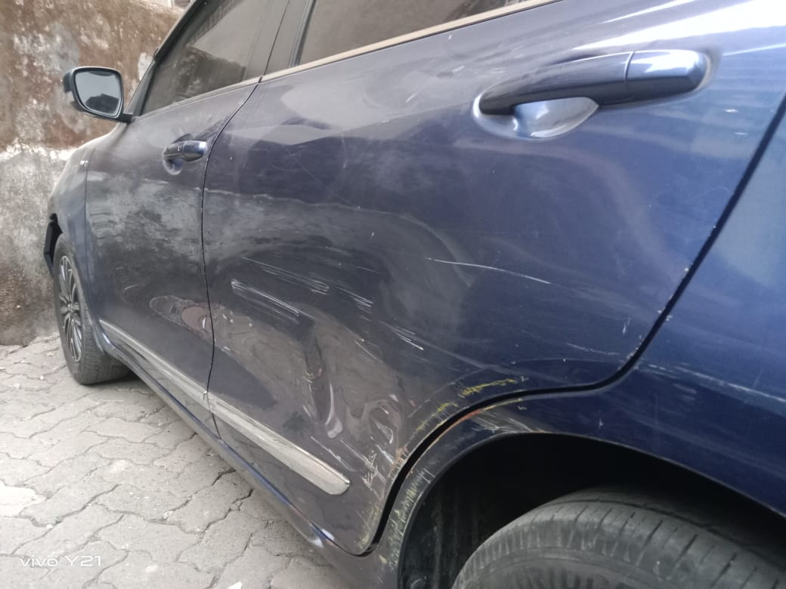
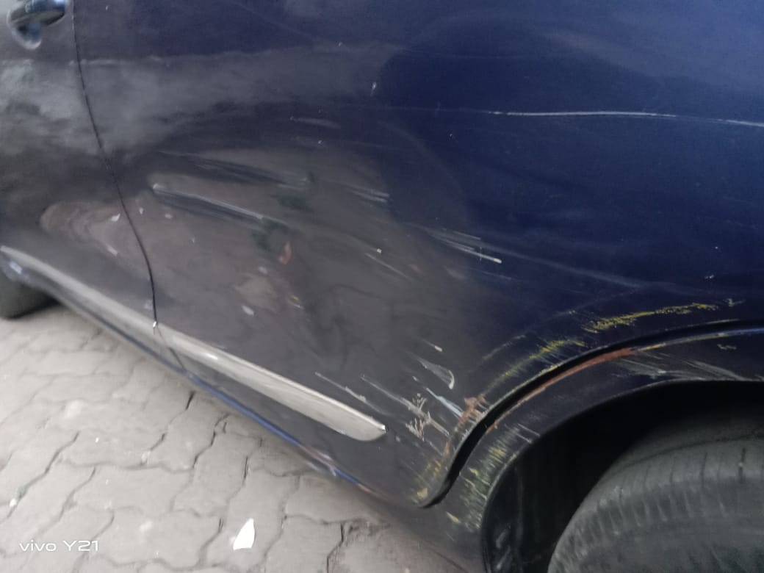

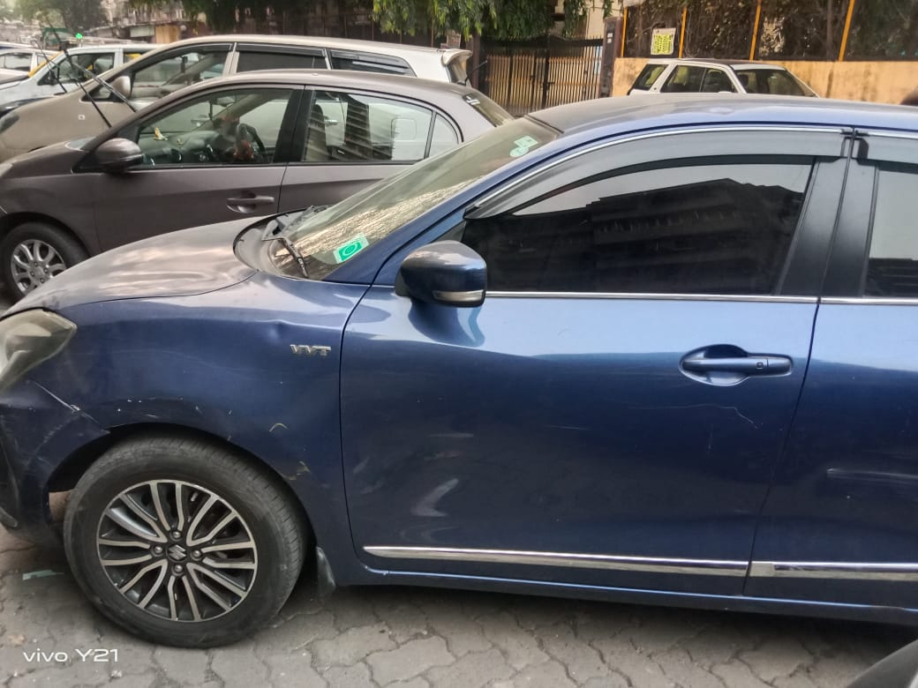
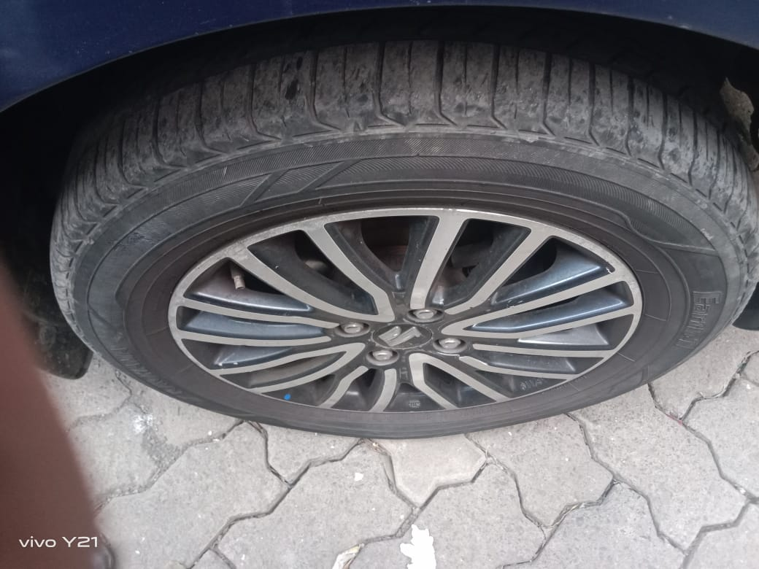

PHOTOGRAPHS
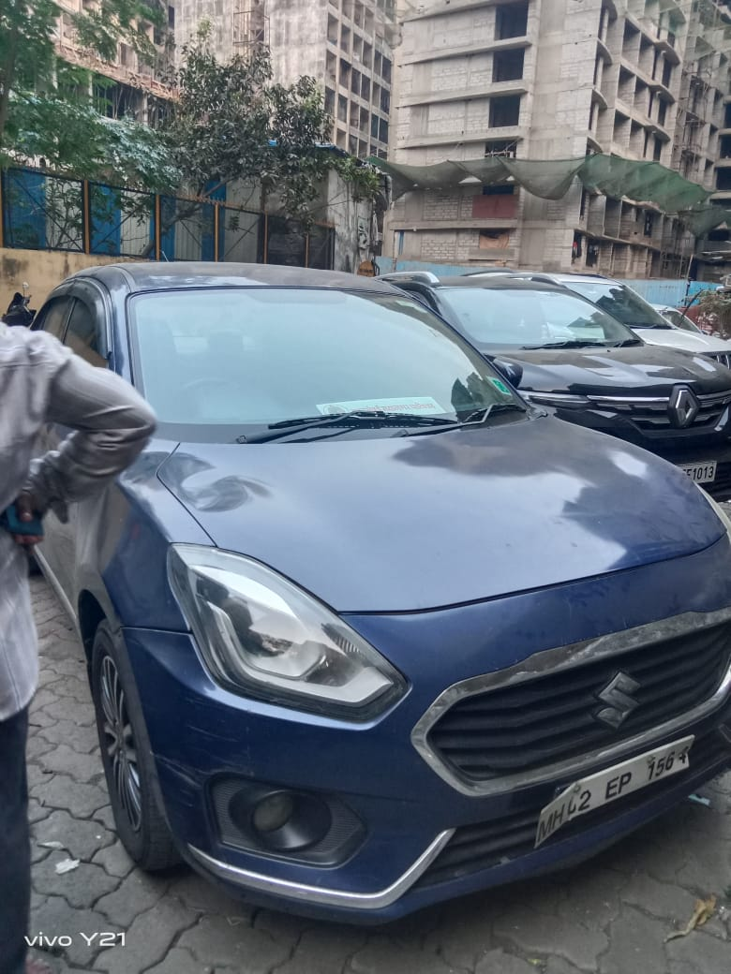
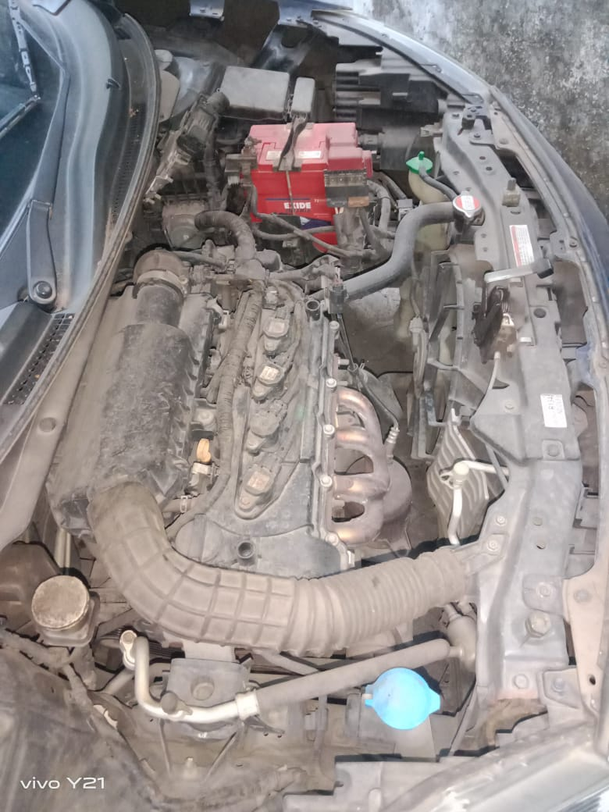

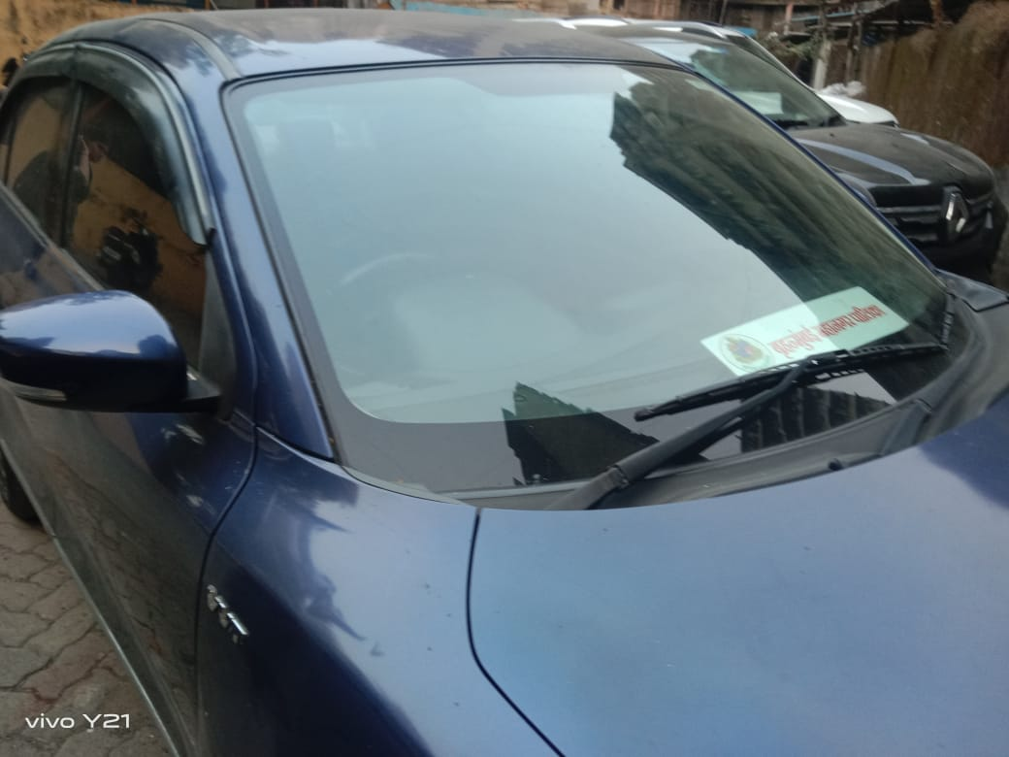

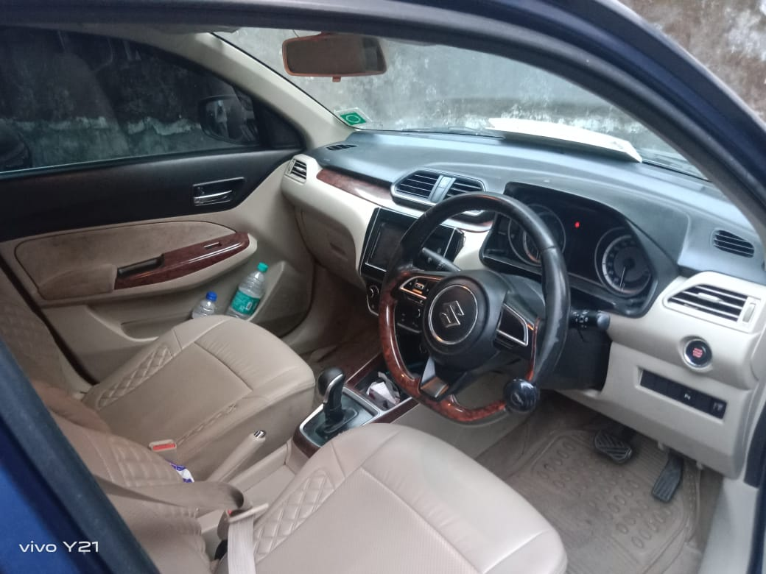

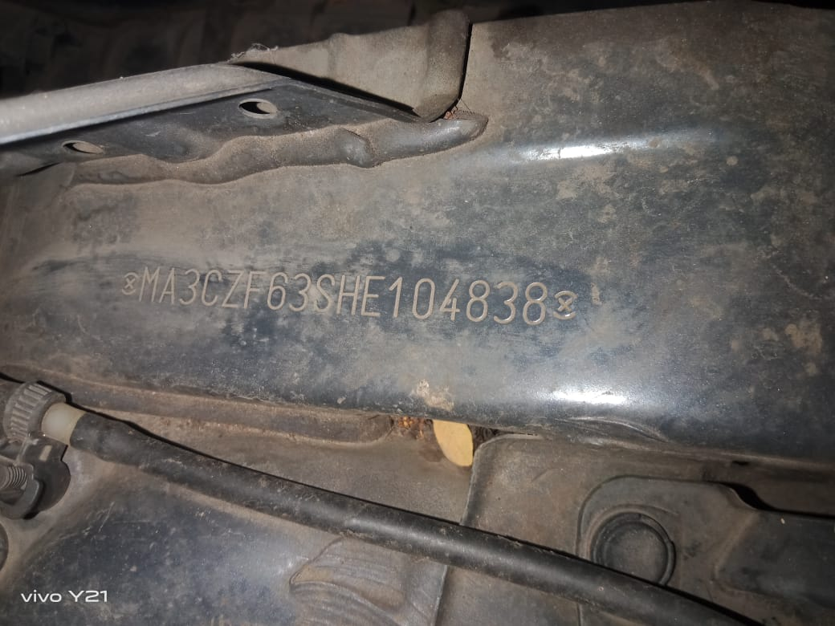
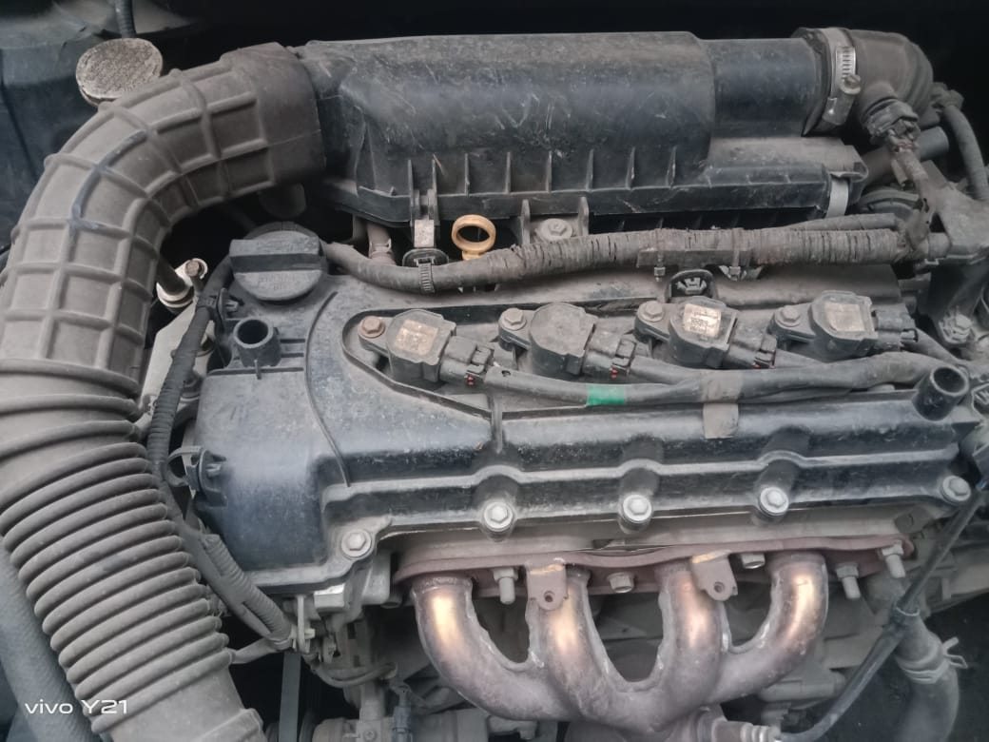

ASSUMPTIONS, CAVEATS, LIMITATION AND DISCLAIMERS
- We assume no responsibility for matters of legal nature affecting the assets appraised or the title thereto, nor do we render our opinion as to the title, which is assumed to be good and marketable.
- The assets are valued as though under responsible ownership.
- It is assumed that the assets are free of liens and encumbrances.
- There is no direct/ indirect interest in the assets valued.
- The statements of fact presented in the report are correct to the best of the valuer’s knowledge.
- The “valuer/ appraiser” word implies the valuer him/herself or any authorised representative of the valuer.
- The analysis & conclusions are limited only by the reported assumptions & conditions.
- It is hereby stated that the valuer has followed the professional requirements and standards in this document.
- The value’s fee is not contingent upon any aspect of the report.
- The valuation was performed in accordance with an ethical code and performance standards.
- The valuer has satisfied professional education requirements.
- The valuer has experience in the location and category of the assets being valued.
- Both legal description and dimension are taken from sources thought to be authoritative, however, no responsibility is assumed for either unless a survey, by a competent surveyor or engineer, is furnished to the appraiser.
- No responsibility is to be assumed for matters legal in nature, nor is any opinion of title rendered by this report. Good title is assumed.
- In no events shall the valuer be held responsible or liable for special, direct or consequential damages, as the assignment has been completed with best efforts, available knowledge & in good intentions following professional ethics.
- I have upon the invoices provided to us by the Client for the technical specification as well as details of manufacturer for the machineries or equipment. I have assumed that no major replacement of components in any of the machineries has been done unless otherwise specific details provided to me.
- Valuation is done on physical verification and external inspection basis. The valuer does not bear any responsibility for any error which is due to the assumptions made for working condition or internal part of machines which are not inspectable without dismantling.
- The Valuer, by reasons of this report, is not required to give testimony in court, with reference to the appraised assets unless arrangements for such contingency have been previously agreed upon.
- The analysis and additional data (like company information, micro-market data) of this report is based on Publicly available information, Industry Benchmark / Standards or my Professional Judgment where the information has not been furnished by the company.
- For the purpose of this exercise, I have assumed (where sufficient ownership data has not been provided) that the assets considered under this exercise are owned by the Company and has a clear and marketable title and is free from any legal and physical encumbrances, disputes, claims and other statutory liabilities and the requisite planning approvals from appropriate authorities has already been pursued; if any, I do not bear any responsibility for the same.
- The condition assessment and the estimation of useful life is based on industry standards as any visual observations / review of maintenance was beyond the scope of work.
- The inspection, due diligence and condition assessment of the asset was made by individuals generally familiar with valuation assessment of such assets. However, I do not opine nor am I responsible for its conformity to any health, safety, environmental or any other regulatory requirements that were not readily apparent to my team of experts during their inspection.
- This valuation is valid only for the purpose mentioned in this report; and neither intended nor valid to be used for any other purposes.
- The valuation is not a precise science and the conclusions arrived at in many cases will be subjective and dependent on the exercise of individual judgement. Hence, there is no indisputable single value. Whilst I consider my conclusions to be both reasonable and defensible based on the information available to us, others may place a different value based on the same information.
- I reserve my rights to change my conclusion at later date, if it is found that the data provided to us was not reliable, complete or accurate in any material aspect.
- For the purpose of this valuation report, the fair market value and fair value of the assets may be considered to be synonymous.
- All figures are in INR, unless mentioned otherwise. Further, round off errors (if any) arising from calculations or conversions to millions/ other units have negligible impact on the final value, therefore, can be ignored.

DEFINITION OF VALUE FOR THIS SPECIFIC PURPOSE
This exercise is to assess Fair Market Value of the Vehicle under reference as on 17st November 2023.
The term Fair Market Value is defined as
“The most probable price, as of a specified date, in cash, terms equivalent to cash, or in other precisely revealed terms for which the specified property rights would sell after reasonable exposure in a competitive market under all conditions requisite to a fair sale, with the buyer and seller each acting prudently knowledgeably and for self-interest assuming that neither is under undue duress”.
Fundamental assumptions and conditions presumed in this definition are:
- Buyer and seller are motivated by self-interest.
- Buyer and seller are well informed and are acting prudently.
- The property is exposed for a reasonable time on the open market.
- Payment is made in cash or equivalent or in specified financing terms.
DECLARATION OF PROFESSIONAL FEES CHARGED
We hereby declare that our professional fees are not contingent upon the valuation findings. However, if the statute AND/OR client demands that, the fees should be charged on the percentage of assessed value then, with the full knowledge of the AND/OR end user, it is being charged accordingly.

VALUATION OF VEHICLE
Considering various parameters recorded, existing economic scenario, and the information that is available with reference to the industrial development and method selected for valuation, we are of the opinion that, the assets can be assessed and valued for particular purpose at:
Particulars | Fair Market Value in (Rs.) | Realizable Value in (Rs.) | Distress Sale Value (Rs.)
Vehicle  (Maruti Dzire ZXI / AGS / Maruti Dzire ZXI + AMT)  Reg. No. MH02EP1564 | 4,75,000 | 4,04,000 | 3,33,000
Place: Mumbai
Date: 17.11.2023
For Vastukala Consultants (I) Pvt. Ltd.

Umang Ashwin Patel
Regd. Valuer
Chartered Engineer (India)
Reg. No. IBBI/RV/04/2019/10803

