Vastu/Nashik/06/32014/2301224
22/20-325-RPV
Date: 09.11.2023

To,
The Branch Manager,
Union Bank of India
Ambad Branch, Nashik
Ramashray Apartment, Sector C, Plot No. 283,
Near Bhadrpad Sector, Ashwin Nagar, Near Sambhaji
Stadium, Cidco Nashik-422009, State – Maharashtra, Country – India.

Sub: Vetting of Extra Amenities

Sir,

With reference to above subject, we have evaluated the Extra Amenities for This is to certify that the property bearing Residential Row House No.2, Ground Floor, Survey No.60/A, Plot No.63, Near English Medium School , Ambedkar Nagar, Chunchale , Village – Chunchale , Taluka & District - Nashik, PIN Code – 422 007, State – Maharashtra, Country – India belongs to Shri.Tulsiram Chindhyaji Ghatode. Name of Proposed Purchaser is Shri.Rajniti Shivdani Singh.

We have verified the rates quoted as per current market rates. Details of Extra Amenities considered as per copy of Extra Amenities Agreement between Shri.Rajniti Shivdani Singh. (First Party). Mr.Madhukar Natha Wagh (Second Party) received on dated 08.11.2023. The Extra Amenities amount is Rs. 3,00,000/- (Rupees Three Lakh Only)

The said Cost Vetting Certificate is valid upto next 6 months Only.

Thanking you

Sincerely yours

Sharadkumar B. Chalikwar
Govt. Reg. Valuer
Chartered Engineer (India)
Reg. No. (N) CCIT/1-14/52/2008-09

Agreement for Extra Work
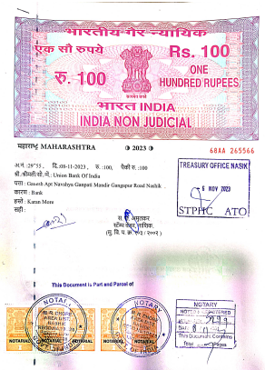
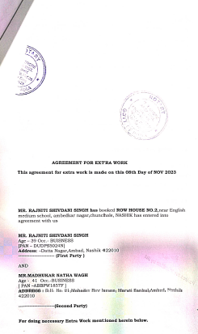

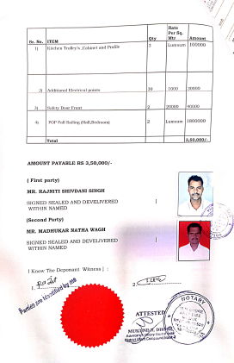

The Extra Amenities amount is Rs. 3,00,000/- (Rupees Three Lakh Only)

