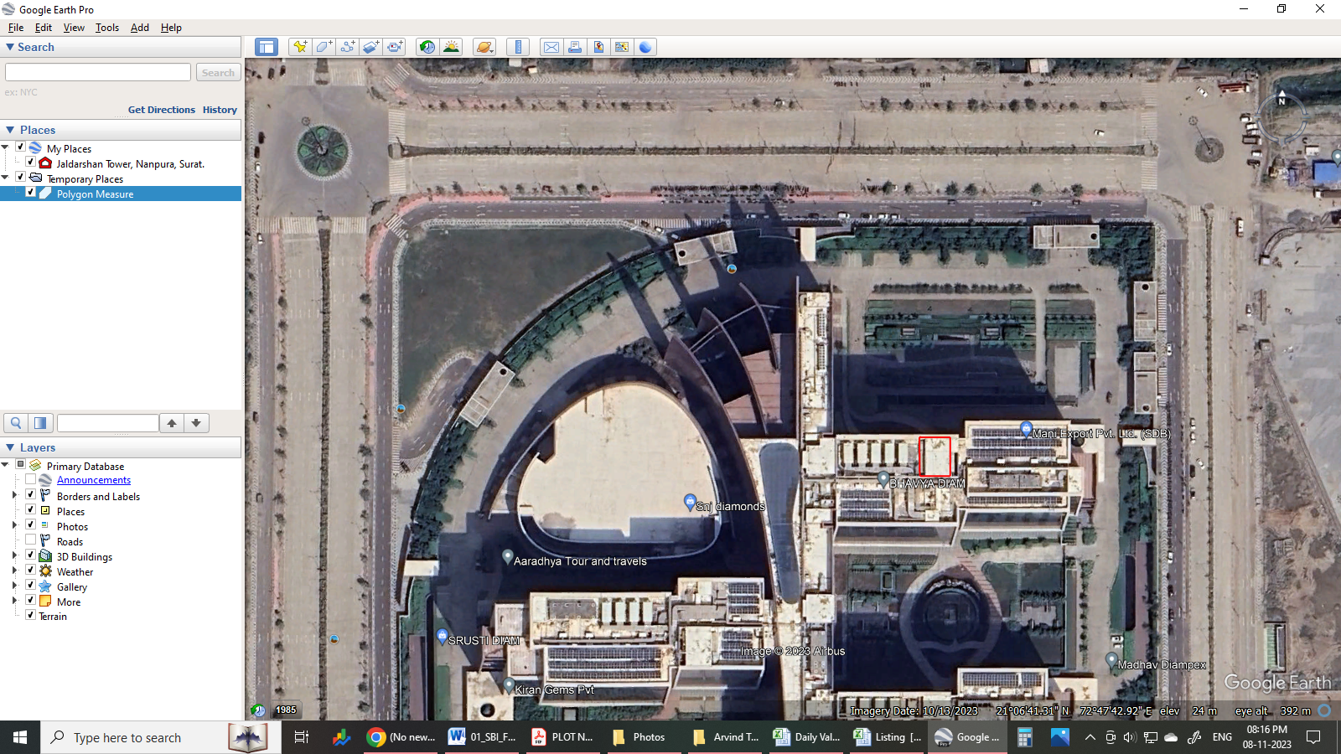

Office no. J-304, 3rd floor, J-Tower, Surat Diamond brouse, Khajod, Surat.

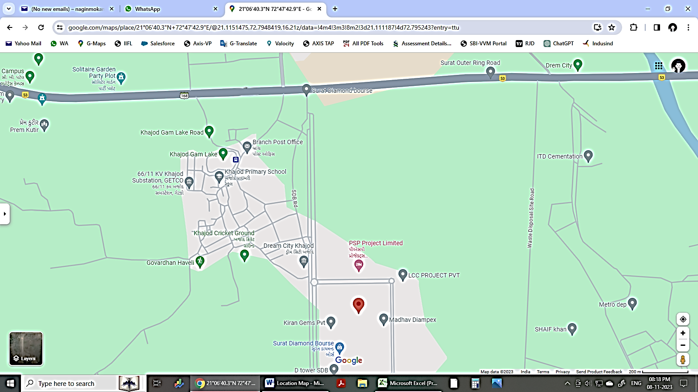

Office no. J-304, 3rd floor, J-Tower, Surat Diamond brouse, Khajod, Surat.