COST VETTING REPORT
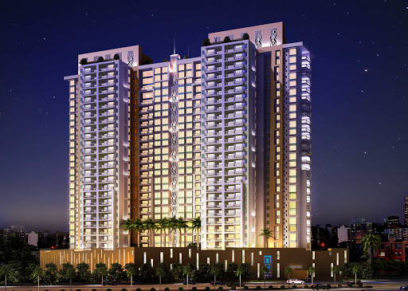

Details of the property under consideration:

Name of Project: "RDK Belvedere"

"RDK Belvedere", Proposed Redevelopment building named “Jayanti CHSL” on Plot bearing CTS No. 353/21, Previously CTS No. 5743/21, TP Scheme No. 3, Sindhu Wadi, R. B. Mehta Road, N Ward, TPS No. III,
Village – Ghatkopar – Kirol, Ghatkopar (East), Mumbai – 400 077, State – Maharashtra, Country – India

Latitude Longitude: 19°04'40.9"N 72°54'30.4"E

Valuation Done for:
State Bank of India
SME Chembur Branch
Unit No. 11, Building No. 11, Ground Floor, Corporate Park, Sion Trombay Road,
Chembur, Mumbai, Pin Code – 400 071, State - Maharashtra, Country – India.

Vastu/SBI/Mumbai/11/2023/4897/2303402
07/02-98-PY
Date: 06.11.2023

To,
The Branch Manager,
State Bank of India
SME Chembur Branch
Unit No. 11, Building No. 11,
Ground Floor, Corporate Park,
Sion Trombay Road, Chembur,
Mumbai, Pin Code – 400 071,
State - Maharashtra, Country – India.

Sub: Cost Vetting Report for "RDK Belvedere" at Ghatkopar (East) Mumbai, Pin Code – 400 077.
Ref: As per your mail dated 14.08.2023

Dear Sir,
In accordance with your letter of engagement as stated above, we enclose our Report on Project Valuation "RDK Belvedere", Proposed Redevelopment building named “Jayanti CHSL” on Plot bearing CTS No. 353/21, Previously CTS No. 5743/21, TP Scheme No. 3, Sindhu Wadi, R. B. Mehta Road, N Ward, TPS No. III, Village – Ghatkopar – Kirol, Ghatkopar (East), Mumbai – 400 077, State – Maharashtra, Country – India.
M/s. RDK Construction is partnership company. It is making a difference requires consistent effort and a commitment to quality.
M/s. RDK Construction is proposing Redevelopment building named “Jayanti CHSL” on Plot bearing CTS No. 353/21, Previously CTS No. 5743/21, TP Scheme No. 3, Sindhu Wadi, R. B. Mehta Road, N Ward, TPS No. III, Village – Ghatkopar – Kirol, Ghatkopar (East), Mumbai – 400 077, State – Maharashtra, Country – India. Project is comprising Residential of Rehab cum Sale Building.
Residential of Rehab cum Sale Building is proposed of Ground Floor + 1st to 12th Residential Floors with total RERA carpet area of 29,779.93 Sq. Ft. which consists 1 BHK, 2 BHK units with 15 nos. of Sell flats, 30 Tenant Flats providing with Fitness Centre, Society Office, & Other Amenities.
In this regard, SBI, SME Chembur Branch, Unit No. 11, Building No. 11, Ground Floor, Corporate Park, Sion Trombay Road, Chembur, Mumbai, Pin Code – 400 071, has approached Vastukala Consultants (I) Pvt. Ltd. (VCIPL) to conduct a Cost Vetting of the said project.
Our analysis of the cost vetting is enclosed in this report. This Report forms an integral whole and cannot be split in parts. The outcome of the report/ study can only lead to proper conclusions if the Report as a whole is taken into account.

The information used by Vastukala Consultants (I) Pvt. Ltd. (VCIPL) in preparing this report has been obtained from a variety of sources and other relevant documents provided by the client & bank. As agreed, we have performed our cost vetting exercise with the data available related to the business, considering the market prospects and projections. Our results are dependent on documents provided by client & bank, the underlying assumptions, which has been analyzed at a broader level by VCIPL while assessing their reasonableness.
Total Project Cost for the completion of Project will be ` 28.26 Cr.

For Vastukala Consultants (I) Pvt. Ltd.

Sharadkumar B. Chalikwar
Govt. Reg. Valuer
Chartered Engineer (India)
Reg. No. (N) CCIT/1-14/52/2008-09
SBI Empanelment No.: SME/TCC/2021-22/85/13
About the Project:
Proposed Redevelopment building named “Jayanti CHSL” on Plot bearing CTS No. 353/21, Previously CTS No. 5743/21, TP Scheme No. 3, Sindhu Wadi, R. B. Mehta Road, N Ward, TPS No. III, Village – Ghatkopar – Kirol, Ghatkopar (East), Mumbai – 400 077. It is about 1.00 Km. travelling distance from Ghatkopar (East) Railway station.

Area Statement as per Approved Plan
A | Proforma A-1 | Area In Sq. M.
1 | Area of Plot as per PRC | 1,104.40
 | Area as per TPS Ghatkopar No. III | 1,104.40
2 | Deductions for  (a) Road set- back area  (b) Proposed Road  (c) Any reservation (sub- plot___)  (d) ___% amenity space as per (sub plot___)  Other | -
3 | Balance area of plot (1 minus 2) | 1,104.40
4 | Deductions for 15% Recreational ground / 10% Amenity space  (If deductible for Ind) | NIL
5 | Net area of plot (3 minus 4) | 1,104.40
6 | Additions for Floor space index  6 (a) 100 % for D.P. Road (restricted to 40% or 80% of (3) above  6 (b) 100 % for set- back (restricted to 40% or 80% of (3) above | -
7 | Permissible Floor Area (BUA of existing bldg. as per Approved building plan u/ no. GB / 763 / BSI / AN dated 23.05.1970 is protected under Reg.30 (C) of DCPR 2034) (1422.20 - 1104.40 = 317.80 Sq. M.) | 1,142.20
8 | Floor Space Index permissible | 1.00
 | Additions for Floor space index  9 (a) FSI credit available by DRC  9 (b) 0.50 F.S.I. as per DCPR 32 (1104.40 x 0.50 = 552.20 sq. m.) Claimed  9 (c) Incentive FSI as per DCPR 33(7) (B) (30 Tenements x 10.00 sq. m.)  9 (d) % as per DCPR 33  9 (e) other | 486.60  300.00
10 | Permissible Floor Area (7 + 8) plus 9 above | 2,208.80
11 | Total Proposed built up area | 2,208.80
12 | FSI consumed on net holding = 11/ 3 | 2.00
B | Details of Residential / Non - Residential Areas | -
1 | Purely Residential Built-up Area | 2,208.80
2 | Remaining Non- Residential Built-up area | -
C | Details of FSI availed as per DCPR 31 (3)
1 | Fungible Built up Area component proposed vide DCPR 31 (3) for purely Residential = or < (B1 x 0.35) as per Proforma (A - 1)  For Rehab purpose without charging premium (1352.15 sq. m. x 35%)  For Sale purpose by charging premium (2208.80 x 35% = 773.08 - 473.25) | 486.60  300.0
2 | Fungible Built up Area component proposed vide DCPR 31 (3) for non-Residential = or < (B2 x 0.35) | -
3 | Total Fungible Built Up Area vide DCPR 31 (3) = (C1 + C2) | 773.08
4 | Total Gross Built Up Area permissible (11 + C3) | 2,981.88
5 | Total Gross Built Up Area proposed | 2,977.43
D | Tenement Statement | -
(i) | Proposed area (item A, 12 above) C-4 | 2,977.43
(ii) | Less deduction of non-Residential area (Shop etc.) | -
(iii) | Area available for tenement [ (i) minus (ii)] | -
(iv) | Tenement permissible 450 tenements / hectare | 134.00
(v) | Tenement proposed | 45.00
(vi) | Tenement existing | -
 | Total tenement on plot | 45.00
E | Parking Statement
(i) | Parking required by Regulations for-  Car  Scooter / Motor Cycle  Outsiders (10% visitors) | 34  3
(ii) | Covered garage permissible
(iii) | Covered garage proposed  Car  Scooter / Motor Cycle  Outsiders (10% visitors) | 47  3
 | Total parkin Required | 37.00
 | Total parking provided | 50.00

Construction Area as per Approved Plan for Rehab cum Sale Building
Sr. No. | Floor | Built Up Area in Sq. M. | Free FSI / Premium FSI Area in Sq. M. |  |  | Total Construction Area in Sq. M.
Sr. No. | Floor | Built Up Area in Sq. M. | Staircase / Lift / Lobby Area | Refuge Area | Amenities Area | Total Construction Area in Sq. M.
1 | Ground Floor | - | 44.28 | - | - | 44.28
2 | 1st Floor | 127.45 | 44.28 | - | 65.30 | 237.03
3 | 2nd Floor | 237.53 | 44.28 | - | - | 281.81
4 | 3rd Floor | 248.43 | 44.28 | - | - | 292.71
5 | 4th Floor | 248.43 | 44.28 | - | - | 292.71
6 | 5th Floor | 248.43 | 44.28 | - | - | 292.71
7 | 6th Floor | 274.04 | 44.28 | - | - | 318.32
8 | 7th Floor | 274.04 | 44.28 | - | - | 318.32
9 | 8th Floor | 222.92 | 44.28 | 52.76 | - | 319.96
10 | 9th Floor | 274.04 | 44.28 | - | - | 318.32
11 | 10th Floor | 274.04 | 44.28 | - | - | 318.32
12 | 11th Floor | 274.04 | 44.28 | - | - | 318.32
13 | 12th Floor | 274.04 | 44.28 | - | - | 318.32
14 | OHT / LMR | - | 44.28 | - | - | 44.28
Total Area in Sq. M. |  | 2,977.43 | 619.92 | 52.76 | 65.30 | 3,715.41
STACK PARKING Nos. |  |  |  |  |  | 50.00

Project Cost
Sr. No. | Particulars | Total Estimated Amount in ` | Total Estimated Amount  in ` Cr.
1 | Land Cost
 | Acquisition Cost of Land or Development Rights, and Legal Cost. | 76,15,447.00 | 0.76
 | Rent to Tenants, Lease premium, Lease Rent, interest cost incurred or payable on Land Cost | 4,47,66,006.00 | 4.48
 | Amount of Premium payable to obtain development rights, FSI, additional FSI, fungible area, and any other incentive under DCR from Local Authority or State Government or any Statutory Authority. | 7,18,61,319.00 | 7.18
 | Acquisition cost of TDR (if any) | - | -
2 | Cost of Construction
 | Estimated construction cost of rehab cum sale building including site development and infrastructure for the same. | 12,28,16,070.00 | 12.28
 | On site expenditure for development of entire project excluding cost of construction as per(i) above,
a. | Architect Fees & Consultant fees | 61,40,804.00 | 0.61
b. | Admin Cost includes salaries, site overheads, development works, cost of services (including water, electricity, sewerage, drainage, layout roads etc.), cost of machineries and equipment including its hire and maintenance cost, consumables etc. All costs directly incurred to complete the construction of the entire phase of the project registered. | 49,12,643.00 | 0.49
c. | Marketing Cost | 80,99,419.00 | 0.81
3 | Interest during the Project | 1,27,00,000.00 | 1.27
4. | Contingency Charges | 36,84,482.00 | 0.37
 | GRAND TOTAL: | 28,25,96,190.00 | 28.26

Sharadkumar B. Chalikwar
Govt. Reg. Valuer
Chartered Engineer (India)
Reg. No. (N) CCIT/1-14/52/2008-09
SBI Empanelment No.: SME/TCC/2021-22/85/13

Comments on each element of Cost of Project: -
- Land Cost:
As per Present Ready Reckoner rate the Project Land Value is ` 8.01 Cr. considering Land Rate @ ` 72,550.00 per Sq. M. & Net Plot Area of 1,104.40 Sq. M.
As per document purchase cost of land & stamp duty cost is ` 76,15,447.00 i.e., ` 0.76 Cr. which is 2.69% of Total Project Cost.
Sr. No. | Agreement Name | Date | Particulars | Total Cost in ` | Incurred Cost in `
1 | Development Agreement | 06-12-2022 | Stamp Duty | 75,48,347.00 | 75,48,347.00
2 | Development Agreement | 06-12-2022 | Reg. Fees | 30,000.00 | 30,000.00
3 | Development Agreement | 06-12-2022 | Reg. Fees | 4,800.00 | 4,800.00
5 | Indemnity Bond | 21-02-2023 | Reg. Fees | 30,000.00 | 30,000.00
6 | Indemnity Bond | 21-02-2023 | Reg. Fees | 500.00 | 500.00
7 | Indemnity Bond | 21-02-2023 | Stamp Duty | 500.00 | 500.00
8 | General Power of Attorney | 06-12-2022 | Reg. Fees | 100.00 | 100.00
9 | General Power of Attorney | 06-12-2022 | Reg. Fees | 700.00 | 700.00
10 | General Power of Attorney | 06-12-2022 | Stamp Duty | 500.00 | 500.00
TOTAL |  |  |  | 76,15,447.00 | 76,15,447.00

- Payment Payable to Rehab Tenants (Rent Cost):
Since it is a having some redevelopment flat from the date of shifting of 30 Tenants till handing over their respective new flats as per the Tenant Agreement. Further the rent keeps on increasing by 10%. The existing Tenants has to be given total rental of ` 4,47,66,006.00 i.e., ` 4.48 Cr. Builder has paid ` 14.66 Cr. which is 15.84 % of Total Project Cost.
Existing Tenants Carpet Area & Rent per month for Flat are as follows:
Sr. No. | Particulars |  | Units
1 | No. Tenants | 30.00 | Nos.
2 | Existing Total Carpet Area (ETCA) | 14,302.00 | Sq. Ft.
3 | Rate / Sq. Ft. on ETCA per Month | 70.00 | Rupees
4 | Rent per Month | 10,01,140.00 | Rupees
5 | Rent per Year April 23 - March 24 | 1,20,13,680.00 | Rupees
6 | Rate / Sq. Ft. on ETCA per Month | 77.00 | Rupees
7 | Rent per Month | 11,01,254.00 | Rupees
8 | Rent per Year April 24 - March 25 | 1,32,15,048.00 | Rupees
9 | Rate / Sq. Ft. on ETCA per Month | 84.70 | Rupees
10 | Rent per Month | 12,11,379.00 | Rupees
11 | Rent per Year April 25 - June 25 | 36,34,138.00 | Rupees
12 | Hardship rate / Sq. Ft. on ETCA | 1,000.00 | Rupees
13 | Hardship Cost | 1,43,02,000.00 | Rupees
14 | Brokerage Cost | 10,01,140.00 | Rupees
15 | Shifting Charges per Tenant | 20,000.00 | Rupees
16 | Shifting Charges Cost | 6,00,000.00 | Rupees
17 | TOTAL RENT COST (5 + 8 + 11 + 13 + 14 + 16) | 4,47,66,006.00 | Rupees

- Building Cost of Construction for Rehab cum Sale Building:
Construction Area of Rehab cum Sale Building = 3,715.41 Sq. M. i.e., 39,992.67 Sq. Ft.
No. of Stack Parking = 50 Nos.
Total estimated cost for construction of Building (includes cost of RCC work, manpower, lift, material, painting, finishing work, site development, etc.) is ` 10,03,16,070.00 i.e., ` 10.03 Cr. which comes ` 27,000.00 per Sq. M. on construction area for building and cost for construction of stack car parking is ` 2,25,00,000.00 i.e., ` 2.25 Cr. which comes ` 4,50,000.00 per stack car parking.
Hence, total cost of construction (Cost of Construction of Building + Cost of Stack Parking) (` 10,03,16,070.00 + ` 2,25,00,000.00) is ` 12,28,16,070.00 i.e., ` 12.28Cr.
The total construction area is 3,715.41 Sq. M., projected cost of ` 12.28 Cr is 43.46% of total project cost
VCIPL opinion the construction cost of 27,000/- Per Sq. M. which is in line with Market-Trend.
Particulars | Rate per Sq. M.
Excavation Work | 1,500.00
Total RCC Work | 13,500.00
Final Finishing Work | 7,000.00
Other Work | 5,000.00
Cost of Construction | 27,000.00
Stack Car Parking | 4,50,000.00 per car parking

- Approval Charges:
The Total Approval Cost (Fungible Cost & Development Cess Premium & TDR Cost) as per architect letter will be ` 7,18,61,319.00 i.e., ` 7.19 Cr. which is 25.43% of Total Project Cost. Builder has paid ` 3.84 Cr.
Sr. No. | Particulars | Projected Cost in ` | Incurred till date in ` | Balance Cost in `
1 | Scrutiny Fee | 2,82,856.00 | 2,82,856.00 | -
2 | Fire NOC | 9,24,588.00 | 9,24,588.00 | -
4 | Bank Guarantee | 12,50,000.00 | 12,50,000.00 | -
5 | Development Charges & Others | 1,57,28,900.00 | 1,57,28,900.00 | -
6 | Permissible FSI & Others | 1,10,01,100.00 | 1,10,01,100.00 | -
7 | Additional FSI | 1,24,91,500.00 | 76,75,900.00 | 48,15,600.00
9 | Scrutiny Fee - Solid Waste Mgmt. | 27,500.00 | 27,500.00 | -
10 | Stamp Duty & Registration | 32,000.00 | 32,000.00 | -
12 | Pest Control Charges | 1,35,411.00 | 1,35,411.00 | -
13 | Scrutiny Fee - Sewerage NOC | 12,149.00 | 12,149.00 | -
14 | HE Remarks | 11,85,580.00 | 11,85,580.00 | -
19 | Mahakhanij Royalty | 1,81,535.00 | 1,81,535.00 | -
22 | Open Deficiency Premium | 1,21,56,200.00 | - | 1,21,56,200.00
23 | Fungible FSI | 59,34,800.00 | - | 59,34,800.00
24 | Staircase Premium | 1,05,17,200.00 | - | 1,05,17,200.00
Total |  | 7,18,61,319.00 | 3,84,37,519.00 | 3,34,23,800.00
As per architect letter provided by developer.

- Architect Cost, RCC & Other Professional Charges:
The total Architect charges of ` 61,40,804.00 i.e., ` 0.61 Cr. is 5% of total construction cost (Rehab cum Sale Building) & it is line up with Market Trend.
The professional charge consists of Architect & Legal which in market is in the range of 2% - 5% of Total Construction cost of the project.

- Administrative Expenses:
Salaries, site overheads, development works, cost of services (including water, electricity, sewerage, drainage, layout roads etc.), cost of machineries and equipment including its hire and maintenance cost, consumables etc. All costs directly incurred to complete the construction of the entire phase of the project registered is estimated 4% of total construction cost (Rehab cum Sale Building) which comes to ` 49,12,643.00 i.e., ` 0.49 Cr.
The admin charges which in market is in the range of 2% - 4% of Total Construction cost of the project.

- Marketing Expenses:
Marketing costs directly incurred to complete the construction of the entire phase of the project registered is estimated at 2% of total Sale income from the project which comes to ` 80,99,419.00 i.e., ` 8.09 Cr.
The marketing charge consists of brokerage & commission which in market is in the range of 1% - 3% of Total Sale income of the property.

- Interest Costs:
The Interest cost for the term loan is ` 1,27,00,000.00 i.e., ` 1.27 Cr., which is 4.49% of total project cost.
As per information provided by the client.

- Contingency Costs:
The contingency charges estimated at 3.0% total construction cost (Rehab cum Sale Building) which comes to ` 36,84,482.00 i.e., ` 0.37 Cr.
Observation and Construction: -
Total estimated cost of project i.e., ` 28,25,96,190.00 (Rupees Twenty – Eight Crore Twenty – Five Lakh Ninety – Six Thousand One Hundred Ninety Only) i.e., ` 28.26 Cr. is fair & reasonable.
The project cost is including land premium payable to concern authorities, Fungible FSI Premium, Cost of Construction of rehab & Sale Building, on site expenses including admin & marketing expenses, premiums / charges to be paid to competent authority and Bank interest, etc. we have not independently verified interest cost hence not consider in cost vetting.
As per sanctioned building plan, permissible built-up area on the said plot is 2,977.43 Sq. M. The rehab cum sale building is sanctioned for Ground Floor + 1st to 12th Residential Upper Floors only. Estimated cost of entire project of 12th upper floor is considered.
Total estimated cost for construction of Building (includes cost of RCC work, manpower, lift, material, painting, finishing work, site development, etc.) is ` 10,03,16,070.00 i.e., ` 10.03 Cr. which comes ` 27,000.00 per Sq. M. on construction area for building and cost for construction of stack car parking is ` 2,25,00,000.00 i.e., ` 2.25 Cr. which comes ` 4,50,000.00 per stack car parking. Hence, total cost of construction (Cost of Construction of Building + Cost of Stack Parking) (` 10,03,16,070.00 + ` 2,25,00,000.00) is ` 12,28,16,070.00 i.e., ` 12.28 Cr., which is fair & reasonable considering the present status of project, type & quality of construction & specification of the building materials to be used, height of the structure, amenities to be provided in proposed building.

Assumptions & Remarks-
- The adequacy of Engineering / Structural design is beyond the scope of our assignment.
- Estimated project completion date is 31/12/2029. The cost is certified based on the assumptions that the project will be completed within time frame. Few assumptions are made regarding inflation & cost rise etc. during construction period.

Photo copy of following document is provided to us & this report should be read along with it:
- Copy of Developer Agreement dated 06.12.2022 between M/s. Jayanthi Co-operative Housing Society Ltd. (The Society) and M/s. RDK Constructions (The Developers) through registered agreement vide No. KRL-5-23646-2022 dated 22.12.2022.
- Copy of Comprehensive Undertaking by Owner / Developer (Indemnity Bond) dated 21.02.2023 through registered agreement vide No. KRL-5-23646-2022 dated 21.02.2023.
- Copy of Irrevocable General Power of Attorney dated 06.12.2022 through registered agreement vide No. KRL-5-23647-2022 dated 06.12.2022.
- Copy of Agreement dated 05.03.1969 between Dhavantrai Keshavlal & Prabhavati Dhavantrai Shah (The Vendors) and M/s. Jayanthi Co-operative Housing Society Ltd. (The Society).
- Copy of Permanent Alternate Accommodation Agreement dated 22.02.2023 between M/s. RDK Constructions (The Developer) and Mrs. Remadevi Prabhakaran (The Member) through registered agreement vide No. KRL-5-3920-2023 dated 22.02.2023.
- Copy of Permanent Alternate Accommodation Agreement dated 22.02.2023 between M/s. RDK Constructions (The Developer) and Mrs. Minaxi Bhupatbhai Doshi & Mr. Bhupatbhai V. Doshi (The Member) through registered agreement vide No. KRL-5-3903-2023 dated 22.02.2023.
- Copy of Permanent Alternate Accommodation Agreement dated 31.03.2023 between M/s. RDK Constructions (The Developer) and Mr. Ritesh Ashok Majithia (The Member) through registered agreement vide No. KRL-5-6755-2023 dated 08.06.2023.
- Copy of Permanent Alternate Accommodation Agreement dated 22.02.2023 between M/s. RDK Constructions (The Developer) and Mr. Ramesh D. Gada (The Member) through registered agreement vide No. KRL-5-3923-2023 dated 22.02.2023.
- Copy of Permanent Alternate Accommodation Agreement dated 22.02.2023 between M/s. RDK Constructions (The Developer) and Mrs. Lalitha Sankar Raman (The Member) through registered agreement vide No. KRL-5-3921-2023 dated 22.02.2023.
- Copy of Permanent Alternate Accommodation Agreement dated 22.02.2023 between M/s. RDK Constructions (The Developer) and Mrs. Kasturi S. Mylavarapu (The Member) through registered agreement vide No. KRL-5-3919-2023 dated 22.02.2023.
- Copy of Permanent Alternate Accommodation Agreement dated 23.02.2023 between M/s. RDK Constructions (The Developer) and Mrs. Devangana A. Mody & Mrs. Alpa Rajesh Mall (The Member) through registered agreement vide No. KRL-5-4025-2023 dated 23.02.2023.
- Copy of Permanent Alternate Accommodation Agreement dated 22.02.2023 between M/s. RDK Constructions (The Developer) and Ms. Sukhbir Kaur Shahid (The Member) through registered agreement vide No. KRL-5-3895-2023 dated 22.02.2023.
- Copy of Permanent Alternate Accommodation Agreement dated 28.02.2023 between M/s. RDK Constructions (The Developer) and Mrs. Ashajyothi Tilak Utchil (The Member) through registered agreement vide No. KRL-5-4402-2023 dated 28.02.2023.
- Copy of Permanent Alternate Accommodation Agreement dated 23.02.2023 between M/s. RDK Constructions (The Developer) and Mr. Rajesh Ganeshdas Mall & Mrs. Alpa Rajesh Mall (The Member) through registered agreement vide No. KRL-5-4036-2023 dated 22.02.2023.
- Copy of Permanent Alternate Accommodation Agreement dated 22.02.2023 between M/s. RDK Constructions (The Developer) and Mr. Dhirajlal Tribuvandas Bhuva (The Member) through registered agreement vide No. KRL-5-3906-2023 dated 22.02.2023.
- Copy of Permanent Alternate Accommodation Agreement dated 23.02.2023 between M/s. RDK Constructions (The Developer) and Mr. Bhavesh M Shah & Mrs. Bharati B Shah (The Member) through registered agreement vide No. KRL-5-4029-2023 dated 23.02.2023.
- Copy of Permanent Alternate Accommodation Agreement dated 22.02.2023 between M/s. RDK Constructions (The Developer) and Mr. Jinendra B. Shah (The Member) through registered agreement vide No. KRL-5-3917-2023 dated 22.02.2023.
- Copy of Permanent Alternate Accommodation Agreement dated 22.02.2023 between M/s. RDK Constructions (The Developer) and Mr. Deepakkumar Mansukhlal Desai (The Member) through registered agreement vide No. KRL-5-3935-2023 dated 22.02.2023.
- Copy of Permanent Alternate Accommodation Agreement dated 22.02.2023 between M/s. RDK Constructions (The Developer) and Mrs. Neelam P. Gupta & Mr. Rohit P. Gupta (The Member) through registered agreement vide No. KRL-5-3929-2023 dated 22.02.2023.
- Copy of Permanent Alternate Accommodation Agreement dated 22.02.2023 between M/s. RDK Constructions (The Developer) and Mr. Harishchandra P. Mehta (The Member) through registered agreement vide No. KRL-5-3897-2023 dated 22.02.2023.
- Copy of Permanent Alternate Accommodation Agreement dated 23.02.2023 between M/s. RDK Constructions (The Developer) and Mr. Ankitkumar Jaysukhlal Shah & Mr. Jaysukhlal Lalji Shah (The Member) through registered agreement vide No. KRL-5-4022-2023 dated 23.02.2023.
- Copy of Permanent Alternate Accommodation Agreement dated 22.02.2023 between M/s. RDK Constructions (The Developer) and Mr. Hitesh Kantilal Ajmera & Mrs. Anita Hitesh Ajmera (The Member) through registered agreement vide No. KRL-5-3901-2023 dated 22.02.2023.
- Copy of Permanent Alternate Accommodation Agreement dated 23.02.2023 between M/s. RDK Constructions (The Developer) and Mr. Mahipat Babulal Shah & Smit Mahipat Shah (The Member) through registered agreement vide No. KRL-5-4033-2023 dated 23.02.2023.
- Copy of Permanent Alternate Accommodation Agreement dated 27.02.2023 between M/s. RDK Constructions (The Developer) and Mr. Nailesh Premchand Malde & Mr. Vinod Premchand Malde (The Member) through registered agreement vide No. KRL-5-4274-2023 dated 27.02.2023.
- Copy of Permanent Alternate Accommodation Agreement dated 27.02.2023 between M/s. RDK Constructions (The Developer) and Mr. Rajesh Mohanlal Shah & Mrs. Dipika Rajesh Shah (The Member) through registered agreement vide No. KRL-5-4271-2023 dated 27.02.2023.
- Copy of Permanent Alternate Accommodation Agreement dated 22.02.2023 between M/s. RDK Constructions (The Developer) and Mr. Anilkumar J. Bhayani (The Member) through registered agreement vide No. KRL-5-3926-2023 dated 22.02.2023.
- Copy of Permanent Alternate Accommodation Agreement dated 22.02.2023 between M/s. RDK Constructions (The Developer) and Mr. Navinchandra H. Shah (The Member) through registered agreement vide No. KRL-5-3910-2023 dated 22.02.2023.
- Copy of Permanent Alternate Accommodation Agreement dated 22.02.2023 between M/s. RDK Constructions (The Developer) and Mrs. Shilpa S. Desai & Mrs. Swati S. Desai (The Member) through registered agreement vide No. KRL-5-3936-2023 dated 22.02.2023.
- Copy of Permanent Alternate Accommodation Agreement dated 27.02.2023 between M/s. RDK Constructions (The Developer) and Mr. Kaushik Mahendra Mehta (The Member) through registered agreement vide No. KRL-5-4280-2023 dated 27.02.2023.
- Copy of Permanent Alternate Accommodation Agreement dated 22.02.2023 between M/s. RDK Constructions (The Developer) and Mr. Manish C. Doshi (The Member) through registered agreement vide No. KRL-5-3937-2023 dated 22.02.2023.
- Copy of Permanent Alternate Accommodation Agreement dated 23.02.2023 between M/s. RDK Constructions (The Developer) and Mrs. Jayshree K. Joisher & Mr. Kiran K. Joisher (The Member) through registered agreement vide No. KRL-5-4020-2023 dated 23.02.2023.
- Copy of Permanent Alternate Accommodation Agreement dated 27.02.2023 between M/s. RDK Constructions (The Developer) and Mr. Ashok P. Khetia & Mrs. Daksha A. Khetia (The Member) through registered agreement vide No. KRL-5-4277-2023 dated 27.02.2023.
- Copy of Permanent Alternate Accommodation Agreement dated 22.02.2023 between M/s. RDK Constructions (The Developer) and Mr. Vipul Suresh Gandhi & Mrs. Niyati Vipul Gandhi (The Member) through registered agreement vide No. KRL-5-3934-2023 dated 22.02.2023.
- Copy of Permanent Alternate Accommodation Agreement dated 22.02.2023 between M/s. RDK Constructions (The Developer) and Mrs. Neelam P. Gupta (The Member) through registered agreement vide No. KRL-5-3928-2023 dated 22.02.2023.
- Copy of IOD Letter for Plan No. P-10256/2022/(353-21)/N Ward/FP/IOD/1/NEW dated 30.01.2023 issued by Municipal Corporation of Greater Mumbai (MCGM).
- Copy of Approved Plan No. P-10256/2022/(353-21)/N Ward/FP/337/1/NEW dated 30.01.2023 issued by Municipal Corporation of Greater Mumbai (MCGM).
Approved upto: Ground Floor + 1st to 12th Residential Upper Floors
- Copy of Commencement Certificate No. P-10256/2022/(353-21)/N Ward/FP/CC/1/NEW dated 29.05.2023 valid upto 28.05.2024 issued by Municipal Corporation of Greater Mumbai (MCGM).
(This CC is endorsed for the work for Stilt Slab Floor)
- Copy of Fire NOC Certificate dated 03.03.2022 issued Municipal Corporation of Greater Mumbai, Mumbai Fire Brigade.
- Copy of Hydraulic Engineer NOC Certificate No. HE/003162/2023/N/ES dated 06.05.2023 issued by Municipal Corporation of Greater Mumbai, Hydraulic Engineer Department.
- Copy of Sewerage NOC Certificate No. 4536/REM/2018/SP/515 dated 06.05.2023 issued by Municipal Corporation of Greater Mumbai.
- Copy of Solid Waste NOC Certificate No. P-10256/2022/(353-21)/N Ward/FP-SWM/1/New dated 27.01.2023 issued by Municipal Corporation of Greater Mumbai, Solid Waste Management Department.
- Copy of CA Certificate dated 04.11.2023 issued by M/s. S. M. Bhat & Associates.
- Copy of RERA Certificate No. P51800052507 dated 08.09.2023 issued by Maharashtra Real Estate Regulatory Authority.
- Copy of Geotechnical Investigation Report No. GG/23-24/05/SIG/051 dated 30.05.2023 issued by M/s. Global Geotechnics.

Actual Site Photographs
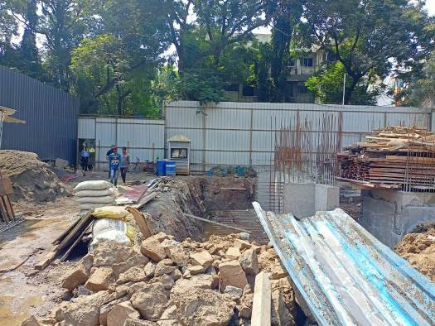
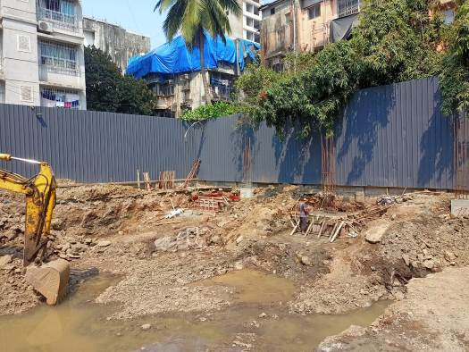
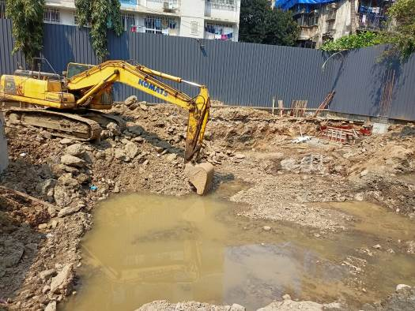
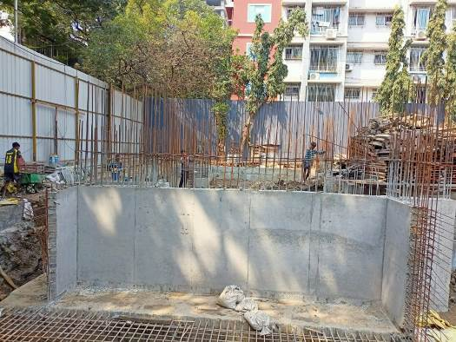
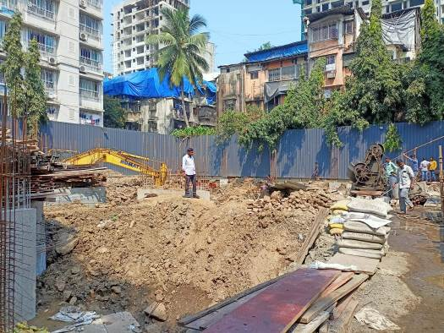
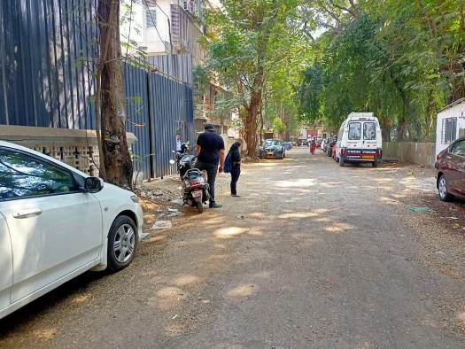

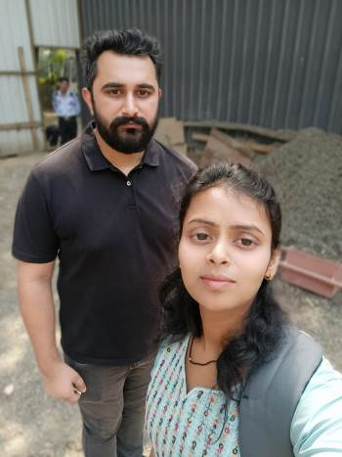
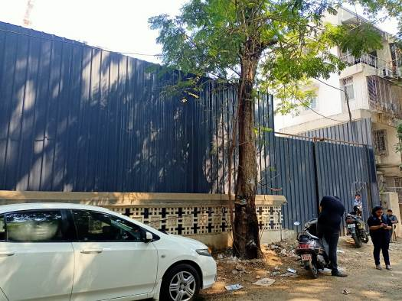
Route Map of the property
Site u/r
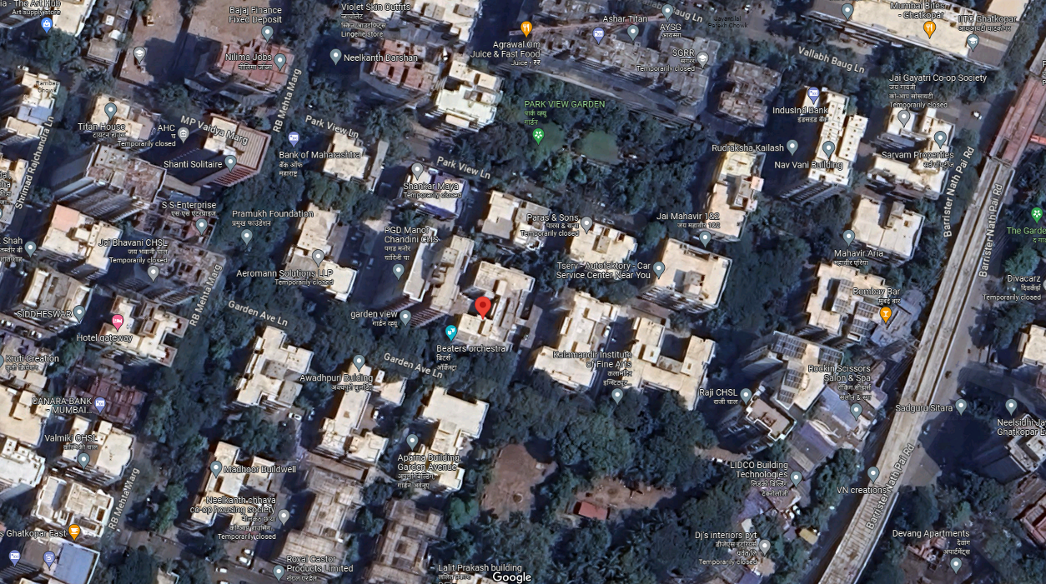

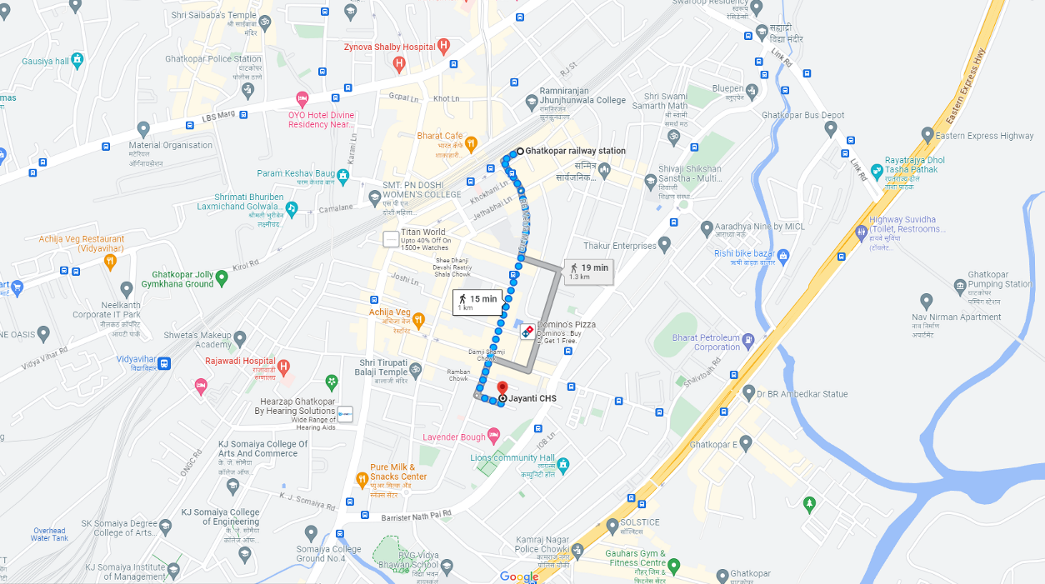

Latitude Longitude: 19°04'40.9"N 72°54'30.4"E
Note: The Blue line shows the route to site from nearest railway station (Ghatkopar – 1.00 Km.)

