# Valuation Report of the Immovable Property

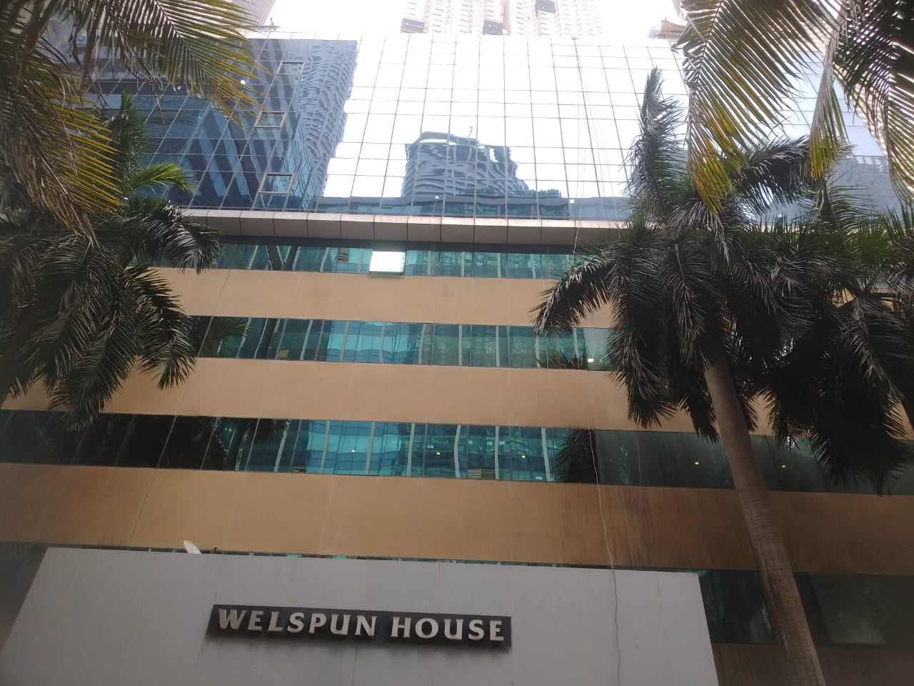

**Details of the property under consideration:**

Name of Proposed Purchaser: **M/s. Hitech Specialities Solutions Ltd.**

Name of Owner: **Jayant Jagannath Sirsat (HUF)**

Commercial Office Premises bearing Unit No. 204, 2nd Floor, Building Y (Trade Centre), **“Welspun House”,** Senapati Bapat Marg, Lower Parel, Mumbai – 400013, State - Maharashtra, Country – India.

# Latitude Longitude - 19°00’12.9”N 72°49’43.0”E

**Valuation Done for:**

**The Zoroastrian Co-operative Bank Ltd**

**Fort Branch**

Yusuf Building, Veer Nariman Road, Fort, Mumbai 400001,

State - Maharashtra, Country – India.

Vastu/Mumbai/11/2023/4873/2303600

22/19-296-SKVSU

Date: 22.11.2023

**VALUATION OPINION REPORT**

This is to certify that the property bearing Commercial Office Premises bearing Unit No. 204, 2nd Floor, Building Y (Trade Centre), **“Welspun House”,** Senapati Bapat Marg, Lower Parel, Mumbai – 400013, State - Maharashtra, Country – India belongs to **Jayant Jagannath Sirsat (HUF).** Name of **Proposed Purchaser** is **M/s. Hitech Specialities Solutions Ltd.**

|  |  |
| --- | --- |
| Boundaries of the property. | |
| North | Lodha Parkside |
| South | Internal Road |
| East | Under Construction Building |
| West | Times Tower |

Considering various parameters recorded, existing economic scenario, and the information that is available with reference to the development of neighbourhood and method selected for valuation, we are of the opinion that, the property premises can be assessed and **Fair Market Value** for this particular purpose at **` 6,64,30,000.00 (Rupees Six Crore Sixty Four Lakh Thirty Thousand Only).**

The valuation of the property is based on the documents produced by the concern. Legal aspects have not been taken into considerations while preparing this report.

Hence certified

**Manoj B. Chalikwar**

Registered Valuer

Chartered Engineer (India)

Reg. No. CAT-I-F-1763

TZCBL Emp. No. Ref: ZCBL/CO/AUD/19-20/100

Encl.: Valuation report

**VALUATION REPORT IN RESPECT OF IMMOVABLE PROPERTY**

|  |  |  |  |  |  |
| --- | --- | --- | --- | --- | --- |
| 1 | Date of Inspection | : | 06.11.2023 | | |
| 2 | Purpose of valuation | : | As per request from The Zoroastrian Co-operative Bank Ltd, Fort Branch, Fair Market Value of the property under reference for Banking purpose | | |
| 3 | Name and address of the Valuer | : | **Manoj B. Chalikwar**  **Vastukala Consultants (I) Pvt. Ltd.**  B1-001, U/B Floor, **Boomerang**, Chandivali Farm Road, Powai, Andheri (East), Mumbai – 400 072 | | |
| 4 | List of Documents Handed Over to The Valuer by The Bank | : |  | | |
|  | 1. Copy of Memorandum of Understanding dated 17.11.2023 between Jayant Jagannath Sirsat (HUF) (the Proposed Vendor) AND M/s. Hitech Specialities Solutions Ltd. (the Proposed Purchaser). 2. Copy of Agreement for Sale dated 03.05.1999 between Kamala Mills Ltd. (the Owner) AND Jayant Jagannathji Sirsat (HUF) (the Purchaser). 3. Copy of Declaration Letter dated 20.09.2023 issued by Kamala Mills Ltd. for Unit No. 204. 4. Copy of Occupancy Certificate No. EEBPO / 3289 / GS / A dated 15.06.1998 issued by Brihanmumbai Mahanagarpalika. 5. Copy of Completion Certificate No. EEBPC / 3058 / GS / A dated 25.02.2008 issued by Municipal Corporation of Greater Mumbai for Proposed Additions & Alterations to the existing Building X (known as Trade World) & Building Y (known as Trade Centre). 6. Copy of Commencement Certificate No. EEBPC / 3058 / GS / A dated 22.10.2007 issued by Municipal Corporation of Greater Mumbai for Proposed Additions & Alterations to the existing Building X (known as Trade World) & Building Y (known as Trade Centre). 7. Copy of Amended Approved Plan No. EEBP / 3058 / GS / A dated 23.10.2007 issued by Municipal Corporation of Greater Mumbai for Proposed Additions & Alterations to the existing Building Y (known as Trade Centre). 8. Copy of Electricity Bill Invoice No. ELE/2023-24/212 dated 14.10.2023 in the name of M/s. Hitech Corporations Ltd. issued by M/s. Kamala Mills Ltd. for Unit Nos. 204 to 206. | | | | |
| 5 | Details of enquiries made/ visited to government Office for arriving fair market value. | : | Market analysis and as per sub-registrar value. | | |
| 6 | Factors for determining its market value. | : | Location, development of surrounding area, type of construction, construction specifications, age of building, condition of the premises & building, facilities provided and its prevailing market rate. | | |
| 7 | ANY CRITICAL ASPECTS ASSOCIATED WITH PROPERTY | : | No | | |
| 8 | Present/Expected Income from the property | : | ` 10,00,000.00 Present rental income per month for Unit Nos. 204 to 206 | | |
|  | **Property Details** | : |  | | |
| 9 | Name(s) of the Owner | : | **Name of Proposed Purchaser**  M/s. Hitech Specialities Solutions Ltd.  **Name of Owner**  Jayant Jagannath Sirsat (HUF) | | |
|  | Address | : | Commercial Office Premises bearing Unit No. 204, 2nd Floor, Building Y (Trade Centre), **“Welspun House”,** Senapati Bapat Marg, Lower Parel, Mumbai – 400013, State - Maharashtra, Country – India. | | |
| 10 | If the property is under joint ownership/ co-ownership share of each such owner/ are the share is undivided. | : | Name of Proposed Purchaser: Ltd. Company Ownership  Name of Owner: Sole Ownership | | |
| 11 | Brief description of the property. | : | The property is Commercial Office Premises located on 2nd Floor. As per site inspection, Unit Nos. 204 to 206 are internally amalgamated to form a single unit having single entrance and given on rent to M/s. Hitech Corporations. The composition of Amalgamated Office Nos. 204 to 206 is Reception + Working Area + Cabins + Toilets + Pantry + Passage. The property is at 1.2 Km. walkable distance from nearest railway station Lower Parel. | | |
| 12 | Location of the property (C.T.S. No., Survey No., Hissa No., Plot No., etc.). | : | C. S. No. 448 of Lower Parel Division | | |
| 13 | **Boundaries** | : | **As per Site** | | **As per Documents** |
|  | North | : | Lodha Parkside | | Details not available |
|  | South | : | Internal Road | | Details not available |
|  | East | : | Under Construction Building | | Details not available |
|  | West | : | Times Tower | | Details not available |
| 14 | Matching of Boundaries | : | N.A. | | |
| 15 | Route map | : | Enclosed | | |
| 16 | Any specific identification marks | : | Kamala Mills Compound | | |
| 17 | Whether covered under Corporation/ Panchayat/ Municipality. | : | Municipal Corporation of Greater Mumbai | | |
| 18 | Whether covered under any land ceiling of State/ Central Government. | : | No | | |
| 19 | Is the land freehold/ leasehold? | : | Free Hold | | |
| 20 | Are there any restrictive covenants in regard to use of Land? If so, attach a copy of the covenant. | : | As Per Agreement | | |
| 21 | Type of the property | : | Residential | | |
| 22 | Year of acquisition/ purchase. | : | Memorandum of Understanding dated 17.11.2023 | | |
| 23 | Purchase value as per document | : | ` 5,77,63,761.00 | | |
| 24 | Whether the property is occupied by owner or tenant. If occupied by tenant since how long he is staying and the amount of rent being paid. | : | Tenant Occupied - Hitech Corporations for Office Nos. 204 to 206.  ` 10,00,000.00 Present rental income per month for Unit Nos. 204 to 206 | | |
| 25 | Classification of the site | : |  | | |
|  | 1. Population group | : | Urban | | |
|  | 1. High/ Middle/ Poor class | : | Higher Middle Class | | |
|  | 1. Residential/ Non-Residential | : | Commercial | | |
|  | 1. Development of surrounding area | : | Developed Area | | |
|  | 1. Possibility of any threat to the property (Floods, calamities etc.). | : | No | | |
| 26 | Proximity of civic amenities (like school, hospital, bus stop, market etc.). | : | All Available near by | | |
| 27 | Level of the land (Plain, rock etc.) | : | Plain | | |
| 28 | Terrain of the Land. | : | Levelled | | |
| 29 | Shape of the land (Square/ rectangle etc.). | : | Irregular | | |
| 30 | Type of use to which it can be put (for construction of house, factory etc.). | : | Commercial purpose | | |
| 31 | Whether the plot is under town planning approved layout? | : | Information not Available | | |
| 32 | Whether the building is intermittent or corner? | : | Intermittent | | |
| 33 | Whether any road facility is available? | : | Yes | | |
| 34 | Type of road available (B.T/Cement Road etc.). | : | B.T. Road | | |
| 35 | Front Width of the Road? | : | 09.00 Mt. | | |
| 36 | Source of water & water potentiality. | : | Municipal Water Supply | | |
| 37 | Type of Sewerage System. | : | Connected to Municipal Sewerage System | | |
| 38 | Availability of power supply. | : | Yes | | |
| 39 | Advantages of the site. | : | Located in developed area | | |
| 40 | Disadvantages of the site. | : | No | | |
| 41 | Give instances of sales of immovable property in the locality on a separate sheet, indicating the name & address of the property, registration No. sale price and area of land sold. | : | As per Sub-Registrar of Assurance records | | |
|  | **Valuation of the property:** | | | | |
| 42 | Total area of the Commercial Office | : | Carpet Area in Sq. Ft. = 5,603.00  (Area as per actual site measurement for Amalgamated Unit Nos. 204 to 206)  **Carpet Area in Sq. Ft. = 1,898.00**  **(Area as per Memorandum of Understanding / Declaration Letter for Unit No. 204)**  Built Up Area in Sq. Ft. = 2,278.00  (Area as per Declaration Letter for Unit No. 204) | | |
| 43 | Prevailing market rate. | : | ` 35,000.00 per Sq. Ft. Rate on Carpet Area | | |
| 44 | Floor Rise Rate per Sq. Ft. | : | ` 0.00 | | |
| 45 | PLC Rate per Sq. Ft. | : | ` 0.00 | | |
| 46 | Total Rate per Sq. Ft. | : | ` 35,000.00 per Sq. Ft. Rate on Carpet Area | | |
| 47 | Guideline rate obtained from the Stamp Duty Ready Reckoner. | : | ` 3,74,860.00 per Sq. M. i.e.  ` 34,825.00 per Sq. Ft. | | |
|  | Guideline rate obtained from the Stamp Duty Ready Reckoner. | : | ` 3,12,673.00 per Sq. M. i.e.  ` 29,048.00 per Sq. Ft. | | |
| 48 | Value of the property | : | **` 6,64,30,000.00** | | |
| 49 | The realizable value of the property | : | **` 5,97,87,000.00** | | |
| 50 | Distress value of the property | : | **` 5,31,44,000.00** | | |
| 51 | Insurable value of the property | : | **` 61,49,520.00** | | |
|  | **Technical details of the building:** | | | | |
| 52 | Type of building (Residential / Commercial / Industrial). | : | | Commercial | |
| 53 | Year of construction. | : | | 1998 (As per Occupancy Certificate) | |
| 54 | Future life of the property. | : | | 35 years Subject to proper, preventive periodic maintenance & structural repairs. | |
| 55 | No. of floors and height of each floor including basement. | : | | Ground + 7 Upper Floors.  2nd Floor is having 6 Offices. | |
|  | **Type of construction** | | | | |
| 56 | (Load bearing/ R.C.C./ Steel framed) | : | | R.C.C. Framed Structure | |
|  | **Condition of the building.** | | | | |
| 57 | External (excellent/ good/ normal/ poor) | : | | Good | |
| 58 | Internal (excellent/ good/ normal/ poor). | : | | Good | |
| 59 | Whether the Commercial Office is constructed strictly according to the sanctioned plan, details of variations noticed if any and effect of the same on the valuation | : | | Copy of Amended Approved Plan No. EEBP / 3058 / GS / A dated 23.10.2007 issued by Municipal Corporation of Greater Mumbai for Proposed Additions & Alterations to the existing Building Y (known as Trade Centre). | |
|  | **Remarks:**   1. As per site inspection, Unit Nos. 204 to 206 are internally amalgamated to form a single unit having single entrance and given on rent to M/s. Hitech Corporations. The said valuation is for Unit No. 204. 2. For the purpose of valuation, we have considered the area as per Area as per Memorandum of Understanding / Declaration Letter. | | | | |
| 60 | **Specifications of Construction:** | | | | |
| **sr.** | **Description** | : | | **2nd Floor** | |
| a | Foundation | : | | R.C.C. Foundation | |
| b | Basement | : | | No | |
| c | Superstructure | : | | R.C.C. frame work with 9-inch-thick B. B. Masonry for external walls 6-inch thick B.B. Masonry for internal walls | |
| d | Joinery/Doors/Windows | : | | Glass doors | |
| e | RCC Work | : | | R.C.C. Framed Structure | |
| f | Plastering | : | | Cement Plastering + POP false ceiling | |
| g | Flooring, Skirting | : | | Vitrified tiles flooring | |
| h | Pantry Platform | : | | Granite | |
| i | Whether any proof course is provided? | : | | No | |
| j | Drainage | : | | Connected to Municipal Sewerage System | |
| k | Compound Wall (Height, length and type of construction) | : | | Provided | |
| l | Electric Installation (Type of wire, Class of construction) | : | | Concealed wiring | |
| m | Plumbing Installation (No. of closets and wash basins etc.) | : | | Concealed plumbing | |
| n | Bore Well | : | | Not Provided | |
| o | Wardrobes, if any | : | | No. | |
| p | Development of open area | : | | 3 Open Car Parking Spaces (as per Memorandum of Understanding / Declaration Letter), Chequered tile in open spaces, etc. | |
|  | **Valuation of proposed construction/ additions/ renovation if any:** | | | | |
| 61 | **SUMMARY OF VALUATION:** | : | |  | |
|  | Part I Land | : | | ` 0.00 | |
|  | Part II Building | : | | **` 6,64,30,000.00** | |
|  | Part III Other amenities/ Miscellaneous | : | | ` 0.00 | |
|  | Part IV Proposed construction | : | | ` 0.00 | |
|  | **TOTAL.** | : | | **` 6,64,30,000.00** | |
|  | **Calculation:** | | | | |
| **1** | **Construction** | : | |  | |
| 1.01 | Built up Area of Commercial Office | : | | 2,278.00 Sq. Ft. | |
| 1.02 | Rate per Sq. Ft. | : | | ` 2,700.00 | |
| 1.03 | Cost of Construction = (1.01 x 1.02) | : | | **` 61,49,520.00** | |
| **2** | **Value of property** | : | |  | |
| 2.01 | Total Carpet Area of Commercial Office | : | | 1,898.00 Sq. Ft. | |
| 2.02 | Rate per Sq. Ft. | : | | ` 35,000.00 | |
| 2.03 | Floor Rise Rate per Sq. Ft. | : | | ` 0.00 | |
| 2.04 | PLC Rate per Sq. Ft. | : | | ` 0.00 | |
| 2.05 | Total Rate per Sq. Ft. | : | | ` 35,000.00 | |
| 2.06 | Value of Commercial Office = (2.01 x 2.05) | : | | **` 6,64,30,000.00** | |
| **3** | **The value of the property.** | : | | **` 6,64,30,000.00** | |

I certify that,

I/ my authorized representative, has inspected the subject property on 06.11.2023.

The rates for valuation of the property are in accordance with the Govt. approved rates and prevailing market rates.

There is no direct/ indirect interest in the property valued.

**Actual site photographs**

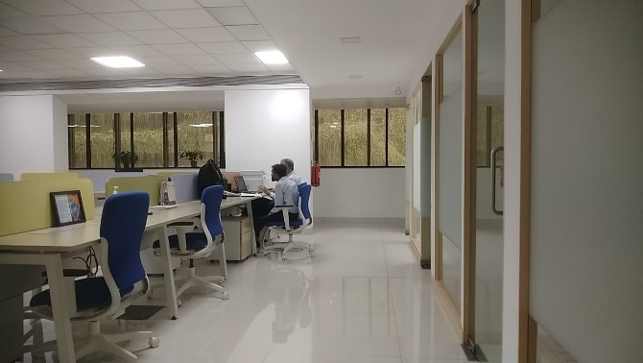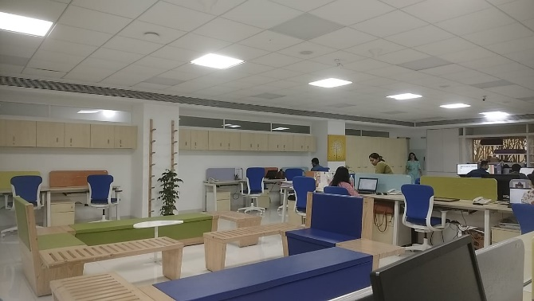

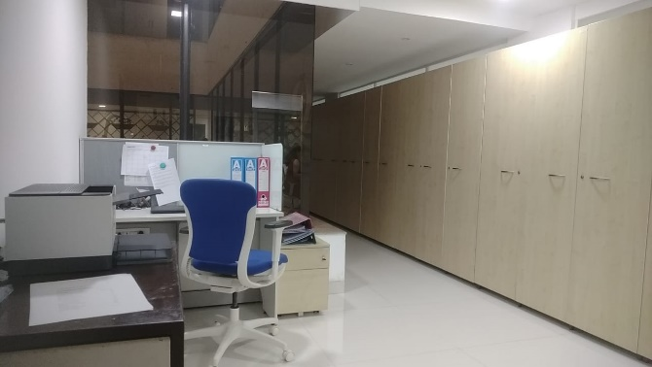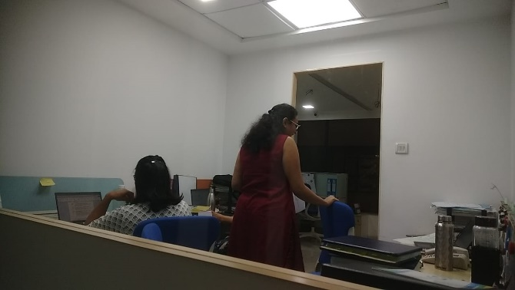

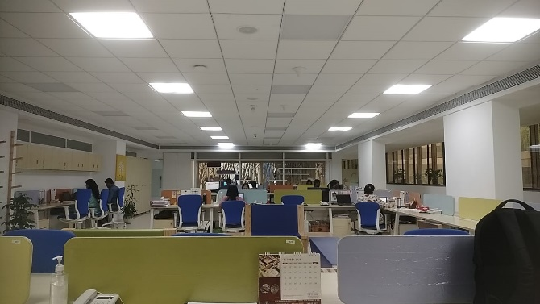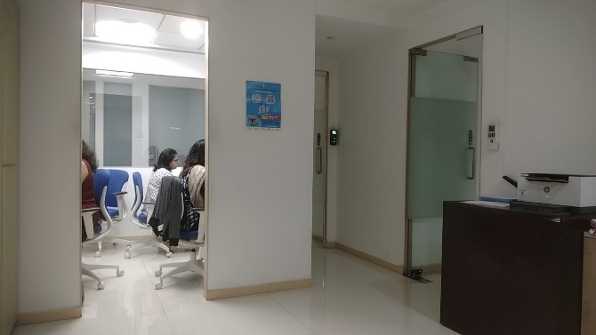

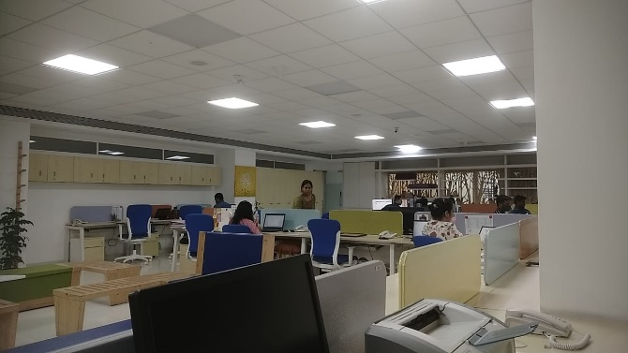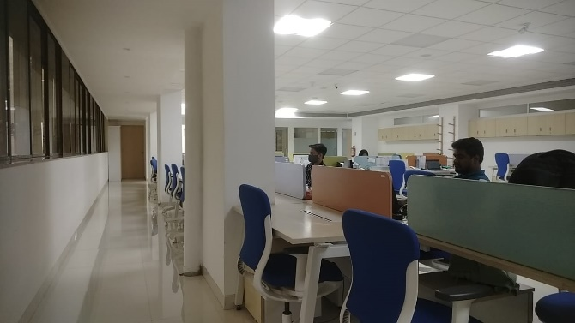

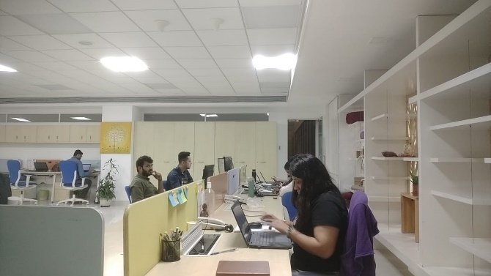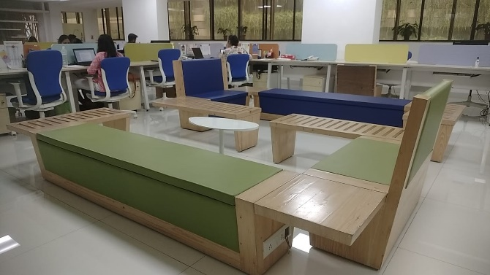

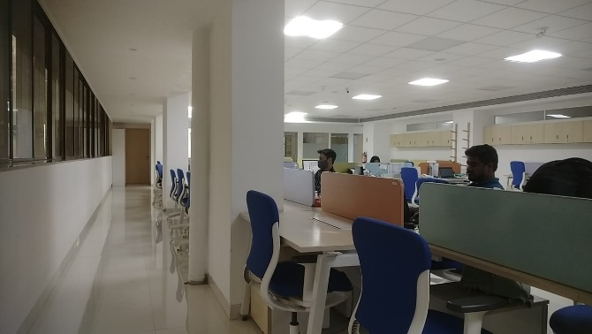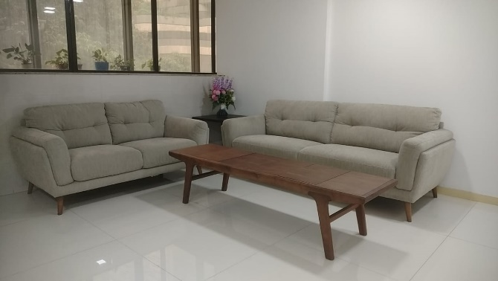**Actual site photographs**

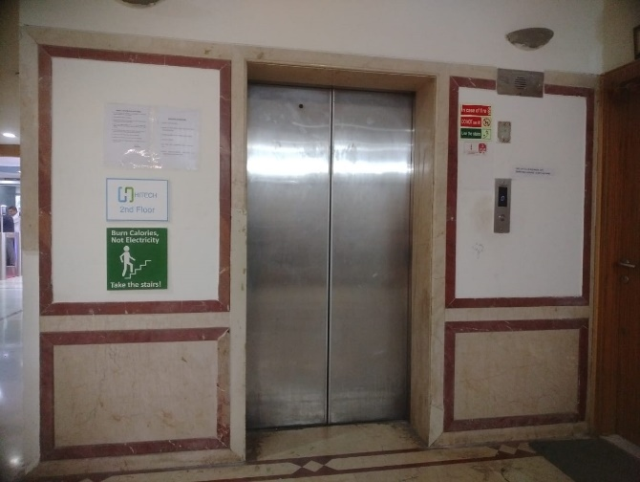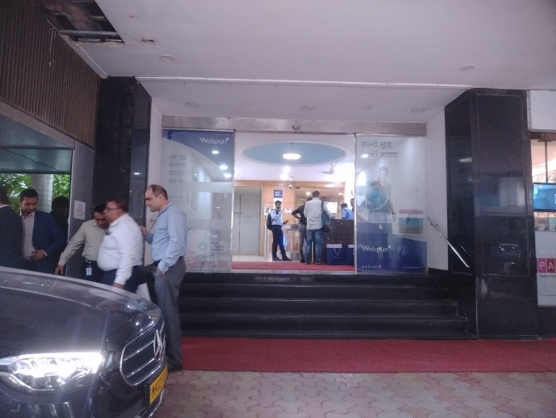

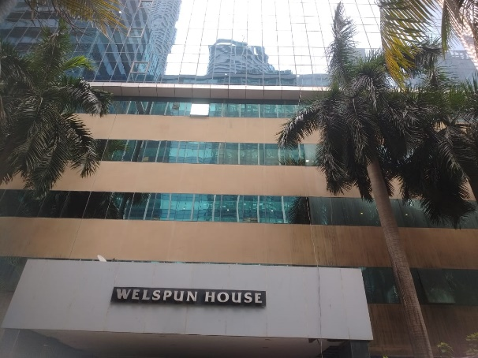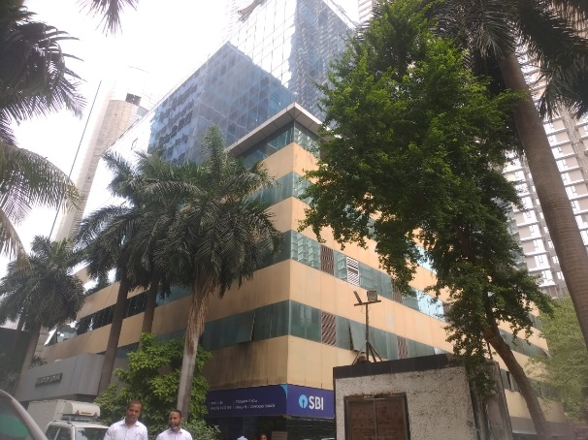

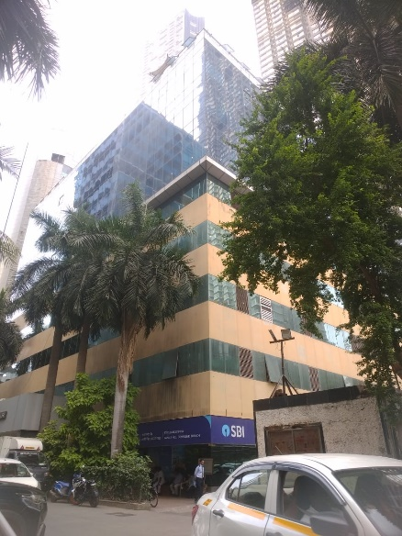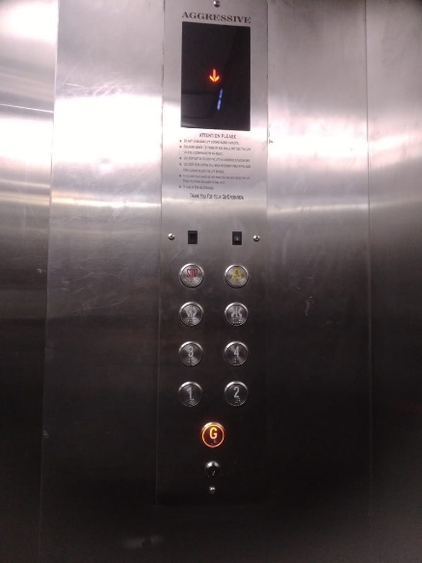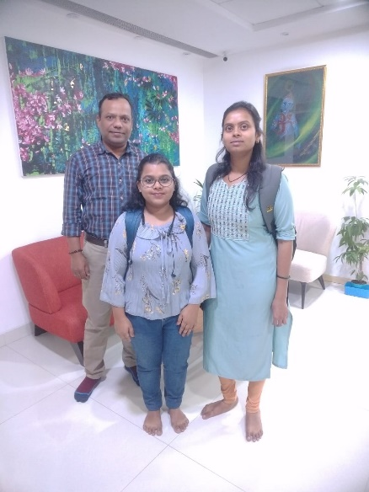

**Route Map of the property**

**Site u/r**

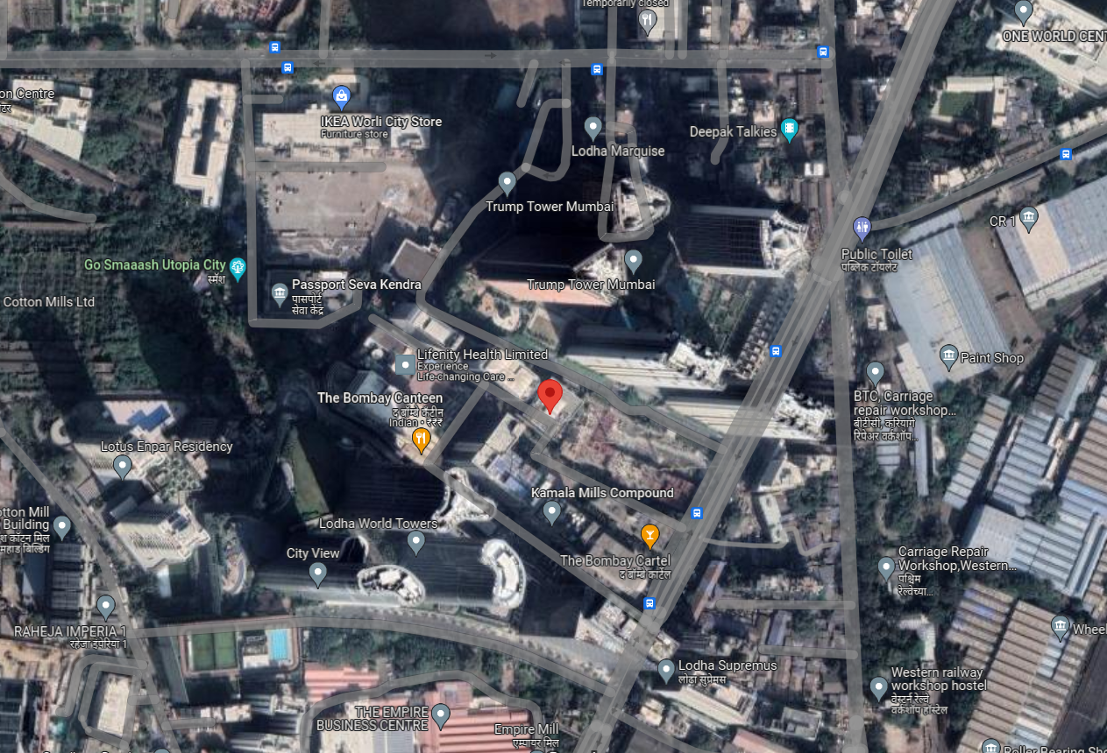

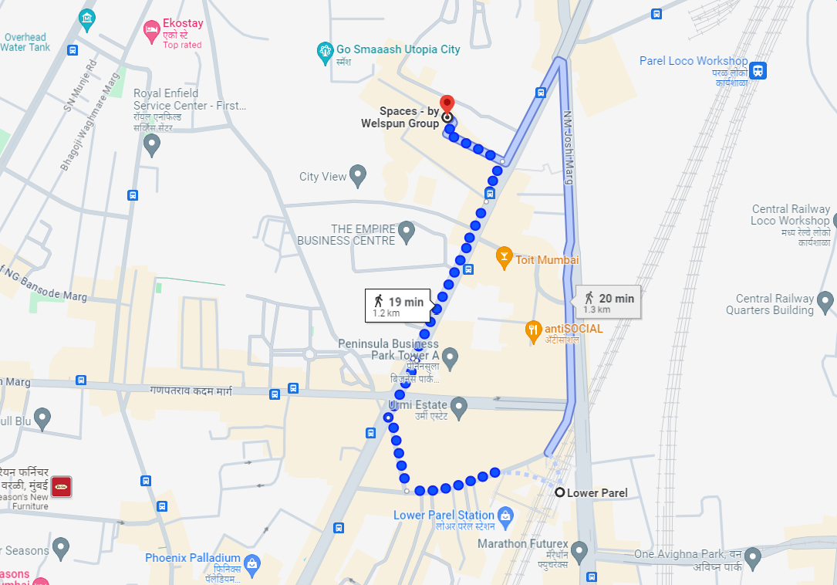

# Latitude Longitude - 19°00’12.9”N 72°49’43.0”E

**Note**: The Blue line shows the route to site from nearest railway station (Lowr Parel – 1.2 KM.)

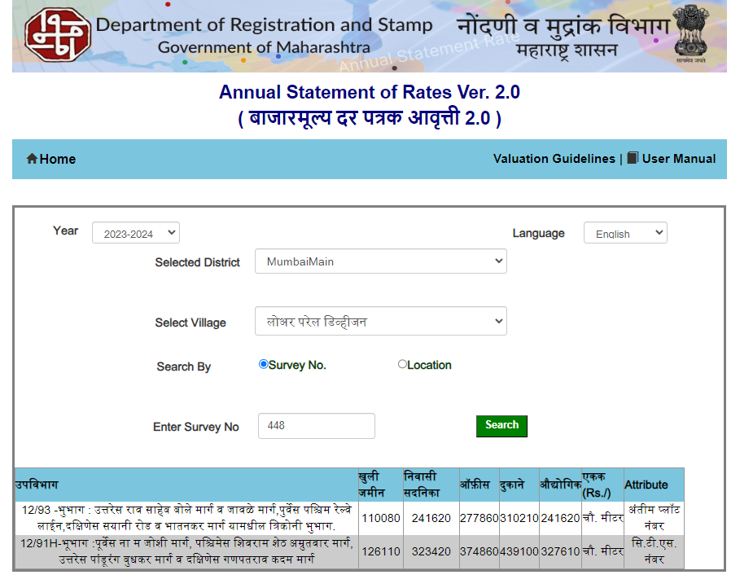**Ready Reckoner Rate**

|  |  |  |  |  |
| --- | --- | --- | --- | --- |
| Stamp Duty Ready Reckoner Market Value Rate for **Unit** | 3,74,860.00 |  |  |  |
| No increase for all floors from ground to 4 floors | 0.00 |  |  |  |
| **Stamp Duty Ready Reckoner Market Value Rate (After Increase) (A)** | 3,74,860.00 | **Sq. Mtr.** | **34,825.00** | **Sq. Ft.** |
| Stamp Duty Ready Reckoner Market Value Rate for **Land (B)** | 1,26,110.00 |  |  |  |
| The difference between land rate and building rate (A – B = C) | 2,48,750.00 |  |  |  |
| Depreciation Percentage as per table (D) [100% - 25%]  (Age of the Building – 25 Years) | 75% |  |  |  |
| **Rate to be adopted after considering depreciation [B + (C x D)]** | **3,12,673.00** | **Sq. Mtr.** | **29,048.00** | **Sq. Ft.** |

**Multi-Storied building with Lift**

For residential premises / commercial unit / office on above floor in multistoried building, the rate mentioned in the ready reckoner will be increased as under:

|  |  |  |
| --- | --- | --- |
|  | **Location of Flat / Commercial Unit in the building** | **Rate** |
| a) | On Ground to 4 Floors | No increase for all floors from ground to 4 floors |
| b) | 5 Floors to 10 Floors | Increase by 5% on units located between 5 to 10 floors |
| c) | 11 Floors to 20 Floors | Increase by 10% on units located between 11 to 20 floors |
| d) | 21 Floors to 30 Floors | Increase by 15% on units located between 21 to 30 floors |
| e) | 31 Floors and above | Increase by 20% on units located on 31 and above floors |

**Table – D: Depreciation Percentage Table**

|  |  |  |
| --- | --- | --- |
| **Completed Age of Building in Years** | **Value in percent after depreciation** | |
|  | **R.C.C. Structure / other Pukka Structure** | **Cessed Building, Half or Semi – Pukka Structure & Kaccha Structure.** |
| 0 to 2 Years | 100% | 100% |
| Above 2 & up to 5 Years | 95% | 95% |
| Above 5 Years | After initial 5 year for every year 1% depreciation is to be considered. However maximum deduction available as per this shall be 70% of Market Value rate | After initial 5 year for every year 1.5% depreciation is to be considered. However maximum deduction available as per this shall be 85% of Market Value rate |

**Sale Instance**

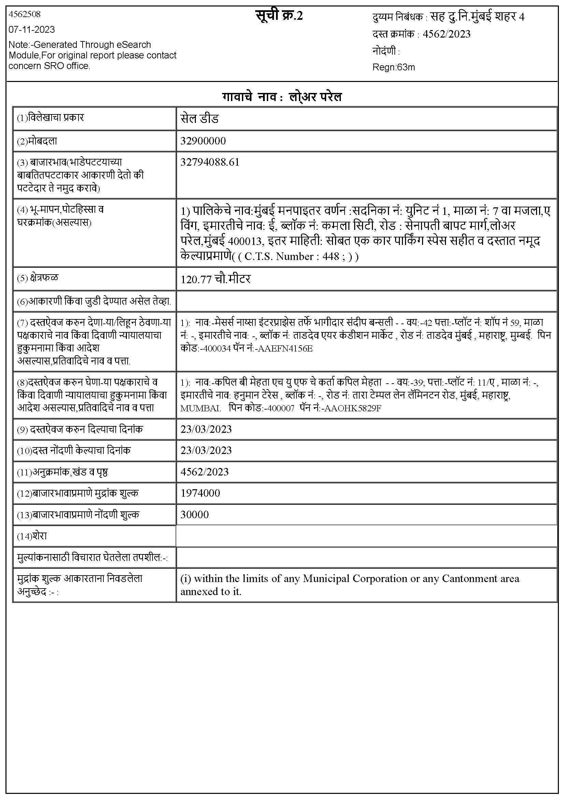

**Sale Instance**

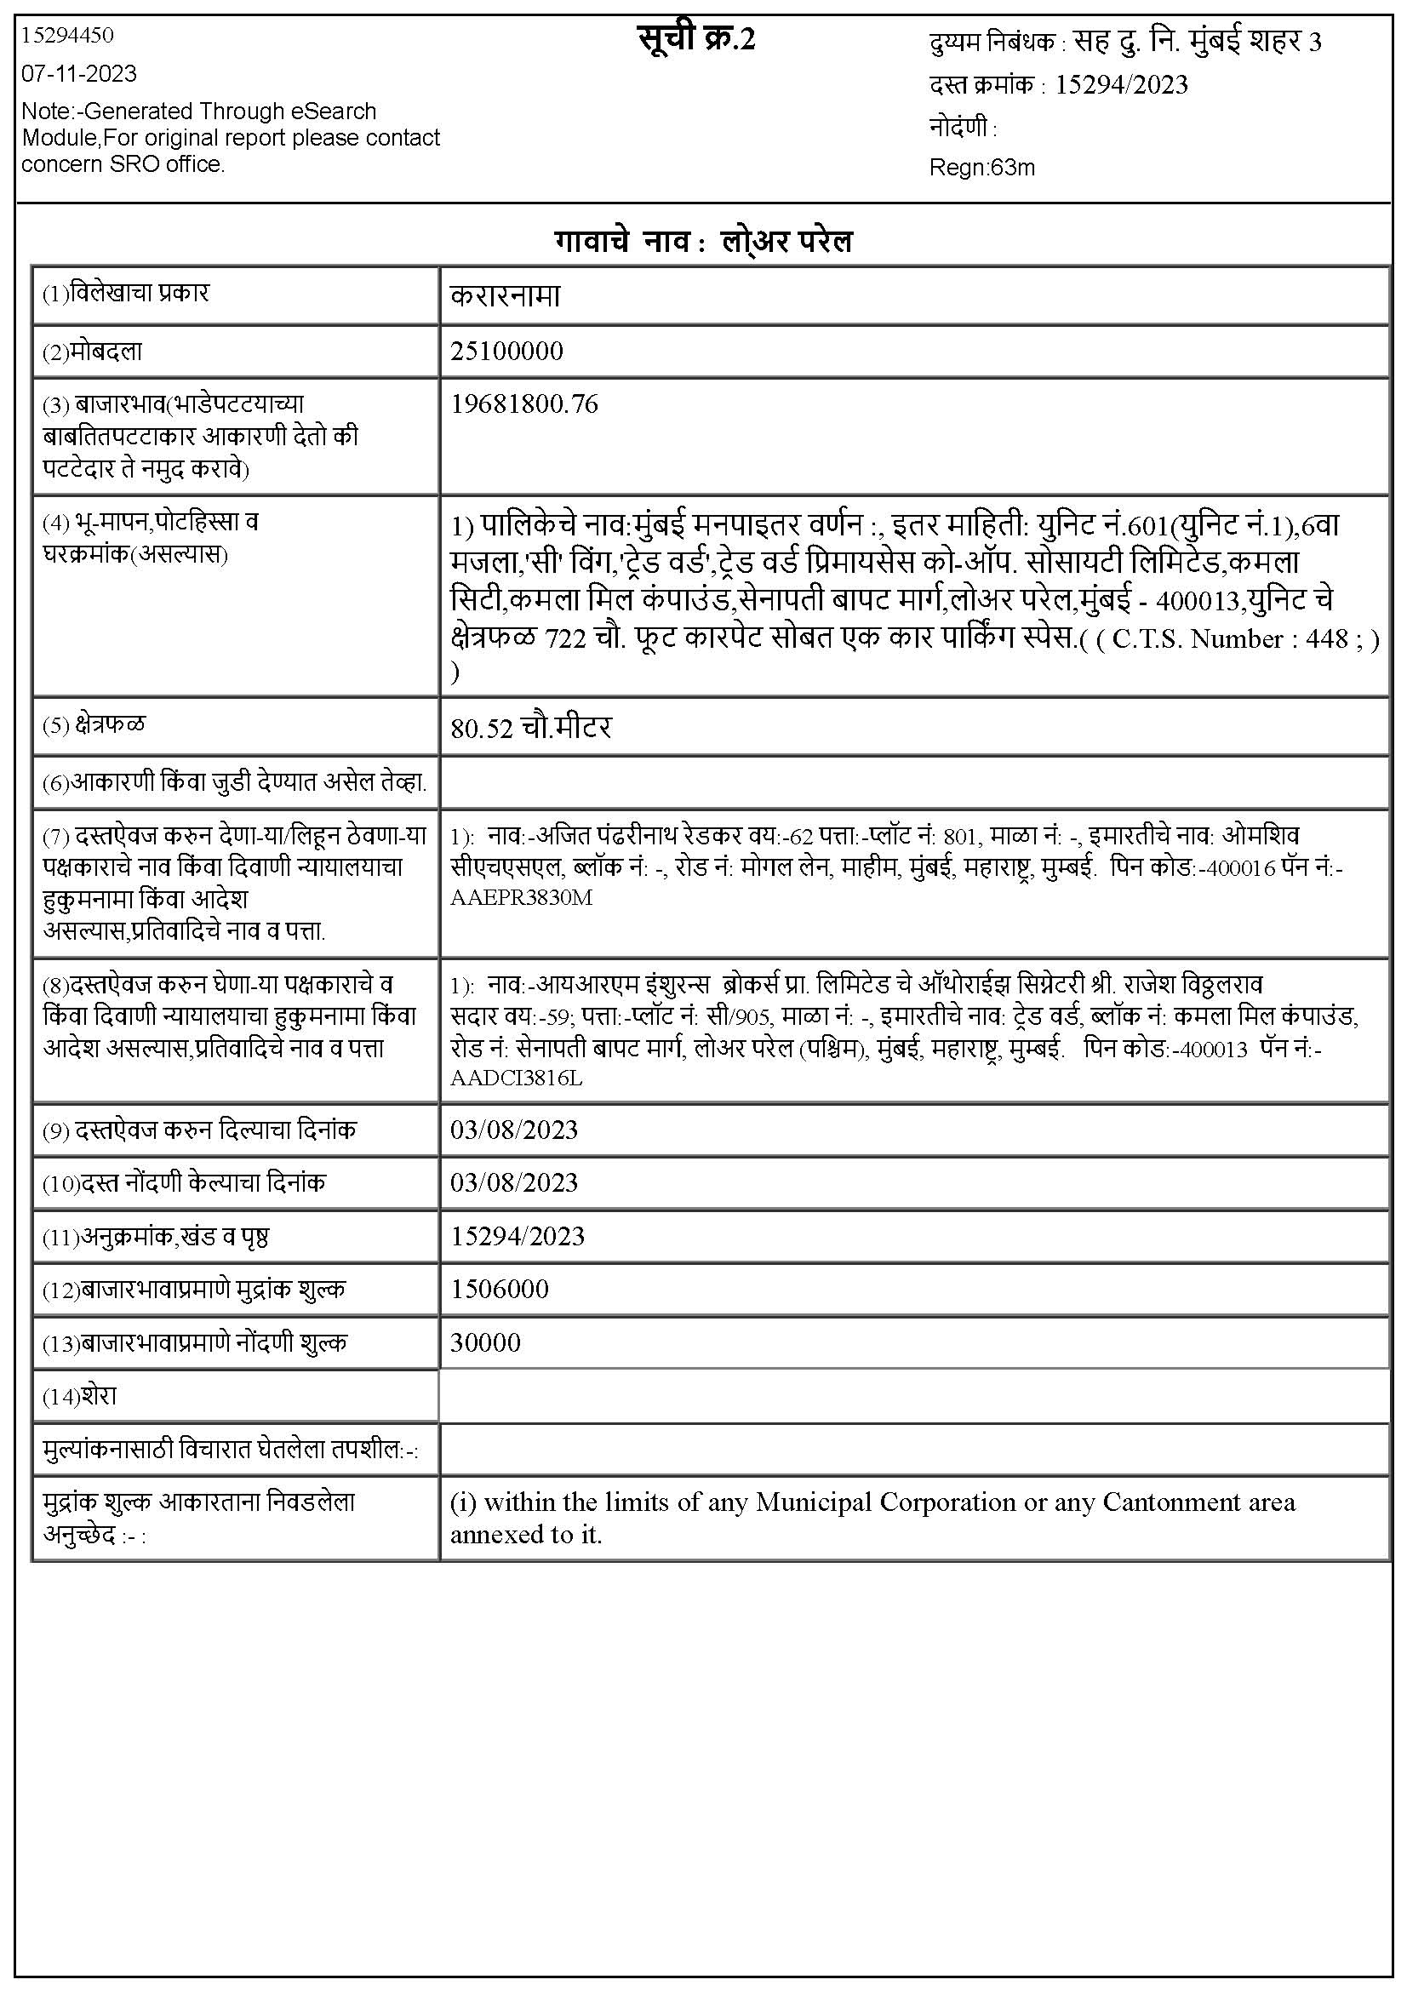

**Price Indicator**

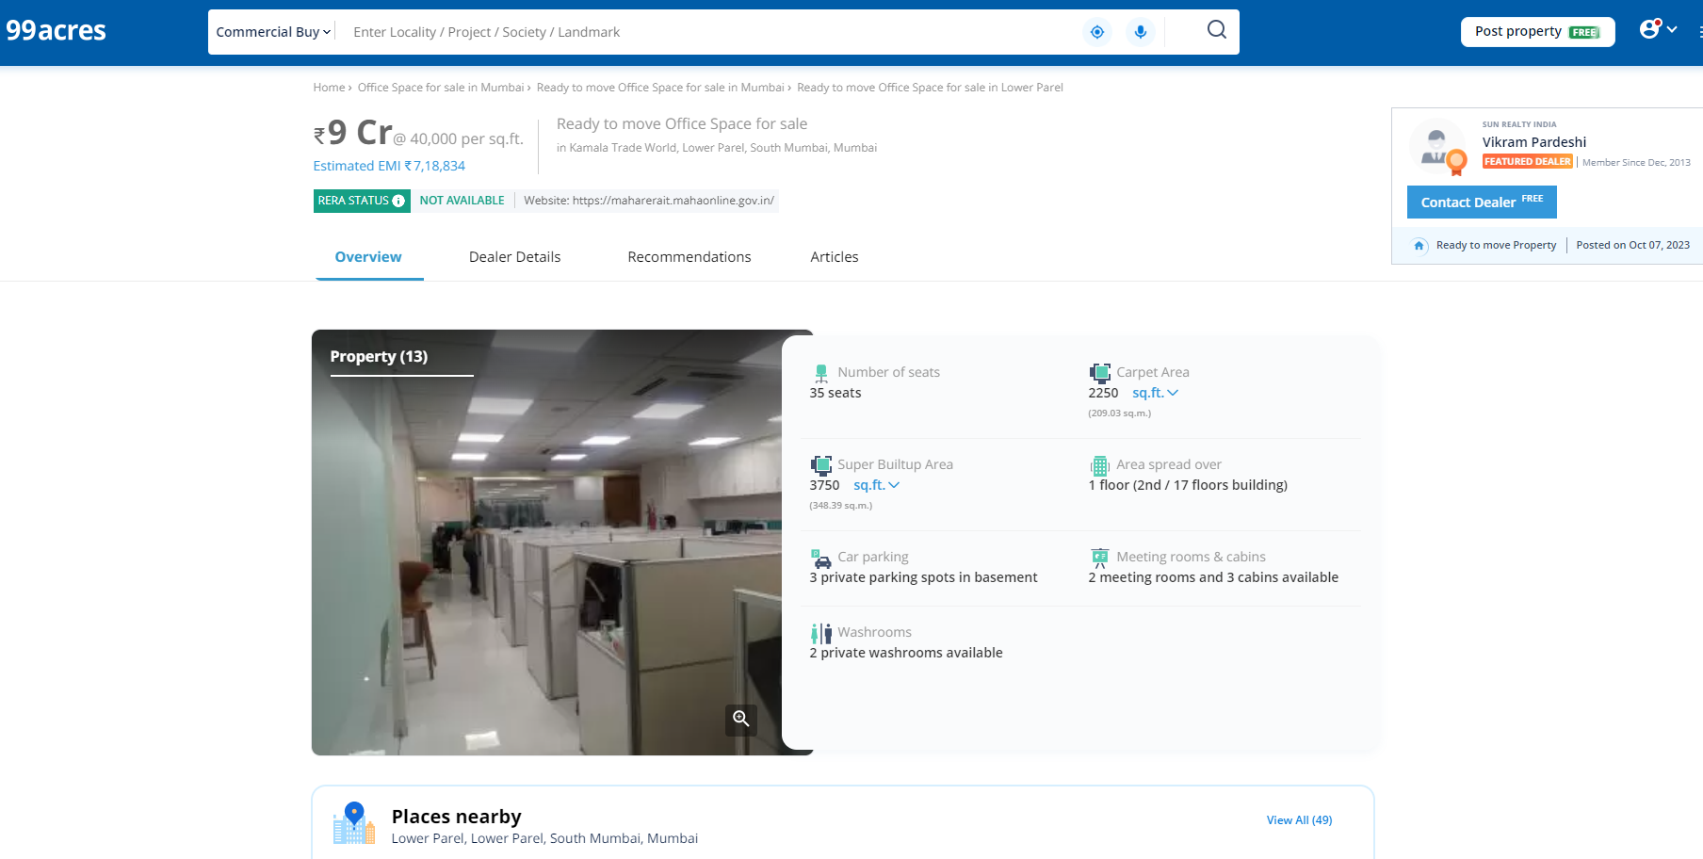

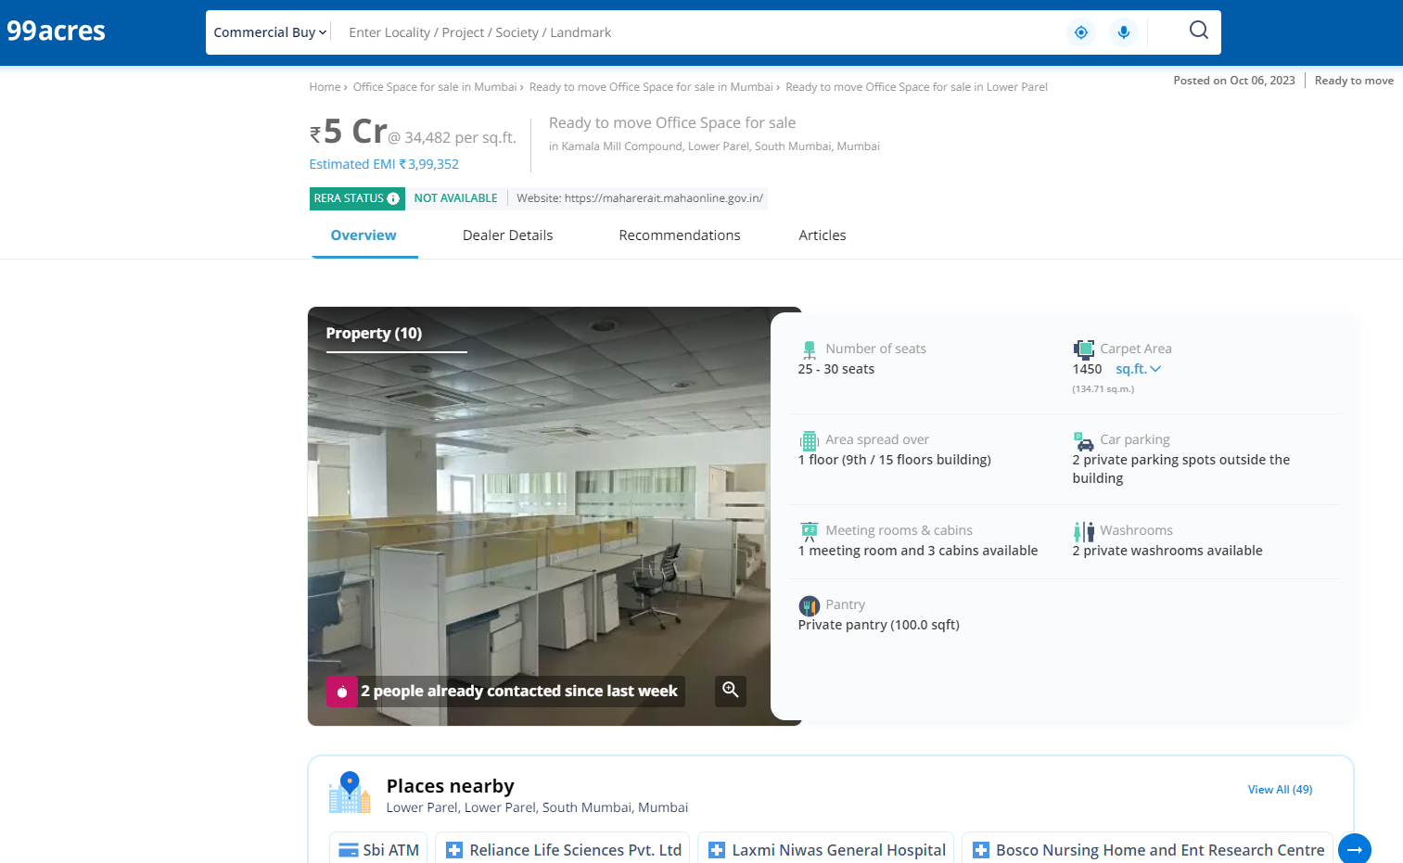

**Price Indicators**

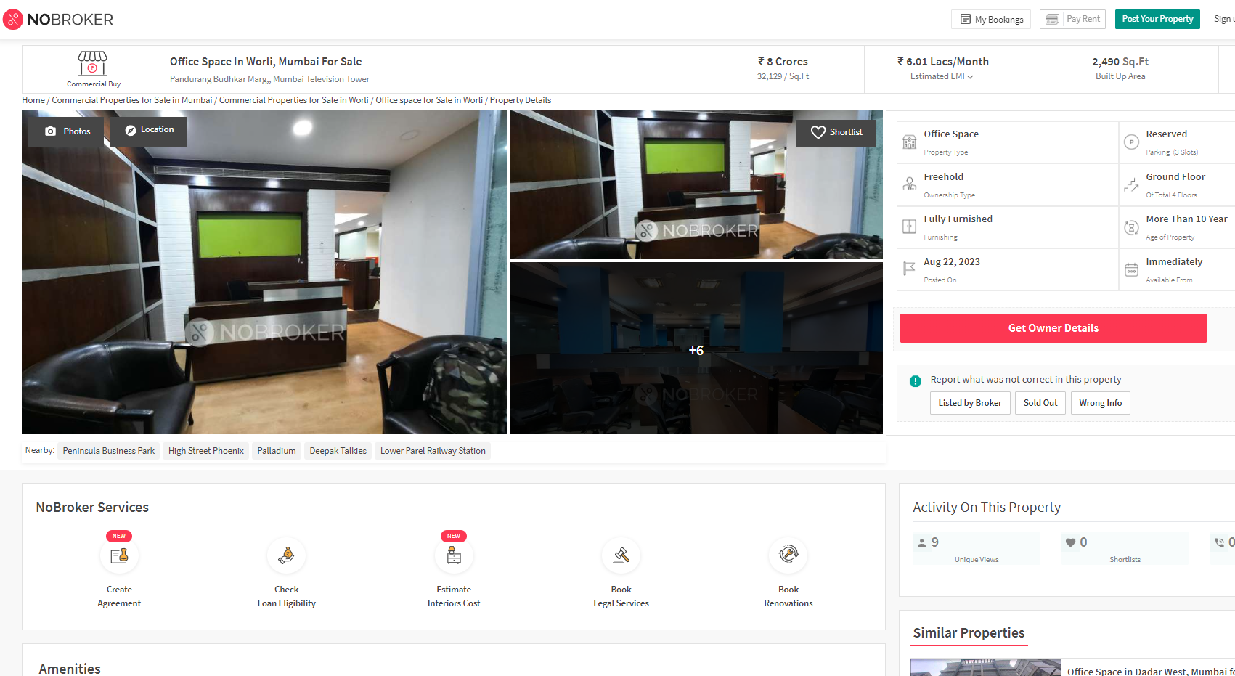

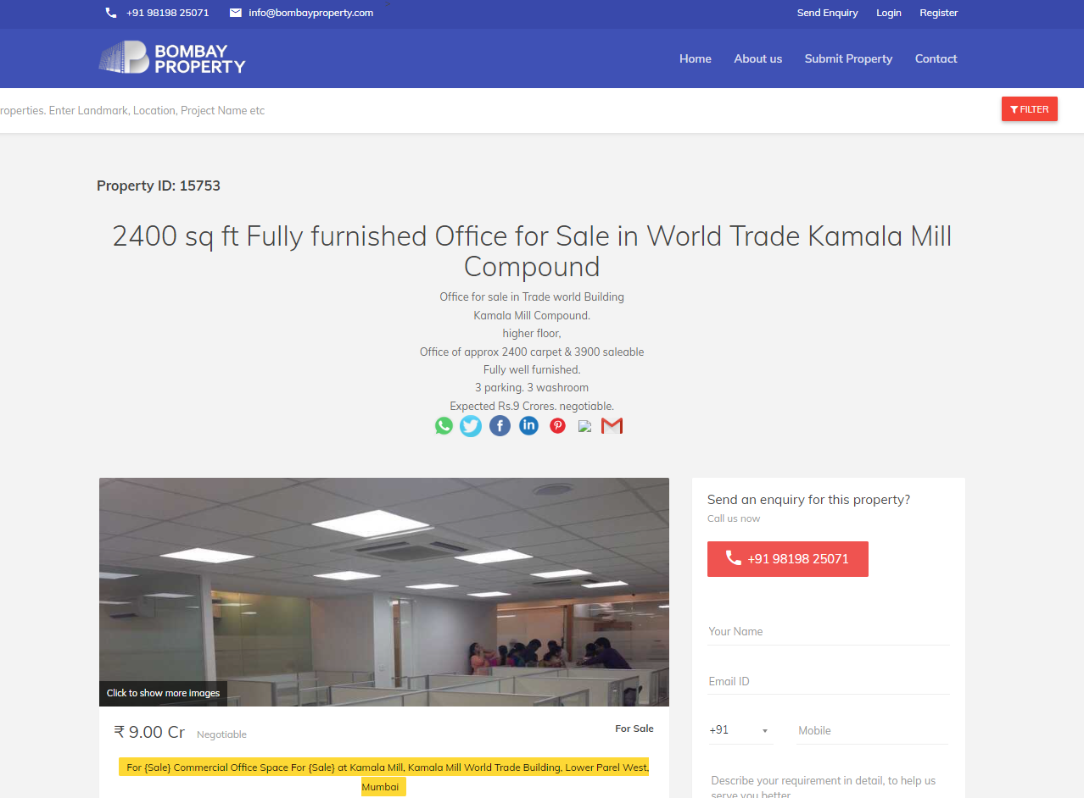

**Declaration Letter**

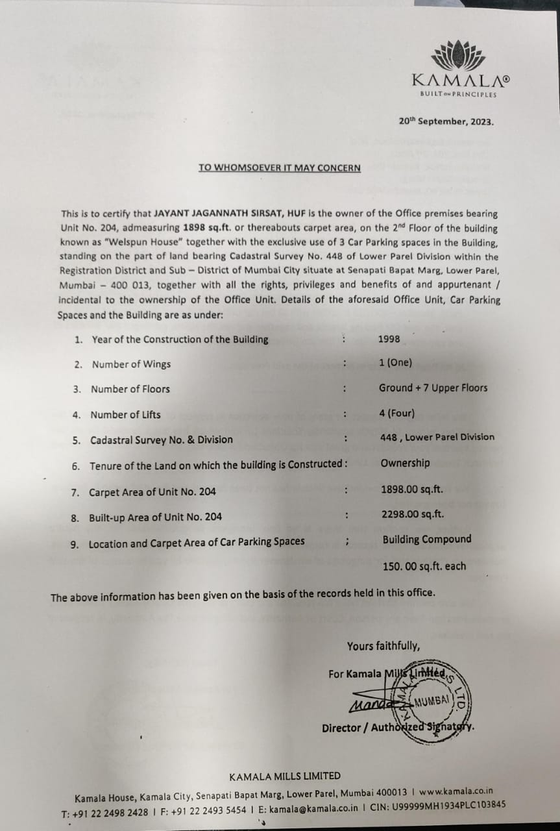

**DEFINITION OF VALUE FOR THIS SPECIFIC PURPOSE**

This exercise is to assess **Fair Market Value** of the property under reference for **Fair Market Value** purpose as on dated **22nd November 2023.**

The term **Fair Market Value** is defined as

*"The most probable price, as of a specified date, in cash, terms equivalent to cash, or in other precisely revealed terms for which the specified property rights would sell after reasonable exposure in a competitive market under all conditions requisite to a fair sale, with the buyer and seller each acting prudently knowledgeably and for self-interest assuming that neither is under undue duress"*

Fundamental assumptions and conditions presumed in this definition are:

1. Buyer and seller are motivated by self-interest.
2. Buyer and seller are well informed and are acting prudently.
3. The property is exposed for a reasonable time on the open market.
4. Payment is made in cash or equivalent or in specified financing terms.

**ASSUMPTIONS, CAVEATS, LIMITATION AND DISCLAIMERS**

1. We assume no responsibility for matters of legal nature affecting the property appraised or the title thereto, nor do we render our opinion as to the title, which is assumed to be good and marketable.
2. The property is valued as though under responsible ownership.
3. It is assumed that there are no hidden or unapparent conditions of the subsoil or structure that would render it more or less valuable. No responsibility is assumed for such conditions or for engineering that might be required to discover such factors.
4. There is no direct/ indirect interest in the property valued.
5. The rates for valuation of the property are in accordance with the Govt. approved rates and prevailing market rates.

**DECLARATION OF PROFESSIONAL FEES CHARGED**

We hereby declare that, our professional fees are not contingent upon the valuation findings. However, if the statute AND/OR clients demands that, the fees should be charged on the percentage of assessed value then, with the full knowledge of the AND/OR end user, it is being charged accordingly.

**VALUATION OF THE PROPERTY PREMISES**

Considering various parameters recorded herein above, existing economic scenario, and the information that is available with reference to the development of neighbourhood and method selected for valuation, we are of the opinion that, the property premises can be assessed and valued for this particular purpose at **` 6,64,30,000.00 (Rupees Six Crore Sixty Four Lakh Thirty Thousand Only).**

**Manoj B. Chalikwar**

Registered Valuer

Chartered Engineer (India)

Reg. No. CAT-I-F-1763

TZCBL Emp. No. Ref: ZCBL/CO/AUD/19-20/100