Vastu/Nashik/11/2023/004858/2303349
03/15-45-RPV
Date: 03.11.2023

To, `
The Branch Manager,
Bank of Baroda
Regional Office
BSNL Building, Datta Mandir Road, Nashik Road,
Nashik -422 101, State - Maharashtra, Country - India.

Sub: Vetting of Extra Amenities

Sir,

With reference to above subject, we have evaluated the Extra Amenities for Residential Row House No. I, Ground + First Floor “Sai Siddhi Row Houses”, Survey No.298/1, Plot No.53 to 58/E to H/1/2/I, Behind Water Tank, Damodar Nagar, Village - Pathardi, Taluka & District - Nashik, PIN Code – 422 010, State – Maharashtra, Country – India. belongs to Asmitaben Maheshbhai Unjiya. Name of Proposed Purchaser: Sau.Jijabai Ravindra Bele & Shri.Ravindra Vitthal Bele.

We have verified the rates quoted as per current market rates. Details of work and Extra Amenities considered as per copy of Agreement for Extra Amenities between Sau.Jijabai Ravindra Bele & Shri.Ravindra Vitthal Bele (First Part) and Shri.Vipul Vallabhbhai Unjiya (Second Part) received on dated 25.10.2023. The Extra Amenities amount is Rs.4,00,000/- (Rupees Four Lakh Only)

The said Cost Vetting Certificate is valid upto next 6 months Only.

Thanking you

Sincerely yours

Sharadkumar B. Chalikwar
Govt. Reg. Valuer
Chartered Engineer (India)
Reg. No. (N) CCIT/1-14/52/2008-09
Encl: Valuation report.

Agreement for Extra Amenities
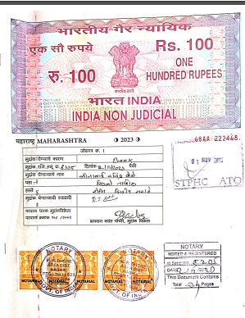
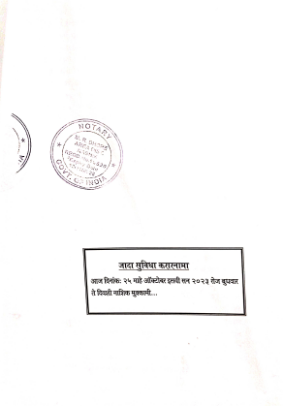

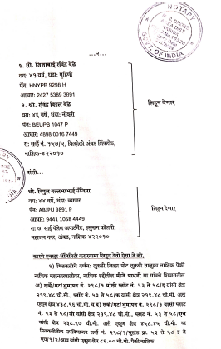
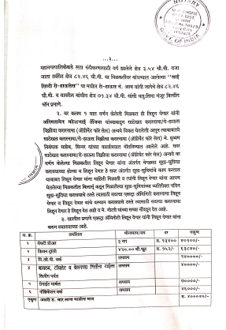

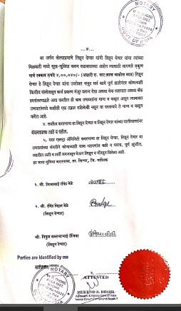

The Extra Amenities amount is Rs.4,00,000/- (Rupees Four Lakh Only)

