Vastu/Nashik/06/32014/2301224
22/20-325-RYV
Date: 03.11.2023

To,
The Branch Manager,
State Bank of India
RACPC Nashik Branch
1st Floor, Patel Plaza, N.D. Patel Road,
Opp. BSNL, Landmark Seawoods Navratna Hotel,
Nashik - 422001, State – Maharashtra, Country – India.

Sub: Vetting of Extra Work

Sir,

With reference to above subject, we have evaluated the Extra Work for Residential Row Bungalow No.1, Ground + First Floor, “ Anubhumi Row Bungalows ”, Survey No.60/1/1, Plot No.58 , Behind Avinash Residency, Dhruv Nagar, Village – Gangapur , Taluka & District - Nashik, PIN Code - 422 007, State - Maharashtra, Country - India belongs M/s.Chandrakirti Developers Name of Proposed Purchaser : Shri. Shrikant Ramdas Kolhe & Sau.Hemlata Pundlik Sabale.

We have verified the rates quoted as per current market rates. Details of Extra Work considered as per copy of Extra Work Agreement between Shri. Shrikant Ramdas Kolhe & Sau.Hemlata Pundlik Sabale (First Part). Shri.Chetan Balchand Sancheti (Second Part) received on dated 02.11.2023. The Extra Work amount is Rs. 10,00,000/- (Rupees Ten Lakh Only)

The said Cost Vetting Certificate is valid upto next 6 months Only.

Thanking you

Sincerely yours

Manoj B. Chalikwar
Registered Valuer
Chartered Engineer (India)
Reg. No. CAT-I-F-1763
SBI Empanelment No.: SME/TCC/2021-22/86/3
Encl: Valuation report

Agreement for Extra Work
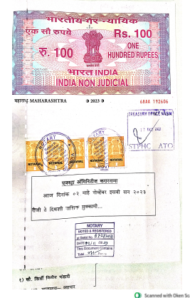
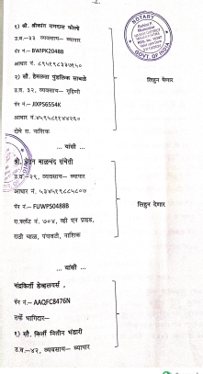

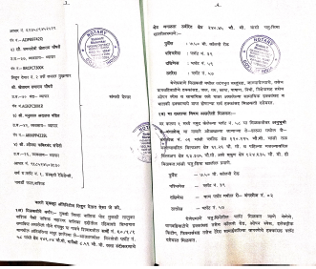
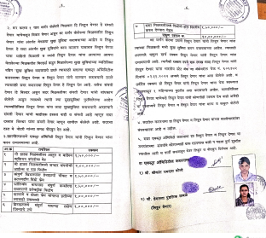

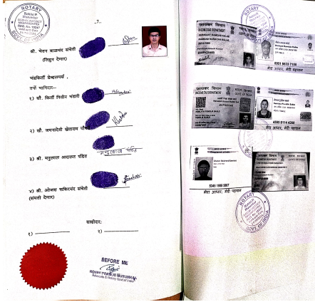

The Extra Amenities amount is is Rs. 10,00,000/- (Rupees Ten Lakh Only)

