LENDERS INDEPENDENT ENGINEER REPORT
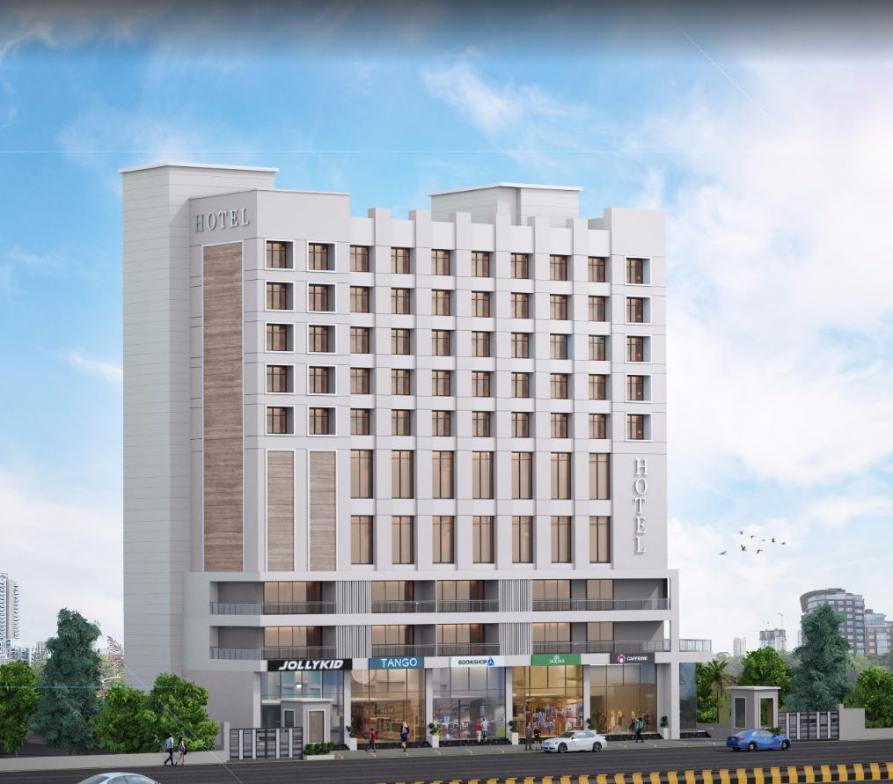

Details of the property under consideration:

Name of Owner: M/s. Gillani Hospitality Pvt. Ltd.

Proposed Commercial Cum Residential (3 Star Hotel) building on plot bearing Survey No. 804 / A / 9 / 1 & 2, Plot No. 1 & 2, Mumbai – Agra Road, Govind Nagar, Village – Nashik, Taluka & District – Nashik, Pin Code – 422 009, State – Maharashtra, Country – India

Latitude Longitude: 19°58'55.8"N 73°46'53.4"E

Valuation Prepared for:

Union Bank of India
Govind Nagar Branch
1,2,3,4 Thakkar Enclave, B/H/ Karmayogi Nagar, Govind Nagar,
Nashik - 422 008, State – Maharashtra, Country – India.

Vastu/UBI/Nashik/11/2023/4844/2301999
10/2-145-PYU
Date: - 30.04.2023

LENDERS INDEPENDENT ENGINEER REPORT

To,
Union Bank of India
Govind Nagar Branch
1,2,3,4 Thakkar Enclave,
B/H/ Karmayogi Nagar,
Govind Nagar, Nashik - 422 008,
State – Maharashtra, Country – India.

Subject: Construction of Proposed Commercial Cum Residential (3 Star Hotel) building on plot bearing Survey No. 804 / A / 9 / 1 & 2, Plot No. 1 & 2, Mumbai – Agra Road, Govind Nagar, Village – Nashik, Taluka & District – Nashik, Pin Code – 422 009, State – Maharashtra, Country – India

Ref: You’re Request for Lenders Independent Engineer Report of under Construction Building.
Dear Sir,
- As per your instruction, we have inspected the under construction 3 Star Hotel Building project situated on plot bearing Survey No. 804 / A / 9 / 1 & 2, Plot No. 1 & 2, Mumbai – Agra Road, Govind Nagar, Village – Nashik, Taluka & District – Nashik, Pin Code – 422 009, State – Maharashtra, Country – India which is being developed by M/s. Gillani Hospitality Pvt. Ltd. in order to give the physical progress at site and to certify cost incurred towards project as on 31/03/2023.

- While Certifying cost incurred toward project as on 31/03/2023, various important factors such as type & Quality of proposed construction, Specification of building material to be used, grade of the building, height, lead & lift condition, current market price of similar type etc. were given due consideration.

- As per cost incurred certificate issued by CA Certificate actual total expenditure occurred as on 31/03/2023 is ` 41.13 Cr. for the 2 Basement + Lower Ground Floor + Ground Floor + 1st to 13th Upper Floor however, developer / client estimated cost of project will go on higher side due to revised FSI as per amended plan.

- Hence, considering current status & progress at site, the total cost incurred as on 31/03/2023 towards the project is fair & reasonable up to ` 39.19 Cr. for the 2 Basement + Lower Ground Floor + Ground Floor + 1st to 10th Upper Floor which is including land & site development, cost of building construction, cost of miscellaneous fixed assets, consultant fees, preliminary & pre-operative expenses, advances to suppliers & material laying at site etc. This is verified by observing the actual progress of the construction work at site.

- Overall Physical progress of the project site as on 31/03/2023 is 55.50% of construction cost and overall financial progress as per C.A. certificate including land cost as on 31/03/2023 is 63.71 % estimated cost of project, which doesn’t include additional area not sanctioned by the UBI and it is recommended to get revised TEV and project report for the future LIE.

DECLARATION
- The information furnished in the report is based on our site visit Dated 15/04/2023 & Document Provided by Client.
- K. S. Ayyadurai TEV Report of the project dated 25/03/2022.
- I have no direct and indirect interest in the property examined for report.
- I have not been found guilty of misconduct in my professional capacity.

Sharadkumar B. Chalikwar
Govt. Reg. Valuer
Chartered Engineer (India)
Reg. No. (N) CCIT/1-14/52/2008-09
Encl.: LIE report

Purpose & Methodology
• Union Bank of India Banks and financial institutions require monitoring & an independent review of the progress of the sanctioned projects
VCIPL undertakes such study to independently review the progress of the project and put forward a comprehensive analysis

Advantages:
- Assurance on present practices
- Identification of risk
- Analyzing the performance of third parties
- Recommendations

The Methodology
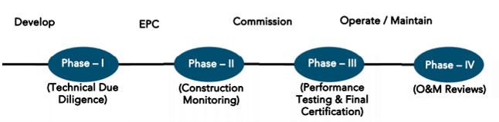
LENDERS INDEPENDENT ENGINEER REPORT
OF
"M/s. Gillani Hospitality Pvt. Ltd."
Proposed Commercial Cum Residential (3 Star Hotel) building on plot bearing Survey No. 804 / A / 9 / 1 & 2, Plot No. 1 & 2, Mumbai – Agra Road, Govind Nagar, Village – Nashik, Taluka & District – Nashik, Pin Code – 422 009, State – Maharashtra, Country – India

Latitude Longitude: 19°58'55.8"N 73°46'53.4"E

NAME OF DEVELOPER: M/s. Gillani Hospitality Pvt. Ltd.
Pursuant to instructions from Union Bank of India, Govind Nagar Branch, Nashik we have duly visited, inspected, surveyed & assessed the above said property on 15th April 2023 to determine the fair & reasonable market value of the said property/project as on Quarter ending 31st March 2023 for LIE purpose.

1. Location Details:
Proposed Commercial Cum Residential (3 Star Hotel) building on plot bearing Survey No. 804 / A / 9 / 1 & 2, Plot No. 1 & 2, Mumbai – Agra Road, Govind Nagar, Village – Nashik, Taluka & District – Nashik, Pin Code – 422 009. It is about 8.80 Km. travelling distance from Nashik Road Railway station. Surface transport to the property is by buses, taxis & private vehicles. The property is in developed locality. All the amenities like shops, banks, hotels, markets, schools, hospitals, etc. are all available in the surrounding locality. The area is higher middle class & developed.
2. Developer Details:
Name of Developer | M/s. Gillani Hospitality Pvt. Ltd.
Project Rera Registration Number | N. A.
Registered office address | 46, Aminabad Building, 7th Floor, Aga Hall, Nesbit Road, Mazgaon, Mumbai, Pin Code – 400 010, State – Maharashtra, Country – India
Contact details | Contact Person:  Mr. Zaheer Jamal  Mobile No. +91 9892216700
E – mail ID and website
3. Boundaries of the Property:
Direction | Particulars
On or towards North | Yashika Plaza
On or towards South | Open Plot
On or towards East | Mumbai – Agra Road
On or towards West | Internal Road

Introduction
As per Information on site M/s. Gillani Hospitality Pvt. Ltd. has acquired land by Conveyance Deed dated 18.02.2016 registered vide No. NSN-3-1638-2016 & registered vide No. NSN-3-1639-2016 admeasuring total area is 2405.00 Sq. M. bearing Survey No. 804/A/9/1 & 2. For the Proposed Commercial cum Residential (3 Star Hotel) Building.

Area Statement:

Land:
Date | Particular | Area in Sq. M.
18.02.2016 | Survey No. 804/A/9/1 | 1,202.50
18.02.2016 | Survey No. 804/A/9/2 | 1,202.50
TOTAL |  | 2,405.00

- Copy of Developer Agreement dated 18.02.2016 between Mr. K. Vasudev Vadiraj Rao & Mrs. Seeta Vasudev Rao (The Vendors) and M/s. Gilani Foods Pvt. Ltd. (The Purchaser) registered vide No. NSN-3-1638-2016 dated 18.02.2016.
- Copy of Developer Agreement dated 18.02.2016 between Mr. K. Shriniwas Vadiraj Shahbhag & Mr. Ravindra Shriniwas Shanbhag (The Vendors) and M/s. Gilani Foods Pvt. Ltd. (The Purchaser) registered vide No. NSN-3-1639-2016 dated 18.02.2016.
- Copy of Change of Ownership Name from M/s. Gilani Foods Private Limited to Gillani Hospitality Private Limited dated 31.03.2022.

Building Area As per Approved Plan:
 | PROFORMA
A | AREA STATEMENT | Sq.mt.
 | AREA OF THE PLOT AS PER AS PER 7/12 (1+2) | 2,405.00
 | (Minimum area of a, b, c to be considered)
a | As per ownership document (7/12 CTS extract) | 2,405.00
b | as per measurement sheet (AS PER F.P RECORD) | 2,405.00
c | as per site | 2,405.00
2 | Deductions for
a | Proposed D.P./D.P. Road widening Area
b | Any M.S.E.B. Reservation area
 | (Total a + b)
3 | GROSS AREA OF THE PLOT (1-2) Mr. | 2,405.00
4 | Recreational Open space
a | Required
b | Proposed | 270.00
5 | Amenity space
 | Required - Proposed-
6 | Service road and highway widening
7 | Internal Road area
8 | Net Area of Plot = [3-5 (b)] | 2,405.00
9 | Built up area with reference to basic FSI as per front road width (sr. no. 8x1.1) | 2,645.50
10 | Addition of area for F.SI.
a | In-situ area against D. P. road [1.1 x sr. no. 2 (a)], if any | NIL
b | in-situ area against amenity space
C | Premium FSI area (subject to maximum of 0.5 of sr.no.8) | 1,202.50
d | TDR area (1.40 of sr. no.8) | 3,367.00
e | additional HOTEL FSI as per rule no-23(D)=1.9 | 4,569.50
 | (Total of a + b + c + d + e) | 11,784.50
11 | Total area available (9+10) | 11,784.50
12 | Maximum utilization of FSI Permissible (as per Road width as per regulation no. 15.4) (3 + 1.9) | 4.90
13 | Total built-up Area in proposal.
 | (Excluding area at sr. no. 15.b)
a | Existing Built-up Area. | 895.36
b | proposed built-up area | 9,402.46
c | excess balcony area counted in F.S.I.
d | excess double height terraces area counted in FSI
 | (Total of a + b + c + d) | 10,297.82
14 | FSI consumed (13/11) (should not be more than serial no. 12 above.) | 0.87%
15 | area for inclusive housing if any
a | Required (20% of sr. no.9)
b | Proposed
16 | TOTAL T.D.R. PURCHASED AREA | 3,350.16
17 | TOTAL PROPOSED T.D.R. AREA | 3,350.00

Floor wise Built – Up Area Statement as per amended approved building plan is as below –
Floors | Built Up Area as per earlier sanction approved plan in Sq. M. | Built Up Area as per revised approved plan in Sq. M.
Basement - 2 | 120.52 | 120.52
Basement - 1 | 337.19 | 435.78
Lower Ground Floor | 247.95 | 402.51
Ground Floor | 664.71 | 791.05
1st Floor | 491.95 | 503.79
2nd Floor | 701.62 | 689.37
3rd Floor | 696.83 | 696.83
4th Floor | 572.20 | 573.42
5th Floor | 572.20 | 573.42
6th Floor | 572.20 | 573.42
7th Floor | 572.20 | 573.42
8th Floor | 572.20 | 573.42
9th Floor | 572.20 | 573.42
10th Floor | 577.08 | 578.30
11th Floor | - | 823.32
12th Floor | - | 1,233.66
13th Floor | - | 553.61
Terrace & OHT & LMR Area | 28.56 | 28.56
TOTAL | 7,299.61 | 10,297.82

Floor wise Total Construction Area Statement as per revised / amended approved building plan is as below –
Floors | FSI Area in Sq. M. | Non - FSI Area in Sq. M. | Total Construction Area in Sq. M.
Basement - 2 | 120.52 | 1,494.08 | 1,614.60
Basement - 1 | 435.78 | 1,221.76 | 1,657.54
Lower Ground Floor | 402.51 | 1,185.65 | 1,588.16
Ground Floor | 791.05 | 168.43 | 959.48
1st Floor | 503.79 | 160.63 | 664.42
2nd Floor | 689.37 | 203.18 | 892.55
3rd Floor | 696.83 | 203.18 | 900.01
4th Floor | 573.42 | 203.18 | 776.60
5th Floor | 573.42 | 203.18 | 776.60
6th Floor | 573.42 | 194.90 | 768.32
7th Floor | 573.42 | 194.90 | 768.32
8th Floor | 573.42 | 194.90 | 768.32
9th Floor | 573.42 | 203.18 | 776.60
10th Floor | 578.30 | 203.18 | 781.48
11th Floor | 823.32 | 194.90 | 1,018.22
12th Floor | 1,233.66 | 194.90 | 1,428.56
13th Floor | 553.61 | 203.18 | 756.79
Terrace & OHT | 28.56 | 728.23 | 756.79
TOTAL | 10,297.82 | 7,355.54 | 17,653.36

List of Approvals:
- Copy of Revised Approved Plan No. A41RBP/237/2022 dated 21.10.2022 issued by Nashik Municipal Corporation.
Approved upto: 2 Basement + Lower Ground Floor + Ground Floor + 1st to 13th Upper Floor.
- Copy of 1st Commencement Certificate No. LND/BP/A4/RBP/237/2022 dated 21.10.2022 issued by Nashik Municipal Corporation.
(This CC is endorsed for the work upto 2 Basement + Lower Ground Floor + Ground Floor + 1st to 13th Upper Floor)

LEVEL OF COMPLETION:

Construction of Building
Sr. No | Floor No. | Construction Area in Sq. M. | Completed Area in Sq. M. | Percentage of work completed | Work Completion as on 15.04.2023
1 | Excavation & Shore Piling |  |  | 100% | Work is Completed
2 | Basement – 2 Floor | 1,614.60 | 1,614.60 | 80% | Slab Work, Block work, Plaster work & Fire Fighting work is completed
3 | Basement – 1 Floor | 1,657.54 | 1,657.54 | 80% | Slab Work, Block work, Plaster work & Fire Fighting work is completed
4 | Lower Ground Floor | 1,588.16 | 1,588.16 | 60% | Slab Work, Block work & Firefighting work is completed
5 | Ground Floor | 959.48 | 959.48 | 60% | Slab Work, Block work & Firefighting work is completed
6 | 1st Floor | 664.42 | 664.42 | 60% | Slab Work, Block work & Firefighting work is completed
7 | 2nd Floor | 892.55 | 892.55 | 60% | Slab Work, Block work & Firefighting work is completed
8 | 3rd Floor | 900.01 | 900.01 | 60% | Slab Work, Block work & Firefighting work is completed
9 | 4th Floor | 776.60 | 776.60 | 60% | Slab Work, Block work & Firefighting work is completed
10 | 5th Floor | 776.60 | 776.60 | 80% | Slab Work, Block work, Plaster work, Door Frame & Window Frame, Gypsum work, Plumbing, Water proofing, flooring, toilet dado, firefighting work is completed
11 | 6th Floor | 768.32 | 768.32 | 80% | Slab Work, Block work, Plaster work, Door Frame & Window Frame, Gypsum work, Plumbing, Water proofing, flooring, toilet dado, firefighting work is completed
12 | 7th Floor | 768.32 | 768.32 | 80% | Slab Work, Block work, Plaster work, Door Frame & Window Frame, Gypsum work, Plumbing, Water proofing, flooring, toilet dado, firefighting work is completed
13 | 8th Floor | 768.32 | 768.32 | 80% | Slab Work, Block work, Plaster work, Door Frame & Window Frame, Gypsum work, Plumbing, Water proofing, flooring, toilet dado, firefighting work is completed
14 | 9th Floor | 776.60 | 776.60 | 80% | Slab Work, Block work, Plaster work, Door Frame & Window Frame, Gypsum work, Plumbing, Water proofing, flooring, toilet dado, firefighting work is completed
15 | 10th Floor | 781.48 | 781.48 | 80% | Slab Work, Block work, Plaster work, Door Frame & Window Frame, Gypsum work, Plumbing, Water proofing, flooring, toilet dado, firefighting work is completed
16 | 11th Floor | 1,018.22 |  |  | Slab Work, Block work, Plaster work, Door Frame & Window Frame, Gypsum work, Plumbing, Water proofing, flooring, toilet dado, firefighting work is completed
17 | 12th Floor | 1,428.56 |  |  | Slab work is completed
18 | 13th Floor | 756.79 |  |  | Slab work is completed
19 | Terrace Floor & OHT & LMR Area | 756.79
Total |  | 17,653.36 | 13,693.00 | 55.50%

Plant and Machinery
Particulars | Work Completion as on 15.04.2023
Air - Conditioning | A/C ducting work is completed up to 11th Floor
Lifts | All the 5 lifts order is placed & received on site, Lift staff work is completed up to 13th Floor
Kitchen & Refrigeration Equipment’s
Gym Equipment’s
Fire Fighting Equipment’s, Sprinkler & Smoke Detector Systems | Fire Fighting work is completed up to 11th Floor
DG Set
Sewage Treatment Plant | RCC work is completed
ELV Systems | Work is in progress
IT Equipment & Software | Work is in progress
Crockery, Cutlery & Glassware
Housekeeping Supplies, Linens & Uniform

Furniture and Fixture
Particulars | Work Completion as on 15.04.2023
FF for 107 keys | 2 Sample rooms work is completed on 7th Floor & order for the remaining rooms are placed
FF for Restaurant
FF for Banquet
FF for Reception
FF for Meeting Rooms
FF for Roof Top Bar
FF for Other Public Area
FF for BOH

Details of the Project as Financed By UBI:

Estimate of the project
Project expenses | Cost as per TEV Report dated 25.03.2023 in `
Land Cost | 6.89
Construction Cost of Building (including Civil work, Plumbing & Sanitation & Electrification, etc.) | 27.63
Plant and Machinery | 9.50
Furniture and Fixture | 9.08
Approval & TDR Cost | 5.00
Architect Cost, RCC & other Professional fees | 1.17
Contingencies Expenses | 1.38
Interest Cost | 3.89
Total Cost | 64.54

Project Cost: (as per C.A. Certificate)
Particulars | Incurred Cost (In ` Cr.) till 31.03.2023 dated 08.05.2023 by M/s. Amogh Ghule & Associates
Land Cost | 5.20
Construction Cost of Building (including Civil work, Plumbing & Sanitation & Electrification, etc.) | 26.41
Plant and Machinery
Furniture and Fixture
Approval & TDR Cost | 4.74
Architect Cost, RCC & other Professional fees | 1.01
Contingencies Expenses | 0.08
Interest Cost | 3.59
Total | 41.13

- The Builder has incurred about 5.20 Cr. as land cost, 26.41 Cr. as construction cost, Plant & Machinery and Furniture & Fixture, 4.74 Cr. for approval of project, 1.01 Cr. for admin cost & 3.59 Cr. for interest cost in last quarter till 31.03.2023 as per C.A. certificate issued by M/s. Amogh Ghule & Associates dated 08.05.2023. All the cost incurred is for the 2 Basement + Lower Ground Floor + Ground Floor + 1st to 13th Upper Floor.

Project Cost: (as per Bills):
Particulars | Incurred Cost (in Cr.)
 | 31.03.2023 as per Bill (Inclusive GST)
Land Cost | 6.90
Construction Cost of Building (including Civil work, Plumbing & Sanitation & Electrification, etc.) | 23.66
Plant and Machinery | 2.72
Furniture and Fixture | 0.08
Approval & TDR Cost | 4.74
Architect Cost, RCC & other Professional fees | 1.02
Contingencies Expenses | 0.48
Interest Cost | 3.59
Total | 43.18
Note: We have considered the Land cost as per agreement, Bank loan processing & stamp duty cost in the LIE report. All the cost incurred is for the 2 Basement + Lower Ground Floor + Ground Floor + 1st to 13th Upper Floor.

Land Cost:
Sr. No. | Date | Particulars | Description | Total Cost in ` | Incurred Cost in `
1 | 16.02.2016 | Survey No. 804/A/9/1 | Purchase Cost | 3,25,00,000.00 | 3,25,00,000.00
2 |  |  | Stamp Duty | 19,50,000.00 | 19,50,000.00
3 |  |  | Reg. Fees | 30,000.00 | 30,000.00
4 |  |  |  | 580.00 | 580.00
5 | 16.02.2016 | Survey No. 804/A/9/2 | Purchase Cost | 3,25,00,000.00 | 3,25,00,000.00
6 |  |  | Stamp Duty | 19,50,000.00 | 19,50,000.00
7 |  |  | Reg. Fees | 30,000.00 | 30,000.00
8 |  |  |  | 580.00 | 580.00
Total |  |  |  | 6,89,61,160.00 | 6,89,61,160.00
As per conveyance agreement.
Summary of Bills
Sr. No. | Particulars | Amount in `  (Till 31.03.2023) | Amount in ` (in Cr.)
1 | Construction Cost of Building (including Civil work, Plumbing & Sanitation & Electrification, etc.) | 23,65,64,728.00 | 23.66
2 | Plant and Machinery | 2,72,13,433.00 | 2.72
3 | Furniture and Fixture | 8,00,360.00 | 0.08
4 | Approval & TDR Cost | 4,74,10,776.00 | 4.74
5 | Architect Cost, RCC & other Professional fees | 1,01,83,686.00 | 1.02
6 | Contingencies Expenses | 47,67,078.00 | 0.48
TOTAL |  | 32,69,40,061.00 | 32.69
- Note: Bills were provided by the client up to 31.03.2023 for the 2 Basement + Lower Ground Floor + Ground Floor + 1st to 13th Upper Floor.

Interest Cost:
Sr. No | Particulars | Cost as per TEV Report in ` | Incurred Amount in ` (till 31.03.2023) | Balance Amount in `
1 | Interest Cost | 3,89,00,000.00 | 3,59,18,194.00 | 1,90,81,806.00
TOTAL |  | 3,89,00,000.00 | 3,59,18,194.00 | 1,90,81,806.00

Cost of Construction as on 15th April 2023:

Construction Cost of Building:
Floors | Completed Area in Sq. M. | Rate per Sq. M. | Full Value after completion | Percentage of work completed | Actual Expenditure till date in `
Basement - 2 | 1,614.60 | 20,069.00 | 3,24,03,407.40 | 80.00% | 2,59,22,725.92
Basement - 1 | 1,657.54 | 20,069.00 | 3,32,65,170.26 | 80.00% | 2,66,12,136.21
Lower Ground Floor | 1,588.16 | 20,069.00 | 3,18,72,783.04 | 60.00% | 1,91,23,669.82
Ground Floor | 959.48 | 20,069.00 | 1,92,55,804.12 | 60.00% | 1,15,53,482.47
1st Floor | 664.42 | 20,069.00 | 1,33,34,244.98 | 60.00% | 80,00,546.99
2nd Floor | 892.55 | 20,069.00 | 1,79,12,585.95 | 60.00% | 1,07,47,551.57
3rd Floor | 900.01 | 20,069.00 | 1,80,62,300.69 | 60.00% | 1,08,37,380.41
4th Floor | 776.60 | 20,069.00 | 1,55,85,585.40 | 60.00% | 93,51,351.24
5th Floor | 776.60 | 20,069.00 | 1,55,85,585.40 | 80.00% | 1,24,68,468.32
6th Floor | 768.32 | 20,069.00 | 1,54,19,414.08 | 80.00% | 1,23,35,531.26
7th Floor | 768.32 | 20,069.00 | 1,54,19,414.08 | 80.00% | 1,23,35,531.26
8th Floor | 768.32 | 20,069.00 | 1,54,19,414.08 | 80.00% | 1,23,35,531.26
9th Floor | 776.60 | 20,069.00 | 1,55,85,585.40 | 80.00% | 1,24,68,468.32
10th Floor | 781.48 | 20,069.00 | 1,56,83,522.12 | 80.00% | 1,25,46,817.70
11th Floor | 1,018.22 | 20,069.00 | 2,04,34,657.18 | 0.00% | -
12th Floor | 1,428.56 | 20,069.00 | 2,86,69,770.64 | 0.00% | -
13th Floor | 756.79 | 20,069.00 | 1,51,88,018.51 | 0.00% | -
Terrace & OHT | - | 20,069.00 | 1,51,88,018.51 | 0.00% | -
TOTAL | 16,896.57 |  | 35,42,85,281.84 | 55.50% | 19,66,39,192.76

Plant and Machinery:
Particulars | Cost as per TEV Report dated 25.03.2023 | Percentage of work completed | Actual Expenditure till date in `
Air - Conditioning | 3,40,00,000.00 | 41.23% | 1,40,19,649.80
Lifts | 1,40,00,000.00 | 68.61% | 96,04,728.00
Kitchen & Refrigeration Equipment’s | 1,00,00,000.00 | 0.00% | -
Gym Equipment’s | 10,00,000.00 | 0.00% | -
Fire Fighting Equipment’s, Sprinkler & Smoke Detector Systems | 80,00,000.00 | 44.86% | 35,89,055.00
DG Set | 70,00,000.00 | 0.00% | -
Sewage Treatment Plant | 10,00,000.00 | 0.00% | -
ELV Systems | 80,00,000.00 | 0.00% | -
IT Equipment & Software | 80,00,000.00 | 0.00% | -
Crockery, Cutlery & Glassware | 20,00,000.00 | 0.00% | -
Housekeeping Supplies, Linens & Uniform | 20,00,000.00 | 0.00% | -
TOTAL | 9,50,00,000.00 | 28.65% | 2,72,13,432.80

Furniture & Fixture:
Particulars | Cost as per TEV Report dated 25.03.2023 | Percentage of work completed | Actual Expenditure till date in `
FF for 125 Rooms keys @ 400000 | 4,28,00,000.00 | 1.87% | 8,00,360.00
FF for Restaurant | 60,00,000.00 | 0.00% | -
FF for Banquet | 60,00,000.00 | 0.00% | -
FF for Reception | 60,00,000.00 | 0.00% | -
FF for Meeting Rooms | - | 0.00%
FF for Roof Top Bar | - | 0.00%
FF for Other Public Area | 1,00,00,000.00 | 0.00% | -
FF for BOH | 2,00,00,000.00 | 0.00% | -
TOTAL | 9,08,00,000.00 | 0.88% | 8,00,360.00

Note: Details of work completed is as per site visit dated 15.04.2023 but 1st LIE report is prepared for quarter ending on 31st March 2023.

Project expenses | Cost as per TEV Report dated 25.03.2022 | Incurred Cost as per Bill till 31.03.2023 | Incurred Cost as per CA till 31.03.2023 | Difference between the Bills & CA | Reasonable Cost certified by VICPL till 31.03.2023
Land Cost | 6.89 | 6.90 | 5.20 | 1.70 | As per Bank Sanctioned | 6.89
Construction Cost of Building (including Civil work, Plumbing and Sanitation & Electrification, etc.) | 27.63 | 23.66 | 26.41 | 0.04 | As per Plinth Area Calculation we have considered till 10th Floor only | 19.66
Plant and Machinery | 9.50 | 2.72 |  |  | As per Bills | 2.72
Furniture and Fixture | 9.08 | 0.08 |  |  | As per Bills | 0.08
Approval & TDR Cost | 5.00 | 4.74 | 4.74 | - | As per Bills & CA Certificate | 4.74
Architect Cost, RCC & other Professional fees | 1.17 | 1.02 | 1.01 | 0.01 | As per Bills & CA Certificate | 1.02
Contingencies Expenses | 1.38 | 0.48 | 0.18 | 0.30 | As per Bills | 0.48
Interest Cost | 3.89 | 3.59 | 3.59 | - | As per Bills & CA Certificate | 3.59
Total Cost | 64.54 | 43.18 | 41.13 | 2.05 | - | 39.18
Note:
We have considered Bank Processing fees & Stamp Duty in Contingencies Expenses but CA has not considered these cost.
We have considered Land Cost & Stamp Duty, as per Sale Agreement but CA has considered deprecation on land purchase cost.

Particulars | Cost as per TEV Report dated 25.03.2022 | Reasonable Cost certified by VICPL till 31.03.2023 | Margin | Client  Contribution | Bank  Loan
Hard Cost (Land Cost + COC + PM + FF) | 53.10 | 29.36 | 58.83% | 17.27 | 12.08
Interest Cost | 3.89 | 3.59 | 21.85% | 0.78 | 2.81
Soft Cost (Approval + Professional + Contingency) | 7.55 | 6.24 | 100.00% | 6.24 | -
TOTAL | 64.54 | 39.19 |  | 24.29 | 14.89

% of Fund Utilised till 31st March 2023
Particulars | Cost as per TEV Report dated 25.03.2022 | % Project cost | Reasonable Cost certified by VICPL till 31.03.2023 | Cost incurred as % total cost of that Component | Cost incurred as % of cost incurred as on 31.03.2023
Land Cost | 6.89 | 10.68% | 6.89 | 100.00% | 10.69%
Construction Cost of Building (including Civil work, Plumbing and Sanitation & Electrification, etc.) | 27.63 | 42.81% | 19.66 | 71.17% | 30.47%
Plant and Machinery | 9.5 | 14.72% | 2.72 | 28.65% | 4.22%
Furniture and Fixture | 9.08 | 14.07% | 0.08 | 0.88% | 0.12%
Approval & TDR Cost | 5 | 7.75% | 4.74 | 94.82% | 7.35%
Architect Cost, RCC & other Professional fees | 1.17 | 1.81% | 1.02 | 87.04% | 1.58%
Contingencies Expenses | 1.39 | 2.14% | 0.48 | 34.54% | 0.74%
Interest Cost | 3.89 | 6.03% | 3.59 | 92.33% | 5.57%
Total | 64.55 | 100% | 39.19 | 60.71% | 60.71%
Based on above Calculation it is found that total Project cost incurred is 60.71 % of the of sanction Project cost.

Means of Finance:
Sr. No. | Particulars | Exp. Cumulative (Cr.)
 | Equity share capital / Quassi Loan from Promoter | 17.79
 | Sales (Advance from customer) | 8.00
 | Bank Laon Amount | 15.34
 | Total | 41.12
The Details of the Means of Finance are provided by Client as on 31.03.2023.

Mandatory Arrangements:
Sr. No. | Particulars | Status
 | Rainwater Harvesting | To be executed after RCC Structure
 | Firefighting System | To be executed after RCC Structure
 | Solid Waste Management | To be executed after RCC Structure

Quality of Construction:
Sr. No. | Particulars | Status
 | Soundness of Structures | Executing as per approved Structural Design
 | Look of Structures | Good
 | Quality of Material Used | Good
 | Safety Measures for Construction/labour | Taken Care by Contractor

Schedule V/s. Actual Progress:
Activity | Date of Implementation | Date of Completion | Status
Land |  |  | Completed
Development of Land |  |  | Completed
Foundation Work |  |  | Completed
Ground Floor Slab |  |  | Slab work is Completed
1st Floor Slab |  |  | Slab work is Completed
2nd Floor Slab |  |  | Slab work is Completed
3rd Floor Slab |  |  | Slab work is Completed
4th Floor Slab |  |  | Slab work is Completed
5th Floor Slab |  |  | Slab work is Completed
6th Floor Slab |  |  | Slab work is Completed
7th Floor Slab |  |  | Slab work is Completed
8th Floor Slab |  |  | Slab work is Completed
9th Floor Slab |  |  | Slab work is Completed
10th Floor Slab |  |  | Slab work is Completed
11th Floor Slab |  |  | Slab work is Completed
12th Floor Slab |  |  | Slab work is Completed
13th Floor Slab |  |  | Slab work is Completed
Block work / Internal Plaster work |  |  | 5th to 11th floor blockwork is completed
Terrace Parapet wall / Overhead water tank / Lift Machine room / compound wall / External Plaster work
Electric Work
Water Proofing
Plumbing Work
Tiling / Marble Flooring |  |  | Work is in progress
Door Frames
Window Installation
Staircase Flooring
Staircase Railing
Refuge Area Flooring
Internal Painting
External Painting
Lift Work |  |  | All the 5 lifts order is placed & received on site, Lift staff work is completed upto 13th Floor
Fire Fighting Installation |  |  | Upto 11th Floor work is completed
Stack Parking
CP Fitting & Sanitary Work
Final Finishing & Fitting

Action initiated to complete the project in time:
For 3 Star Hotel Building: 13th Floor Slab RCC work is completed. Interior work is in progress.

Comments related to cost overrun if any:
The cost of 3-star Hotel Building as per Sanction Letter was 64.55 Cr. but client has revised the Plan and increased existing capacity of 107 Room to 125 Room as per revised Approved Plan hence estimated project will increase and estimated project cost as per TEV Report dated 22.03.2023 is 64.55 Cr.

Balance investment required for completion of project:
We opinion amount of ` 25.36 Cr. Will be required to complete the Project till 10th Floor.

Mandatory Approval Status:
Sr. No. | Particulars | Name of Department | Status | Order Details
1 | IOD of Building | Nashik Municipal Corporation | Obtained and available at site | P-6954/2021/(669)/K/E Ward/Andheri dated 11.01.2022
1A | 1st Amended | Nashik Municipal Corporation | Obtained and available at site | P-6954/2021/(669)/K/E Ward/Andheri dated 13.04.2022
2A | First C.C. | Nashik Municipal Corporation | Obtained and available at site | P – 6954 / 2021 / (669) / K / E Ward / Andheri / FCC / New dated 21.10.2022 valid till 22.10.2023. This CC is endorsed for the work upto Ground for Parking + 1st to 10th Upper Floor of Wing A & B
2B | Second C.C. | Nashik Municipal Corporation | Obtained and available at site | P – 6954 / 2021 / (669) / K / E Ward / Andheri / FCC / 1 / Amend dated 09.11.2022 valid till 08.11.2023. This CC is endorsed for the work upto Ground for Parking + 1st to 10th Upper Floor of Wing A & B
3B | Occupancy | Nashik Municipal Corporation | Pending (Project is not completed)

Status Insurance Coverage:
Information not provided

Observations & Conclusion:
- Overall Physical progress of the project site as on 31/03/2023 is 55.50% of construction cost and overall financial progress as per C.A. certificate including land cost as on 31/03/2023 is 63.71 % estimated cost of project, which doesn’t include additional area not sanctioned by the UBI and it is recommended to get revised TEV and project report for the future LIE.
- As per cost incurred certificate issued by CA Certificate actual total expenditure occurred as on 31/03/2023 is ` 41.13 Cr. for the 2 Basement + Lower Ground Floor + Ground Floor + 1st to 13th Upper Floor however, developer / client estimated cost of project will go on higher side due to revised FSI as per amended plan.
- Hence, considering current status & progress at site, the total cost incurred as on 31/03/2023 towards the project is fair & reasonable up to ` 39.19 Cr. for the 2 Basement + Lower Ground Floor + Ground Floor + 1st to 10th Upper Floor which is including land & site development, cost of building construction, cost of miscellaneous fixed assets, consultant fees, preliminary & pre-operative expenses, advances to suppliers & material laying at site etc. This is verified by observing the actual progress of the construction work at site.
- Building revised Plan is sanction for entire development of Copy of 2 Basement + Lower Ground Floor + Ground Floor + 1st to 13th Upper Floor. Construction work was in progress as per 1st Commencement Certificate No. LND/BP/A4/RBP/237/2022 dated 21.10.2022 issued by Nashik Municipal Corporation.
- It is important to observe all provisions of the various relevant codes of the Bureau of Indian Standards (BIS) during the stage of engineering- design as well as during the stage of construction. It will be advisable to have on the record of the bank a certificate from anu licensed structural engineer that such BIS codal provisions are followed during the ‘design’ as well as during the ‘construction’ stage of the project so as to ensure the safety and stability of the structure.

Assumptions & Remarks:
- The adequacy of Engineering / Structural design is beyond the scope of our assignment.
- Estimated project completion date is 31/03/2024. The cost is certified based on the assumptions that the project will be completed within period. Few assumptions were made regarding inflation & cost rise etc. during construction period.

Sharadkumar B. Chalikwar
Govt. Reg. Valuer
Chartered Engineer (India)
Reg. No. (N) CCIT/1-14/52/2008

About the Project:
1. Introduction
a) | Project Name  (With Address & Phone Nos.) | Proposed Commercial Cum Residential (3 Star Hotel) building on plot bearing Survey No. 804 / A / 9 / 1 & 2, Plot No. 1 & 2, Mumbai – Agra Road, Govind Nagar, Village – Nashik, Taluka & District – Nashik, Pin Code – 422 009, State – Maharashtra, Country – India  Contact Person:  Mr. Zaheer Jamal  Mobile No. +91 98922 16700
b) | Purpose of Valuation | As per request from Union Bank of India, Govind Nagar Branch, Nashik to assess fair market value of the Project for LIE purpose.
c) | Date of Inspection of Property | 15.04.2023
d) | Date of LIE Report | 30.04.2023
e) | Name of the Developer of Property  (in case of developer built properties) | M/s. Gillani Hospitality Pvt. Ltd.  46, Aminabad Building, 7th Floor, Aga Hall, Nesbit Road, Mazgaon, Mumbai, Pin Code – 400 010, State – Maharashtra, Country – India
2. Physical Characteristics of the Property
a) | Location of the Property | Proposed Commercial Cum Residential (3 Star Hotel) building on plot bearing Survey No. 804 / A / 9 / 1 & 2, Plot No. 1 & 2, Mumbai – Agra Road, Govind Nagar, Village – Nashik, Taluka & District – Nashik, Pin Code – 422 009, State – Maharashtra, Country – India
 | Brief description of the property
TYPE OF THE BUILDING
- Commercial cum Residential (3 Star Hotel) Building

No. of Floors | 2 Basement + Lower Ground Floor + Ground Floor + 1st to 13th Upper Floor.
Building type | Commercial cum Residential (3 Star Hotel) building

Commercial cum Residential (3 Star Hotel) Building work is given on contract based for RCC contract. Developer has grant to the contractor do the work of construction and completion includes Concrete work, Reinforcement work, Masonry, Internal Plaster, External Plaster and other miscellaneous work such as repairing, joints b/w concrete and masonry surface, etc. Bill must be paid on measurement of construction area exclusive of Steel, Cement & other construction material.
Lift & lift installation contract is not finalized till now.
Firefighting work contract is not finalized.

PROPOSED DATE OF COMPLETION & FUTURE LIFE:
Expected completion date as per developer is 31st March 2024
 | Nearby landmark | Near Mumbai – Agra Road
 | Postal Address of the Property | Proposed Commercial Cum Residential (3 Star Hotel) building on plot bearing Survey No. 804 / A / 9 / 1 & 2, Plot No. 1 & 2, Mumbai – Agra Road, Govind Nagar, Village – Nashik, Taluka & District – Nashik, Pin Code – 422 009, State – Maharashtra, Country – India
 | Area of the plot/land  (Supported by a plan) | Plot Area: 2,405.00 Sq. M.
 | Type of Land: Solid, Rocky, Marsh land, reclaimed land, Water-logged, Land locked. | Solid land
 | Independent access/approach to the property etc. | Yes
 | Google Map Location of the Property with a neighborhood layout map | Provided
 | Details of roads abutting the property | East Side – 30 M. wide road  West Side – 12 M. wide road
 | Description of adjoining property | Located in Higher Middle-class locality
 | Plot No. Survey No. | Survey No. 804 / A / 9 / 1 & 2, Plot No. 1 & 2
 | Ward/Village/Taluka | Village – Nashik, Taluka – Nashik
 | Sub-Registry/Block | Nashik
 | District | District – Nashik
b) | Boundaries of the Plot
 | As per Agreement | Actual
North | CTS No. 665 | Yashika Plaza
South | CTS No. 670 | Open Plot
East | Proposed 13.20 M. wide D. P. Road & presently bearing CTS No. 668. | Mumbai – Agra Road
West | Private Road bearing CTS No. 672 leading from Sahar Road | Internal Road

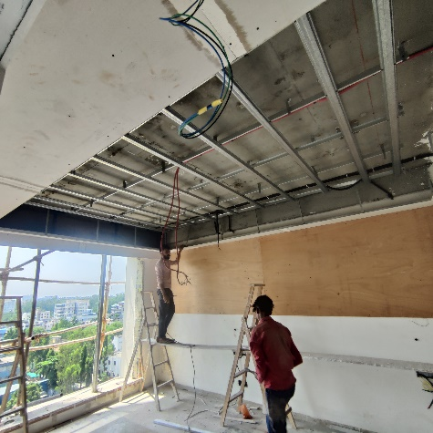
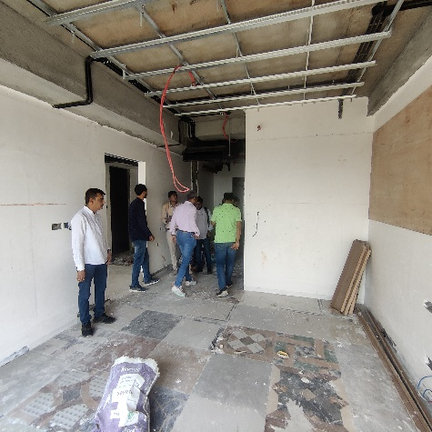
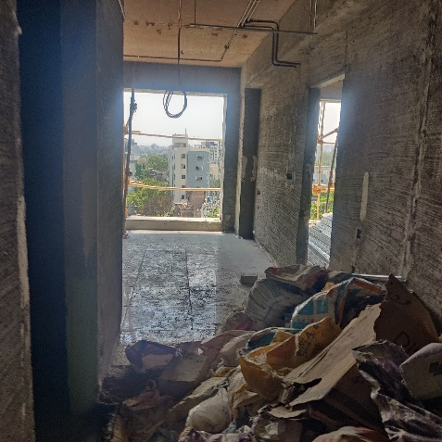
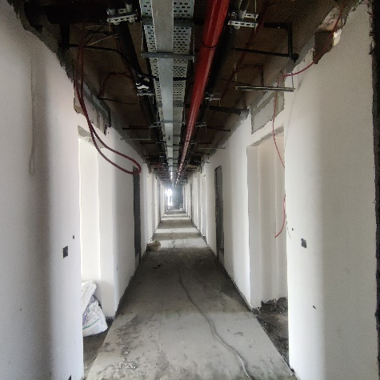
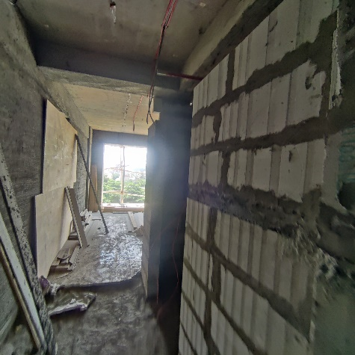
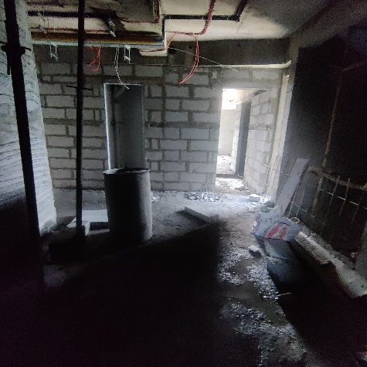
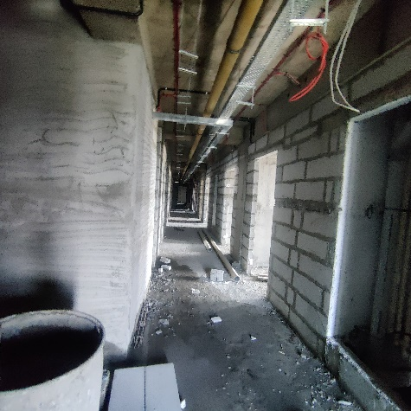
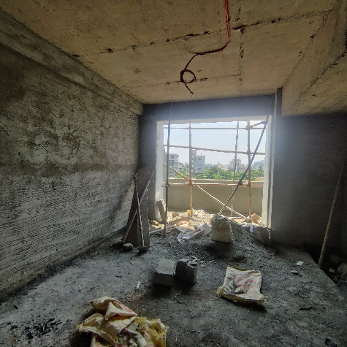
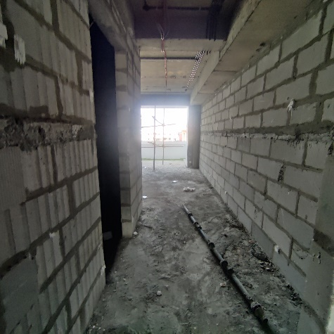
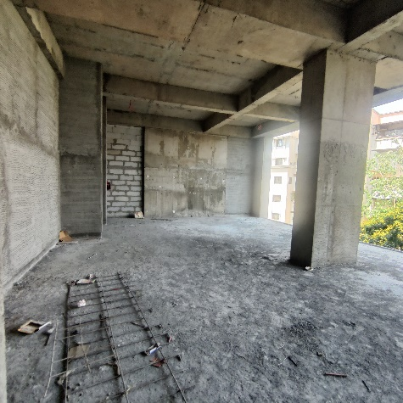
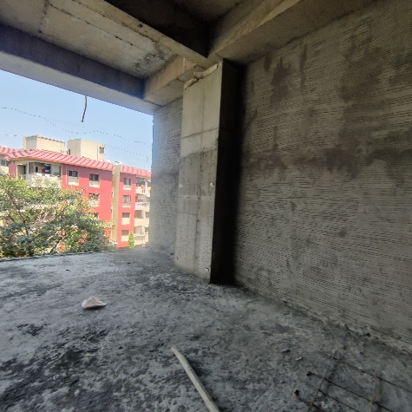
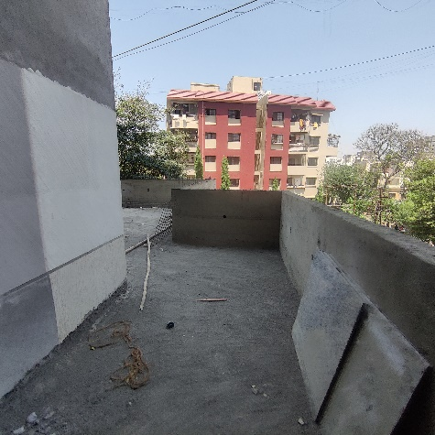
Actual Site Photographs as on 15.04.2023

Actual Site Photographs as on 15.04.2023
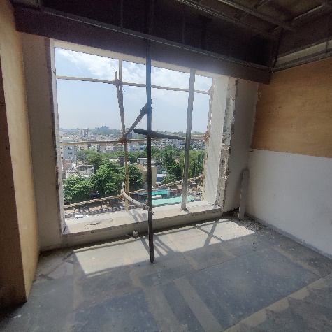
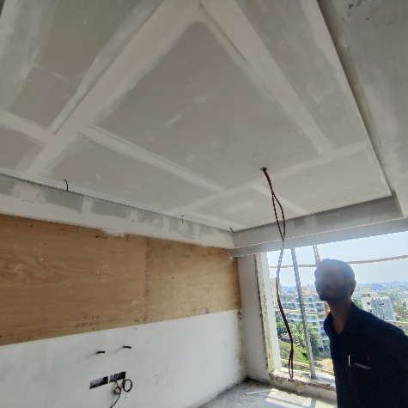
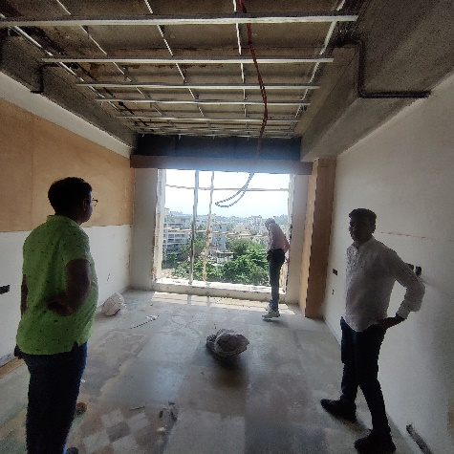
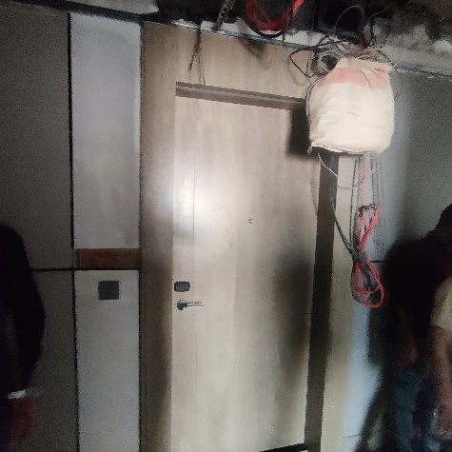
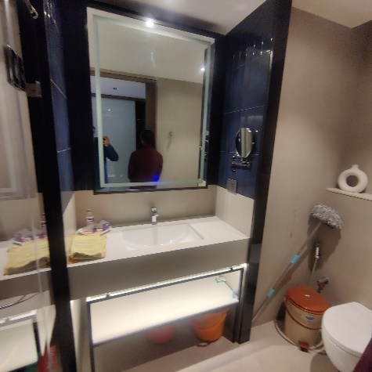
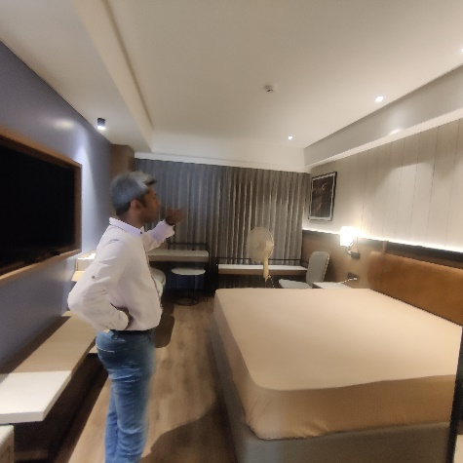
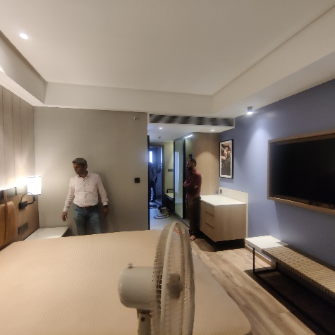
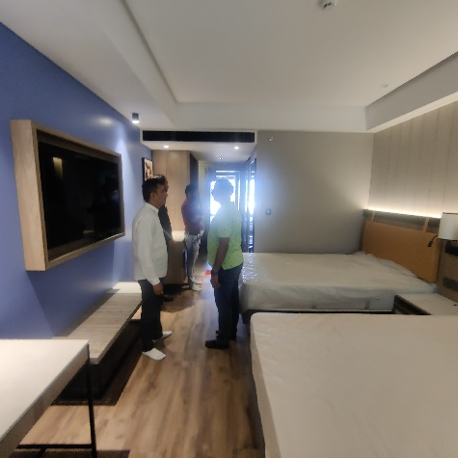
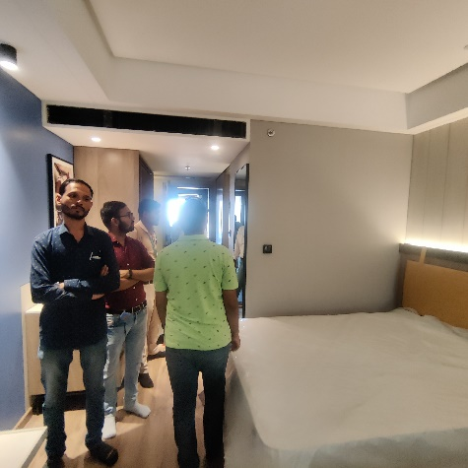
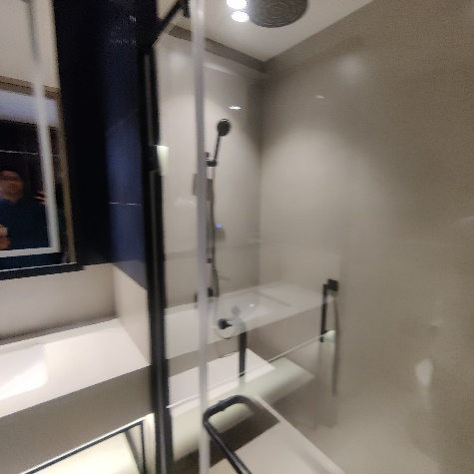
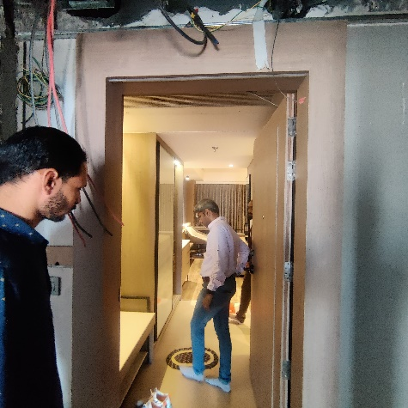
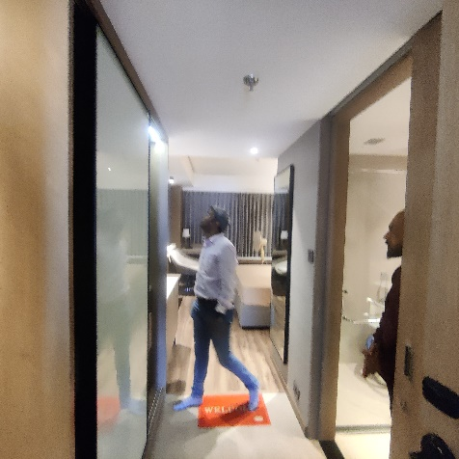

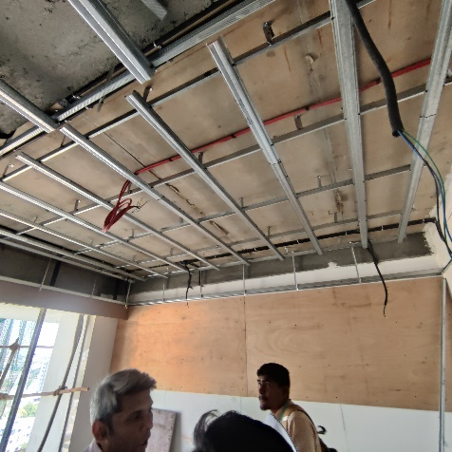
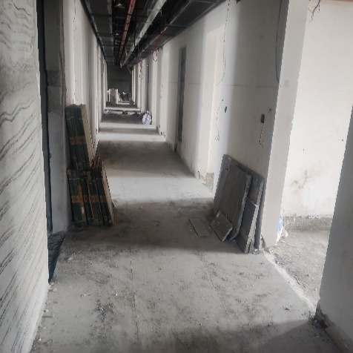
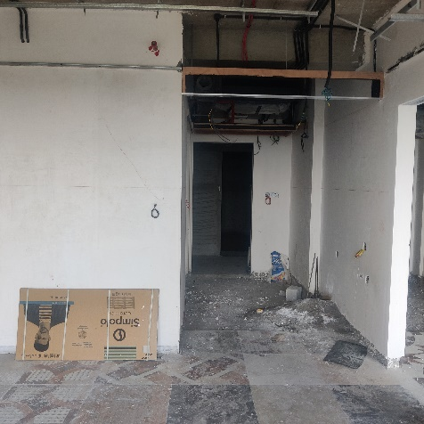
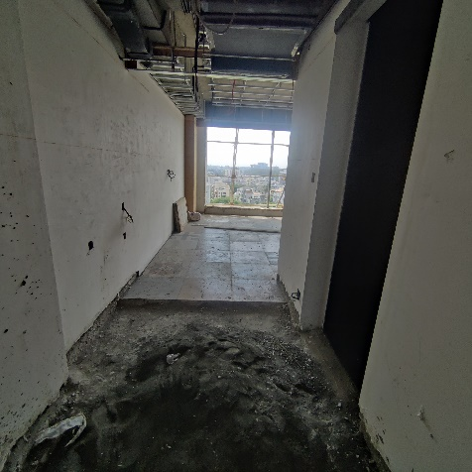
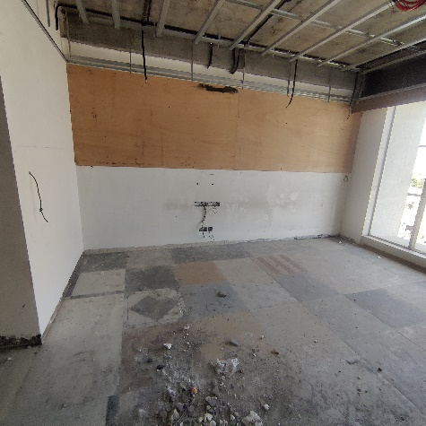
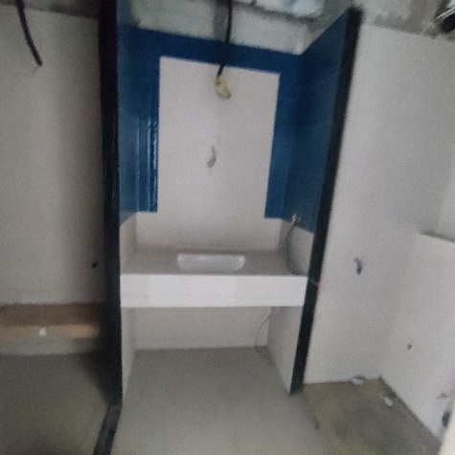
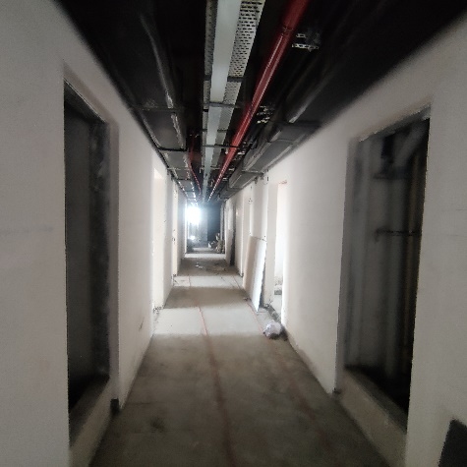
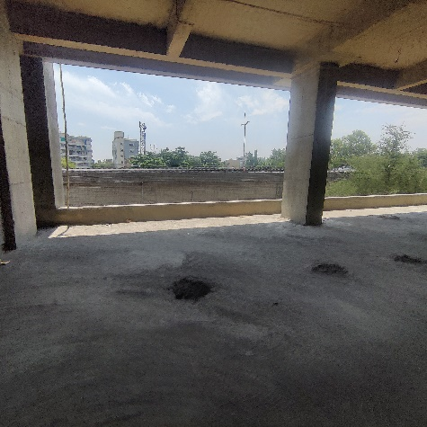
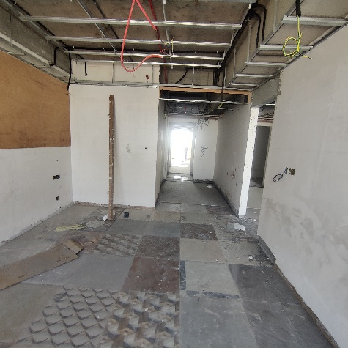
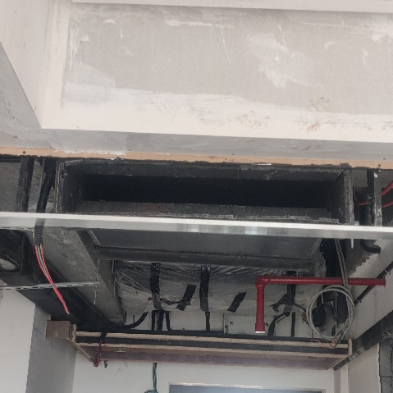
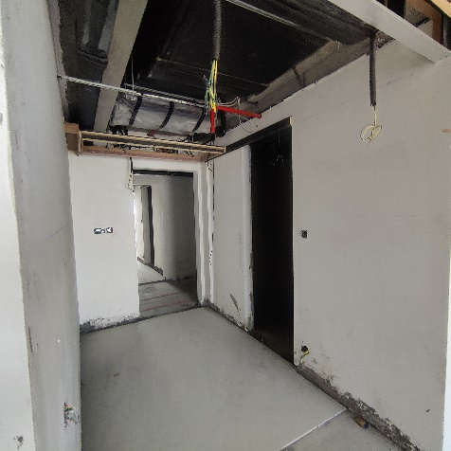
Actual Site Photographs as on 15.04.2023
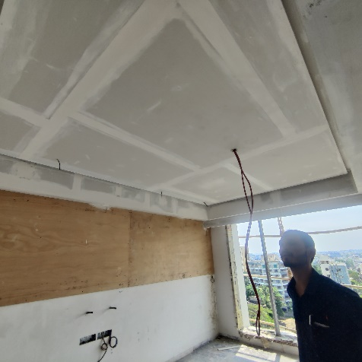
Actual Site Photographs as on 15.04.2023
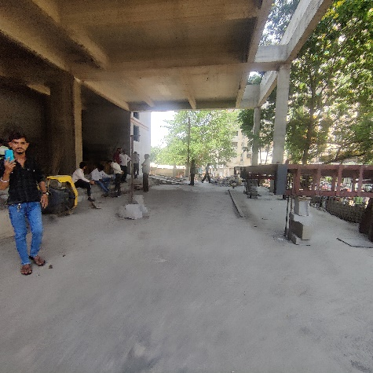
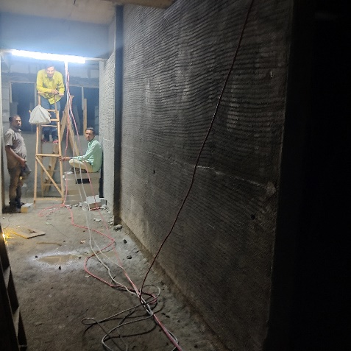
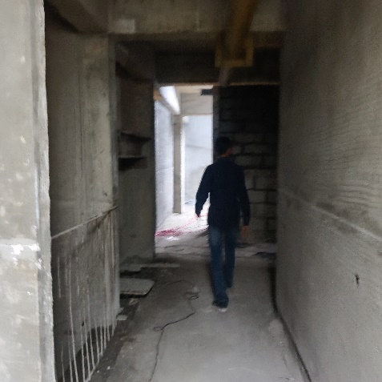
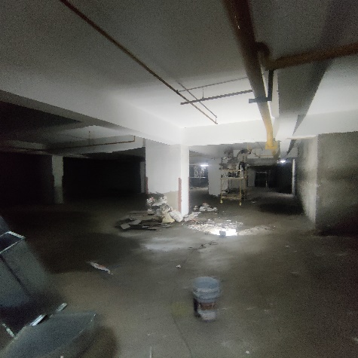
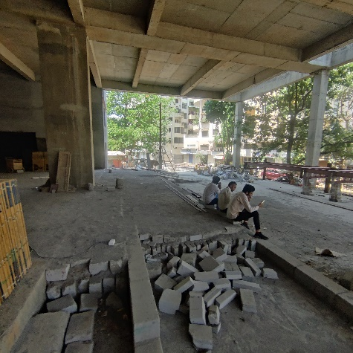
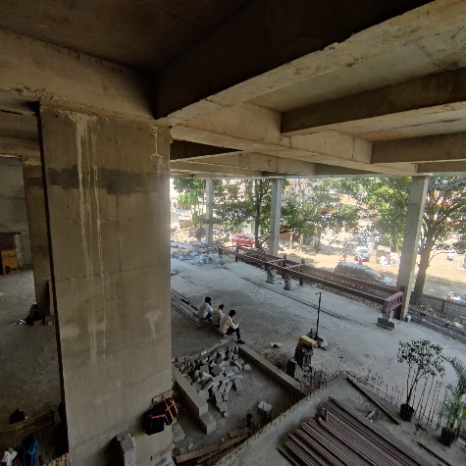
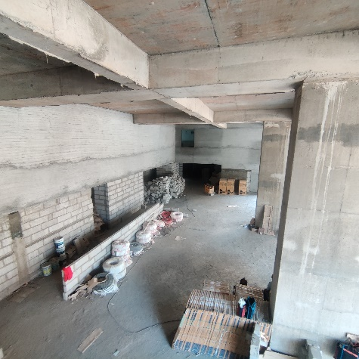
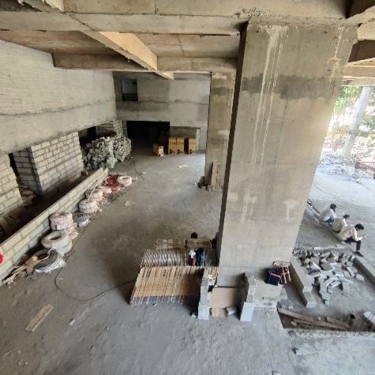
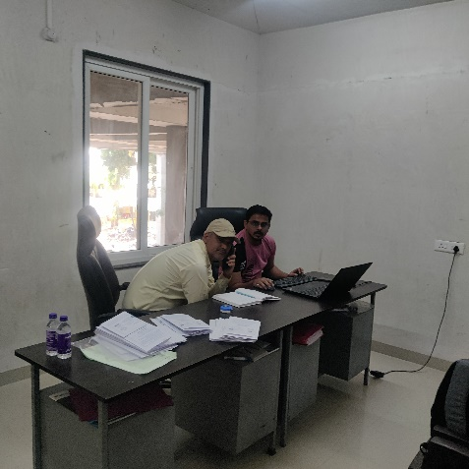
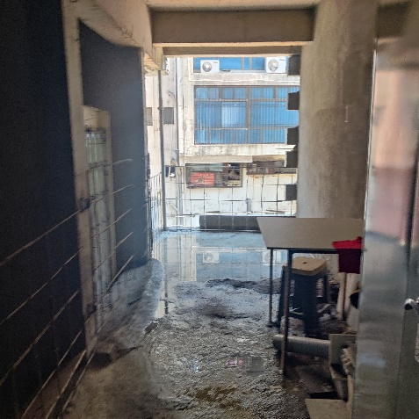
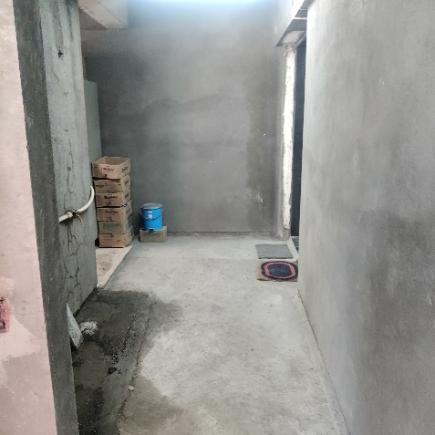
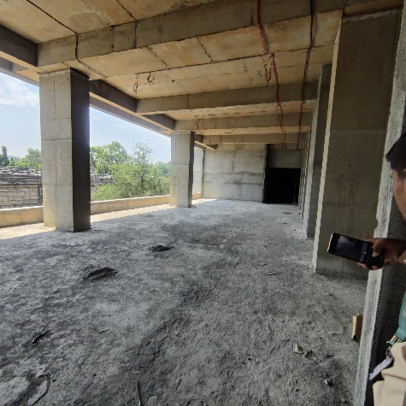
Actual Site Photographs as on 15.04.2023
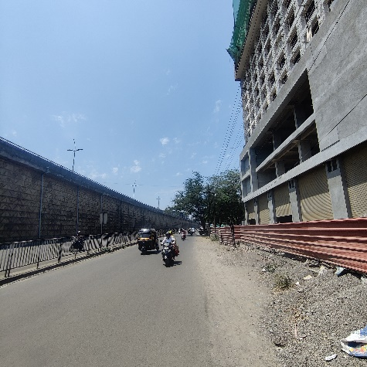
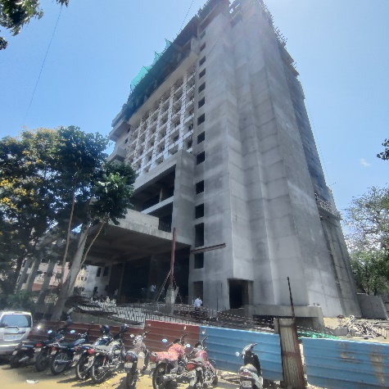
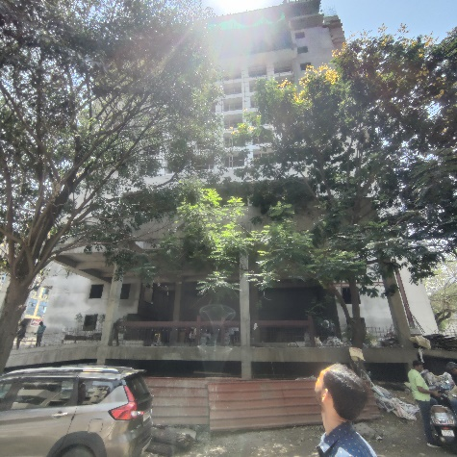
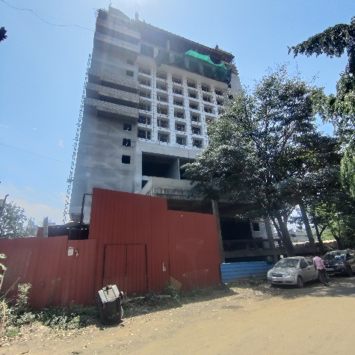
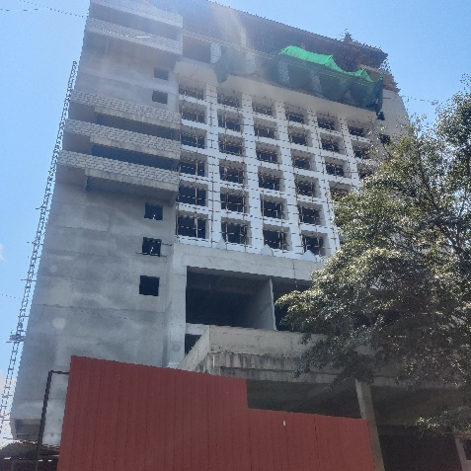
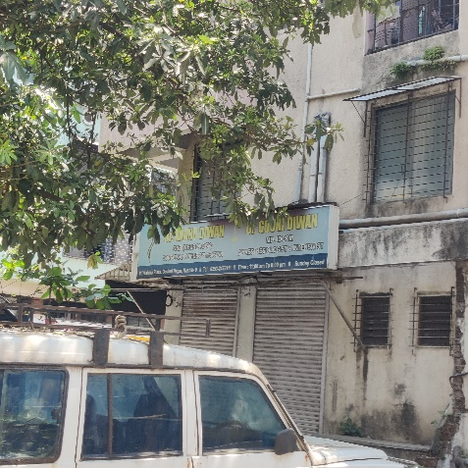
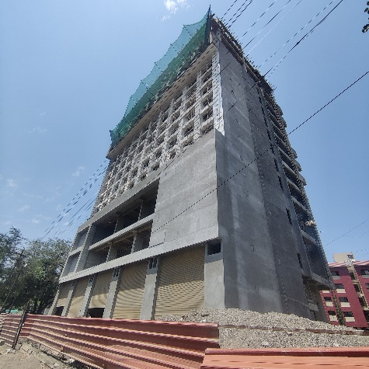
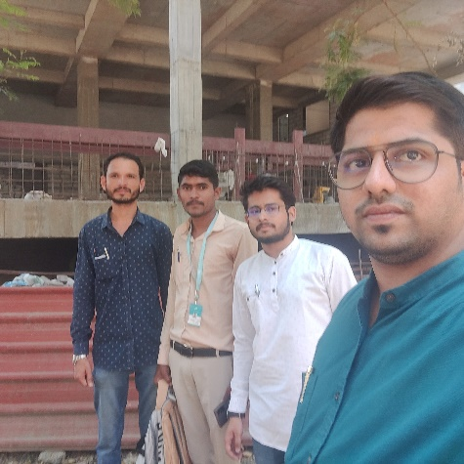
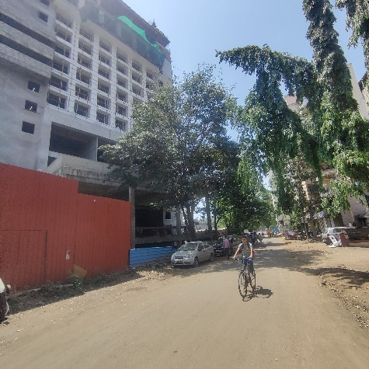

Route Map of the property
Site u/r
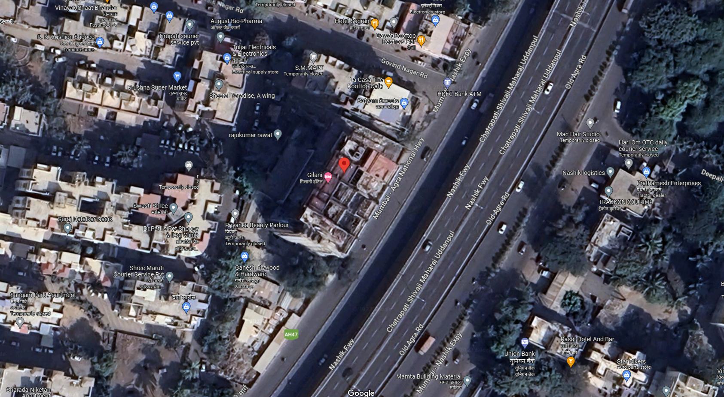

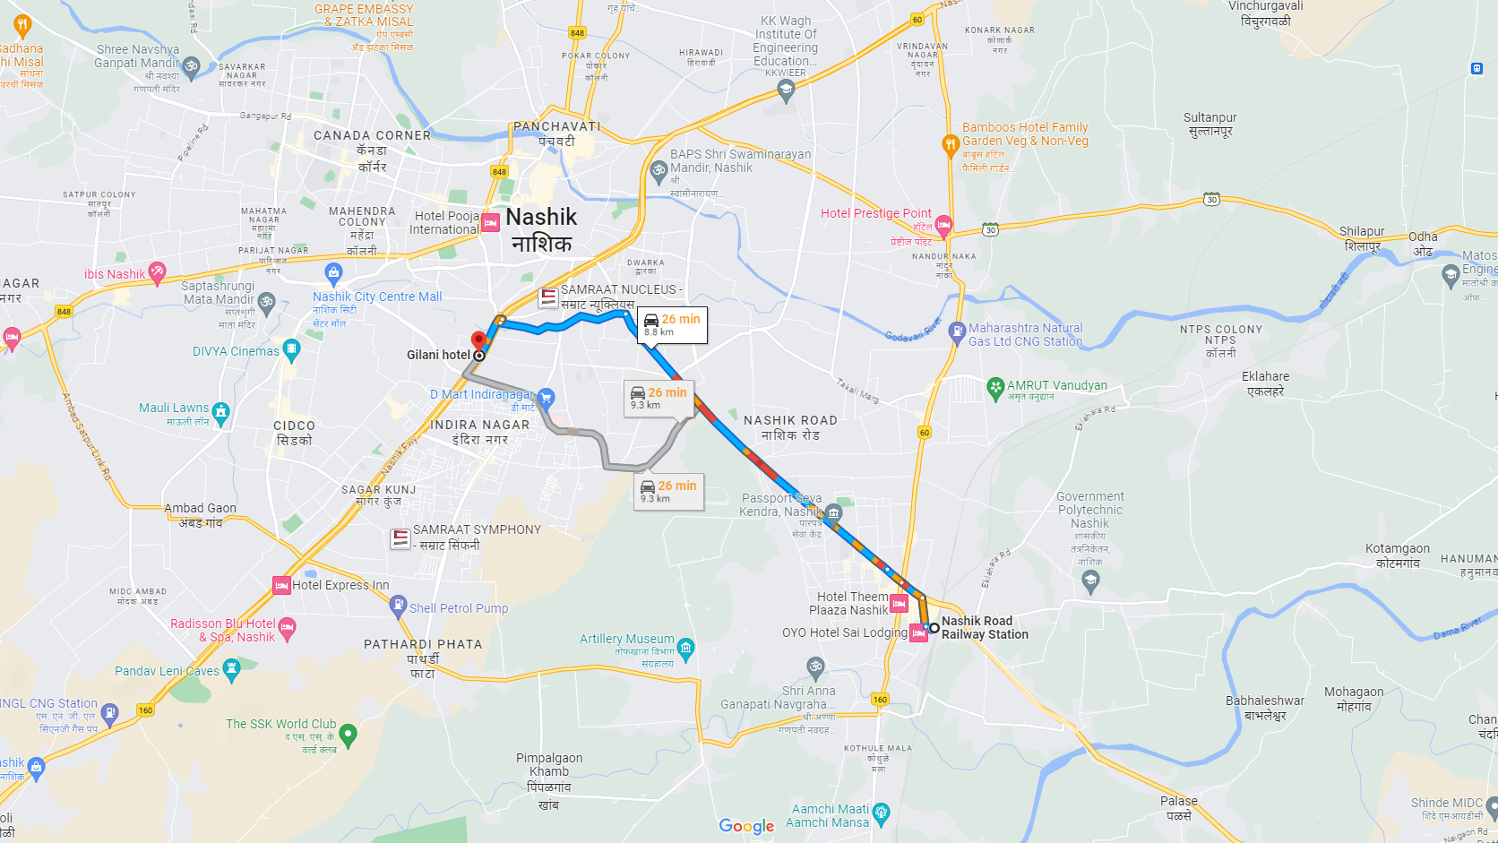

Latitude Longitude: 19°58'55.8"N 73°46'53.4"E
Note: The Blue line shows the route to site from nearest railway station (Nashik Road – 8.80 Km.)

