Valuation Report of the Immovable Property
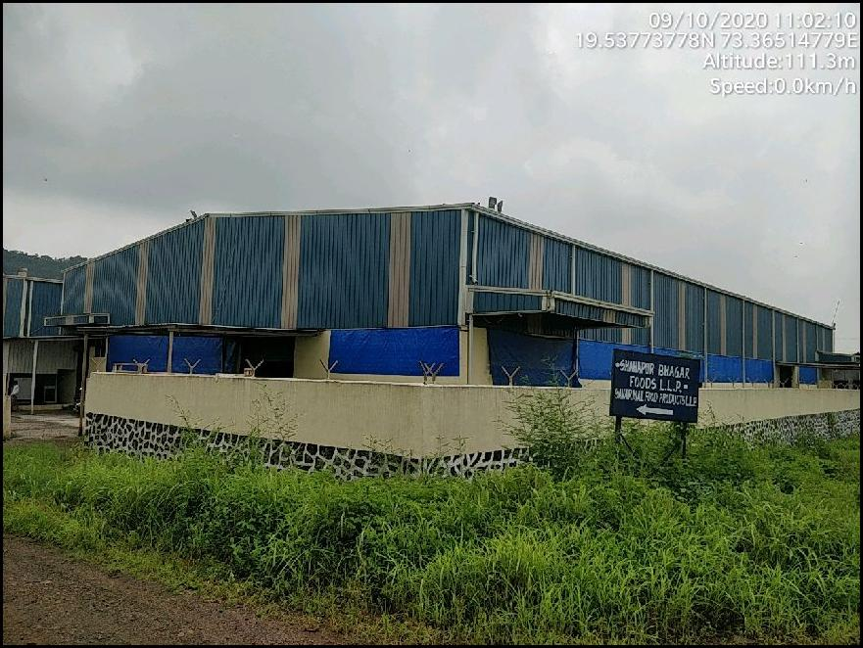

Details of the property under consideration:

Name of Owner: M/s. Shahapur Bhagar Food LLP

N.A. Land or Ground bearing Plot No. 10, 11 & 12, Survey No. 152, 153 & 157 at Village - Lahe, Taluka Shahapur, District - Thane, PIN - 421 601, State - Maharashtra, Country - India

Latitude Longitude: 19°32'14.6"N 73°21'55.7"E

Valuation Done for:

State Bank of India
SME Goregaon (East) Branch
Block No. 101, 1st Floor, Kohinoor Industrial Estate, Western Express Highway,
Goregaon (East), Mumbai - 400063, State – Maharashtra, Country-India

Vastukala Consultants (I) Pvt. Ltd.
Mumbai • Delhi NCR • Aurangabad • Nanded

Vastu/Mumbai/09/2020/017726/33277
30/03-145-V
Date: 30.09.2020

VALUATION OPINION REPORT

This is to certify that the property N.A. Land or Ground bearing Plot No. 10, 11 & 12, Survey No. 152, 153 & 157 at Village - Lahe, Taluka Shahapur, District - Thane, PIN - 421 601, State - Maharashtra, Country - India being valued for M/s. Shahapur Bhagar Food LLP.

Considering various parameters recorded, existing economic scenario, and the information that is available with reference to the development of neighbourhood and method selected for valuation, we are of the opinion that , the property premises can be assessed and Realizable value for SARFAESI Securitisation and Reconstruction of Financial Assets and Enforcement of Security Interest Act, 2002 purpose at ` 2,39,17,657.00 (Rupees Two Crore Thirty Nine Lakh Seventeen Thousand Six Hundred Fifty Seven Only).
Boundaries of the property.

North | : | Internal Road
South | : | Open Plot
East | : | Open Plot
West | : | Internal Road & Open Plot

The valuation of the property is based on the documents produced by the concern. Legal aspects have not been taken into considerations while preparing this valuation report.

Hence certified

Sharadkumar B. Chalikwar
Govt. Reg. Valuer
Chartered Engineer (India)
Reg. No. (N) CCIT/1-14/52/2008-09
SBI Empanelment No.: SME/TCC/2017-18/942/178
Encl: Valuation report.

Vastukala Consultants (I) Pvt. Ltd.
121, 1st Floor, Ackruti Star, Central Road, MIDC, Andheri (E), Mumbai - 400 093

To,
The Branch Manager,
State Bank of India
SME Goregaon (East) Branch
Block No. 101, 1st Floor, Kohinoor Industrial Estate,
Western Express Highway,
Goregaon (East), Mumbai - 400063,
State – Maharashtra, Country-India

VALUATION REPORT (IN RESPECT OF OPEN LAND)
I | General
1. | Purpose for which the valuation is made |  |  | : | As per the request from State Bank of India, SME Goregaon (East) Branch to assess realizable value of the property for SARFAESI Securitisation and Reconstruction of Financial Assets and Enforcement of Security Interest Act, 2002 purpose.
2. | a) |  | Date of inspection | : | 10.09.2020
 | b) |  | Date on which the valuation is made | : | 30.09.2020
 | List of documents produced for perusal
- Copy of Deed of Conveyance dated 03.10.2015 for plot no. 10 & 11
- Copy of Deed of Conveyance dated 10.03.2016 for plot no. 12
- Copy of N.A. Order dated 16.06.2010
- Copy of Layout plan issued by A.D.T.P. Thane
4. | Name of the client(s) and his / their address (es) with Phone no. (details of share of each owner in case of joint ownership) |  |  | : | M/s. Shahapur Bhagar Food LLP  Address:  N.A. Land or Ground bearing Plot No. 10, 11 & 12, Survey No. 152, 153 & 157 at Village - Lahe, Taluka Shahapur, District - Thane, PIN - 421 601, State - Maharashtra, Country - India  Contact Person:  Mr. Harshad (SBI Employee - Mobile No. 9833554226)  Company Ownership
5. | Brief description of the property (Including Leasehold / leasehold etc.) |  |  | :
The property is located in a developing area and well connected by train and road. The immovable property comprises of Freehold N.A. open land. It is located at about 8.7 Km. travel distance from Khardi Railway Station.

As per Deed of Conveyance, the land area is as below:
Plot No. | Area in Sq. M.
10 | 1340.00
11 | 1120.00
12 | 1120.00
Total | 3580.00

As per our measurement Constructed area are as under and considered for valuation:
Floors | Specification | Area (Sq. Ft.)
Ground Floor on Main Shed & Office | Main Shed - It consists of Working area + Toilet.  AC sheet roofing and Kota flooring in the shed. Open wiring, MS rolling shutters, Aluminium Sliding windows are also provided.  Office Area - It consists of Working area + Cabin + Storage room.  Amenities such as Wooden flooring in office. Concealed wiring, glass doors, MS rolling shutters, Aluminium Sliding windows are also provided | 19606.00

6. | Location of property |  |  | :
 | a) | Plot No. / Survey No. |  | : | Survey No. 152, 153 & 157
 | b) | Door No. |  | : | Not applicable
 | c) | C. T.S. No. / Village |  | : | Village Lahe
 | d) | Ward / Taluka |  | : | Taluka Shahapur
 | e) | Mandal / District |  | : | District - Raigad
7. | Postal address of the property |  |  | : | N.A. Land or Ground bearing Plot No. 10, 11 & 12, Survey No. 152, 153 & 157 at Village - Lahe, Taluka Shahapur, District - Thane, PIN - 421 601, State - Maharashtra, Country - India
8. | City / Town |  |  | : | Shahapur
 | Residential area |  |  | : | Not available
 | Commercial area |  |  | : | Not available
 | Industrial area |  |  | : | Not available
9. | Classification of the area |  |  | :
 | i) High / Middle / Poor |  |  | : | Middle Class
 | ii) Urban / Semi Urban / Rural |  |  | : | Rural
10. | Coming under Corporation limit / Village Panchayat / Municipality |  |  | : | Gram Panchayat Lahe
11. | Whether covered under any State / Central Govt. enactments (e.g., Urban Land Ceiling Act) or notified under agency area/ scheduled area / cantonment area |  |  | : | N.A.
12. | In Case it is Agricultural land, any conversion to house site plots is contemplated |  |  | : | N.A. as it is Industrial Land and Building
13. | Boundaries of the property |  |  |  | As on Site
 | North |  |  | : | Open Plot & Internal Road
 | South |  |  | : | Open Plot
 | East |  |  | : | Open Plot
 | West |  |  | : | Internal Road & Open Plot
14.1 | Dimensions of the site
 |  |  |  |  | A As per the Deed | B Actuals
 | North |  |  | : | Information not available
 | South |  |  | :
 | East |  |  | :
 | West |  |  | :
14.2 | Latitude, Longitude & Co-ordinates |  |  | : | 19°32'14.6"N 73°21'55.7"E
14.3 | Extent of the site |  |  | : | As per Deed of Conveyance, the land area is as below:  Structure = As per valuation table
  Plot No. | Area in Sq. M.
  10 | 1340.00
  11 | 1120.00
  12 | 1120.00
  Total | 3580.00
15. | Extent of the site considered for Valuation (least of 14A& 14B) |  |  | : | As per Deed of Conveyance, the land area is as below:  Structure = As per valuation table
  Plot No. | Area in Sq. M.
  10 | 1340.00
  11 | 1120.00
  12 | 1120.00
  Total | 3580.00
16 | Whether occupied by the owner / tenant? If occupied by tenant since how long? Rent received per month. |  |  | : | Vacant
II | CHARACTERSTICS OF THE SITE
 | Classification of locality |  |  | : | Middle class
 | Development of surrounding areas |  |  | : | Developing
 | Possibility of frequent flooding/ sub-merging |  |  | : | No
 | Feasibility to the Civic amenities like School, Hospital, Bus Stop, Market etc. |  |  | : | All available within the radius of 2 to 4 km.
 | Level of land with topographical conditions |  |  | : | Plain
 | Shape of land |  |  | : | Rectangular
 | Type of use to which it can be put |  |  | : | Industrial Use
 | Any usage restriction |  |  | : | Industrial Use
 | Is plot in town planning approved layout? |  |  | : | Information not available
 | Corner plot or intermittent plot? |  |  | : | Intermittent
 | Road facilities |  |  | : | Yes
 | Type of road available at present |  |  | : | 6.00 M. wide road
 | Width of road – is it below 20 ft. or more than 20 ft. |  |  | : | N.A.
 | Is it a Land – Locked land? |  |  | : | No
 | Water potentiality |  |  | : | Yes, Grampanchayat
 | Underground sewerage system |  |  | : | Yes
 | Is Power supply is available in the site |  |  | : | Yes
 | Advantages of the site |  |  | : | Located in developing area
 | Special remarks, if any like threat of acquisition of land for publics service purposes, road widening or applicability of CRZ provisions etc.(Distance from sea-cost / tidal level must be incorporated) |  |  | : | Approvals of structure such as Approved Plan, Building Completion Certificate etc. are not provided for our verification.
Part – A (Valuation of land)
1 | Size of plot |  |  | : | 3580.00 Sq. M.
 | North & South |  |  | : | --
 | East & West |  |  | : | --
2 | Total extent of the plot |  |  | : | 3580.00 Sq. M.
3 | Prevailing market rate (Along With details / reference of at least two latest deals / transactions with respect to adjacent properties in the areas) |  |  | : | ` 2,000.00 per Sq. M.
4 | Guideline rate obtained from the Register’s Office ( an evidence thereof to be enclosed) |  |  | : | ` 1,720.00 per Sq. M.
5 | Assessed / adopted rate of valuation |  |  | : | ` 2,000.00 per Sq. M.
6 | Estimated value of land |  |  | : | ` 71,60,000.00
Part – B (Valuation of Building)
1 | Technical details of the building |  |  | :
 | - Type of Building (Residential / Commercial / Industrial) |  |  | : | Industrial
 | - Type of construction (Load bearing / RCC / Steel Framed) |  |  | : | RCC framed structure with AC Sheet roofing
 | - Year of construction |  |  | : | 2014 (As per Previous Valuation report)
 | - Number of floors and height of each floor including basement, if any |  |  | : | As per brief description
 | - Plinth area floor-wise |  |  | : | As per brief description
 | - Condition of the building |  |  | :
 | - Exterior – Excellent, Good, Normal, Poor |  |  | : | Normal
 | - Interior – Excellent, Good, Normal, Poor |  |  | : | Normal
 | - Date of issue and validity of layout of approved map |  |  | : | Copy of Approved Plan not provided for our verification.
 | - Approved map / plan issuing authority |  |  | :
 | - Whether genuineness or authenticity of approved map / plan is verified |  |  | : | N.A.
 | - Any other comments by our empanelled valuers on authentic of approved plan |  |  | : | N.A.

Specifications of construction (floor-wise) in respect of

Sr.  No. | Description
 | Foundation | : | As per Brief Description
 | Basement | : | As per Brief Description
 | Superstructure | : | As per Brief Description
 | Joinery / Doors & Windows (Please furnish details about size of frames, shutters, glazing, fitting etc. and specify the species of timber | : | As per Brief Description
 | RCC Works | : | As per Brief Description
 | Plastering | : | As per Brief Description
 | Flooring, Skirting, dado | : | As per Brief Description
 | Special finish as marble, granite, wooden paneling, grills etc. | : | As per Brief Description
 | Roofing including weather proof course | : | As per Brief Description
 | Drainage | : | As per Brief Description

2. | Compound Wall | :
 | Height | : | As per Brief Description
 | Length | : | As per Brief Description
 | Type of construction | : | As per Brief Description
3. | Electrical installation | :
 | Type of wiring | : | Open
 | Class of fittings (superior / ordinary / poor) | : | Ordinary
 | Number of light points | : | Provided as per requirement
 | Fan points | : | Provided as per requirement
 | Spare plug points | : | Provided as per requirement
 | Any other item | : | Provided as per requirement
4. | Plumbing installation
 | - No. of water closets and their type | : | Provided as per requirement
 | - No. of wash basins | : | Provided as per requirement
 | - No. of urinals | : | Provided as per requirement
 | - No. of bath tubs | : | Provided as per requirement
 | - Water meters, taps etc. | : | Provided as per requirement
 | - Any other fixtures | : | Provided as per requirement

Particulars | Plinth  Area  Sq. Ft. | Year Of Const. | Age Of Building | Estimated replacement rate of construction  (`) | Replacement cost / Insurance Value  (`) | Depreciation  (`) | Net Value after depreciation  (`)
Ground floor | 19606.00 | 2014 | 6 | 1200.00 | 2,35,27,200.00 | 25,40,938.00 | 2,09,78,420.00
TOTAL |  |  |  |  | 2,35,27,200.00 | 25,40,938.00 | 2,09,78,420.00

Part – C (Extra Items) |  | : | Amount in `
 | Portico | : | Included in the Cost of Construction
 | Ornamental front door | :
 | Sit out / Verandah with steel grills | :
 | Overhead water tank | :
 | Extra steel / collapsible gates | :
 | Total

Part – D (Amenities) |  | : | Amount in `
 | Wardrobes | : | Included in the Cost of Construction
 | Glazed tiles | :
 | Extra sinks and bath tub | :
 | Marble / ceramic tiles flooring | :
 | Interior decorations | :
 | Architectural elevation works
 | Paneling works
 | Aluminum works
 | Aluminum hand rails
 | False ceiling
 | Total

Part – E (Miscellaneous) |  | : | Amount in `
 | Separate toilet room | : | Included in the Cost of Construction
 | Separate lumber room | :
 | Separate water tank / sump | :
 | Trees, gardening | :
 | Total

Part – F (Services) |  | : | Amount in `
 | Water supply arrangements | : | Included in the Cost of Construction
 | Drainage arrangements | :
 | Compound wall | :
 | C.B. deposits, fittings etc. | :
 | Pavement
 | Total

Government Value

Particulars | Area in Sq. M. | Rate in ` | Value in `
Land | 3580.00 | 1,720.00 | 61,57,600.00

Total abstract of the entire property

Part – A | Land | : | ` 71,60,000.00
Part – B | Building | : | ` 2,09,78,420.00
Part – C | Compound wall | :
Part - D | Amenities | :
Part – E | Pavement | :
Part – F | Services | :
 | Fair Market Value | : | ` 2,81,38,420.00
 | Realizable Value | : | ` 2,39,17,657.00
 | Distress Value |  | ` 1,96,96,894.00
Remarks | Approvals of structure such as Approved Plan, Building Completion Certificate etc. are not provided for our verification.

Land cost can be estimated using the Sales Comparison Approach by studying recent sales of land close to the subject property, and these sales should be comparable in size and location with subject property.

we have adopted Sales Comparison Approach for the purpose of valuation. The Price for similar type of property in the nearby vicinity is in the range of ` 1,800.00 to ` 2,200.00 per Sq. M. for developed land Considering the rate with attached report, current market conditions, demand and supply position, Land size, location, demand for plot uses of plot, all round development of residential, commercial and industrial application in the locality etc. We estimate ` 2,000.00 per Sq. M. for developed Land for valuation.

The saleability of the property is : Normal
Likely rental values in future in: N.A.
Any likely income it may generate: N.A.

Sharadkumar B. Chalikwar
Govt. Reg. Valuer
Chartered Engineer (India)
Reg. No. (N) CCIT/1-14/52/2008-09

Place : Mumbai
Date : 30.09.2020
Actual Site Photographs
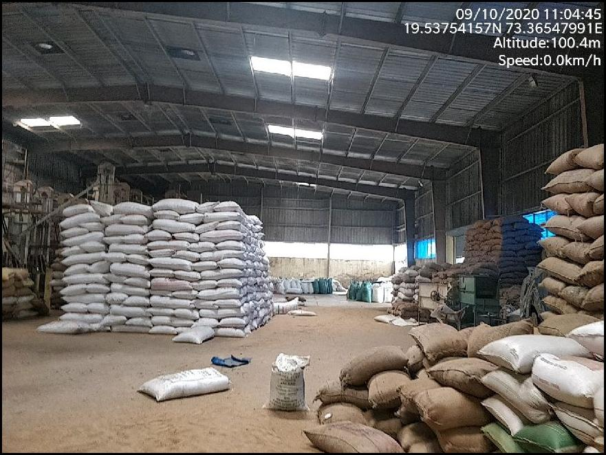
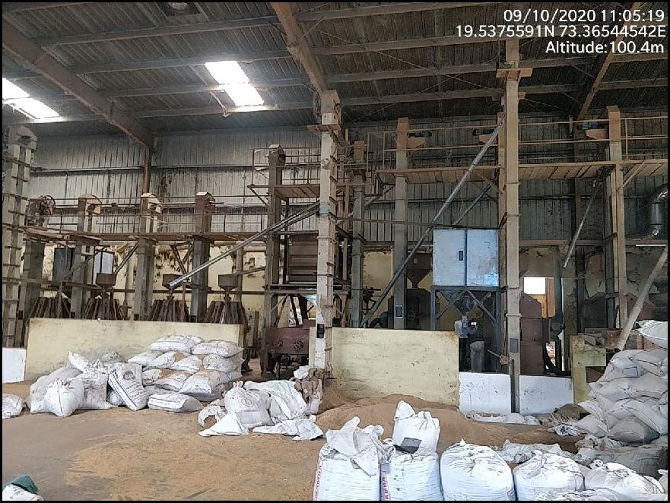
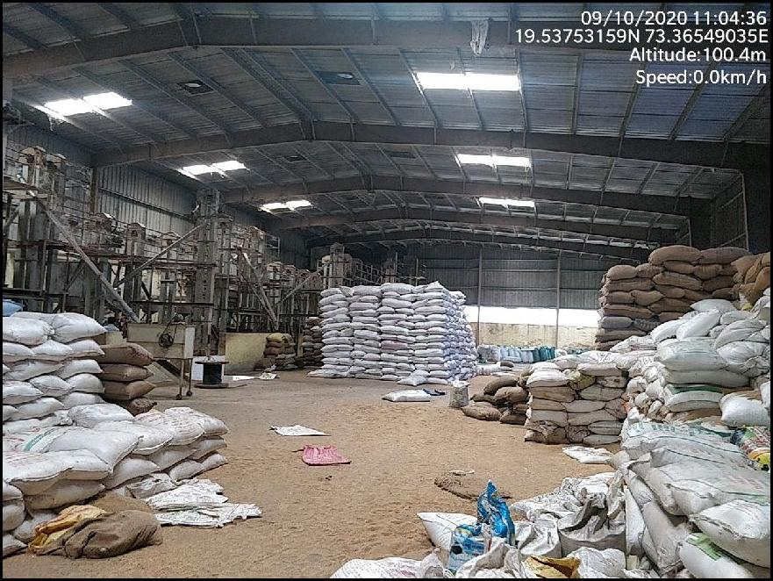
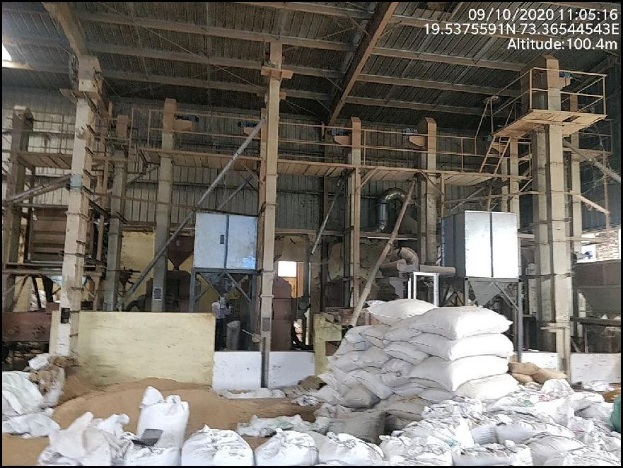
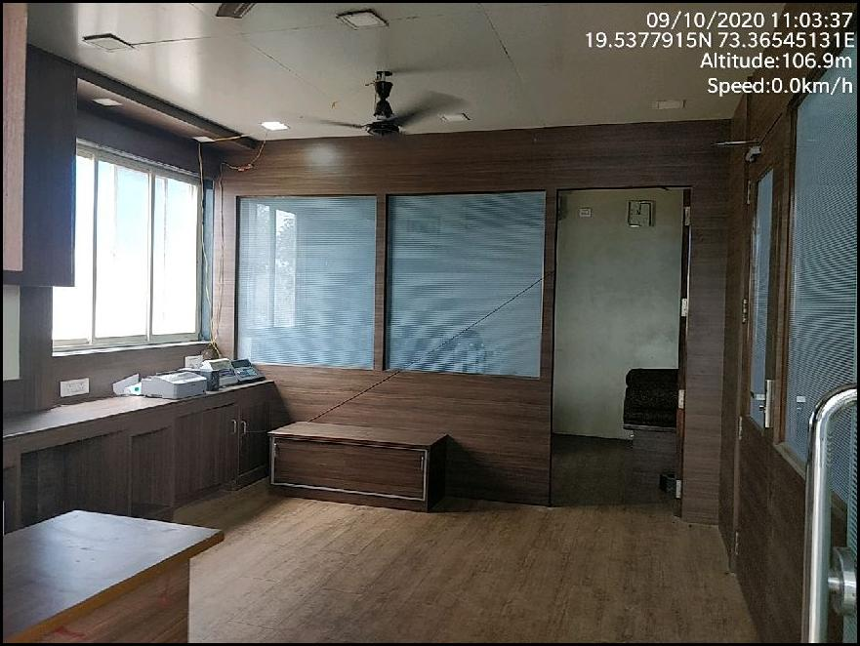
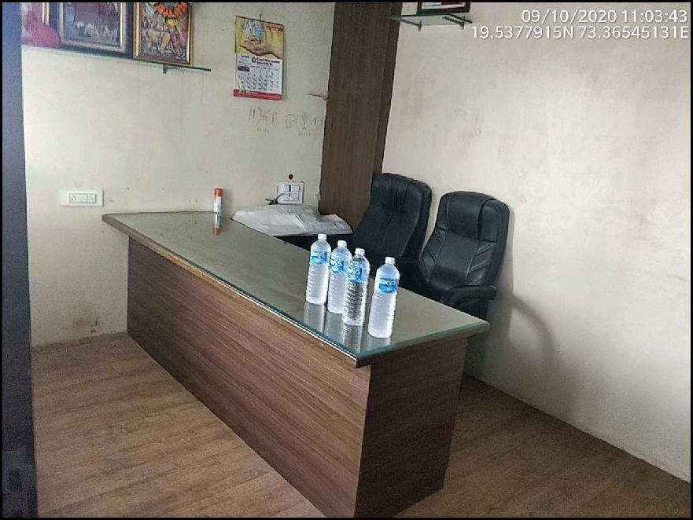
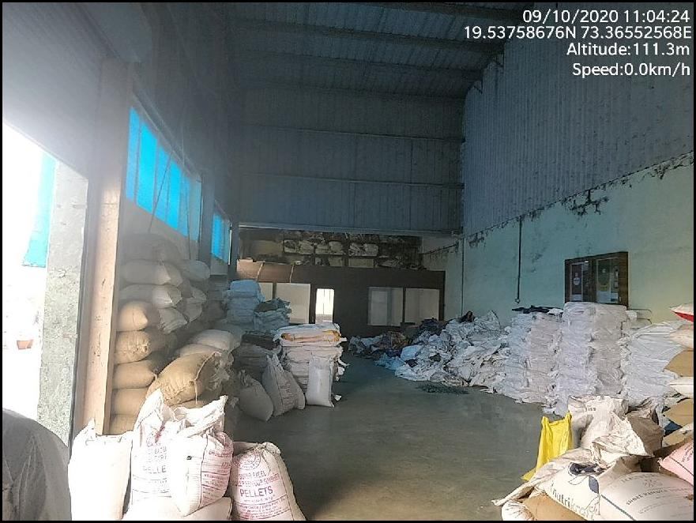
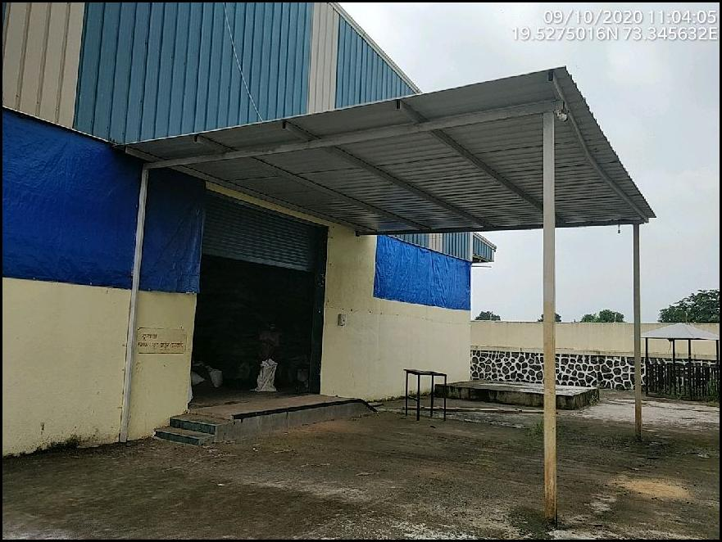
Actual Site Photographs
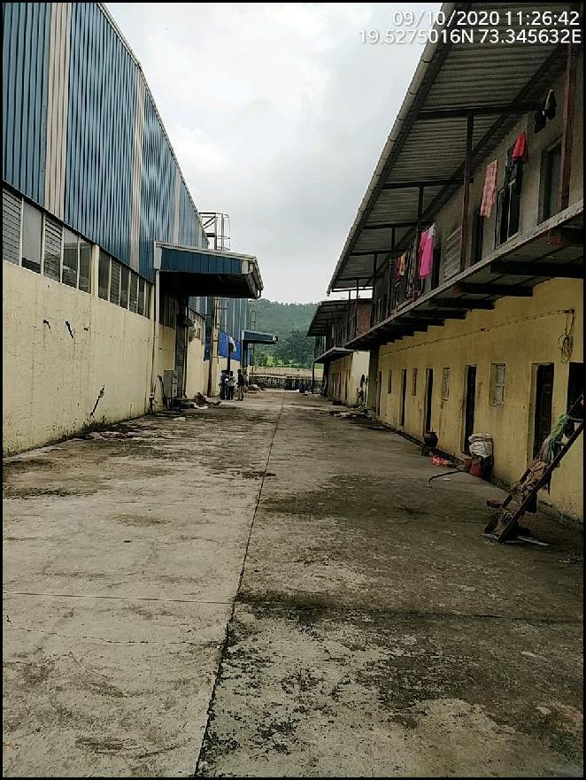
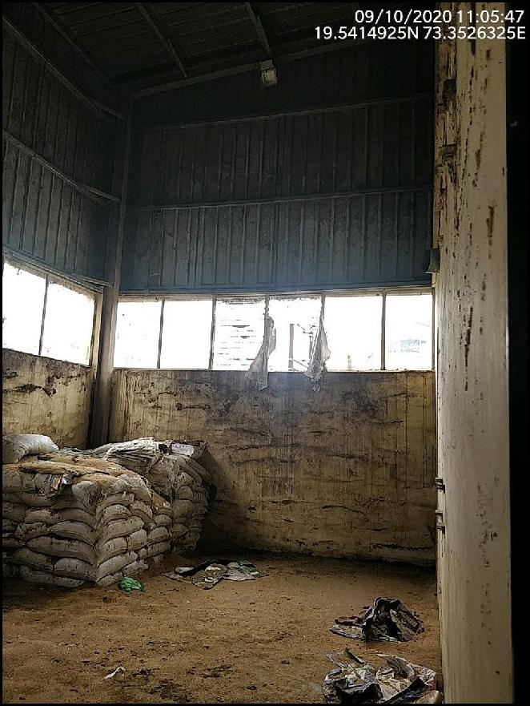
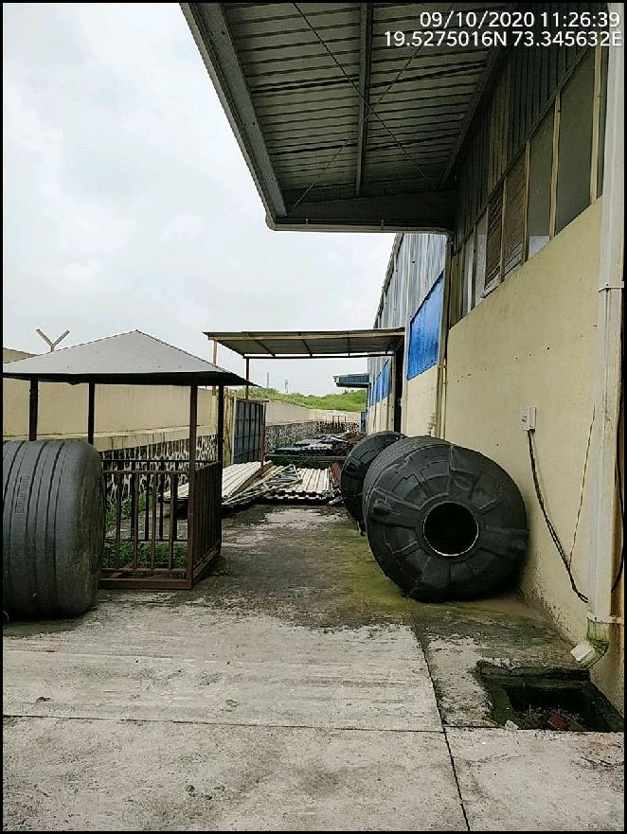

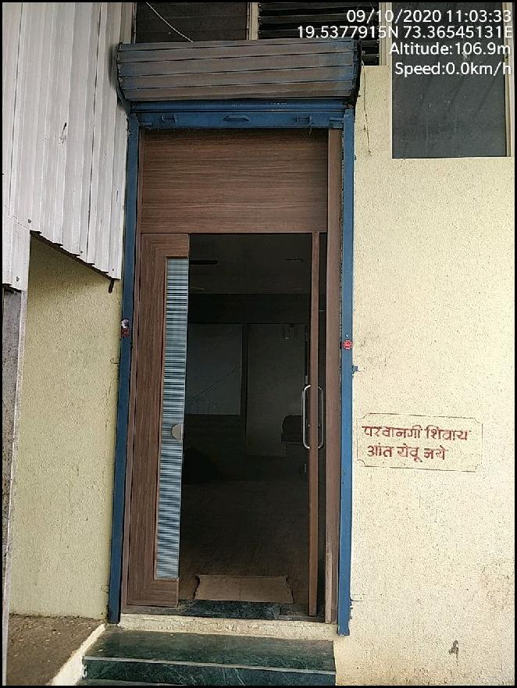
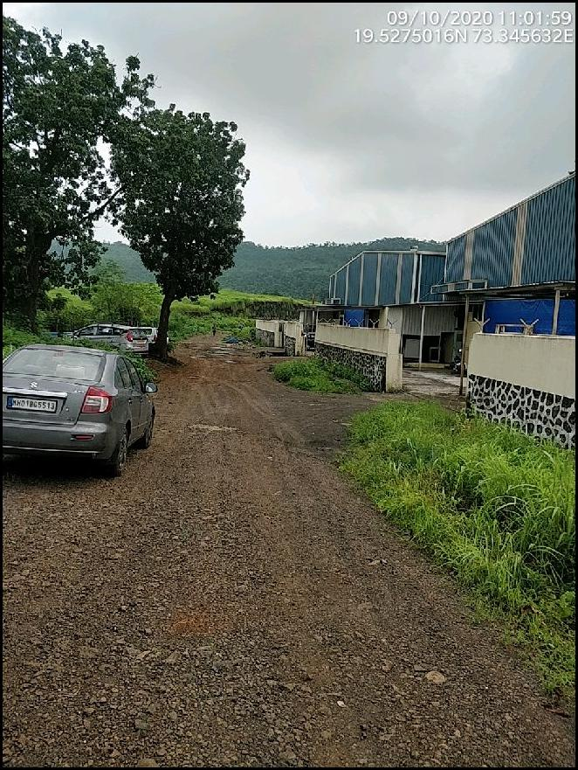
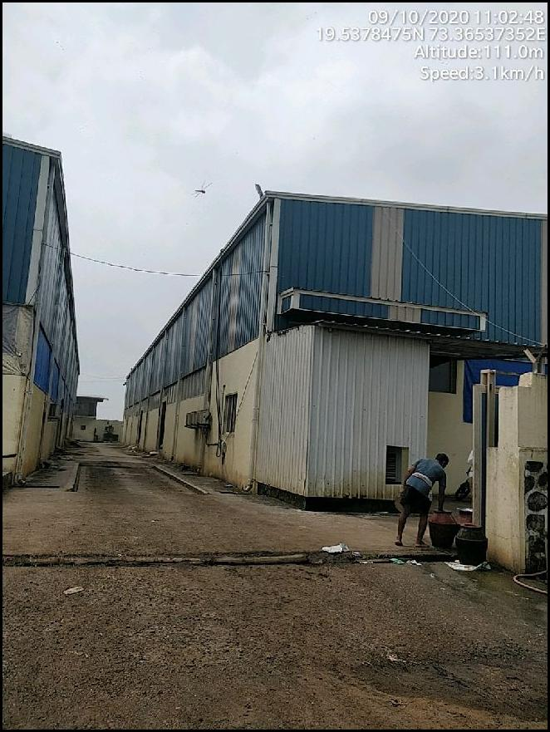
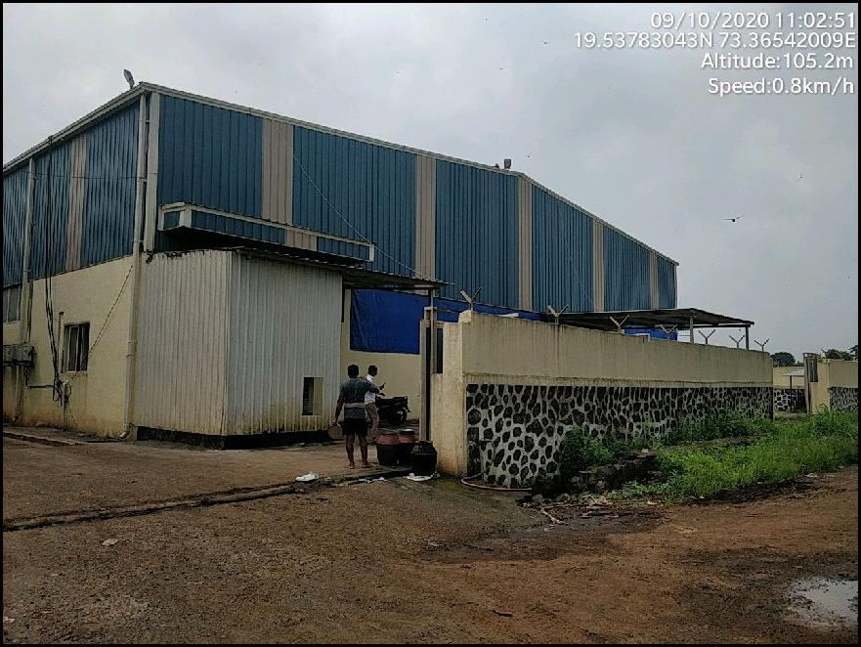
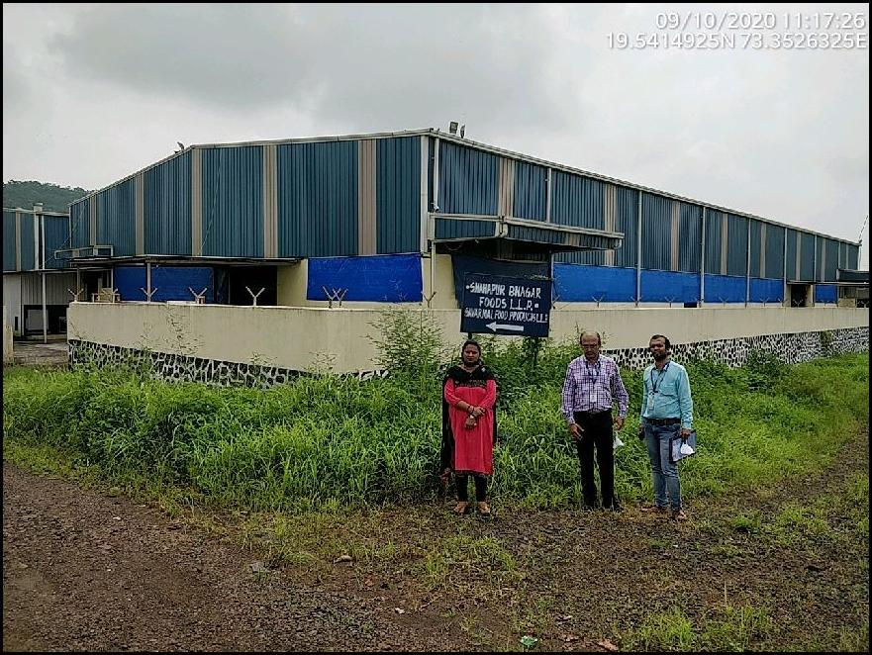
Route Map of the property
Site u/r
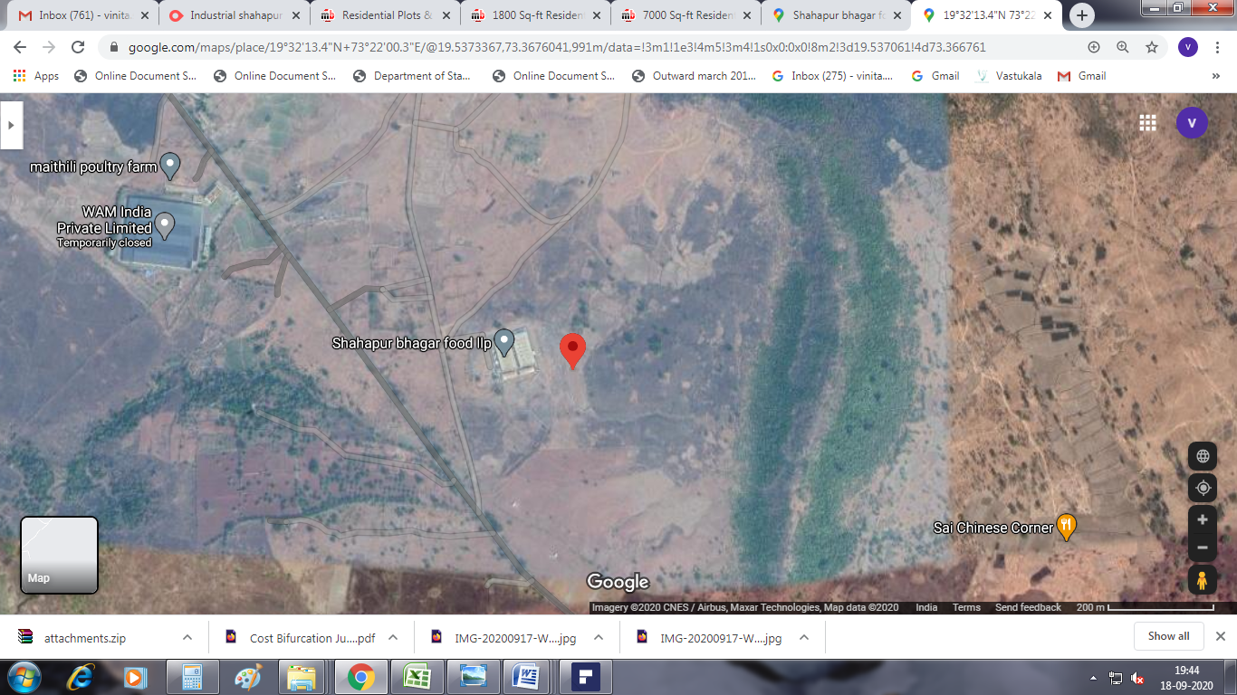

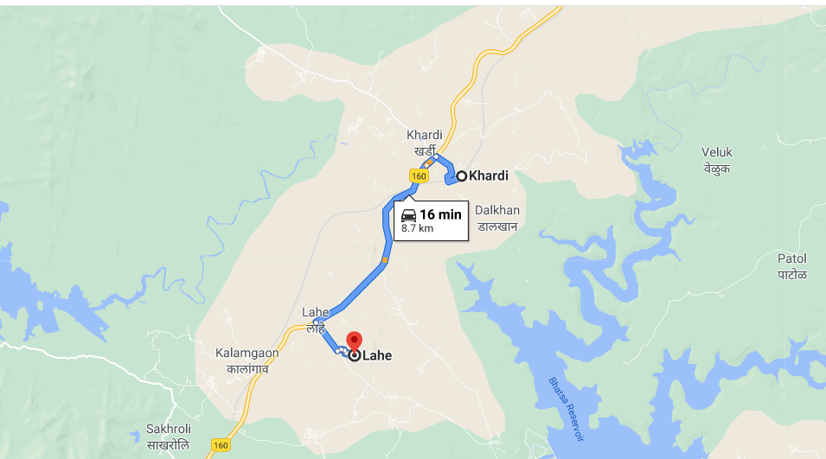

Latitude Longitude: 19°32'13.4"N 73°22'00.3"E

Note: The Blue line shows the route to site from nearest railway station (Khardi – 8.7 Km.)
Ready Reckoner Rate
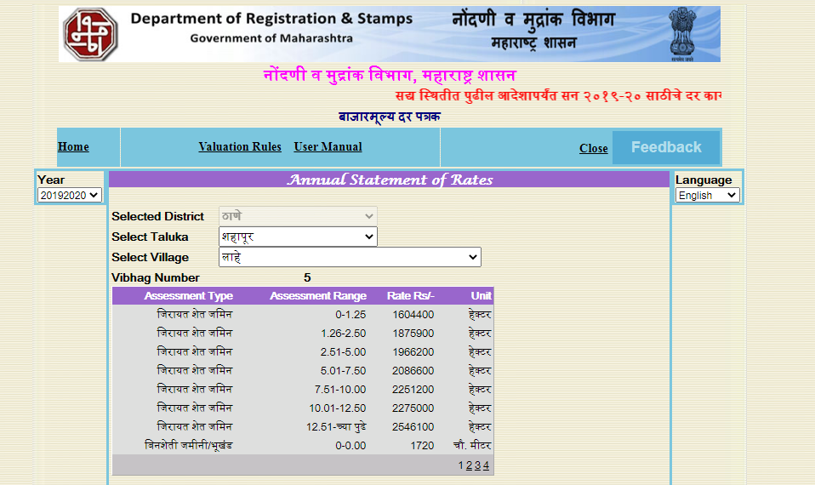
Price Indicator
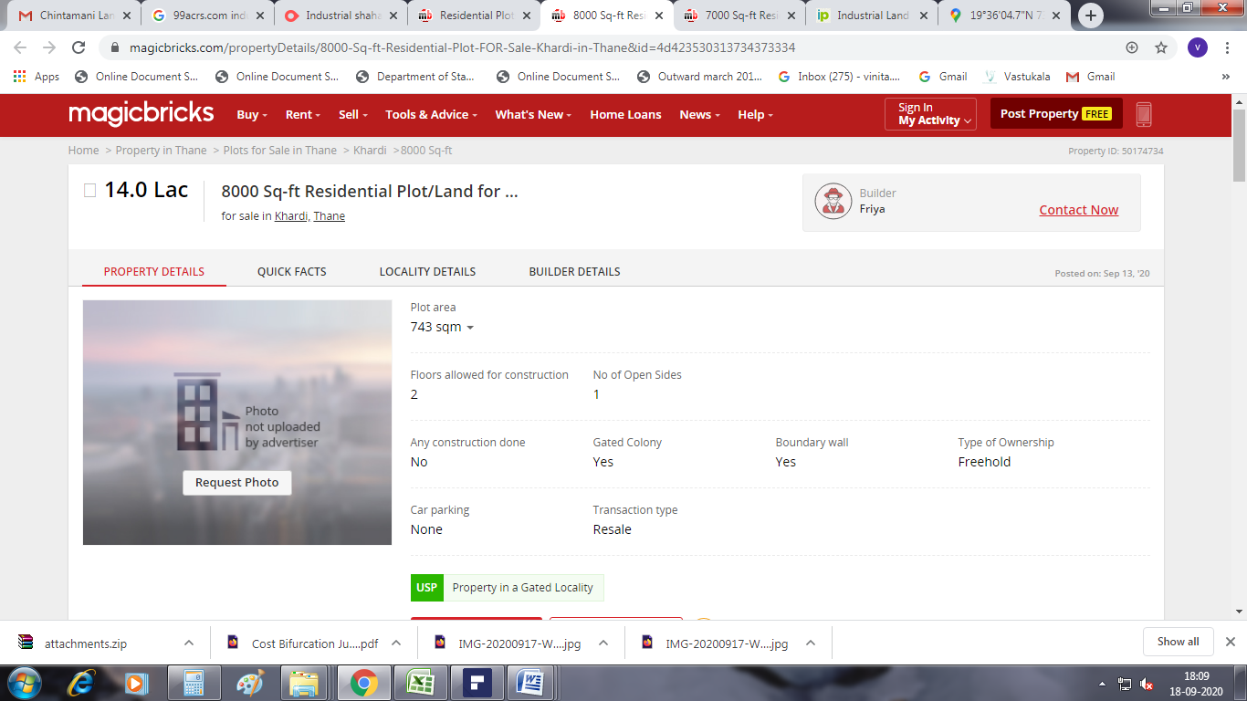
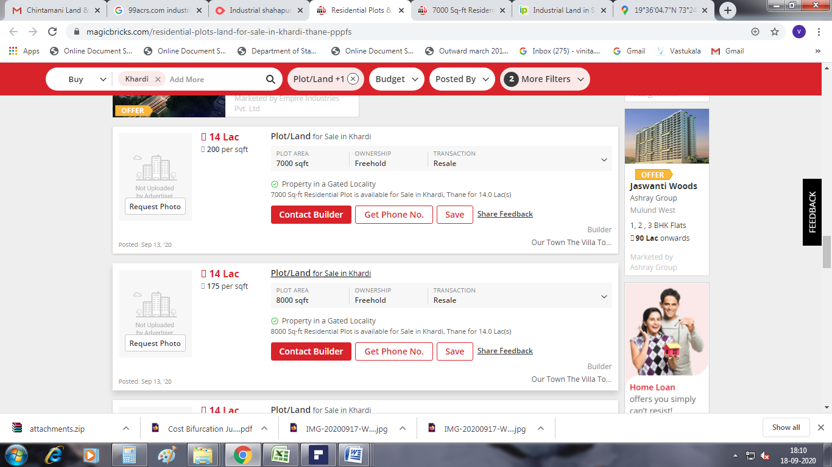
Justification for price /rate

The Market Value of the property is based on facts of markets discovered by us during our enquiries, however the government rate value in this case is less than the market value arrived by us. We are of the opinion that the value arrive by us will prove to be correct if an Auction of the subject property is carried out. As far as Market Value in Index II is concerned, it is not possible to comment on same, may be government rates are fixed by sampling during same point of time in part and whereas, Market values change every month.
In most of the cases the actual deal amount or Transaction value is not reflected in Index II because of various Market practices. As Valuer, we always try to give a value which is correct reflection of actual transaction value irrespective of any factors in market.
We Hope this will satisfy your requirements

As a result of my appraisal and analysis, it is my considered opinion that the Realizable Value of the above property in the prevailing condition with aforesaid specification is ` 2,39,17,657.00 (Rupees Two Crore Thirty Nine Lakh Seventeen Thousand Six Hundred Fifty Seven Only).

Place : Mumbai
Date : 30.09.2020

Sharadkumar B. Chalikwar
Govt. Reg. Valuer
Chartered Engineer (India)
Reg. No. (N) CCIT/1-14/52/2008-09

The undersigned has inspected the property detailed in the Valuation Report dated _______________________

on ____________________. We are satisfied that the fair and reasonable market value of the property is

`_________________________ (Rupees ________________________________________________________

________________________________________only).

Date
Signature
(Name & Designation of the Inspecting Official/s)

Countersigned
(BRANCH MANAGER)

Enclosures
 | Declaration-cum-undertaking from the valuer (Annexure- I) | Attached
 | Model code of conduct for valuer - (Annexure II) | Attached
(Annexure-I)

DECLARATION-CUM-UNDERTAKING

I, Sharadkumar Chalikwar son of Shri. Baburao Chalikwar do hereby solemnly affirm and state that:

- I am a citizen of India.

- I will not undertake valuation of any assets in which I have a direct or indirect interest or become so interested at any time during a period of three years prior to my appointment as valuer or three years after the valuation of assets was conducted by me.

- The information furnished in my valuation report dated 30.09.2020 is true and correct to the best of my knowledge and belief and I have made an impartial and true valuation of the property.

- I/ my authorized representative have personally inspected the property on 10.09.2020 The work is not sub - contracted to any other valuer and carried out by myself.

- Valuation report is submitted in the format as prescribed by the bank.

- I have not been depanelled / delisted by any other bank and in case any such depanelment by other banks during my empanelment with you, I will inform you within 3 days of such depanelment.

- I have not been removed / dismissed from service / employment earlier.

- I have not been convicted of any offence and sentenced to a term of imprisonment

- I have not been found guilty of misconduct in my professional capacity.

- I have not been declared to be unsound mind

- I am not an undischarged bankrupt, or has not applied to be adjudicated as a bankrupt;

- I am not an undischarged insolvent.

- I have not been levied a penalty under section 271J of Income-tax Act, 1961 (43 of 1961) and time limit for filing appeal before Commissioner of Income-tax (Appeals) or Income-tax Appellate Tribunal, as the case may be has expired, or such penalty has been confirmed by Income-tax Appellate Tribunal, and five years have not elapsed after levy of such penalty

- I have not been convicted of an offence connected with any proceeding under the Income Tax Act 1961, Wealth Tax Act 1957 or Gift Tax Act 1958 and

- My PAN Card number as applicable is AEAPC0117Q

- I undertake to keep you informed of any events or happenings which would make me ineligible for empanelment as a valuer

- I have not concealed or suppressed any material information, facts and records and I have made a complete and full disclosure

- I have read the Handbook on Policy, Standards and procedure for Real Estate Valuation, 2011 of the IBA and this report is in conformity to the "Standards" enshrined for valuation in the Part - B of the above handbook to the best of my ability.

- I have read the International Valuation Standards (IVS) and the report submitted to the Bank for the respective asset class is in conformity to the "Standards" as enshrined for valuation in the IVS in "General Standards" and "Asset Standards" as applicable. The valuation report is submitted in the prescribed format of the bank.

- I abide by the Model Code of Conduct for empanelment of valuer in the Bank. (Annexure V - A signed copy of same to be taken and kept along with this declaration)

- I am registered under Section 34 AB of the Wealth Tax Act, 1957.

- I am valuer registered with Insolvency & Bankruptcy Board of India (IBBI)

- My CIBIL Score and credit worthiness is as per Bank's guidelines.

- I am Chairman & Managing Director of the company, who is competent to sign this valuation report.

- I will undertake the valuation work on receipt of Letter of Engagement generated from the system (i.e. LLMS / LOS) only.

- Further, I hereby provide the following information.

 | Particulars | Valuer comment
 | Background information of the asset being valued; | The property under consideration is being owned by M/s. Shahapur Bhagar Food LLP from Mr. Anil Govindprasad Jain & Mrs. Shilpa Anil Jain (Plot No. 10, 11 & 12) vide as per Deed of Conveyance dated 03.10.2015 & dated 10.3.2016
 | Purpose of valuation and appointing authority | As per the request from State Bank of India, SMECC-Goregaon (East) Branch to assess realizable value of the property for Banking purpose
 | Identity of the Valuer and any other experts involved in the valuation; | Sharadkumar B. Chalikwar – Regd. Valuer  Manoj B. Chalikwar – Regd. Valuer  Nikhil Sonavane – Valuation Engineer  Vinita Surve – Processing Officer
 | Disclosure of Valuer interest or conflict, if any; | We have no interest, either direct or indirect, in the property valued. Further to state that we do not have relation or any connection with property owner / applicant directly or indirectly. Further to state that we are an independent Valuer and in no way related to property owner / applicant
 | Date of appointment, valuation date and date of report; | Date of Appointment – 09.09.2020  Valuation Date – 30.09.2020  Date of Report - 30.09.2020
 | Inspections and/or investigations undertaken; | Physical Inspection done on date 10.09.2020
 | Nature and sources of the information used or relied upon; | Market Survey at the time of site visit  Online search for Registered Transactions  Online Price Indicators on real estate portals  Enquiries with Real estate consultants  Existing data of Valuation assignments carried out by us
 | Procedures adopted in carrying out the valuation and valuation standards followed; | Comparative Sales Method (For Land Component)
 | Restrictions on use of the report, if any; | This valuation is for the use of the party to whom it is addressed and for no other purpose. No responsibility is accepted to any third party who may use or rely on the whole or any part of this valuation. The valuer has no pecuniary interest that would conflict with the proper valuation of the property.
- . | Major factors that were taken into account during the valuation; | current market conditions, demand and supply position, size of plot, location, upswing in real estate prices, sustained demand for industrial plot, all round development of commercial and industrial application in the locality etc.

 | Caveats, limitations and disclaimers to the extent they explain or elucidate the limitations faced by valuer, which shall not be for the purpose of limiting his responsibility for the valuation report. | Attached

Date: 30.09.2020
Place: Mumbai

Sharadkumar B. Chalikwar
Govt. Reg. Valuer
Chartered Engineer (India)
Reg. No. (N) CCIT/1-14/52/2008-09

(Annexure - II)

MODEL CODE OF CONDUCT FOR VALUERS

Integrity and Fairness
- A valuer shall, in the conduct of his/its business, follow high standards of integrity and fairness in all his/its dealings with his/its clients and other valuers.
- A valuer shall maintain integrity by being honest, straightforward, and forthright in all professional relationships.
- A valuer shall endeavour to ensure that he/it provides true and adequate information and shall not misrepresent any facts or situations.
- A valuer shall refrain from being involved in any action that would bring disrepute to the profession.
- A valuer shall keep public interest foremost while delivering his services.

Professional Competence and Due Care
- A valuer shall render at all times high standards of service, exercise due diligence, ensure proper care and exercise independent professional judgment.
- A valuer shall carry out professional services in accordance with the relevant technical and professional standards that may be specified from time to time.
- A valuer shall continuously maintain professional knowledge and skill to provide competent professional service based on up-to-date developments in practice, prevailing regulations / guidelines and techniques.
- In the preparation of a valuation report, the valuer shall not disclaim liability for his/its expertise or deny his/its duty of care, except to the extent that the assumptions are based on statements of fact provided by the company or its auditors or consultants or information available in public domain and not generated by the valuer.
- A valuer shall not carry out any instruction of the client insofar as they are incompatible with the requirements of integrity, objectivity and independence.
- A valuer shall clearly state to his client the services that he would be competent to provide and the services for which he would be relying on other valuers or professionals or for which the client can have a separate arrangement with other valuers.
Independence and Disclosure of Interest
- A valuer shall act with objectivity in his/its professional dealings by ensuring that his/its decisions are made without the presence of any bias, conflict of interest, coercion, or undue influence of any party, whether directly connected to the valuation assignment or not.

- A valuer shall not take up an assignment if he/it or any of his/its relatives or associates is not independent in terms of association to the company.
- A valuer shall maintain complete independence in his/its professional relationships and shall conduct the valuation independent of external influences.
- A valuer shall wherever necessary disclose to the clients, possible sources of conflicts of duties and interests, while providing unbiased services.
- A valuer shall not deal in securities of any subject company after any time when he/it first becomes aware of the possibility of his / its association with the valuation, and in accordance with the Securities and Exchange Board of India (Prohibition of Insider Trading)Regulations,2015 or till the time the valuation report becomes public, whichever is earlier.
- A valuer shall not indulge in "mandate snatching" or offering "convenience valuations" in order to cater to a company or client's needs.
- As an independent valuer, the valuer shall not charge success fee.
- In any fairness opinion or independent expert opinion submitted by a valuer, if there has been a prior engagement in an unconnected transaction, the valuer shall declare the association with the company during the last five years.
Confidentiality
- A valuer shall not use or divulge to other clients or any other party any confidential information about the subject company, which has come to his / its knowledge without proper and specific authority or unless there is a legal or professional right or duty to disclose.
Information Management
- A valuer shall ensure that he/ it maintains written contemporaneous records for any decision taken, the reasons for taking the decision, and the information and evidence in support of such decision. This shall be maintained so as to sufficiently enable a reasonable person to take a view on the appropriateness of his /its decisions and actions.
- A valuer shall appear, co-operate and be available for inspections and investigations carried out by the authority, any person authorised by the authority, the registered valuers organisation with which he/it is registered or any other statutory regulatory body.
- A valuer shall provide all information and records as may be required by the authority, the Tribunal, Appellate Tribunal, the registered valuers organisation with which he/it is registered, or any other statutory regulatory body.
- A valuer while respecting the confidentiality of information acquired during the course of performing professional services, shall maintain proper working papers for a period of three years or such longer period as required in its contract for a specific valuation, for production before a regulatory authority or for a peer review. In the event of a pending case before the Tribunal or Appellate Tribunal, the record shall be maintained till the disposal of the case.
Gifts and hospitality:
- A valuer or his / its relative shall not accept gifts or hospitality which undermines or affects his independence as a valuer.
Explanation: For the purposes of this code the term 'relative' shall have the same meaning as defined in clause (77) of Section 2 of the Companies Act, 2013 (18 of 2013).
- A valuer shall not offer gifts or hospitality or a financial or any other advantage to a public servant or any other person with a view to obtain or retain work for himself / itself, or to obtain or retain an advantage in the conduct of profession for himself / itself.
Remuneration and Costs.
- A valuer shall provide services for remuneration which is charged in a transparent manner, is a reasonable reflection of the work necessarily and properly undertaken, and is not inconsistent with the applicable rules.
- A valuer shall not accept any fees or charges other than those which are disclosed in a written contract with the person to whom he would be rendering service.
Occupation, employability and restrictions.
- A valuer shall refrain from accepting too many assignments, if he/it is unlikely to be able to devote adequate time to each of his/ its assignments.
- A valuer shall not conduct business which in the opinion of the authority or the registered valuer organisation discredits the profession.
Miscellaneous
- A valuer shall refrain from undertaking to review the work of another valuer of the same client except under written orders from the bank or housing finance institutions and with knowledge of the concerned valuer.
- A valuer shall follow this code as amended or revised from time to time.

DEFINITION OF VALUE FOR THIS SPECIFIC PURPOSE

This exercise is to assess Realizable Value of the property under reference as on 30th September 2020.

The term Fair Market Value is defined as

“The most probable price, as of a specified date, in cash, terms equivalent to cash, or in other precisely revealed terms for which the specified property rights would sell after reasonable exposure in a competitive market under all conditions requisite to a fair sale, with the buyer and seller each acting prudently knowledgeably and for self interest assuming that neither is under undue duress”.

Fundamental assumptions and conditions presumed in this definition are:

1. Buyer and seller are motivated by self-interest.
2. Buyer and seller are well informed and are acting prudently.
3. The property is exposed for a reasonable time on the open market.
4. Payment is made in cash or equivalent or in specified financing terms.

DECLARATION OF PROFESSIONAL FEES CHARGED

We hereby declare that, our professional fees are not contingent upon the valuation findings. However, if the statute AND/OR clients demands that, the fees should be charged on the percentage of assessed value then, with the full knowledge of the AND/OR end user, it is being charged accordingly.

VALUATION OF THE PROPERTY PREMISES

Considering various parameters recorded, existing economic scenario, and the information that is available with reference to the development of neighbourhood and method selected for valuation, we are of the opinion that, the property premises can be assessed and Realizable value for SARFAESI Securitisation and Reconstruction of Financial Assets and Enforcement of Security Interest Act, 2002 purpose at ` 2,39,17,657.00 (Rupees Two Crore Thirty Nine Lakh Seventeen Thousand Six Hundred Fifty Seven Only).

Sharadkumar B. Chalikwar
Govt. Reg. Valuer
Chartered Engineer (India)
Reg. No. (N) CCIT/1-14/52/2008-09

