**MICRO MARKET STUDY REPORT FOR SAI ORCHID AND SAI FORTUNE BUSINESS CENTRE PROJECT**

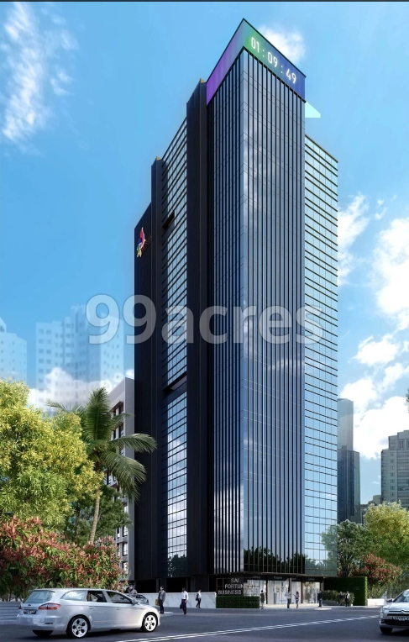

Vastu/SBI/Mumbai/11/2023/4799/2303309

01/05-05-PY

Date: 01.11.2023

**To,**

**The Branch Manager,**

**State Bank of India**

**SME Chembur Branch,**

Unit No. 11, Building No. 11,

Ground Floor, Corporate Park,

Sion Trombay Road, Chembur,

Mumbai, Pin Code – 400 071,

State - Maharashtra, Country – India.

**Sub:** Micro Market Study Report for **"Sai Orchid And Sai Fortune Business Centre"** at Ghatkopar, Pin Code – 400 077.

Dear Sir,

In accordance with your Mail as stated above, we herewith enclose our Micro Study Report on **"Sai Orchid And Sai Fortune Business Centre",** Proposed Residential cum Commercial Buildings on plot bearing on Final Plot No. 28, CTS No. 5948, TRS III, Tilak Road, Village – Ghatkopar Karol, Ghatkopar (East), Mumbai, Pin Code – 400 077, State - Maharashtra, Country – India.

The project is being developed by M/s. Sai Shakti Realtors is a partnership firm.

Project is comprised of two building named as Sai Orchid (Wing C) is proposed of Stilt Floor + 1st to 7th Upper Floors and Sai Fortune Business Centre (Wing B) is proposed of Basement + Part Ground Floor + Part Stilt Floor + 1st to 17th Upper Floors with total RERA carpet area of 42,233 Sq. Ft. which consists 66 units for sale.

In this regard, State Bank of India, SME Chembur Branch, Unit No. 11, Building No. 11, Ground Floor, Corporate Park, Sion Trombay Road, Chembur, Mumbai, Pin Code – 400 071, has approached us to conduct a Micro Study of the said project.

Our analysis of the market study is enclosed in this report.

## ***Manoj B. Chalikwar***

Registered Valuer

Chartered Engineer (India)

Reg. No. IBBI / RV / 07/2018/10366

Reg. No. CAT-I-F-1763

# **PROJECT DETAILS**

## **About “Sai Orchid And Sai Fortune Business Centre" Project:**

Sai Orchid and Sai Fortune Business Centre can be the right bet for you. It is an under-construction project in Ghatkopar East, Central Mumbai suburbs, offering investment options within your budget. For those looking for exciting returns on investment, Sai Orchid and Sai Fortune Business Centre is Central Mumbai suburbs's most desirable commercial project, where property options are available in varied budget range. Sai Orchid and Sai Fortune Business Centre Ghatkopar East has commercial properties, offering maximum visibility and high footfalls.

## **TYPE OF THE BUILDING:**

|  |  |
| --- | --- |
| Building | Number of Floors |
| "Sai Orchid” | Proposed Residential Building of Stilt Floor + 1st to 7th Upper Floors as per approved plan. |
| "Sai Fortune Business Centre” | Proposed Commercial Building of Basement + Part Ground Floor + Part Stilt Floor + 1st to 17th Upper Floors as per approved plan. |

## **PROPOSED DATE OF COMPLETION & FUTURE LIFE:**

Expected completion date as informed by builder is 30.06.2023 (As per RERA Certificate)

Future estimated life of the Structure is 60 years (after completion) Subject to proper, preventive periodic maintenance & Structural repairs.

## **PROPOSED PROJECT AMENITIES:**

|  |
| --- |
| Italian Tile flooring in all the rooms |
| Granite Kitchen platform |
| Powder coated aluminum sliding windows |
| Laminated wooden flush doors with Safety door |
| Concealed wiring |
| Concealed plumbing |
| Recreational Area |
| Open Car Parking |
| Fire Fighting System |
| Rain Water Harvesting |

# **About Location:**

## **GHATKOpar**

Ghatkopar is a suburb in eastern Mumbai. The area is served by the railway station on the Central Line of the Mumbai Suburban Railway and the metro station on Line 1 of the Mumbai Metro. The eastern part has a large Gujarati population.

## **MUMBAI METRO PROJECT**

The Versova-Andheri-Ghatkopar Metro corridor of the Mumbai Metro project is an 11.07 km long double line corridor on an elevated viaduct. The route uses Standard Gauge air-conditioned trains with 12 elevated stations.[4] It has a carrying capacity of 60,000 persons per hour and the commuting time on the entire stretch is 21 minutes. The commute time between Versova and Ghatkopar was reduced by 70 minutes by this line. Metro started running successfully from July 2014

## **HISTORY**

Ghatkopar in the 1920s was a village ringed by creeks and salt pans. It was administered by a municipal council led by a Collector of the Suburban District. It became part of Greater Bombay in 1945.

There are many interpretations to how Ghatkopar got its name. Some say it refers to the hill range tapering off at Thane, "Ghat ke upar", which roughly means "on top of hill". Others believe the name is derived from the Marathi word for "corner" of the Western Ghats- "Kopara", therefore, Ghat-kopara.

The names given to roads in Ghatkopar offer an interesting peek into its recent history. It has roads like Nowrojee Lane for Nowrojee Sheth, Cama Lane after Lady Cama, Hingwala Lane after a family dealing with asafoetida

# **PRICES TRENDS IN GHATKOPAR**

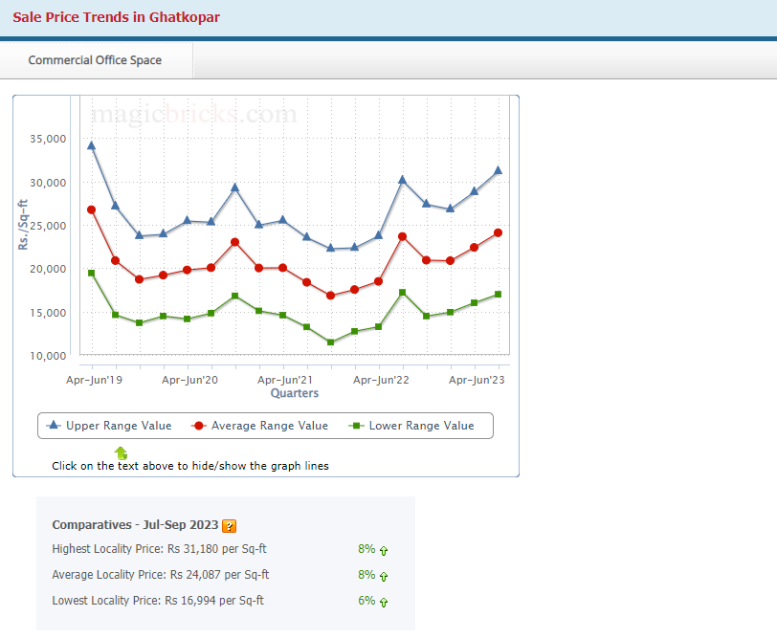

# **PRICES TRENDS IN GHATKOPAR**

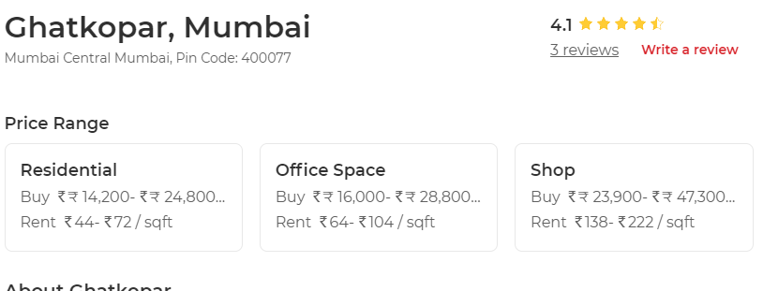

# PRICES indicators

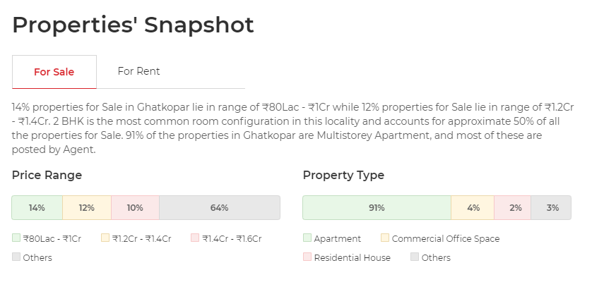

# **PRICES indicators**

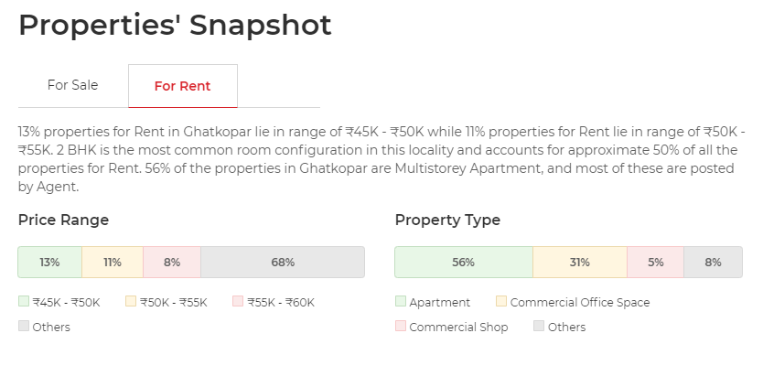

# **PRICES indicators**

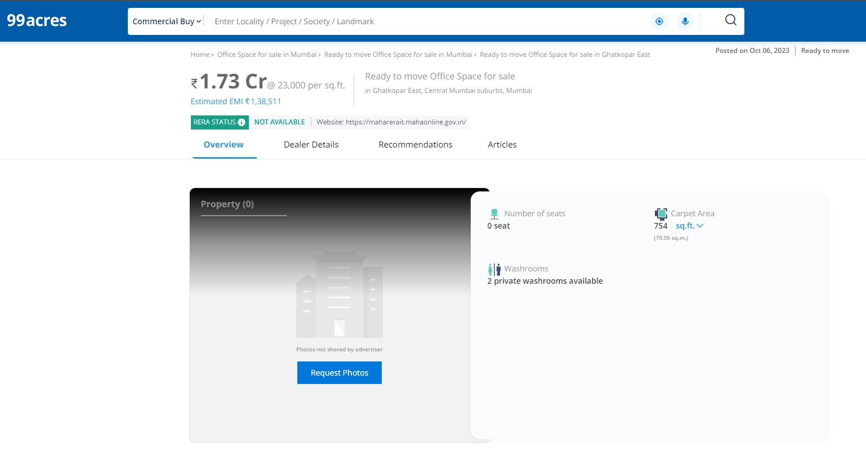

# **PRICES indicators**

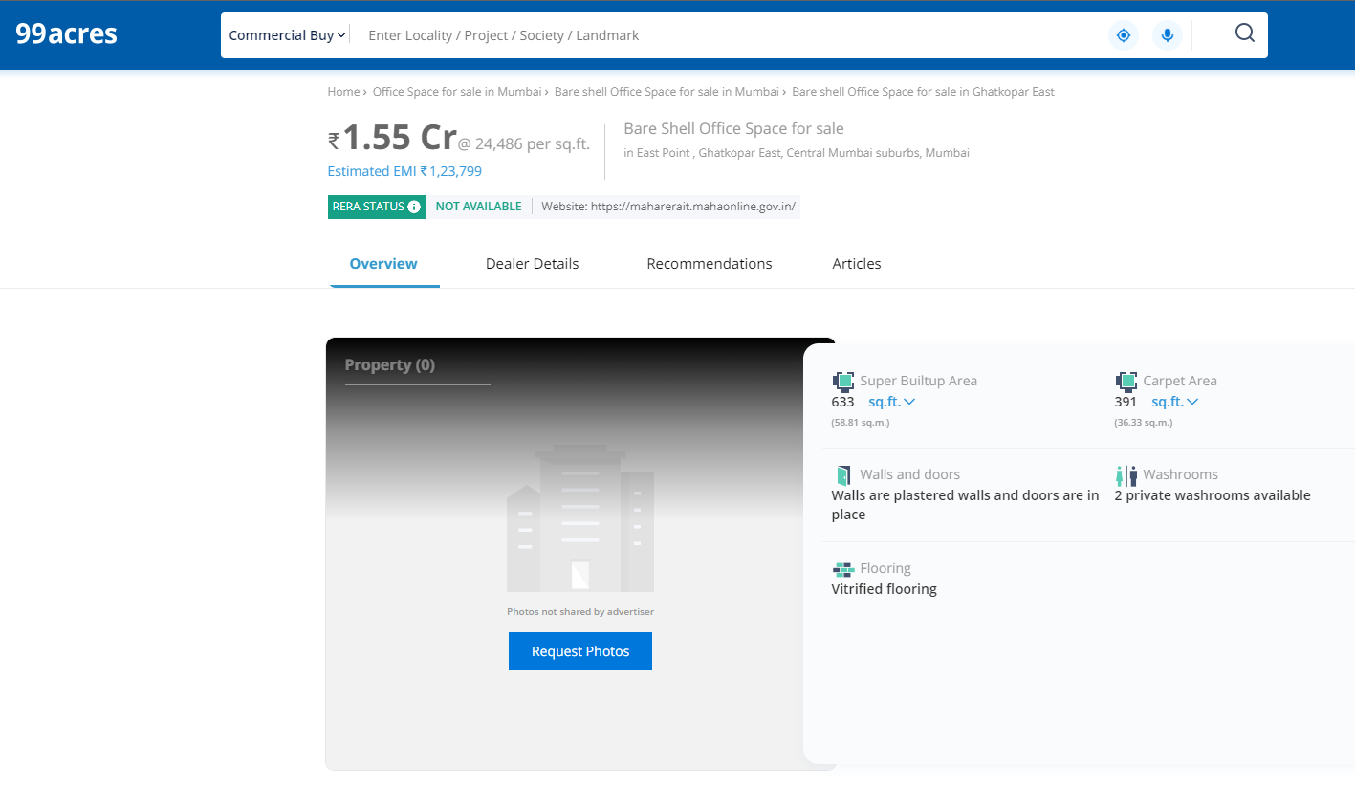

# **PRICES indicators**

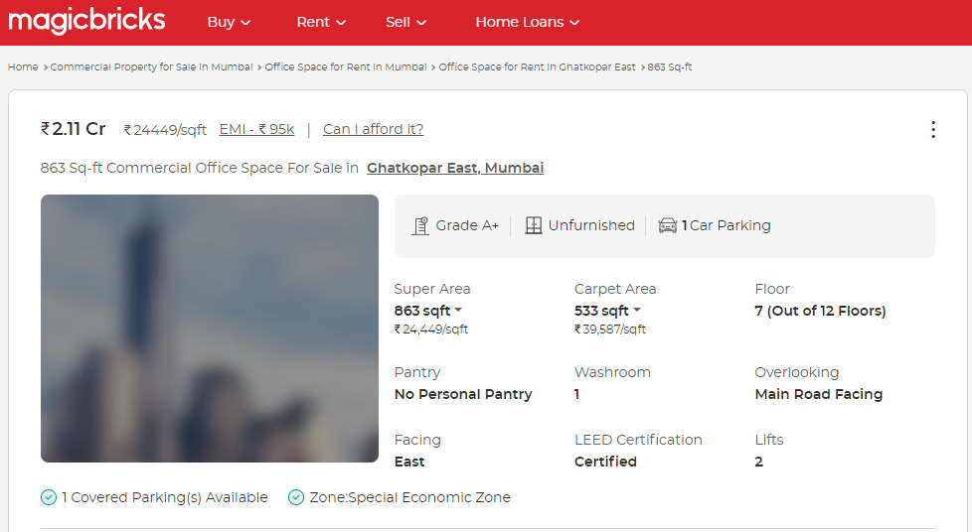

# **PRICES indicators**

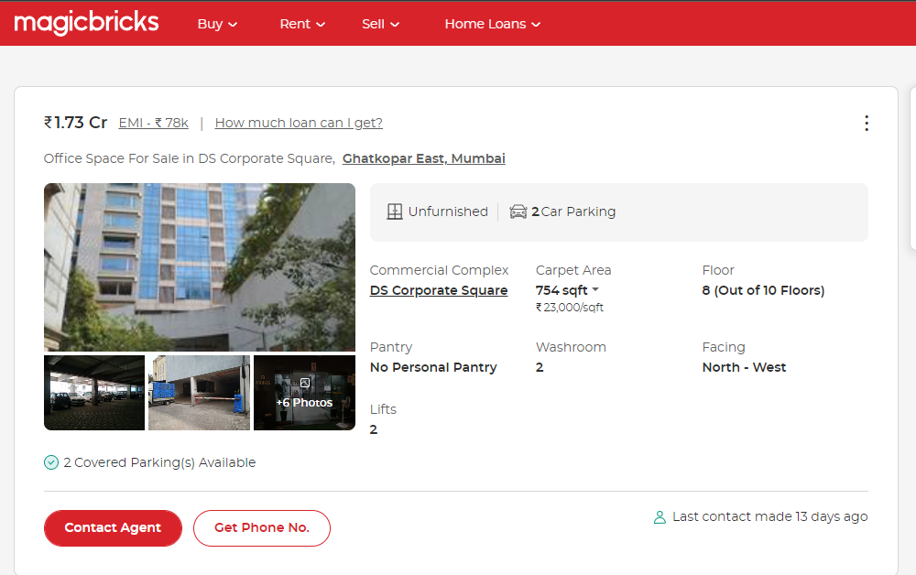

# **LOCALITY SUPPLY**

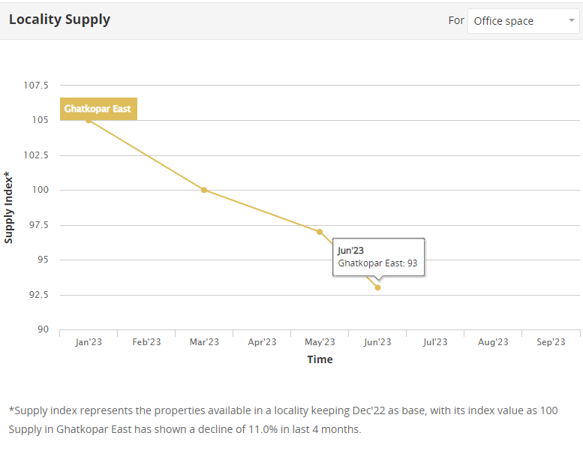

# **LOCALITY DEMAND**

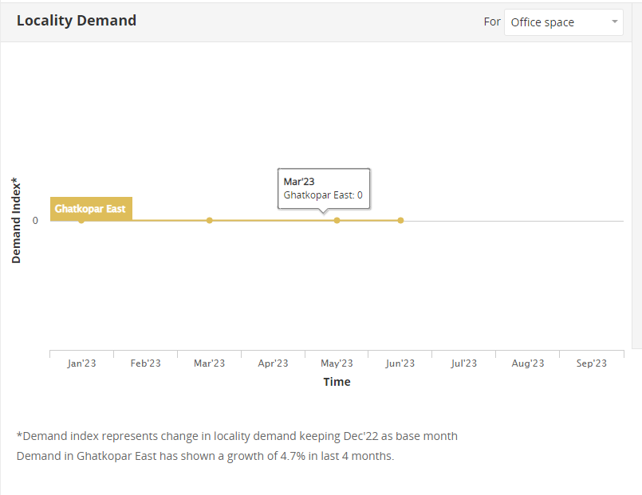

# **LOCALITY RENTAL YIELD**

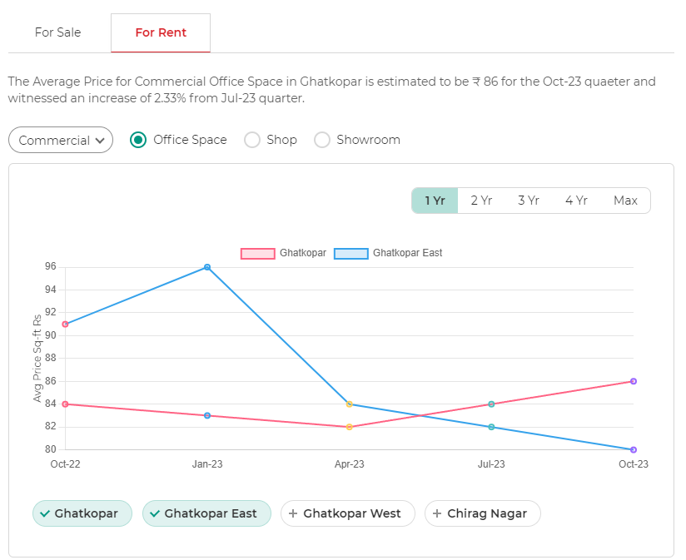

# **LOCALITY AVERAGE PRICE**

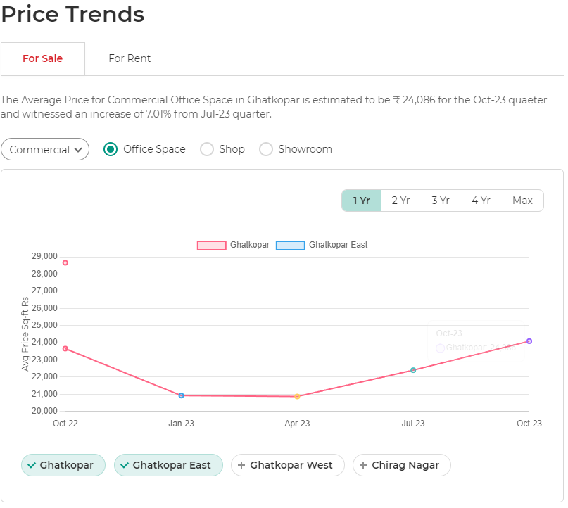

# **CONCLUSION**

Our micro market study suggests following parameters:

|  |  |
| --- | --- |
| Supply of Commercial Property | 11.0% Decrease |
| Demand for Commercial Property | **4.70% Increase** |
| Rental Yield from Commercial Property | **2.33 % Increase** |
| Average price may increase | **7.01 % Increase** |

Looking at overall inventory in the area, prices and demand, there is Neutral indication about prospective sale of the subject project.

## ***Manoj B. Chalikwar***

Registered Valuer

Chartered Engineer (India)

Reg. No. IBBI / RV / 07/2018/10366

Reg. No. CAT-I-F-1763