# **READY RECKONER RATE**

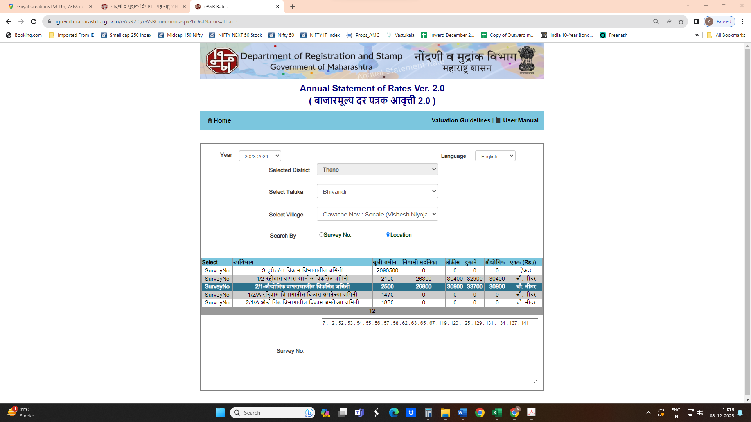

|  |  |  |  |  |
| --- | --- | --- | --- | --- |
| Stamp Duty Ready Reckoner Market Value Rate for **Industrial Unit (A)** | 30,900.00 | **Sq. Mtr.** | 2,871.00 | **Sq. Ft.** |
| Stamp Duty Ready Reckoner Market Value Rate for **Land (B)** | 2,500.00 | **Sq. Mtr.** |  |  |
| The difference between land rate and building rate (A – B = C) | 28,400.00 |  |  |  |
| Depreciation Percentage as per table (D) [100% - 14%]  (Age of the Building – 14 Years) | 86% |  |  |  |
| **Rate to be adopted after considering depreciation [B + (C x D)]** | **26,924.00** | **Sq. Mtr.** | **2,501.00** | **Sq. Ft.** |

**Multi-Storied building with Lift**

For residential premises / commercial unit / office on above floor in multistoried building, the rate mentioned in the ready reckoner will be increased as under:

|  |  |  |
| --- | --- | --- |
|  | **Location of Flat / Commercial Unit in the building** | **Rate** |
| a) | On Ground to 4 Floors | No increase for all floors from ground to 4 floors |
| b) | 5 Floors to 10 Floors | Increase by 5% on units located between 5 to 10 floors |
| c) | 11 Floors to 20 Floors | Increase by 10% on units located between 11 to 20 floors |
| d) | 21 Floors to 30 Floors | Increase by 15% on units located between 21 to 30 floors |
| e) | 31 Floors and above | Increase by 20% on units located on 31 and above floors |

**Table – D: Depreciation Percentage Table**

|  |  |  |
| --- | --- | --- |
| **Completed Age of Building in Years** | **Value in percent after depreciation** | |
|  | **R.C.C. Structure / other Pukka Structure** | **Cessed Building, Half or Semi – Pukka Structure & Kaccha Structure.** |
| 0 to 2 Years | 100% | 100% |
| Above 2 & up to 5 Years | 95% | 95% |
| Above 5 Years | After initial 5 year for every year 1% depreciation is to be considered. However maximum deduction available as per this shall be 70% of Market Value rate | After initial 5 year for every year 1.5% depreciation is to be considered. However maximum deduction available as per this shall be 85% of Market Value rate |

