Vastu/Nashik/10/004747/2303272
30/3-469-RYBS
Date: 30.10.2023

To,
The Branch Manager,
State Bank of India
RACPC Nashik Branch
1st Floor, Patel Plaza, N.D. Patel Road,
Opp. BSNL, Landmark Seawoods Navratna Hotel,
Nashik - 422001, State – Maharashtra, Country – India.

Sub: Vetting of Extra Work

Sir,

With reference to above subject, we have evaluated the Extra Work for Residential Flat No. G - 102, Ground Floor, Wing – A, "Royal Residency", Survey No. 770/2 + 459, Plot No. 27, 28 & 29, Village - Adgaon, Datta Nagar, Off Deola Nashik Road, Taluka & District - Nashik, PIN Code – 422 006, State – Maharashtra, Country – India belongs to Name of Owner: M/s. Sadguru Associates. Name of Client / Proposed Buyer: Mr. Babasaheb Kondiram Golvad & Mrs. Archana Babasaheb Golvad.

We have verified the rates quoted as per current market rates. Details of Extra Work considered as per copy of Extra Work Agreement between Mr. Babasaheb Kondiram Golvad & Mrs. Archana Babasaheb Golvad (First Part). Mr.Shubham Suhas Joshi (Second Part) received on dated 13.10.2023. The Extra Work amount is Rs.4,00,000/- (Rupees Four Lakh Only)

The said Cost Vetting Certificate is valid upto next 6 months Only.

Thanking you

Sincerely yours

Sharadkumar B. Chalikwar

Govt. Reg. Valuer
Chartered Engineer (India)
Reg. No. (N) CCIT/1-14/52/2008-09
SBI Empanelment No.: SME/TCC/2021-22/85/13
Encl: Valuation report

Agreement for Extra Work
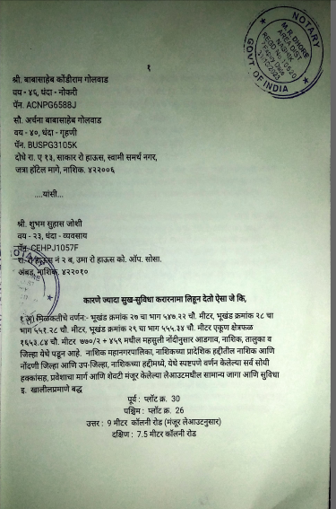
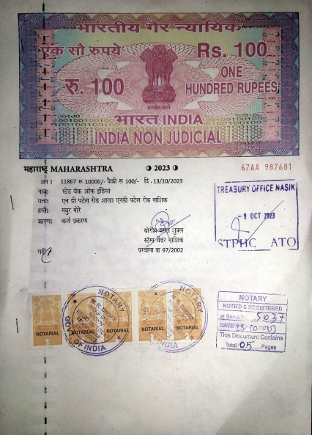
1

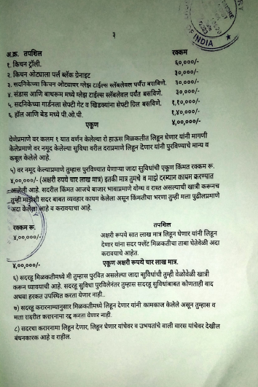
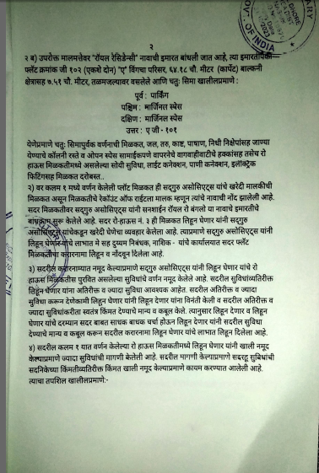

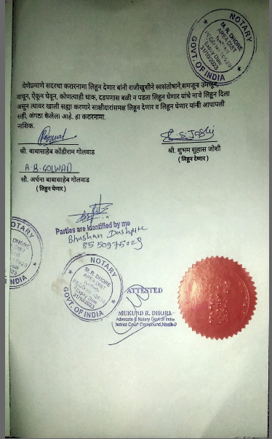

The Extra Amenities amount is Rs.4,00,000/- (Rupees Four Lakh Only)

