Vastu/Nashik/06/32014/2301224
22/20-325-RYV
Date: 28.10.2023

To,
The Branch Manager,
State Bank of India
RACPC Nashik Branch
1st Floor, Patel Plaza, N.D. Patel Road,
Opp. BSNL, Landmark Seawoods Navratna Hotel,
Nashik - 422001, State – Maharashtra, Country – India.

Sub: Vetting of Extra Work

Sir,

With reference to above subject, we have evaluated the Extra Work for Residential Flat No. 601, 6th Floor, “Ambika Harmony Apartment”, Survey No. 774 / 775 / 2 / 46 to 48, Plot No. 46, to 48, Karmayogi Nagar, Sadguru Nagar, Near Roongta Imperia, Village – Nashik City - 5, Taluka & District – Nashik, PIN Code – 422 008, State – Maharashtra, Country – India belongs to Mr. Nitin Harishchandra Pawar & Mrs. Ashwini Nitin Pawar.

We have verified the rates quoted as per current market rates. Details of Extra Work considered as per copy of Extra Work Agreement between Mr. Nitin Harishchandra Pawar & Mrs. Ashwini Nitin Pawar (First Part). Mr. Sushant Sunil Patil (Second Part) received on dated 18.10.2023. The Extra Work amount is Rs. 2,50,000/- (Rupees Two Lakh Fifty Thousand Only)

The said Cost Vetting Certificate is valid upto next 6 months Only.

Thanking you

Sincerely yours

Sharadkumar B. Chalikwar

Govt. Reg. Valuer
Chartered Engineer (India)
Reg. No. (N) CCIT/1-14/52/2008-09
SBI Empanelment No.: SME/TCC/2021-22/85/13
Encl: Valuation report

Agreement for Extra Work
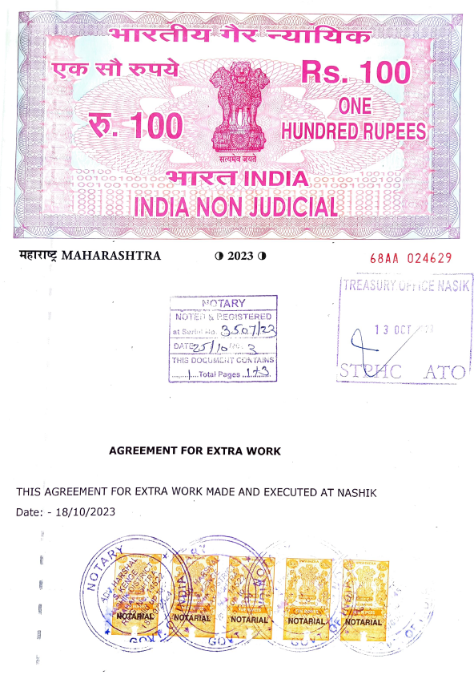
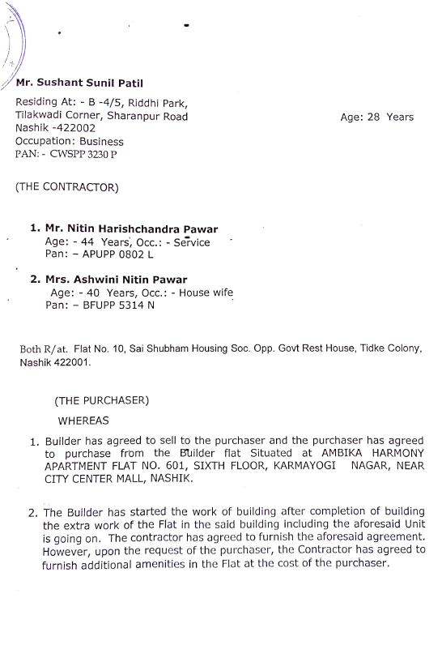

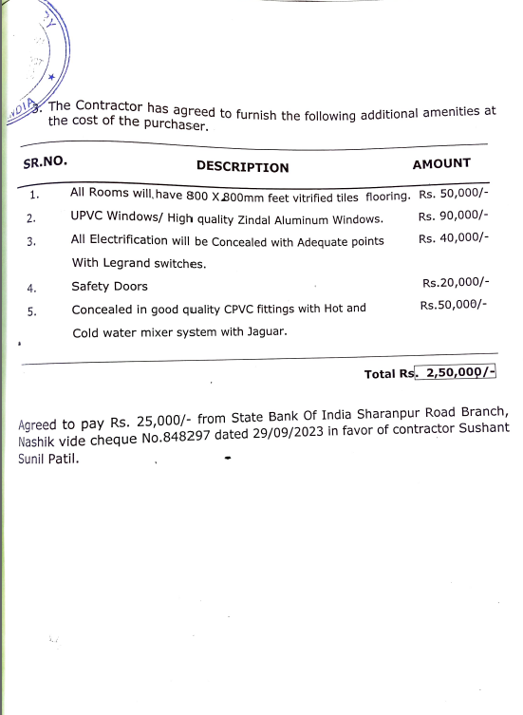
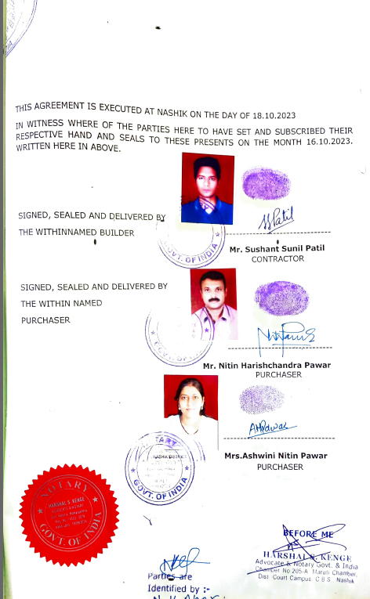

The Extra Amenities amount is Rs. 2,50,000/- (Rupees Two Lakh Fifty Thousand Only)

