Vastu/Nashik/06/32014/2301224
22/20-325-RYV
Date: 28.10.2023

To,
The Branch Manager,
State Bank of India
RACPC Nashik Branch
1st Floor, Patel Plaza, N.D. Patel Road,
Opp. BSNL, Landmark Seawoods Navratna Hotel,
Nashik - 422001, State – Maharashtra, Country – India.

Sub: Vetting of Extra Work

Sir,

With reference to above subject, we have evaluated the Extra Work for Residential Row Bungalow No. 05 on Plot No. 9 + 10/ 5, Gat No. 296/1, “Swaroop Classic”, Konark Nagar, Near Anukul Bungalow, Village – Adgaon, Taluka & District – Nashik, PIN Code – 422 003, State – Maharashtra, Country – India belongs to Shri. Vishwanath Nimba Rathod & Smt. Manisha Vishwanath Rathod.

We have verified the rates quoted as per current market rates. Details of Extra Work considered as per copy of Extra Work Agreement between Mr. Vishwanath Nimba Rathod (First Part). Mr. Kailas Vishram Mahale (Second Part) received on dated 17.10.2023. The Extra Work amount is Rs. 7,00,000/- (Rupees Seven Lakh Only)

The said Cost Vetting Certificate is valid upto next 6 months Only.

Thanking you

Sincerely yours

Sharadkumar B. Chalikwar

Govt. Reg. Valuer
Chartered Engineer (India)
Reg. No. (N) CCIT/1-14/52/2008-09
SBI Empanelment No.: SME/TCC/2021-22/85/13
Encl: Valuation report

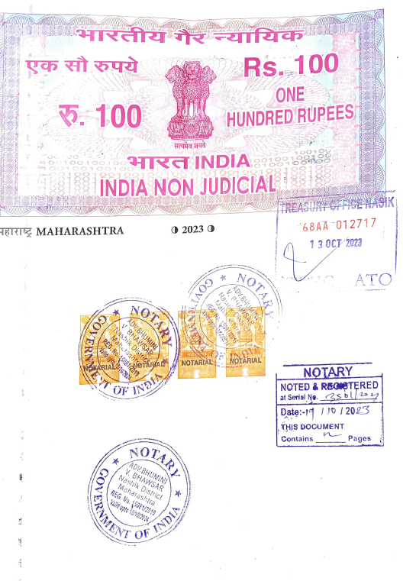
Agreement for Extra Work
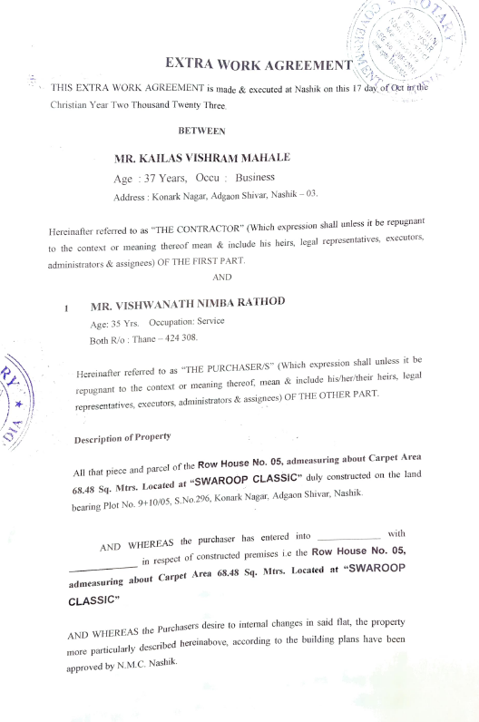

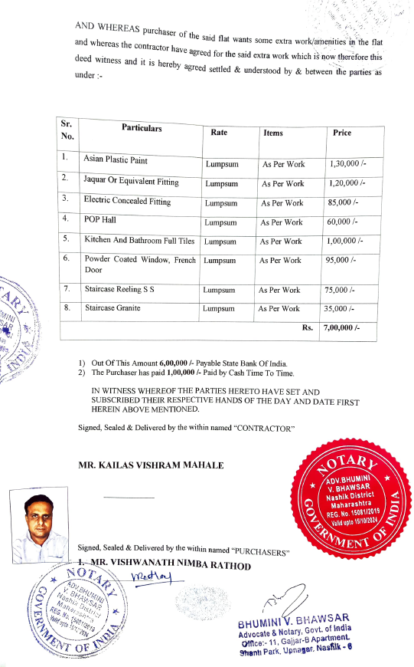

The Extra Amenities amount is Rs. 7,00,000/- (Rupees Seven Lakh Only)

