Vastu/Nashik/10/2023/004693/2303218
27/5-415-RPBS
Date: 27.10.2023

To, `
The Branch Manager,
Bank of Baroda
Regional Office Nashik Road Branch
BSNL Building, Datta Mandir Road, Nashik Road,
Nashik -422 101, State - Maharashtra, Country - India.

Sub: Vetting of Extra Amenities

Sir,

With reference to above subject, we have evaluated the Extra Amenities for Residential Flat No.8, Fourth Floor, "Parijat Niwas Apartment", Survey No.731/4/1/13, Plot No.57, TP Scheme-II, Near Aura Spa, Samarth Nagar, Parijat Nagar, Village – Nashik, Taluka & District - Nashik, PIN Code – 422 005, State – Maharashtra, Country – India belongs to Shri. Mohan Shankar Deshpande & Sau. Meghana Mohan Deshpande Name of Proposed Purchaser: Shri. Yogesh Namadev Bhamare & Sau. Savita Ramkrushna Thakare.

We have verified the rates quoted as per current market rates. Details of work and Extra Amenities considered as per copy of Agreement for Extra Amenities issued by Shri. Yogesh Namadev Bhamare & Sau. Savita Ramkrushna Thakare (First Part) and Shri. Mohan Shankar Deshpande & Sau. Meghana Mohan Deshpande (Second Party) received on dated 26.10.2023. The Extra Amenities amount is Rs.17,50,000/- (Rupees Seventeen Lakh Fifty Thousand Only)

The said Cost Vetting Certificate is valid upto next 6 months Only.

Thanking you

Sincerely yours

Sharadkumar B. Chalikwar
Govt. Reg. Valuer
Chartered Engineer (India)
Reg. No. (N) CCIT/1-14/52/2008-09
Encl: Valuation report.

Agreement for Extra Amenities
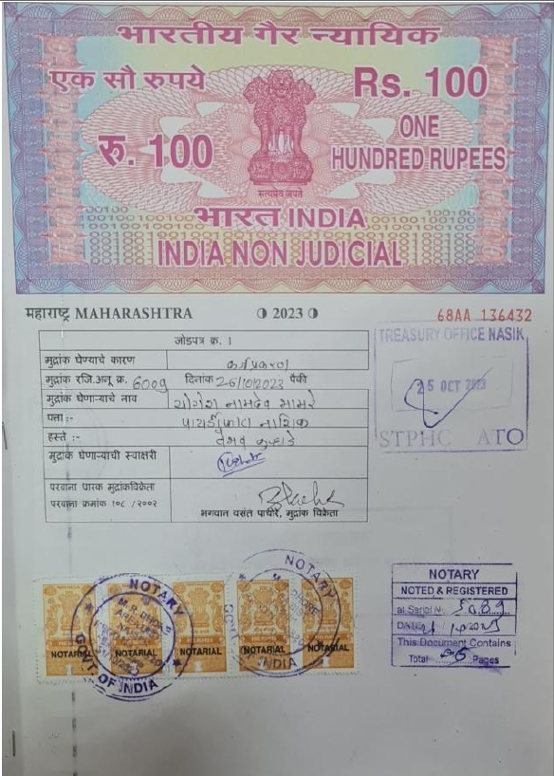
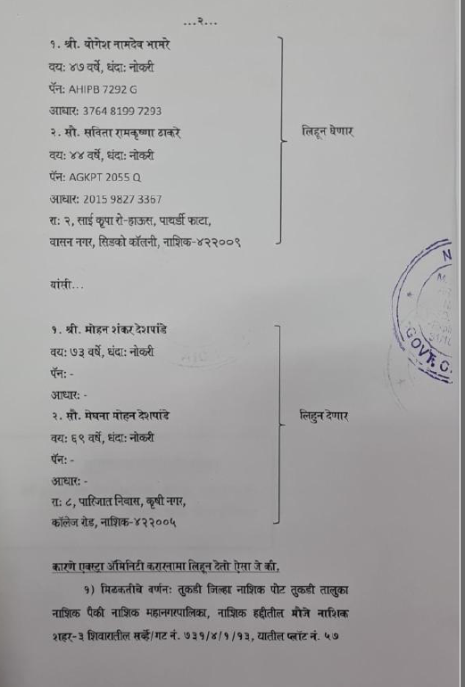

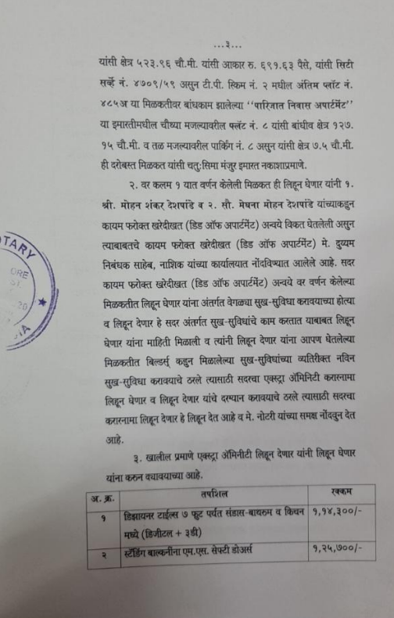
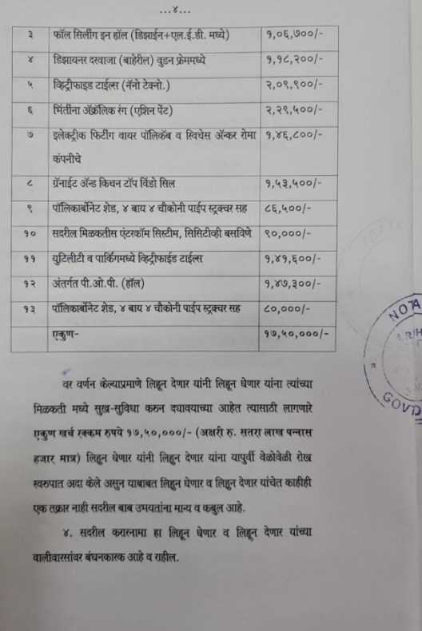

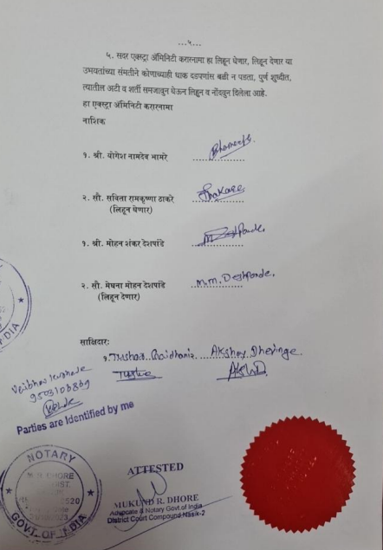

The Extra Amenities amount is Rs.17,50,000/- (Rupees Seventeen Lakh Fifty Thousand Only)

