VALUATION REPORT OF THE MOVABLE PROPERTY

**Details of the property under consideration:**

**Name of Client: M/s. Pratibha Shipping Company Pvt. Ltd.**

Movable Assets Available at Residential Flat No. 501, 5th Floor, Building Known as **“Laxmi Gopal”**,

Cadastral Survey No. 33, Mahim Division, Final Plot NO. 1281, T. P. Scheme IV, Hatiskar Road,

Prabhadevi, Mumbai, Pin Code – 400 025, State – Maharashtra, Country – India.

**Latitude Longitude: 19°00'59.5"N 72°49'31.4"E**

**Valuation Done for:**

**Cosmos Bank**

**Dadar Branch**

Horizon Bldg.,1st Floor, Ranade Road & Gokhale Road, Dadar (West), Mumbai - 400 028,

State - Maharashtra, Country - India.

|  |  |  |  |  |  |  |  |  |  |  |  |  |  |  |  |  |  |  |  |  |  |  |  |  |  |  |  |  |  |  |  |  |  |  |  |  |  |  |  |  |  |  |  |  |  |  |  |  |  |  |  |  |  |  |  |  |  |  |  |  |  |  |  |  |  |  |  |  |  |  |  |  |  |  |  |  |  |  |  |  |  |  |  |  |  |  |  |  |  |  |  |  |  |  |  |  |  |  |  |  |  |  |  |  |  |  |  |  |  |  |  |  |  |  |  |  |  |  |  |  |  |  |  |  |  |  |  |  |
| --- | --- | --- | --- | --- | --- | --- | --- | --- | --- | --- | --- | --- | --- | --- | --- | --- | --- | --- | --- | --- | --- | --- | --- | --- | --- | --- | --- | --- | --- | --- | --- | --- | --- | --- | --- | --- | --- | --- | --- | --- | --- | --- | --- | --- | --- | --- | --- | --- | --- | --- | --- | --- | --- | --- | --- | --- | --- | --- | --- | --- | --- | --- | --- | --- | --- | --- | --- | --- | --- | --- | --- | --- | --- | --- | --- | --- | --- | --- | --- | --- | --- | --- | --- | --- | --- | --- | --- | --- | --- | --- | --- | --- | --- | --- | --- | --- | --- | --- | --- | --- | --- | --- | --- | --- | --- | --- | --- | --- | --- | --- | --- | --- | --- | --- | --- | --- | --- | --- | --- | --- | --- | --- | --- | --- | --- | --- | --- | --- |
| Vastu/Cosmos/ Mumbai/10/2023/4617/2303170 25/01-367-PY  Date: 25.10.2023  To,  **The Branch Manager,**  **Cosmos Bank**  **Dadar Branch**  Horizon Bldg.,1st Floor,  Ranade Road & Gokhale Road,  Dadar (West), Mumbai - 400 028,  State - Maharashtra, Country - India.  **Sub:** Valuation of "**Movable Property**" at Laxmi Gopal Building, Prabhadevi, Mumbai, Pin Code – 400 025.  Dear Sir,  This is to certify that the Movable Assets available at Residential Flat No. 501, 5th Floor, Building Known as “Laxmi Gopal”, Cadastral Survey No. 33, Mahim Division, Final Plot NO. 1281, T. P. Scheme IV, Hatiskar Road, Prabhadevi, Mumbai, Pin Code – 400 025, State – Maharashtra, Country – India belongs to M/s. Pratibha Shipping Company Pvt. Ltd.  Considering various parameters recorded, existing economic scenario, and the information that is available with reference to the development of neighborhood and method selected for valuation, we are of the opinion that, the asset can be assessed for this particular purpose at **` 50,000.00 (Rupees Fifty Thousand Only).**  The valuation of the property is based on the documents produced by the concern. Legal aspects have not been taken into considerations while preparing this valuation report.  Hence certified  **Sharadkumar B. Chalikwar**  Govt. Reg. Valuer  Chartered Engineer (India)  Reg. No. (N) CCIT/1-14/52/2008-09  Encl: Valuation Report  **Movable Properties Details as per below table:**  **Movable Property considered for the Valuation as per Application submitted to High Court Order dated 11.09.2023.**   |  |  |  |  |  |  | | --- | --- | --- | --- | --- | --- | | **Sr. No.** | **Location** | **Particulars** | **Onsite** | **Number** | **Disposal Value /**  **Scrap Value as on Date** | | 1 | Living Room | 3 Seating Sofa | Available | 1 | 17,000.00 | | 2 | 2 Seating Sofa | Available | 2 | | 3 | Glass Table | Available | 1 | | 4 | Sony TV of 29" | Available | 1 | | 5 | Showcase Cabinet | Available | 1 | | 6 | Hitachi 1 Ton Split A/C | Available | 1 | | 7 | Ceiling Fan | Available | 2 | | 8 | Computer Table | Available | 1 | | 9 | Wooden Table | Available | 1 | | 10 | Dining Table of 4 seating person of wooden | Available | 1 | | 11 | Almery | Available | 1 | | 12 | Shoes Cupboard | Available | 1 | | 13 | Computer | Not Available | 1 | | 14 | Lenovo Laptop | Not Available | 1 | | 15 | Kitchen | LG Double Door Refrigerator | Available | 1 | 9,000.00 | | 16 | Senator Washing Machine | Available | 1 | | 17 | Ceiling Fan | Available | 1 | | 18 | Wooden Fixed Furniture on Wall | Available | 1 | | 19 | Bedroom 1 | LG TV | Available | 1 | 13,000.00 | | 20 | LG Window A/C | Available | 1 | | 21 | Ceiling Fan | Available | 1 | | 22 | Wooden Wardrobe having 4 Doors | Available | 1 | | 23 | Dressing Table with Glass | Available | 1 | | 24 | Bedroom 2 | Carrier 0.5 Ton Window A/C | Available | 1 | 11,000.00 | | 25 | Wooden Wardrobe having 4 Doors | Available | 1 | | 26 | Ceiling Fan | Available | 1 | | 27 | Wooden Stool | Available | 1 | | **TOTAL** | | | | **29** | **50,000.00** |   **Note: -** At the time of Site Inspection, there were few items such as Oven, Bed with Mattress (2 Nos.), Bath Tub, Greaser, Wooden Table were present at the property and same items were not mentioned in the order. Hence, we have not considered these items for Valuation. |

**Actual Site Photographs**

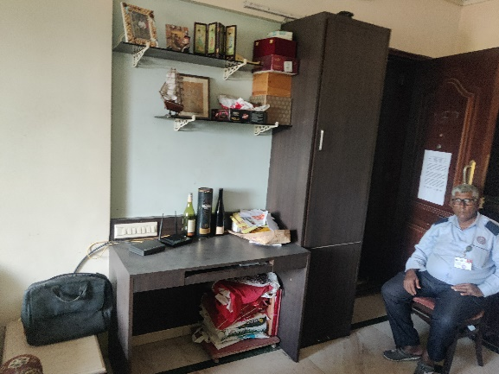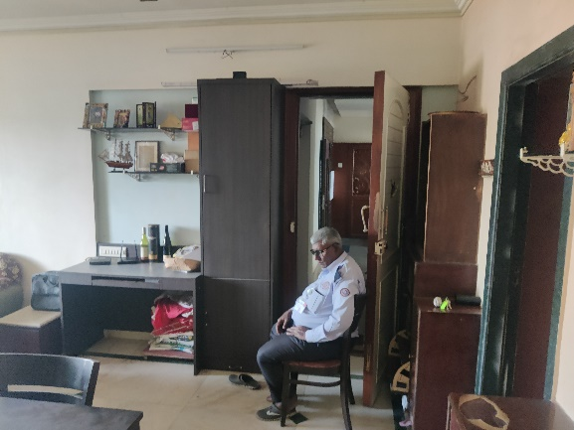

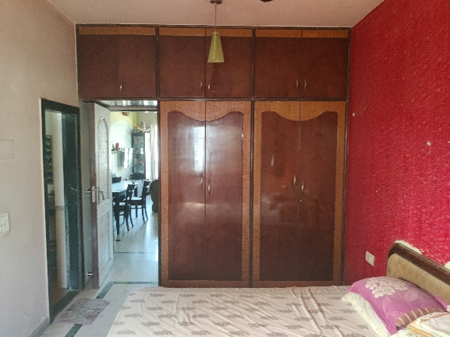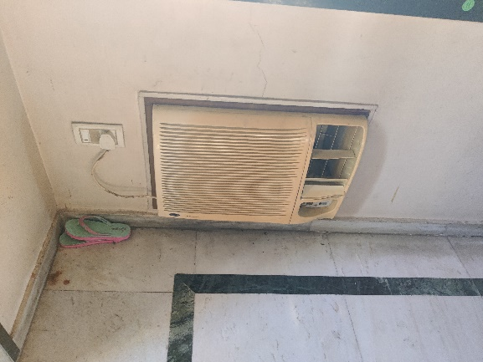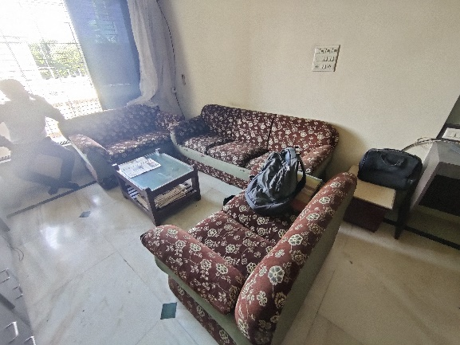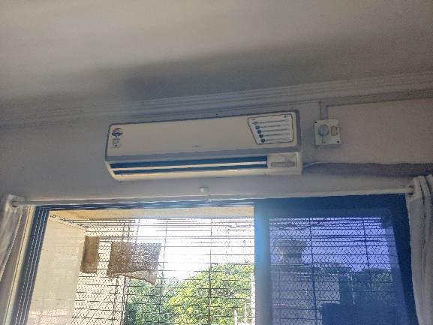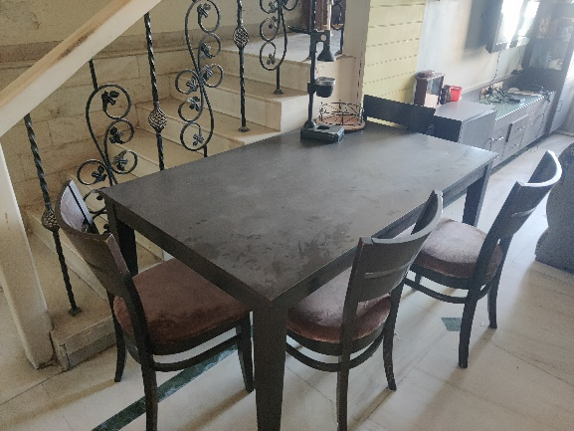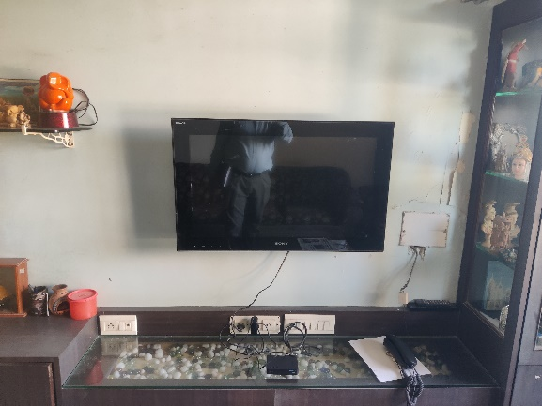**Actual Site Photographs**

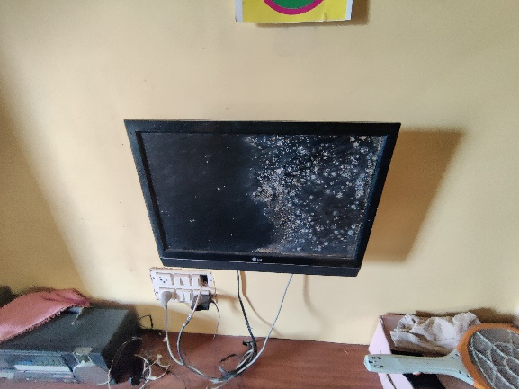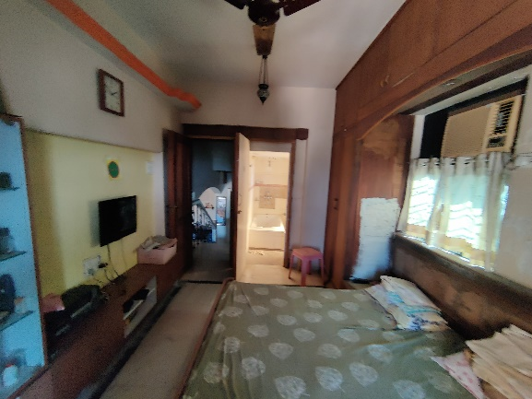

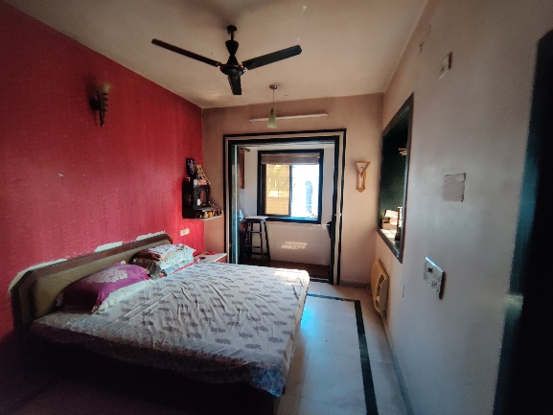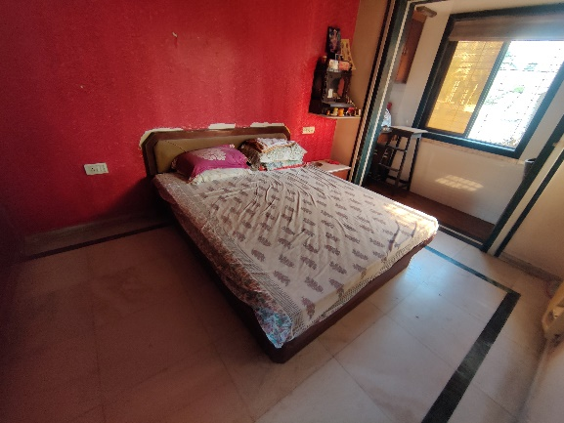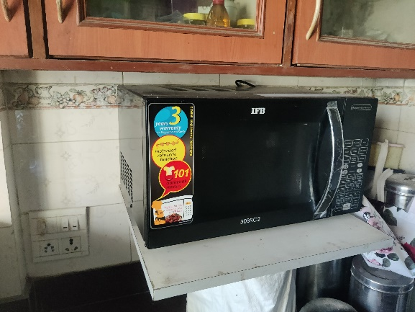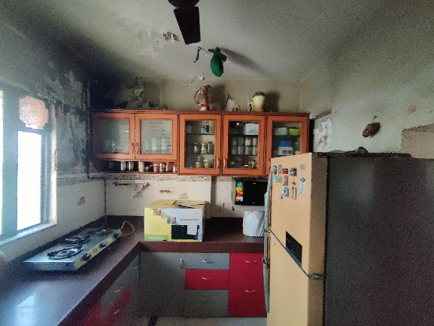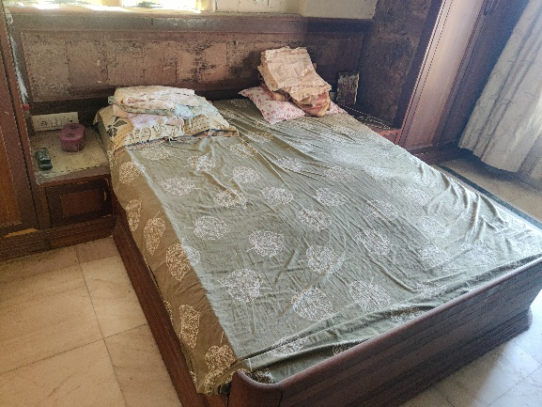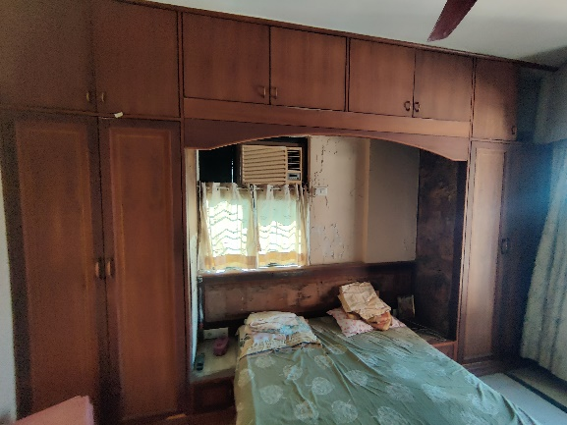

**Actual Site Photographs**

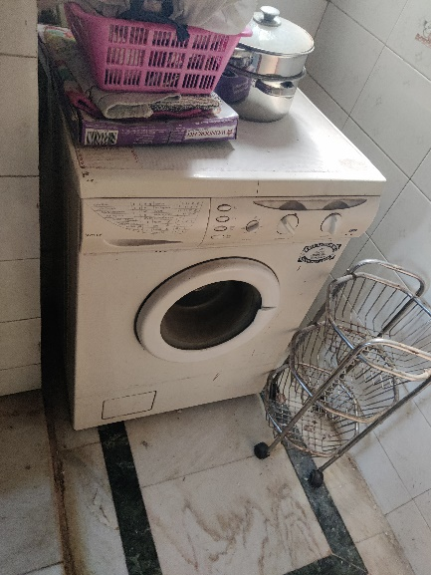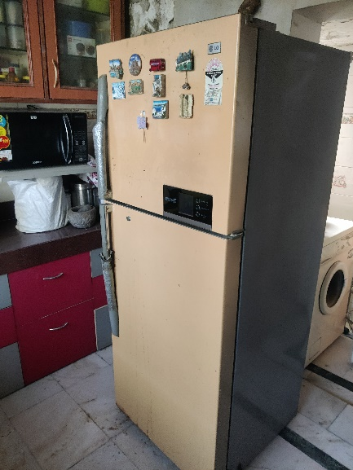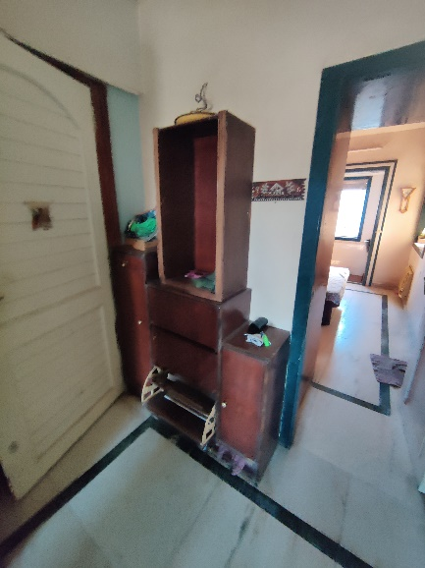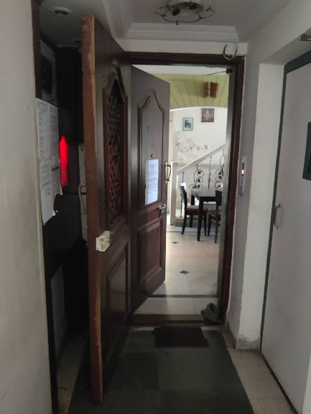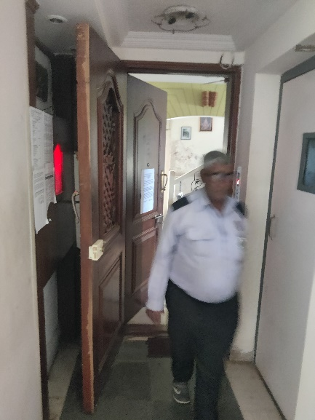

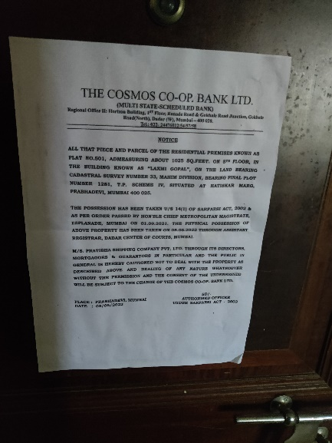

**Route Map of the property**

**Site u/r**

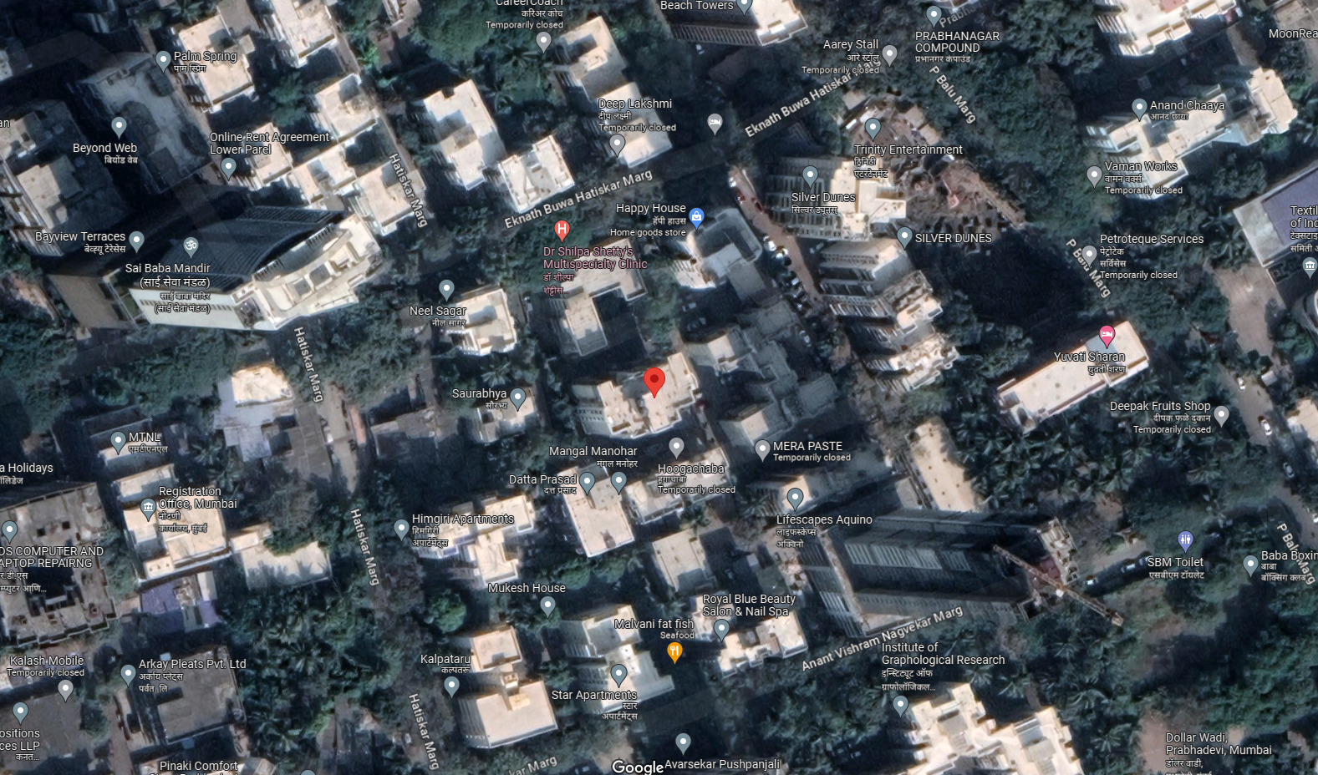

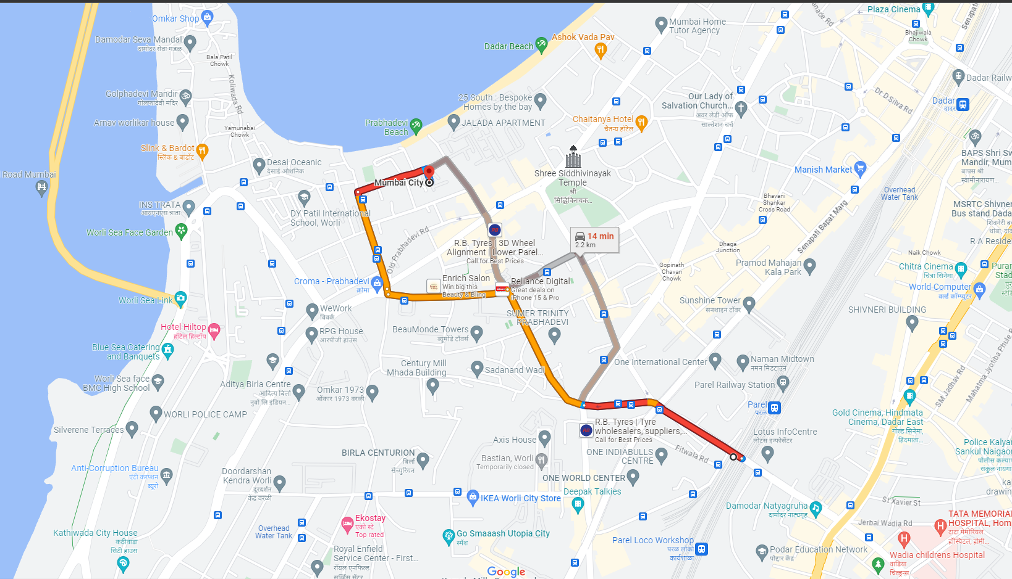

# **Latitude Longitude: 19°00'59.5"N 72°49'31.4"E**

# **Note:** The Blue line shows the route to site from nearest railway station (Prabhadevi – 2.20 Km.)