Vastu/Nashik/10/2023/004612/2303172
25/3-369-RPBS
Date: 25.10.2023

To, `
The Branch Manager,
Bank of Baroda
Regional Office Nashik Road Branch
BSNL Building, Datta Mandir Road, Nashik Road,
Nashik -422 101, State - Maharashtra, Country - India.

Sub: Vetting of Extra Amenities

Sir,

With reference to above subject, we have evaluated the Extra Amenities for Residential Flat No.D-2,Ground + Stilt Floor, Kashyapi-B "Kashyapi Apartment B", Survey No.689C/3/2/2/2/2 +1+3+2, Final Plot No.440, Plot No.1+2+3/A+B, TP Scheme No.II, Behind Saubhagya Nagar Nagrik Krida Mandal, Saubhagya Nagar, Pumping Station Road,Village - Nashik, Taluka & District - Nashik, PIN Code – 422 013,State – Maharashtra, Country – India belongs to Shri.Balu Ramchandra Deore. Name of Proposed Purchaser: Shri. Pradip Eknath Jadhav.

We have verified the rates quoted as per current market rates. Details of work and Extra Amenities considered as per copy of Agreement for Extra Amenities issued by Shri. Pradip Eknath Jadhav (First Part) and Shri. Natha Ambadas Shewale (Second Part) received on dated 17.09.2023. The Extra Amenities amount is Rs.10,00,000/- (Rupees Ten Lakh Only)

The said Cost Vetting Certificate is valid upto next 6 months Only.

Thanking you

Sincerely yours

Manoj B. Chalikwar
Registered Valuer
Chartered Engineer (India)
Reg. No. CAT-I-F-1763
Reg. No. IBBI/RV/07/2018/10366
BOB Empanelment No.: ZO:MZ:ADV:46:941
Encl: Valuation report.

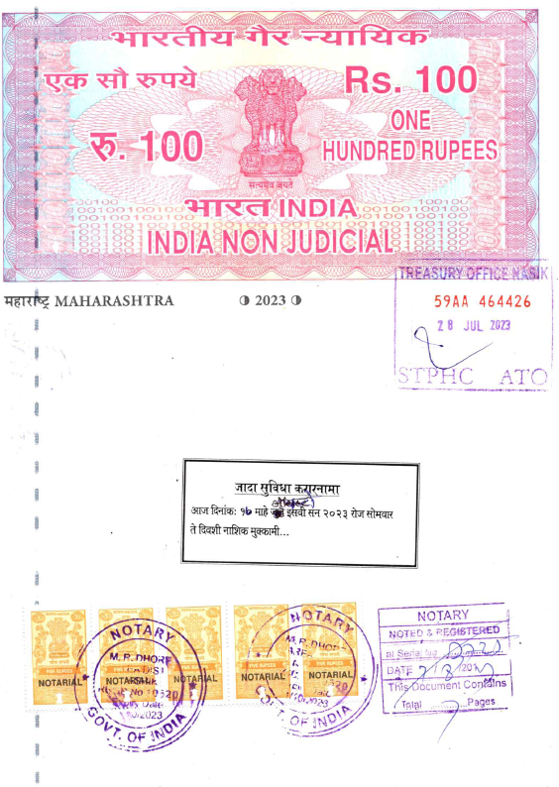
Agreement for Extra Amenities
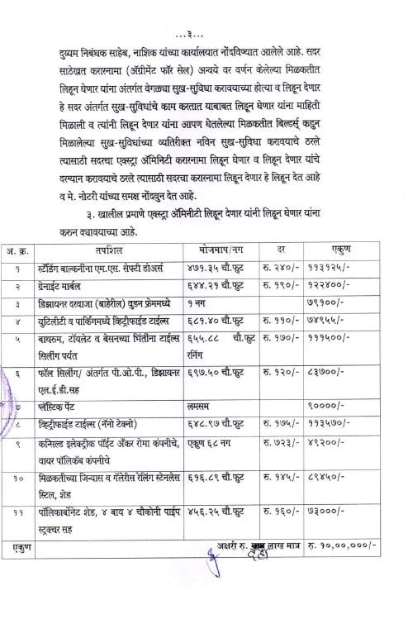

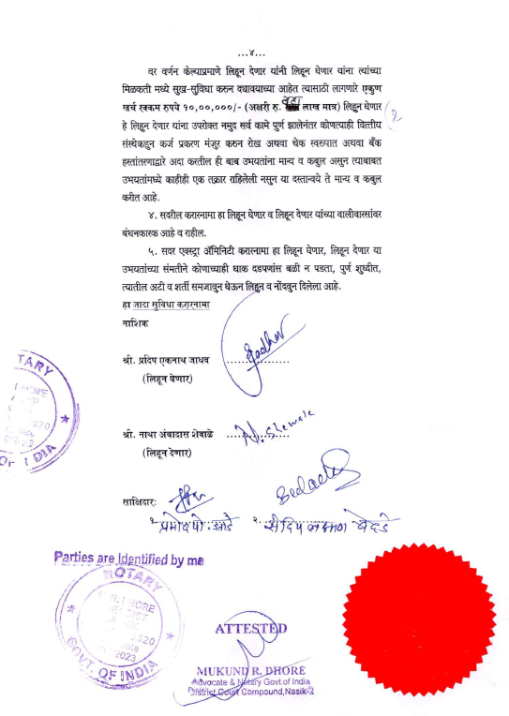

The Extra Amenities amount is Rs.10,00,000/- (Rupees Ten Lakh Only. )

