Valuation Report of the Immovable Property
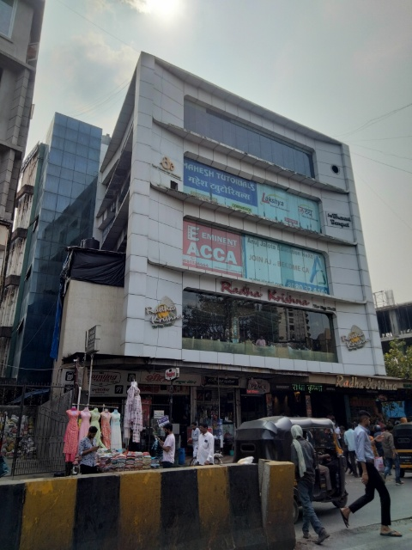

Details of the property under consideration:

Name of Owner: Mr. Kiran Manharlal Mehta

Commercial Unit No. 02, 2nd Floor, "Sun Plaza", Opp. Diamond Talkies, Lokmanya Tilak Road,
Borivali (West), Mumbai – 400 092, State – Maharashtra, Country – India.

Latitude Longitude: 19°13'42.7"N 72°51'16.9"E

Valuation Done for:
Janseva Sahakari Bank
Borivali (West) Branch
Aravali Business Centre (Phhol Mahal), Ramdas Surtale Marg, Off. Sodawala Lane, Boriwali (West),
Mumbai – 400 092, State – Maharashtra, Country – India.

Vastu/Mumbai/10/2023/4564/2303151
23/04-348-SBSH
Date: 20.10.2023

VALUATION OPINION REPORT

This is to certify that the property bearing Commercial Unit No. 02, 2nd Floor, "Sun Plaza", Opp. Diamond Talkies, Lokmanya Tilak Road, Borivali (West), Mumbai – 400 092, State – Maharashtra, Country – India belongs to Mr. Kiran Manharlal Mehta.

Boundaries of the property.

North | : | Lokmanya Tilak Road
South | : | Indraprastha Shopping Centre
East | : | Shop Line
West | : | Express Tower
Considering various parameters recorded, existing economic scenario, and the information that is available with reference to the development of neighbourhood and method selected for valuation, we are of the opinion that, the property premises can be assessed for this particular purpose at ` 2,50,00,000.00 (Rupees Two Crore Fifty Lakh Only).

The valuation of the property is based on the documents produced by the concern. Legal aspects have not been taken into considerations while preparing this valuation report.

Hence certified

Sharadkumar B. Chalikwar
Govt. Reg. Valuer
Chartered Engineer (India)
Reg. No. (N) CCIT/1-14/52/2008-09
JSB Emp. No. 36/LOAN H.O./2016-17/232
Encl. Valuation Report

Vastukala Consultants (I) Pvt. Ltd.
B1-001, U/B Floor, Boomerang, Chandivali Farm Road, Powai, Andheri (East), Mumbai – 400 072.

VALUATION REPORT (IN RESPECT OF UNIT)
I | General
1. | Purpose for which the valuation is made |  |  | : | As per the request from Janseva Sahakari Bank, Borivali (West) Branch to assess fair market value of the property for Provision of Sec.101 of MCS Act,1960 and Under rule of 107 of the Maharashtra Co-operative Societies Rules,1961.
2. | a) | Date of inspection |  | : | 20.10.2023
 | b) | Date on which the valuation is Made |  | : | 20.10.2023
3. | List of documents produced for perusal:  - Copy of Agreement dated 20.07.2005 Between M/s. Sundaram Developers (the Developers) & Mr. Kiran Manharlal Mehta (the Purchasers).
4. | Name of the owner(s) and his / their address (es) with Phone no. (details of share of each owner in case of joint ownership) |  |  | : | Mr. Kiran Manharlal Mehta.  Address: Commercial Unit No. 02, 2nd Floor, "Sun Plaza", Opp. Diamond Talkies, Lokmanya Tilak Road, Borivali (West), Mumbai – 400 092, State – Maharashtra, Country – India.  Contact Person:  Mr. Vimal Soni (Branch Manager)  Contact No. 7977761831  Sole Ownership
5. | Brief description of the property (Including Leasehold / freehold etc.) |  |  | : | The property is a Commercial Unit located on 2nd Floor. The composition of Unit is single unit. The property is at 280 Mtr. walkable distance from nearest railway station Borivali.
6. | Location of property |  |  | :
 | a) |  | Plot No. / Survey No. | : | Survey No. 234, Final Plot No. 105
 | b) |  | Door No. | : | Commercial Unit No. 02
 | c) |  | C.T.S. No. / Village | : | C.T.S No. 2782, 2782/1 to 18 at Village – Eksar
 | d) |  | Ward / Taluka | : | Taluka – Borivali
 | e) |  | Mandal / District | : | District – Mumbai Suburban
 | f) |  | Date of issue and validity of layout of approved map / plan | : | Copy of Approved Building plans were not provided and not verified.
 | g) |  | Approved map / plan issuing authority | :
 | h) |  | Whether genuineness or authenticity of approved map/ plan is verified | :
 | i) |  | Any other comments by our empanelled valuers on authentic of approved plan |  | N.A.
7. | Postal address of the property |  |  | : | Commercial Unit No. 02, 2nd Floor, "Sun Plaza", Opp. Diamond Talkies, Lokmanya Tilak Road, Borivali (West), Mumbai – 400 092, State – Maharashtra, Country – India.
8. | City / Town |  |  | : | Borivali (West), Mumbai
 | Residential area |  |  | : | No
 | Commercial area |  |  | : | Yes
 | Industrial area |  |  | : | No
9. | Classification of the area |  |  | :
 | i) High / Middle / Poor |  |  | : | Middle Class
 | ii) Urban / Semi Urban / Rural |  |  | : | Urban
10. | Coming under Corporation limit / Village Panchayat / Municipality |  |  | : | Village – Eksar  Municipal Corporation of Greater Mumbai
11. | Whether covered under any State / Central Govt. enactments (e.g., Urban Land Ceiling Act) or notified under agency area/ scheduled area / cantonment area |  |  | : | No
12. | Boundaries of the property |  |  |  | As per site |  | As per documents
 | North |  |  | : | Lokmanya Tilak Road |  | Details not available
 | South |  |  | : | Indraprastha Shopping Centre |  | Details not available
 | East |  |  | : | Shop Line |  | Details not available
 | West |  |  | : | Express Tower |  | Details not available
13 | Dimensions of the site |  |  |  | N. A. as property under consideration is a unit in an apartment building.
 |  |  |  |  | A As per the Deed | B Actuals
 | North |  |  | : | - | -
 | South |  |  | : | - | -
 | East |  |  | : | - | -
 | West |  |  | : | - | -
14. | Extent of the site |  |  | : | Carpet Area in Sq. Ft. = 503.00  (Area as per actual site measurement)  Carpet Area in Sq. Ft. = 500.00  (Area as per Agreement)  Built Up Area in Sq. Ft. = 600.00  (Carpet Area + 20%)
14.1 | Latitude, Longitude & Co-ordinates of unit |  |  | : | 19°13'42.7"N 72°51'16.9"E
15. | Extent of the site considered for Valuation (least of 13A& 13B) |  |  | : | Carpet Area in Sq. Ft. = 500.00  (Area as per Agreement)
16 | Whether occupied by the owner / tenant? If occupied by tenant since how long? Rent received per month. |  |  | : | Vacant & in Bank possession
II | APARTMENT BUILDING
 | Nature of the Apartment |  |  | : | Commercial
 | Location |  |  | :
 | C.T.S. No. |  |  | : | Survey No. 234, Final Plot No. 105, C.T.S No. 2782, 2782/1 to 18
 | Block No. |  |  | : | -
 | Ward No. |  |  | : | -
 | Village / Municipality / Corporation |  |  | : | Village – Eksar  Municipal Corporation of Greater Mumbai
 | Door No., Street or Road (Pin Code) |  |  | : | Commercial Unit No. 02, 2nd Floor, "Sun Plaza", Opp. Diamond Talkies, Lokmanya Tilak Road, Borivali (West), Mumbai – 400 092, State – Maharashtra, Country – India.
 | Description of the locality Residential / Commercial / Mixed |  |  | : | Commercial
 | Year of Construction |  |  | : | 2009 (Approx.)
 | Number of Floors |  |  | : | Ground + 4 Upper Floors
 | Type of Structure |  |  | : | R.C.C. Framed Structure
 | Number of Dwelling units in the building |  |  | : | 3 Units on 2nd Floor
 | Quality of Construction |  |  | : | Good
 | Appearance of the Building |  |  | : | Good
 | Maintenance of the Building |  |  | : | Good
 | Facilities Available |  |  | :
 | Lift |  |  | : | 2 Lifts
 | Protected Water Supply |  |  | : | Municipal Water supply
 | Underground Sewerage |  |  | : | Connected to Municipal Sewerage System
 | Car parking - Open / Covered |  |  | : | Open Car Parking
 | Is Compound wall existing? |  |  | : | Yes
 | Is pavement laid around the building |  |  | : | Yes

III | UNIT
1 | The floor in which the unit is situated | : | 2nd Floor
2 | Door No. of the unit | : | Commercial Unit No. 02
3 | Specifications of the unit | :
 | Roof | : | R.C.C. Slab
 | Flooring | : | Vitrified flooring
 | Doors | : | Glass Door
 | Windows | : | -
 | Fittings | : | Electrical wiring with Casing capping.
 | Finishing | : | Cement Plastering
4 | House Tax | :
 | Assessment No. | : | Details not available
 | Tax paid in the name of: | : | Details not available
 | Tax amount: | : | Details not available
5 | Electricity Service connection No.: | : | Details not available
 | Meter Card is in the name of: | : | Details not available
6 | How is the maintenance of the unit? | : | Good
7 | Sale Deed executed in the name of | : | Mr. Kiran Manharlal Mehta
8 | What is the undivided area of land as per Sale Deed? | : | Details not available
9 | What is the plinth area of the unit? | : | Built Up Area in Sq. Ft. = 600.00  (Carpet Area + 20%)
10 | What is the floor space index (app.) | : | As per MCGM norms
11 | What is the Carpet Area of the unit? | : | Carpet Area in Sq. Ft. = 503.00  (Area as per actual site measurement)  Carpet Area in Sq. Ft. = 500.00  (Area as per Agreement)
12 | Is it Posh / I Class / Medium / Ordinary? | : | Medium
13 | Is it being used for Residential or Commercial purpose? | : | Commercial purpose
14 | Is it Owner-occupied or let out? | : | Vacant & in Bank possession
15 | If rented, what is the monthly rent? | : | ` 83,000.00 Expected rental income per month
IV | MARKETABILITY | :
1 | How is the marketability? | : | Good
2 | What are the factors favouring for an extra Potential Value? | : | Located in developed area
3 | Any negative factors are observed which affect the market value in general? | : | No
V | Rate | :
1 | After analyzing the comparable sale instances, what is the composite rate for a similar unit with same specifications in the adjoining locality? - (Along with details / reference of at - least two latest deals / transactions with respect to adjacent properties in the areas) | : | ` 48,000.00 to ` 52,000.00 per Sq. Ft. on Carpet Area
2 | Assuming it is a new construction, what is the adopted basic composite rate of the unit under valuation after comparing with the specifications and other factors with the unit under comparison (give details). | : | ` 50,000.00 per Sq. Ft. on Carpet Area
3 | Break – up for the rate | :
 | I. Building + Services | : | ` 3,000.00 per Sq. Ft.
 | II. Land + others | : | ` 47,000.00 per Sq. Ft.
4 | Guideline rate obtained from the Registrar's office | : | ` 2,18,700.00 per Sq. M. i.e. ` 20,318.00 per Sq. Ft.
5 | Age of the building | : | 14 years
6 | Life of the building estimated | : | 46 years Subject to proper, preventive periodic maintenance & structural repairs.
 | Remark:

Details of Valuation:

Sr. No. | Description | Qty. | Rate per  unit (`) | Estimated  Value (`)
1 | Present value of the Unit (incl. car parking, if provided) | 500.00 Sq. Ft. | 50,000.00 | 2,50,00,000.00
2 | Total Fair Market Value of the Property |  |  | 2,50,00,000.00
3 | Realizable value of the property |  |  | 2,12,50,000.00
4 | Distress value of the property |  |  | 1,75,00,000.00
5 | Insurable value of the property (600.00 X 3,000.00) |  |  | 18,00,000.00
6 | Guideline Value / Ready Reckoner Value of the property (600.00 X 20,318.00) |  |  | 1,21,90,800.00

Justification for price / rate

The Market Value of the property is based on facts of markets discovered by us during our enquiries, however the government rate value in this case is less than the market value arrived by us. We are of the opinion that the value arrive by us will prove to be correct if an Auction of the subject property is carried out. As far as Market Value in Index II is concerned, it is not possible to comment on same, may be government rates are fixed by sampling during same point of time in part and whereas, Market values change every month.
In most of the cases the actual deal amount or Transaction value is not reflected in Index II because of various Market practices. As Valuer, we always try to give a value which is correct reflection of actual transaction value irrespective of any factors in market.
Method of Valuation / Approach

The sales comparison approach uses the market data of sale prices to estimate the value of a real estate property. Property valuation in this method is done by comparing a property to other similar properties that have been recently sold. Comparable properties, also known as comparables, or comps, must share certain features with the property in question. Some of these include physical features such as square footage, number of rooms, condition, and age of the building; however, the most important factor is no doubt the location of the property. Adjustments are usually needed to account for differences as no two properties are exactly the same. To make proper adjustments when comparing properties, real estate appraisers must know the differences between the comparable properties and how to value these differences. The sales comparison approach is commonly used for Commercial Unit, where there are typically many comparables available to analyze. As the property is a Commercial Unit, we have adopted Sale Comparison Approach Method for the purpose of valuation. The Price for similar type of property in the nearby vicinity is in the range of ` 48,000.00 to ` 52,000.00 per Sq. Ft. on Carpet Area. Considering the rate with attached report, current market conditions, demand and supply position, unit size, location, upswing in real estate prices, sustained demand for Commercial Unit, all round development of Residential and Commercial application in the locality etc. We estimate ` 50,000.00 per Sq. Ft. on Carpet Area for valuation.

Actual site photographs
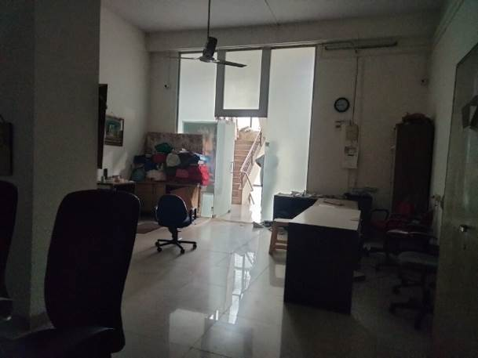
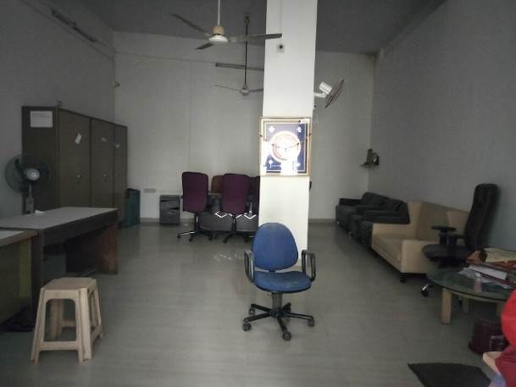

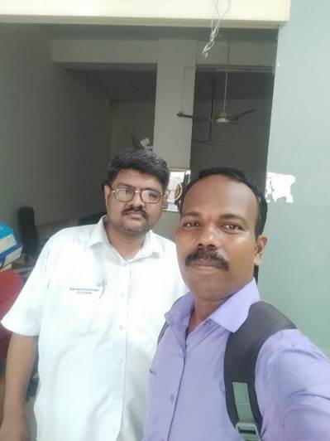
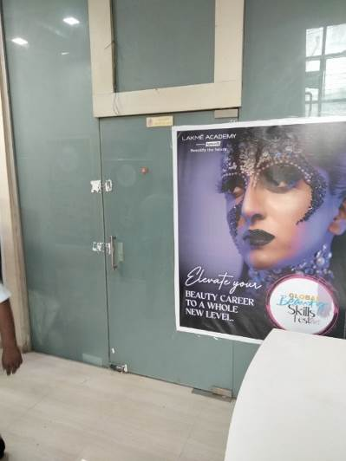
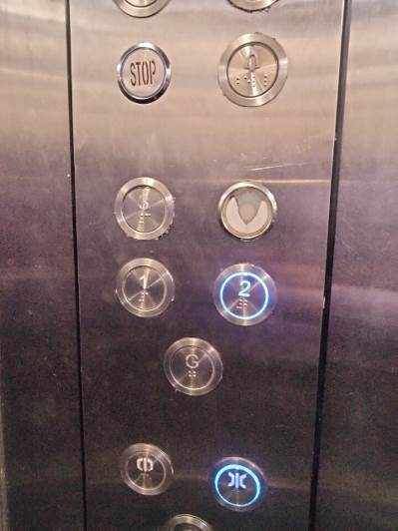

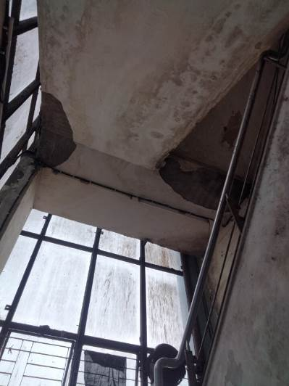
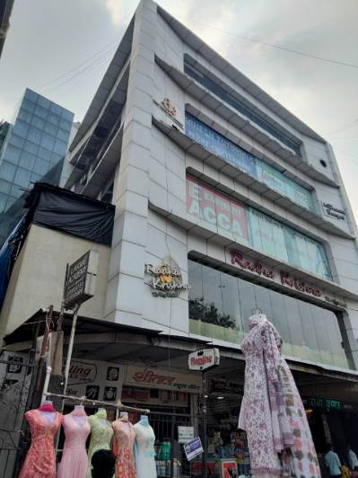
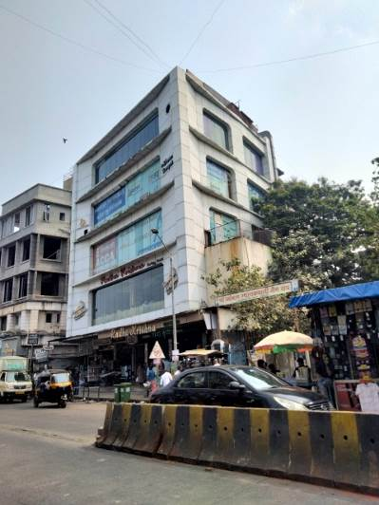
Route Map of the property
Site u/r
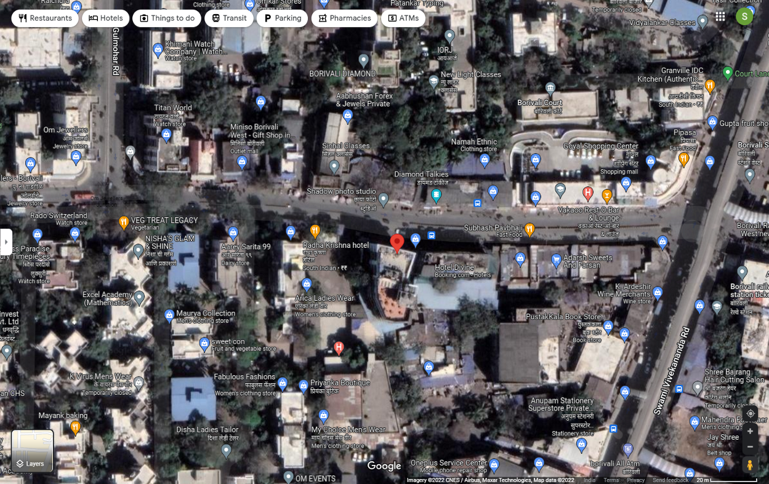

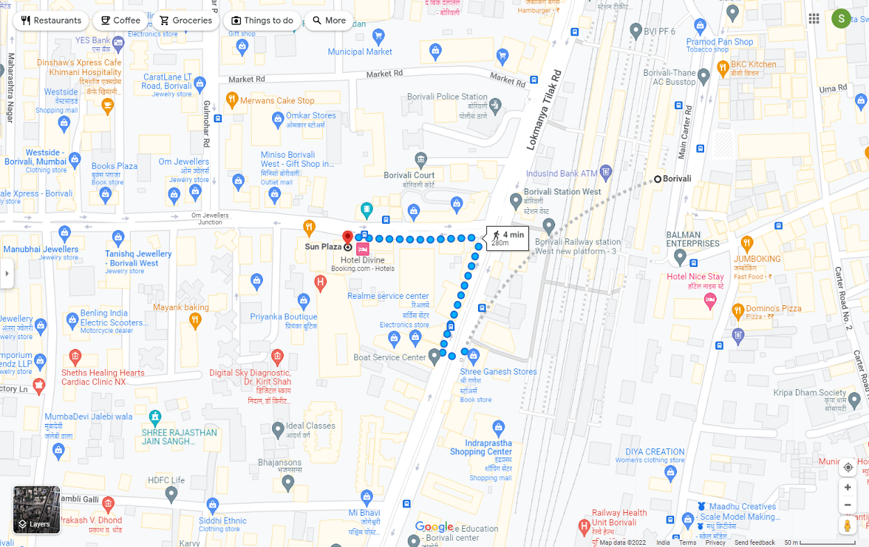


Latitude Longitude: 19°13'42.7"N 72°51'16.9"E
Note: The Red line shows the route to site from nearest railway station (Borivali – 280 Mt.)

Ready Reckoner Rate
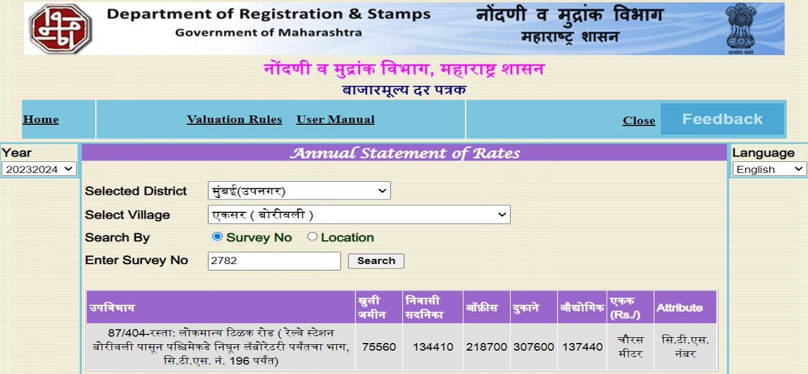

Price Indicators
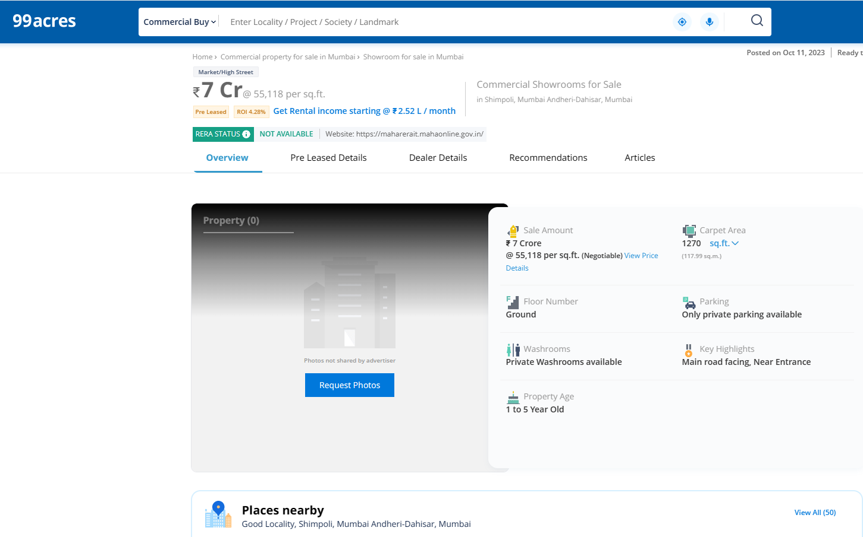

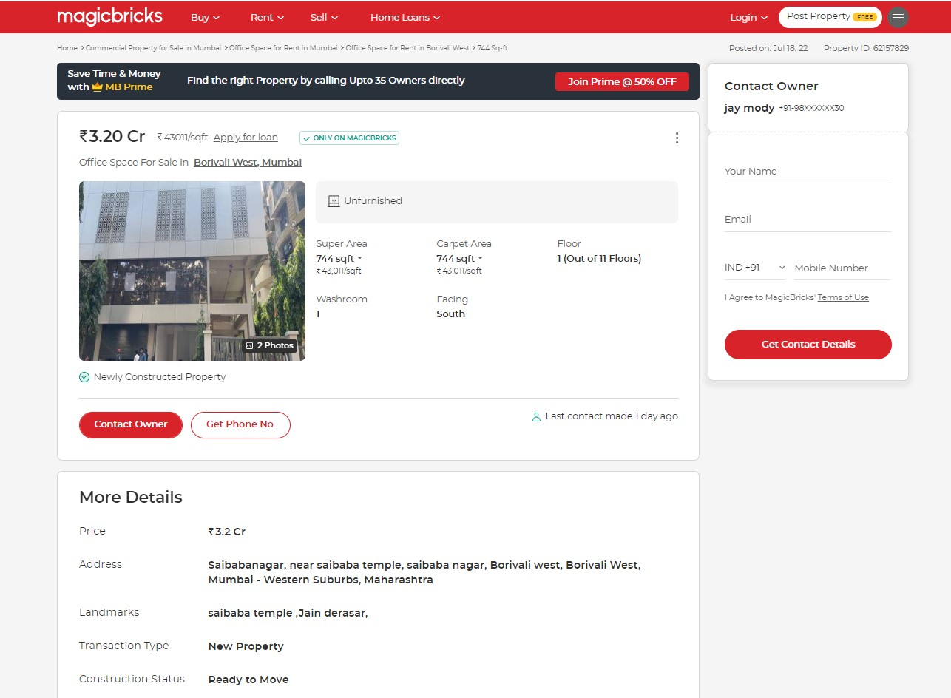

Price Indicators
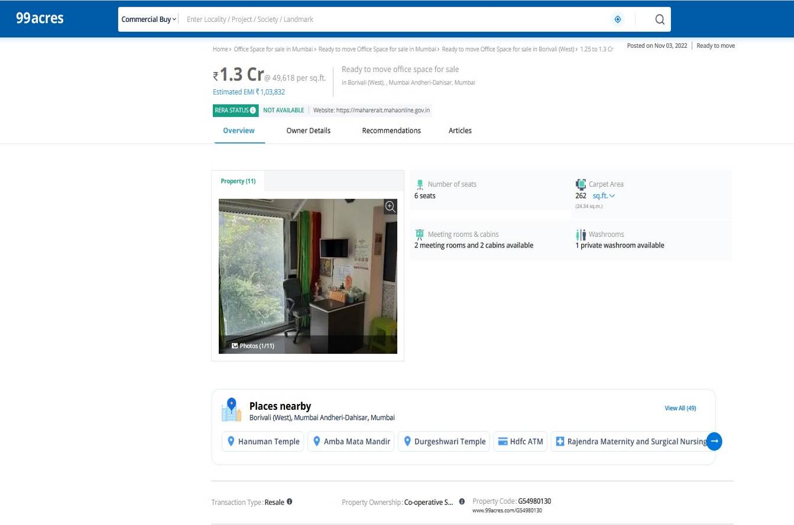

As a result of my appraisal and analysis, it is my considered opinion that the Fair Market Value of the above property in the prevailing condition with aforesaid specifications is ` 2,50,00,000.00 (Rupees Two Crore Fifty Lakh Only).
Sr. No. | Particulars | Valuer comment
 | Background information of the asset being valued; | The property under consideration was owned by Mr. Kiran Manharlal Mehta.
 | Purpose of valuation and appointing authority | As per the request from Janseva Sahakari Bank, Borivali (West) Branch to assess fair market value of the property for Provision of Sec.101 of MCS Act,1960 and Under rule of 107 of the Maharashtra Co-operative Societies Rules,1961.
 | Identity of the valuer and any other experts involved in the valuation; | Sharadkumar B. Chalikwar – Regd. Valuer  Aniket Navale – Valuation Engineer  Shobha Kuperkar – Technical Manager  Shamal Bodke – Technical Officer
 | Disclosure of valuer interest or conflict, if any; | We have no interest, either direct or indirect, in the property valued. Further to state that we do not have relation or any connection with property owner / applicant directly or indirectly. Further to state that we are an independent Valuer and in no way related to property owner / applicant
 | Date of appointment, valuation date and date of  report; | Date of Appointment – 20.10.2023  Valuation Date – 20.10.2023  Date of Report – 20.10.2023
 | Inspections and/or investigations undertaken; | Physical Inspection done on 20.10.2023
 | Nature and sources of the information used or relied upon; | - Market Survey at the time of site visit  - Ready Reckoner rates / Circle rates  - Online search for Registered Transactions  - Online Price Indicators on real estate portals  - Enquiries with Real estate consultants  - Existing data of Valuation assignments carried out by us
 | Procedures adopted in carrying out the valuation and valuation standards followed; | Sales Comparison Method
 | Restrictions on use of the report, if any; | This valuation is for the use of the party to whom it is addressed and for no other purpose. No responsibility is accepted to any third party who may use or rely on the whole or any part of this valuation. The valuer has no pecuniary interest that would conflict with the proper valuation of the property.
 | Major factors that were taken intoaccount during the valuation; | current market conditions, demand and supply position, Commercial Unit size, location, upswing in real estate prices, sustained demand for Commercial Unit, all round development of commercial and residential application in the locality etc.
- 10 | Caveats, limitations and disclaimers to the extent they explain or elucidate the limitations faced by valuer, which shall not be for the purpose of limiting his responsibility for the valuation report. | Attached

Assumptions, Disclaimers, Limitations & Qualifications

Value Subject to Change
The subject appraisal exercise is based on prevailing market dynamics as on 20th October 2023 and does not take into account any unforeseeable developments which could impact the same in the future.

Our Investigations
We are not engaged to carry out all possible investigations in relation to the subject property. Where in our report we identify certain limitations to our investigations, this is to enable the reliant party to instruct further investigations where considered appropriate or where we recommend as necessary prior to reliance. Vastukala Consultants India Pvt. Ltd. (VCIPL) is not liable for any loss occasioned by a decision not to conduct further investigations
Assumptions
Assumptions are a necessary part of undertaking valuations. VCIPL adopts assumptions for the purpose of providing valuation advise because some matters are not capable of accurate calculations or fall outside the scope of our expertise, or out instructions. The reliant party accepts that the valuation contains certain specific assumptions and acknowledge and accept the risk of that if any of the assumptions adopted in the valuation are incorrect, then this may have an effect on the valuation.
Information Supplied by Others
The appraisal is based on the information provided by the client. The same has been assumed to be correct and has been used for appraisal exercise. Where it is stated in the report that another party has supplied information to VCIPL, this information is believed to be reliable but VCIPL can accept no responsibility if this should prove not to be so.
Future Matters
To the extent that the valuation includes any statement as to a future matter, that statement is provided as an estimate and/or opinion based on the information known to VCIPL at the date of this document. VCIPL does not warrant that such statements are accurate or correct.
Map and Plans
Any sketch, plan or map in this report is included to assist the reader while visualising the property and assume no responsibility in connection with such matters.
Site Details
Based on inputs received from Client and site visit conducted, we understand that the subject property is Commercial Unit, admeasuring 500.00 Sq. Ft. Carpet Area in the name of Mr. Kiran Manharlal Mehta. Further, VCIPL has assumed that the subject property is free from any encroachment and is available as on the date of the appraisal.
Property Title
Based on our discussion with the Client, we understand that the subject property is owned by Mr. Kiran Manharlal Mehta. For the purpose of this appraisal exercise, we have assumed that the subject property has a clear title and is free from any encumbrances, disputes and claims. VCIPL has made no further enquiries with the relevant local authorities in this regard and does not certify the property as having a clear and marketable title. Further, no legal advice regarding the title and ownership of the subject property has been obtained for the purpose of this appraisal exercise. It has been assumed that the title deeds are clear and marketable.
Environmental Conditions
We have assumed that the subject property is not contaminated and is not adversely affected by any existing or proposed environmental law and any processes which are carried out on the property are regulated by environmental legislation and are properly licensed by the appropriate authorities.
Area
Based on the information provided by the Client, we understand that the Commercial Unit, admeasuring 500.00 Sq. Ft. Carpet Area.
Condition & Repair
In the absence of any information to the contrary, we have assumed that there are no abnormal ground conditions, nor archaeological remains present which might adversely affect the current or future occupation, development or value of the property. The property is free from rat, infestation, structural or latent defect. No currently known deleterious or hazardous materials or suspect techniques will be used in the construction of or subsequent alteration or additions to the property and comments made in the property details do not purport to express an opinion about, or advise upon, the condition of uninspected parts and should not be taken as making an implied representation or statement about such parts
Valuation Methodology
For the purpose of this valuation exercise, the valuation methodology used is Direct Comparison Approach / Method and proposed Current use / Existing use premise is considered for this assignment.
The Direct Comparison Approach involves a comparison of the property being valued to similar properties that have actually been sold in arms - length transactions or are offered for sale. This approach demonstrates what buyers have historically been willing to pay (and sellers willing to accept) for similar properties in an open and competitive market and is particularly useful in estimating the value of the Unit and properties that are typically traded on a unit basis.
In case of inadequate recent transaction activity in the subject micro-market, the appraiser would collate details of older transactions. Subsequently, the appraiser would analyse rental / capital value trends in the subject micro-market in order to calculate the percentage increase / decrease in values since the date of the identified transactions. This percentage would then be adopted to project the current value of the same.
Where reliance has been placed upon external sources of information in applying the valuation methodologies, unless otherwise specifically instructed by Client and/or stated in the valuation, VCIPL has not independently verified that information and VCIPL does not advise nor accept it as reliable. The person or entity to whom the report is addressed acknowledges and accepts the risk that if any of the unverified information in the valuation is incorrect, then this may have an effect on the valuation.
Not a Structural Survey
We state that this is a valuation report and not a structural survey
Other
All measurements, areas and ages quoted in our report are approximate
Legal
We have not made any allowances with respect to any existing or proposed local legislation relating to taxation on realization of the sale value of the subject property. VCIPL is not required to give testimony or to appear in court by reason of this appraisal report, with reference to the property in question, unless arrangement has been made thereof. Further, no legal advice on any aspects has been obtained for the purpose of this appraisal exercise
Property specific assumptions
Based on inputs received from the client and site visit conducted, we understand that the subject property is Commercial Unit, admeasuring 500.00 Sq. Ft. Carpet Area.

ASSUMPTIONS, CAVEATS, LIMITATION AND DISCLAIMERS
1. We assume no responsibility for matters of legal nature affecting the property appraised or the title thereto, nor do we render our opinion as to the title, which is assumed to be good and marketable.
2. The property is valued as though under responsible ownership.
3. It is assumed that the property is free of liens and encumbrances.
4. It is assumed that there are no hidden or unapparent conditions of the subsoil or structure that would render it more or less valuable. No responsibility is assumed for such conditions or for engineering that might be required to discover such factors.
5. There is no direct/ indirect interest in the property valued.
6. The rates for valuation of the property are in accordance with the Govt. approved rates and prevailing market rates.

DEFINITION OF VALUE FOR THIS SPECIFIC PURPOSE

This exercise is to assess Fair Market Value of the property under reference for Provision of Sec.101 of MCS Act,1960 and Under rule of 107 of the Maharashtra Co-operative Societies Rules,1961 purpose as on dated 20th October 2023.

The term Fair Market Value is defined as

“The most probable price, as of a specified date, in cash, terms equivalent to cash, or in other precisely revealed terms for which the specified property rights would sell after reasonable exposure in a competitive market under all conditions requisite to a fair sale, with the buyer and seller each acting prudently knowledgeably and for self interest assuming that neither is under undue duress”.

Fundamental assumptions and conditions presumed in this definition are:

1. Buyer and seller are motivated by self-interest.
2. Buyer and seller are well informed and are acting prudently.
3. The property is exposed for a reasonable time on the open market.
4. Payment is made in cash or equivalent or in specified financing terms.
DECLARATION OF PROFESSIONAL FEES CHARGED

We hereby declare that, our professional fees are not contingent upon the valuation findings. However, if the statute AND/OR clients demands that, the fees should be charged on the percentage of assessed value then, with the full knowledge of the AND/OR end user, it is being charged accordingly.

VALUATION OF THE PROPERTY PREMISES

Considering various parameters recorded, existing economic scenario, and the information that is available with reference to the development of neighbourhood and method selected for valuation, we are of the opinion that, the property premises can be assessed for this particular purpose at ` 2,50,00,000.00 (Rupees Two Crore Fifty Lakh Only).

Sharadkumar B. Chalikwar
Govt. Reg. Valuer
Chartered Engineer (India)
Reg. No. (N) CCIT/1-14/52/2008-09
JSB Emp. No. 36/LOAN H.O./2016-17/232

