Vastu/Nashik/03/2023833/30490/46262
22/24-455-RPV
Date: 21.10.2023

To, `
The Branch Manager,
Bank of Baroda
Regional Office Nashik Road Branch
BSNL Building, Datta Mandir Road, Nashik Road,
Nashik -422 101, State - Maharashtra, Country - India.

Sub: Vetting of Extra Amenities

Sir,

With reference to above subject, we have evaluated the Extra Amenities for Residential Row House No.17, Ground + First Floor, Block (Wing) -G "Kalpataru Phase - 5", Gat No. 99+100D/2/A, Near Samarth Hospital, Medage Nagar, MHADA Road, Village – Chunchale, Taluka – Nashik, District - Nashik, PIN Code – 422 007, State – Maharashtra, Country – India belongs to M/s. Ashoka Infraways Pvt. Ltd. Name of Proposed Purchaser: Shri. Shubham Bhausaheb Sabale & Sau. Sunita Bhausaheb Sabale.

We have verified the rates quoted as per current market rates. Details of work and Extra Amenities considered as per copy of Agreement for Extra Amenities between Shri. Shubham Bhausaheb Sabale & Sau. Sunita Bhausaheb Sabale (First Party) and Shri.Sachin Wishwanath Patil (Second Party) received on dated 20.10.2023. The Extra Amenities amount is Rs.1,80,000/- ( Rupees One Lakh Eighty Thousand Only. )

The said Cost Vetting Certificate is valid upto next 6 months Only.

Thanking you

Sincerely yours

Sharadkumar B. Chalikwar
Govt. Reg. Valuer
Chartered Engineer (India)
Reg. No. (N) CCIT/1-14/52/2008-09
Encl: Vetting Report.

Agreement for Extra Amenities
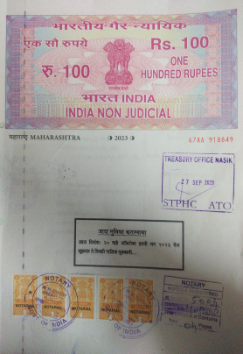
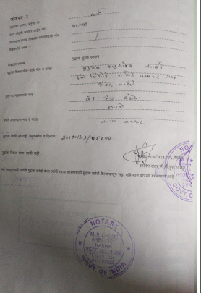

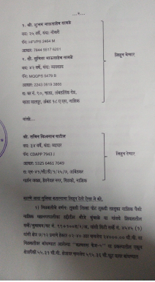
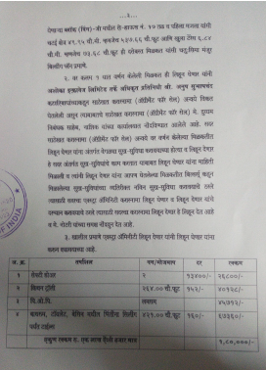

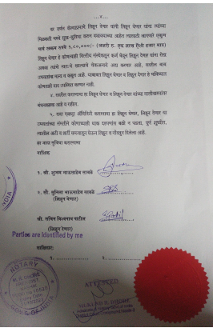

The Extra Amenities amount is Rs.1,80,000/- ( Rupees One Lakh Eighty Thousand Only. )

