Vastu/Mumbai/10/2023/4533/33161

08/01-35-BSU

Date: 25.10.2023

VALUATION REPORT OF MACHINERY

# 

**GENERAL INFORMATION:**

|  |  |  |  |
| --- | --- | --- | --- |
|  | Date of Report | **25.10.2023** | |
| 1. | Name of the Borrower | **M/s. Shah Brothers Ispat Pvt. Ltd.** | |
| 2. | Purpose for which valuation is made | To ascertain the Fair Market Value of Plant & Machinery. | |
| 3. | Date of Visit | 20.10.2023 | |
| 4. | Particulars of the Machinery valued | As per Working Sheet Attached with this report. | |
| 5. | Location of the Machine | **M/s. Shah Brothers Ispat Pvt. Ltd.:** Plot No. L – 5, Taloja Industrial Area, Additional Engineering Zone, M.I.D.C. - I, Village - Pale Khurd, Taluka – Panvel, District – Raigad, PIN – 410 208,  State - Maharashtra, India | |
| 6. | **Brief Description: -**  The Subject Plot No. L-5 is about 8.9 km travelling distance from Taloja Panchnand railway station, falling in village Pale – Khurd, Taluka - Panvel, Raigad - District. The subject plot is fully developed plot with ample water supply & electricity. The area is having all the necessary civic amenities like Roads, Electricity, Markets and Easy access to Railway Station, National Highway etc. The property is leased by MIDC.  **Observation: -**   * **M/s. Shah Brothers Ispat Pvt. Ltd.**is in to Renting of Machinery for  Steel Metal Industries. * The Machine under Valuation is Crane Gantry & EOT for Movement of Heavy Steel Materials approx. 10 years old few cranes where installed in phase wise manner details of year of Manufacturing was not available at site. * The machine was in operational condition. * During the date and time of our visit the Machine was partly operational. * The photographs are enclosed for your reference | | |
| 7. | Name of the Owner/s of the Machine. | | **M/s. Shah Brothers Ispat Pvt. Ltd** |
| 8. | Condition of the Machine | | Partly operation |
| 9. | Break down hours | | Break down hours records not provided. |
| 10. | Basis of valuation. | | Fair Market value is calculated by applying depreciation on the Gross Block considering following factor: -   * Purchase Price * Age * Visual Observation * Condition * Type of Assets * Market Scenario |
| 11. | Market rate / rate adopted? | | Deprecated Replacement Cost Approach |

**NOTES & DISCLAIMERS FORMING PART OF OUR REPORT:**

1) In the preparation of the report, we have relied on the following information: -

i. Information provided by Client.

ii. Recent data on the industry segments.

iii. Other relevant information available to us and publicly available information, internet information & reports.

2) The FMV is based on the Plant & Machinery shown during the date and time of visit.

3) The report is issued at the specific request of the party for specific purpose and the said report is not valid if the purpose of use and party is different.

4) It should be noted that our value assessments are based upon the facts and evidence available at the time of assessment and must be periodically reviewed.

5) The valuation will change if the items stated above are sold individually or shifted to another place.

6) Our report should be read along with disclaimers. The value given in our report is only an opinion on the Fair Market Value as on date of inspection.

7) Our valuation is only for the use of the party to whom it is addressed and no responsibility is accepted to any third party for the whole or any part of its contents. The said report will not hold good / should not be used for any court / legal matters.

**FAIR MARKET VALUE: -**

**Rs. 1,34,00,000/- (Rupees One Crore Thirty-Four Lakh Only)**

**REALIZABLE SALE VALUATION: -**

**Rs.1,13,90,000/- (Rupees One Crore Thirteen Lakh Ninety Thousand Only)**

**DISTRESS SALE VALUE: -**

**Rs. 93,80,000/- (Rupees Ninety-Three Lakh Eighty Thousand Only)**

### We further declare that: --

### The information furnished in this Report is true and correct to the best of our knowledge and belief.

1. Notes given in our report are forming important part of the report.
2. We have no direct or indirect interest in the machinery valued.
3. We / our Engineers have personally inspected the right machinery on 20.08.2020.
4. Value of the machinery mentioned above varies with the purpose. This report is not to be referred if the purpose is different.
5. Working Sheet is enclosed with this report.

For Vastukala Consultants (I) Pvt. Ltd.

**Umang A. Patel**

Govt. Reg. Valuer

Reg. No. CAT-VII-A-5062

PLACE: MUMBAI

DATED:25.10.2023

**PHOTOGRAPHS: -**

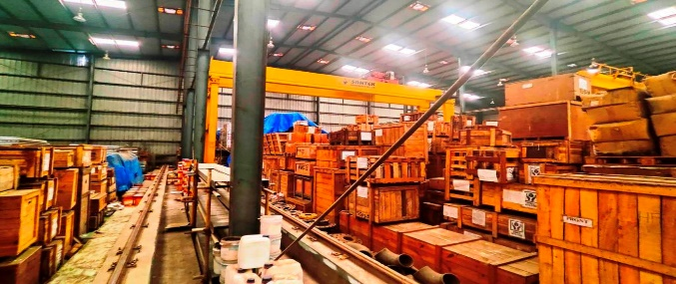

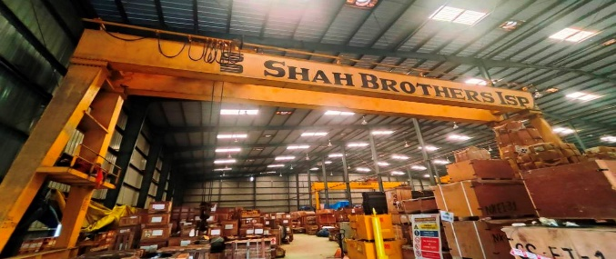

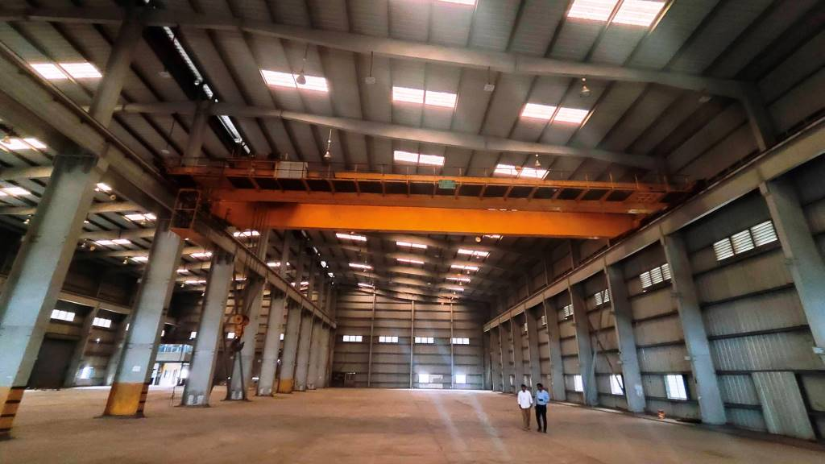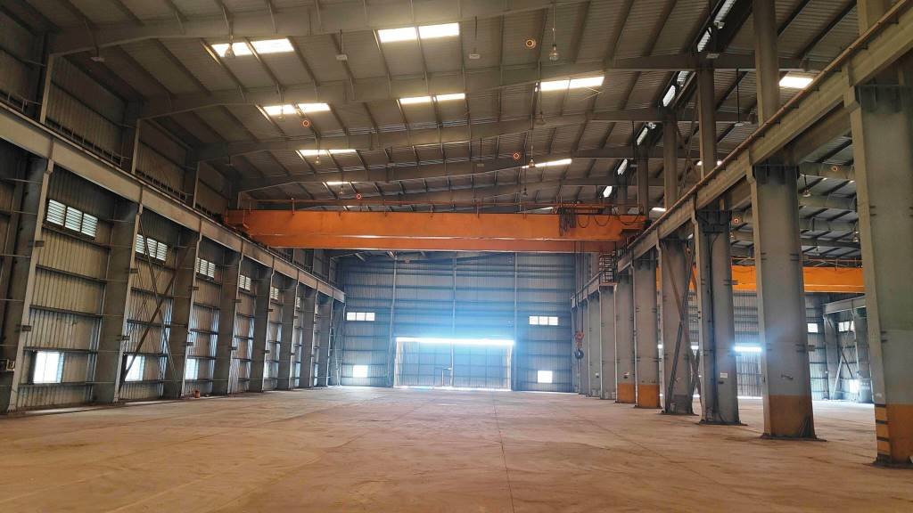

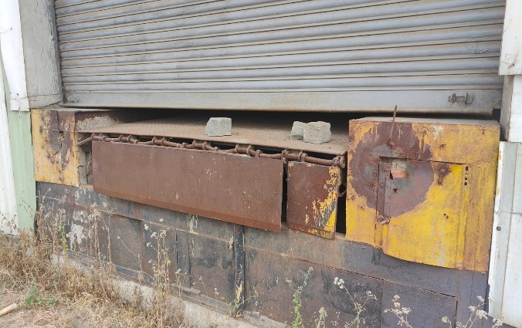

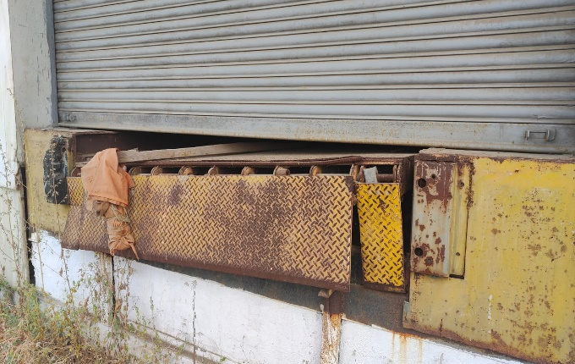

|  |
| --- |
| WORKING SHEET |
| M/s. Shah Brothers Ispat Pvt. Ltd. |
| DATE OF VISIT: 20.10.2023 |
| LOCATED AT :- Plot No. L – 5, Taloja Industrial Area, Additional Engineering Zone, M.I.D.C. - I, Village - Pale Khurd, Taluka – Panvel, District – Raigad, PIN – 410 208, State - Maharashtra, India |
| WORKING OF FAIR MARKET VALUE OF PLANT & MACHINERY |

|  |  |  |  |  |  |  |  |
| --- | --- | --- | --- | --- | --- | --- | --- |
| S. No. | **Description** | **Model No.** | **Qty.** | **Supplier** | **Age (Yrs)** | **Residual Life (Yrs)** | **Fair Market Value (Rs)** |
| 1 | [20 Ton Heavy Duty Girder Gantry Crane](https://www.google.com/url?sa=i&url=https%3A%2F%2Fwww.indiamart.com%2Fproddetail%2F20-ton-heavy-duty-girder-gantry-crane-22475169512.html&psig=AOvVaw2XJZ6JLXac7Ujs82RJwhMa&ust=1698151975276000&source=images&cd=vfe&opi=89978449&ved=0CBMQjhxqFwoTCODf_5ubjIIDFQAAAAAdAAAAABAE) | G.C.01 | 1 | 1 | 10 | 20 | 20,00,000.00 |
| 2 | [25 Ton Heavy Duty Girder Gantry Crane (SANKET)](https://www.google.com/url?sa=i&url=https%3A%2F%2Fwww.indiamart.com%2Fproddetail%2F20-ton-heavy-duty-girder-gantry-crane-22475169512.html&psig=AOvVaw2XJZ6JLXac7Ujs82RJwhMa&ust=1698151975276000&source=images&cd=vfe&opi=89978449&ved=0CBMQjhxqFwoTCODf_5ubjIIDFQAAAAAdAAAAABAE) |  | 1 | Sanket | 10 | 20 | 22,00,000.00 |
| 3 | [35 Ton Heavy Duty Girder Gantry Crane](https://www.google.com/url?sa=i&url=https%3A%2F%2Fwww.indiamart.com%2Fproddetail%2F20-ton-heavy-duty-girder-gantry-crane-22475169512.html&psig=AOvVaw2XJZ6JLXac7Ujs82RJwhMa&ust=1698151975276000&source=images&cd=vfe&opi=89978449&ved=0CBMQjhxqFwoTCODf_5ubjIIDFQAAAAAdAAAAABAE) |  | 1 |  | 10 | 20 | 25,00,000.00 |
| 4 | 35Ton EOT Double Gride Crane (Federal) |  | 1 | Federal | 3 | 27 | 30,00,000.00 |
| 5 | 35Ton EOT Double Gride Crane (Federal) |  | 1 | Federal | 3 | 27 | 30,00,000.00 |
| 6 | Dock leveler 2 Nos |  | 2 |  | 3 | 27 | 7,00,000.00 |
|  |  |  |  |  |  |  | 1,34,00,000.00 |