Vastu/Nashik/09/3069/2302454
08/15-98-RYV
Date: 20.10.2023

To,
The Branch Manager,
State Bank of India
Mumbai Naka Nashik Branch
Anusuya Commercial Complex, Shop No. 1 To 6,
Near Mahamarg Bus Stand, Mumbai Naka,
District- Nashik, PIN - 422001, State -Maharashtra, Country - India.

Sub: Vetting of Estimate

Sir,

With reference to above subject, we have evaluated the Estimate for Residential Land and Proposed Bungalow On Plot No. 15, Ground + First Floor, Survey No. 229/ 1/ B, Near Siddhivinayak Park, Asha Nagar, Meri - Rasbihari Link Road, Village - Nashik, Taluka & District - Nashik, PIN Code - 422 003, State - Maharashtra, Country - India. Belongs to Name of Owner: Shri. Pandharinath Ramdas Bagul & Sau. Vijaya Pandharinath Bagule.

We have verified the rates quoted as per current market rates. Details of Estimate considered as per copy of Estimate Provided by Baneshwar Desgin & Associates More received on dated 20.10.2023. The Estimate amount is Rs.31,00,000/- (Rupees Thirty One Lakh Only )

Note:1) The said Cost Vetting Certificate is valid upto next 6 months Only.

Thanking you

Sincerely yours

Manoj B. Chalikwar
Registered Valuer
Chartered Engineer (India)
Reg. No. CAT-I-F-1763
SBI Empanelment No.: SME/TCC/2021-22/86/3

Estimate
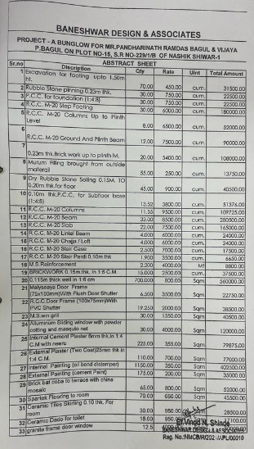
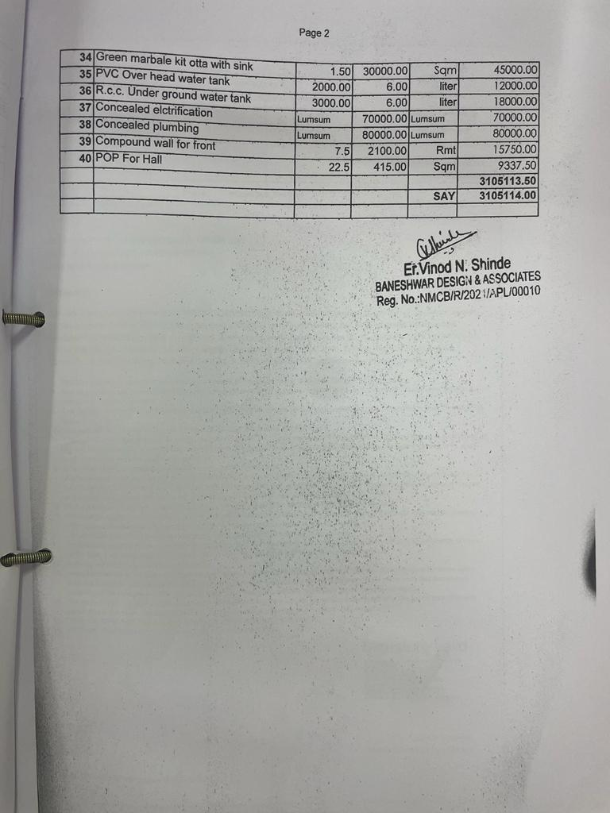

The Estimate amount is Rs.31,00,000/- (Rupees Thirty One Lakh Only )

