Vastu/Nashik/10/004527/2303110
20/5-307-RYVBS
Date: 20.10.2023

To,
The Branch Manager,
State Bank of India
RACPC Nashik Branch
1st Floor, Patel Plaza, N.D. Patel Road,
Opp. BSNL, Landmark Seawoods Navratna Hotel,
Nashik - 422001, State – Maharashtra, Country – India.

Sub: Vetting of Extra Amenities

Sir,

With reference to above subject, we have evaluated the Extra Amenities for Residential Flat No. 201, Second Floor, " Sahayadri Heights ", Survey No. 901, Plot No. 102, Near Shree Swami Samarth Mandir, Lal Bagh Chowk, Chetana Nagar, Rane Nagar, Nagarkar link Road, Village – Nashik, Taluka & District - Nashik, PIN Code – 422 009, State – Maharashtra, Country – India belongs to Name of Proposed Purchaser: Sau. Neelakshi Devendra Mishal & Sau. Jayashri Damodar Rembhotkar. Name of Owner: Bajirao Bhausaheb Thorat & Shri. Yogesh Shivram Matale, Shri. Sachin Shankar Matale.

We have verified the rates quoted as per current market rates. Details of Extra Amenities considered as per copy of Extra Amenities Agreement between Sau. Neelakshi Devendra Mishal & Sau. Jayashri Damodar Rembhotkar (First Party). Shri. Vivekanand Narayan Chaudhary (Second Party) received on dated 18.10.2023. The Extra Amenities amount is Rs. 5,80,000/- (Rupees Five Lakh Eighty Thousand Only)

The said Cost Vetting Certificate is valid upto next 6 months Only.

Thanking you

Sincerely yours

Sharadkumar B. Chalikwar

Govt. Reg. Valuer
Chartered Engineer (India)
Reg. No. (N) CCIT/1-14/52/2008-09
SBI Empanelment No.: SME/TCC/2021-22/85/13
Encl: Valuation report

Agreement for Extra Work
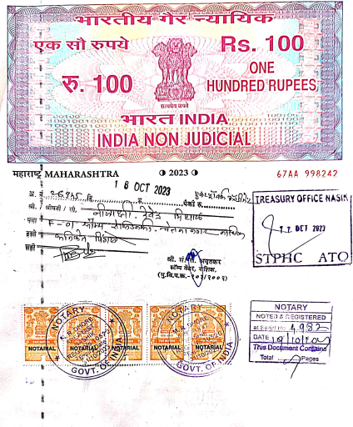
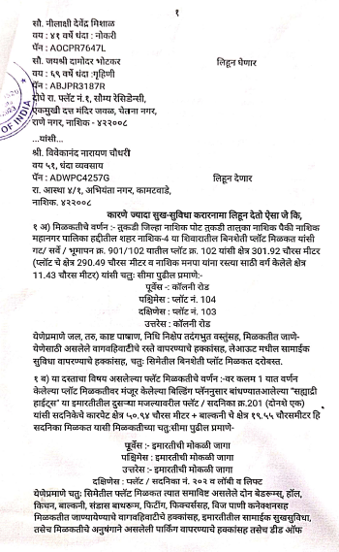

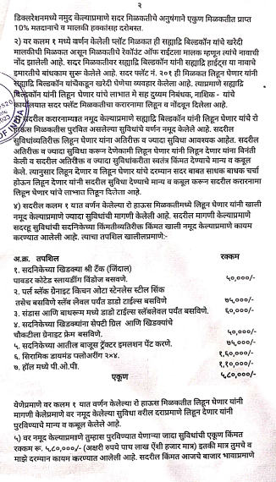
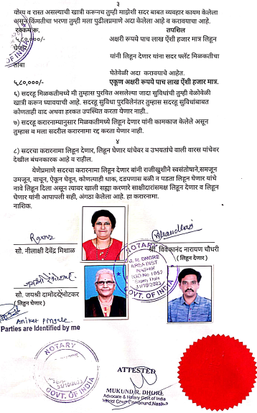

The Extra Amenities amount is Rs. 5,80,000/- (Rupees Five Lakh Eighty Thousand Only)

