Vastu/Nashik/06/32014/2301224
22/20-325-RYV
Date: 19.10.2023

To,
The Branch Manager
Union Bank of India
Nashik Highway Branch
Shop No. 2, 3, 4, Sagar Plaza, Amrut Dham, Panchavati, Nashik – 422 003,
State – Maharashtra, Country – India

Sub: Vetting of Extra Amenities

Sir,

With reference to above subject, we have evaluated the Extra Amenities for Residential Flat No. 304, Third Floor, B - Wing, " Hari Darshan Heights Apartment ", Survey No. 234/ 1/ 1+2A/ 2/ 2, Plot No. 15, Near Cutie - Pie Preschool, Hari Om Kalpesh Nagar, Asha Nagar, Meri - Rasbihari Road, Village – Nashik, Taluka & District - Nashik, PIN Code – 422 003, State – Maharashtra, Country – India. belongs to Name of Owner: Mr. Nayan Vishnu Ahire.

We have verified the rates quoted as per current market rates. Details of Extra Amenities considered as per copy of Extra Amenities Agreement between Mr. Nayan Vishnu Ahire (First Party). Mr. Nikhil Sharad Patil (Second Party) received on dated 17.10.2023. The Extra Amenities amount is Rs. 2,80,000/- (Rupees Two Lakh Eighty Thousand Only)

The said Cost Vetting Certificate is valid upto next 6 months Only.

Thanking you

Sincerely yours

Sharadkumar B. Chalikwar
Govt. Reg. Valuer
Chartered Engineer (India)
Reg. No. (N) CCIT/1-14/52/2008-09

Agreement for Extra Work
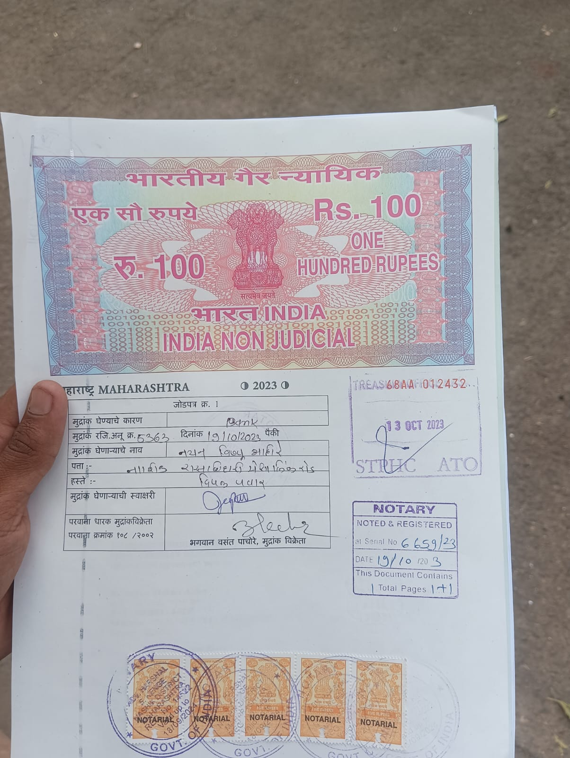
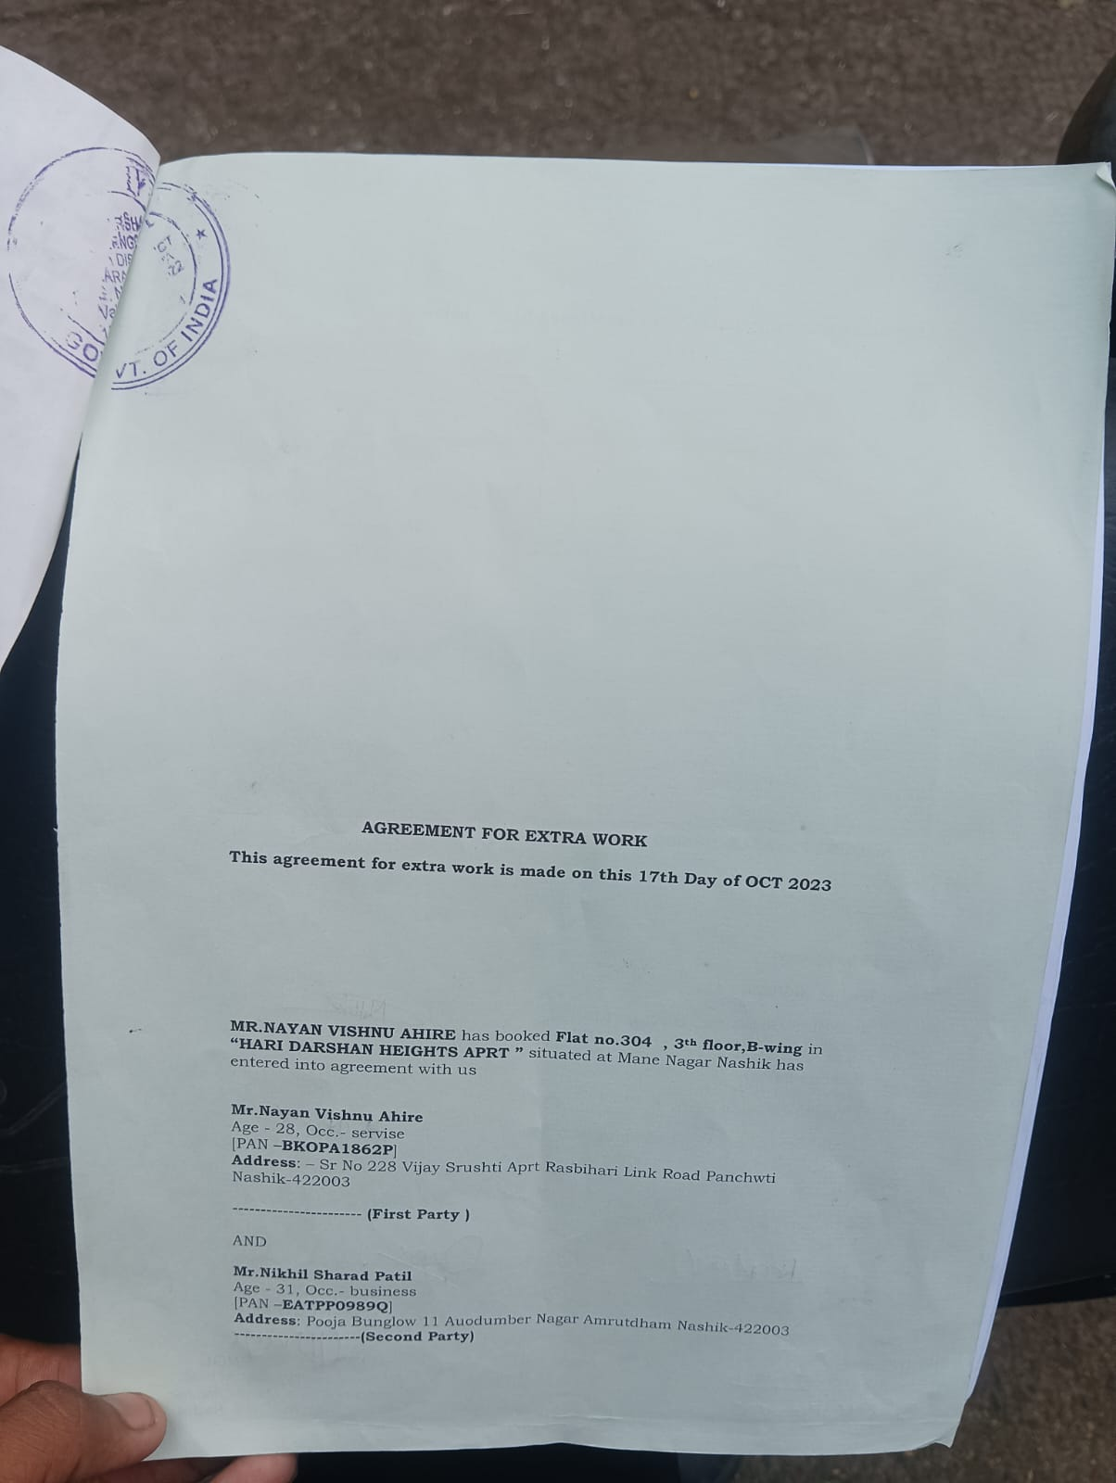

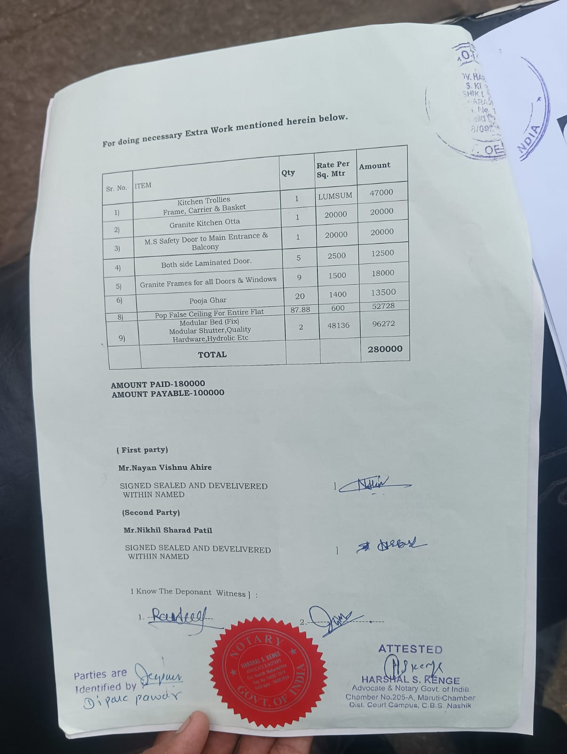

The Extra Amenities amount is Rs. 2,80,000/- (Rupees Two Lakh Eighty Thousand Only)

