Vastu/Nashik/10/4514/2303099
19/21-296-CHV
Date: 19.10.2023

To,
State Bank of India
RACPC Nashik Branch
1st Floor, Patel Plaza, N.D. Patel Road, Opp. BSNL,
Landmark Seawoods Navratna Hotel, Nashik - 422001,
State – Maharashtra, Country – India.

Sub: Vetting of Estimate

Sir,

With reference to above subject, we have evaluated the Estimate for Residential Flat No.1, First Floor, Survey No. 750+751+755/2/2, F.P. No. 541, TP Scheme No. II, Near Mango Garden, Utkarsh Nagar, Parijat Nagar, Mahatma Nagar- Untwadi Road, Village -Nashik, Taluka & District - Nashik, PIN Code - 422 005, State - Maharashtra, Country - India belongs Sau. Suvarna Eknath Tambe alias Suvarna Sunil Wake.

We have verified the rates quoted as per current market rates. Details of Estimate considered as per copy of Estimate Provided by Elite People Er. Bhushan. P. More received on dated 19.10.2023. The Estimate amount is Rs.57,50,000/- (Rupees Fifty Seven Lakh Fifty Thousand Only)

Note:1) The said Cost Vetting Certificate is valid upto next 6 months Only.

Thanking you

Sincerely yours

Manoj B. Chalikwar
Registered Valuer
Chartered Engineer (India)
Reg. No. CAT-I-F-1763
SBI Empanelment No.: SME/TCC/2021-22/86/3

Estimate
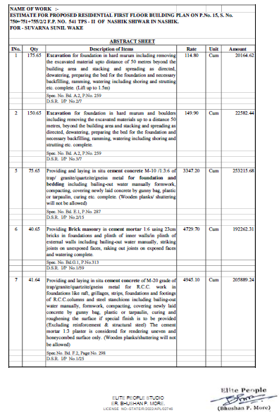
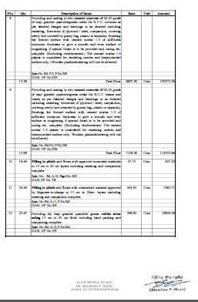

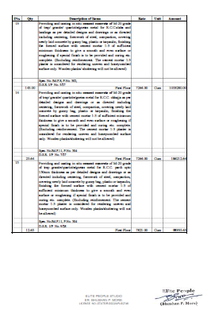
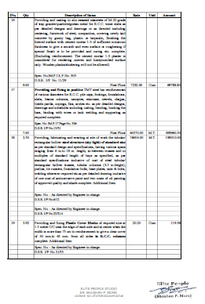

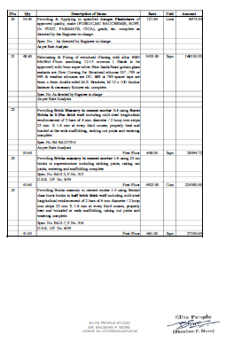
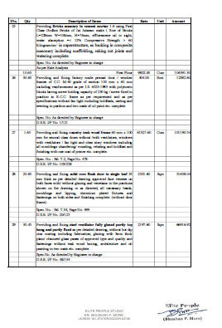

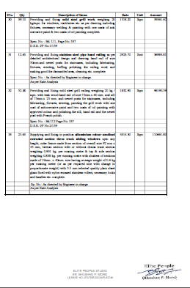
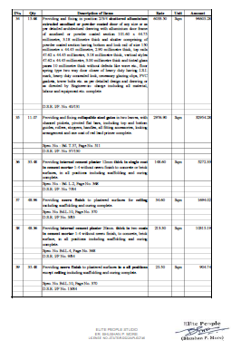

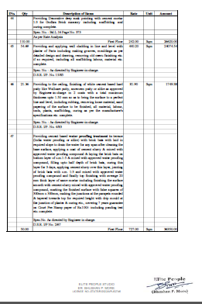
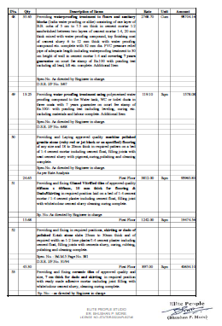
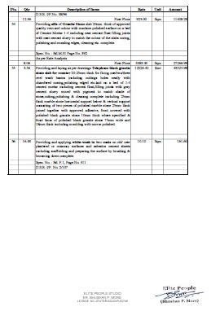
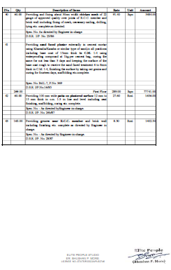

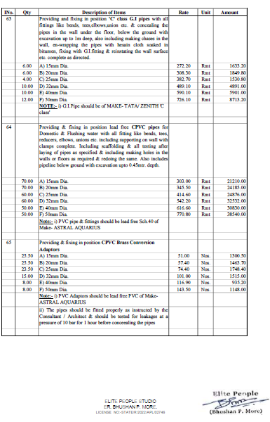
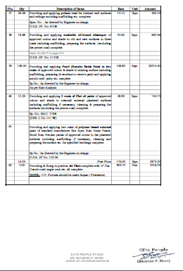

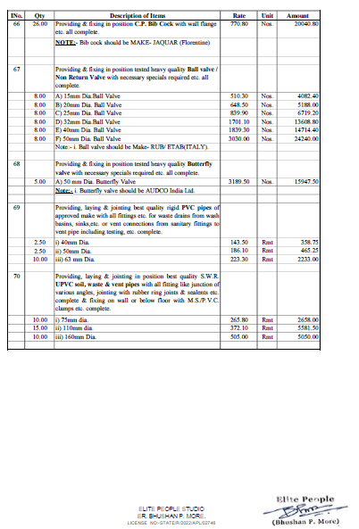
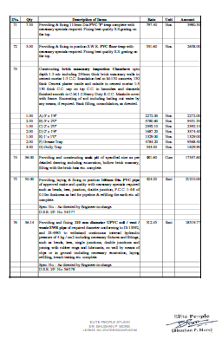

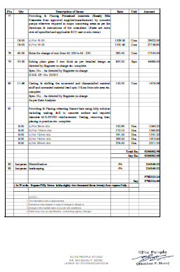

The Estimate amount is Rs.57,50,000/- (Rupees Fifty Seven Lakh Fifty Thousand Only )

