Vastu/Nashik/10/2023/004476/2303070
18/14-267-RPBS
Date: 18.10.2023

To, `
The Branch Manager,
Bank of Baroda
Regional Office Nashik Road Branch
BSNL Building, Datta Mandir Road, Nashik Road,
Nashik -422 101, State - Maharashtra, Country - India.

Sub: Vetting of Extra Amenities

Sir,

With reference to above subject, we have evaluated the Extra Amenities for Residential Flat No.701, Seventh Floor, "Atharva Serenity Apartment",Survey No.31/1P/B/26/3/3A, Plot No.1+2 , Opposite Shree Arpan Apartment, Right Canal Road, Gangapur Road,Village – Anandwalli, Taluka & District - Nashik, PIN Code – 422 013, State – Maharashtra, Country – India belongs to Shri.Atul Gajanan Champanerkar & Sau.Pallavi Atul Champanerkar & M/s.JMD Builder and Developers Name of Proposed Purchaser: Shri.Swapnil Mahesh Dangrikar.

We have verified the rates quoted as per current market rates. Details of work and Extra Amenities considered as per copy of Agreement for Extra Amenities between by Shri.Swapnil Mahesh Dangrikar (First Party) and Shri. Gurugovind Daroga Kumbhar (Second Party) received on dated 12.10.2023. The Extra Amenities amount is Rs.12,00,000/- (Rupees Twelve Lakh Only)

The said Cost Vetting Certificate is valid upto next 6 months Only.

Thanking you

Sincerely yours

Sharadkumar B. Chalikwar
Govt. Reg. Valuer
Chartered Engineer (India)
Reg. No. (N) CCIT/1-14/52/2008-09
Encl: Vetting Report.

Agreement for Extra Amenities
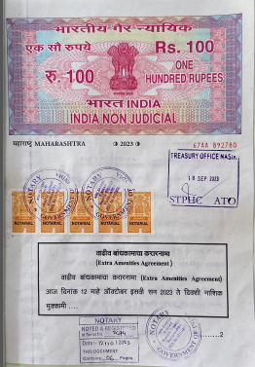
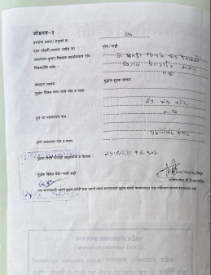

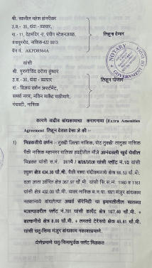
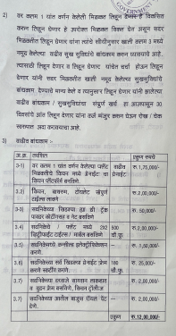

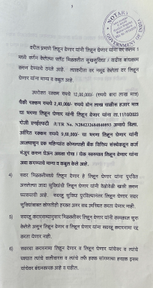
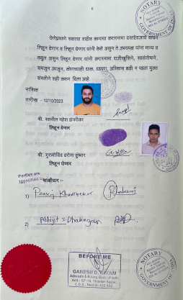

The Extra Amenities amount Rs.12,00,000/- (Rupees Twelve Lakh Only)

