Vastu/Nashik/09/2023/4031/2302722
26/8-366-CHSHBS
Date: 18.10.2023

To,
The Branch Manager,
Bank of Baroda
Regional Office
BSNL Building, Datta Mandir Road, Nashik Road,
Nashik, PIN – 422 101, State - Maharashtra, Country - India.

Sub: Vetting of Extra Amenities

Sir,

With reference to above subject, we have evaluated the Extra Amenities for Residential Flat No. 201, Second Floor, "Marhaba Residency", Survey No.812/2/1/1 Plot No.1, Beside Nashik Vapi Transport, Pakhal Road, Village – Nashik, Taluka & District - Nashik, PIN Code – 422 011, State – Maharashtra, Country – India belongs to Mrs. Farhanaz Sarfaraz Shaikh & Mr. Sarfaraj Yusuf Shaikh.

We have verified the rates quoted as per current market rates. Details of work and Extra Amenities considered as per copy of Agreement for Extra Amenities issued by Mrs. Farhanaz Sarfaraz Shaikh & Mr. Sarfaraj Yusuf Shaikh (First Part) and M/s. S. S. Traders Prop. (Second Part) received on dated 12.10.2023. The Extra Amenities amount is Rs.8,24,000/- ( Rupees Three Lakh Twenty Four Thousand Only. )

Note: 1) The said Cost Vetting Certificate is valid upto next 6 months Only.

Thanking you

Sincerely yours

Manoj B. Chalikwar
Registered Valuer
Chartered Engineer (India)
Reg. No. CAT-I-F-1763
Reg. No. IBBI/RV/07/2018/10366
BOB Empanelment No.: ZO:MZ:ADV:46:941
Encl: Vetting Report
.

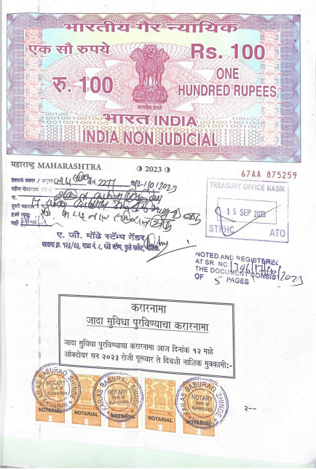
Agreement for Extra Amenities
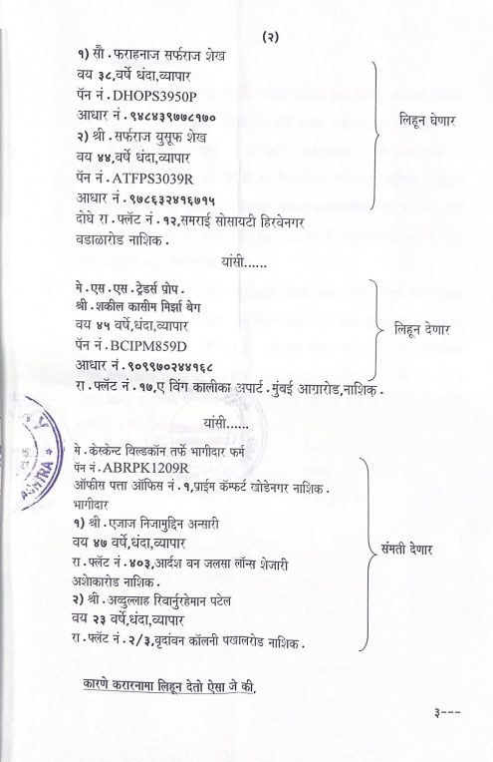

Agreement for Extra Amenities

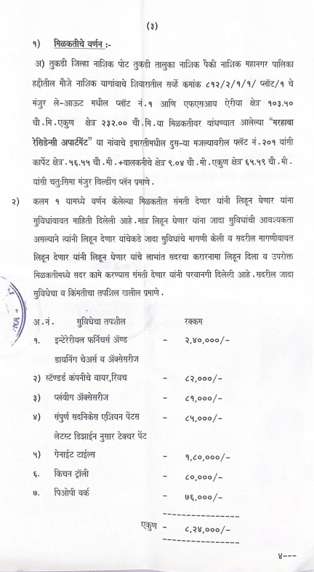
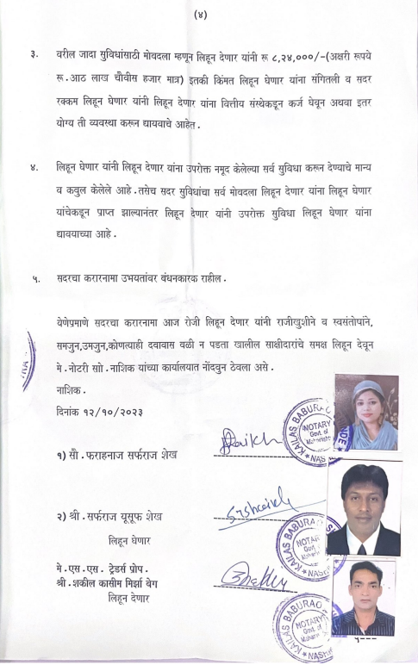

Agreement for Extra Amenities
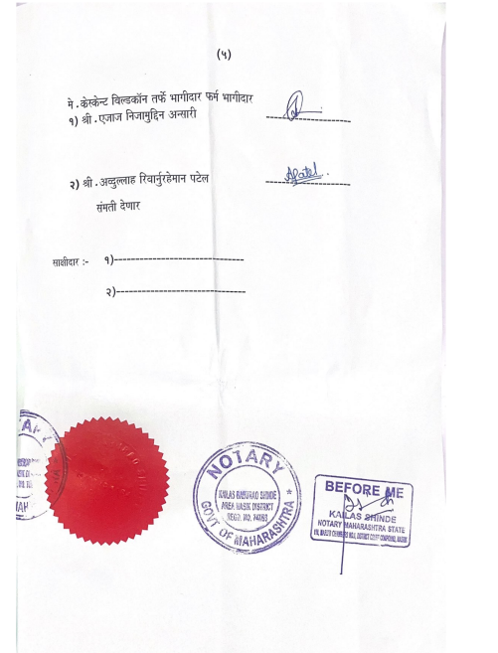

The Extra Work Cost Sheet amount is Rs.8,24,000/- ( Rupees Three Lakh Twenty Four Thousand Only. )

