Vastu/Nashik/03/2023833/30490/46262
22/24-455-RPV
Date: 17.10.2023

To, `
The Branch Manager,
Bank of Baroda
Regional Office Nashik Road Branch
BSNL Building, Datta Mandir Road, Nashik Road,
Nashik -422 101, State - Maharashtra, Country - India.

Sub: Vetting of Extra Amenities

Sir,

With reference to above subject, we have evaluated the Extra Amenities for Residential Flat No. 102, First Floor, "Green Residency", Survey No. 501/2 to 15/1/1/B+501/2 to 15/1/1/29, Final Plot No. 25, Plot No. 3, TP Scheme No. II, Behind Leva Samaj Kalyan Mandal, Fatema Manzil Hirve Nagar, Wadala Pathardi Road, Village – Nashik, Taluka & District - Nashik, PIN Code – 422 011, State – Maharashtra, Country – India belongs to M/s. Green Life Developers. Name of Proposed Purchaser: Mr. Parvez Zahoor Ahmed Shaikh & Mrs. Farhat Parvez Shaikh.

We have verified the rates quoted as per current market rates. Details of work and Extra Amenities considered as per copy of Agreement for Extra Amenities issued by Mr. Parvez Zahoor Ahmed Shaikh & Mrs. Farhat Parvez Shaikh (First Party) and Shri. Kanhaiya Baijyanath Shaha (Second Party) received on dated 17.10.2023. The Extra Amenities amount is Rs.9,00,000/- ( Rupees Nine Lakh Only. )

The said Cost Vetting Certificate is valid upto next 6 months Only.

Thanking you

Sincerely yours

Sharadkumar B. Chalikwar
Govt. Reg. Valuer
Chartered Engineer (India)
Reg. No. (N) CCIT/1-14/52/2008-09
Encl: Vetting Report.

Agreement for Extra Amenities
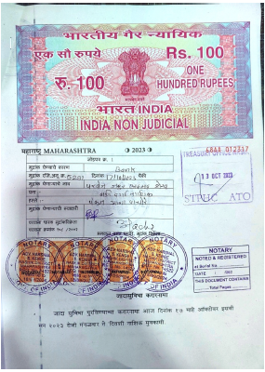
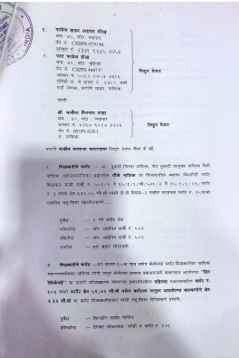

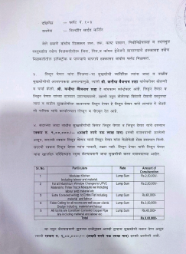
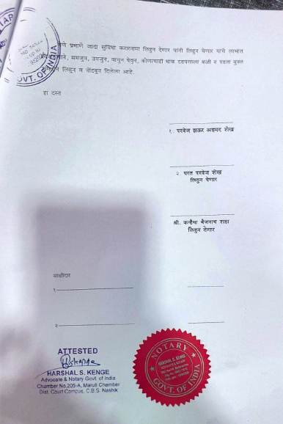

The Extra Amenities amount is Rs.9,00,000/- ( Rupees Nine Lakh Only. )

