Valuation Report of the Immovable Property
(For Capital Gain Purpose)
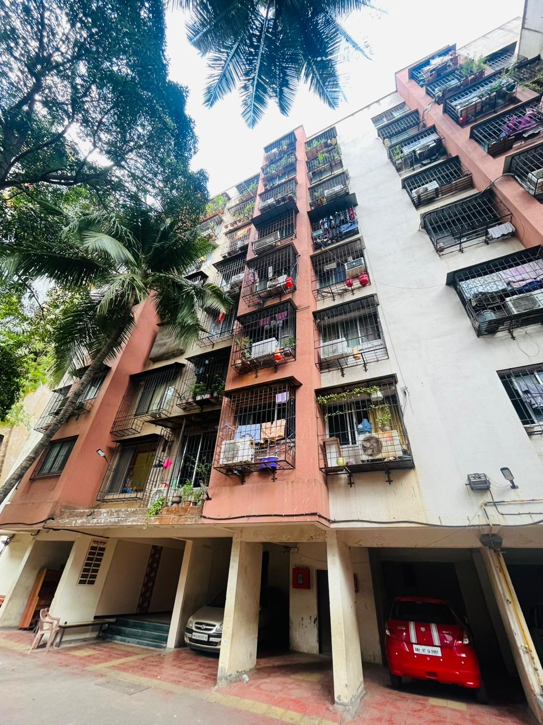

Details of the property under consideration:

Name of Owner: Mr. Fardun Hormasjee Powvalla

Residential Flat No. 16, 1st Floor, Wing – B, “Malad Sangata Co-Op. Hsg. Soc. Ltd.”,
Opp. Madhur Society, Chincholi Bunder Road, Malad (West), Mumbai – 400 064,
State – Maharashtra, Country - India

Latitude Longitude: 19°10'46.6"N 72°50'21.8"E

Table of Contents
1. VALUATION OPINION REPORT 3
2. Part-1 Form 0-1 5
2.1. GENERAL: 5
2.2. LAND 6
2.3. IMPROVEMENTS 6
2.4. RENTS 7
2.5. SALES 8
2.6. COST OF CONSTRUCTION 8
3. PART II- VALUATION 8
3.1. General: 8
3.2. Location: 8
3.3. History: 9
3.4. Flat: 9
3.5. Valuation as on 01st April 2001 to 28.12.2010 of the Residential Flat: 9
3.6. Valuation as on 28th December 2010 of the Residential Flat: 10
3.6.1. Indexed Cost of Acquisition 10
3.7. NOTES 11
4. ANNEXURE TO FORM 0-1 11
5. PART III- DECLARATION 12
5.1. DECLARATION OF PROFESSIONAL FEES CHARGED 12
5.2. DEFINITION OF VALUE FOR THIS SPECIFIC PURPOSE 13
5.3. UNDER LYING ASSUMPTIONS 13
6. Actual site photographs 14
7. Route Map of the property 15
8. Ready Reckoner Rate for Year 2001 16
8.1. Rate for Property 16
8.2. Construction Rate 16
9. Ready Reckoner Rate for Year 2010 17
9.1. Rate for Property 17
9.2. Construction Rate 17
10. VALUATION OF THE PROPERTY PREMISES 18

Vastu/Mumbai/05/2023/29298/2300808
26/18-419-VSU
Date: 16.10.2023

VALUATION OPINION REPORT

This is to certify that the property bearing Residential Flat No. 16, 1st Floor, Wing – B, “Malad Sangata Co-Op. Hsg. Soc. Ltd.”, Opp. Madhur Society, Chincholi Bunder Road, Malad (West), Mumbai – 400 064, State – Maharashtra, Country - India was belonged to Mr. Fardun Hormasjee Powvalla. The building was gone for redevelopment in the year 2006. New flat allotted to Mr. Fardun Hormasjee Powvalla as per Agreement 28.12.2010. He sold his new flat to Mr. Manoj R. Bhosle & Mrs. Riddhi Manoj Bhosle as per Agreement for Sale dated 22.05.2023.

Boundaries of the property.

North | : | Dheeraj Jamuna CHSL
South | : | Chincholi Bunder Road
East | : | Dheeraj Ganga CHSL
West | : | Mashayakh Tower

- The purpose of this report is to ascertain the Indexed Cost of Acquisition ( F. Y. 2023 - 24) of the property as detailed above.
- The property premises can be assessed and valued for calculation of Capital Gain Tax purpose as on 28.12.2010 at ` 24,54,723.00 (Rupees Twenty Four Lakh Fifty Four Thousand Seven Hundred Twenty Three Only).
- The Indexed Cost of Acquisition of Property under consideration as on 2023 – 24 is ` 57,71,916.00 (Rupees Fifty Seven Lakh Seventy One Thousand Nine Hundred Sixteen Only) without any major Renovation & improvement after 2010.
- The following documents were perused :
- Copy of Agreement for Redevelopment dated 21.12.2006 between Malad Sangata Co-Op. Hsg. Soc. Ltd. (Society) and M/s. Navshakti Developers (Developers).
- Copy of Agreement 28.12.2010 between M/s. Navshakti Developers (Developers) and Mr. Fardun Hormasjee Powvalla (Member).
- Copy of Agreement for Sale dated 22.05.2023 between Mr. Fardun Hormasjee Powvalla (Transferor) & Mr. Manoj R. Bhosle & Mrs. Riddhi Manoj Bhosle (Transferee).
- Copy of Share Certificate vide No. 55 transferred on 17.08.2005 in the name Mr. Fardun Hormasjee Powvalla.

This assignment is undertaken based on the request from our client Mr. Fardun Hormasjee Powvalla.

The valuation of the property is based on the documents produced by the concern. Legal aspects have not been taken into considerations while preparing this valuation report.

Hence certified.

For Vastukala Architects & Engineers

Sharadkumar B. Chalikwar
Govt. Reg. Valuer
Chartered Engineer (India)
Reg. No. (N) CCIT/1-14/52/2008-09
Valuation Report of Residential Flat No. 16, 1st Floor, Wing – B, “Malad Sangata Co-Op. Hsg. Soc. Ltd.”,
Opp. Madhur Society, Chincholi Bunder Road, Malad (West), Mumbai – 400 064,
State – Maharashtra, Country - India

Part-1 Form 0-1

(See Rule 8 D)
REPORT OF VALUATION OF IMMOVABLE PROPERTY (OTHER THAN AGRICULTURAL LANDS, PLANTATIONS, FORESTS, MINES AND QUARRIES)

GENERAL:

1 | Purpose for which the valuation is made | To assess the Fair Market Value as on 28.12.2010 for computation of Capital Gains Tax.
2 | Date of Report | 16.10.2023
3 | Name of the Owner | Mr. Fardun Hormasjee Powvalla. The building was gone for redevelopment in the year 2006. New flat allotted to Mr. Fardun Hormasjee Powvalla as per Agreement 28.12.2010. He sold his new flat to Mr. Manoj R. Bhosle & Mrs. Riddhi Manoj Bhosle as per Agreement for Sale dated 22.05.2023
4 | If the property is under joint ownership, Ownership / co-ownership, share of each such owner. Are the shares undivided? | Sole Ownership
5 | Brief description of the property | Residential Flat No. 16, 1st Floor, Wing – B, “Malad Sangata Co-Op. Hsg. Soc. Ltd.”, Opp. Madhur Society, Chincholi Bunder Road, Malad (West), Mumbai – 400 064, State – Maharashtra, Country - India
6 | Location, street, ward no | Chincholi Bunder Road,
7 | Survey/ Plot no. of land | CTS No. 972 – D, Village Malad (South), Taluka Borivali
8 | Is the property situated in Residential / commercial/ mixed area/ industrial area? | Residential
9 | Classification of locality-high class/ middle class/poor class | Middle Class
10 | Proximity to civic amenities like schools, Hospitals, Offices, market, cinemas etc. | All the amenities are available in the vicinity.
11 | Means and proximity to surface communication by which the locality is served | Served by BEST Buses, Auto, Taxies, Private Vehicles

LAND

12 | Area of land supported by documentary proof. Shape, dimension and physical features | For 2001 – 2010  Old Carpet Area = 400.00 Sq. Ft.  (Area as per Agreement)  Built up area = 480.00 Sq. Ft.  (Carpet Area + 20%)  For 2010 – 2023  New Carpet Area = 485.00 Sq. Ft.  (Area as per Agreement)  Built up area = 582.00 Sq. Ft.  (Carpet Area + 20%)
13 | Roads, Streets or lanes on which the land is abutting | Chincholi Bunder Road
14 | If freehold or leasehold land | Freehold
15 | If leasehold, the name of Lessor/lessee, nature of lease, date of commencement and termination of lease and terms of renewal of lease.  (i) Initial premium  (ii) Ground rent payable per annum  (iii) Unearned increase payable to the Lessor in the event of sale or transfer | Not applicable
16 | Is there any restriction covenant in regard to use of land? If so attach a copy of the covenant. | As per documents
17 | Are there any agreements of easements? If so attach a copy of the covenant | Information not available
18 | Does the land fall in an area included in any Town Planning Scheme or any Development Plan of Government or any statutory body? If so give Particulars. | Municipal Corporation of Greater Mumbai
19 | Has any contribution been made towards development or is any demand for such contribution still outstanding. | Information not available
20 | Has the whole or part of the land been notified for acquisition by government or any statutory body? Give date of the notification. | No
21 | Attach a dimensioned site plan | Attached

IMPROVEMENTS

22 | Attach plans and elevations of all structures standing on the land and a lay-out plan. | N.A.
23 | Furnish technical details of the building on a separate sheet (The Annexure to this form may be used) | Attached
24 | Is the building owner occupied/ tenanted/ both? | Owner occupied
 | If the property owner occupied, specify portion and extent of area under owner-occupation | N.A.
25 | What is the Floor Space Index permissible and Percentage actually utilized? | - Floor Space Index Permissible – As per Development Control of Regulation of Municipal Corporation of Greater Mumbai  - FSI percentage actually utilized - Information not available

RENTS

26 | (i) | Names of tenants/ lessees/ licensees, etc | Not applicable
 | (ii) | Portions in their occupation | Not applicable
 | (iii) | Monthly or annual rent /compensation/license fee, etc. paid by each | Not applicable
 | (iv) | Gross amount received for the whole property | Not applicable
27 | Are any of the occupants related to, or close to business associates of the owner? |  | Not applicable
28 | Is separate amount being recovered for the use of fixtures, like fans, geysers, refrigerators, cooking ranges, built-in wardrobes, etc. or for services charges? If so, give details |  | Not applicable
29 | Give details of the water and electricity charges, If any, to be borne by the owner |  | Information not available
30 | Has the tenant to bear the whole or part of the cost repairs and maintenance? Give particulars |  | Not applicable
31 | If a lift is installed, who is to bear the cost of maintenance and operation- owner or tenant? |  | Not applicable
32 | If a pump is installed, who is to bear the cost of maintenance and operation- owner or tenant? |  | Information not available
33 | Who has to bear the cost of electricity charges for lighting of common space like entrance hall, stairs, passage, compound, etc. owner or tenant? |  | Information not available
34 | What is the amount of property tax? Who is to bear it? Give details with documentary proof |  | Information not available
35 | Is the building insured? If so, give the policy no., amount for which it is insured and the annual premium |  | Information not available
36 | Is any dispute between landlord and tenant regarding rent pending in a court of rent? |  | Not applicable
37 | Has any standard rent been fixed for the premises under any law relating to the control of rent? |  | Not applicable

SALES

38 | Give instances of sales of immovable property in the locality on a separate sheet, indicating the Name and address of the property, registration No., sale price and area of land sold. | As per sub registrar assurance records
39 | Land rate adopted in this valuation | N. A. as the property is valued by composite rate method
40 | If sale instances are not available or not relied up on, the basis of arriving at the land rate | Copy of Stamp Duty Ready Reckoner for the year 2001 & 2010 attached

COST OF CONSTRUCTION

41 | Year of commencement of construction and year of completion | Year of Completion – 1976 (As per Development Agreement) and redeveloped in the year 2010 (As per Possession Letter)
42 | What was the method of construction, by contract/By employing Labour directly/ both? | Information not available
43 | For items of work done on contract, produce copies of agreements | Not applicable
44 | For items of work done by engaging Labour directly, give basic rates of materials and Labour supported by documentary proof. | Not applicable

PART II- VALUATION

General:

Under the instructions of Mr. Fardun Hormasjee Powvalla., we have valued the Residential Flat No. 16, 1st Floor, Wing – B, “Malad Sangata Co-Op. Hsg. Soc. Ltd.”, Opp. Madhur Society, Chincholi Bunder Road, Malad (West), Mumbai – 400 064, State – Maharashtra, Country - India to ascertain the market value of said property, as on 01.04.2001 for computation of Capital Gains Tax.

We are in receipt of the following documents:

- Copy of Agreement for Redevelopment dated 21.12.2006 between Malad Sangata Co-Op. Hsg. Soc. Ltd. (Society) and M/s. Navshakti Developers (Developers).
- Copy of Agreement 28.12.2010 between M/s. Navshakti Developers (Developers) and Mr. Fardun Hormasjee Powvalla (Member).
- Copy of Agreement for Sale dated 22.05.2023 between Mr. Fardun Hormasjee Powvalla (Transferor) & Mr. Manoj R. Bhosle & Mrs. Riddhi Manoj Bhosle (Transferee).
- Copy of Share Certificate vide No. 55 transferred on 17.08.2005 in the name Mr. Fardun Hormasjee Powvalla.

Location:
The said building is located at CTS No. 972 – D, Village Malad (South), Taluka Borivali in Municipal Corporation of Greater Mumbai. The property falls in Residential Zone. It is at 2 KM. travel distance from Malad railway station.

History:

Client was owner of Residential Flat No. 16, 1st Floor, Wing – B in Malad Sangata Co-Op. Hsg. Soc. Ltd. The residential building was of Ground + 3 upper floors which was used for Residential purpose. It was without lift. Area of Old Flat was 400.00 Sq. Ft. Carpet (Built up area with 20% loading – 480.00 Sq. Ft.)

The said building gone for redevelopment in the year 2006. New building is of Stilt + 7 upper floors with one lift. New flat bearing Flat No. 16 on 1st Floor, Wing – B in Malad Sangata Co-Op. Hsg. Soc. Ltd. allotted to Mr. Fardun Hormasjee Powvalla as per Agreement 28.12.2010. Area of new flat is 485.00 Sq. Ft. Carpet (Built up area with 20% loading - 582.00 Sq. Ft.).

He sold new flat to Mr. Manoj R. Bhosle & Mrs. Riddhi Manoj Bhosle as per Agreement for Sale dated 22.05.2023.

Flat:

The flat under in the new redeveloped building is situated on the 1st Floor. The composition of property is Living Room + 2 Bedrooms + Kitchen + 1 WC + 1 Bath. It is finished with Vitrified flooring, Teak wood door frames with solid flush doors with Aluminum Sliding windows, Concealed plumbing & Concealed electrification is provided.

Valuation as on 01st April 2001 to 28.12.2010 of the Residential Flat:

The Built up area of the Property in Sq. Ft. | : | 480.00
The Built up area of the Property in Sq. M. | : | 44.59
Depreciation Calculation:
Year of Construction of the building | : | 1976 (As per Development Agreement)
Expected total life of building | : | 60 years
Age of the building as on 01.04.2001 | : | 25 years
Cost of Construction | : | 44.59 x ` 5,500.00  = ` 2,45,245.00
Depreciation | : | 37.50%
Amount of depreciation | : | ` 91,967.00
Rate as on 01-04-2001 for Residential Property Premises (As per Ready Reckoner 2001) | : | ` 22,200.00 per Sq. M.
Rate considered for valuation Value of Property as on 2001. | : | 44.59 Sq. M. x ` 22,200.00  = ` 9,89,898.00
Depreciated Fair Value of the property as on 01-04-2001 | : | ` 9,89,898.00 (-) ` 91,967.00  = ` 8,97,931.00
Add for Stamp Duty charges ( B ) | : | ` 32,630.00
Add for Registration charges ( C ) | : | ` 8,979.00
Total Cost of Acquisition (A + B + C) | : | ` 9,39,540.00

As Old flat underwent redevelopment in the year 2006 & Possession for the New flat was given in the year 2010 hence for the purpose of capital gain we have considered area of new flat & year of construction as 2010 only.

Valuation as on 28th December 2010 of the Residential Flat:

The Built up area of the Property in Sq. Ft. | : | 582.00
The Built up area of the Property in Sq. M. | : | 54.07
Depreciation Calculation:
Year of Construction of the building | : | 2010 (As per Possession Receipt)
Expected total life of building | : | 60 years
Age of the building as on 28.12.2010 | : | New Construction
Cost of Construction | : | 54.07 Sq. M x ` 11,000.00 = ` 5,94,770.00
Depreciation | : | Nil
Amount of depreciation | : | Nil
Rate as on 28-12-2010 for Residential Property Premises  (As per Ready Reckoner 2010) | : | ` 42,400.00 per Sq. M.
Rate considered for valuation Value of Property as on 2010 (A) | : | 54.07 Sq. M. x ` 42,400.00  = ` 22,92,568.00
Add for Stamp Duty charges ( B ) | : | ` 1,42,155.00
Add for Registration charges ( C ) | : | ` 20,000.00
Total Cost of Acquisition (A + B + C) | : | ` 24,54,723.00

Indexed Cost of Acquisition
- Cost Inflation Index for 28.12.2010 : 148
(Considering the transaction shall be made
after 01.04.2017)
- Cost Inflation Index for 2023 - 24 : 348
- Indexed Cost of Acquisition : ` 57,71,916.00
(` 24,54,723.00 x 348 / 148)

Taking into consideration above said facts, we can evaluate the value of Residential Flat No. 16, 1st Floor, Wing – B, “Malad Sangata Co-Op. Hsg. Soc. Ltd.”, Opp. Madhur Society, Chincholi Bunder Road, Malad (West), Mumbai – 400 064, State – Maharashtra, Country - India for this particular purpose at ` 24,54,723.00 (Rupees Twenty Four Lakh Fifty Four Thousand Seven Hundred Twenty Three Only) as on 28.12.2010.

NOTES

- I, Sharadkumar B. Chalikwar with my experience and ability to judgment I am of the considered opinion that the fair market value of the property as on 28.12.2010 is ` 24,54,723.00 (Rupees Twenty Four Lakh Fifty Four Thousand Seven Hundred Twenty Three Only). Value varies with time and purpose and hence this value should not be referred for any purpose other than mentioned in this report.

- This valuation is done on the basis of information, which the valuer has obtained by information provided by the client about the premises and location of the surrounding area and also prevailing rates in the surrounding area, and further subject to document as mentioned in valuation report.
- This valuer should not be held responsible for authentication of documents, clear title and other such related matters. For that purpose Latest Legal Opinion should be sought.

ANNEXURE TO FORM 0-1

1. | No. of floors and height of each floor | Stilt + 7 upper floors
2. | Plinth area floor wise as per IS 3361-1966 | Information not available
3 | Year of construction | Year of Completion – 1976 (As per Development Agreement) and redeveloped in the year 2010 (As per Possession Letter)
4 | Estimated future life as on year 2001 | 60 years
5 | Type of construction- load bearing walls/RCC frame/ steel frame | R.C.C. Framed structure
6 | Type of foundations | R.C.C
7 | Walls | All external walls are 9” thick and partition walls are 6” thick.
8 | Partitions | 6” thick brick wall
9 | Doors and Windows | Teak wood door frames with solid flush doors with Aluminium Sliding windows
10 | Flooring | Vitrified tiles flooring
11 | Finishing | Internal walls are finished with POP + Cement Plaster. External walls are finished with sand faced plaster
12 | Roofing and terracing | RCC slab
13 | Special architectural or decorative features, if any | POP false ceiling
14 |  | Concealed  Ordinary
  (i) | Internal wiring – surface or conduit
  (ii) | Class of fittings: Superior / Ordinary / Poor.
15 | Sanitary installations  Class of fittings: Superior colored / superior white/ordinary. | As per requirement  Ordinary
  (i) | No. of water closets
  (ii) | No. of lavatory basins
  (iii) | No. of urinals
  (iv) | No. of sinks
16 | Compound wall  Height and length  Type of construction | 5’ to 6’ brick masonry compound wall
17 | No. of lifts and capacity | 1 lift
18 | Underground sump – capacity and type of construction | R.C.C. Tank
19 | Over-head tank  Location, capacity  Type of construction | Overhead Water Tank
20 | Pumps- no. and their horse power | Available as per requirement
21 | Roads and paving within the compound approximate area and type of paving | Cemented road in open spaces, Open parking Space etc.
22 | Sewage disposal – whereas connected to public sewers, if septic tanks provided, no. and capacity | Connected to Municipal Sewers

PART III- DECLARATION
I hereby declare that
    - The information furnished in part I is true and correct to the best of my knowledge and belief;
    - I have no direct or indirect interest in the property valued:

DECLARATION OF PROFESSIONAL FEES CHARGED

We hereby declare that, our professional fees are not contingent upon the valuation findings. However, if the statute AND/OR clients demands that, the fees should be charged on the percentage of assessed value then, with the full knowledge of the AND/OR end user, it is being charged accordingly.

DEFINITION OF VALUE FOR THIS SPECIFIC PURPOSE

This exercise is to assess Fair Market Value of the property under reference as on 01.04.2001 for calculation of Capital Gains Tax.

The term Fair Market Value is defined as

“The most probable price, as of a specified date, in cash, terms equivalent to cash, or in other precisely revealed terms for which the specified property rights would sell after reasonable exposure in a competitive market under all conditions requisite to a fair sale, with the buyer and seller each acting prudently knowledgeably and for self-interest assuming that neither is under undue duress”.
Fundamental assumptions and conditions presumed in this definition are:

1. Buyer and seller are motivated by self-interest.

2. Buyer and seller are well informed and are acting prudently.

3. The property is exposed for a reasonable time on the open market.

- Payment is made in cash or equivalent or in specified financing terms.

UNDER LYING ASSUMPTIONS
1. We assume no responsibility for matters of legal nature affecting the property appraised or the title thereto, nor do we render our opinion as to the title, which is assumed to be good and marketable.
2. The property is valued as though under responsible ownership.
3. It is assumed that the property is free of liens and encumbrances.
4. It is assumed that there are no hidden or unapparent conditions of the subsoil or structure that would render it more or less valuable. No responsibility is assumed for such conditions or for engineering that might be required to discover such factors.

Actual site photographs
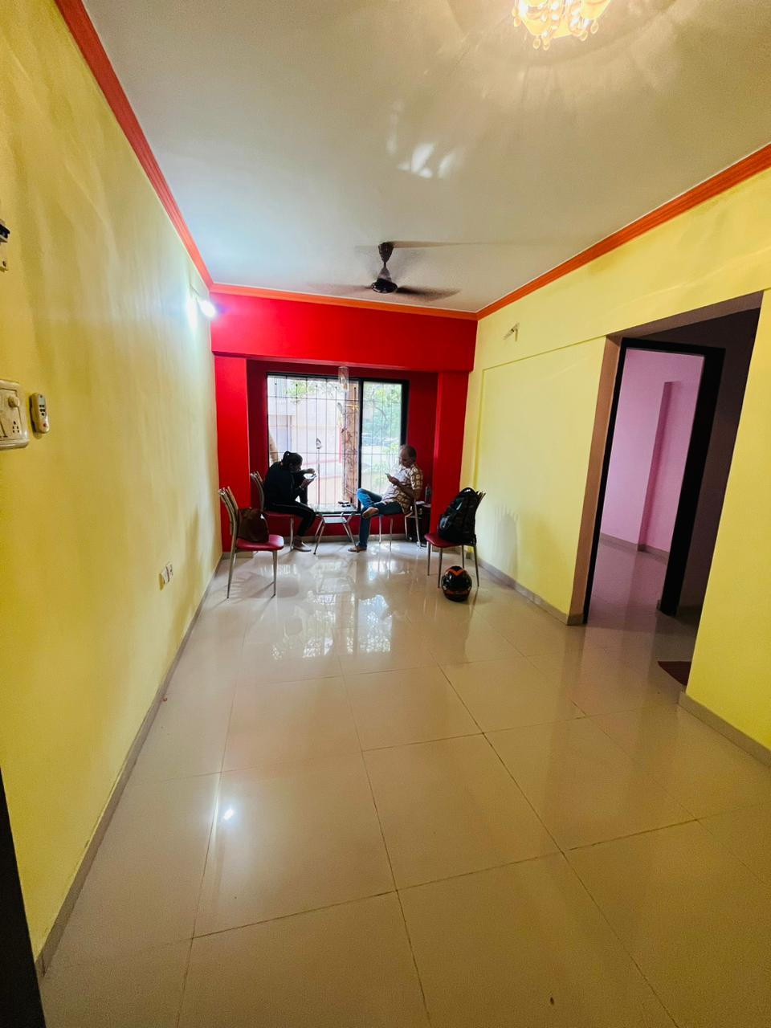
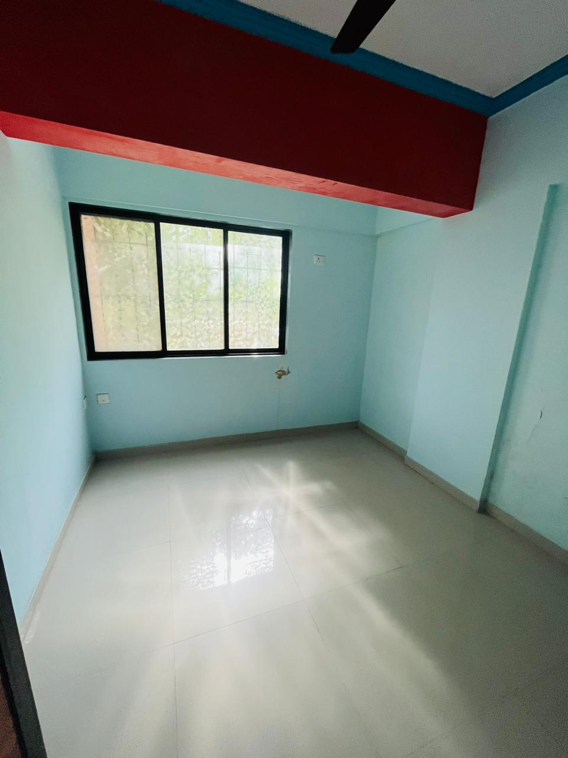
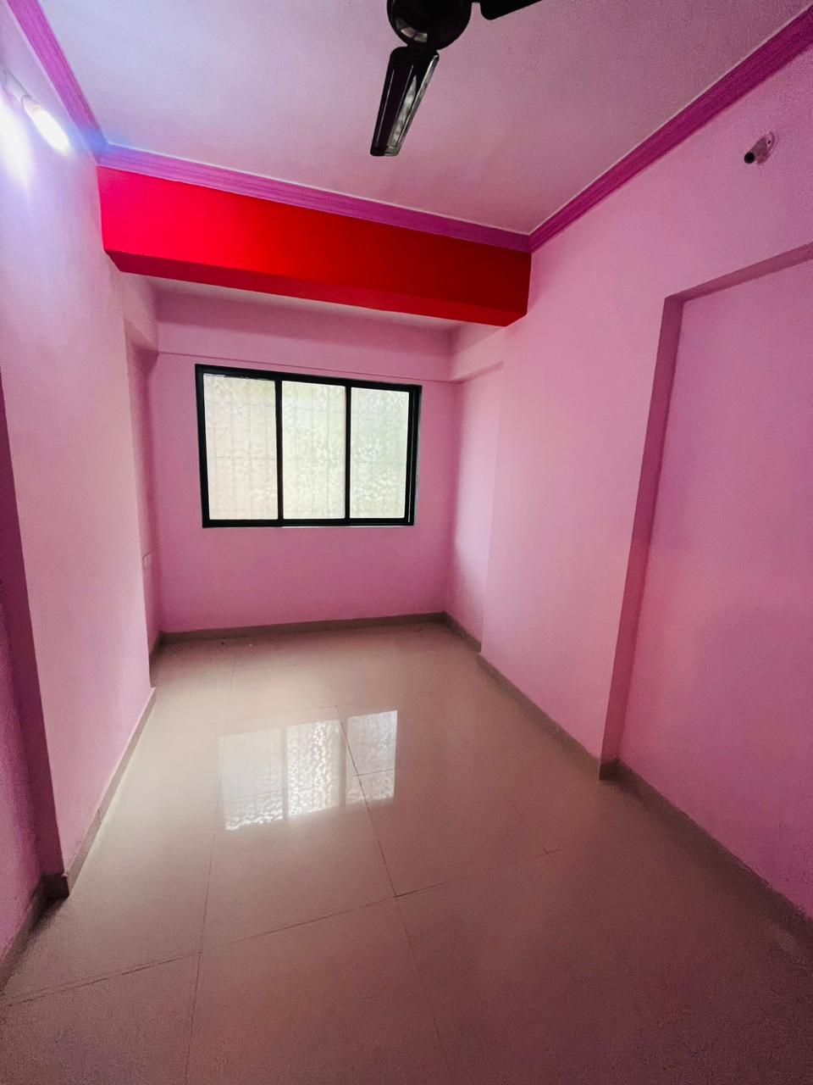

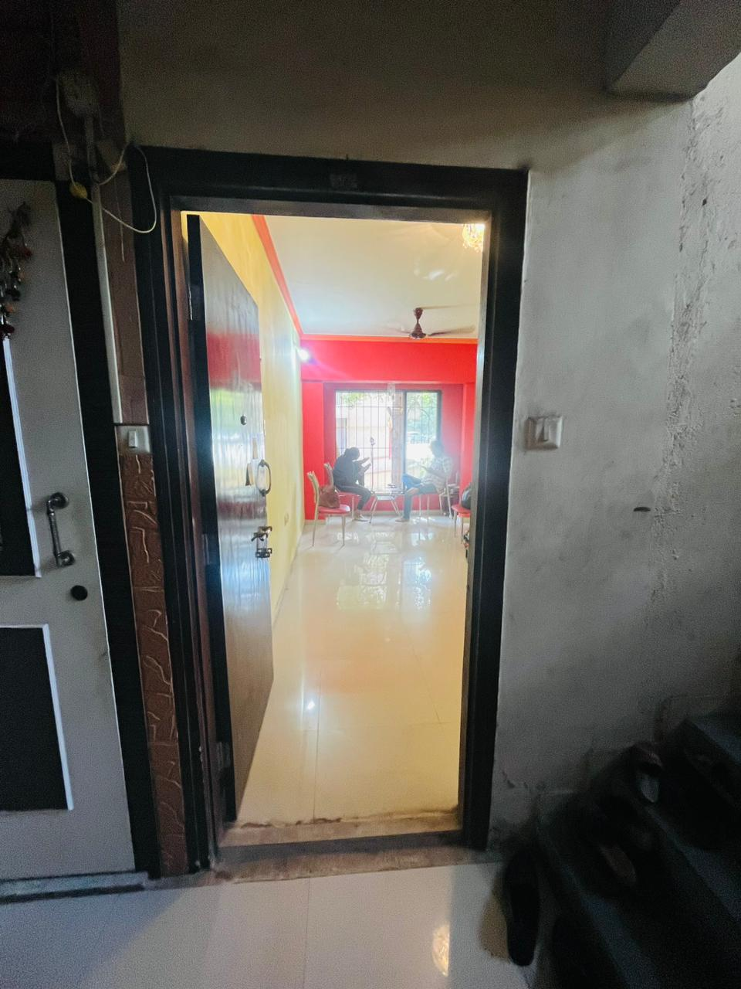
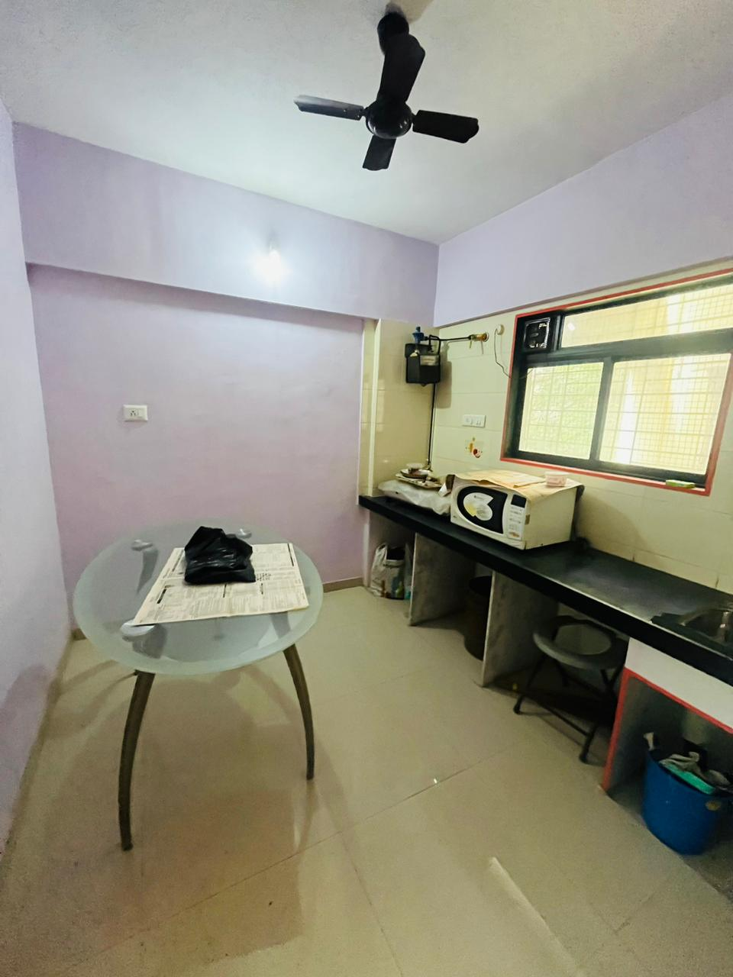

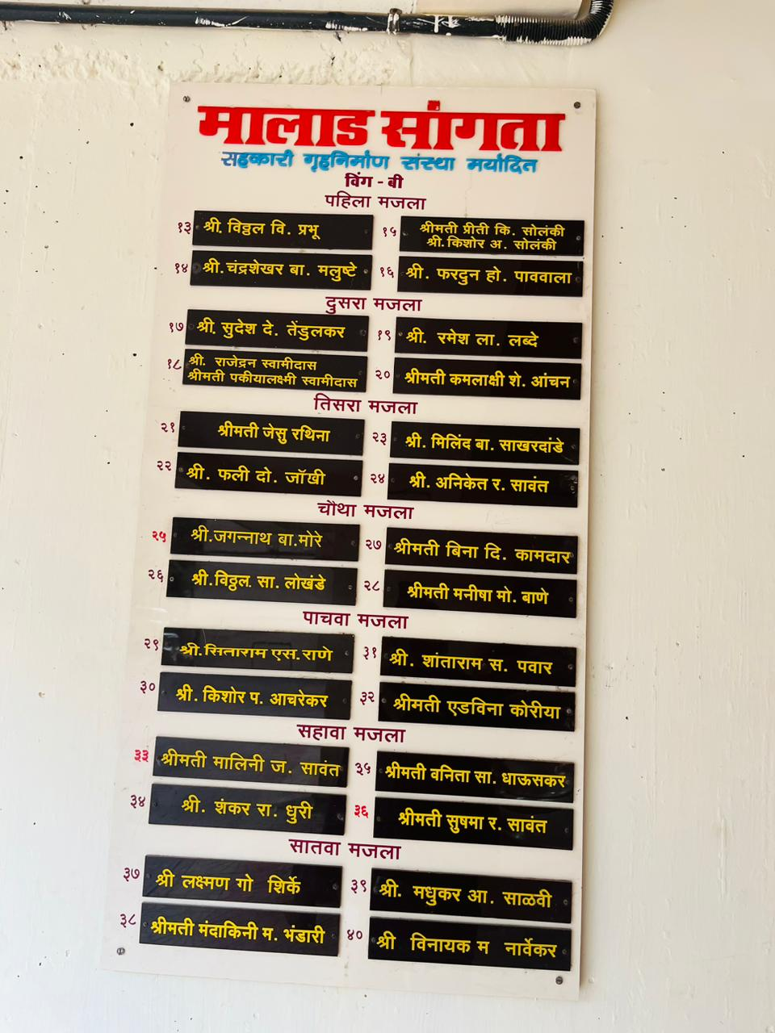
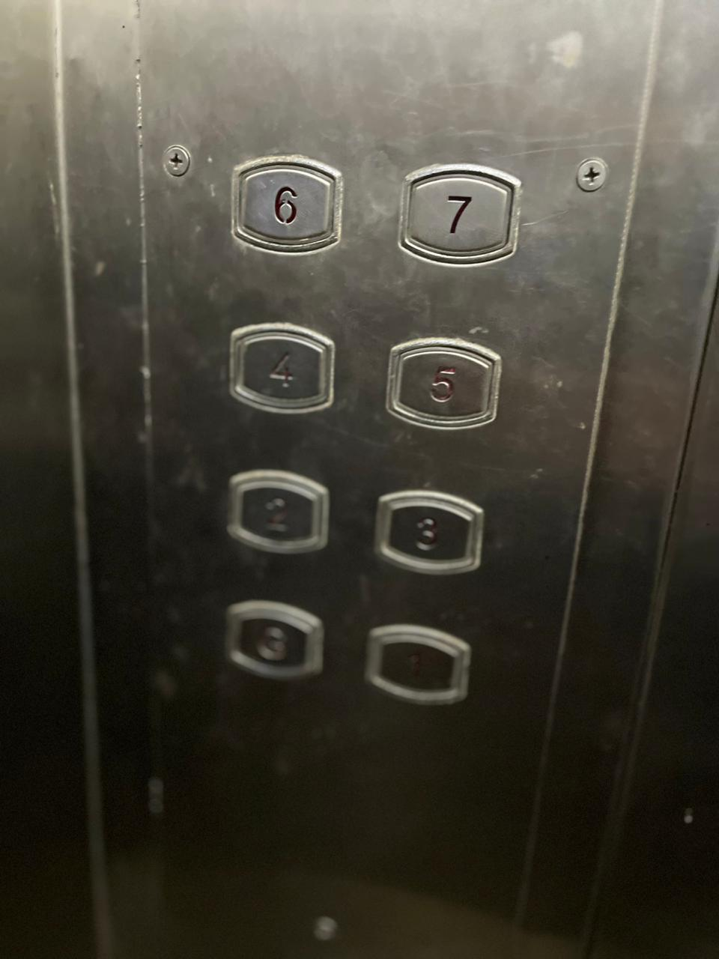
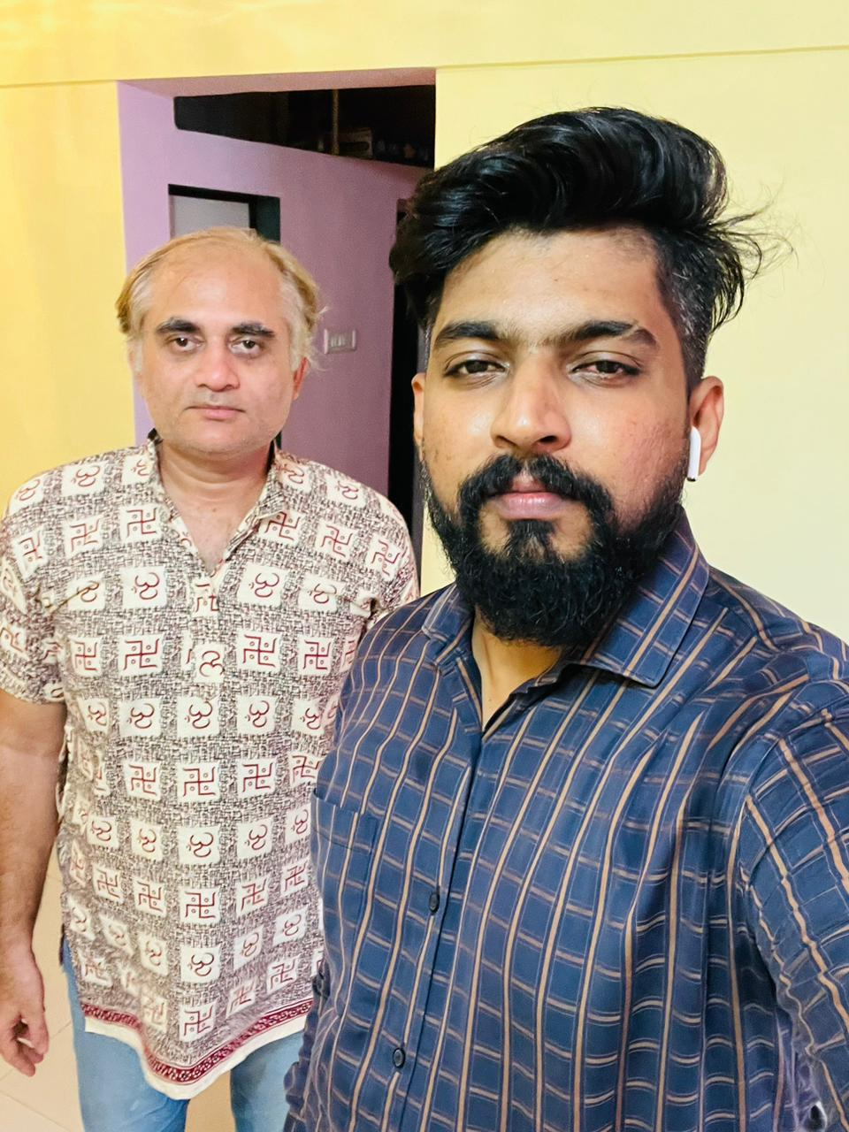

Route Map of the property
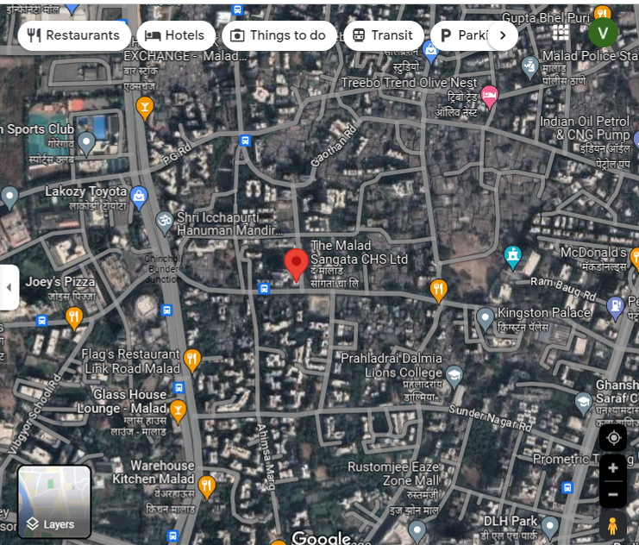
Site U/R

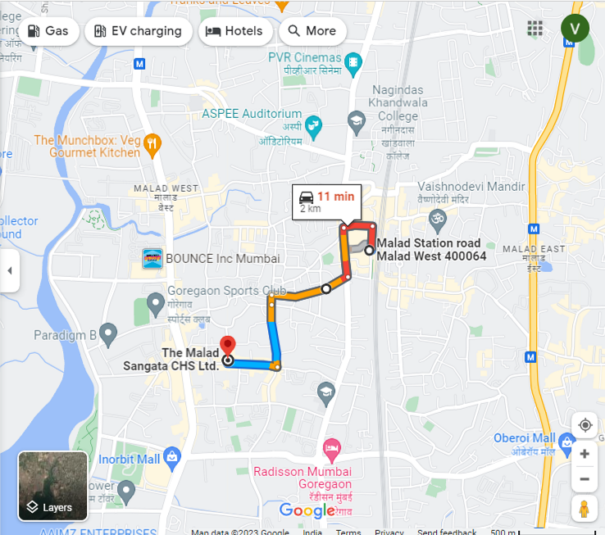

Latitude Longitude: 19°10'46.6"N 72°50'21.8"E

Note: The Blue line shows the route to site from nearest Railway station (Malad – 2 KM.)

Ready Reckoner Rate for Year 2001

Rate for Property
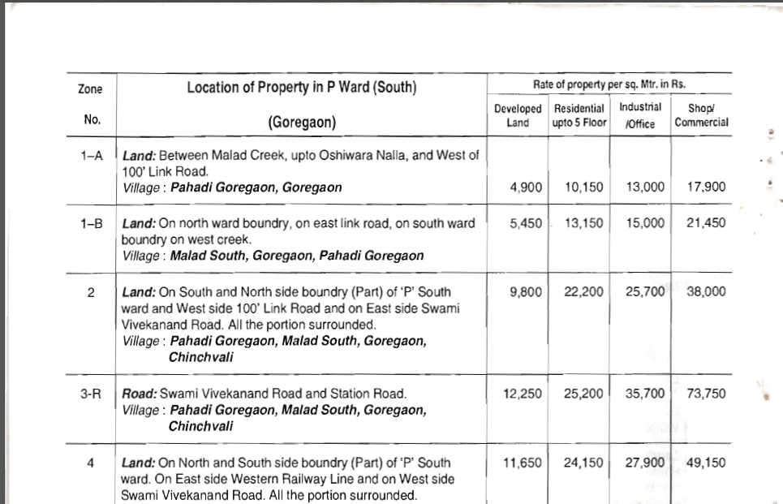

Construction Rate

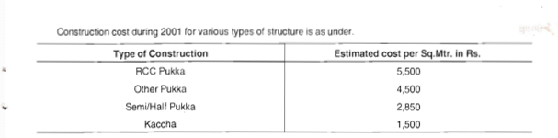

Ready Reckoner Rate for Year 2010

Rate for Property
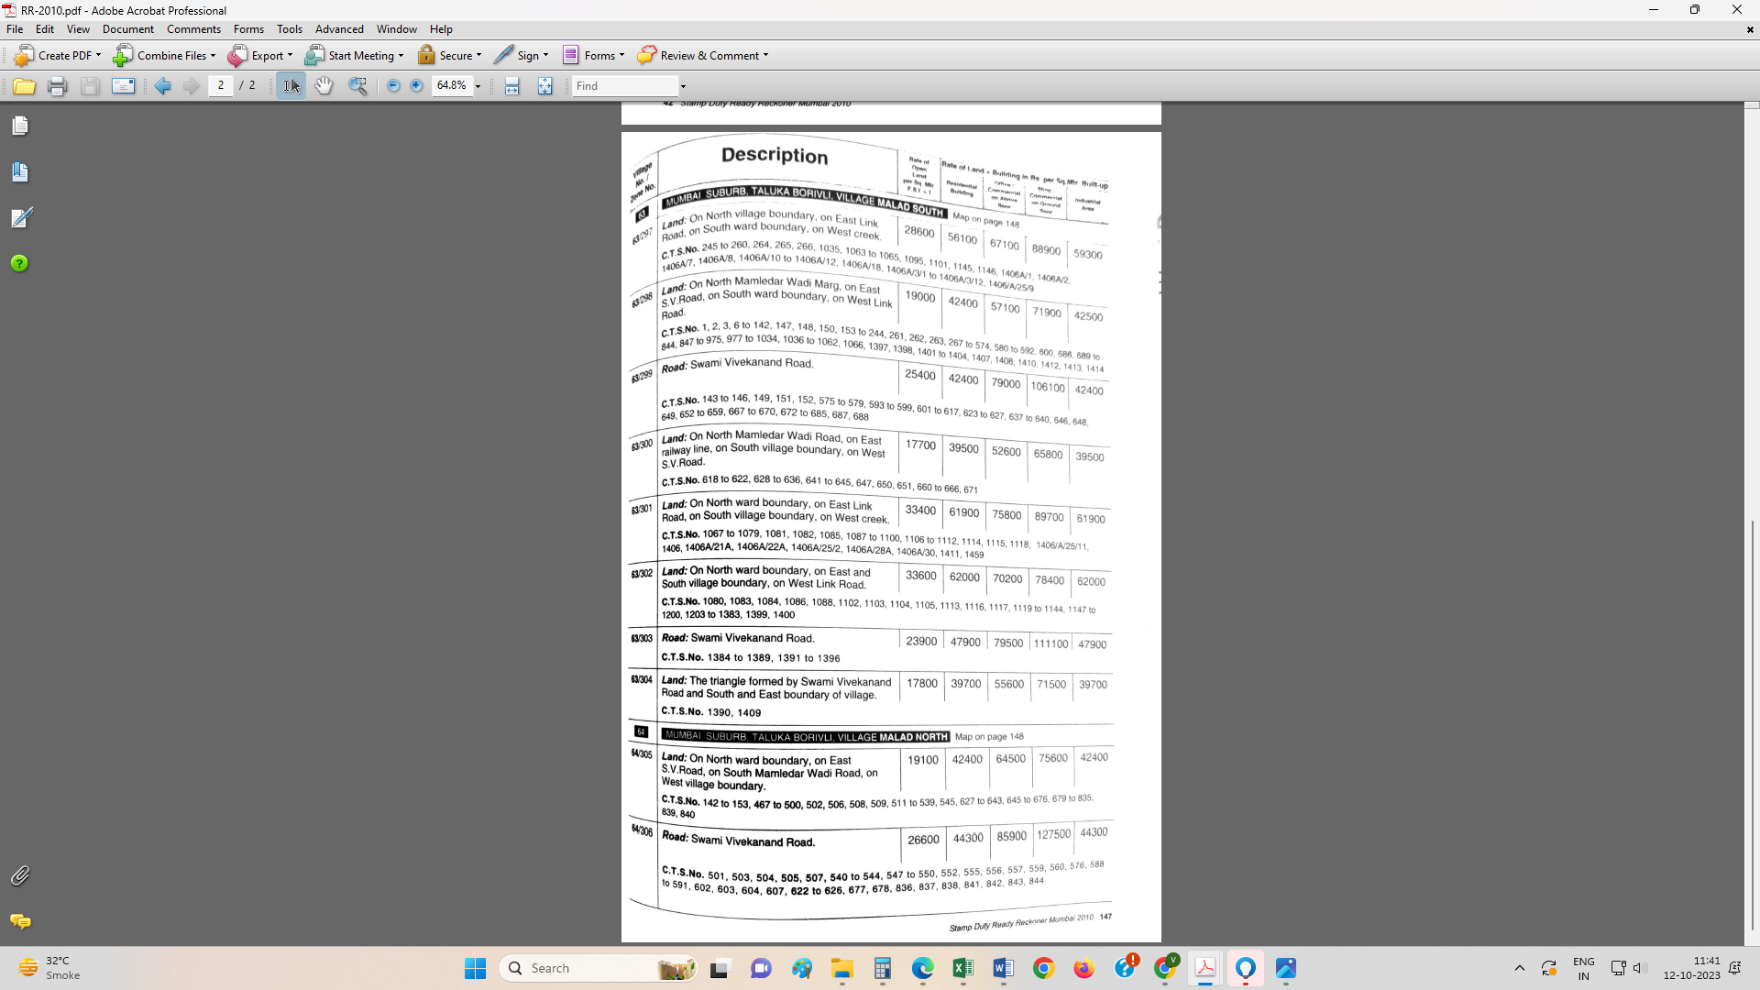

Construction Rate
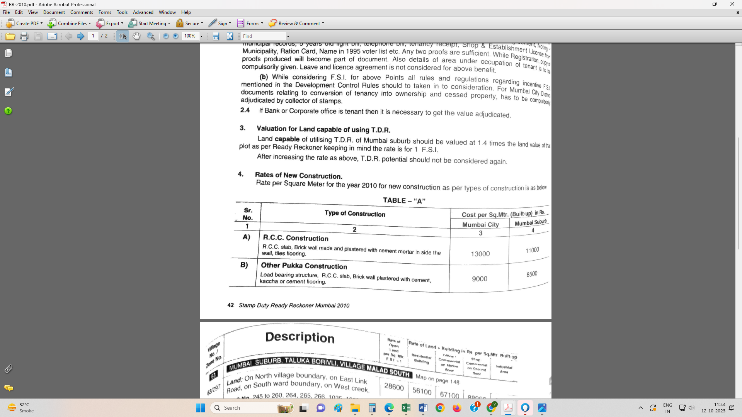

VALUATION OF THE PROPERTY PREMISES

Considering various parameters recorded herein above, existing economic scenario, and the information that is available with reference to the development of neighbourhood and method selected for valuation, we are of the opinion that, the property premises can be assessed and valued for calculation of Capital Gain Tax for ` 24,54,723.00 (Rupees Twenty Four Lakh Fifty Four Thousand Seven Hundred Twenty Three Only).

For Vastukala Architects & Engineers

Sharadkumar B. Chalikwar
Govt. Reg. Valuer
Chartered Engineer (India)
Reg. No. (N) CCIT/1-14/52/2008-09

