Valuation Report of the Immovable Property
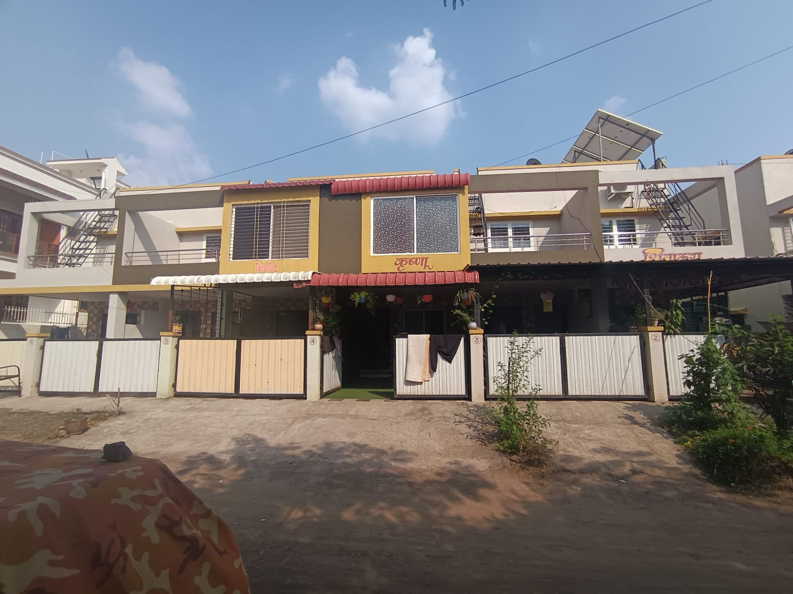

Details of the property under consideration

Name of Owner: Shri. Mayur Rajkishor Singh &
Sau. Dipana Mayur Singh

Residential Row House No.3, Ground + First Floor “Shree Satyam Row House”, Survey No. 424/1 to
5/3, Plot No.32+33/1 to 32+33/6, Opp. Kirti Apartment, Mankar Mala, Shree Krushna Nagar,
Village – Makhmalabad, Taluka & District – Nashik, PIN – 422 003,
State – Maharashtra, Country – India.

Longitude Latitude: 20°03'06.8"N 73°46'36.9"E

Valuation Prepared for:

Private Valuation

Vastu/Nashik/10/2023/4382/2302980
13/01-177-CHV
Date: 13.10.2023

VALUATION OPINION REPORT

This is to certify that the property bearing Residential Row House No. 3, Ground + First Floor, “Shree Satyam Row House”, Survey No. 424/1 to 5/3, Plot No. 32+33/1 to 32+33/6, Opp Kirti Apartment, Mankar Mala, Shree Krushna Nagar, Village – Makhmalabad, Taluka & District – Nashik, PIN – 422 003, State – Maharashtra, Country – India belongs to Shri. Mayur Rajkishor Singh & Sau. Dipana Mayur Singh.

Boundaries of the property.
Boundaries | Row House
North | Plot No.32/33/4
South | Plot No.32/33/2
East | Plot No.23
West | Colony Road

Considering various parameters recorded, existing economic scenario, and the information that is available with reference to the development of neighborhood and method selected for valuation, we are of the opinion that, the property premises can be assessed for this particular purpose at ₹ 42,54,000.00 (Rupees Forty Two Lakh Fifty Four Thousand Only).

The valuation of the property is based on the documents produced by the concern. Legal aspects have not been taken into considerations while preparing this valuation report.

Hence certified

Manoj B. Chalikwar
Registered Valuer
Chartered Engineer (India)
Reg. No. CAT-I-F-1763
Encl: Valuation report.

Vastukala Consultants (I) Pvt. Ltd.
B1-001, U/B Floor, Boomerang, Chandivali Farm Road, Powai, Andheri (East), Mumbai – 400 072.

VALUATION REPORT (IN RESPECT OF ROW HOUSE)
I | General
1. | Purpose for which the valuation is made |  |  |  | : | to assess value of the property Fair Market Value purpose
2. | a) | Date of inspection |  |  | : | 12.10.2023
 | b) | Date on which the valuation is Made |  |  | : | 13.10.2023
3. | List of documents produced for perusal:  - Copy of Sale Deed Vide No. 5673/2020 dated 08.10.2020  - Copy of Approved Building Plan Accompanying Commencement Certificate No. C2 / 191/2019 dated 29.05.2019, issued by Executive Engineer Town Planning Nashik Municipal Corporation, Nashik.  - Copy of Commencement Certificate No. LND / BP / C2 / 191 / 2019 dated 29.05.2019 issued by Nashik Municipal Corporation  - Copy of Occupancy Certificate Javak No. NRV / 82 / 26854 / 2020 dated 24.08.2020 issued by Nashik Municipal Corporation.
 | Name of the owner(s) and his / their address (es) with Phone no. (details of share of each owner in case of joint ownership) |  |  | : |  | Shri. Mayur Rajkishor Singh  Sau. Dipana Mayur Singh  Address: Residential Row House No. 3, Ground + First Floor, “Shree Satyam Row House”, Survey No. 424/1 to 5/3 Plot No. 32+33/1 to 32+33/6, Opp Kirti Apartment, Mankar Mala, Shree Krushna Nagar, Village – Makhmalabad, Taluka & District – Nashik, PIN – 422 003, State – Maharashtra, Country – India.  Contact Person:  Shri. Mayur Rajkishor Singh (Owner)  Contact No.: +91 7741903506  Joint Ownership  Details of share of each owner not available.
5. | Brief description of the property (Including Leasehold / freehold etc.) |  |  | : |  | The property is a residential Row House No.3 is on. The composition of Row House is:  Ground Floor – Hall + Kitchen + WC + Bath + Passage+ Staircase+ Porch + Open Space +  First Floor – 2 Bedrooms + Toilet + Passage + Staircase (i.e. 2BHK)  The property is at 17.8 KM. distance from Nashik Road Railway Station.  Landmark: Opp Kirti Apartment
6. | Location of property |  |  | :
 | a) |  | Plot No. / Survey No. | : |  | Survey No. 424/1 to 5/3 Plot No. 32+33/1 to 32+33/6
 | b) |  | Door No. | : |  | Residential Row House No.3
 | c) |  | C.T.S. No. / Village | : |  | Village – Makhmalabad
 | d) |  | Ward / Taluka | : |  | Taluka – Nashik
 | e) |  | Mandal / District | : |  | District – Nashik
 | f) |  | Date of issue and validity of layout of approved map / plan | : |  | Copy of Approved Building Plan Accompanying Commencement Certificate No. C2 / 191/2019 dated 29.05.2019, issued by Executive Engineer Town Planning Nashik Municipal Corporation, Nashik
 | g) |  | Approved map / plan issuing authority | : |  | Nashik Municipal Corporation
 | h) |  | Whether genuineness or authenticity of approved map/ plan is verified | : |  | Yes
 | i) |  | Any other comments by our empanelled valuers on authentic of approved plan |  |  | No
7. | Postal address of the property |  |  | : |  | Residential Row House No.3, Ground + First Floor, “Shree Satyam Row House”, Survey No. 424/1 to 5/3, Plot No. 32+33/1 to 32+33/6, Opp Kirti Apartment, Mankar Mala, Shree Krushna Nagar, Village – Makhmalabad, Taluka & District – Nashik, PIN – 422 003, State – Maharashtra, Country – India
8. | City / Town |  |  | : |  | Village - Makhmalabad
 | Residential area |  |  | : |  | Yes
 | Commercial area |  |  | : |  | No
 | Industrial area |  |  | : |  | No
9. | Classification of the area |  |  | :
 | i) High / Middle / Poor |  |  | : |  | Middle Class
 | ii) Urban / Semi Urban / Rural |  |  | : |  | Urban
10. | Coming under Corporation limit / Village Panchayat / Municipality |  |  | : |  | Village – Makhmalabad  Nashik Municipal Corporation
11. | Whether covered under any State / Central Govt. enactments (e.g., Urban Land Ceiling Act) or notified under agency area/ scheduled area / cantonment area |  |  | : |  | No
12. | Boundaries of the property
 | Plot |  |  | : |  | As per actual site | As per document
 | North |  |  | : |  | - | -
 | South |  |  | : |  | - | -
 | East |  |  | : |  | - | -
 | West |  |  | : |  | - | -
12.1 | Row House |  |  |  |  | As per actual site | As per document
 | North |  |  | : |  | Plot No. 32/33/4 | Plot No. 32/33/4
 | South |  |  | : |  | Plot No. 32/33/2 | Plot No. 32/33/2
 | East |  |  | : |  | Plot No.23 | Plot No.23
 | West |  |  | : |  | Colony Road | Colony Road
13 | Dimensions of the site |  |  |  |  | N. A. as property under consideration is a Residential Row House.
 |  |  |  |  |  | A As per site | B  As per Document
 | North |  |  | : |  | - | -
 | South |  |  | : |  | - | -
 | East |  |  | : |  | - | -
 | West |  |  | : |  | - | -
14. | Extent of the site |  |  | : |  | Ground Floor Area in Sq. Ft. = 357.00  First Floor Area in Sq. Ft. = 403.00  Porch Area in Sq. Ft. = 95.00  (Carpet Area as per site measurement)  Carpet Area in Sq. Ft. = 643.00  Porch Area in Sq. Ft. = 66.00  Total Carpet Area in Sq. Ft. = 709.00  (Carpet Area as per Sale Deed)  Built Up Area in Sq. Ft. = 851.00  (Carpet Area as per Sale Deed+20%)
14.1 | Latitude, Longitude & Co-ordinates of Row House |  |  | : |  | 20°03'06.8"N 73°46'36.9"E
15. | Extent of the site considered for Valuation (least of 13A & 13B) |  |  | : |  | Carpet Area in Sq. Ft. = 643.00  Porch Area in Sq. Ft. = 66.00  Total Carpet Area in Sq. Ft. = 709.00  (Carpet Area as per Sale Deed)
16 | Whether occupied by the owner / tenant? If occupied by tenant since how long? Rent received per month. |  |  | : |  | Owner Occupied
II | APARTMENT BUILDING
 | Nature of the Apartment |  |  | : |  | Residential
 | Location |  |  | :
 | C.T.S. No. |  |  | : |  | Survey No. 424/1 to 5/3 Plot No.32+33/1 to 32+33/6
 | Block No. |  |  | : |  | -
 | Ward No. |  |  | : |  | -
 | Village / Municipality / Corporation |  |  | : |  | Village – Makhmalabad  Nashik Municipal Corporation
 | Door No., Street or Road (Pin Code) |  |  | : |  | Residential Row House No.3, Ground + First Floor, “Shree Satyam Row House”, Survey No. 424/1 to 5/3, Plot No. 32+33/1 to 32+33/6, Opp Kirti Apartment, Mankar Mala, Shree Krushna Nagar, Village – Makhmalabad, Taluka & District – Nashik, PIN – 422 003, State – Maharashtra, Country – India
 | Description of the locality Residential / Commercial / Mixed |  |  | : |  | Residential
 | Year of Construction |  |  | : |  | 2020 (As per Occupancy Certificate)
 | Number of Floors |  |  | : |  | Ground + First Floor
 | Type of Structure |  |  | : |  | R.C.C. Framed Structure
 | Number of Dwelling units in the building |  |  | : |  | 6 Row Houses
 | Quality of Construction |  |  | : |  | Good
 | Appearance of the Building |  |  | : |  | Good
 | Maintenance of the Building |  |  | : |  | Good
 | Facilities Available |  |  | :
 | Lift |  |  | : |  | N.A.
 | Protected Water Supply |  |  | : |  | Municipal Water supply
 | Underground Sewerage |  |  | : |  | Connected to Municipal Sewerage System
 | Car parking - Open / Covered |  |  | : |  | Covered Parking
 | Is Compound wall existing? |  |  | : |  | Yes
 | Is pavement laid around the building |  |  | : |  | Yes
III | Residential Row House
1 | The floor in which the Row House is situated |  |  | : |  | Ground + First Floor
2 | Door No. of the Row House |  |  | : |  | Residential Row House No. 3
3 | Specifications of the Row House |  |  | :
 | Roof |  |  | : |  | R.C.C. Slab
 | Flooring |  |  | : |  | Vitrified tiles flooring
 | Doors |  |  | : |  | Teak Wood door frame with flush doors
 | Windows |  |  | : |  | Aluminum sliding windows
 | Fittings |  |  | : |  | Concealed Plumbing with C.P. fittings & Electrical wiring
 | Finishing |  |  | : |  | Cement Plastering
4 | House Tax |  |  | :
 | Assessment No. |  |  | : |  | Details Not Provided
 | Tax paid in the name of: |  |  | : |  | Details Not Provided
 | Tax amount: |  |  | : |  | Details Not Provided
5 | Electricity Service connection No.: |  |  | : |  | Details Not Provided
 | Meter Card is in the name of: |  |  | : |  | Details Not Provided
6 | How is the maintenance of the Row House? |  |  | : |  | Good
7 | Sale Deed executed in the name of |  |  | : |  | Shri. Mayur Rajkishor Singh &  Sau. Dipana Mayur Singh
8 | What is the undivided area of land as per Sale Deed? |  |  | : |  | Not applicable
9 | What is the plinth area of the Row House? |  |  | : |  | Built Up Area in Sq. Ft. = 851.00  (Carpet Area as per Sale Deed + 20%)
10 | What is the floor space index (app.) |  |  | : |  | As per Nashik Municipal Corporation norms
11 | What is the Carpet area of the Row House? |  |  | : |  | Ground Floor Area in Sq. Ft. = 357.00  First Floor Area in Sq. Ft. = 403.00  Porch Area in Sq. Ft. = 95.00  (Carpet Area as per site measurement)  Carpet Area in Sq. Ft. = 643.00  Porch Area in Sq. Ft. = 66.00  Total Carpet Area in Sq. Ft. = 709.00  (Carpet Area as per Sale Deed)
12 | Is it Posh / I Class / Medium / Ordinary? |  |  | : |  | Medium Class
13 | Is it being used for Residential or Commercial purpose? |  |  | : |  | Residential purpose
14 | Is it Owner-occupied or let out? |  |  | : |  | Owner Occupied
15 | If rented, what is the monthly rent? |  |  | : |  | ₹ 8,000.00 Expected rental income per month
IV | MARKETABILITY |  |  | :
1 | How is the marketability? |  |  | : |  | Good
2 | What are the factors favoring for an extra Potential Value? |  |  | : |  | Located in developed area
3 | Any negative factors are observed which affect the market value in general? |  |  | : |  | None
V | Rate |  |  | :
1 | After analyzing the comparable sale instances, what is the composite rate for a similar Row House with same specifications in the adjoining locality? - (Along with details / reference of at - least two latest deals / transactions with respect to adjacent properties in the areas) |  |  | : |  | ₹ 5,500.00 to ₹ 6,500.00 per Sq. Ft. on Carpet area
2 | Assuming it is a new construction, what is the adopted basic composite rate of the Row House under valuation after comparing with the specifications and other factors with the Row Houseunder comparison (give details). |  |  | : |  | ₹ 6,000.00 per Sq. Ft. on Carpet area
3 | Break – up for the rate |  |  | :
 | I. Building + Services |  |  | : |  | ₹ 2,000.00 per Sq. Ft.
 | II. Land + others |  |  | : |  | ₹ 4,000.00 per Sq. Ft.
4 | Guideline rate obtained from the Registrar's Office |  |  | : |  | ₹ 30,000.00 per Sq. M. i.e.  ₹ 2,787.00 per Sq. Ft.
4 | Guideline rate (after Depreciation) |  |  |  |  | N.A. as the age of the property is below 5 years
5 | In case of variation of 20% or more in the valuation proposed by the Valuer and the Guideline value provided in the State Govt. notification or Income Tax Gazette justification on variation has to be given |  |  | : |  | It is a foregone conclusion that market value is always more than the RR price. As the RR Rates area Fixed by respective State Government for computing Stamp Duty / Rgstn. Fees. Thus the differs from place to place and Location, Amenities per se as evident from the fact than even RR Rates Decided by Government Differs.
6 | Age of the building |  |  | : |  | 03 Years
7 | Life of the building estimated |  |  | : |  | 57 Years Subject to proper, preventive periodic maintenance & structural repairs.
 | Remark:

Details of Valuation:

Sr. No. | Description | Qty. | Rate per  unit (₹) | Estimated  Value (₹)
1 | Present value of the Row House | 709.00 Sq. Ft. | 6,000.00 | 42,54,000.00
 | Total value of the property |  |  | 42,54,000.00
 | The realizable value of the property |  |  | 40,41,300.00
 | Distress value of the property |  |  | 34,03,200.00
 | Insurable value of the property (851.00 Sq. Ft. x 2,000.00) |  |  | 17,02,000.00
 | Guideline value of the property (851.00 Sq. Ft. x 2,787.00) |  |  | 23,71,737.00

Justification for price / rate
The Market Value of the property is based on facts of markets discovered by us during our enquiries, however the government rate value in this case is less than the market value arrived by us. We are of the opinion that the value arrive by us will prove to be correct if an Auction of the subject property is carried out. As far as Market Value in Index II is concerned, it is not possible to comment on same, may be government rates are fixed by sampling during same point of time in part and whereas, Market values change every month.

In most of the cases the actual deal amount or Transaction value is not reflected in Index II because of various Market practices. As Valuer, we always try to give a value which is correct reflection of actual transaction value irrespective of any factors in market.
Method of Valuation / Approach

The sales comparison approach uses the market data of sale prices to estimate the value of a real estate property. Property valuation in this method is done by comparing a property to other similar properties that have been recently sold. Comparable properties, also known as comparables, or comps, must share certain features with the property in question. Some of these include physical features such as square footage, number of rooms, condition, and age of the building; however, the most important factor is no doubt the location of the property. Adjustments are usually needed to account for differences as no two properties are exactly the same. To make proper adjustments when comparing properties, real estate appraisers must know the differences between the comparable properties and how to value these differences. The sales comparison approach is commonly used for Residential Row House, where there are typically many comparables available to analyze. As the property is a Residential Row House, we have adopted Sale Comparison Approach Method for the purpose of valuation. The Price for similar type of property in the nearby vicinity is in the range of ₹ 5,500.00 to ₹ 6,500.00 per Sq. Ft. on Carpet Area. Considering the rate with attached report, current market conditions, demand and supply position, Row House size, location, upswing in real estate prices, sustained demand for Residential Row House, all-round development of residential and Commercial application in the locality etc. We estimate ₹ 6,000.00 per Sq. Ft. on Carpet Area.

Impending threat of acquisition by government for road widening / publics service purposes, sub merging & applicability of CRZ provisions (Distance from sea-cost / tidal level must be incorporated) and their effect on
- Saleability | Good
- Likely rental values in future | ₹ 8,000.00 expected rental income per month
- Any likely income it may generate | Rental Income

Actual site Photographs
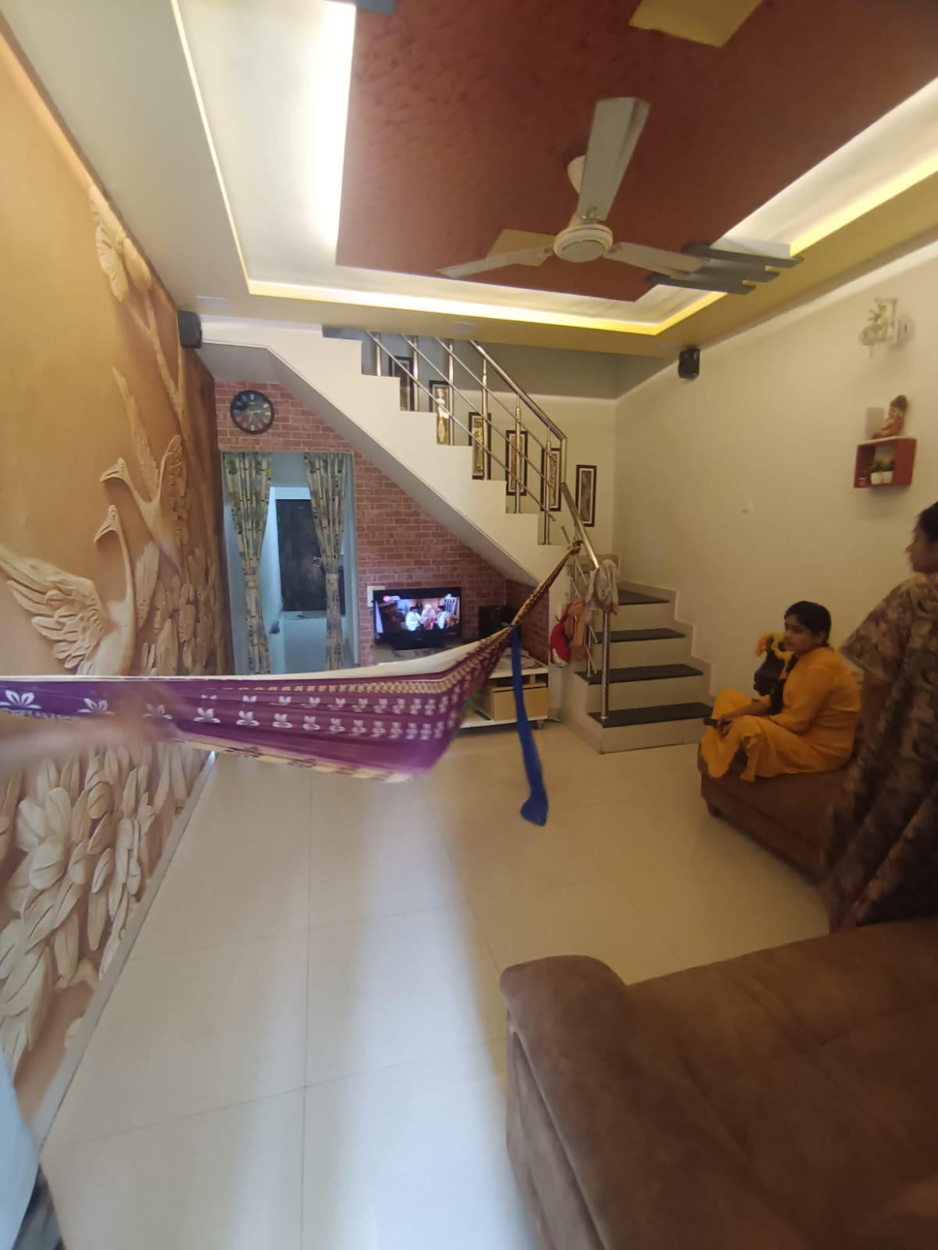
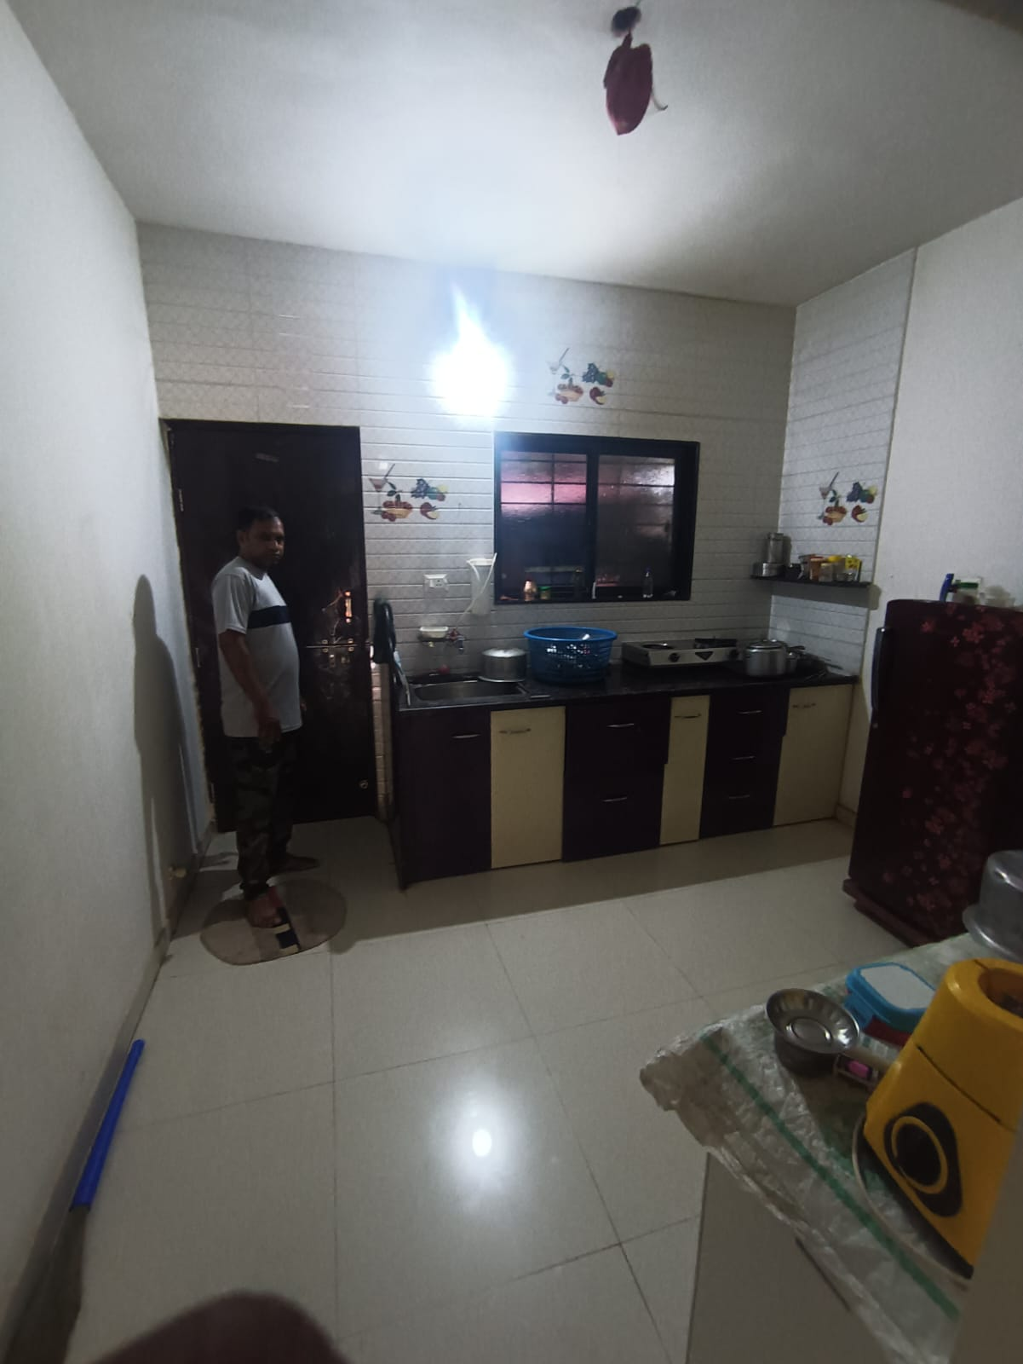
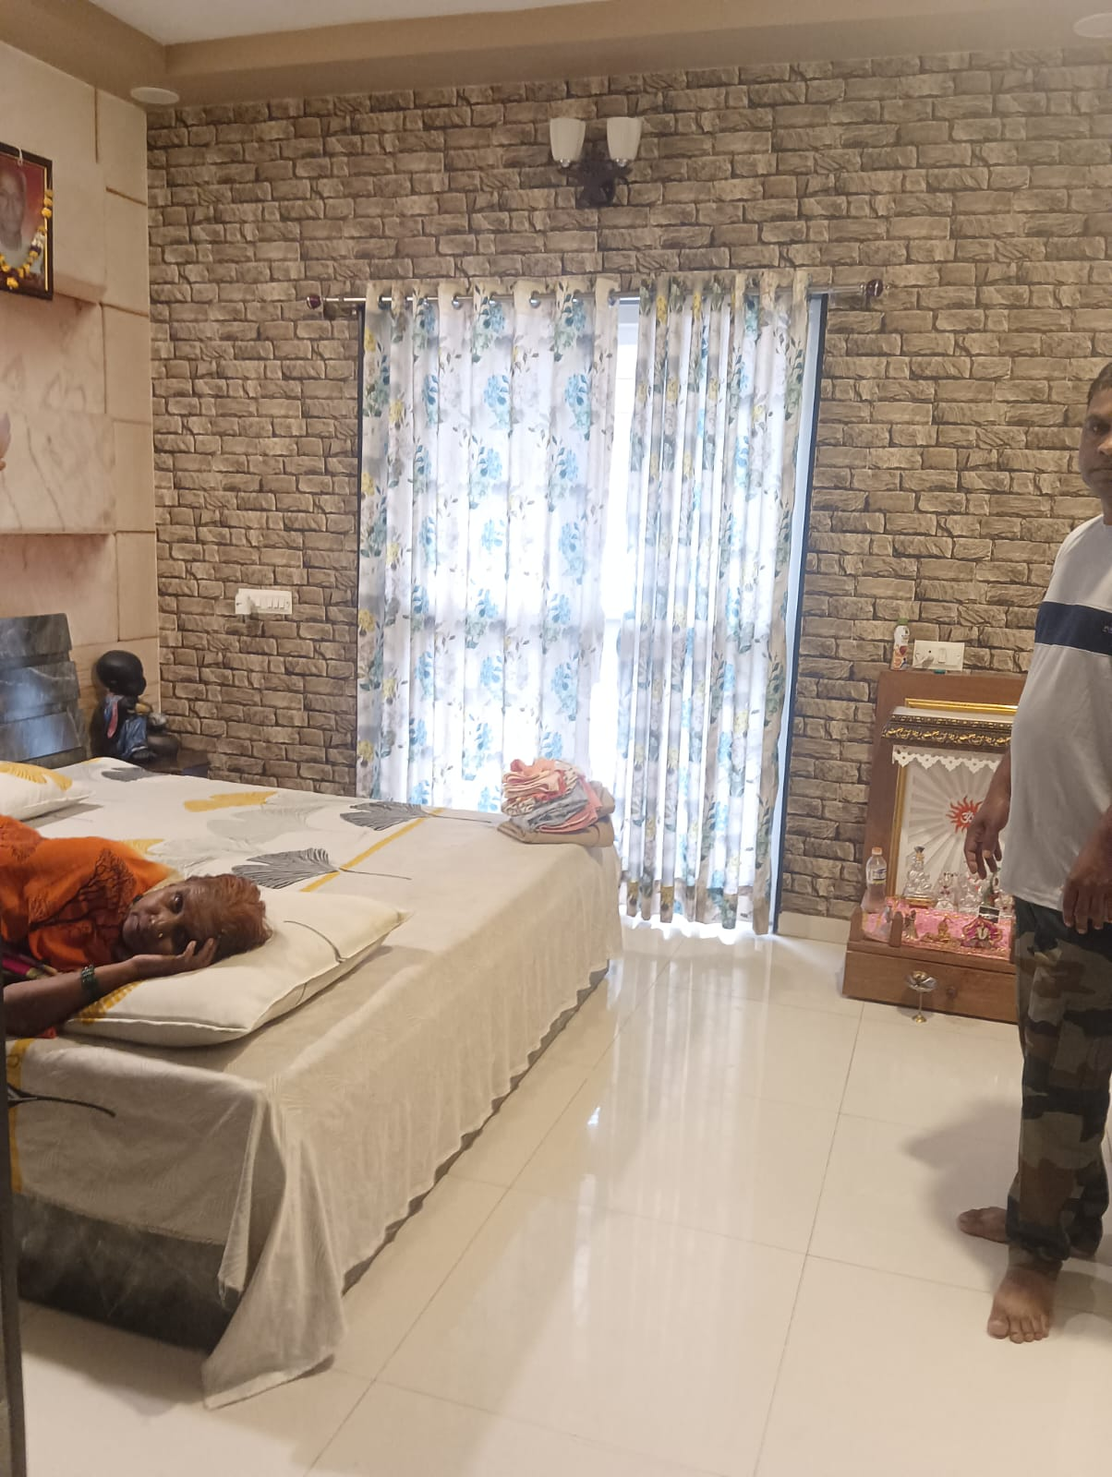

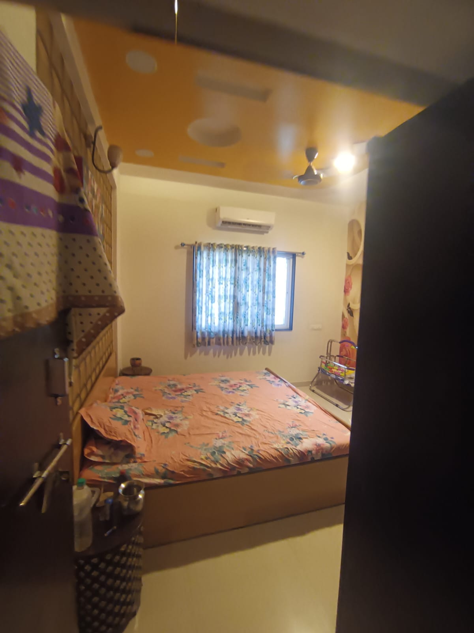
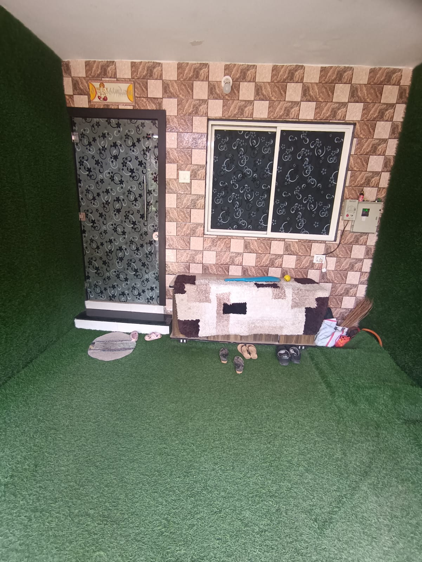



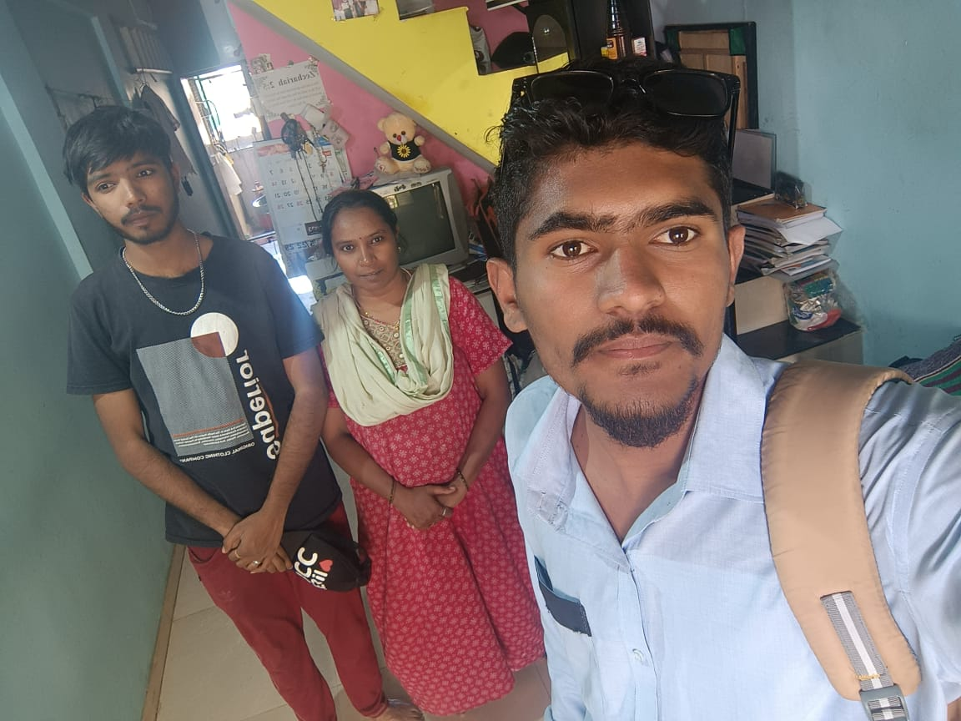

Route Map of the property
Site u/r

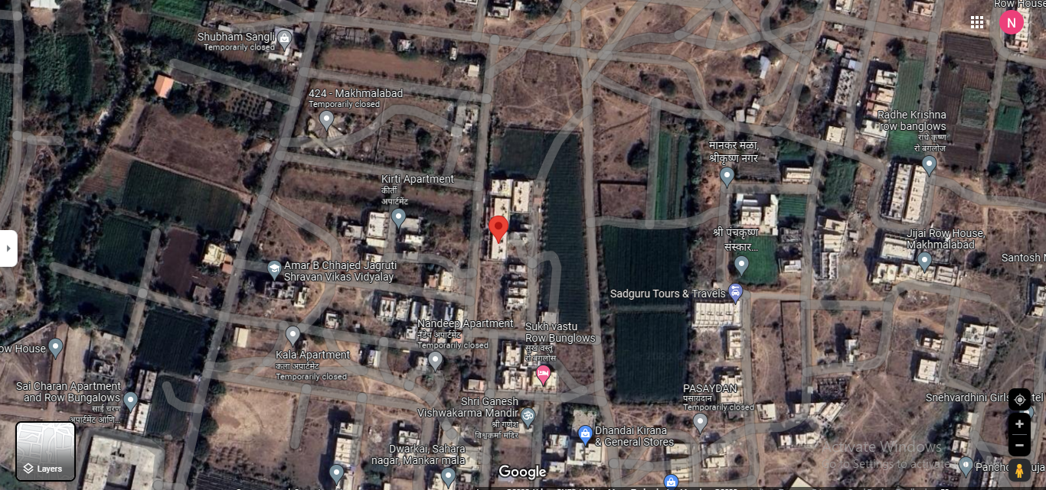

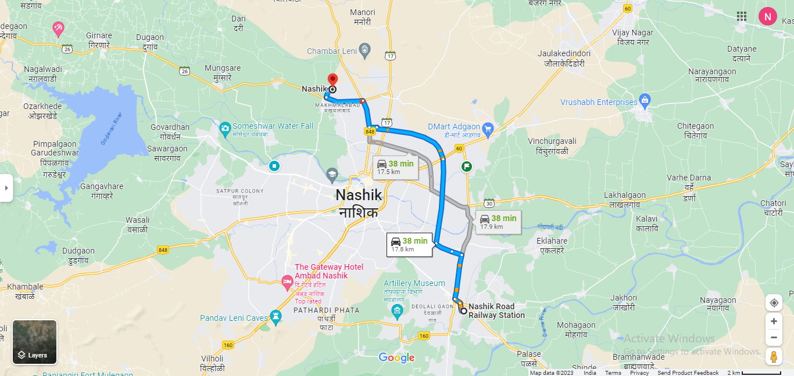

Longitude Latitude: 20°03'06.8"N 73°46'36.9"E

Note: The Blue line shows the route to site from Nashik Road Railway Station (Nashik – 17.8 KM.)

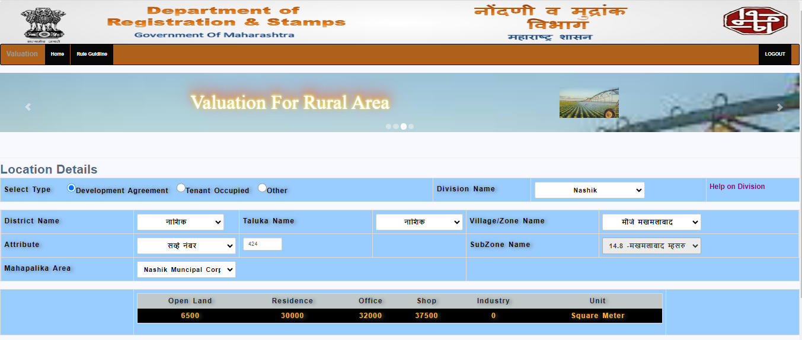
Ready Reckoner Rate

Price Indicators
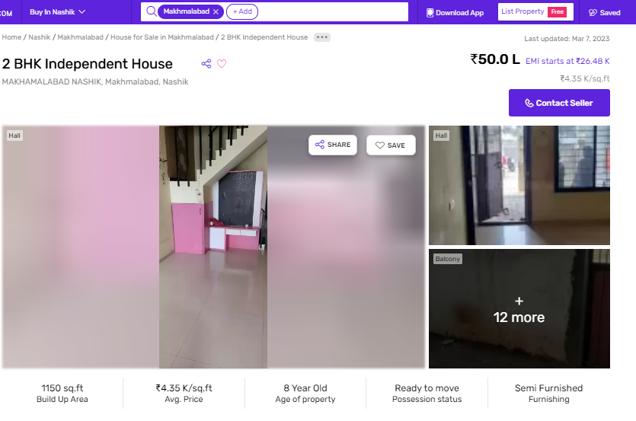

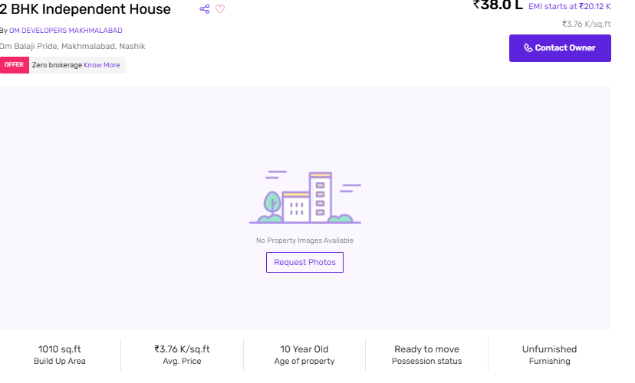

Sr.  No. | Particulars | Valuer comment
 | background information of the asset being valued; | The property under consideration is purchased by Shri. Mayur Rajkishor Singh & Sau. Dipana Mayur Singh from Smt. Chandrabhaga Karbhari Shinde & three others vide Sale Deed dated 08.10.2020
 | purpose of valuation and appointing authority | to assess value of the property Fair Market Value purpose
 | identity of the valuer and any other experts involved in the valuation; | Manoj B. Chalikwar – Regd. Valuer  Sachin Raundal – Valuation Engineer  Vinit Surve – Technical Manager  Chintamani Chaudhari – Technical Officer
 | disclosure of valuer interest or conflict, if any; | We have no interest, either direct or indirect, in the property valued. Further to state that we do not have relation or any connection with property owner / applicant directly or indirectly. Further to state that we are an independent Valuer and in no way related to property owner / applicant
 | date of appointment, valuation date and date of  report; | Date of Appointment – 12.10.2023  Valuation Date – 13.10.2023  Date of Report – 13.10.2023
 | inspections and/or investigations undertaken; | Physical Inspection done on 12.10.2023
 | nature and sources of the information used or relied upon; | - Market Survey at the time of site visit  - Ready Reckoner rates / Circle rates  - Online Price Indicators on real estate portals  - Enquiries with Real estate consultants  - Existing data of Valuation assignments carried out by us
 | Procedures adopted in carrying out the valuation and valuation standards followed; | Sales Comparison Method
 | restrictions on use of the report, if any; | This valuation is for the use of the party to whom it is addressed and for no other purpose. No responsibility is accepted to any third party who may use or rely on the whole or any part of this valuation. The valuer has no pecuniary interest that would conflict with the proper valuation of the property.
 | major factors that were taken into account during the valuation; | current market conditions, demand and supply position, Residential Row House size, location, upswing in real estate prices, sustained demand for Residential Row House, all round development of commercial and Commercial application in the locality etc.
 | Caveats, limitations and disclaimers to the extent they explain or elucidate the limitations faced by valuer, which shall not be for the purpose of limiting his responsibility for the valuation report. | Attached

Assumptions, Disclaimers, Limitations & Qualifications
Value Subject to Change
The subject appraisal exercise is based on prevailing market dynamics as on 13th October 2023 and does not take into account any unforeseeable developments which could impact the same in the future.
Our Investigations
We are not engaged to carry out all possible investigations in relation to the subject property. Where in our report we identify certain limitations to our investigations, this is to enable the reliant party to instruct further investigations where considered appropriate or where we recommend as necessary prior to reliance. Vastukala Consultants India Pvt. Ltd. (VCIPL) is not liable for any loss occasioned by a decision not to conduct further investigations
Assumptions
Assumptions are a necessary part of undertaking valuations. VCIPL adopts assumptions for the purpose of providing valuation advice because some matters are not capable of accurate calculations or fall outside the scope of our expertise, or out instructions. The reliant party accepts that the valuation contains certain specific assumptions and acknowledge and accept the risk of that if any of the assumptions adopted in the valuation are incorrect, then this may have an effect on the valuation.
Information Supplied by Others
The appraisal is based on the information provided by the client. The same has been assumed to be correct and has been used for appraisal exercise. Where it is stated in the report that another party has supplied information to VCIPL, this information is believed to be reliable but VCIPL can accept no responsibility if this should prove not to be so.
Future Matters
To the extent that the valuation includes any statement as to a future matter, that statement is provided as an estimate and/or opinion based on the information known to VCIPL at the date of this document. VCIPL does not warrant that such statements are accurate or correct.
Map and Plans
Any sketch, plan or map in this report is included to assist the reader while visualising the property and assume no responsibility in connection with such matters.
Site Details
Based on inputs received from Client's representative and site visit conducted, we understand that the subject property is Residential Row House, admeasuring area Total Carpet Area in Sq. Ft. = 709.00 owned by Shri. Mayur Rajkishor Singh & Sau. Dipana Mayur Singh. Further, VCIPL has assumed that the subject property is free from any encroachment and is available as on the date of the appraisal.

Property Title
Based on our discussion with the Client, we understand that the subject property is owned by Shri. Mayur Rajkishor Singh & Sau. Dipana Mayur Singh. For the purpose of this appraisal exercise, we have assumed that the subject property has a clear title and is free from any encumbrances, disputes and claims. VCIPL has made no further enquiries with the relevant local authorities in this regard and does not certify the property as having a clear and marketable title. Further, no legal advice regarding the title and ownership of the subject property has been obtained for the purpose of this appraisal exercise. It has been assumed that the title deeds are clear and marketable.
Environmental Conditions
We have assumed that the subject property is not contaminated and is not adversely affected by any existing or proposed environmental law and any processes which are carried out on the property are regulated by environmental legislation and are properly licensed by the appropriate authorities.
Area
Based on the information provided by the Client's representative, we understand that the Residential Row House, admeasuring area Total Carpet Area in Sq. Ft. = 709.00
Condition & Repair
In the absence of any information to the contrary, we have assumed that there are no abnormal ground conditions, nor archaeological remains present which might adversely affect the current or future occupation, development or value of the property. The property is free from rat, infestation, structural or latent defect. No currently known deleterious or hazardous materials or suspect techniques will be used in the construction of or subsequent alteration or additions to the property and comments made in the property details do not purport to express an opinion about, or advise upon, the condition of uninspected parts and should not be taken as making an implied representation or statement about such parts
Valuation Methodology
For the purpose of this valuation exercise, the valuation methodology used is Direct Comparison Approach Method and proposed Current use / Exiting use premise is considered for this assignment.
The Direct Comparison Approach involves a comparison of the property being valued to similar properties that have actually been sold in arms - length transactions or are offered for sale. This approach demonstrates what buyers have historically been willing to pay (and sellers willing to accept) for similar properties in an open and competitive market and is particularly useful in estimating the value of the Row Houseand properties that are typically traded on a unit basis.
In case of inadequate recent transaction activity in the subject micro-market, the appraiser would collate details of older transactions. Subsequently, the appraiser would analyse rental / capital value trends in the subject micro-market in order to calculate the percentage increase / decrease in values since the date of the identified transactions. This percentage would then be adopted to project the current value of the same.
Where reliance has been placed upon external sources of information in applying the valuation methodologies, unless otherwise specifically instructed by Client and/or stated in the valuation, VCIPL has not independently verified that information and VCIPL does not advise nor accept it as reliable. The person or entity to whom the report is addressed acknowledges and accepts the risk that if any of the unverified information in the valuation is incorrect, then this may have an effect on the valuation.
Not a Structural Survey
We state that this is a valuation report and not a structural survey
Other
All measurements, areas and ages quoted in our report are approximate
Legal
We have not made any allowances with respect to any existing or proposed local legislation relating to taxation on realization of the sale value of the subject property. VCIPL is not required to give testimony or to appear in court by reason of this appraisal report, with reference to the property in question, unless arrangement has been made thereof. Further, no legal advice on any aspects has been obtained for the purpose of this appraisal exercise

Property specific assumptions

Based on inputs received from the client and site visit conducted, we understand that the subject property is Residential Row House, admeasuring area Total Carpet Area in Sq. Ft. = 709.00

ASSUMPTIONS, CAVEATS, LIMITATION AND DISCLAIMERS
- We assume no responsibility for matters of legal nature affecting the property appraised or the title thereto, nor do we render our opinion as to the title, which is assumed to be good and marketable.
- The property is valued as though under responsible ownership.
- It is assumed that the property is free of liens and encumbrances.
- It is assumed that there are no hidden or unapparent conditions of the subsoil or structure that would render it more or less valuable. No responsibility is assumed for such conditions or for engineering that might be required to discover such factors.
- There is no direct/ indirect interest in the property valued.
- The rates for valuation of the property are in accordance with the Govt. approved rates and prevailing market rates.
DEFINITION OF VALUE FOR THIS SPECIFIC PURPOSE

This exercise is to assess Fair Market Value of the property under reference as on 13th October 2023.

The term Fair Market Value is defined as

“The most probable price, as of a specified date, in cash, terms equivalent to cash, or in other precisely revealed terms for which the specified property rights would sell after reasonable exposure in a competitive market under all conditions requisite to a fair sale, with the buyer and seller each acting prudently knowledgeably and for self interest assuming that neither is under undue duress”.

Fundamental assumptions and conditions presumed in this definition are:

1. Buyer and seller are motivated by self-interest.
2. Buyer and seller are well informed and are acting prudently.
3. The property is exposed for a reasonable time on the open market.
4. Payment is made in cash or equivalent or in specified financing terms.
DECLARATION OF PROFESSIONAL FEES CHARGED

We hereby declare that, our professional fees are not contingent upon the valuation findings. However, if the statute AND/OR clients demands that, the fees should be charged on the percentage of assessed value then, with the full knowledge of the AND/OR end user, it is being charged accordingly.

VALUATION OF THE PROPERTY PREMISES

Considering various parameters recorded herein above, existing economic scenario, and the information that is available with reference to the development of neighborhood and method selected for valuation, we are of the opinion that, the property premises can be assessed and Fair Market value for this particular purpose at ` 42,54,000.00 (Rupees Forty Two Lakh Fifty Four Thousand Only).

Manoj B. Chalikwar
Registered Valuer
Chartered Engineer (India)
Reg. No. CAT-I-F-1763

