Valuation Report of the Immovable Property

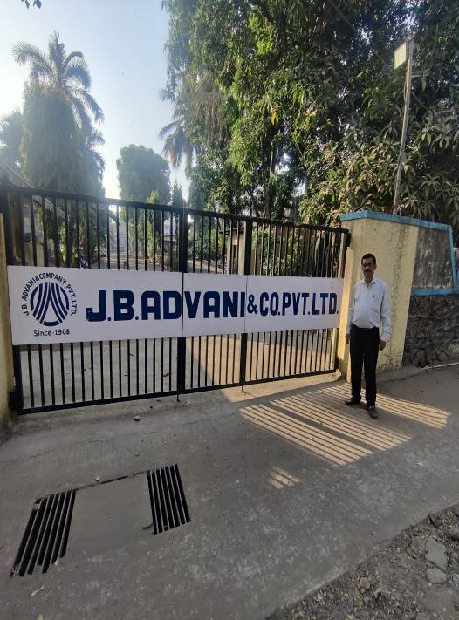

Details of the property under consideration:

Name of Owner as on 01.04.2001 : M/s. J. B. Advani & Co. Pvt. Ltd.

Industrial Land & Building at Survey No. 192, Hissa No. 2, CTS No. 216A and 216C (part), Opp. Asian Paints,
Lal Bahadur Shastri Marg, Bhandup (West), Mumbai – 400 078, State – Maharashtra, Country – India.

Latitude Longitude: 19°09'38.9"N 72°56'12.5"E

Table of Contents
1. VALUATION REPORT 3
1.1. GENERAL: 5
1.2. LAND 5
1.3. IMPROVEMENTS 6
1.4. RENTS 7
1.5. SALES 8
1.6. COST OF CONSTRUCTION 8
2. PART II- VALUATION 8
2.1. General: 8
2.2. Location: 9
2.3. Industrial Land & Building: 9
2.4. Valuation as on 1st April 2001 of the Land & Structure: 10
2.5. NOTES 12
3. ANNEXURE TO FORM 0-1 13
4. PART III- DECLARATION 14
4.1. DECLARATION OF PROFESSIONAL FEES CHARGED 14
4.2. DEFINITION OF VALUE FOR THIS SPECIFIC PURPOSE 14
4.3. UNDER LYING ASSUMPTIONS 14
5. Actual site photographs 15
6. Actual site photographs 16
7. Actual site photographs 17
8. Route Map of the property 18
9. Ready Reckoner Rate for Year 2001 19
9.1. Rate for Property 19
9.2. Construction Rate 19
10. VALUATION OF THE PROPERTY PREMISES 20

Vastu/Mumbai/05/2022/24288/40483
07/07/63-VS
Date: 07.05.2022

VALUATION REPORT

This is to certify that the property bearing Industrial Land & Building at Survey No. 192, Hissa No. 2, CTS No. 216A and 216C (part), Opp. Asian Paints, Lal Bahadur Shastri Marg, Bhandup (West), Mumbai – 400 078, State – Maharashtra, Country – India belongs to M/s. J. B. Advani & Co. Pvt. Ltd..

Boundaries of the property.
North | : | Open Plot
South | : | Filix Tower
East | : | LBS Marg
West | : | Lake Road

- The purpose of this report is to ascertain the Cost of Acquisition as on 01.04.2001 for F. Y. 2023-2024 of the property as detailed above.
- The land can be assessed and valued as on 1st April 2001 at ` 24,36,89,664/- (Rupees Twenty Four Crore Thirty Six Lakh Eighty Nine Thousand Six Hundred Sixty Four Only)
- The following documents were perused :
- Copy of Indenture dated 13.04.1949 between Ramchandra Kisan Mhatre (Vendor) & J. B. Advani & Co. Ltd. (Purchaser) – 37,960.00 Sq. Yd.
- Copy of Indenture dated 24.03.1959 between Sheshmal Pragji & Hajarimal Pragji (Vendors) & J. B. Advani & Co. Pvt. Ltd. (Purchaser) – 4,613.00 Sq. Yd.
- Copy of Indenture dated 27.11.1961 between Umedmal Chaturbhuj & Devichand Ratanji (Vendors) & J. B. Advani & Co. Pvt. Ltd. (Purchaser) – 2,864.00 Sq. Yd.
- Copy of Plot Layout issued dated 24.07.2003 issued by Collector, Bombay Suburban District.
- Copy of Property Card for plot no. 216 A and 216C (Part).
- Copy of property tax bill for the year 2022-23
- Copy of Electricity Bill dated 05.03.2023 in the name of M/s. J. B. Advani & Co. Pvt. Ltd.
- Copy of Water bill dated 27.02.2023 for the period of 25.11.2022 to 26.12.2022 in the name of M/s. J. B. Advani & Co. Pvt. Ltd.
- Copy of details of Capital value calculation vide Property A/c No. SX0701990030000, SX0702000520000, SX0701940010000, SX0701990200000, SX0701970010000, SX0702050030000, SX0701890080000, SX0701980150000, SX0702010080000, SX0701860090000, SX0701980070000, SX0701880010000, SX0702000100000 & SX0701840060000

This assignment is undertaken based on the request from our client M/s. J. B. Advani & Co. Pvt. Ltd.

The valuation of the property is based on the documents produced by the concern. Legal aspects have not been taken into considerations while preparing this valuation report.

Hence certified.

For Vastukala Architects & Engineers

Sharadkumar B. Chalikwar
Govt. Reg. Valuer
Chartered Engineer (India)
Reg. No. (N) CCIT/1-14/52/2008-09
Encl: Valuation report in Form – 01
Valuation Report of Industrial Land & Building at Survey No. 192, Hissa No. 2, CTS No. 216A and 216C (part), Opp. Asian Paints, Lal Bahadur Shastri Marg, Bhandup (West), Mumbai – 400 078,
State – Maharashtra, Country – India

Part-1 Form 0-1
(See Rule 8 D)
REPORT OF VALUATION OF IMMOVABLE PROPERTY (OTHER THAN AGRICULTURAL LANDS, PLANTATIONS, FORESTS, MINES AND QUARRIES)

GENERAL:

1 | Purpose for which the valuation is made | To assess the Fair Market Value as on 01.04.2001
2 | Date of Report | 11.10.2023
3 | Name of the Owner | M/s. J. B. Advani & Co. Pvt. Ltd.
4 | If the property is under joint ownership, Ownership / co-ownership, share of each such owner. Are the shares undivided? | Pvt. Ltd. Co. Ownership
5 | Brief description of the property | Industrial Land & Building at Survey No. 192, Hissa No. 2, CTS No. 216A and 216C (part), Opp. Asian Paints, Lal Bahadur Shastri Marg, Bhandup (West), Mumbai – 400 078, State – Maharashtra, Country – India
6 | Location, street, ward no | Lal Bahadur Shastri Marg
7 | Survey/ Plot no. of land | Survey No. 192, Hissa No. 2, CTS No. 216A and 216C (part)
8 | Is the property situated in Residential / commercial/ mixed area/ industrial area? | Industrial area
9 | Classification of locality-high class/ middle class/poor class | Middle Class
10 | Proximity to civic amenities like schools, Hospitals, Offices, market, cinemas etc. | All the amenities are available in the vicinity.
11 | Means and proximity to surface communication by which the locality is served | Served by BEST Buses, Taxies, Autos and Private Vehicles

LAND

12 | Area of land supported by documentary proof. Shape, dimension and physical features | Area as per Plot Layout:  Area as per Property Card:  Constructed Area = As per valuation table  (Area as per Capital value calculation)
  Plot A | Area (Sq. M.)
  Plot area | 25,048.74
  Less: Set back area | 24.38
  Less: Set back on lake road | 983.12
  Less: Reservation | 65.00
  Net area of plot | 23,976.24
  Plot C (Part)
  Plot area | 2,500.00
  Less: Area owned by the Axis Reality Pvt. Ltd. | 427.00
  Net area of plot | 2,073.00
  CTS No. | Area (Sq. M.)
  216 A | 25,027.70
  216 C (part) - 427 sq. M. owned by the Axis Reality Pvt. Ltd. | 2,085.20 (2,512.20-427)
  Total area | 27,112.90
13 | Roads, Streets or lanes on which the land is abutting | Lal Bahadur Shastri Marg
14 | If freehold or leasehold land | Freehold
15 | If leasehold, the name of Lessor/lessee, nature of lease, date of commencement and termination of lease and terms of renewal of lease.  (i) Initial premium  (ii) Ground rent payable per annum  (iii) Unearned increase payable to the Lessor in the event of sale or transfer | Not applicable
16 | Is there any restriction covenant in regard to use of land? If so attach a copy of the covenant. | No
17 | Are there any agreements of easements? If so attach a copy of the covenant | There is no Agreements of easements
18 | Does the land fall in an area included in any Town Planning Scheme or any Development Plan of Government or any statutory body? If so give Particulars. | Municipal Corporation of Greater Mumbai
19 | Has any contribution been made towards development or is any demand for such contribution still outstanding. | No
20 | Has the whole or part of the land been notified for acquisition by government or any statutory body? Give date of the notification. | No
21 | Attach a dimensioned site plan | Attached

IMPROVEMENTS

22 | Attach plans and elevations of all structures standing on the land and a lay-out plan. | Not available
23 | Furnish technical details of the building on a separate sheet (The Annexure to this form may be used) | Attached
24 | Is the building owner occupied/ tenanted/ both? | Vacant
 | If the property owner occupied, specify portion and extent of area under owner-occupation | Vacant
25 | What is the Floor Space Index permissible and Percentage actually utilized? | - Floor Space Index Permissible – As per Development Control of Regulation of Municipal Corporation of Greater Mumbai  - FSI percentage actually utilized - Information not available

RENTS

26 | (i) | Names of tenants/ lessees/ licensees, etc | Not applicable
 | (ii) | Portions in their occupation | Not applicable
 | (iii) | Monthly or annual rent /compensation/license fee, etc. paid by each | Not applicable
 | (iv) | Gross amount received for the whole property | Not applicable
27 | Are any of the occupants related to, or close to business associates of the owner? |  | Not applicable
28 | Is separate amount being recovered for the use of fixtures, like fans, geysers, refrigerators, cooking ranges, built-in wardrobes, etc. or for services charges? If so, give details |  | Not applicable
29 | Give details of the water and electricity charges, If any, to be borne by the owner |  | Not applicable
30 | Has the tenant to bear the whole or part of the cost repairs and maintenance? Give particulars |  | Not applicable
31 | If a lift is installed, who is to bear the cost of maintenance and operation- owner or tenant? |  | Not applicable
32 | If a pump is installed, who is to bear the cost of maintenance and operation- owner or tenant? |  | Owner
33 | Who has to bear the cost of electricity charges for lighting of common space like entrance hall, stairs, passage, compound, etc. owner or tenant? |  | Paid by owner of ` 9,060.00 as per Copy of Electricity Bill dated 05.03.2023 in the name of M/s. J. B. Advani & Co. Pvt. Ltd.
34 | What is the amount of property tax? Who is to bear it? Give details with documentary proof |  | Paid by owner of ` 39,66,520.00 Copy of Property Tax Invoices & Receipts for the year 2022-23
35 | Is the building insured? If so, give the policy no., amount for which it is insured and the annual premium |  | Information not available
36 | Is any dispute between landlord and tenant regarding rent pending in a court of rent? |  | Not applicable
37 | Has any standard rent been fixed for the premises under any law relating to the control of rent? |  | Not applicable

SALES

38 | Give instances of sales of immovable property in the locality on a separate sheet, indicating the Name and address of the property, registration No., sale price and area of land sold. | As per sub registrar assurance records
39 | Land rate adopted in this valuation | ` 7,400/- per Sq. M. (As per Copy of Stamp Duty Ready Reckoner for the year 2001 attached)
40 | If sale instances are not available or not relied up on, the basis of arriving at the land rate | Sale instance are not readily available on the date of valuation. Copy of Stamp Duty Ready Reckoner for the year 2001 attached

COST OF CONSTRUCTION

41 | Year of commencement of construction and year of completion | As per valuation table
42 | What was the method of construction, by contract/By employing Labour directly/ both? | Information not available
43 | For items of work done on contract, produce copies of agreements | Not available
44 | For items of work done by engaging Labour directly, give basic rates of materials and Labour supported by documentary proof. | Not available

PART II- VALUATION

General:

Under the instructions of M/s. J. B. Advani Co. Pvt. Ltd., we have valued the Industrial Land & Building at Survey No. 192, Hissa No. 2, CTS No. 216A and 216C (part), Opp. Asian Paints, Lal Bahadur Shastri Marg, Bhandup (West), Mumbai – 400 078, State – Maharashtra, Country – India to ascertain the market value of said property, as on 1st April 2001.

We are in receipt of the following documents:

- Copy of Indenture dated 13.04.1949 between Ramchandra Kisan Mhatre (Vendor) & J. B. Advani & Co. Ltd. (Purchaser) – 37,960.00 Sq. Yd.
- Copy of Indenture dated 24.03.1959 between Sheshmal Pragji & Hajarimal Pragji (Vendors) & J. B. Advani & Co. Pvt. Ltd. (Purchaser) – 4,613.00 Sq. Yd.
- Copy of Indenture dated 27.11.1961 between Umedmal Chaturbhuj & Devichand Ratanji (Vendors) & J. B. Advani & Co. Pvt. Ltd. (Purchaser) – 2,864.00 Sq. Yd.
- Copy of Plot Layout issued dated 24.07.2003 issued by Collector, Bombay Suburban District.
- Copy of Property Card for plot no. 216 A and 216C (Part).
- Copy of property tax bill for the year 2022-23
- Copy of Electricity Bill dated 05.03.2023 in the name of M/s. J. B. Advani & Co. Pvt. Ltd.
- Copy of Water bill dated 27.02.2023 for the period of 25.11.2022 to 26.12.2022 in the name of M/s. J. B. Advani & Co. Pvt. Ltd.
- Copy of details of Capital value calculation vide Property A/c No. SX0701990030000, SX0702000520000, SX0701940010000, SX0701990200000, SX0701970010000, SX0702050030000, SX0701890080000, SX0701980150000, SX0702010080000, SX0701860090000, SX0701980070000, SX0701880010000, SX0702000100000 & SX0701840060000

Location:
The said plot is located in Industrial Land & Building at Survey No. 192, Hissa No. 2, CTS No. 216A and 216C (part), in Municipal Corporation of Greater Mumbai. The property falls in Industrial Zone. It is at 2.5 KM. travel distance from Bhandup Railway Station.

Industrial Land & Building:

The Property under reference is freehold piece and parcel of Plot A & Plot C of Survey No. 192, H. No. 2. Plot area as per Plot Layout Map are as under:

Area as per Plot Layout:
Plot A | Area (Sq. M.)
Plot area | 25,048.74
Less: Set back area | 24.38
Less: Set back on lake road | 983.12
Less: Reservation | 65.00
Net area of plot | 23,976.24
Plot C (Part)
Plot area | 2,500.00
Less: Area owned by the Axis Reality Pvt. Ltd. | 427.00
Net area of plot | 2,073.00

Area as per Property Card are as under and considered for valuation:
CTS No. | Area (Sq. M.)
216 A | 25,027.70
216 C (part) - 427 sq. M. owned by the Axis Reality Pvt. Ltd. | 2,085.20 (2,512.20-427)
Total area | 27,112.90

Valuation as on 1st April 2001 of the Land & Structure:

The Plot area of the in Sq. M. | :
216 A | : | 25,027.70 Sq. M.
216 C (part) | : | 2,085.20 Sq. M.
Total | : | 27,112.90 Sq. M.
Rate as on 01.04.2001 for plot (As per Ready Reckoner 2001) | : | ` 7,400/- per Sq. M.
Value of Land as on 01.04.2001 | : | ` 20,06,35,460/-
Value of Structures | :
Area in Sq. M. | : | As per valuation Table below
Expected total life of Structures | : | As per valuation Table below
Age of the Structures as on 2001 | : | As per valuation Table below
Cost of Construction Rate as on 01.04.2001 | : | As per valuation Table below
Cost of Construction | : | As per valuation Table below
Depreciation | : | As per valuation Table below
Amount of depreciation | : | As per valuation Table below
Cost of construction After depreciation | : | As per valuation Table below

Age / Expected life of building
As per site observation the structures on the said plot was in poor and dilapidated condition. As per MCGM Capital value determination Statement details of structure are as under :
Particulars | Area  (Sq. M.) | Year Of Const. | Valuation Year | Total Life of Structure | Age Of Building in years | Balance Life in Years
Semi Permanent / kachcha building including chawls (2004) | 5356.13 | 1968 | 2001 | 60 | 33 | 27
RCC Building - Ground | 901.49 | 1988 | 2001 | 60 | 13 | 47
RCC Building - First | 293.00 | 1988 | 2001 | 60 | 13 | 47
Semi Permanent / kachcha building including chawls (2004) | 634.85 | 1967 | 2001 | 60 | 34 | 26
RCC Building | 140.00 | 1981 | 2001 | 60 | 20 | 40
RCC - storage tank | 20.00 | 1981 | 2001 | 60 | 20 | 40
Factory including refineries IFC 04 | 731.41 | 1965 | 2001 | 60 | 36 | 24
Watchman Cabin | 29.00 | 1988 | 2001 | 60 | 13 | 47
Electric substation of commercial building | 32.55 | 1968 | 2001 | 60 | 33 | 27
Semi Permanent / kachcha building including chawls (2004) - Weighbridge | 35.78 | 1968 | 2001 | 60 | 33 | 27
Semi Permanent / kachcha building including chawls (2004) - Weighbridge | 108.60 | 1993 | 2001 | 60 | 8 | 52
RCC Building - Ground | 21.85 | 1961 | 2001 | 60 | 40 | 20
Semi Permanent / kachcha building including chawls (2004) - Workshop | 339.22 | 1973 | 2001 | 60 | 28 | 32
RCC Building - Ground | 789.60 | 1968 | 2001 | 60 | 33 | 27
Pucca building excluding chawls - Ground / Loft | 17.25 | 1968 | 2001 | 60 | 33 | 27
RCC Building - Ground / Loft | 21.90 | 1968 | 2001 | 60 | 33 | 27
Pucca building excluding chawls (2003) | 771.00 | 1962 | 2001 | 60 | 39 | 21
Value of Structures

Particulars | Area  (Sq. M.) | Full Rate  (`) | % of the depreciation rate | % Value (`) | Depreciated Rate  (`) | Full Value  (`) | Depreciation  (`) | Depreciated Value  (`)
Semi Permanent / kachcha building including chawls (2004) | 5356.13 | 2,850.00 | 49.50 | 1,410.75 | 1,439.00 | 1,52,64,971.00 | 75,57,500.00 | 77,07,471.00
RCC Building - Ground | 901.49 | 5,500.00 | 19.50 | 1,072.50 | 4,428.00 | 49,58,195.00 | 9,66,397.00 | 39,91,798.00
RCC Building - First | 293.00 | 5,500.00 | 19.50 | 1,072.50 | 4,428.00 | 16,11,500.00 | 3,14,096.00 | 1,297,404.00
Semi Permanent / kachcha building including chawls (2004) | 634.85 | 2,850.00 | 51.00 | 1,453.50 | 1,397.00 | 18,09,323.00 | 9,22,438.00 | 8,86,885.00
RCC Building | 140.00 | 5,500.00 | 30.00 | 1,650.00 | 3,850.00 | 770,000.00 | 2,31,000.00 | 5,39,000.00
RCC - storage tank | 20.00 | 5,500.00 | 30.00 | 1,650.00 | 3,850.00 | 110,000.00 | 33,000.00 | 77,000.00
Factory including refineries IFC 04 | 731.41 | 4,500.00 | 54.00 | 2,430.00 | 2,070.00 | 32,91,345.00 | 17,77,326.00 | 15,14,019.00
Watchman Cabin | 29.00 | 5,500.00 | 19.50 | 1,072.50 | 4,428.00 | 1,59,500.00 | 31,088.00 | 1,28,412.00
Electric substation of commercial building | 32.55 | 4,500.00 | 49.50 | 2,227.50 | 2,273.00 | 1,46,475.00 | 72,489.00 | 73,986.00
Semi Permanent / kachcha building including chawls (2004) - Weighbridge | 35.78 | 2,850.00 | 49.50 | 1,410.75 | 1,439.00 | 1,01,973.00 | 50,486.00 | 51,487.00
Semi Permanent / kachcha building including chawls (2004) - Weighbridge | 108.60 | 2,850.00 | 12.00 | 342.00 | 2,508.00 | 3,09,510.00 | 37,141.00 | 2,72,369.00
RCC Building - Ground | 21.85 | 5,500.00 | 60.00 | 3,300.00 | 2,200.00 | 1,20,175.00 | 72,105.00 | 48,070.00
Semi Permanent / kachcha building including chawls (2004) - Workshop | 339.22 | 2,850.00 | 42.00 | 1,197.00 | 1,653.00 | 9,66,777.00 | 4,06,046.00 | 5,60,731.00
RCC Building - Ground | 789.60 | 5,500.00 | 49.50 | 2,722.50 | 2,778.00 | 43,42,800.00 | 21,49,291.00 | 21,93,509.00
Pucca building excluding chawls - Ground / Loft | 17.25 | 4,500.00 | 49.50 | 2,227.50 | 2,273.00 | 77,625.00 | 38,416.00 | 39,209.00
RCC Building - Ground / Loft | 21.90 | 5,500.00 | 49.50 | 2,722.50 | 2,778.00 | 1,20,450.00 | 59,612.00 | 60,838.00
Pucca building excluding chawls (2003) | 771.00 | 4,500.00 | 58.50 | 2,632.50 | 1,868.00 | 34,69,500.00 | 20,29,272.00 | 14,40,228.00
 |  |  |  |  | TOTAL | 3,76,30,119.00 | 1,67,47,703.00 | 2,08,82,416.00

Value of Land as on 01.04.2001 | : | ` 20,06,35,460/-
Value of Structures as on 01.04.2001 | : | ` 2,08,82,416/-
Value of Property As on 01.04.2001 (Land + Structure) = (A) | : | ` 22,15,17,876/-
Stamp Duty (B) | : | ` 2,21,51,788/-
Registration (C) | : | ` 20,000/-
Total Cost of Acquisition as on 01.04.2001 (A+B+C) | : | ` 24,36,89,664/-

Indexed Cost of Acquisition
- Cost Inflation Index for 2001 : 100
- Cost Inflation Index for 2023-24 : 348
- Indexed Cost of Acquisition
(` 24,36,89,664/- * 348/ 100) : ` 84,80,40,031/-

Taking into consideration above said facts, we can evaluate the value of Industrial Land & Building at Survey No. 192, Hissa No. 2, CTS No. 216A and 216C (part), Opp. Asian Paints, Lal Bahadur Shastri Marg, Bhandup (West), Mumbai – 400 078, State – Maharashtra, Country – India for this particular purpose at ` 24,36,89,664/- (Rupees Twenty Four Crore Thirty Six Lakh Eighty Nine Thousand Six Hundred Sixty Four Only) as on 1st April 2001.

NOTES
- I, Sharadkumar B. Chalikwar with my experience and ability to judgment I am of the considered opinion that the fair market value of the property as on 1st April 2001 is ` 24,36,89,664/- (Rupees Twenty Four Crore Thirty Six Lakh Eighty Nine Thousand Six Hundred Sixty Four Only). Value varies with time and purpose and hence this value should not be referred for any purpose other than mentioned in this report.

- This valuation is done on the basis of information, which the valuer has obtained by information provided by the client about the premises and location of the surrounding area and also prevailing rates in the surrounding area, and further subject to document as mentioned in valuation report.

- This valuer should not be held responsible for authentication of documents, clear title and other such related matters. For that purpose Latest Legal Opinion should be sought.

ANNEXURE TO FORM 0-1

1. | No. of floors and height of each floor | As per valuation table
2. | Plinth area floor wise as per IS 3361-1966 | Information not available
3 | Year of construction | As per valuation table
4 | Estimated future life as on year 2001 | As per valuation table
5 | Type of construction- load bearing walls/RCC frame/ steel frame | As per valuation table
6 | Type of foundations | RCC
7 | Walls | All external walls are 9” thick and partition walls are 6” thick.
8 | Partitions | 6” thick brick wall
9 | Doors and Windows | MS Gate, MS Rolling Shutter, MS Doors, Aluminium sliding windows
10 | Flooring | Cement
11 | Finishing | Poor
12 | Roofing and terracing | RCC slab and AC sheet roof
13 | Special architectural or decorative features, if any | Not found
14 |  | Concealed  Ordinary
  (i) | Internal wiring – surface or conduit
  (ii) | Class of fittings: Superior/ Ordinary/ Poor.
15 | Sanitary installations  Class of fittings: Superior colored / superior white/ordinary. | Not found
  (i) | No. of water closets
  (ii) | No. of lavatory basins
  (iii) | No. of urinals
  (iv) | No. of sinks
16 | Compound wall  Height and length  Type of construction | 6'.0" High, brick masonry compound wall.
17 | No. of lifts and capacity | No lift
18 | Underground sump – capacity and type of construction | RCC tank
19 | Over-head tank  Location, capacity  Type of construction | No
20 | Pumps- no. and their horse power | May be provided as per requirement
21 | Roads and paving within the compound approximate area and type of paving | Cemented road in open spaces, Open parking Space etc.
22 | Sewage disposal – whereas connected to public sewers, if septic tanks provided, no. and capacity | Connected to Municipal Sewers

PART III- DECLARATION
I hereby declare that
    - The information furnished in part I is true and correct to the best of my knowledge and belief;
    - I have no direct or indirect interest in the property valued:

DECLARATION OF PROFESSIONAL FEES CHARGED

We hereby declare that, our professional fees are not contingent upon the valuation findings. However, if the statute AND/OR clients demands that, the fees should be charged on the percentage of assessed value then, with the full knowledge of the AND/OR end user, it is being charged accordingly.

DEFINITION OF VALUE FOR THIS SPECIFIC PURPOSE

This exercise is to assess Fair Market Value of the property under reference as on 01st April 2001

The term Fair Market Value is defined as

“The most probable price, as of a specified date, in cash, terms equivalent to cash, or in other precisely revealed terms for which the specified property rights would sell after reasonable exposure in a competitive market under all conditions requisite to a fair sale, with the buyer and seller each acting prudently knowledgeably and for self-interest assuming that neither is under undue duress”.
Fundamental assumptions and conditions presumed in this definition are:

1. Buyer and seller are motivated by self-interest.

2. Buyer and seller are well informed and are acting prudently.

3. The property is exposed for a reasonable time on the open market.

- Payment is made in cash or equivalent or in specified financing terms.

UNDER LYING ASSUMPTIONS
1. We assume no responsibility for matters of legal nature affecting the property appraised or the title thereto, nor do we render our opinion as to the title, which is assumed to be good and marketable.
2. The property is valued as though under responsible ownership.
3. It is assumed that the property is free of liens and encumbrances.
4. It is assumed that there are no hidden or unapparent conditions of the subsoil or structure that would render it more or less valuable. No responsibility is assumed for such conditions or for engineering that might be required to discover such factors.

Actual site photographs
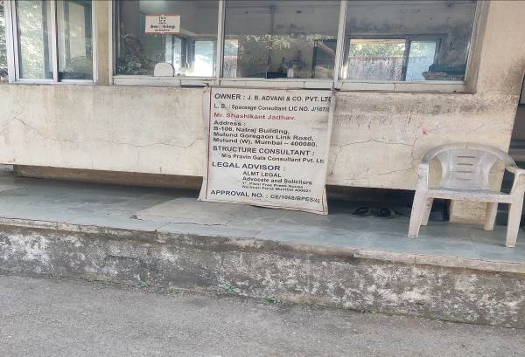
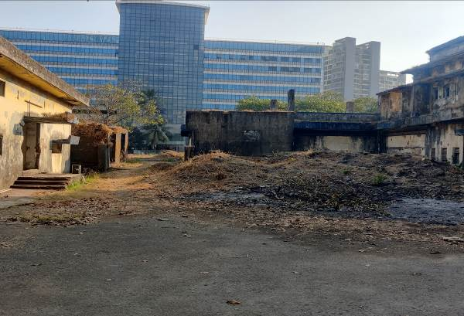

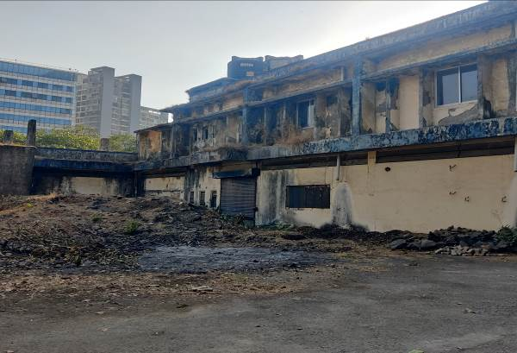
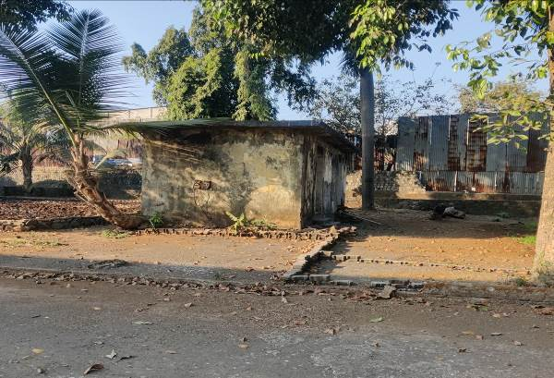

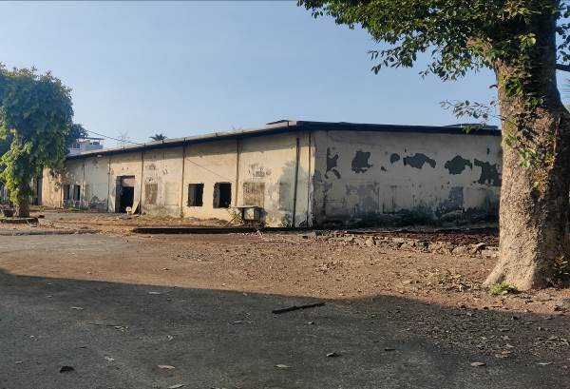
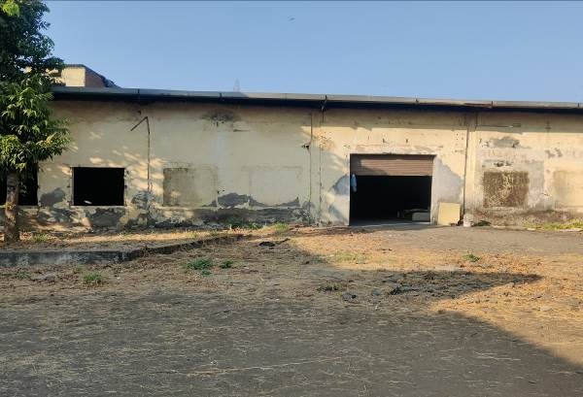

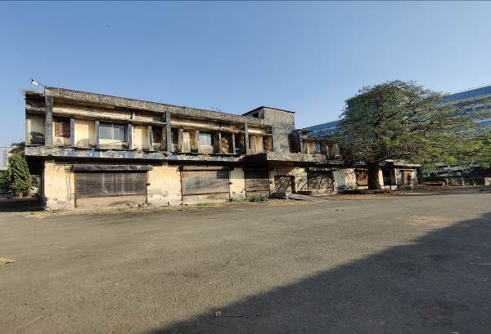
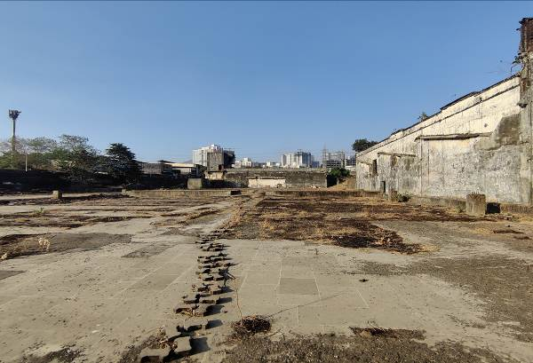

Actual site photographs
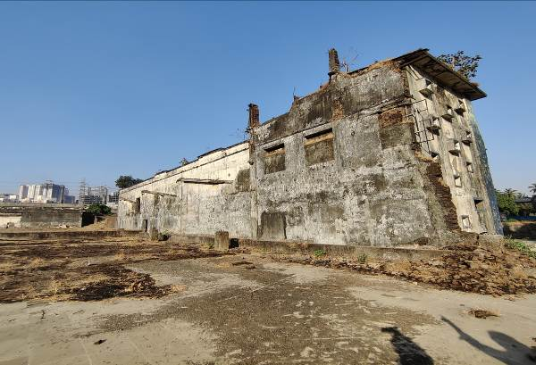
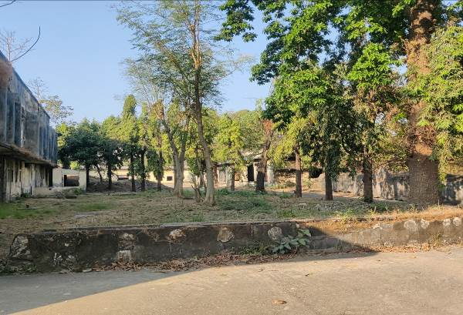

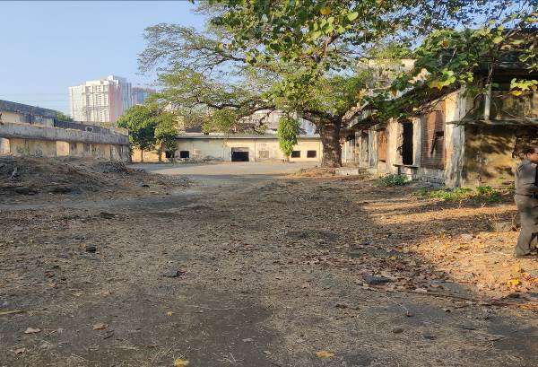
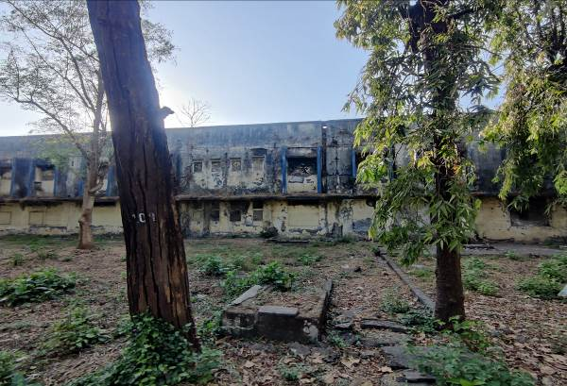

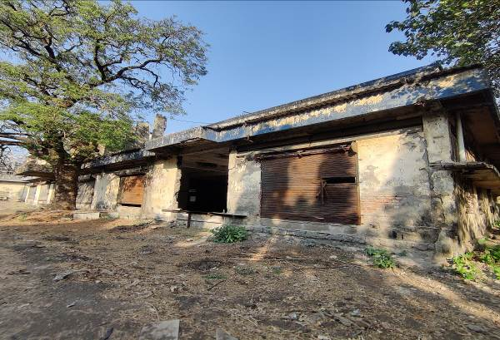
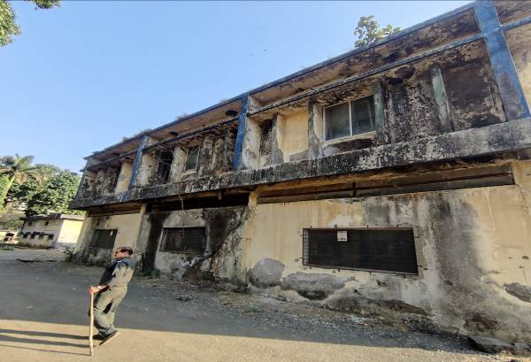

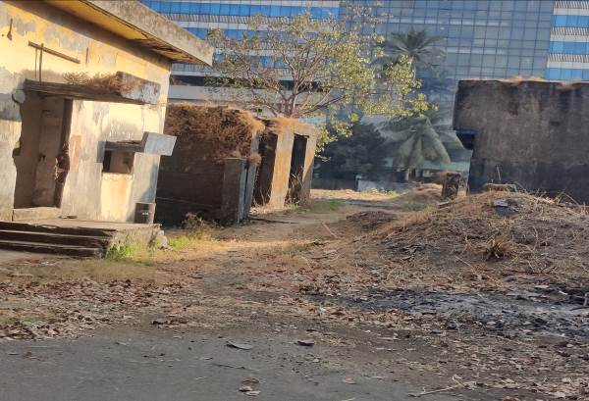
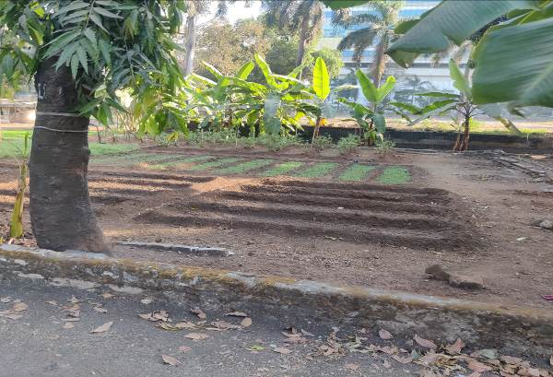

Actual site photographs
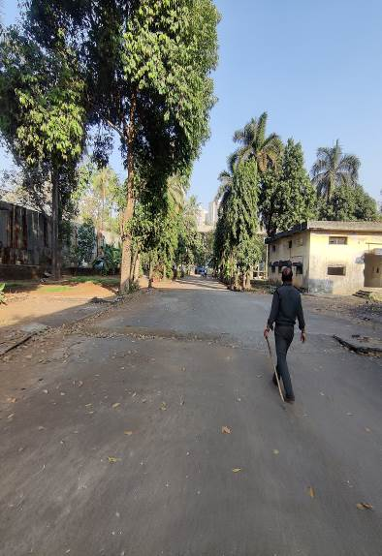
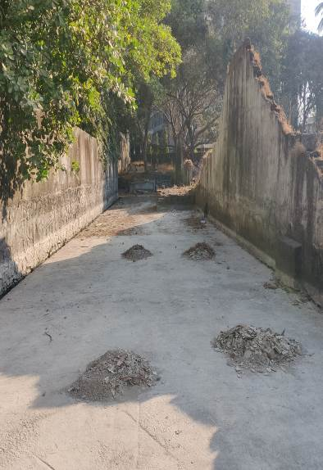
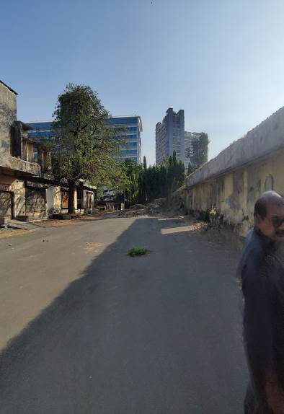

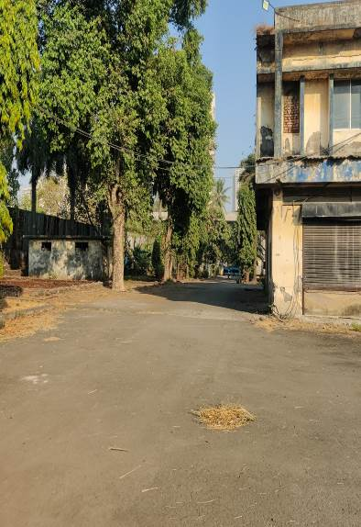
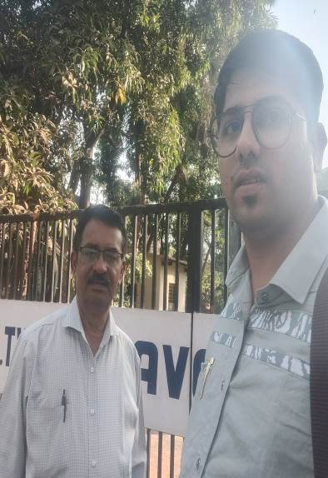
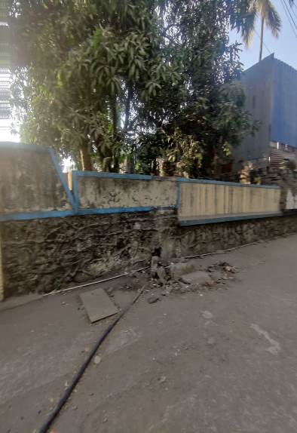

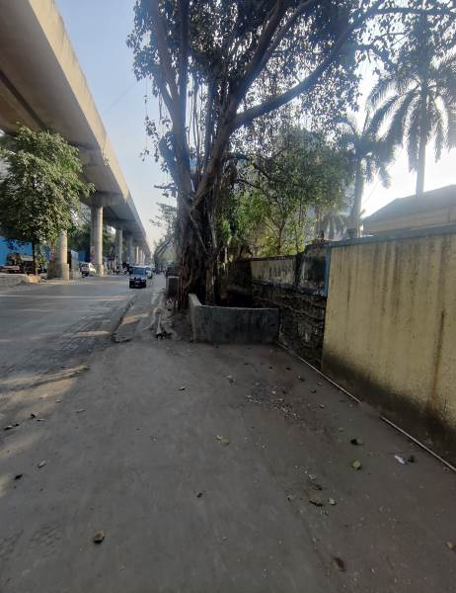
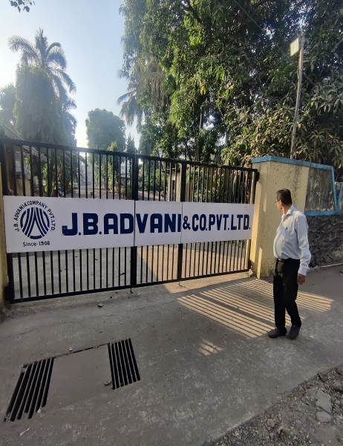

Route Map of the property
Site U/R
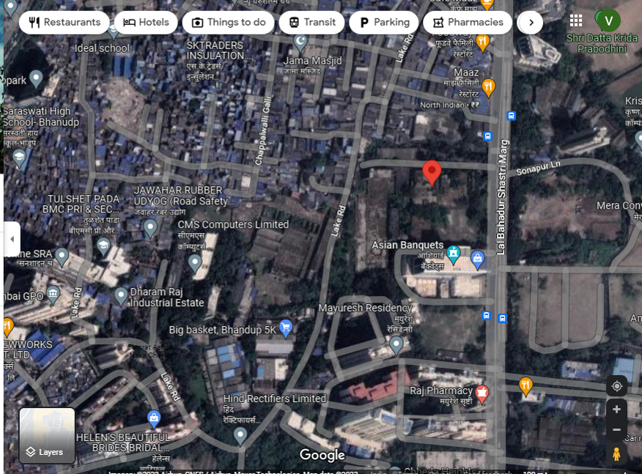

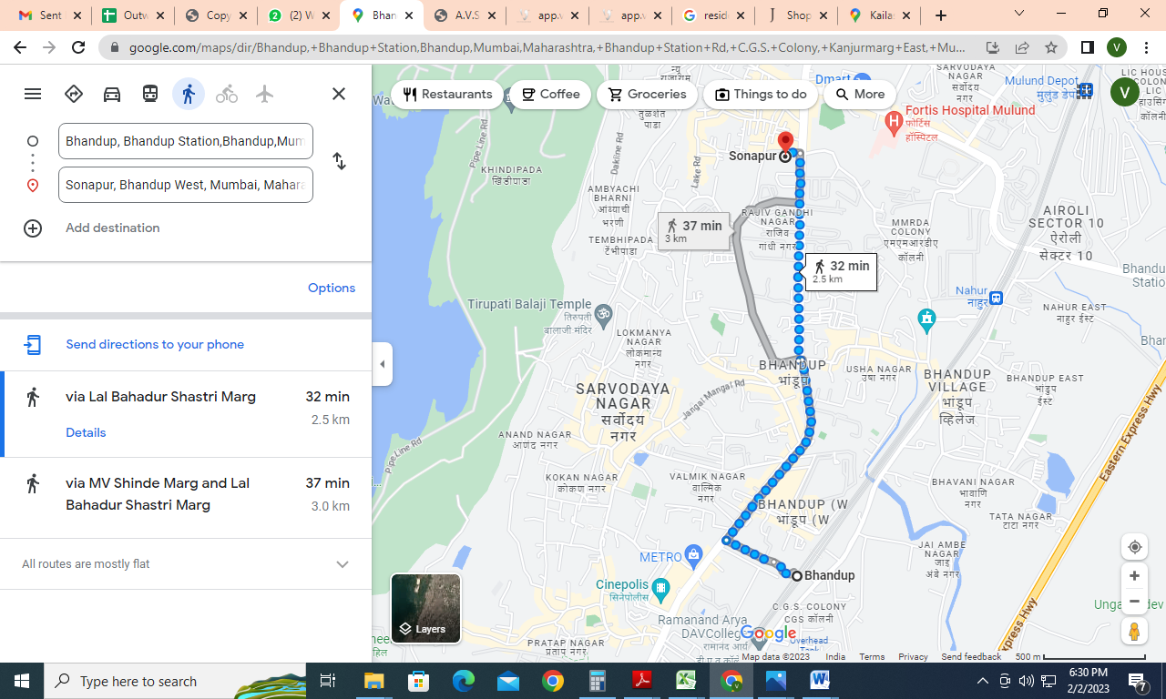

Latitude Longitude: 19°09'38.9"N 72°56'12.5"E
Note: The Blue line shows the route to site from nearest Railway station (Bhandup (West) – 2.5 KM.)

Ready Reckoner Rate for Year 2001

Rate for Property
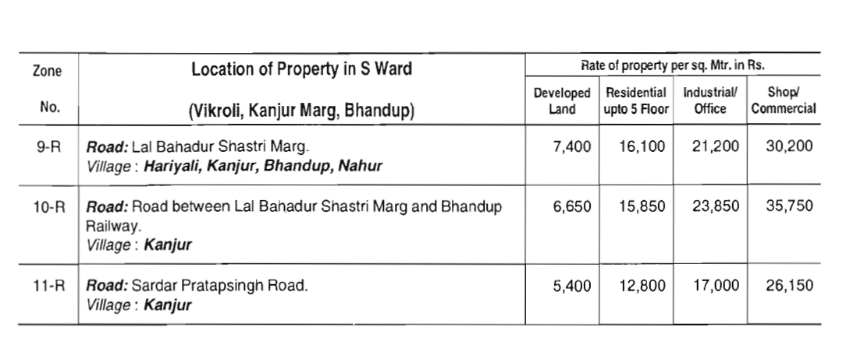

Construction Rate

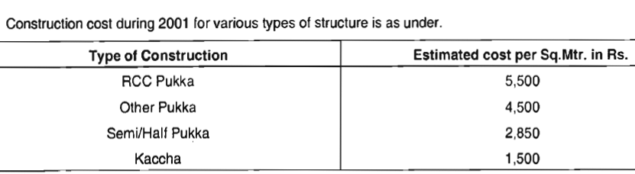

VALUATION OF THE PROPERTY PREMISES

Considering various parameters recorded herein above, existing economic scenario, and the information that is available with reference to the development of neighbourhood and method selected for valuation, we are of the opinion that, the property premises can be assessed and valued as on 1st April 2001 for ` 24,36,89,664/- (Rupees Twenty Four Crore Thirty Six Lakh Eighty Nine Thousand Six Hundred Sixty Four Only)

For Vastukala Architects & Engineers

Sharadkumar B. Chalikwar
Govt. Reg. Valuer
Chartered Engineer (India)
Reg. No. (N) CCIT/1-14/52/2008-09

