Vastu/Nashik/10/2023/004283/2302898
07/16-95 -RYBS
Date: 07.10.2023

To, `
The Branch Manager,
Bank of Baroda
Regional Office Nashik Road Branch
BSNL Building, Datta Mandir Road, Nashik Road,
Nashik -422 101, State - Maharashtra, Country - India.

Sub: Vetting of Extra Amenities

Sir,

With reference to above subject, we have evaluated the Extra Amenities for Residential Row Bungalow on Plot No. 57/ 1, Ground + First Floor, " Champaranya Row Bungalow ", Survey No. 06, Behind Shanti Nagar Bus Stop, Near Shree Ekdant Ganesh Garden, Ramkrishna Nagar, Village – Makhmalabad - 2, Taluka & District - Nashik, PIN Code – 422 004, State – Maharashtra, Country – India. belongs to Name of Proposed Purchaser: Shri. Rupesh Arun Badhan. Name of Owner: M/s. Shreemangal Buildcon.

We have verified the rates quoted as per current market rates. Details of work and Extra Amenities considered as per copy of Agreement for Extra Amenities Between by Shri. Rupesh Arun Badhan (First Party) and Shri. Shripal Champalal Bhatevara (Second Party) received on dated 26 September 2023. The Extra Amenities amount is Rs.5,00,000/- (Rupees Five Lakh Only)

The said Cost Vetting Certificate is valid upto next 6 months Only.

Thanking you

Sincerely yours

Sharadkumar B. Chalikwar
Govt. Reg. Valuer
Chartered Engineer (India)
Reg. No. (N) CCIT/1-14/52/2008-09
Encl: Valuation report.

Agreement for Extra Amenities
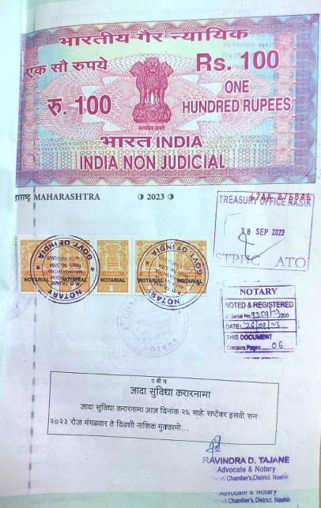
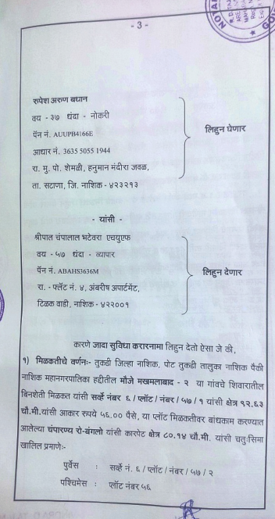

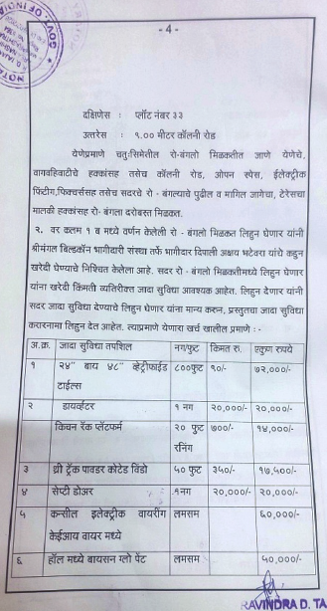
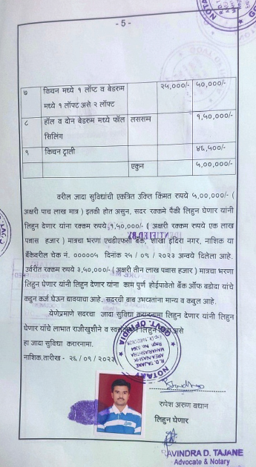

The Extra Amenities amount is Rs.5,00,000/- (Rupees Five Lakh Only)

