Valuation Report of the Immovable Property

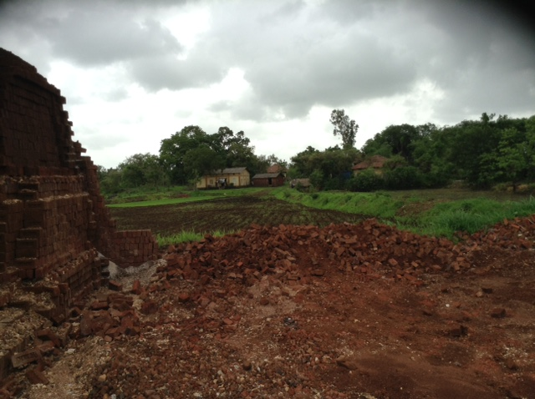

Details of the property under consideration:

Name of Owner: M/s. Shree Vaishnav Udyog Pvt. Ltd.

Amalgamated plots of bearing Survey No. 85 (Part), Survey No. 85 (Part), Survey No. 89 (Part 1), Survey No. 89 (Part 2), Survey No. 89 (Part 3), Survey No. 87 A, Survey No. 87 B & 88, Survey No. 293 (Part), Survey No. 294 (Part), Survey No. 298, Survey No. 295, Village Sapronde, Taluka Wada, P.O. Kudus Kondia Road,
Wada, District, Thane - 421 312

Latitude Longitude: 19°31'47.2"N 73°06'55.1"E

Valuation Done for:
State Bank of India
Commercial Branch, Mumbai
N.G.N. Vaidya Marg, Bank Street, Horiman Circle,
Post Box 10141, Mumbai - 400 001

Vastukala Consultants (I) Pvt. Ltd.
Mumbai • Nanded • Navi Mumbai • Aurangabad

Vastu/SBI/Mumbai/07/2015/010225
17/07-197-NM
Date: 17.07.2015

CERTIFICATE

This is to certify that the Amalgamated plots of bearing Survey No. 85 (Part), Survey No. 85 (Part), Survey No. 89 (Part 1), Survey No. 89 (Part 2), Survey No. 89 (Part 3), Survey No. 87 A, Survey No. 87 B & 88, Survey No. 293 (Part), Survey No. 294 (Part), Survey No. 298, Survey No. 295, Village Sapronde, Taluka Wada, P.O. Kudus Kondia Road, Wada, District Thane - 421 312 belongs to M/s. Shree Vaishnav Udyog Pvt. Ltd.
Boundaries of the property.

North | : | Open Land
South | : | Open Land
East | : | Internal Road & Open Land
West | : | Open Land
Considering various parameters recorded, existing economic scenario, and the information that is available with reference to the development of neighborhood and method selected for valuation, we are of the opinion that, the property premises along with business premium can be assessed and valued for this particular purpose at ` 9,88,90,000/-(Rupees Nine Crore Eighty Eight Lac & Ninety Thousand Only).

The valuation of the property is based on the documents produced by the concern. Legal aspects have not been taken into considerations while preparing this valuation report.

Hence certified

Sharad B. Chalikwar
Govt. Reg. Valuer & Chartered Engineer (India)
Reg. No. (N) CCIT/1-14/52/2008-09
Encl: Valuation report.
Valuation Report of Immovable Property

1. Introduction
a) |  |  | Name of the Property Owner  (with address & phone nos.) |  |  |  |  | M/s. Shree Vaishnav Udyog Pvt. Ltd.  Address – Amalgamated plots of bearing Survey No. 85 (Part), Survey No. 85 (Part), Survey No. 89 (Part 1), Survey No. 89 (Part 2), Survey No. 89 (Part 3), Survey No. 87 A, Survey No. 87 B & 88, Survey No. 293 (Part), Survey No. 294 (Part), Survey No. 298, Survey No. 295, Village Sapronde, Taluka Wada, P.O. Kudus Kondia Road, Wada, District Thane - 421 312.  Phone Nos. - +91 98812 34560 (Mr. Harish Agrawal – Director)
b) |  |  | Purpose of Valuation |  |  |  |  | As per request from State Bank of India, Commercial Branch, Mumbai, to assess fair market value of the property for bank loan purpose
c) |  |  | Date of Inspection of Property |  |  |  |  | 07.07.2015 (Property identified & shown by Mr. Vasant Narayan Patil – Company supervisor Mobile No. +91 92735 79177)
d) |  |  | Date of Valuation Report |  |  |  |  | 17.07.2015
e) |  |  | Name of the Developer of Property  (in case of developer built properties) |  |  |  |  | N.A.
2. Physical Characteristics of the Property
a) |  |  | Location of the Property |  |  |  |  | Amalgamated industrial plots of bearing Survey No. 85 (Part), Survey No. 85 (Part), Survey No. 89 (Part 1), Survey No. 89 (Part 2), Survey No. 89 (Part 3), Survey No. 87 A, Survey No. 87 B & 88, Survey No. 293 (Part), Survey No. 294 (Part), Survey No. 298, Survey No. 295, Village Sapronde, Taluka Wada, P.O. Kudus Kondia Road, Wada, District Thane - 421 312
 |  |  | Brief description of the property
The property is located in a developing industrial area well connected by road. The immovable property comprises of freehold amalgamated plots of Industrial land. It is located at about 5 to 10 minutes travelling distance from Kudus Bus Stop. As per revenue records the property is to be used as Industrial land only.
Land Area as per agreement –
Particular Survey No. | Area in Sq. M
85 (Part) | 24000
85 (Part) | 4000
89 (Part) | 6000
89 (Part) | 15830
89 (Part) | 9460
87 A | 3540
87 B & 88 | 5440
293 Part 1 | 1400
294 Part | 700
298 | 200
295 | 2200
Total area | 72770 Sq.M

 |  |  | Nearby landmark |  |  |  |  | Near Mohityacha Pada
 |  |  | Postal Address of the Property |  |  |  |  | Amalgamated plots of bearing Survey No. 85 (Part), Survey No. 85 (Part), Survey No. 89 (Part 1), Survey No. 89 (Part 2), Survey No. 89 (Part 3), Survey No. 87 A, Survey No. 87 B & 88, Survey No. 293 (Part), Survey No. 294 (Part), Survey No. 298, Survey No. 295, Village Sapronde, Taluka Wada, P.O. Kudus Kondia Road, Wada, District Thane - 421 312.
 |  |  | Area of the plot / land (supported by a plan) |  |  |  |  | 72770 Sq. M.  (Area as per agreement)
 |  |  | Type of Land: Solid, Rocky, Marsh land, reclaimed land, Water-logged, Land locked. |  |  |  |  | Industrial land
 |  |  | Independent access/approach to the property etc. |  |  |  |  | Yes.
 |  |  | Google Map Location of the Property with a neighborhood layout map |  |  |  |  | Provided.
 |  |  | Details of roads abutting the property |  |  |  |  | 6 M. wide B.T. Road (Cement concrete work is in progress)
 |  |  | Description of adjoining property |  |  |  |  | Located in Middle class rural locality
 |  |  | Plot No. Survey No. |  |  |  |  | Survey No. 85 (Part), Survey No. 85 (Part), Survey No. 89 (Part 1), Survey No. 89 (Part 2), Survey No. 89 (Part 3), Survey No. 87 A, Survey No. 87 B & 88, Survey No. 293 (Part), Survey No. 294 (Part), Survey No. 298, Survey No. 295
 |  |  | Ward/Village/Taluka |  |  |  |  | Village Sapronde, Taluka Wada, P.O. Kudus Kondia Road
 |  |  | Sub-Registry/Block |  |  |  |  | Wada
 |  |  | District |  |  |  |  | Thane
 |  |  | Any other aspect |  |  |  |  | -
b) |  |  | Plinth Area, Built up Area, are to be mentioned separately and clarified |  |  |  |  | N.A. as the property is open Industrial land
c) |  |  | Boundaries of the Plot
 |  |  | As per Sale Deed/TIR |  | North |  | South |  | East |  |  |  |  |  |  | West
 |  |  | Survey No.
 |  |  | Survey no. 85 (Part) |  | Gut No. 60 & 64 |  | Gut No. 86 & 89 |  | Gut No. 85 Balance Land & Gut No. 88 Land |  |  |  |  |  |  | Gut No. 66,83, 86 & 87
 |  |  | Survey No. 85 (Part) |  | Gut No. 60 B |  | Gut No. 88 |  | Village Usar Boundary lane |  |  |  |  |  |  | Gut No. 85 (Part) Dilip Kashinath Thakur Land
 |  |  | Survey No. 87 A |  | Gut No. 86 land |  | Gut No. 87B land |  | Gut No. 85 land |  |  |  |  |  |  | Gut No. 83 land
 |  |  | Survey No. 87 B |  | Gut No. 87 A land |  | Gut No. 89 land |  | Gut No. 85 & 89 land |  |  |  |  |  |  | Gut No. 89, 90 & 83 land
 |  |  | Survey No. 88 |  | Gut No. 85 land |  | Gut No. 89 land |  | Gut No. 85 land |  |  |  |  |  |  | Gut No. 85 land
 |  |  | Survey No. 89 (Part 1) |  | Shri. Sandeep Damodar Jadhav Land |  | Gut No. 115 land & Gut No. 89 (Part) & Prakash Pandurang Patil Land |  | Village Usar Boundary lane & Road |  |  |  |  |  |  | Gut No. 91 land, Gut No. 89 (Part) & Govind Jadhav Land
 |  |  | Survey No. 89 (Part 2) |  | Gut No. 85, 87 & 88 land |  | Gut No. 89 Part land |  | Village Usar Boundary lane |  |  |  |  |  |  | Gut No. 83 & 90 land
 |  |  | Survey No. 89 (Part 3) |  | Gut No. 83 & 90 land |  | Gut No. 89 Part & 110 land |  | Gut No. 83, 91 & 110 Land |  |  |  |  |  |  | Gut No. 89 Part
 |  |  | Survey No. 293 (Part) |  | Gut No. 294 is road |  | Kudus Kondal Road |  | Gut No. 293 (Part 1) Part Land |  |  |  |  |  |  | Village Sapronde Boundary lane
 |  |  | Survey No. 294 (Part) |  | Gut No. 295 is road |  | Gut No. 293 Road land |  | Gut No. 294 (Part 1) Part Land |  |  |  |  |  |  | Village Sapronde Boundary lane
 |  |  | Survey No. 295 (Part) |  | Ussar (Gut No. 298 Land & Village Sapronde Boundary lane |  | Gut No. 294 land |  | Gut No. 295 Part Land |  |  |  |  |  |  | Village Sapronde Boundary lane
 |  |  | Survey No. 298 (Part) |  | Gut No. 298 Part land |  | Gut No. 295 land |  | Gut No.298 Land |  |  |  |  |  |  | Village Sapronde Boundary lane
 |  |  | As per Site Inspection (Amalgamated Plots) |  | Open Plot |  | Open Plot |  | Internal Road & Open Plot |  |  |  |  |  |  | Open Plot
3. Town Planning parameters
a) |  |  |  | Master Plan provisions related to property in terms of land use |  |  |  | N.A. as the property is open Industrial land
a) |  |  |  | FAR- Floor Area Rise/FSI- Floor Space Index permitted & consumed |  |  |  | N.A. as the property is open Industrial land
a) |  |  |  | Ground coverage |  |  |  | N.A. as the property is open Industrial land
a) |  |  |  | Comment on whether OC- Occupancy Certificate has been issued or not |  |  |  | N.A. as the property is open Industrial land
a) |  |  |  | Comment on unauthorized constructions if any |  |  |  | N.A. as the property is open Industrial land
a) |  |  |  | Transferability of developmental rights if any, Building by-laws provision as applicable to the property viz. setbacks, height restriction etc. |  |  |  | No TDR Applicable
a) |  |  |  | Planning area/zone |  |  |  | Industrial
a) |  |  |  | Developmental controls |  |  |  | As per Development Control rules
a) |  |  |  | Zoning regulations |  |  |  | As per Development Control rules
a) |  |  |  | Comment on the surrounding land uses and adjoining properties in terms of uses |  |  |  | Agricultural & Industrial
a) |  |  |  | Comment on demolition proceedings if any |  |  |  | N.A. as the property is open Industrial land
a) |  |  |  | Comment on compounding / regularization proceedings |  |  |  | Land will be used for Industrial Purpose only. Land boundary cannot be defined at the time of site visit, hence area as per agreement is considered for the purpose of valuation.
a) |  |  |  | Any other Aspect
 | 4. Document Details and Legal Aspects of Property
a) |  |  |  | Ownership Documents
 |  |  |  | Sale Deed, Gift Deed, Lease Deed
 |  |  |  | - Copy of Agreements for sale
 |  |  |  | Conveyance Deed /Agreement date |  | Survey No. |  |  |  | AREA  (H – R –P) |  |  | Area in Sq. M.
 |  |  |  | 02.08.2007 |  | 85 (Part) |  |  |  | 2-40-0 |  |  | 24000
 |  |  |  | 20.02.2008 |  | 85 (Part) |  |  |  | 0-40-0 |  |  | 4000
 |  |  |  | 09.07.2007 |  | 89 (Part) |  |  |  | 0-60-0 |  |  | 6000
 |  |  |  | 09.07.2007 |  | 89 (Part) |  |  |  | 1-58-3 |  |  | 15830
 |  |  |  | 18.12.2007 |  | 89 (Part) |  |  |  | 0-94-6 |  |  | 9460
 |  |  |  | 20.02.2008 |  | 87 A |  |  |  | 0-35-4 |  |  | 3540
 |  |  |  | 20.02.2008 |  | 87 B & 88 |  |  |  | 0-54-4 |  |  | 5440
 |  |  |  | 09.07.2007 |  | 293 Part 1 |  |  |  | 0-14-0 |  |  | 1400
 |  |  |  | 09.07.2007 |  | 294 Part |  |  |  | 0-07-0 |  |  | 700
 |  |  |  | 09.07.2007 |  | 298 |  |  |  | 0-02-0 |  |  | 200
 |  |  |  | 25.06.2007 |  | 295 |  |  |  | 0-22-0 |  |  | 2200
 |  |  |  | Total area |  |  |  |  |  | 17.98 Acre |  |  | 72770.00
 |  |  |  | 2) Copy of 7/12 Extract
 |  |  |  | 3) Copy of Previous Valuation Report dated 16.04.2012 issued by Archinova Design INC
 |  |  |  | 4) TIR of the Property |  |  |  | Not provided
b) |  |  |  | Name of the Owner/s |  |  |  | M/s. Shree Vaishnav Udyog Pvt. Ltd
c) |  |  |  | Ordinary status of freehold or leasehold including restrictions on transfer |  |  |  | Freehold to be used as industrial only
d) |  |  |  | Agreement of easement if any |  |  |  | Information not available
e) |  |  |  | Notification of acquisition if any |  |  |  | Information not available
f) |  |  |  | Notification of road widening if any |  |  |  | Information not available
g) |  |  |  | Heritage restriction, if any |  |  |  | No
h) |  |  |  | Comment on transferability of the property ownership |  |  |  | As per TIR
i) |  |  |  | Comment on existing mortgages/charges/encumbrances on the property, if any |  |  |  | As per TIR
j) |  |  |  | Comment on whether the owners of the property have issued any guarantee (personal or corporate) as the case may be |  |  |  | Information not available
k) |  |  |  | Building plan sanction: Authority approving the plan - Name of the Unit of the Authority - Any violation from the approved Building Plan |  |  |  | N.A. as the property is open Industrial land
l) |  |  |  | Whether Property is Industrial Land if yes, any conversion is contemplated |  |  |  | Industrial Land
m) |  |  |  | Whether the property is SARFAESI compliant |  |  |  | As per TIR
n) |  |  |  | a. All legal documents, receipts related to electricity, Water tax, Municipal tax and other building taxes to be verified and copies as applicable to be enclosed with the report. b. Observation on Dispute or Dues if any in payment of bills/taxes to be reported. |  |  |  | All the provided documents are enclosed with the valuation report.
o) |  |  |  | Whether entire piece of land on which the unit is set up / property is situated has been mortgaged or to be mortgaged. |  |  |  | Information not available
p) |  |  |  | Qualification in TIR/mitigation suggested if any. |  |  |  | TIR report not provided
q) |  |  |  | Any other aspect |  |  |  | -
 | 5. Economic Aspects of the Property
a) |  |  |  | Reasonable letting value |  |  |  | N.A. as the property is open Industrial land
a) |  |  |  | If property is occupied by tenant |  |  |  | N.A.
a) |  |  |  | Number of tenants |  |  |  | N.A.
a) |  |  |  | Since how long (tenant- wise) |  |  |  | N.A.
a) |  |  |  | Status of tenancy right |  |  |  | N.A.
a) |  |  |  | Rent received per month (tenant-wise) with a comparison of existing market rent |  |  |  | N.A.
a) |  |  |  | Taxes and other outings |  |  |  | Not provided
a) |  |  |  | Property Insurance |  |  |  | N.A. as the property is open Industrial land
a) |  |  |  | Monthly maintenance charges |  |  |  | N.A.
a) |  |  |  | Security charges |  |  |  | N.A.
a) |  |  |  | Any other aspect
 | 6. Socio-cultural Aspects of the Property
a) |  |  |  | Descriptive account of the location of the property in terms of social structure of the area, population, social stratification, regional origin, economic level, location of slums, squatter settlements nearby, etc. |  |  |  | Developing industrial Locality, lower & Middle Class
b) |  |  |  | Whether property belongs to social infrastructure like hospital, school, old age homes etc. |  |  |  | No
 | 7. Functional and Utilitarian Aspects of the Property
a) |  |  |  | Description of the functionality and utility of the property in terms of:
 |  |  |  | Space allocation |  |  |  | N.A. as the property is open Industrial land
 |  |  |  | Storage Spaces |  |  |  | N.A. as the property is open Industrial land
 |  |  |  | Utility spaces provided within the building |  |  |  | N.A. as the property is open Industrial land
 |  |  |  | Car Parking facility |  |  |  | N.A. as the property is open Industrial land
 |  |  |  | Balconies, etc. |  |  |  | N.A. as the property is open Industrial land
b) |  |  |  | Any other aspect |  |  |  | -
 | 8. Infrastructure Availability
a) |  |  |  | Description of aqua infrastructure availability in terms of i.e.
a) |  |  |  | Water supply |  |  |  | Presently not available at site
a) |  |  |  | Sewerage/sanitation System Underground or Open |  |  |  | Presently not available at site
a) |  |  |  | Storm water drainage |  |  |  | Presently not available at site
b) |  |  |  | Description of other physical infrastructure facilities viz.
 |  |  |  | Solid waste management |  |  |  | Presently not available at site
 |  |  |  | Electricity |  |  |  | Presently not available at site
 |  |  |  | Road and public transport connectivity |  |  |  | Available
 |  |  |  | Availability of other public utilities nearby |  |  |  | All basic utilities available at Kudus
c) |  |  |  | Social infrastructure in terms of  - School  - Medical facilities  - Recreational facility in terms of parks and open space |  |  |  | Primary education facilities available at Kudus
 | 9. Marketability of the Property
a) |  |  |  | Marketability of the property in terms of |  |  |  | Location, development of surrounding area, terrain of land, road connectivity, present & future infrastructure facilities, prevailing market rate.
 |  |  |  | Locational attributes |  |  |  | Developing Area
 |  |  |  | Scarcity |  |  |  | Average
 |  |  |  | Demand and supply of the kind of subject property |  |  |  | Average
 |  |  |  | Comparable sale prices in the locality |  |  |  | Information not available
b) |  |  |  | Any other aspect which has relevance on the value or marketability of the property |  |  |  | Land parcels not contagious
 | 10. Engineering and Technology Aspects of the Property
a) |  |  | Type of construction |  |  |  |  | N.A. as the property is open Industrial land
b) |  |  | Material & technology used |  |  |  |  | N.A. as the property is open Industrial land
c) |  |  | Specifications, |  |  |  |  | N.A. as the property is open Industrial land
d) |  |  | Maintenance issues |  |  |  |  | N.A. as the property is open Industrial land
e) |  |  | Age of the building |  |  |  |  | N.A. as the property is open Industrial land
f) |  |  | Total life of the building |  |  |  |  | N.A. as the property is open Industrial land
g) |  |  | Extent of deterioration |  |  |  |  | N.A. as the property is open Industrial land
h) |  |  | Structural safety |  |  |  |  | N.A. as the property is open Industrial land
i) |  |  | Protection against natural disaster viz. earthquakes, |  |  |  |  | N.A. as the property is open Industrial land
j) |  |  | Visible damage in the building |  |  |  |  | N.A. as the property is open Industrial land
k) |  | System of air-conditioning |  |  |  |  |  | N.A. as the property is open Industrial land
l) |  | Provision of firefighting |  |  |  |  |  | N.A. as the property is open Industrial land
m) |  | Copies of the plan and elevation of the building to be included |  |  |  |  |  | N.A. as the property is open Industrial land
11. Environmental Factors
a) |  | Use of environment friendly building materials, Green Building techniques if any |  |  |  |  |  | N.A. as the property is open Industrial land
b) |  | Provision of rain water harvesting |  |  |  |  |  | N.A. as the property is open Industrial land
c) |  | Use of solar heating and lightening systems, etc., |  |  |  |  |  | N.A. as the property is open Industrial land
d) |  | Presence of environmental pollution in the vicinity of the property in terms of industry, heavy traffic etc. |  |  |  |  |  | N.A. as the property is open Industrial land
12. Architectural and aesthetic quality of the Property
a) |  | Descriptive account on whether the building is modern, old fashioned, plain looking or decorative, heritage value, presence of landscape elements etc. |  |  |  |  |  | N.A. as the property is open Industrial land
13. Valuation
a) |  | Methodology of valuation – Procedures adopted for arriving at the valuation. Valuers may consider various approaches and state explicitly the reason for adopting particular approach and assumptions made, basis adopted with supporting data, comparable sales, and reconciliation of various factors on which final value judgment is arrived at. |  |  |  |  |  | Land Valuation Method used for this valuation report.
b) |  | Prevailing Market Rate/Price trend of the Property in the locality/city from property search sites viz magickbricks.com, 99acres.com, makaa  n.com etc. if available |  |  |  |  |  | 50,00,000/- per Acre to 60,00,000/- Per Acre
c) |  | Guideline Rate obtained from the Stamp Duty Ready Reckoner for Land |  |  |  |  |  | Rate in Sq.M `
 |  | Land |  |  |  |  |  | 920.00
d) |  | Summary of Valuation
 |  | - Guideline Value
 |  |  |  |  |  |  |  | Area in  Sq. M. |  |  | Rate in ` |  |  | Value in `
 |  | Land |  |  |  |  |  | 72770.00 |  |  | 920.00 |  |  | 6,69,48,400/-
 |  | Total Value |  |  |  |  |  |  |  |  |  |  |  | 6,69,48,400/-
 |  | - Fair Market Value
 |  |  |  |  |  |  |  | Area in  Acre |  |  | Rate in per Acre ` |  |  |  | Value in `
 |  | Land |  |  |  |  |  | 17.98 Acre |  |  | 55,00,000.00 |  |  |  | 9,88,90,000/-
 |  | Summary of Valuation
 |  | Total Value of the Property |  |  |  |  |  | ` 9,88,90,000/-
 |  | Realizable Value |  |  |  |  |  | ` 8,90,01,000/-
 |  | Forced/ Distress Sale value. |  |  |  |  |  | ` 7,91,12,000/-
e) |  | In case of variation of 20% or more in the valuation proposed by the valuer and the Guideline value provided in the State Govt. notification or Income Tax Gazette justification on variation has to be given. |  |  |  |  |  | Price Indicators Attached
 |  | Details of last two transactions in the locality/area to be provided, if available. |  |  |  |  |  | Not available
14. Declaration
I hereby declare that:
- The information provided is true and correct to the best of my knowledge and belief.
- The analysis and conclusions are limited by the reported assumptions and conditions.
- I have read the Handbook on Policy, Standard and Procedures for Real Estate Valuation by Banks and HFIs in India, 2011, issued by IBA and NHB, fully understood the provisions of the same and followed the provisions of the same to the best of my ability and this report is in conformity to the Standards of Reporting enshrined in the above Handbook.
- I have no direct or indirect interest in the above property valued.
- I/ my authorized representative, has inspected the subject property on 07.07.2015
- I am a registered Valuer under Section 34AB of Wealth Tax Act, 1957, Category-I for valuing property up to no limit
- I am an approved Valuer under SARFAESI ACT-2002 and am approved by the Bank.
- I have not been depanelled or removed from any Bank/Financial Institution/Government Organization at any point of time in the past.
- I have submitted the Valuation Report (s) directly to the Bank.

S. B. Chalikwar
Govt. Reg. Valuer & Chartered Engineer (India)
Wealth Tax Reg. No.: (N) CCIT/1-14/52/2008-09

Address:
Vastukala Consultants (I) Pvt. Ltd.
Unit No. 121, 1st Floor, Ackruti Star,
Central Road, MIDC, Andheri (East),
Mumbai - 400 093

Name of Valuer association of which I am a bonafide member in good standing: Institution of Valuers & Practicing Valuers Association of India.
Date 06.07.2015
Tel No. - +91 22 26571324 /25
Mobile No. - +91 98195 97579
Email Id – mumbai@vastukala.org

15. Enclosures
a) |  | Layout plan sketch of the area in which the property is located with latitude and longitude |  |  |  |  |  | Latitude and longitude provided along with satellite image of the building
b) |  | Building Plan |  |  |  |  |  | N.A.
c) |  | Floor Plan |  |  |  |  |  | N.A.
d) |  | Site Photograph of the property |  |  |  |  |  | Attached
e) |  | Certified copy of the approved / sanctioned plan wherever applicable from the concerned Unit |  |  |  |  |  | N.A. as the property is open Industrial land
f) |  | Google Map location of the property |  |  |  |  |  | Attached
g) |  | Price trend of the Property in the locality/city from property search sites viz Magickbricks.com,99Acres.com, Makan.com, stamp duty ready reckoner etc. |  |  |  |  |  | Attached
h) |  | Any other relevant documents/ extracts |  |  |  |  |  | All Documents mentioned in report

[

Actual Site Photographs
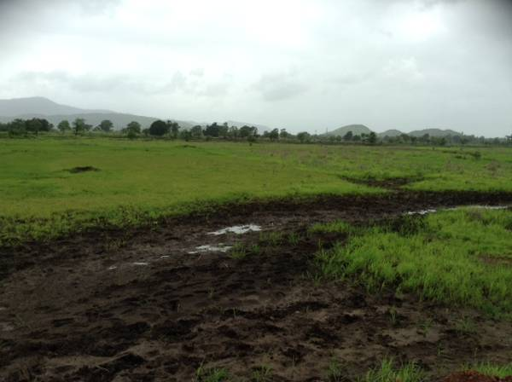
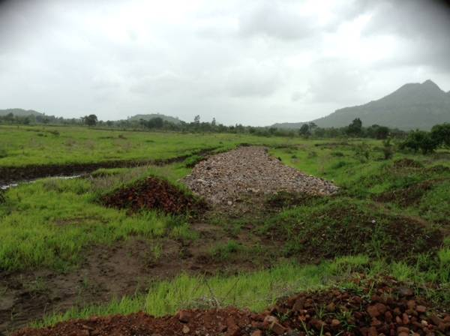

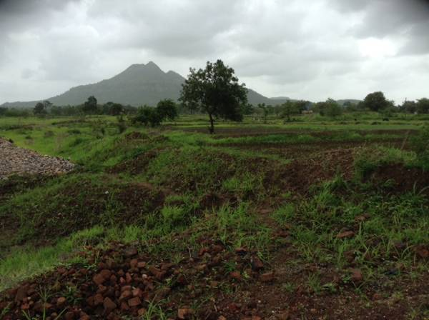
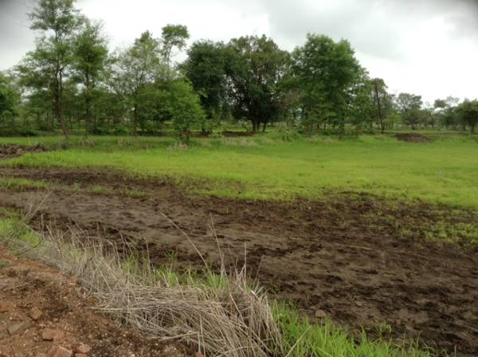

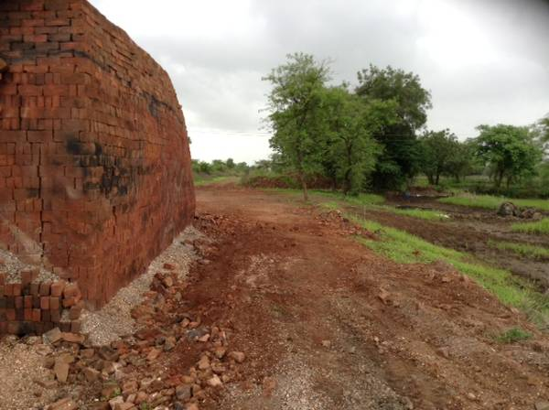
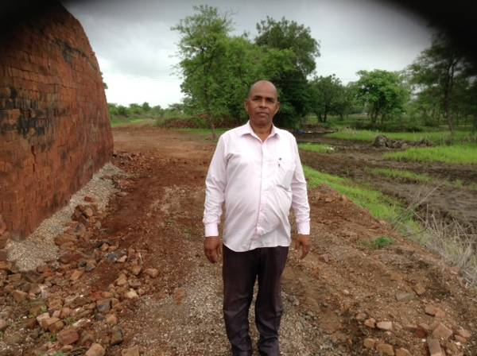

Actual Site Photographs
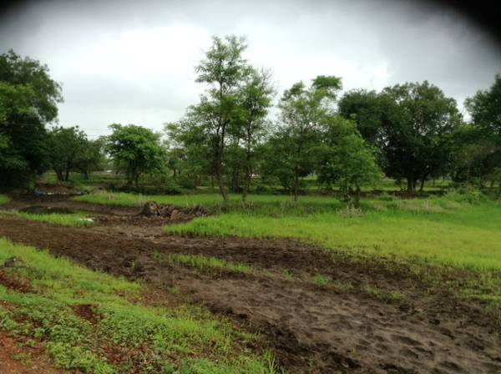
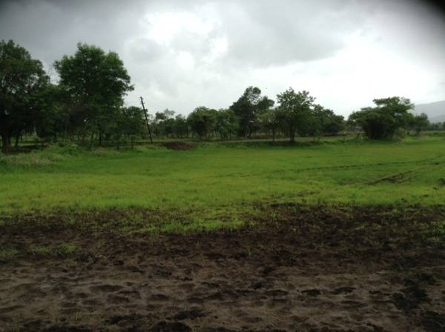

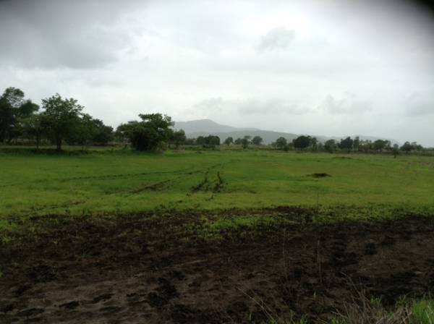

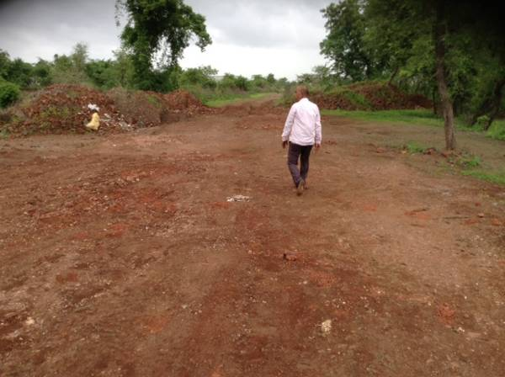
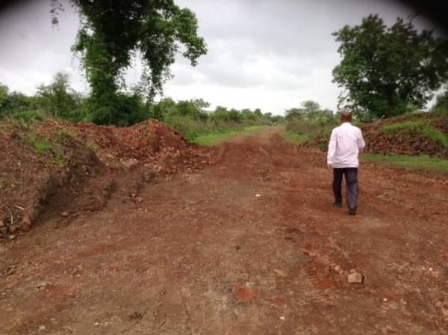

Route Map of the property
Site u/r
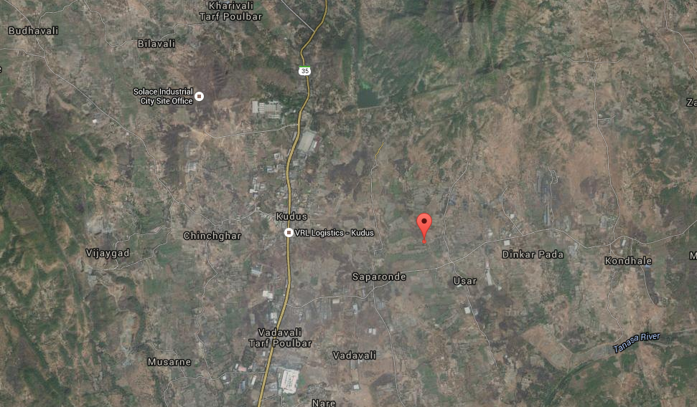

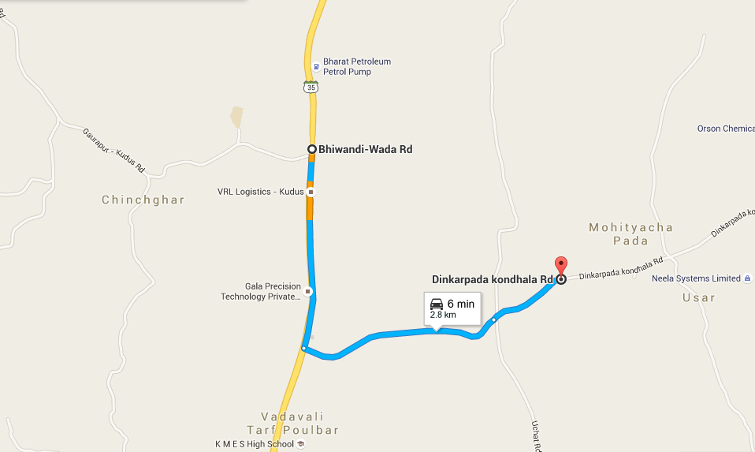

[

Latitude Longitude: 19°31'47.2"N 73°06'55.1"E

Note: The Blue line shows the route to site from nearest Bus Stop (Kudus – 2.8 Km.)

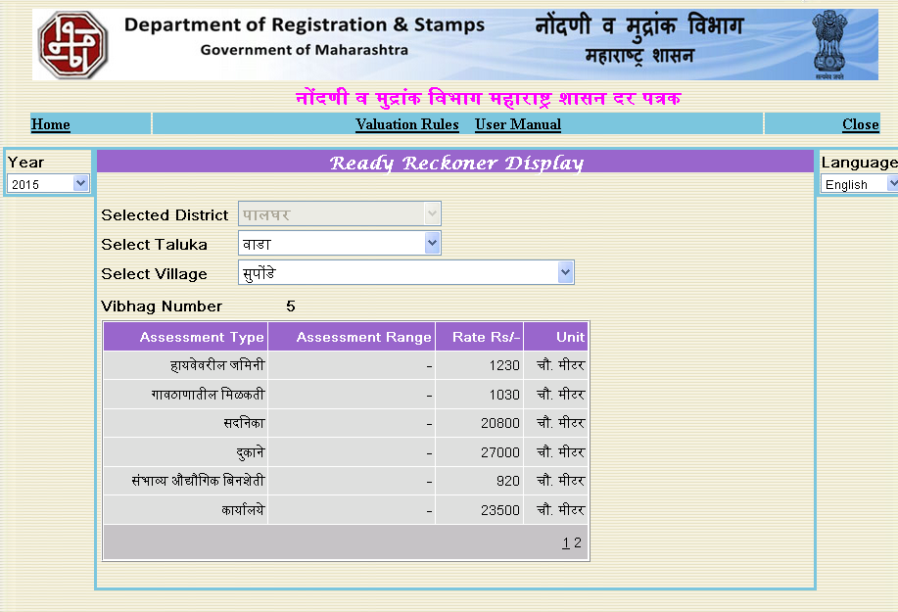
Ready Reckoner Rate

Price Indictor
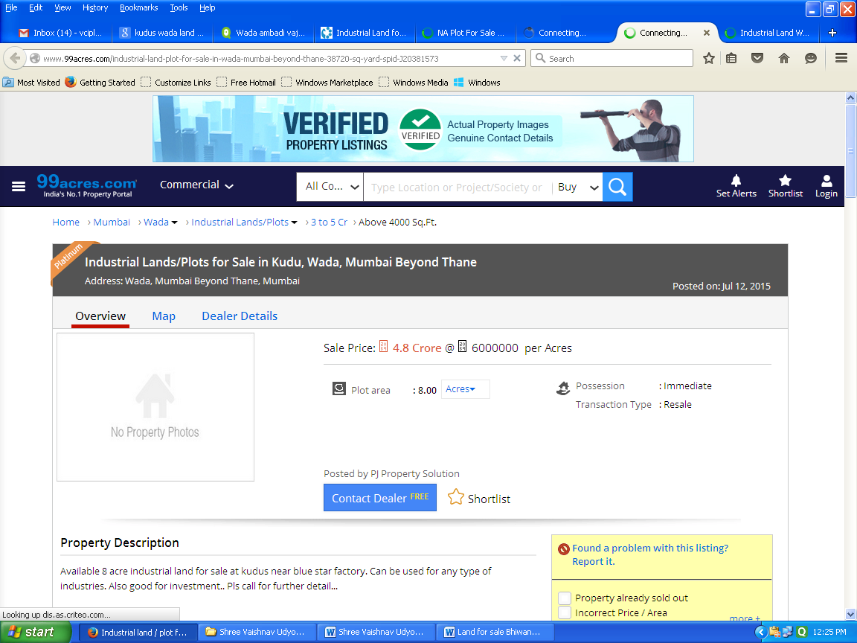

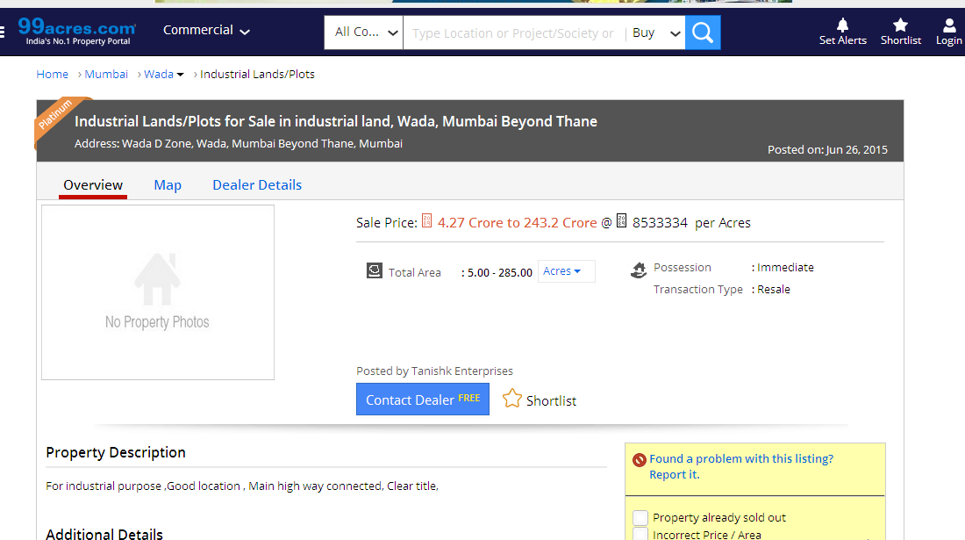

DEFINITION OF VALUE FOR THIS SPECIFIC PURPOSE

This exercise is to assess Fair Market Value of the property under reference as on 17th July 2015.

The term Fair Market Value is defined as

“The most probable price, as of a specified date, in cash, terms equivalent to cash, or in other precisely revealed terms for which the specified property rights would sell after reasonable exposure in a competitive market under all conditions requisite to a fair sale, with the buyer and seller each acting prudently knowledgeably and for self-interest assuming that neither is under undue duress”.

Fundamental assumptions and conditions presumed in this definition are:

1. Buyer and seller are motivated by self-interest.
2. Buyer and seller are well informed and are acting prudently.
3. The property is exposed for a reasonable time on the open market.
4. Payment is made in cash or equivalent or in specified financing terms.

UNDER LYING ASSUMPTIONS
1. We assume no responsibility for matters of legal nature affecting the property appraised or the title thereto, nor do we render our opinion as to the title, which is assumed to be good and marketable.
2. The property is valued as though under responsible ownership.
3. It is assumed that the property is free of liens and encumbrances.
4. It is assumed that there are no hidden or unapparent conditions of the subsoil or structure that would render it more or less valuable. No responsibility is assumed for such conditions or for engineering that might be required to discover such factors.

Sharad B. Chalikwar
Govt. Reg. Valuer & Chartered Engineer (India)
Reg. No. (N) CCIT/1-14/52/2008-09

DECLARATION OF PROFESSIONAL FEES CHARGED

We hereby declare that, our professional fees are not contingent upon the valuation findings. However, if the statute AND/OR clients demands that, the fees should be charged on the percentage of assessed value then, with the full knowledge of the AND/OR end user, it is being charged accordingly.

VALUATION OF THE PROPERTY PREMISES

Considering various parameters recorded herein above, existing economic scenario, and the information that is available with reference to the development of neighborhood and method selected for valuation, we are of the opinion that, the property premises along with business premium can be assessed and valued for this particular purpose at ` 9,88,90,000/-(Rupees Nine Crore Eighty Eight Lac & Ninety Thousand Only).

STATEMENT OF LIMITING CONDITIONS

1. Assumptions are made to the best of our knowledge and belief. Reliance is based on the information furnished to us by the identifier AND/OR client.
2. The valuer shall not be responsible for matters of legal nature that affects the value and opinion expressed by us.
3. If our appearance is required, we will be pleased to appear and give the necessary clarification, provided the fees for each appearance (excluding traveling, dearness allowance and out of pocket expenses) is pre-determined before the acceptance of the assignment under reference.
4. In no event shall the valuer be held responsible or liable for special, direct, indirect or consequential damages, as the assignment has been completed on best efforts, available knowledge and in good intentions of persons concerned and belief.
5. If it is proved that there is an apparent negligence on the part of a valuer, liability of this assignment (whether arising from this assignment, negligence or whatsoever) is limited in respect of anyone event or series of events to the actual loss or damage sustained subject to maximum of 80% of the professional fees for the services rendered and in any case not exceeding the amount of ` 1,000/- (Rupees one Thousand Only). All the claims against us shall expire after three month from the date of submission of the valuation report provided by us.
6. We hereby declare that, the information furnished above is true and correct to the best of our knowledge and belief. We have no direct or indirect interest in the assets valued. We have not been convicted of any offence and sentenced to a term of imprisonment. We have not been found guilty of misconduct in our professional capacity.

Sharad B. Chalikwar
Govt. Reg. Valuer & Chartered Engineer (India)
Reg. No. (N) CCIT/1-14/52/2008-09

