Valuation Report of the Immovable Property

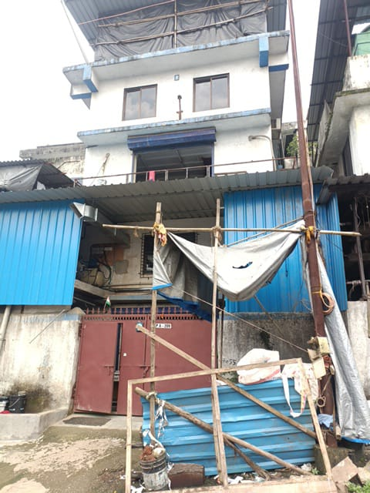

**Details of the property under consideration:**

Name of Borrower A/c: **M/s. Sri Packaging**

Name of Owner: **Mrs. Krishna Sravani Cherukuri**

**Industrial Land & Building** on Plot No. PAP – A - 209, **“Trans Thane Creek Industrial Area”,** M.I.D.C.,

Village – Mahape, Taluka & District – Thane, PIN – 400 710, State – Maharashtra, Country – India

# Latitude Longitude - 19°07'04.4"N 73°01'23.7"E

# 

**Valuation Done for:**

**Cosmos Bank**

# Naupada Thane Branch

# Kusumanjali, Opp. Deodhar Hospital, Naupada, State - Maharashtra, Country – India

Vastu/Thane/10/2023/004127/2300085

13/12-83-AU Date: 13.10.2023

# VALUATION OPINION REPORT

The property bearing **Industrial Land & Building** on Plot No. PAP – A - 209, **“Trans Thane Creek Industrial Area”,** M.I.D.C., Village – Mahape, Taluka & District – Thane, PIN – 400 710, State – Maharashtra, Country – Indiabelongs to **Mrs. Krishna Sravani Cherukuri.**

|  |  |  |
| --- | --- | --- |
| **Boundaries of the property.** | | |
| North | : | Plot No. A – 377 | |
| South | : | Road | |
| East | : | Plot No. PAP – A – 208 | |
| West | : | Plot No. PAP – A - 210 | |

Considering various parameters recorded, existing economic scenario, and the information that is available with reference to the development of neighborhood and method selected for valuation, we are of the opinion that, the property premises can be assessed and valued for banking purpose as below –

|  |  |
| --- | --- |
| **Particulars** | **Value (`)** |
| **Fair Market Value** | **64,55,418.00** |
| **Realizable Value** | **58,09,876.00** |
| **Distress Sale Value** | **51,64,334.00** |
| **Insurance Value** | **13,59,456.00** |

The valuation of the property is based on the documents produced by the concern. Legal aspects have not been taken into considerations while preparing this valuation report.

Hence certified

## Manoj B. Chalikwar

Registered Valuer

Chartered Engineer (India)

Reg. No. IBBI / RV / 07/2018/10366

Reg. No. CAT-I-F-1763

Encl: Valuation report in Form – 01

**Industrial Land & Building** on Plot No. PAP – A - 209, **“Trans Thane Creek Industrial Area”,** M.I.D.C., Village – Mahape, Taluka & District – Thane, PIN – 400 710, State – Maharashtra, Country – India

*Form 0-1*

*(See Rule 8 D)*

REPORT OF VALUATION OF IMMOVABLE PROPERTY (OTHER THAN AGRICULTURAL LANDS, PLANTATIONS, FORESTS, MINES AND QUARRIES)

GENERAL:

|  |  |  |  |
| --- | --- | --- | --- |
| 1 | Purpose for which the valuation is made | | To assess the Fair Market Value as on 13.10.2023 for Bank loan Purpose |
| 2 | Date of inspection | | 30.09.2023 |
|  | Name of the owner/ owners | | **Mrs. Krishna Sravani Cherukuri** |
| 4 | If the property is under joint ownership / co-ownership, share of each such owner. Are the shares undivided? | | Sole Ownership |
| 5 | Brief description of the property | | **Industrial Land & Building** on Plot No. PAP – A - 209, **“Trans Thane Creek Industrial Area”,** M.I.D.C., Village – Mahape, Taluka & District – Thane, PIN – 400 710, State – Maharashtra, Country – India. |
| 6 | Location, street, ward no | | Village – Mahape, Off Shil Phata – Mahape Road |
| 7 | Survey/ Plot no. of land | | Plot No. PAP – A – 209 |
| 8 | Is the property situated in residential/ commercial/ mixed area/ industrial area? | | Industrial area |
| 9 | Classification of locality-high class/ middle class/poor class | | Middle Class |
| 10 | Proximity to civic amenities like schools, Hospitals, Offices, market, cinemas etc. | | All the amenities are available in the vicinity |
| 11 | Means and proximity to surface communication by which the locality is served | | Served by Buses, Auto, and Private cars |
|  | *LAND* | |  |
| 12 | Area of land supported by documentary proof. Shape, dimension and physical features | | 100.00 Sq. M.  (As per Lease Deed) |
| 13 | Roads, Streets or lanes on which the land is abutting | | Village – Mahape, Off Shil Phata – Mahape Road |
| 14 | If freehold or leasehold land | | Leasehold land from M.I.D.C. |
| 15 | If leasehold, the name of Lessor/lessee, nature of lease, date of commencement and termination of lease and terms of renewal of lease. | | Details not available |
| (i) Initial premium | | Details not available |
| (ii) Ground rent payable per annum | | Details not available |
| (iii) Unearned increase payable to the Lessor in the event of sale or transfer | | Details not available |
| 16 | Is there any restriction covenant in regard to use of land? If so attach a copy of the covenant. | | Industrial |
| 17 | Are there any agreements of easements? If so, attach a copy of the covenant | | Information not available |
| 18 | Does the land fall in an area included in any Town Planning Scheme or any Development Plan of Government or any statutory body? If so, give Particulars. | | Maharashtra Industrial Development Corporation |
| 19 | Has any contribution been made towards development or is any demand for such contribution still outstanding? | | Information not available |
| 20 | Has the whole or part of the land been notified for acquisition by government or any statutory body? Give date of the notification. | | No |
| 21 | Attach a dimensioned site plan | | Copy of Approved Building Plan digitally signed by Yashwant K Meshram dated 27.08.2018, 17:32:54 +05’30’ |
|  | *IMPROVEMENT* | |  |
| 22 | Attach plans and elevations of all structures standing on the land and a lay-out plan. | | Copy of Approved Building Plan digitally signed by Yashwant K Meshram dated 27.08.2018, 17:32:54 +05’30’ |
| 23 | Furnish technical details of the building on a separate sheet (The Annexure to this form may be used) | | Attached |
| 24 | Is the building owner occupied/tenanted/both? | | Owner Occupied in the name & style of M/s. Sri Packaging |
|  | If the property owner occupied, specify portion and extent of area under owner-occupation | | Fully Owner Occupied |
| 25 | What is the Floor Space Index permissible and Percentage actually utilized? | | As per Building Completion Certificate   |  |  |  | | --- | --- | --- | | **Particulars** | **Permissible**  **F.S.I.** | **Consumed**  **F.S.I.** | | Plot No. PAP – A - 209 | 1.00 | 0.99 | |
| 26 | *RENTS* | |  |
|  | (i) | Names of tenants/ lessees/ licensees, etc. | N.A. |
|  | (ii) | Portions in their occupation | N.A. |
|  | (iii) | Monthly or annual rent/ compensation / license fee, etc. paid by each | N.A. |
|  | (iv) | Information not available | N.A. |
| 27 | Are any of the occupants related to, or close to business associates of the owner? | | N.A. |
| 28 | Is separate amount being recovered for the use of fixtures, like fans, geysers, refrigerators, cooking ranges, built-in wardrobes, etc. or for services charges? If so, give details | | N.A. |
| 29 | Give details of the water and electricity charges, if any, to be borne by the owner | | Information not available |
| 30 | Has the tenant to bear the whole or part of the cost repairs and maintenance? Give particulars | | N.A. |
| 31 | If a lift is installed, who is to bear the cost of maintenance and operation- owner or tenant? | | N.A. |
| 32 | If a pump is installed, who is to bear the cost of maintenance and operation- owner or tenant? | | N.A. |
| 33 | Who has to bear the cost of electricity charges for lighting of common space like entrance hall, stairs, passage, compound, etc. owner or tenant? | | N.A. |
| 34 | What is the amount of property tax? Who is to bear it? Give details with documentary proof | | Information not available |
| 35 | Is the building insured? If so, give the policy no., amount for which it is insured and the annual premium | | Information not available |
| 36 | Is any dispute between landlord and tenant regarding rent pending in a court of rent? | | N.A. |
| 37 | Has any standard rent been fixed for the premises under any law relating to the control of rent? | | As per M.I.D.C. norms |
|  | *SALES* | |  |
| 38 | Give instances of sales of immovable property in the locality on a separate sheet, indicating the Name and address of the property, registration No., sale price and area of land sold. | | As per sub registrar of assurance |
| 39 | Land rate adopted in this valuation | | ` 50,000.00 Per Sq. M. |
| 40 | If sale instances are not available or not relied up on, the basis of arriving at the land rate | | Online Price Indicators, Location, development of surrounding area, type of land and construction, construction specifications, age of building, condition of the premises & building, facilities provided and its prevailing market rate. |
|  | *COST OF CONSTRUCTION* | |  |
| 41 | Year of commencement of construction and year of completion | | 2018  (As per Building Completion Certificate) |
| 42 | What was the method of construction, by contract / By employing Labour directly / both? | | Information Not available |
| 43 | For items of work done on contract, produce copies of agreements | | Information Not available |
| 44 | For items of work done by engaging Labour directly, give basic rates of materials and Labour supported by documentary proof. | | Information Not available |

*PART II- VALUATION*

GENERAL:

Under the instruction of Cosmos Bank, Naupada Thane Branch to assess fair market value as on **13th October 2023** for **Industrial Land & Building** on Plot No. PAP – A - 209, **“Trans Thane Creek Industrial Area”,** M.I.D.C., Village – Mahape, Taluka & District – Thane, PIN – 400 710, State – Maharashtra, Country – India belongs to **Mrs. Krishna Sravani Cherukuri.**

We are in receipt of the following documents:

|  |  |
| --- | --- |
|  | Copy of Lease Deed (7 pages from the document) dated 13.02.2019 b/w. M.I.D.C. (the Lessor) AND Mrs. Krishna Sravani Cherukuri (the Lessee) |
|  | Copy of Order dated 13.02.2019 issued by M.I.D.C. |
|  | Copy of Occupancy Certificate No. EE/ MHP II/ Plot No. PAP – A - 209 / IFMS / D49434 dated 17.10.2018 issued by M.I.D.C. |
|  | Copy of Building Completion Certificate No. EE/ MHP II/ Plot No. PAP – A - 209 / IFMS / D49434 dated 17.10.2018 |
|  | Copy of Burglary Insurance Policy, Policy No. OG – 23 – 1104 – 4010 – 00000832, Issue Date – 20.03.2023, Valid upto 15.03.2024 issued by Bajaj Allianz General Insurance Company Ltd., Insurance Amount – ` 2,25,00,000/- |
|  | Copy of M.I.D.C. Letter No. DE / MHP (C) / PAP – A – 209 / IFMS / C86809 / 18 dated 27.08.2018 for approval of Fresh Engineering Workshop Building & drainage plans |
|  | Copy of Approved Building Plan digitally signed by Yashwant K Meshram dated 27.08.2018, 17:32:54 +05’30’ |

**Property:**

The said property is **Industrial Land & Building** on Plot No. PAP – A - 209, **“Trans Thane Creek Industrial Area”,** M.I.D.C., Village – Mahape, Taluka & District – Thane, PIN – 400 710, State – Maharashtra, Country – India. It is falls in Industrial Zone. It is at 2.4 KM. travel distance from Ghansoli Railway station.

**As per Lease Deed / Building Completion Certificate, the Plot area is 100.00 Sq. M. and considered for the purpose of valuation.**

**BUILDING:**

Structure area consist of Factory Building of Ground + 3 upper floor. It is R.C.C. Framed structure With A. C. Sheet roofing on top terrace above 3rd floor. The composition is manufacturing / processing area + Office working area. The top terrace area is used for storage purpose. Open space on ground floor is partly covered into lean to Sheds area.

The factory is finished with Kota Stone Flooring. 6" thick B. B. Masonry internal walls with cement plastering + Neeru finish and 9" thick B.B. Masonry external wall with sand faced plaster finish, Power coated sliding windows, Glass Wooden frame door with M. S. Rolling Shutter, Partly industrial and Partly Concealed type Wiring and plumbing.

**As per Building Completion Certificate / Approved building plan, the construction area is as below which is considered for the purpose of valuation.**

|  |  |
| --- | --- |
| **Particulars** | **Built up Area in Sq. M.** |
| Factory Building |  |
| Ground Floor | 49.98 |
| First Floor | 49.98 |
| **Total** | **99.96** |

**Valuation as on 13th October 2023:**

1. **Land Valuation**

|  |  |  |  |
| --- | --- | --- | --- |
| **Particulars** | **Area in Sq. M.** | **Rate per Sq. M.** | **Value in `** |
| Plot No. PAP – A - 209 | 100.00 | 50,000.00 | 50,00,000.00 |
| **Total** | | | **50,00,000.00** |

1. **Valuation of Structures.**

The Built-up area of the building : 99.96 Sq. M.

**Deduct Depreciation:**

Year of Construction of the building : 2018

Expected total life of building : 50 Years

Age of the building as on 2023 : 5 Years

Cost of Construction : ` 16,000.00

Depreciation : As per valuation table below

Amount of depreciation : As per valuation table below

**Depreciated cost of construction** : As per valuation table below

|  |  |  |  |  |  |
| --- | --- | --- | --- | --- | --- |
| **Particulars** | **Built up Area in**  **Sq. M.** | **Estimated Replacement Rate in `** | **Depreciated Replacement Rate in `** | **Depreciated Replacement Value in `** | **Full Value**  **in `** |
| Factory Building | 99.96 | 16,000 | 14,560 | 14,55,418 | 15,99,360 |
| **Total** |  |  |  | **14,55,418** | **15,99,360** |

**GUIDELINE VALUE:**

|  |  |
| --- | --- |
| M.I.D.C. Circle Rate for Land per Sq. M. | ` 25,108.00 |

|  |  |
| --- | --- |
| **Particulars** | **Value (`)** |
| **Land** | 100.00 |
| **Rate per Sq. M.** | 25,108.00 |
| **Total Land Value** | **25,10,800.00** |
| **Total Building Value**  (As per valuation table) | **14,55,418.00** |
| **TOTAL** | **39,66,218.00** |

**TOTAL VALUE OF THE PROPERTY:**

|  |  |
| --- | --- |
| **Particulars** | **Value (`)** |
| **Land** | 50,00,000.00 |
| **Buildings** | 14,55,418.00 |
| **Fair Market Value** | **64,55,418.00** |
| **Realizable Value** | **58,09,876.00** |
| **Distress Sale Value** | **51,64,334.00** |
| **Insurable Value** (Full Replacement Cost (15,99,360/-) – Subsoil structure cost (15%) | **13,59,456.00** |

Taking into consideration above said facts, we can evaluate the value of **Industrial Land & Building** on Plot No. PAP – A - 209, **“Trans Thane Creek Industrial Area”,** M.I.D.C., Village – Mahape, Taluka & District – Thane, PIN – 400 710, State – Maharashtra, Country – India for this particular purpose at **` 64,55,418.00 (Amount in words Rupees Sixty Four Lakhs Fifty Five Thousand Four Hundred Eighteen Only)** as on **13th October 2023.**

**NOTES**

1. I, Manoj B. Chalikwar with my experience and ability to judgment I am of the considered opinion that the fair market value of the property as on 13th October 2023 is ` 64,55,418.00 (Amount in words Rupees Sixty Four Lakhs Fifty Five Thousand Four Hundred Eighteen Only).
2. Value varies with time and purpose and hence this value should not be referred for any purpose other than mentioned in this report.
3. This valuation is done on the basis of information, which the valuer has obtained by information provided by the client about the premises and location of the surrounding area and also prevailing rates in the surrounding area, and further subject to document as mentioned in valuation report.
4. This valuer should not be held responsible for authentication of documents, clear title and other such related matters. For that purpose, Latest Legal Opinion should be sought.

*PART III- DECLARATION*

I hereby declare that

* + 1. The information furnished in part I is true and correct to the best of my knowledge and belief;
    2. I have no direct or indirect interest in the property valued:

ANNEXURE TO FORM 0-1

Technical details Main Building

|  |  |  |
| --- | --- | --- |
| 1. | No. of floors and height of each floor | As per brief description |
| 2. | Plinth area floor wise as per IS- 1225 | Plot Area = 100.00 Sq. M.  Structure - 99.96 Sq. M.  (As per Building Completion Certificate) |
| 3 | Year of construction | Year - 2018  (As per Building Completion Certificate) |
| 4 | Estimated future life | 45 Years Subject to proper, preventive periodic maintenance and structural repairs. |
| 5 | Type of construction- load bearing walls/RCC frame/ steel frame | As per brief description |
| 6 | Type of foundations | R.C.C. Footing |
| 7 | Walls | All external walls are 9” thick and partition walls are 6” thick. |
| 8 | Partitions | 6” thick brick wall |
| 9 | Doors and Windows | Power coated sliding windows, Glass Wooden frame door with M. S. Rolling Shutter |
| 10 | Flooring | Kota Stone Flooring |
| 11 | Finishing | Internal walls are finished with Neeru Finish. External walls are finished with sand faced plaster. |
| 12 | Roofing and terracing | RCC slabs and A.C. sheet roofing on top |
| 13 | Special architectural or decorative features, if any | No |
| 14 | |  |  | | --- | --- | | (i) | Internal wiring – surface or conduit | | (ii) | Class of fittings: Superior/ Ordinary/ Poor. | | Partly Concealed wiring and Partly Open Industrial type wiring  Ordinary |
| 15 | Sanitary installations   |  |  | | --- | --- | | (i) | No. of water closets | | (ii) | No. of lavatory basins | | (iii) | No. of urinals | | (iv) | No. of sinks |   Class of fittings: Superior colored / superior white/ordinary. | As per requirement having ordinary class of fitting |
| 16 | Compound wall  Height and length  Type of construction | Compound wall of R.C.C. columns with Brick Masonry wall |
| 17 | No. of lifts and capacity | No Lift |
| 18 | Underground sump – capacity and type of construction | R.C.C. |
| 19 | Over-head tank Location, capacity Type of construction | R.C.C. |
| 20 | Pumps- no. and their horse power | Information not available |
| 21 | Roads and paving within the compound approximate area and type of paving | Concrete cement finish in open spaces, etc. |
| 22 | Sewage disposal – whereas connected to public sewers, if septic tanks provided, no. and capacity | Connected to M.I.D.C. sewer line |
| 23 | General Remarks |  |
|  | 1. *For the purpose of valuation, we have considered the plot area as per lease deed / approved building plan.* 2. *As per site inspection, the building is Ground + 3 Upper floors. But as per approved building plan / Building completion Certificate, the building is Ground + 2 Upper floors. For the purpose of valuation, we have considered the construction area as per approved building plan / Building completion Certificate.* | |

**Actual site photographs**

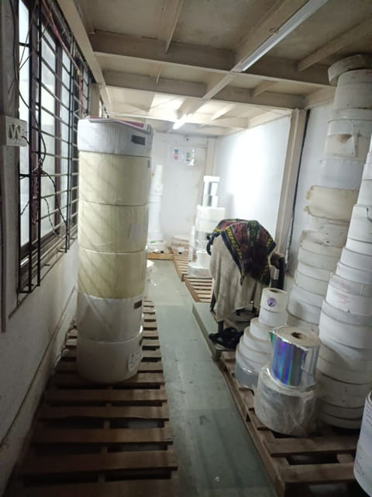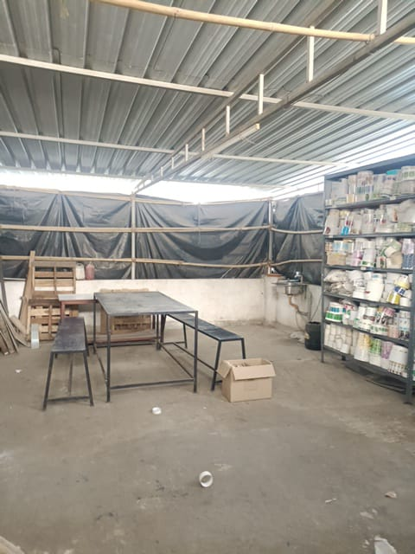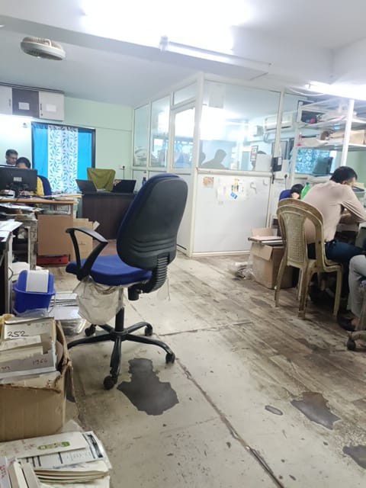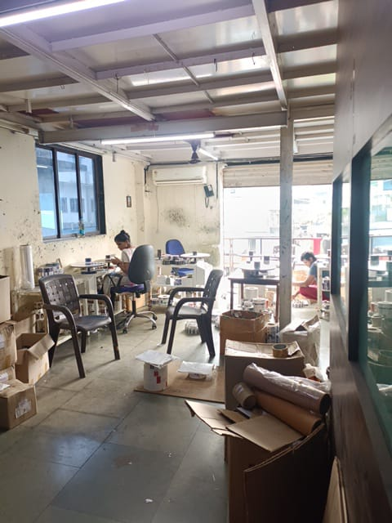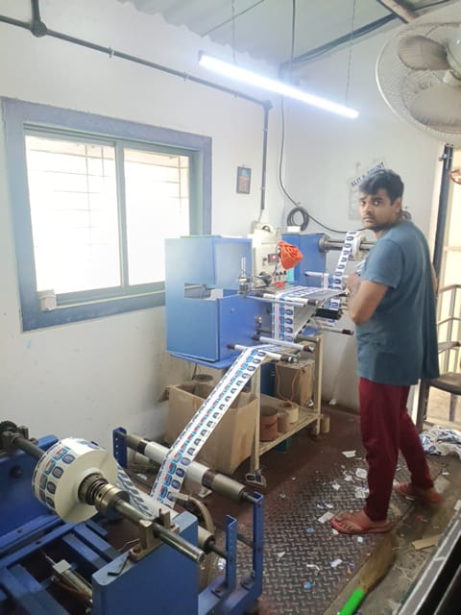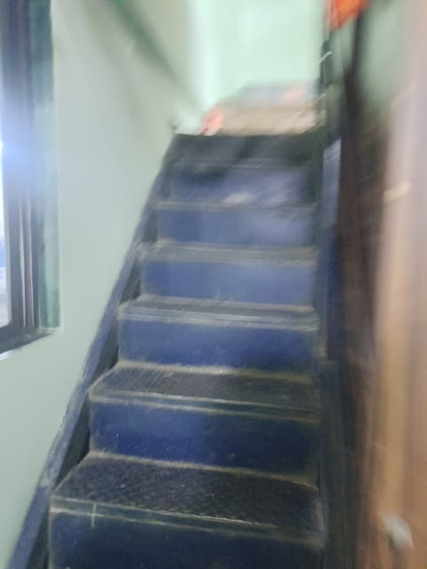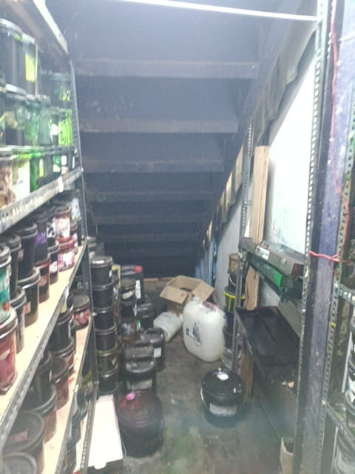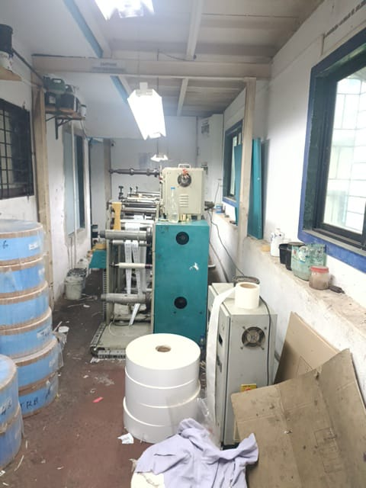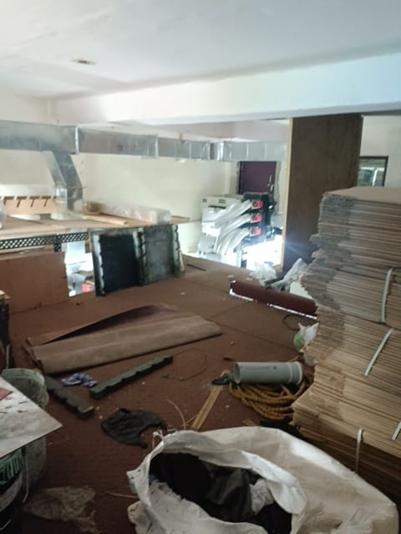

**Actual site photographs**

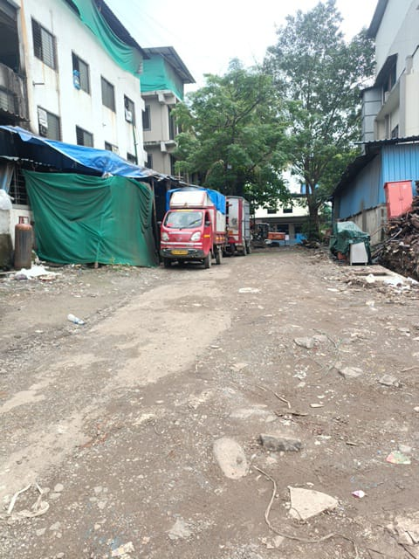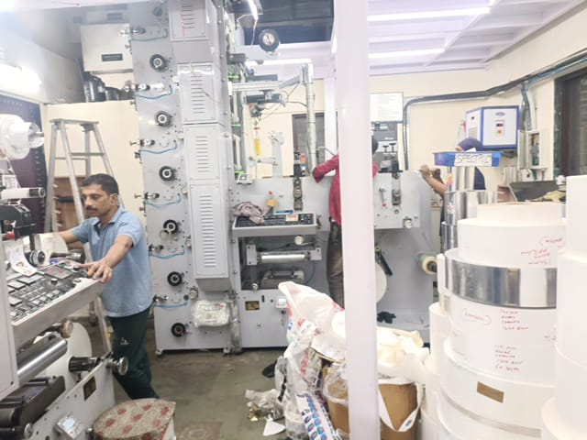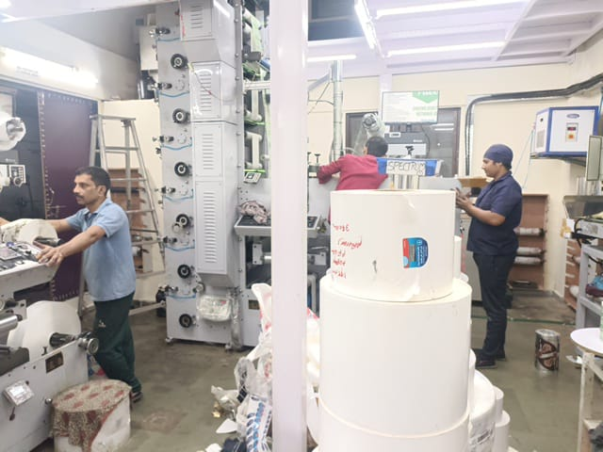

Route Map of the property

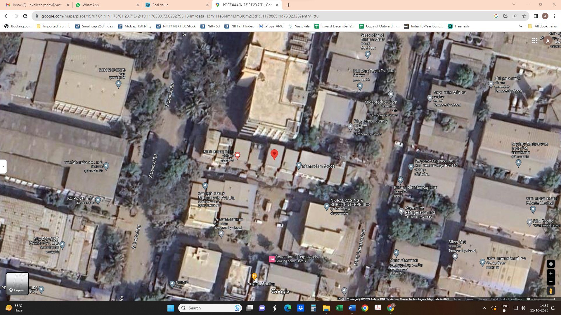**Site u/r**

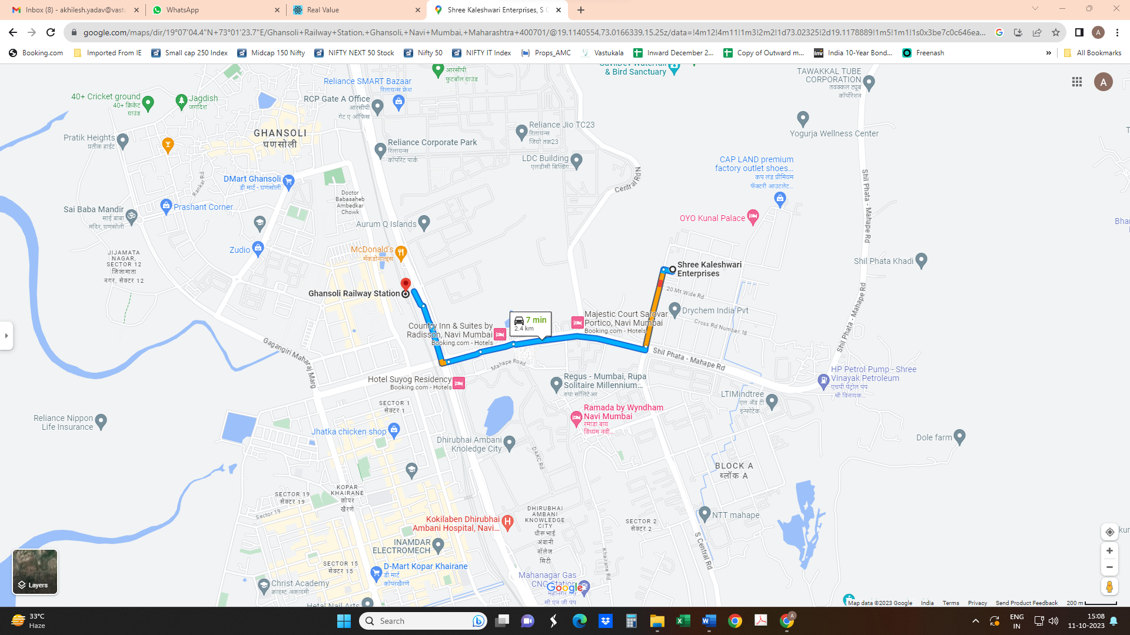

# Latitude Longitude - 19°07'04.4"N 73°01'23.7"E

**Note:** The Blue line shows the route to site from nearest Railway Station (Ghansoli – 2.4 KM.)

**M.I.D.C. MAP**

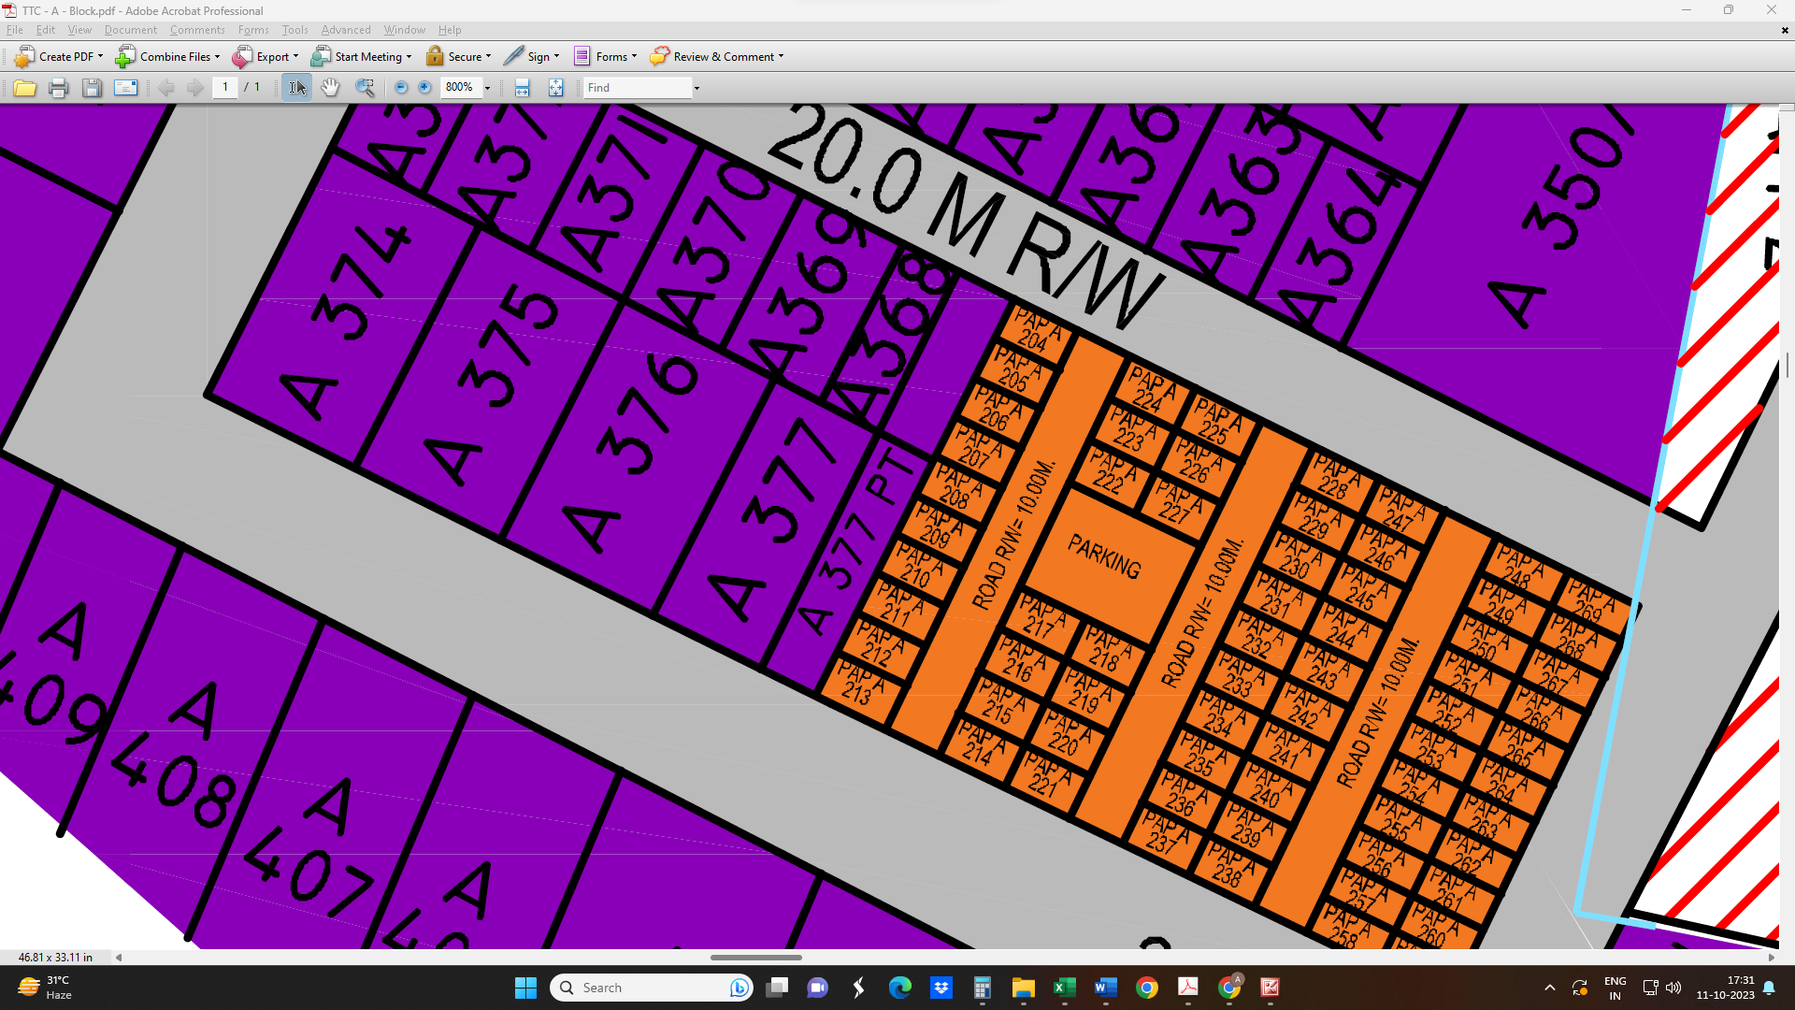

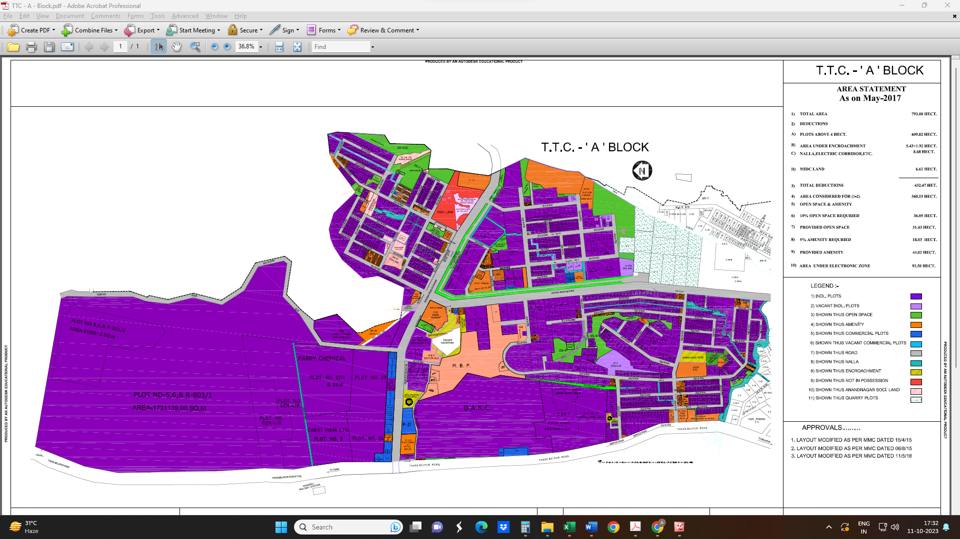

**M.I.D.C. CIRCLE RATE**

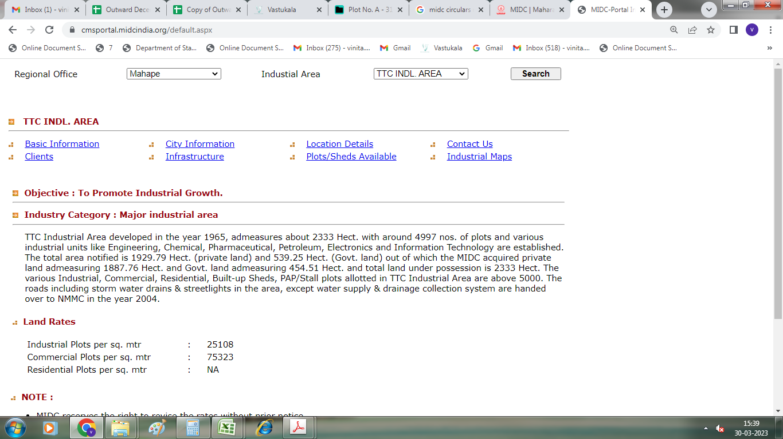

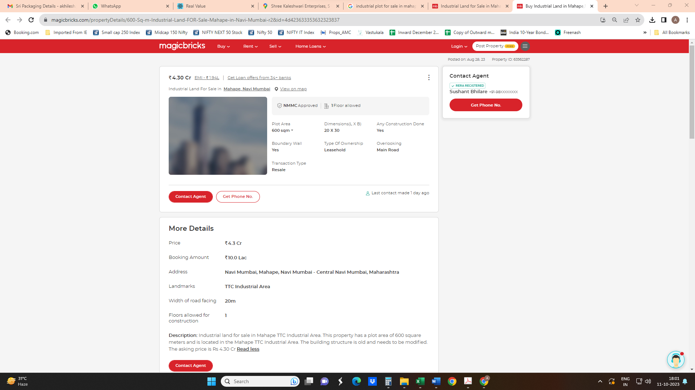**Price Indicators**

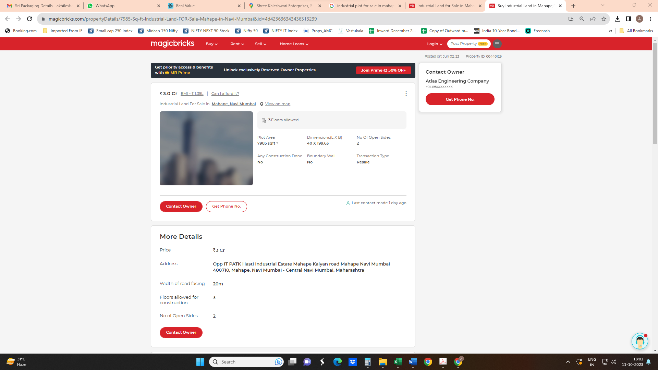

**DEFINITION OF VALUE FOR THIS SPECIFIC PURPOSE**

This exercise is to assess **Fair Market Value** of the property under reference as on **13th October 2023.**

The term **Fair Market Value** is defined as

*“The most probable price, as of a specified date, in cash, terms equivalent to cash, or in other precisely revealed terms for which the specified property rights would sell after reasonable exposure in a competitive market under all conditions requisite to a fair sale, with the buyer and seller each acting prudently knowledgeably and for self-interest assuming that neither is under undue duress”.*

Fundamental assumptions and conditions presumed in this definition are:

1. Buyer and seller are motivated by self-interest.

2. Buyer and seller are well informed and are acting prudently.

3. The property is exposed for a reasonable time on the open market.

4. Payment is made in cash or equivalent or in specified financing terms.

#### UNDER LYING ASSUMPTIONS

1. We assume no responsibility for matters of legal nature affecting the property appraised or the title thereto, nor do we render our opinion as to the title, which is assumed to be good and marketable.

2. The property is valued as though under responsible ownership.

3. It is assumed that the property is free of liens and encumbrances.

4. It is assumed that there are no hidden or unapparent conditions of the subsoil or structure that would render it more or less valuable. No responsibility is assumed for such conditions or for engineering that might be required to discover such factors.

5. There is no direct/ indirect interest in the property valued

6. The rates for valuation of the property are in accordance with the Govt. approved rates and prevailing market rates.

## Manoj B. Chalikwar

Registered Valuer

Chartered Engineer (India)

Reg. No. IBBI / RV / 07/2018/10366

Reg. No. CAT-I-F-1763