Valuation Report of the Immovable Property

Details of the property under consideration:

Name of Owner: Mr. Praful Nanji Satra & Mrs. Minaxi Praful Satra

Residential Bungalow “Satra Villa” Plot No. 76, Survey No. 18, 23, 24, Hissa No. 1 to 5, Lonavala, Village – Tungarli, Taluka – Maval, Dist. – Pune, State - Maharashtra, Country - India.

Latitude Longitude - 18°46'16.6"N 73°23'47.6"E

Valuation Done for:

Union Bank of India
Bandra (East) Branch
Renuka Co-Op Hsg. Soc. Ltd., Behind Guru Nanak Hospital,
Bandra (East), Mumbai - 400 051, State – Maharashtra, Country – India.

Vastukala Consultants (I) Pvt. Ltd.
Mumbai • Delhi NCR • Nanded • Aurangabad

Vastu/Mumbai/06/2013/007986/23597
26/09-349-N
Date: 26.06.2017

VALUATION OPINION REPORT

The property bearing Residential Bungalow “Satra Villa” Plot No. 76, Survey No. 18, 23, 24, Hissa No. 1 to 5, Lonavala, Village – Tungarli, Taluka – Maval, Dist. – Pune, State - Maharashtra, Country - India belongs to Mr. Praful Nanji Satra & Mrs. Minaxi Praful Satra.
Boundaries of the property.
North | : | Internal Road
South | : | Rohira Bungalow
East | : | Road
West | : | Arun Govil Bungalow
Considering various parameters recorded, existing economic scenario, and the information that is available with reference to the development of neighborhood and method selected for valuation, we are of the opinion that, the property premises can be assessed and valued for this particular purpose at ` 7,39,04,000/- (Rupees Seven Crore Thirty Nine Lac Four Thousand Only).

The valuation of the property is based on the documents produced by the concern. Legal aspects have not been taken into considerations while preparing this valuation report.

Hence certified

Manoj B. Chalikwar
Approved Valuer & Chartered Engineer
Reg. No. CAT-I-F-1763
Encl: Valuation report.

VALUATION REPORT IN RESPECT OF IMMOVABLE PROPERTY

1 | Date of Inspection | : | 23rd June 2017
 | Purpose of valuation | : | As per request from Union Bank of India, Bandra (East) Branch to assess Fair Market Value of the property under reference for Banking purpose
2 | Name and address of the Valuer. | : | S. B. Chalikwar
2 | Name and address of the Valuer. | : | Vastukala Consultants (I) Pvt. Ltd.
2 | Name and address of the Valuer. | : | 121, 1st Floor, Ackruti Star, Central Road, MIDC, Andheri (E), Mumbai - 400 093
3 | List Of Documents Handed Over To The Valuer By The Bank
 | a.  b.  c.  d. | :  :  :  : | Copy of Indenture dated 26.03.2013  Copy of Occupancy Certificate No. ENG / BP / 36/08/09 / 1759 dated 05.02.2009 issued by Lonavala Municipal Council  Copy of Commencement Certificate No. ENG / BP / 36/08/09 / 14445 dated 08.10.2008 issued by Lonavala Municipal Council  Copy of Approved plan No. ENG / BP / 36/08/09 / 1759 dated 05.02.2009 issued by Lonavala Municipal Council
 | e. | : | Copy of 7/12 Extracts
4 | Details of enquiries made/ visited to govt. Offices for arriving fair market value.
 | a. | : | Market analysis and as per sub-registrar value.
5 | Factors for determining its market value. | : | Location, development of surrounding area, type of construction, construction specifications, age of building, condition of the premises & building, facilities provided and its prevailing market rate.
6 | ANY CRITICAL ASPECTS ASSOCIATED WITH PROPERTY: No.
7 | Property Details : | :
 | Name(s) and Postal address of the owner(s). | : | Mr. Praful Nanji Satra & Mrs. Minaxi Praful Satra.
 |  | : | Residential Bungalow “Satra Villa” Plot No. 76, Survey No. 18, 23, 24, Hissa No. 1 to 5, Lonavala, Village – Tungarli, Taluka – Maval, Dist. – Pune, State - Maharashtra, Country - India.
 | If the property is under joint ownership/ co-ownership share of each such owner/ are the share is undivided. | : | Joint Ownership

 | Brief description of the property. | : | Residential Bungalow
 |  | : | The property is located in a developing area having good infrastructure, well connected by road. The immovable property comprises of freehold residential land and structures thereof. It is located at about 15 to 20 minutes travelling distance from Lonavala Railway Station.  Structures –  Residential Bungalow – It is R.C.C. framed Ground + 1 upper floor structure. The composition of Ground floor is 2 Bedrooms + Hall + Pooja room + Varanda + 4 Toilets. The composition of 1st floor is 5 Bedrooms + 5 Toilets + Store Room + Indoor Games + Attached Terrace + Balcony.  Servant’s room with Toilet / Driver Room – It is load bearing structure of ground floor only.  The area of the land as per agreement is 1233.75 Sq.M  Structure Area is as per agreement is 5630.00 Sq.Ft  Structure Area is as per Approved plan is as below and considered for valuation.
  Description | Built up area in Sq.Ft
  Ground Floor | 3195.00
  First Floor | 2651.00
  Total area | 5846.00
 | Location of the property. | : | Plot No. 76, Survey No. 18, 23, 24, Hissa No. 1 to 5, Lonavala, Village – Tungarli, Taluka – Maval, Dist. – Pune
 | (C.T.S. No., Survey No., Hissa No., Plot No., etc.).
 | Boundaries of the property | : | Actual Site | As per indenture
 | North | : | Internal Road | Road
 | South | : | Rohira Bungalow | Plot No. 79
 | East | : | Road | Road
 | West | : | Arun Govil Bungalow | Plot No. 75
 | Route map | : | Enclosed
 | Any specific identification marks | : | Near Swapnalok Society
 | Whether covered under Corporation/ Panchayat/ Municipality. | : | Lonavala Municipal Council
 | Whether covered under any land ceiling of State/ Central Government. | : | No
 | Is the land freehold/ leasehold. | : | Free hold
 | Are there any restrictive covenants in regard to use of Land? If so attach a copy of the covenant. | : | As per agreement
 | Type of the property | : | Residential
 | Year of acquisition/ purchase. | : | 26.03.2013
 | Whether the property is occupied by owner or tenant. If occupied by tenant since how long he is staying and the amount of rent being paid. | : | Owner Occupied
 | Classification of the site. | :
 | a. Population group. | : | Rural
 | b. High/ Middle/ Poor class. | : | Middle class
 | c. Residential/ nonresidential. | : | Residential
 | d. Development of surrounding area. | : | Developed hill station
 | e. Possibility of any threat to the property. | : | No
 | (Floods, calamities etc.). | :
 | Proximity of civic amenities. | : | All Available at Lonavala City, 3.5 Kms. From the site
 | (like school, hospital, bus stop, market etc.).  Level of the land (Plain, rock etc.,) | : | Irregular
 | Terrain of the Land. | : | Levelled
 | Shape of the land (Square/ rectangle etc.). | : | Rectangular
 | Type of use to which it can be put  (for construction of house, factory etc.). | : | For Residential purpose
 | Any usage restrictions on the property. | : | As per agreement
 | Whether the plot is under town planning approved layout? | : | Information not available
 | Whether the building is intermittent or corner? | : | Corner
 | Whether any road facility is available? | : | Yes
 | Type of road available (B.T./ Cement Road etc.). | : | W.B.M. Road
 | Front Width of the Road? | : | 09.00 M. wide road
 | Source of water & water potentiality. | : | Municipal Water supply
 | Type of Sewerage System. | : | Connected to Municipal sewer
 | Availability of power supply. | : | Yes
 | Advantages of the site. | : | Located in developed Hill Station
 | Disadvantages of the site. | : | No.
 | Give instances of sales of immovable property in the locality on a separate sheet, indicating the name & address of the property, registration No. sale price and area of land sold. | : | As per Sub-Registrar of Assurance records
9. | Valuation of the property :
 | Part-I: (Valuation of Bungalow) :
 | 1) Total area of the Bungalow. | : | Built up area in Sq.Ft  Ground floor = 3195.00 Sq.Ft  First floor = 2651.00 Sq.Ft.  Total area = 5846.00 Sq.Ft  Terrace area = 128.00 Sq.Ft. (50% = 64.00 Sq.Ft)  Open area = 10085.00 Sq.Ft (33% = 3328.05 Sq.Ft)  (Area as per Approved plan)
 |  | : | Saleable up area = 9238.00 Sq. Ft. (Built up area + Terrace area 50%+ Open area 33%)
 | 2) Prevailing market rate. | : | ` 8,000/- per Sq. Ft.
 | 3) Guideline rate obtained from the  Stamp Duty Ready Reckoner | : | ` 60850.00 Per Sq. M. i.e. ` 5653.00 Per Sq. Ft.
 | 4) Value of the property | : | ` 7,39,04,000/-
 | 5) The realizable value of the property | : | ` 6,65,13,600/-
 | 6) Distress value of the property | : | ` 5,91,23,200/-
 | 7) Insurable Value of the Assets | : | ` 1,16,92,000/-
 | a. Technical details of the building :
 | Type of building (Residential/ Commercial/ Industrial). | : | Residential
 | Year of construction. | : | 2009
 | Future life of the property. | : | 52 years Subject to proper preventive periodic Maintenance.
 | No. of floors and height of each floor including basement. | : | Ground + 1 Upper floor
 | Type of construction.
 | (Load bearing/ R.C.C./ Steel framed). | : | R.C.C. Framed Structure
 | Condition of the building. | :
 | External (excellent/ good/ normal/ poor). | : | Good
 | Internal (excellent/ good/ normal/ poor). | : | Good
 | Whether the building/ property is constructed strictly according to the sanctioned plan, details of variations noticed if any and effect of the same on the valuation | : | Yes
 | b. Specifications of Construction :
Sr. | Description |  | Ground + 1 upper floor
a | Foundation. | : | R.C.C. Footing
b | Basement. | : | N.A.
c | Superstructure. | : | R.C.C. frame work with 9" thick B. B. Masonry for external walls. 6" Thk. B.B. Masonry for internal walls
d | Joinery/ Doors & Windows. | : | T.W. door frames with solid flush doors with safety door, Anodized sliding windows with M. S. Grills
e | RCC work. | : | Footing, Column, Beam, Slab
f | Plastering. | : | Cement plastering + POP finish internally, sand faced plaster externally
g | Flooring, Skirting. | : | All rooms are finished with Vitrified tiles flooring. Toilets are finished with ceramic tiles flooring & full height glazed tiles dado. Balconies are finished with ceramic tiles flooring. Staircase is floored with wooden flooring.
h | Kitchen Platform | : | Granite kitchen platform
i | Whether any weather proof course is provided. | : | Yes
j | Drainage | : | By Municipal Drainage
k | Compound wall (Height, length and type of construction). | : | 5'6" High, R.C.C. columns with B. B. Masonry walls
l | Electric installation (Type of wire, Class of fittings) | : | Concealed class-two type wiring
m | Plumbing installation (No. of water closets & wash basins etc.) | : | Toilets with concealed plumbing and wash basin
n | Bore well. | : | Information not available
o | Wardrobes, if any. | : | No
p | Development of open area | : | Paver Block in open spaces, Lawn area, one covered / open parking etc.

 | Part-IV: Valuation of proposed construction/ additions/ renovation if any :
 | SUMMARY OF VALUATION :
 | Part I Land | ` | 0.00
 | Part II Building | ` | 7,39,04,000.00
 | Part III Other amenities / Miscellaneous | ` | 0.00
 | Part IV Proposed construction | ` | 0.00
 | TOTAL. | ` | 7,39,04,000.00
 | Calculation:
1.00 | Construction
1.01 | Area of Bungalow = 5846.00 Sq. Ft. (Built up Area)
1.02 | Rate per Sq. Ft. = 2,000/-
1.03 | Cost of Construction = (1.01x1.02) | ` | 1,16,92,000.00
2.00 | Value of property
2.01 | Area of Bungalow = 9238.00 Sq. Ft.  (Saleable area)
2.02 | Rate per Sq. Ft. = 8,000/-
2.03 | Value of Bungalow = (2.01x2.02) | ` | 7,39,04,000.00
3.00 | The value of the property. | ` | 7,39,04,000.00
I certify that,

I/ my authorized representative, has inspected the subject property on 23.06.2017 with Mr. Rishabh Singh & Mr. Deepak Prasad (Assistant Manager - Mobile No. 9619249905) & Mr. Khandu Gholap (Owner’s Care Taker – Mobile – 8806887577) has shown the property.

The rates for valuation of the property are in accordance with the Govt. approved rates and prevailing market rates.
There is no direct/ indirect interest in the property valued.

The fair value of the property as on today is ` 7,39,04,000/- (Rupees Seven Crore Thirty Nine Lac Four Thousand Only).

Manoj B. Chalikwar
Date: 26.06.2017
Approved Valuer & Chartered Engineer | Place: Mumbai
Reg. No. CAT-I-F-1763

Actual site photographs
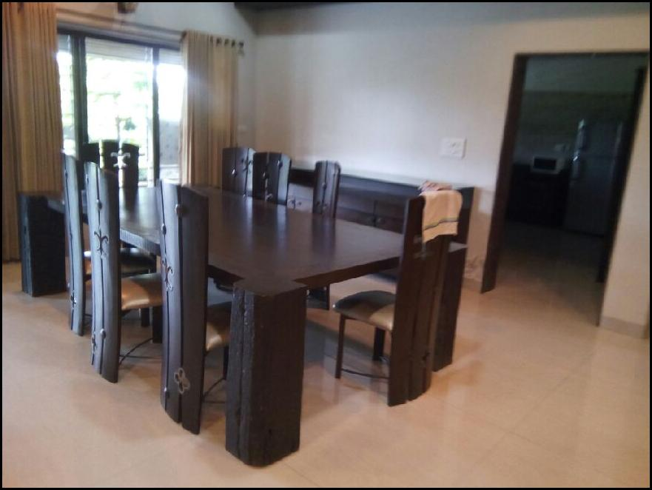
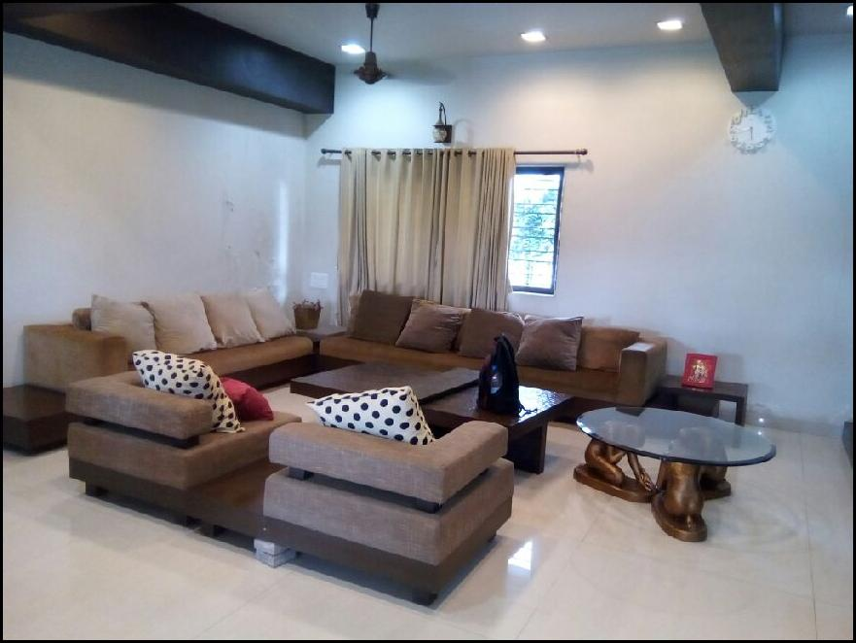
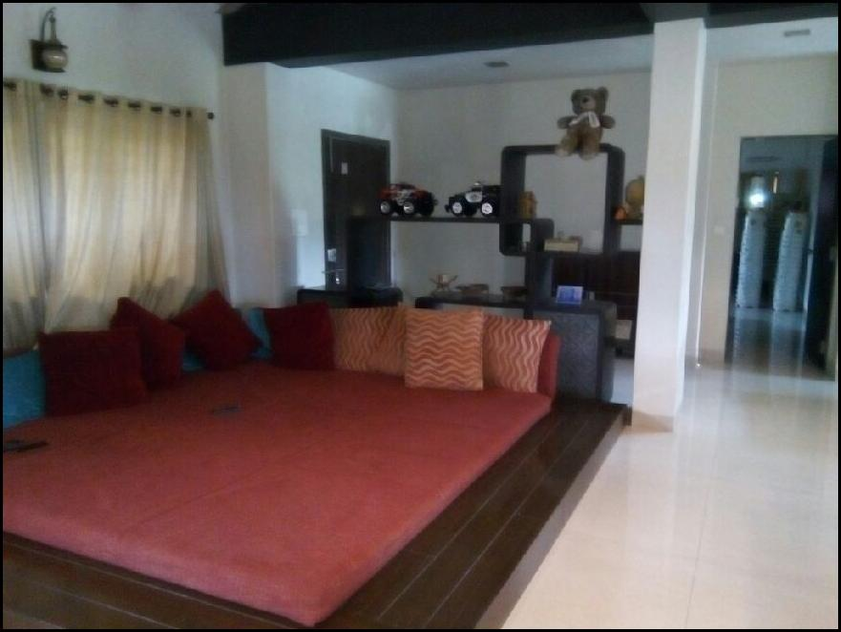
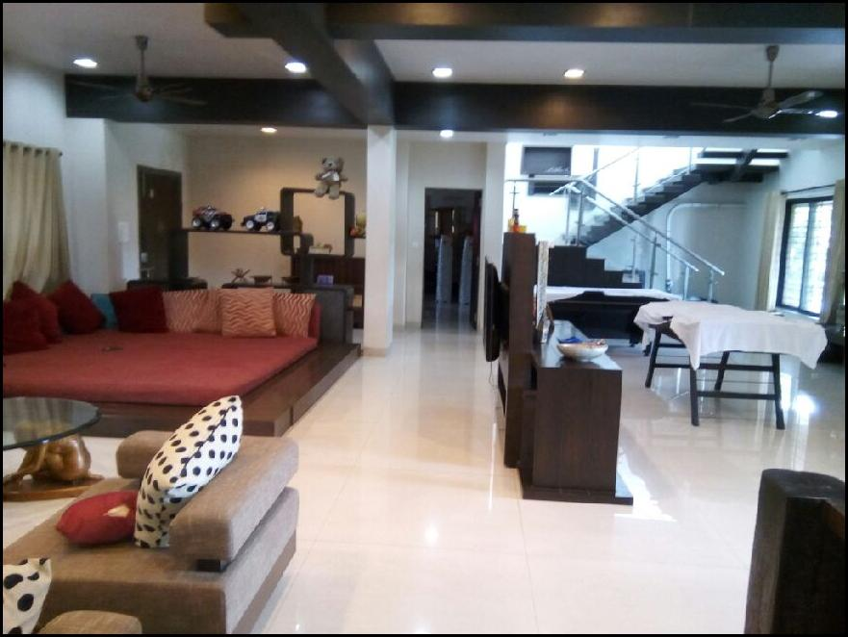
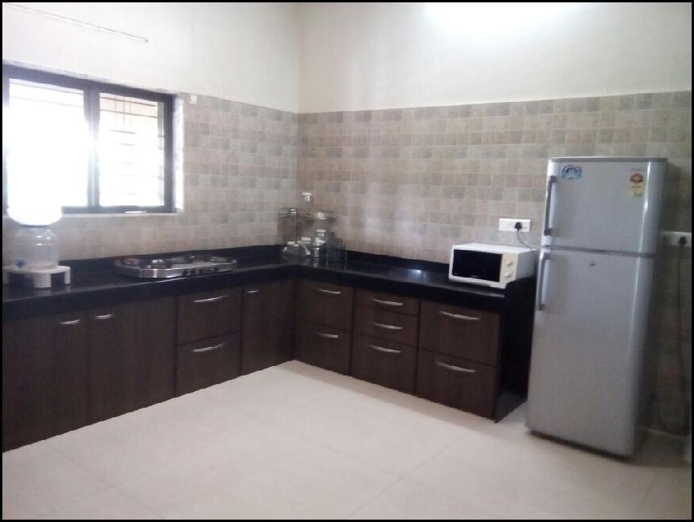
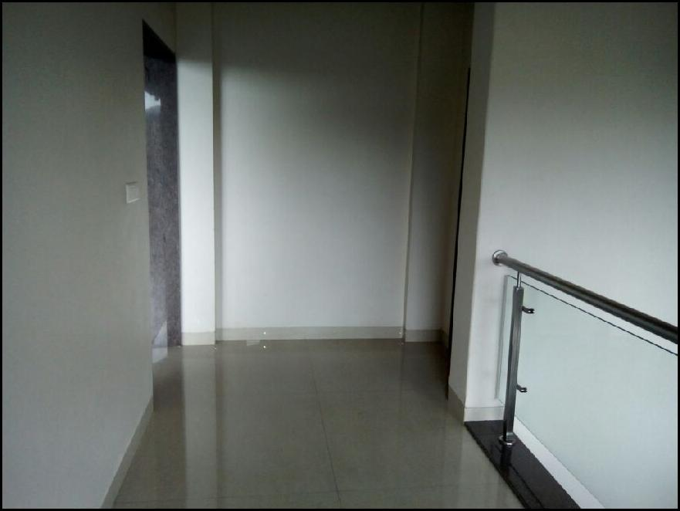

Actual site photographs
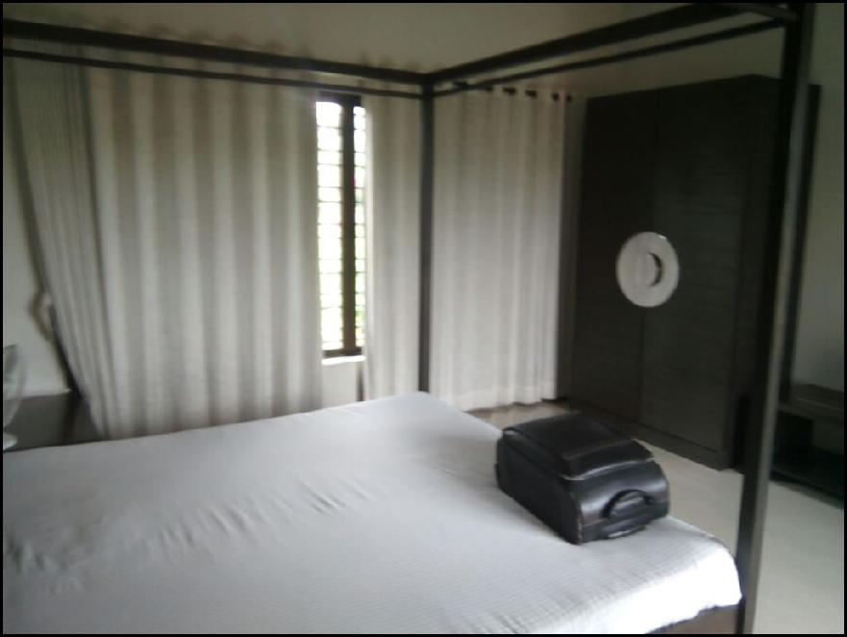
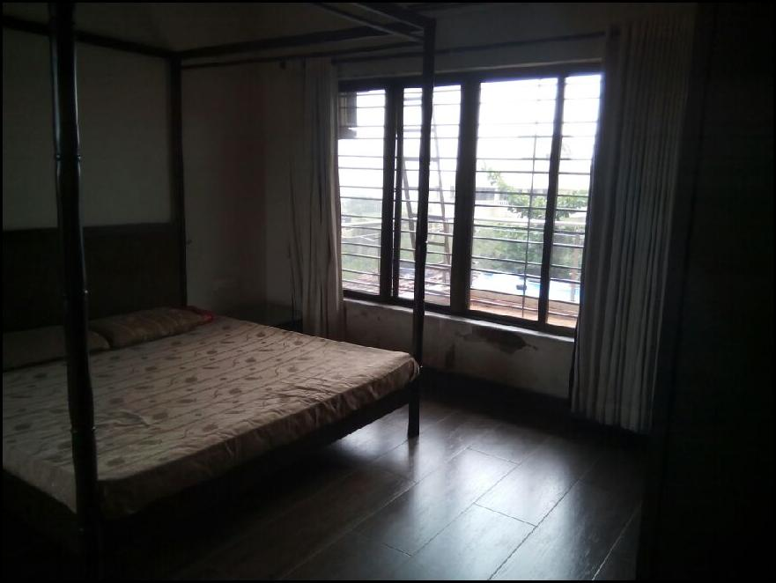
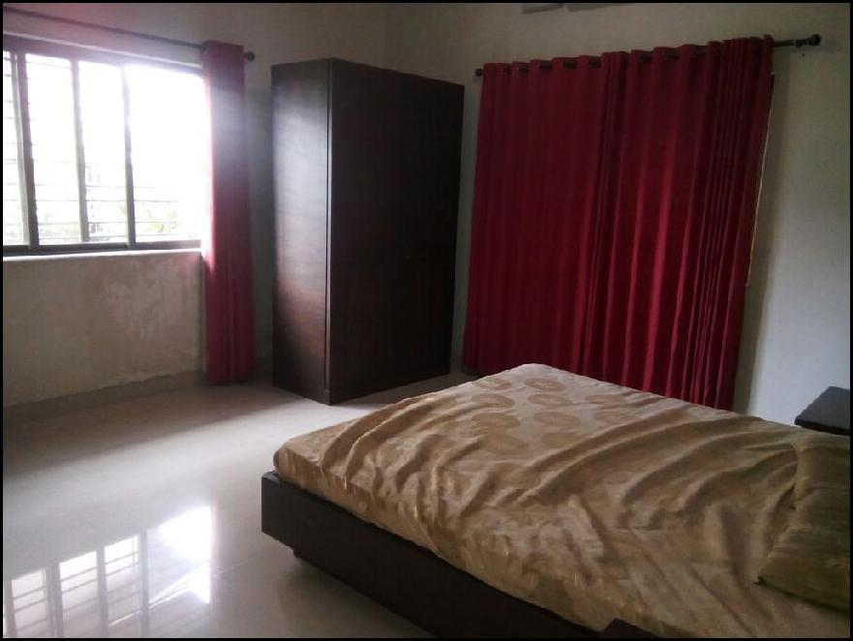
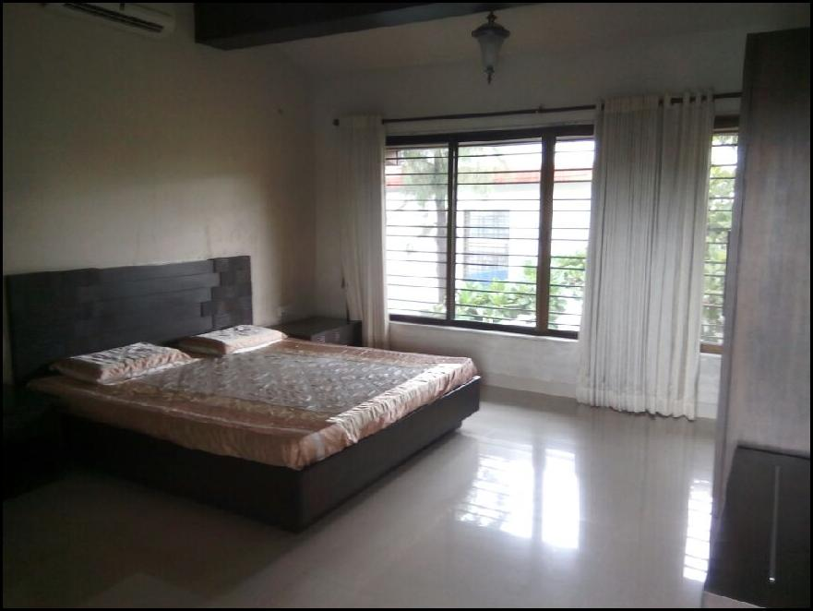
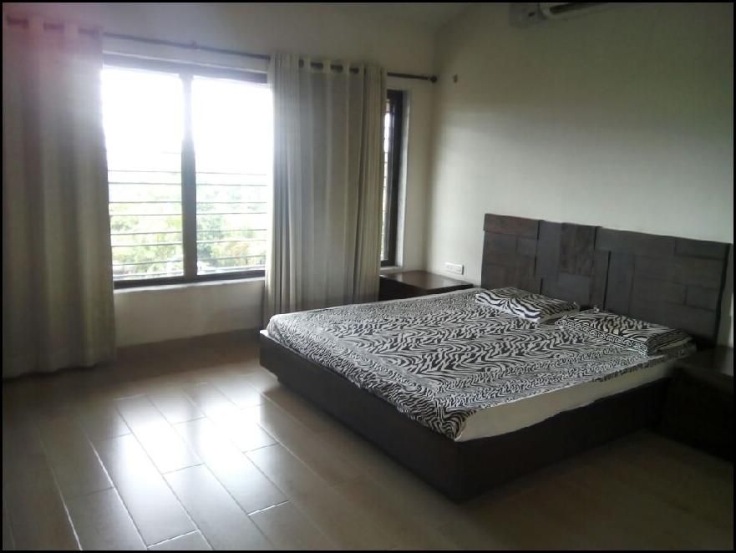
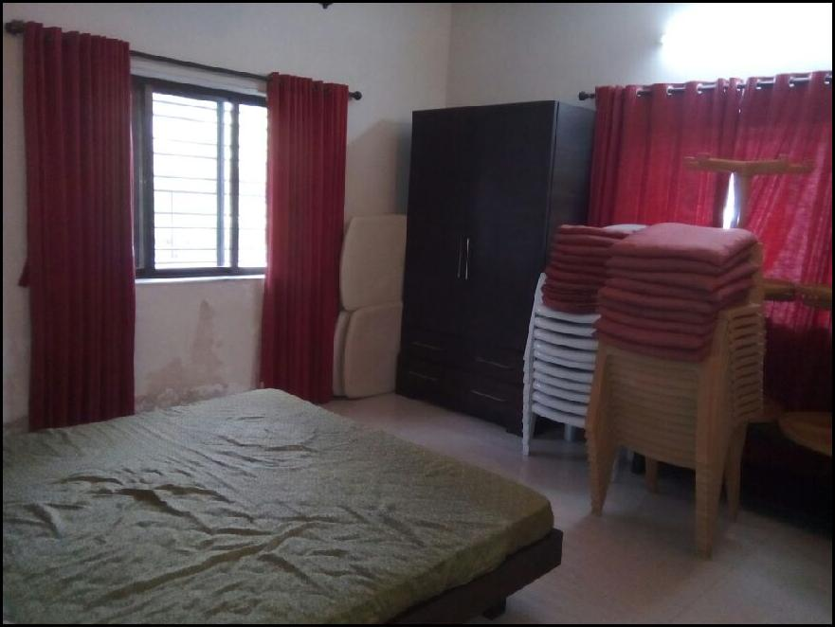
Actual site photographs
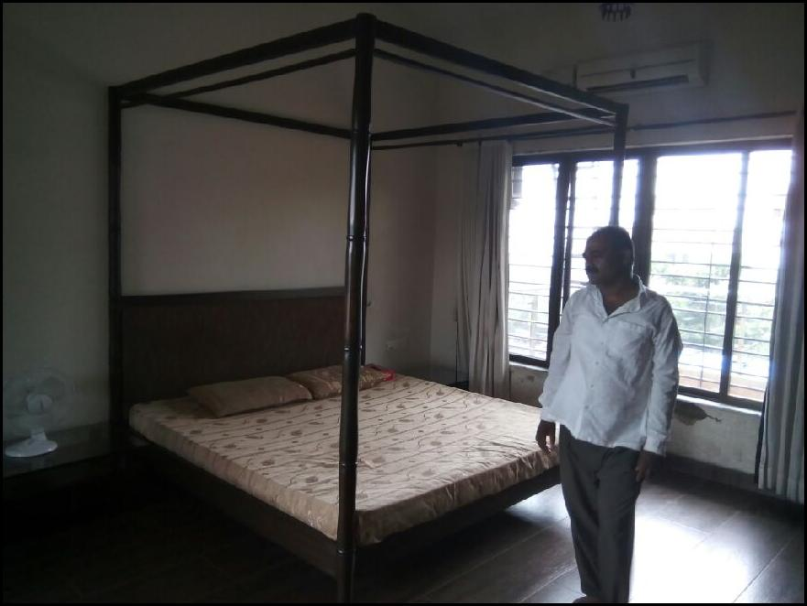
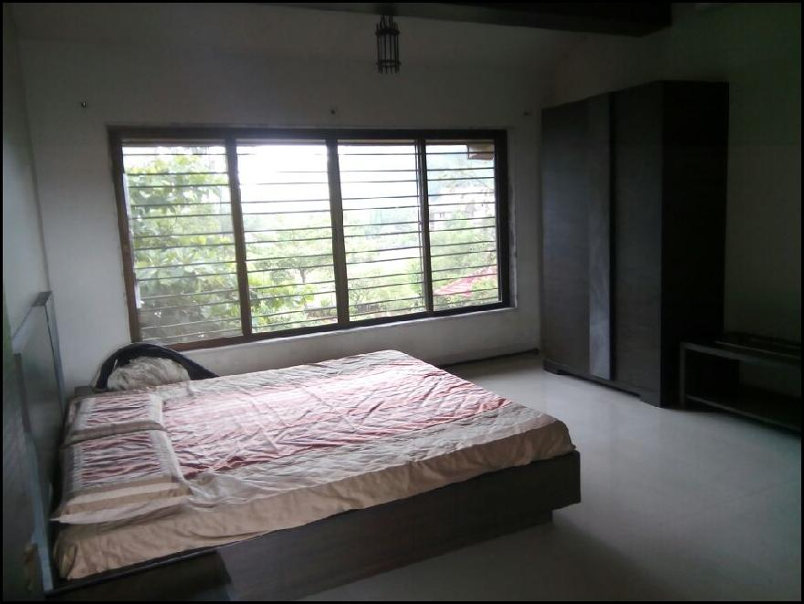
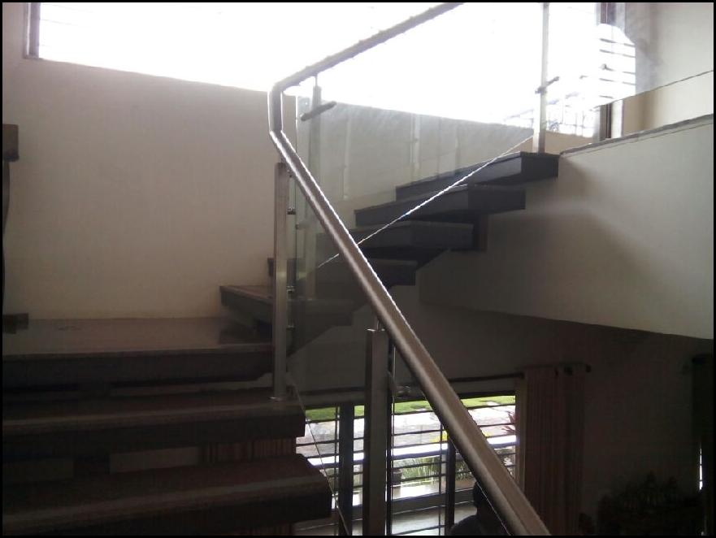
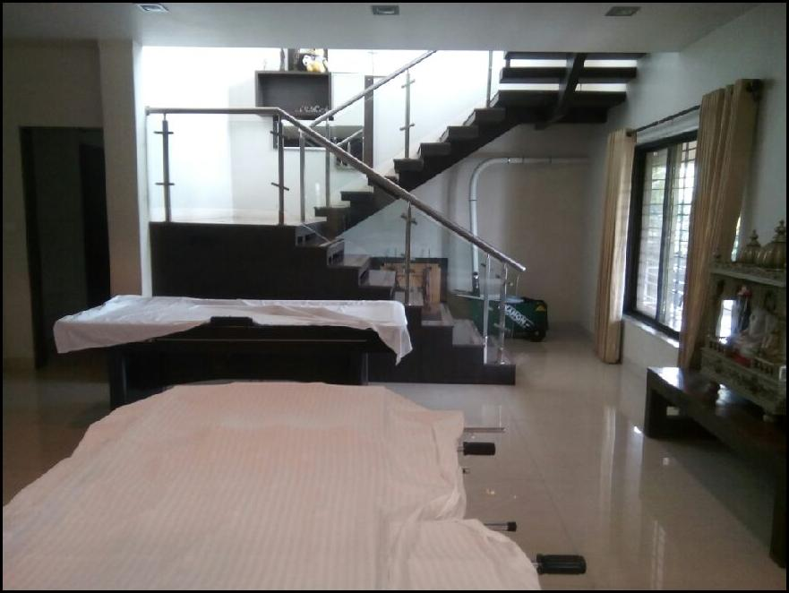
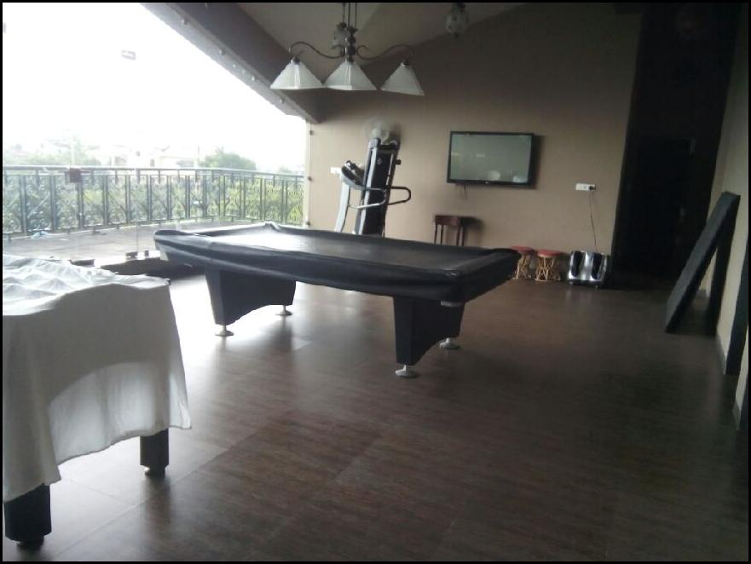
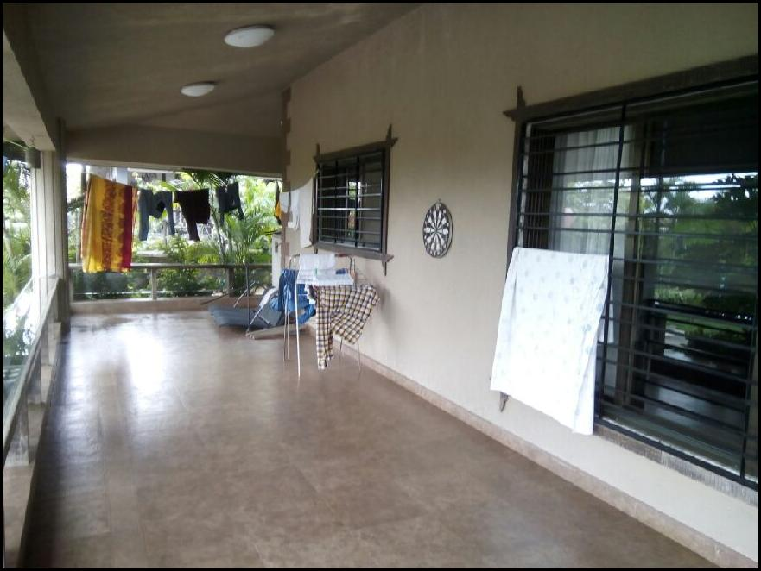
Actual site photographs
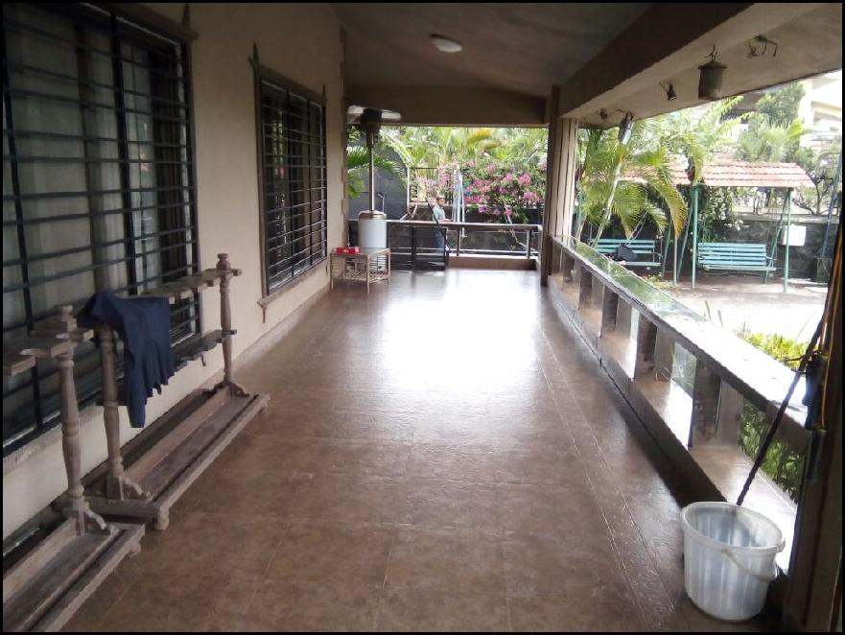
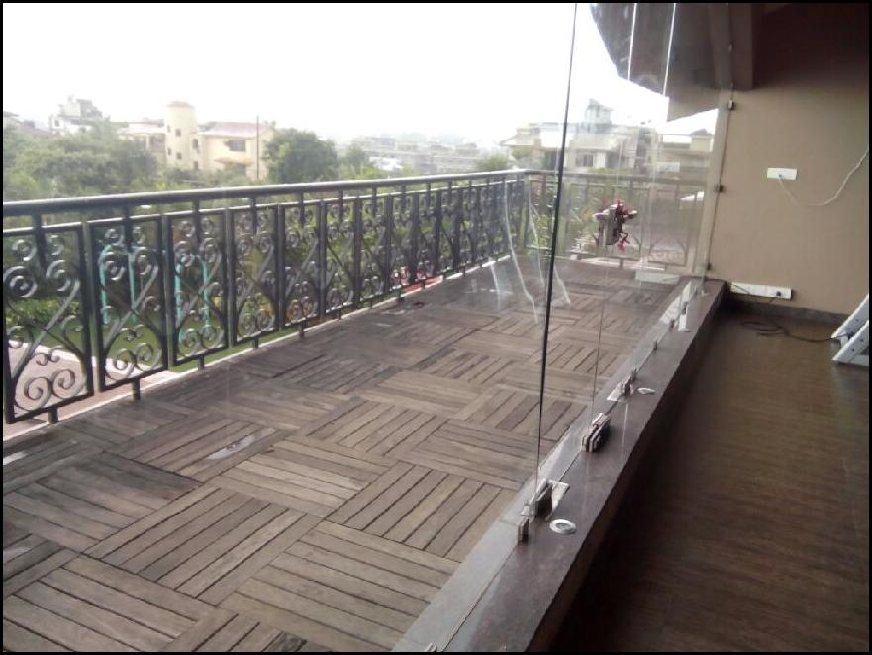
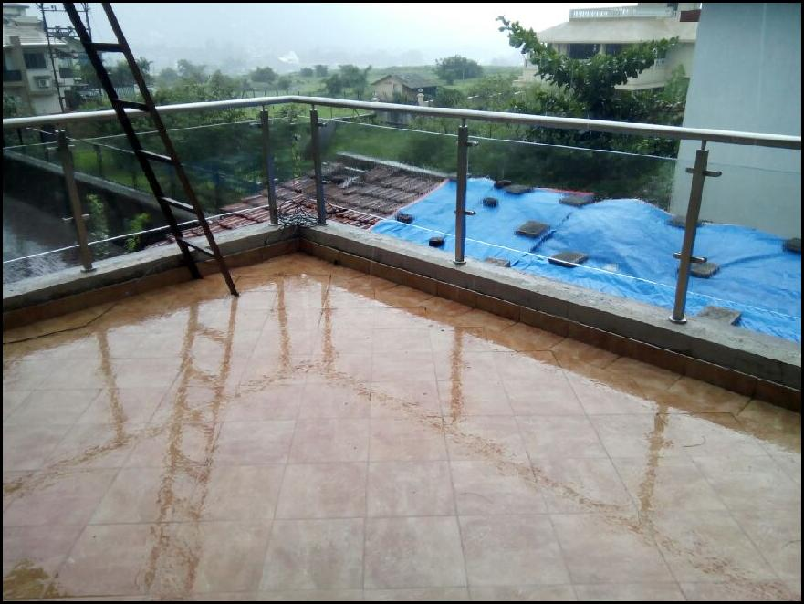
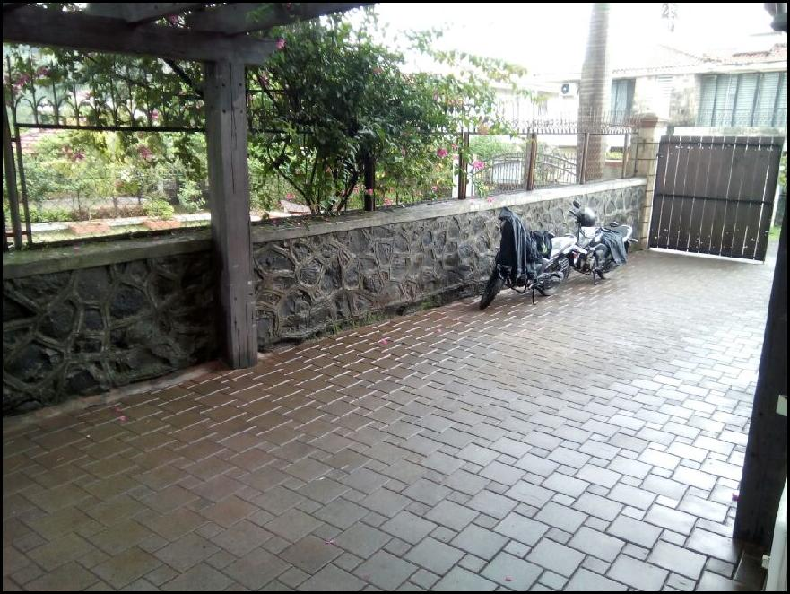
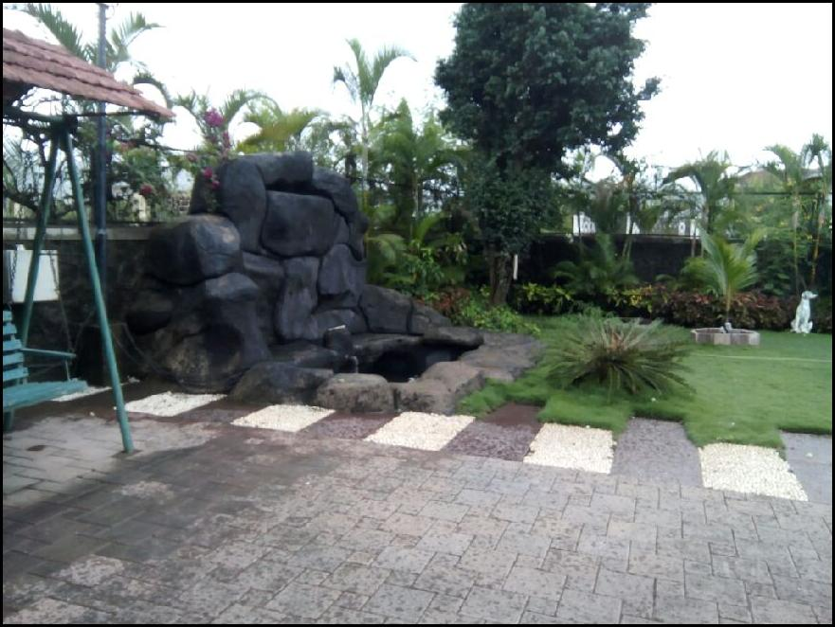
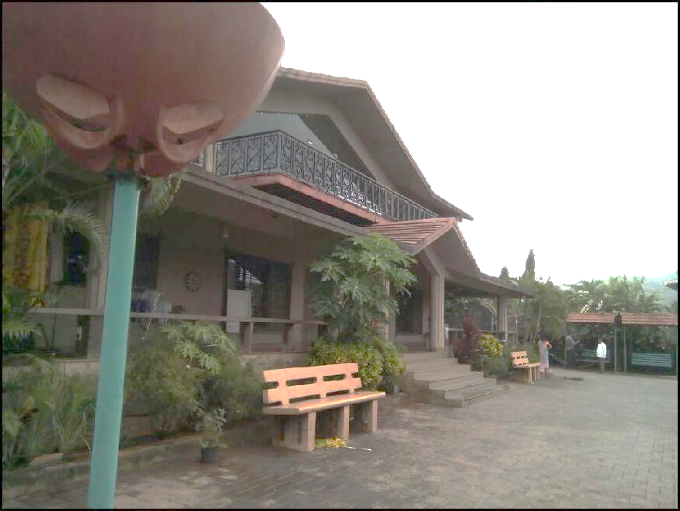
Actual site photographs
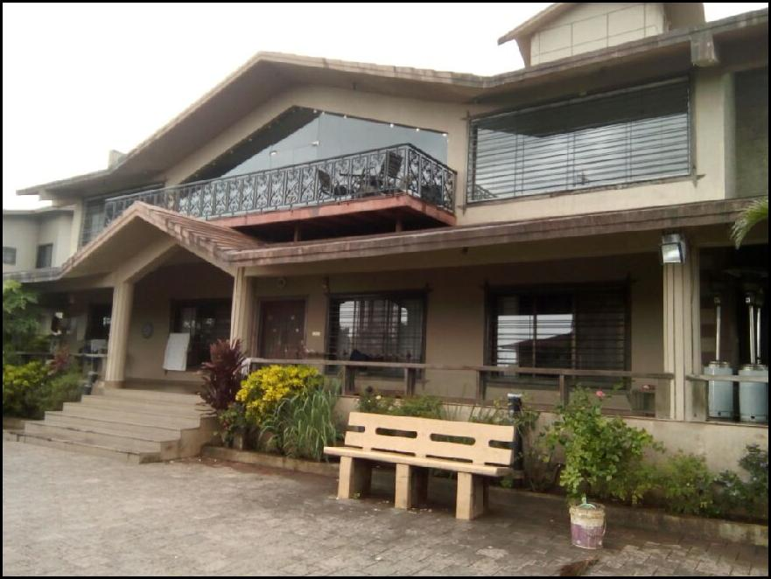
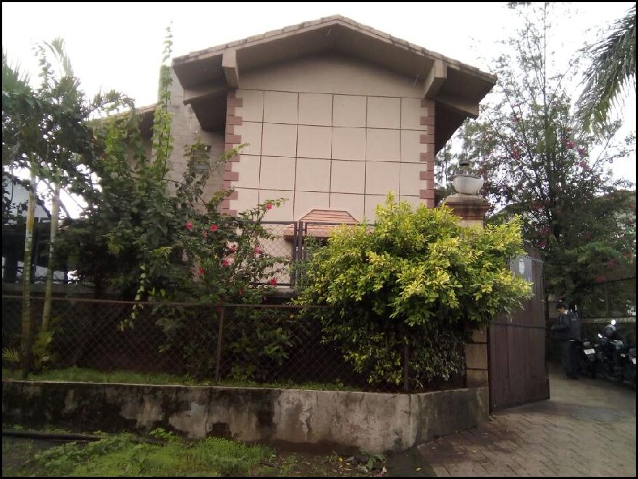
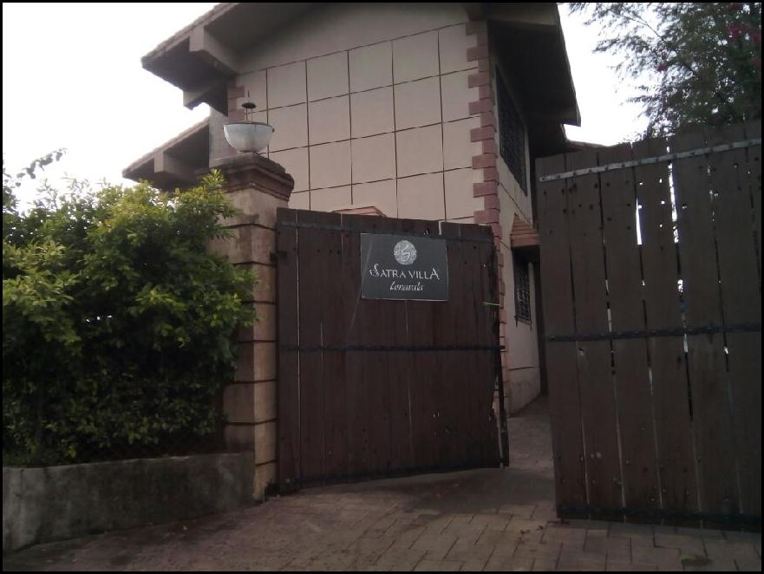
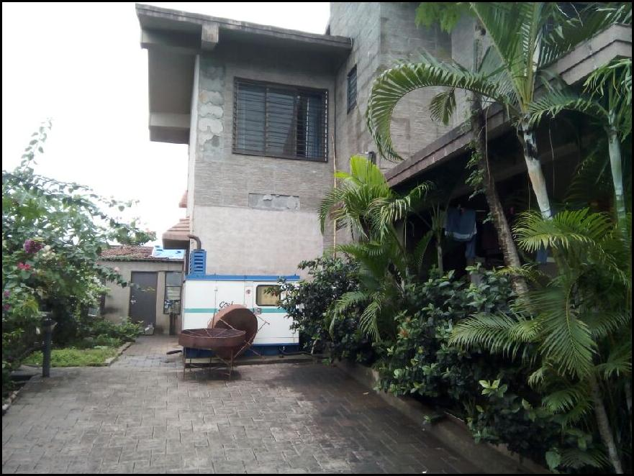
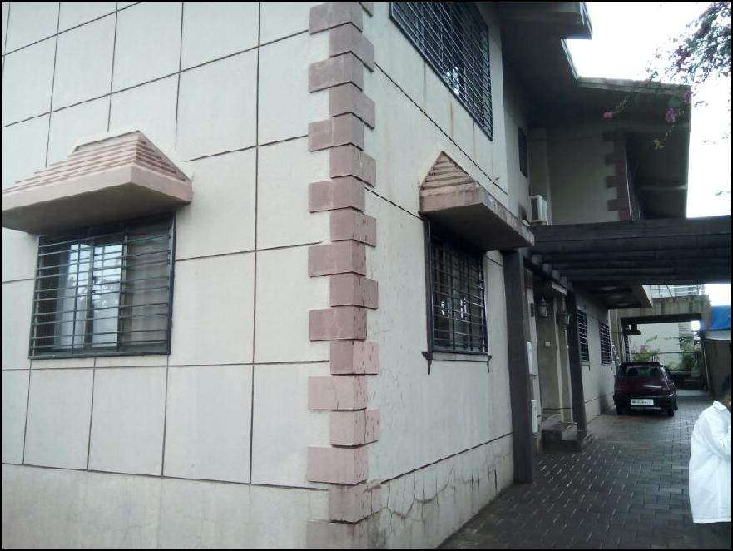
Route Map of the property
Site u/r

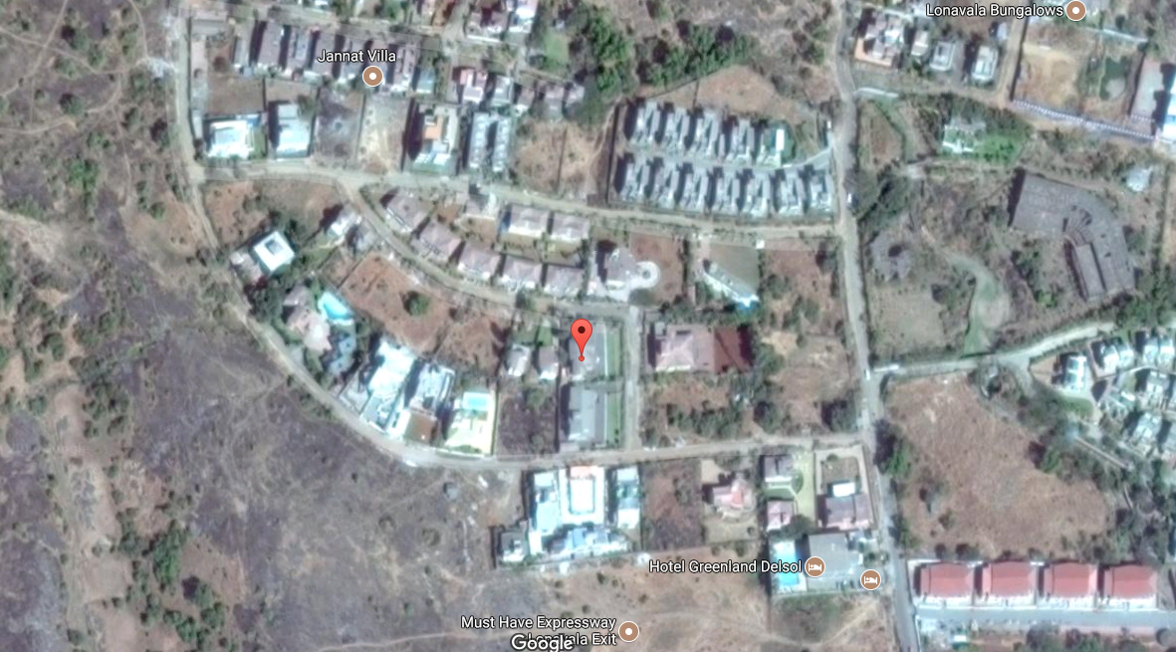

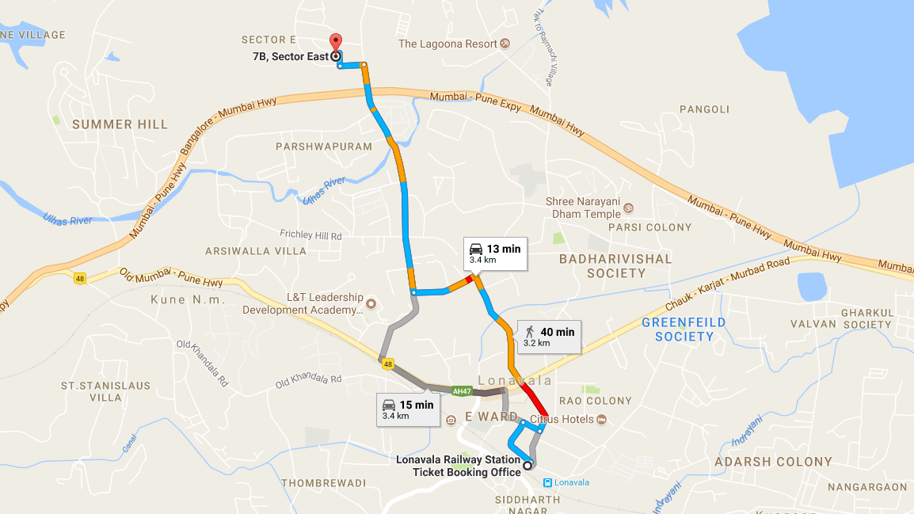

Latitude Longitude - 18°46'16.6"N 73°23'47.6"E

Note: The Blue line shows the route to site from nearest railway station (Lonavala – 3.4 Kms.)

DEFINITION OF VALUE FOR THIS SPECIFIC PURPOSE

This exercise is to assess Fair Market Value of the property under reference for Housing Loan purpose as on dated 26th June 2017.

“The most probable price, as of a specified date, in cash, terms equivalent to cash, or in other precisely revealed terms for which the specified property rights would sell after reasonable exposure in a competitive market under all conditions requisite to a fair sale, with the buyer and seller each acting prudently knowledgeably and for self interest assuming that neither is under undue duress”.

Fundamental assumptions and conditions presumed in this definition are:

1. Buyer and seller are motivated by self-interest.
2. Buyer and seller are well informed and are acting prudently.
3. The property is exposed for a reasonable time on the open market.
4. Payment is made in cash or equivalent or in specified financing terms.

UNDER LYING ASSUMPTIONS
1. We assume no responsibility for matters of legal nature affecting the property appraised or the title thereto, nor do we render our opinion as to the title, which is assumed to be good and marketable.
2. The property is valued as though under responsible ownership.
3. It is assumed that the property is free of liens and encumbrances.
4. It is assumed that there are no hidden or unapparent conditions of the subsoil or structure that would render it more or less valuable. No responsibility is assumed for such conditions or for engineering that might be required to discover such factors.

Manoj B. Chalikwar
Approved Valuer & Chartered Engineer
Reg. No. CAT-I-F-1763

DECLARATION OF PROFESSIONAL FEES CHARGED

We hereby declare that, our professional fees are not contingent upon the valuation findings. However, if the statute AND/OR clients demands that, the fees should be charged on the percentage of assessed value then, with the full knowledge of the AND/OR end user, it is being charged accordingly.

VALUATION OF THE PROPERTY PREMISES

Considering various parameters recorded herein above, existing economic scenario, and the information that is available with reference to the development of neighborhood and method selected for valuation, we are of the opinion that, the property premises can be assessed and valued for this particular purpose at ` 7,39,04,000/- (Rupees Seven Crore Thirty Nine Lac Four Thousand Only).

STATEMENT OF LIMITING CONDITIONS

1. Assumptions are made to the best of our knowledge and belief. Reliance is based on the information furnished to us by the identifier AND/OR client.
2. The valuer shall not be responsible for matters of legal nature that affects the value and opinion expressed by us.
3. If our appearance is required, we will be pleased to appear and give the necessary clarification, provided the fees for each appearance (excluding traveling, dearness allowance and out of pocket expenses) is pre-determined before the acceptance of the assignment under reference.
4. In no event shall the valuer be held responsible or liable for special, direct, indirect or consequential damages, as the assignment has been completed on best efforts, available knowledge and in good intentions of persons concerned and belief.
5. If it is proved that there is an apparent negligence on the part of a valuer, liability of this assignment (whether arising from this assignment, negligence or whatsoever) is limited in respect of anyone event or series of events to the actual loss or damage sustained subject to maximum of 80% of the professional fees for the services rendered and in any case not exceeding the amount of ` 1,000/- (Rupees one Thousand Only). All the claims against us shall expire after three month from the date of submission of the valuation report provided by us.
6. We hereby declare that, the information furnished above is true and correct to the best of our knowledge and belief. We have no direct or indirect interest in the assets valued. We have not been convicted of any offence and sentenced to a term of imprisonment. We have not been found guilty of misconduct in our professional capacity

Manoj B. Chalikwar
Approved Valuer & Chartered Engineer
Reg. No. CAT-I-F-1763

