Vastu/Nashik/06/32014/2301224
22/20-325-RYV
Date: 27.09.2023

To,
The Branch Manager,
Union Bank of India
RLP Nashik Branch
Nawandar Sankul, 1366, Racca Colony, Near Soni Paithani,
Sharanpur Road, Nashik – 422 002, State – Maharashtra, Country – India

Sub: Vetting of Extra Amenities

Sir,

With reference to above subject, we have evaluated the Extra Amenities for Residential Flat No. B-204, Second Floor, “ Shreevenkatesh Park”, Survey No.13/4(P)/14/1, Plot No.1+2, Near Nawas Lawns , Vidhate Nagar, Khode Nagar, Pakhal Road, Village – Wadala, Taluka & District – Nashik,PIN Code – 422 011, State – Maharashtra, Country – India belongs to Mr.Samadhan Sudam Ghuge & Mrs.Kanchan Samadhan Ghuge.

We have verified the rates quoted as per current market rates. Details of Extra Amenities considered as per copy of Extra Amenities Agreement between Mr.Samadhan Sudam Ghuge (First Party). Mr.Rahul Dnyaneshwar Landage (Second Party) received on dated 18.09.2023. The Extra Amenities amount is Rs. 9,00,000/- (Rupees Nine Lakh Only)

The said Cost Vetting Certificate is valid upto next 6 months Only.

Thanking you

Sincerely yours

Sharadkumar B. Chalikwar
Govt. Reg. Valuer
Chartered Engineer (India)
Reg. No. (N) CCIT/1-14/52/2008-09

Agreement for Extra Work

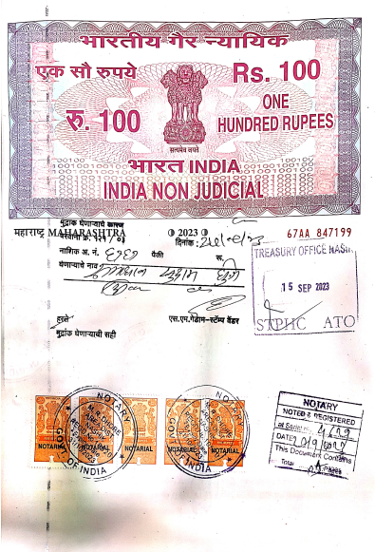
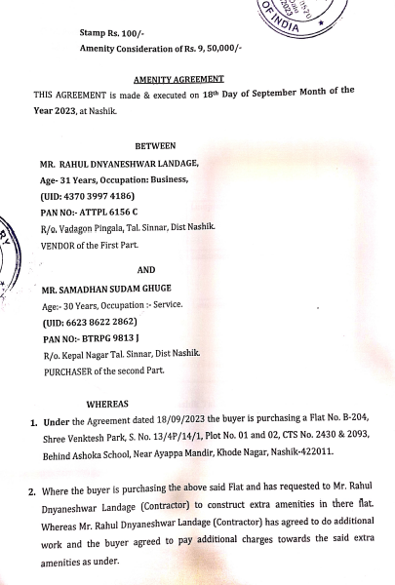

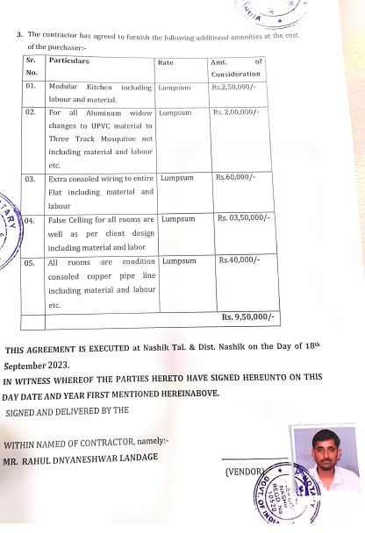
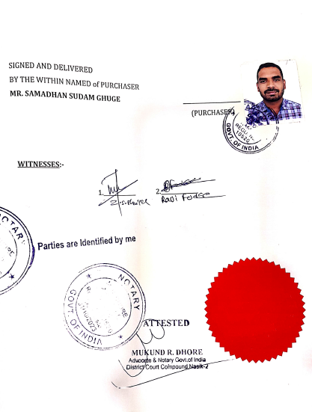

The Extra Amenities amount is Rs. 9,00,000/- (Rupees Nine Lakh Only)

