Vastu/Nashik/09/4009/2302698
25/03-342-CHV
Date: 25.09.2023

To,
Bank of Baroda
Regional Office
BSNL Building, Datta Mandir Road, Nashik Road,
Nashik, PIN – 422 101, State - Maharashtra, Country - India.

Sub: Vetting of Estimate

Sir,

With reference to above subject, we have evaluated the Estimate for Residential Land and Bungalow on Plot No. 225, Ground + First Floor, Gat No.184, Near Vishwakarma Chowk, Shramik Nagar, Village – Pimpalgaon Bahula, Taluka – Nashik, District – Nashik, Pin Code – 422 007, State - Maharashtra, Country – India belongs Sau. Sonali Nana Kekan & Shri. Nana Shivaji Kekan.

We have verified the rates quoted as per current market rates. Details of Estimate considered as per copy of Estimate Provided by The Designers received on dated 09.08.2023. The Estimate amount is Rs. 12,72,000/- (Rupees Twelve Lakh Seventy Two Thousand Only)

Note:1) The said Cost Vetting Certificate is valid upto next 6 months Only.

Thanking you

Sincerely yours

Manoj B. Chalikwar
Registered Valuer
Chartered Engineer (India)
Reg. No. CAT-I-F-1763
Reg. No. IBBI/RV/07/2018/10366
BOB Empanelment No.: ZO:MZ:ADV:46:941
Encl: Valuation Report

Estimate
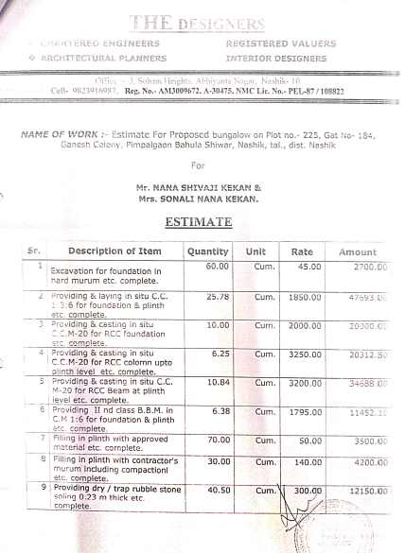
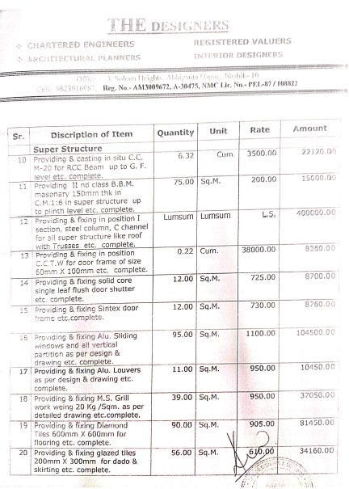

Estimate
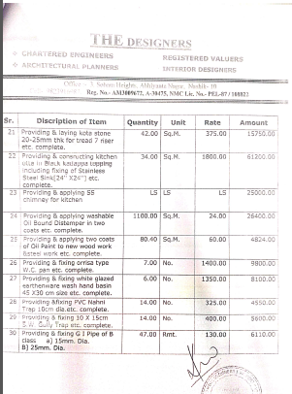
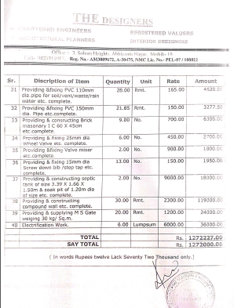

The Estimate amount is Rs.12,72,000/- (Rupees Twelve Lakh Seventy Two Thousand)

