Valuation Report of the Immovable Property
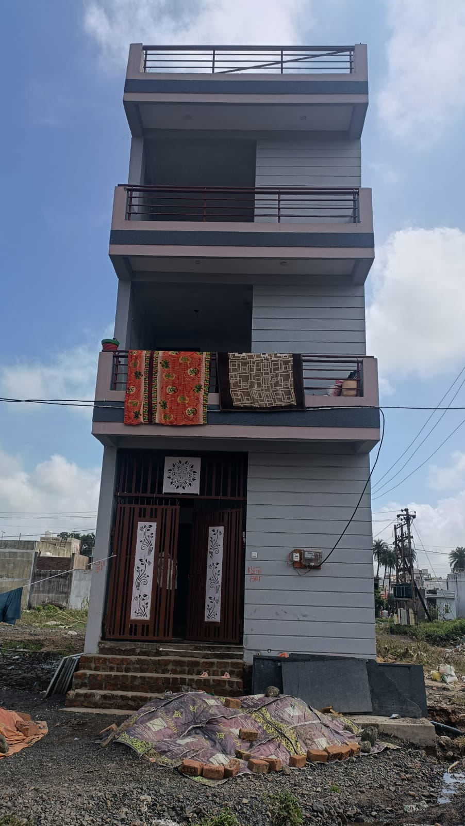

Details of the property under consideration:

Name of Owner: Shri. Baban Prasad Gaur S/o Shri. Ramuna Gaur

Residential Row House on Plot No. KE-18, “Gyanshila City”
Gram Dhabli, Tehsil Sanwer & District– Indore, PIN – 453 771,
State – Madhya Pradesh, Country – India

Latitude Longitude: 22°48’36.1”N 75°54’18.4”E

Valuation Done for:
SVC Co-Operative Bank Ltd.
MIG Branch
Aditya Enclave, C – 1, HIG Square, HIG Main Road, Khajarani, District – Indore,
PIN – 452 008, State – Madhya Pradesh, India

Vastu/Indore/07/2023/002129/2301407
04/8-32 -AKT
Date: 22.09.2023

VALUATION OPINION REPORT

This is to certify that the property bearing Residential Row House on Plot No. KE-18, “Gyanshila City” Gram Dhabli, Tehsil Sanwer & District– Indore, PIN – 453 771, State – Madhya Pradesh, Country – India belongs to Shri. Baban Prasad Gaur S/o Shri. Ramuna Gaur.
.

Considering various parameters recorded herein above, existing economic scenario, and the information that is available with reference to the development of neighborhood and method selected for valuation, we are of the opinion that, the property premises can be assessed and valued for this particular purpose as follows -
Boundaries of the property.

North | : | Plot No. KE -19
South | : | Plot No. KE -17
East | : | Open Plot
West | : | Road

Particulars | Fair Market Value In (`) | Realizable Value In (`) | Distress Sale Value In (`) | Insurable Value In (`)
Residential Row House | 43,77,000/- | 39,39,300/- | 35,01,600/- | 16,77,000/-

The valuation of the property is based on the documents produced by the concern. Legal aspects have not been taken into considerations while preparing this valuation report.

Manoj B. Chalikwar
Registered Valuer
Chartered Engineer (India)
Reg. No. CAT-I-F-1763
Encl: Valuation report

Vastukala Consultants (I) Pvt. Ltd.
106, 1st Floor, Gold Star Tower, Opp. Treasure Island Mall, M.G. Road, Indore – 452 001

To,
The Branch Manager,
SVC Co-Operative Bank Ltd.
MIG Branch
Aditya Enclave, C – 1, HIG Square
HIG Main Road, Khajarani
District – Indore, PIN – 452 008
State – Madhya Pradesh, India

VALUATION REPORT (IN RESPECT OF RESIDENTIAL LAND AND BUILDING)
I | General
1. | Purpose for which the valuation is made |  |  | : | To assess value of the property for Bank Loan Purpose.
2. | a) | Date of inspection |  | : | 21.06.2023
 | b) | Date on which the valuation is made |  | : | 22.09.2023
3. | Copy of documents produced for perusal |  |  | : | - i) Sale Deed, E-Registration No.MP179092022A1856690 dated 22.08.2022 between Shri. Ashish Mali S/o Shri. B.M. Mali (the Seller) AND Shri. Baban Prasad Gaur S/o Shri. Ramuna Gaur (the Purchasers).  - Approved Building Plan, Memo No. 470, dated 30.09.2022, Passed by Gram Panchayat, Dhabli, Janpad Panchayat Sanwer, District Indore, Signed by Sachive & Sarpanch.  - Commencement Latter of Plot No. KE-18, Memo No. 84/2022, dated 07.10.2022, Passed by Gram Panchayat, Dhabli, Janpad Panchayat Sanwer, District Indore, Signed by Sachive & Sarpanch.
4. | Name of the owner(s) and his / their address (es) with Phone no. (details of share of each owner in case of joint ownership) |  |  | : | Shri. Baban Prasad Gaur S/o Shri. Ramuna Gaur  Address: Residential Row House on Plot No. KE-18, “Gyanshila City” Gram Dhabli, Tehsil Sanwer & District– Indore, PIN – 453 771, State – Madhya Pradesh, Country – India.  Contact Person:  Shri. Baban Prasad Gaur (Owner)  Contact No.: +91 90099 97337  Sole Ownership
5. | Brief description of the property (Including Leasehold / freehold etc.) |  |  | :
The immovable property comprising of freehold residential land and structure thereof. The property is located in a developed area having basic infrastructure, well connected by road and train. The property is located at a travelling distance of 12.8 KM. from Indore Junction railway station.
Nearest Landmark: Gyanshila City Goal Chouraha

Land:
As per Sale Deed / Approved Building Plan, the plot area is 83.58 Sq. M. i.e. 900.00Sq. Ft. which is considered for valuation.

Structure:
The property consists of Residential Row House is of Ground + 2(pt.) upper floor. It is a R.C.C. framed structure with RCC beams, columns, slabs and RCC staircase is provided for access to the upper floor.

The composition of the building as per site inspection is as below -
Floor | Composition
Ground Floor | Hall + 2 Bedroom + Kitchen + 2 Toilets + Porch
Firs Floor | 3 Room + 2 Toilet + Balcony + Open Terrace + Balcony
Second Floor | Hall + Open Terrace + Balcony

As per site inspection, the B.Up. area is as below -
Particulars | Sq. Ft.
Ground floor | 900.00
First floor | 900.00
Second Floor | 555.00
Total | 2,355.00
Terrace on Second floor | 345.00

The composition of the row house as per Approved Plan is as below -
Floor | Composition
Ground Floor | Open Space + 2 Bedroom + Hall + Kitchen + Toilets
First Floor | 2 Bedrooms + 2 Dressing Rooms + Toilet + Balcony
Second Floor | Bed Room + Toilet + Open Terrace

As per Approved Building Plan, the construction area is as below, which is considered for the purpose of valuation.

Permissible FAR 1.25 (i.e. 104.51 Sq. M.)

Floor | B.Up. Area (Sq. M.) | Less Cut Area (Sq. M.) | Less Stair Case Area (Sq. M.) | Net B. Up. Area (Sq. M.) | Net B. Up. Area (Sq. Ft.)
Ground Floor | 55.35 | 2.10 | 8.64 | 44.61 | 480.00
First Floor | 55.35 | 2.10 | 8.64 | 44.61 | 480.00
Second Floor | - | - | - | 14.66 | 157.00
Total |  |  |  | 103.88 | 1,118.00

6. | Location of property |  |  | :
 | a) |  | Plot No. / Survey No. | : | Plot No. KE-18
 | b) |  | Door No. | : | -
 | c) |  | T.S. No. / Village | : | Gram Dhabli
 | d) |  | Ward / Taluka | : | Tehsil – Indore
 | e) |  | Mandal / District | : | District – Indore
 | f) |  | Date of issue and validity of layout of approved map / plan | : | Approved Building Plan, Memo No. 470, dated 30.09.2022, Passed by Gram Panchayat, Dhabli, Janpad Panchayat Sanwer, District Indore, Signed by Sachive & Sarpanch.
 | g) |  | Approved map / plan issuing authority | :
 | h) |  | Whether genuineness or authenticity of approved map/ plan is verified | :
 | i) |  | Any other comments by our empanelled valuers on authentic of approved plan |  | No
7. | Postal address of the property |  |  | : | Residential Row House on Plot No. KE-18, “Gyanshila City ”, Gram Dhabli, Tehsil Sanwer & District– Indore, PIN – 453 771, State – Madhya Pradesh, Country – India.
8. | City / Town |  |  | : | City
 | Residential area |  |  | : | Yes
 | Commercial area |  |  | : | No
 | Industrial area |  |  | : | No
9. | Classification of the area |  |  | :
 | i) High / Middle / Poor |  |  | : | Middle Class
 | ii) Urban / Semi Urban / Rural |  |  | : | Urban
10. | Coming under Corporation limit / Village Panchayat / Municipality |  |  | : | Gram - Dhabli  Nagar Palika Nigam Indore
11. | Whether covered under any State / Central Govt. enactments (e.g., Urban Land Ceiling Act) or notified under agency area/ scheduled area / cantonment area |  |  | : | No
12. | Boundaries of the property |  |  |  | As per actual site | As per sale deed
 | North |  |  | : | Plot No. KE -19 | Plot No. KE -19
 | South |  |  | : | Plot No. KE -17 | Plot No. KE -17
 | East |  |  | : | Open Plot | Plot No. KE -02
 | West |  |  | : | Road | Road
13 | Dimensions of the site |  |  |  | 4.58 M. X 18.25 M.  (As per Approve Map)
14. | Extent of the site |  |  | : | As per Brief Description
14. | Latitude, Longitude & Co-ordinates of House |  |  | : | 22°48’36.1”N 75°54’18.4”E
15. | Extent of the site considered for Valuation (least of 13A& 13B) |  |  | : | Plot Area = 900.00Sq. Ft.  (As per Sale Deed)  Built up area = 1,118.00 Sq. Ft.  (As per Approved Building Plan)
16 | Whether occupied by the owner / tenant? If occupied by tenant since how long? Rent received per month. |  |  | : | Tenant Occupied
II | APARTMENT BUILDING
 | Nature of the Apartment |  |  | : | Residential
 | Location |  |  | :
 | C.T.S. No. |  |  | : | -
 | Block No. |  |  | : | Plot No. KE-18
 | Ward No. |  |  | : | Ward No. 70 (Sanwer)
 | Village / Municipality / Corporation |  |  | : | Gram - Dhabli  Gram Panchayat Dhabli
 | Door No., Street or Road |  |  | : | Residential Row House on Plot No. KE-18, “Gyanshila City ”, Gram Dhabli, Tehsil Sanwer & District– Indore, PIN – 453 771, State – Madhya Pradesh, Country – India.
 | Description of the locality Residential / Commercial / Mixed |  |  | : | Residential
 | Year of Construction |  |  | : | 2023
 | Number of Floors |  |  | : | Ground + 2(pt) upper floor
 | Type of Structure |  |  | : | R.C.C. framed structure
 | Number of Dwelling units in the building |  |  | : | Single structure with Ground + 2(pt) upper floor
 | Quality of Construction |  |  | : | Good
 | Appearance of the Building |  |  | : | Good
 | Maintenance of the Building |  |  | : | New Building
 | Facilities Available |  |  | :
 | Lift |  |  | : | No lift
 | Protected Water Supply |  |  | : | Municipal Water Supply
 | Underground Sewerage |  |  | : | Connected to Municipal Sewerage System
 | Car parking - Open / Covered |  |  | : | No
 | Is Compound wall existing? |  |  | : | No
 | Is pavement laid around the building |  |  | : | No
III | HOUSE
1 | The floor in which the House is situated |  |  | : | Entire Row House
2 | Door No. of the House |  |  | : | Plot No. KE-18
3 | Specifications of the House |  |  | :
 | Roof |  |  | : | R.C.C. Slab
 | Flooring |  |  | : | Vitrified tiles flooring
 | Doors |  |  | : | Teak Wood door frame, Solid flush door shutters
 | Windows |  |  | : | Powder coated Aluminum sliding windows
 | Fittings |  |  | : | Concealed wiring and Plumbing
 | Finishing |  |  | : | Cement Plastering with OBD paint, POP false ceiling
4 | House Tax |  |  | :
 | Assessment No. |  |  | : | Details not available
 | Tax paid in the name of: |  |  | : | Details not available
 | Tax amount: |  |  | : | Details not available
5 | Electricity Service connection No.: |  |  | : | Details not available
 | Meter Card is in the name of: |  |  | : | Details not available
6 | How is the maintenance of the House? |  |  | : | Good
7 | Sale Deed executed in the name of |  |  | : | Shri. Baban Prasad Gaur S/o Shri. Ramuna Gaur
8 | What is the undivided area of land as per Sale Deed? |  |  | : | Plot Area = 900.00Sq. Ft.  (As per Sale Deed)
9 | What is the plinth area of the House? |  |  | : | Built up area = 1,118.00 Sq. Ft.  (As per Approved Building Plan)
10 | What is the floor space index (app.) |  |  | : | As per local norms
11 | Is it Posh / I Class / Medium / Ordinary? |  |  | : | Middle Class
12 | Is it being used for Residential or Commercial purpose? |  |  | : | Residential
13 | Is it Owner-occupied or let out? |  |  | : | Owner Occupied
14 | If rented, what is the monthly rent? |  |  | : | ` 9,000/- Expected rental income per month
IV | MARKETABILITY |  |  | :
1 | How is the marketability? |  |  | : | Good
2 | What are the factors favouring for an extra Potential Value? |  |  | : | Located in developed residential area
3 | Any negative factors are observed which affect the market value in general? |  |  | : | No
V | Rate |  |  | :
1 | After analyzing the comparable sale instances, what is the composite rate for a similar House with same specifications in the adjoining locality? - (Along with details / reference of at - least two latest deals / transactions with respect to adjacent properties in the areas) |  |  | : | ` 2,500/- to ` 3,500/- per Sq. Ft. for Plot  ` 1,500/- per Sq. Ft. for Construction
2 | Assuming it is a new construction, what is the adopted basic composite rate of the House under valuation after comparing with the specifications and other factors with the House under comparison (give details). |  |  | : | ` 3000/- per Sq. Ft. for Plot  ` 1,500/- per Sq. Ft. for Construction
3 | Break – up for the rate |  |  | :
 | I. Building + Services |  |  | : | ` 1,500/- per Sq. Ft.
 | II. Land + others |  |  | : | ` 3000/- per Sq. Ft.
4 | Guideline rate obtained from the Government Portal (evidence thereof to be enclosed) of land |  |  | : | ` 9,200/- per Sq. M. i.e. ` 855/- per Sq. Ft.
VI | COMPOSITE RATE ADOPTED AFTER DEPRECIATION
a | Depreciated building rate |  |  | :
 | Replacement cost of House with Services (v(3)i) |  |  | : | ` 1,500/- per Sq. Ft.
 | Age of the building |  |  | : | 2023
 | Life of the building estimated |  |  | : | 60 years Subject to proper, preventive periodic maintenance & structural repairs.
 | Depreciation percentage assuming the salvage value as 10% |  |  | : | N.A.
 | Depreciated Ratio of the building |  |  | : | N.A.
b | Total composite rate arrived for Valuation |  |  | :
 | Depreciated building rate VI (a) |  |  | : | ` 1,500/- per Sq. Ft.
 | Rate for Land & other V (3) ii |  |  | : | ` 3000/- per Sq. Ft.
 | Remarks:

Government Value

Particulars | Area in Sq. Ft. | Rate in ` | Value in `
Land | 900.00 | 855/- | 7,69,500/-
Structure | As per valuation table |  | 16,77,000/-
Total |  |  | 24,46,500/-

Annexure
Fair Market Value
A) Land | Area in  Sq. Ft. | Rate in ` | Fair Market Value in `
A) Land | 900.00 | 3000/- | 27,00,000/-

B) Structure:
Particulars | Built up Area in  Sq. Ft. | Year of Const. | Total Life of Structure | Replacement Rate (`) | Age Of Build. | Final Rate (`) | Final Value (`)
Ground Floor | 1,118.00 | 2023 | 60 | 1,500/- | 2023 | 1,500/- | 16,77,000/-
Total |  |  |  |  |  |  | 16,77,000/-

Details of Valuation:

Sr. No. | Description | Area in  Sq. Ft. | Rate per  unit (`) | Full Value  (`) (A + B)
1 | Present value of the Row House
 | Plot area | As per Annexure |  | 27,00,000/-
 | Built up area |  |  | 16,77,000/-
2 | Wardrobes
3 | Showcases /
4 | Kitchen arrangements
5 | Superfine finish
6 | Interior Decorations
7 | Electricity deposits / electrical fittings, etc.
8 | Extra collapsible gates / grill works etc.
9 | Potential value, if any
10 | Others
 | Fair Market value of the property |  |  | 43,77,000/-
 | Realizable value of the property |  |  | 39,39,300/-
 | Distress Value of the property |  |  | 35,01,600/-
 | Insurable value of the property  (Full Replacement Cost (25,72,200/-) – Subsoil structure cost (15%) |  |  | 16,77,000/-
 | Guideline value of the property
 | Total Guideline Value |  |  | 24,46,500/-

Justification for price /rate
The Market Value of the property is based on facts of markets discovered by us during our enquiries, however the government rate value in this case is less than the market value arrived by us. We are of the opinion that the value arrive by us will prove to be correct if an Auction of the subject property is carried out. As far as Market Value as per property document is concerned, it is not possible to comment on same, may be government rates are fixed by sampling during same point of time in part and whereas, Market values change every month.
In most of the cases the actual deal amount or Transaction value is not reflected in the property documents because of various Market practices. As Valuer, we always try to give a value which is correct reflection of actual transaction value irrespective of any factors in market.

Approach adopted for valuation: Cost Approach
- The cost approach is a Real Property Valuation method which considers the value of a property as the cost of the land plus the replacement cost of the building (construction costs) minus the physical and functional depreciation.

- Land cost can be estimated using the Sales Comparison Approach by studying recent sales of land close to the subject property, and these sales should be comparable in size and location with subject property.

- There are different ways to estimate replacement costs, the most common being finding out the cost to build a square foot of comparable properties multiplied by the total square footage of the building. The cost approach is commonly used for Residential Bungalow, Residential Land and Buildings, independent buildings, Industrial Building and real estate properties that are not easily sold like schools, hospitals, government buildings. The property is a residential land and independent house thereof, we have adopted Cost approach / Land and Building Method for the purpose of valuation.

- The Price for similar type of property in the nearby vicinity is in the range of ` 3,500/- to ` 4,500/- per Sq. Ft. for land Considering the rate with attached report, current market conditions, demand and supply position, Land size, location, sustained demand for Residential Row House / Plot, all round development of residential application in the locality etc. We estimate ` 3000/- per Sq. Ft. for Land with appropriate cost of construction for valuation.
Actual site photographs

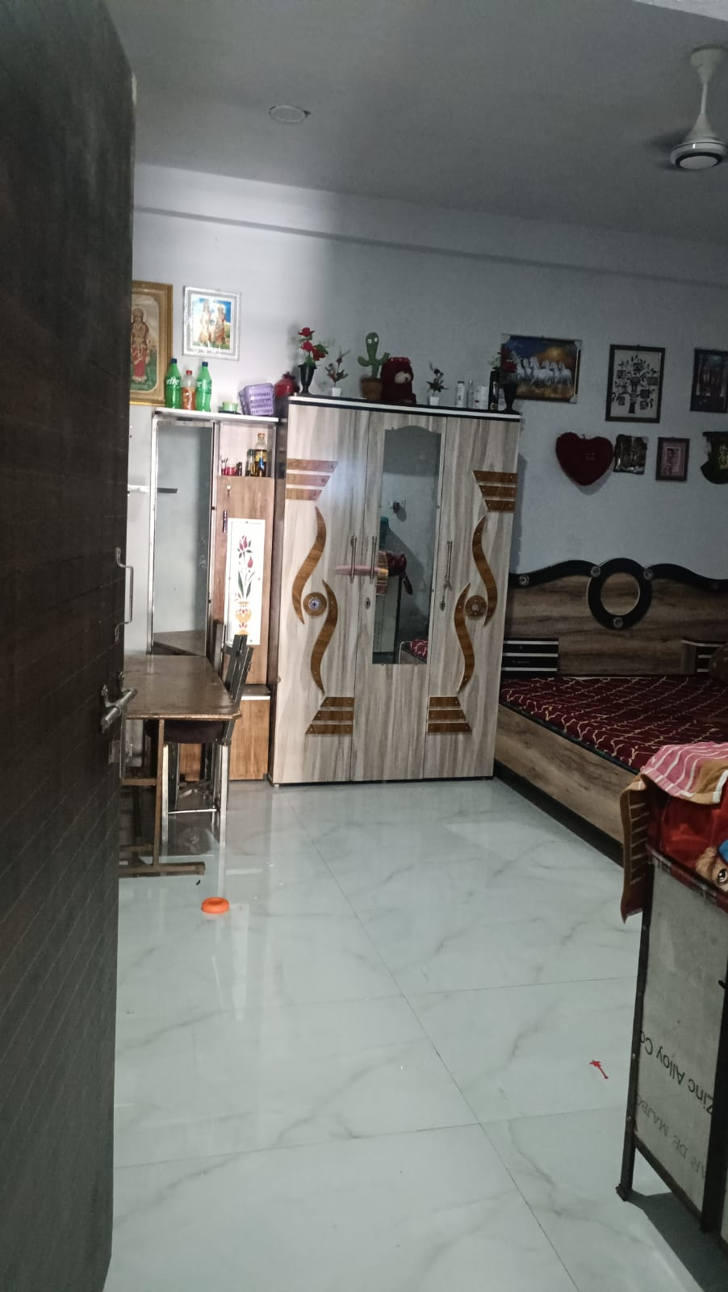
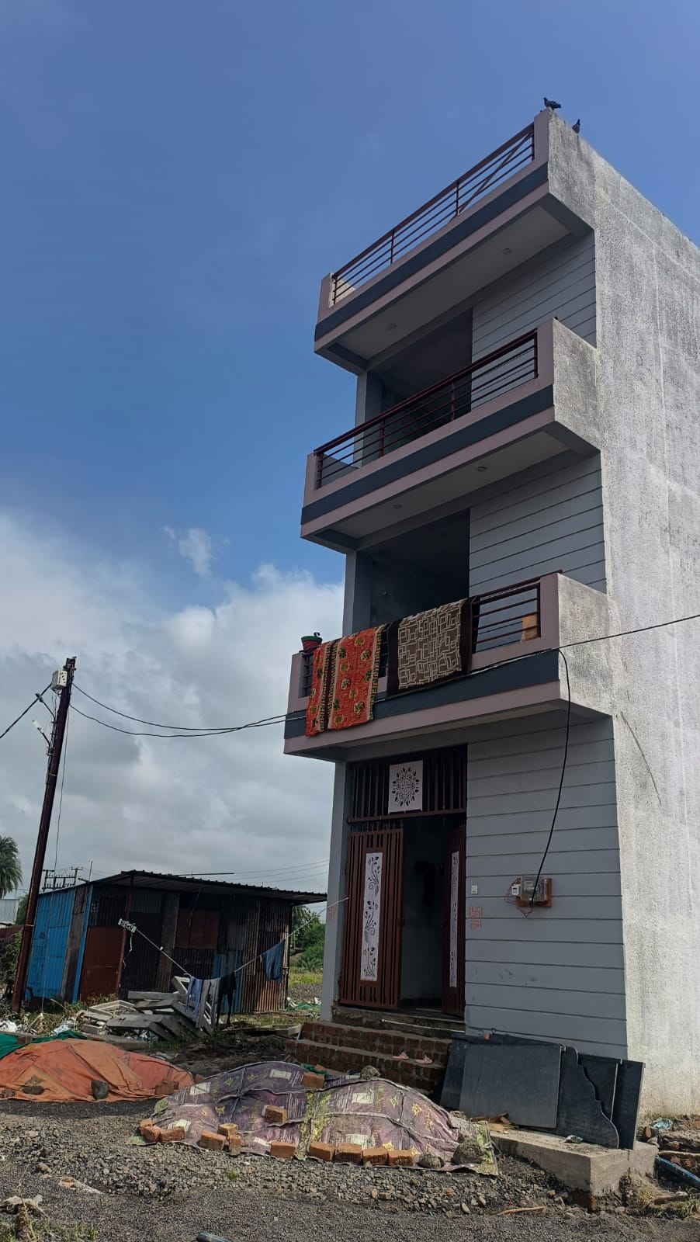
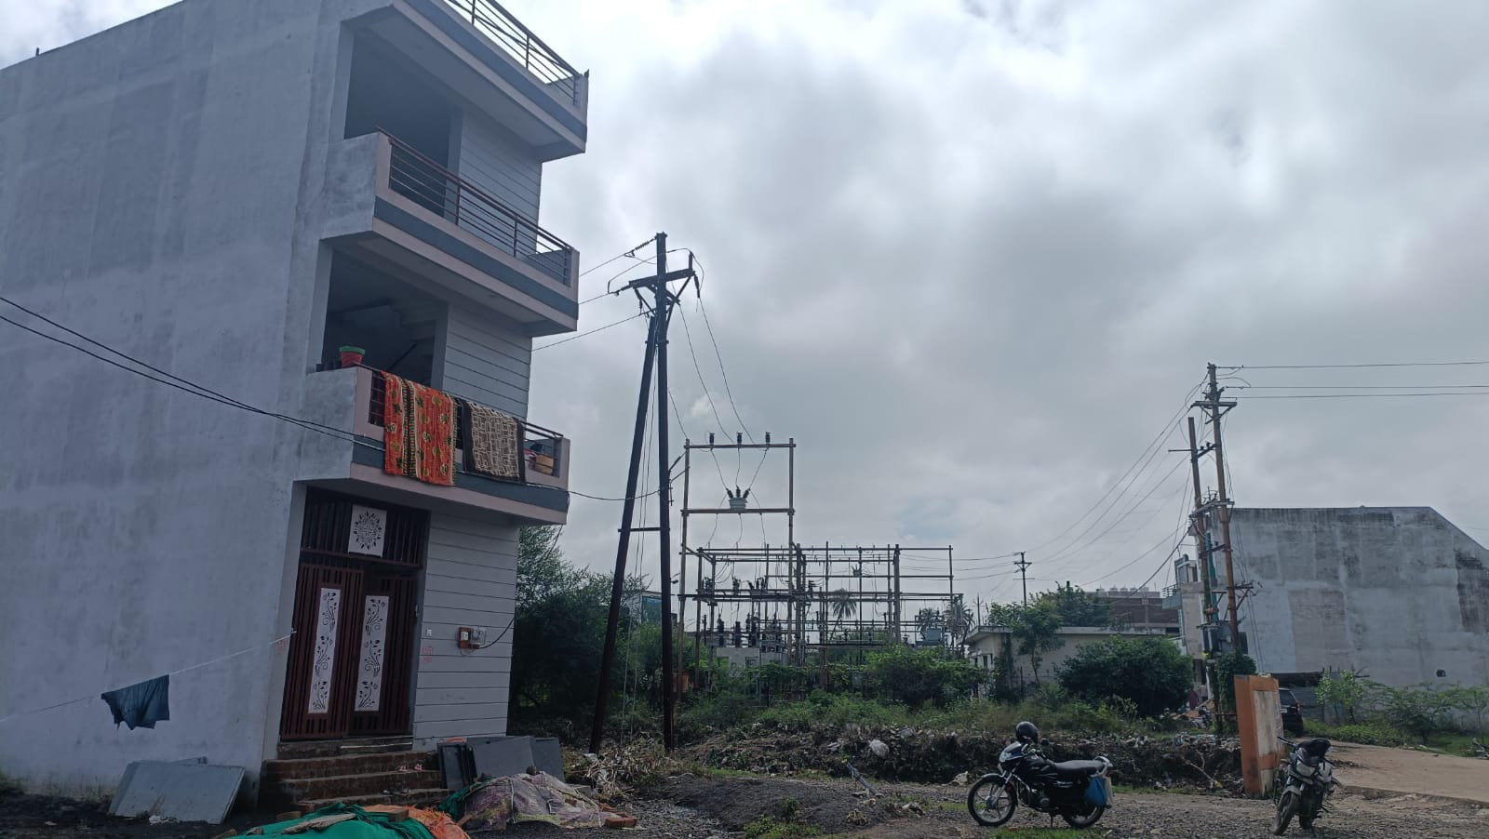

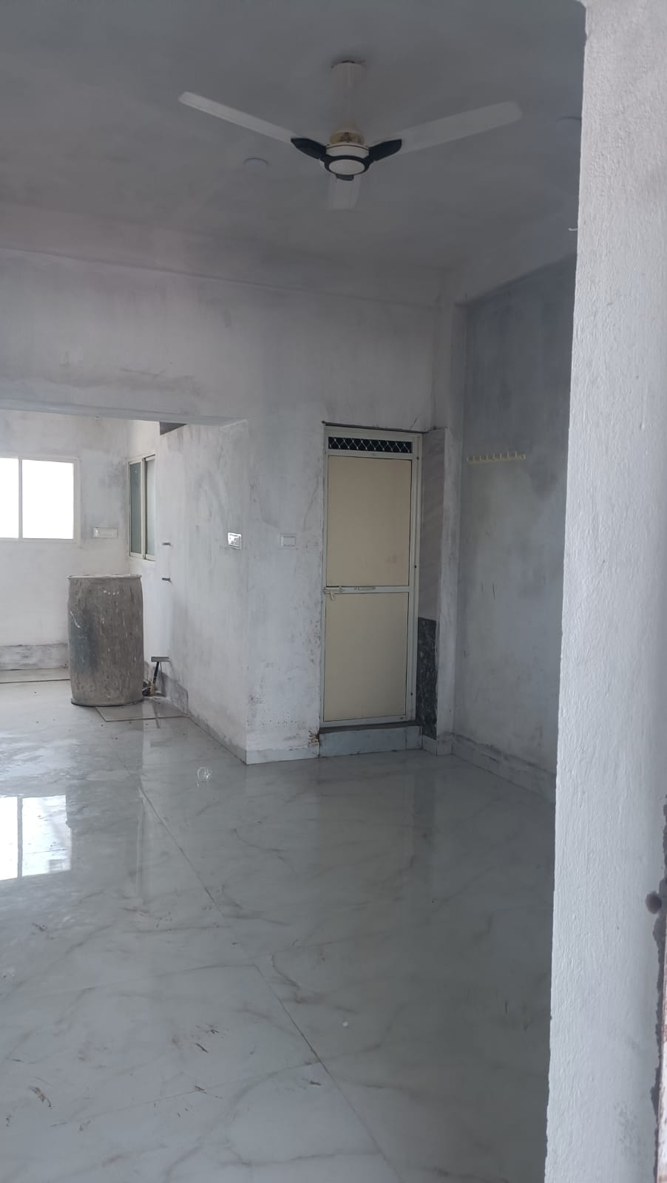
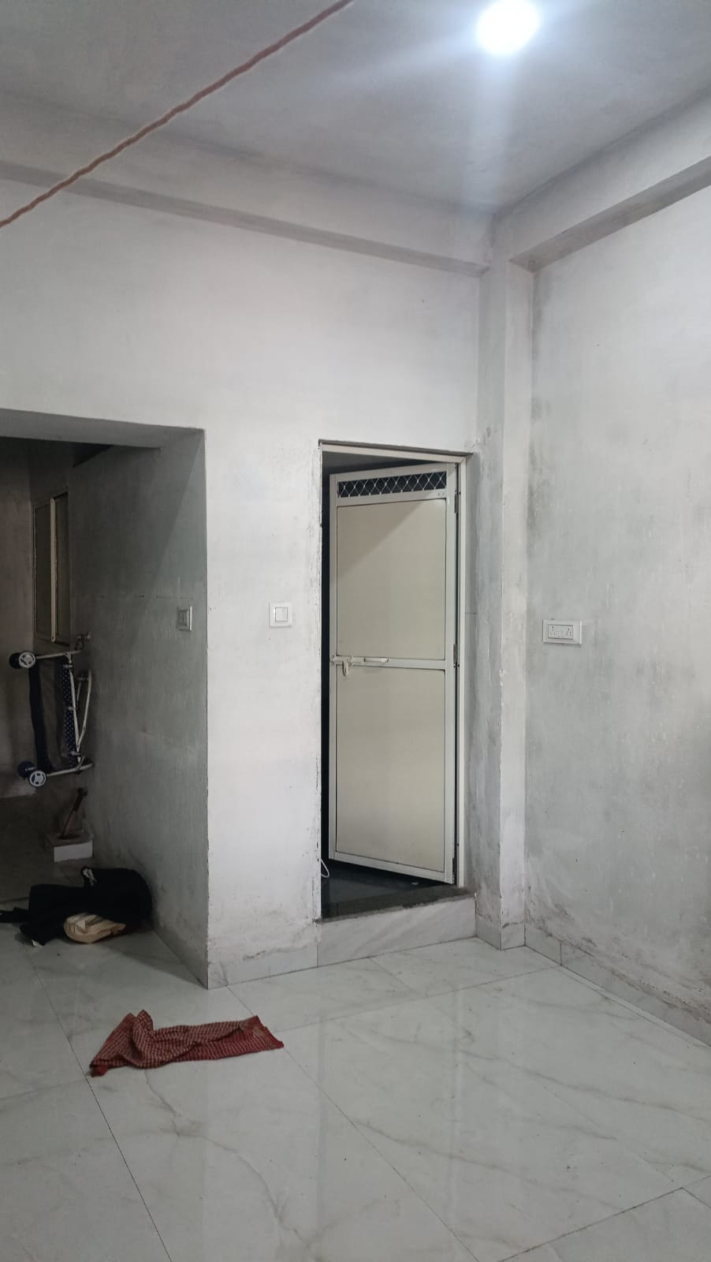
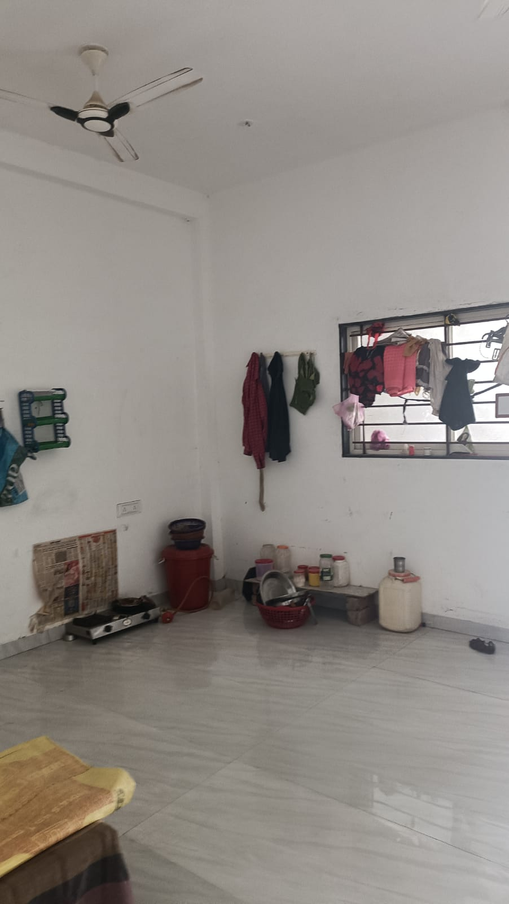

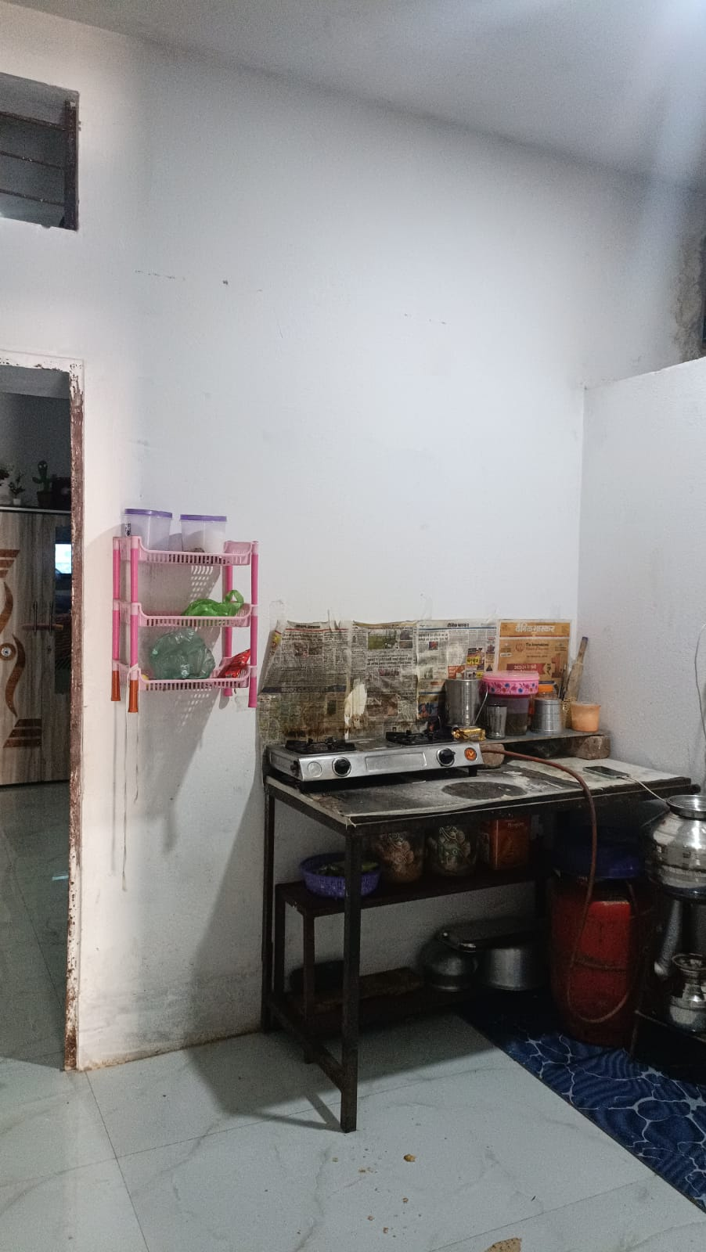
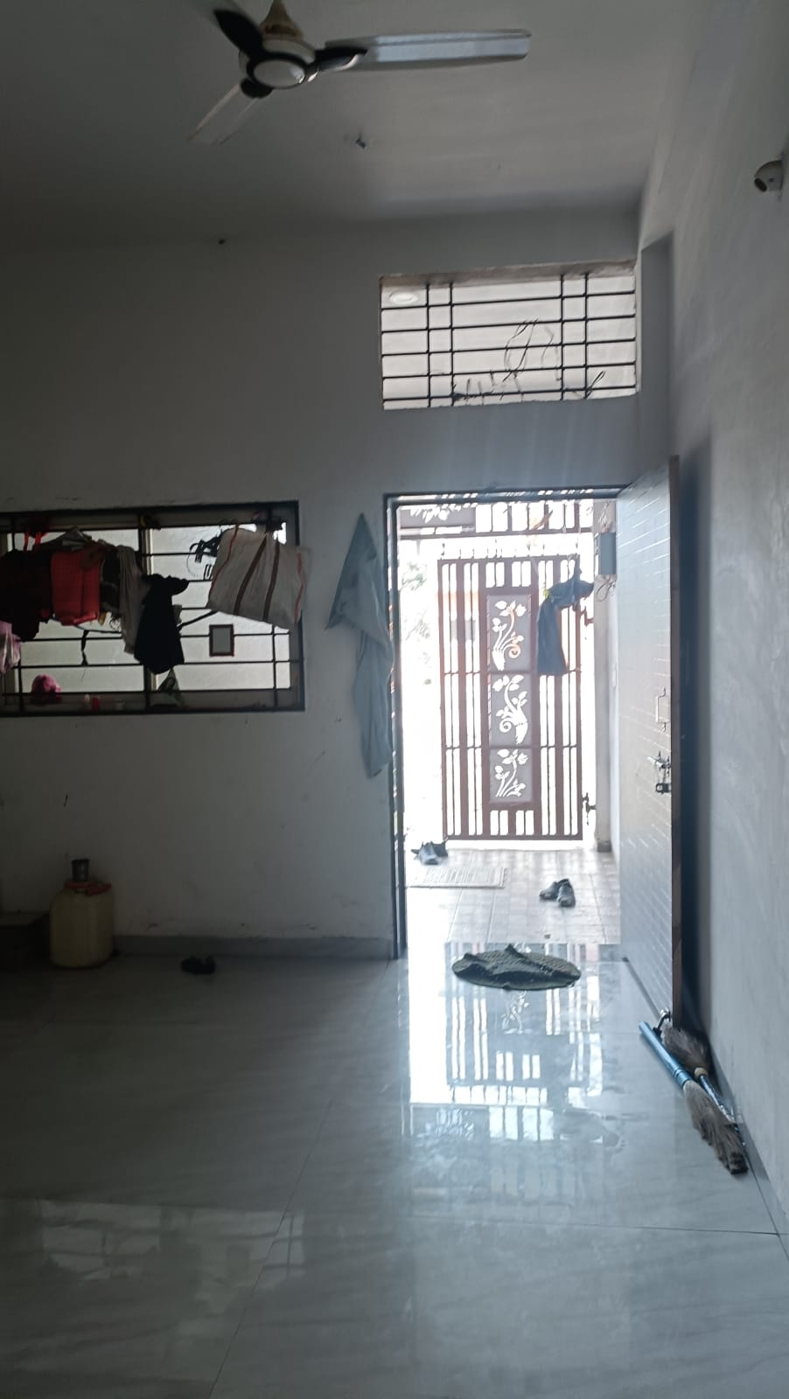
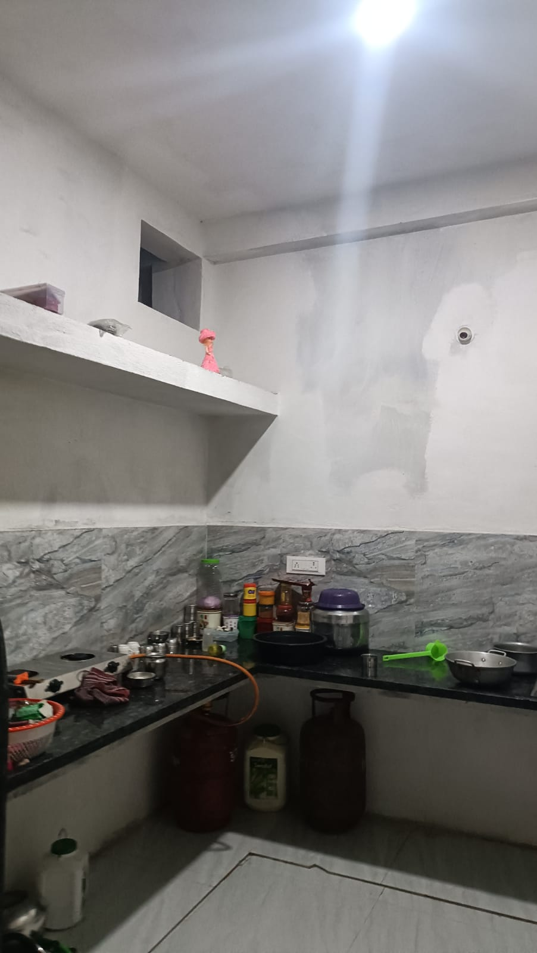

Actual site photographs
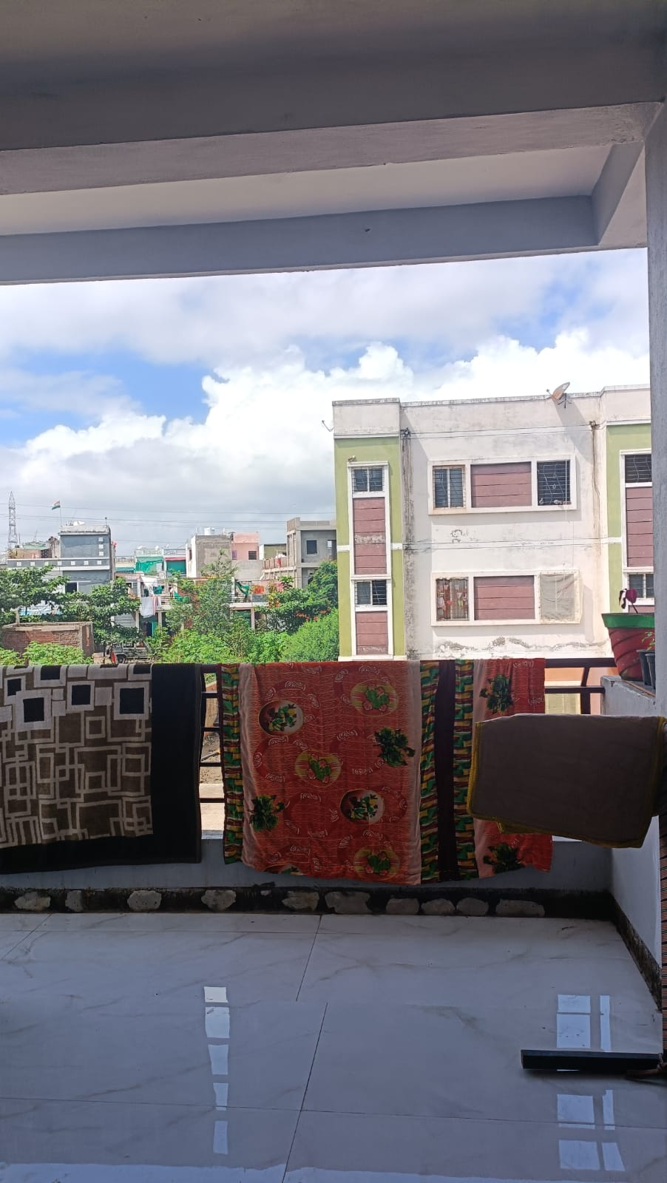
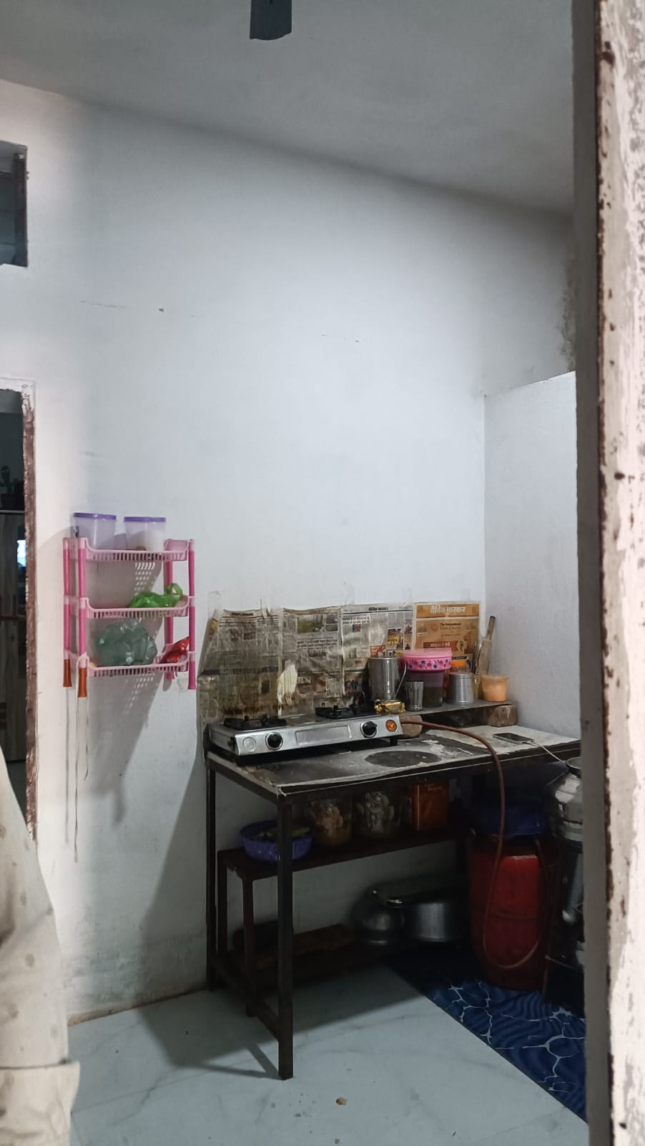
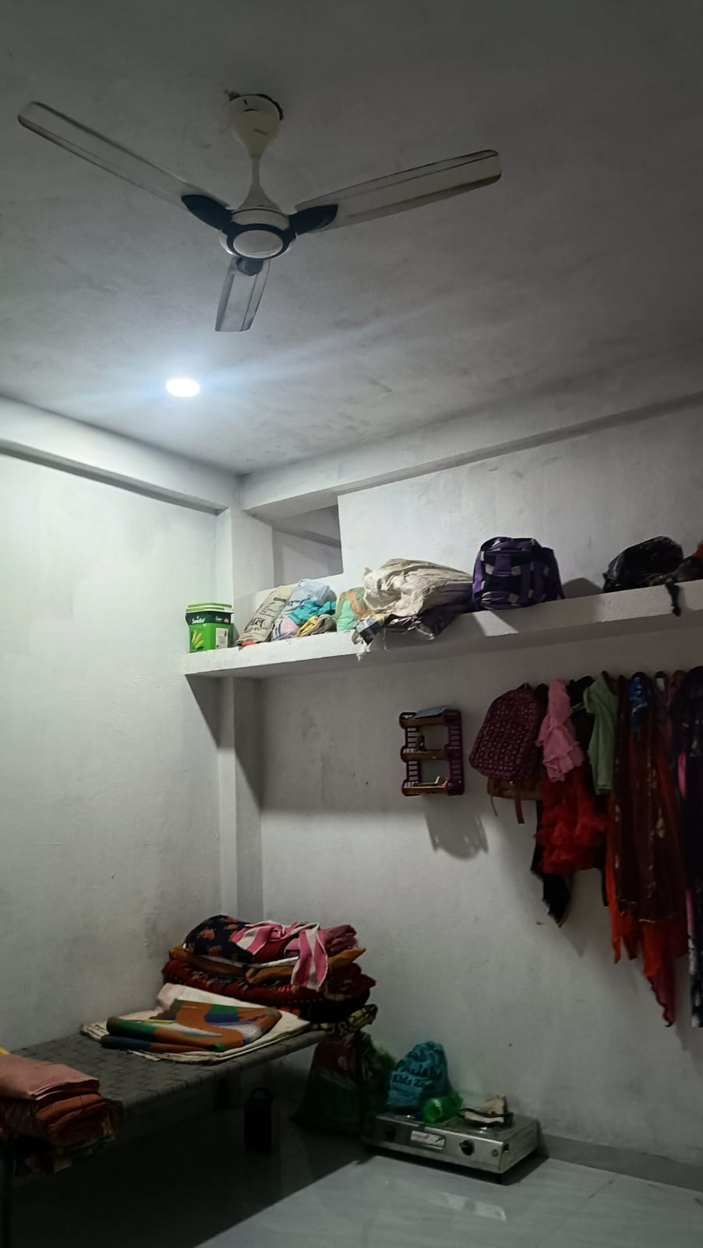

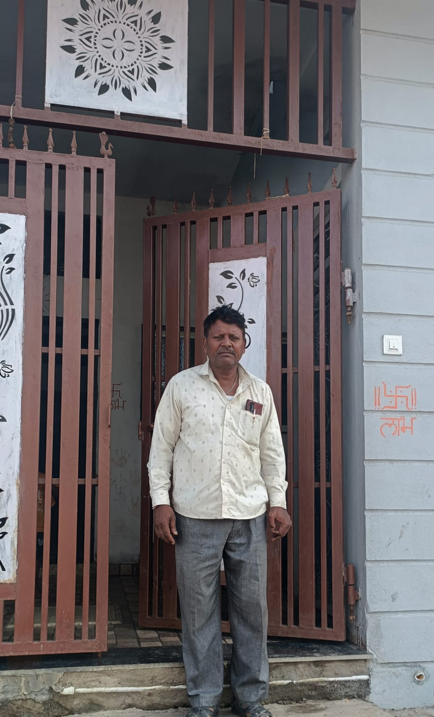
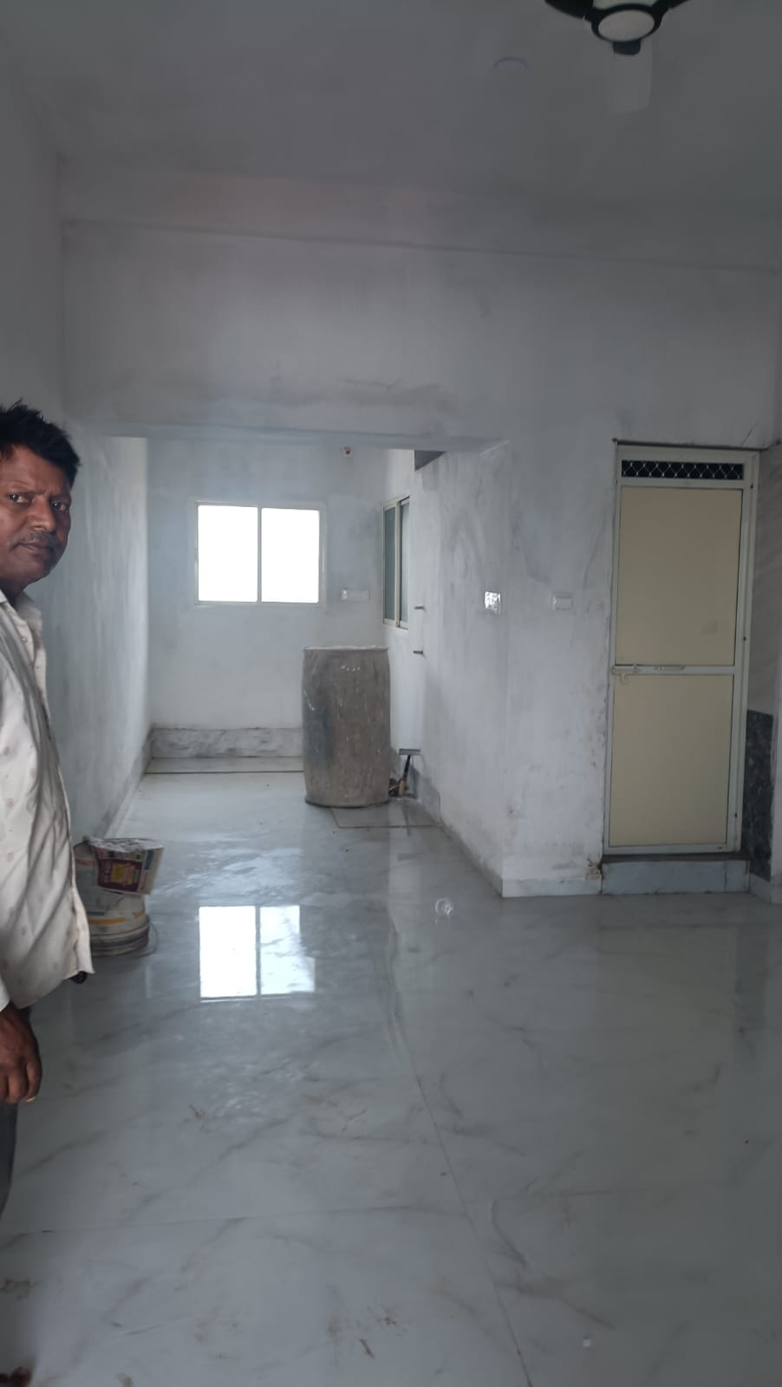
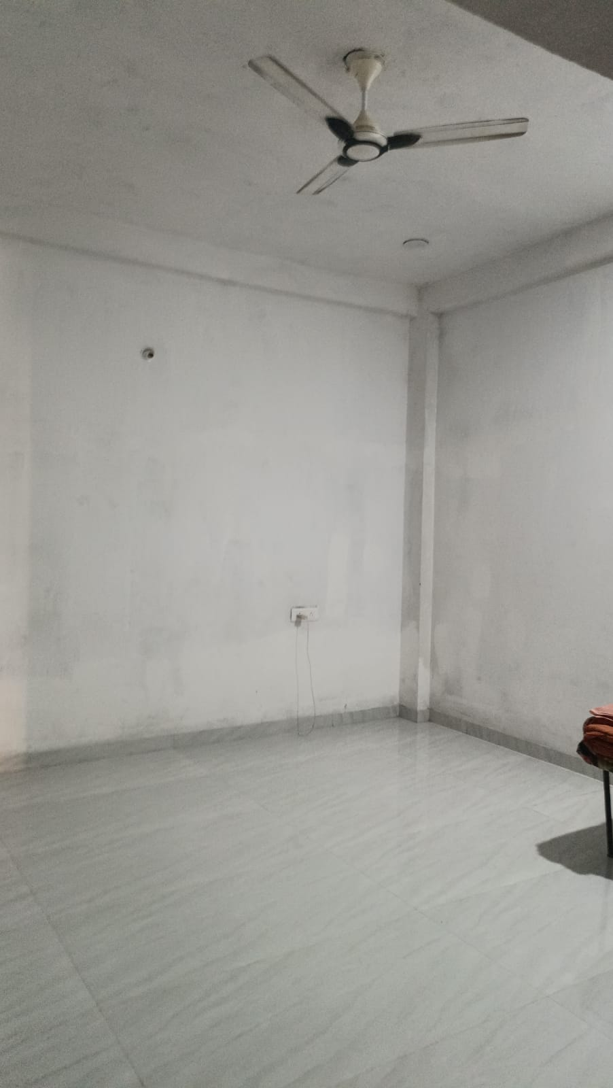

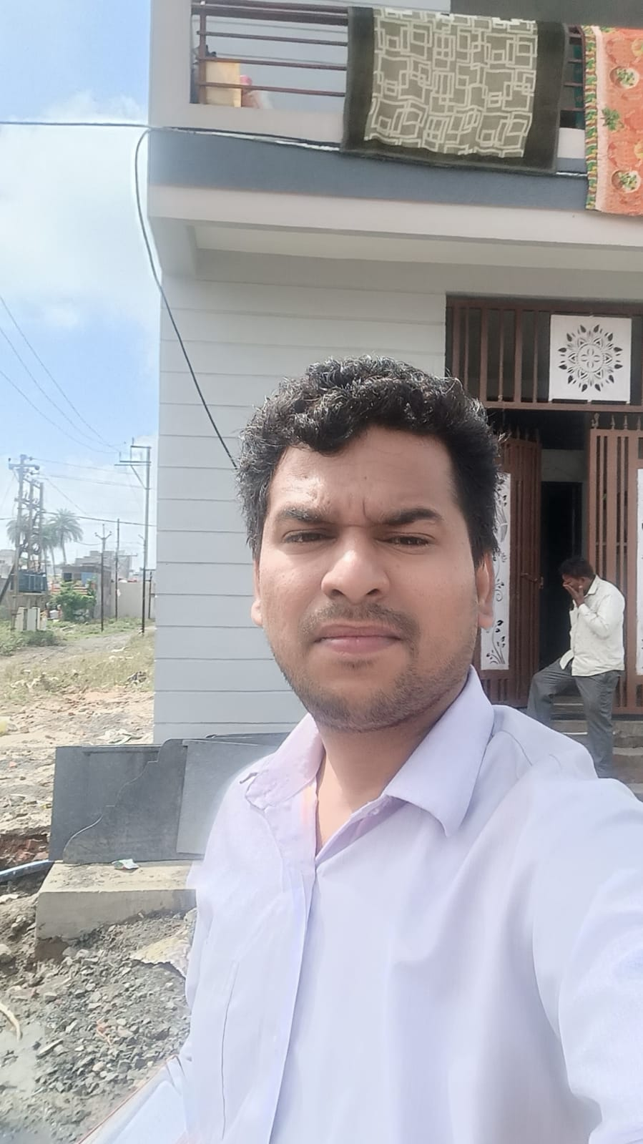

Route Map of the property
Site u/r
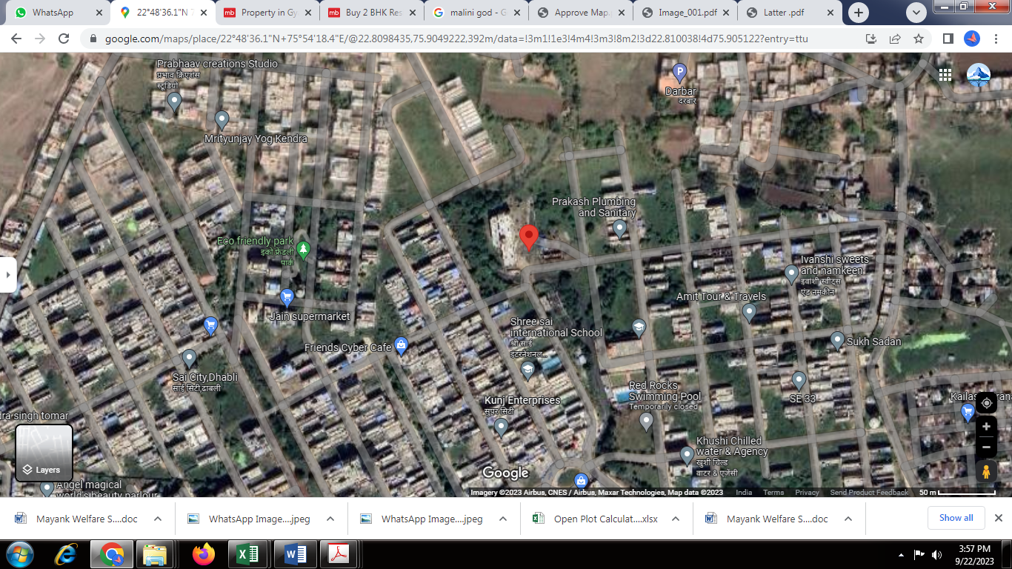


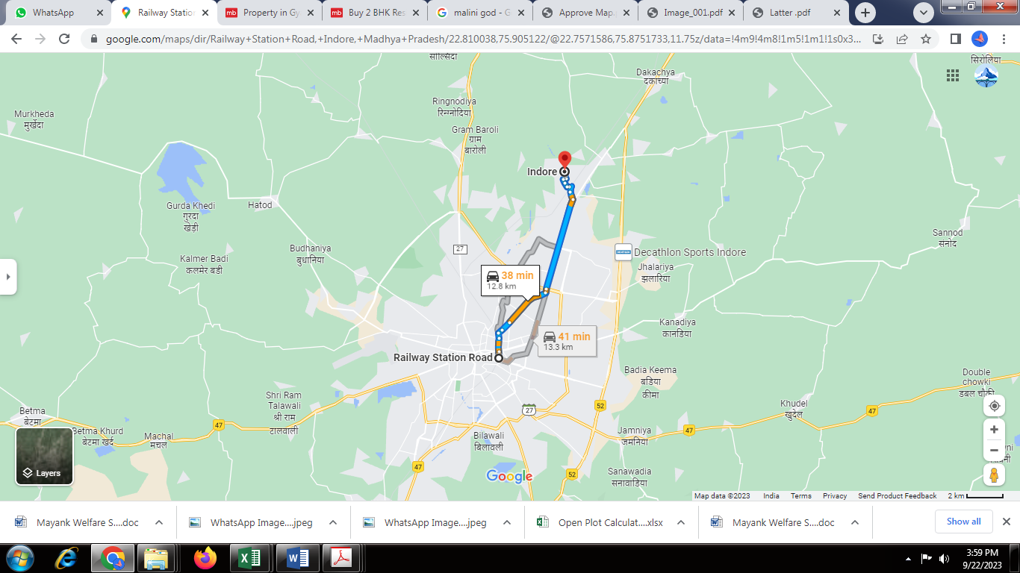

Latitude Longitude: 22°48’36.1”N 75°54’18.4”E
Note: The Blue line shows the route to site from nearest railway station (Indore Junction – 12.8 KM.)

Price Indicators
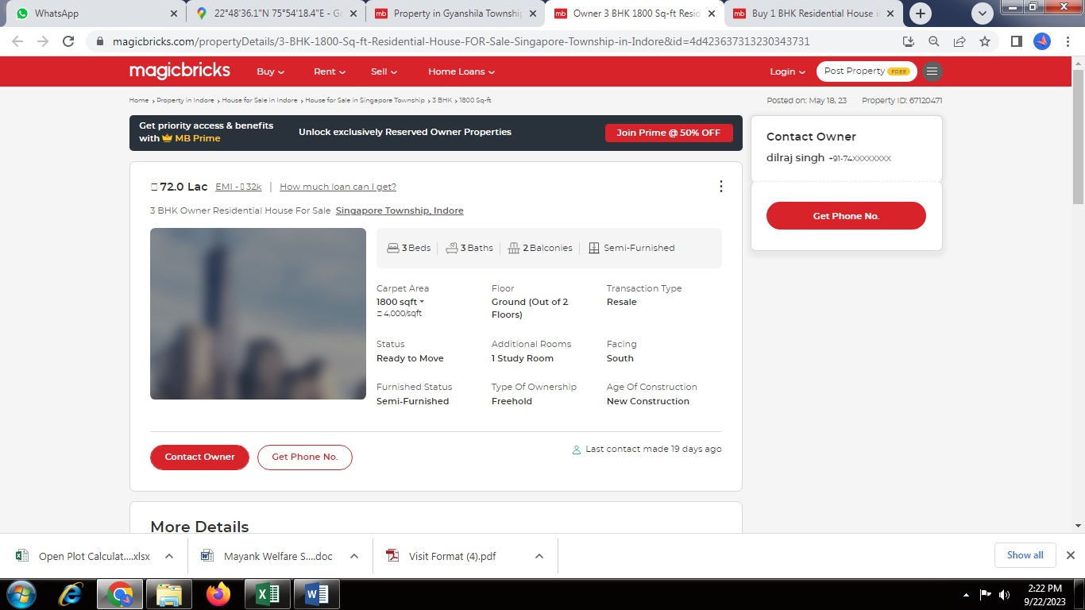

Government Guideline Rate
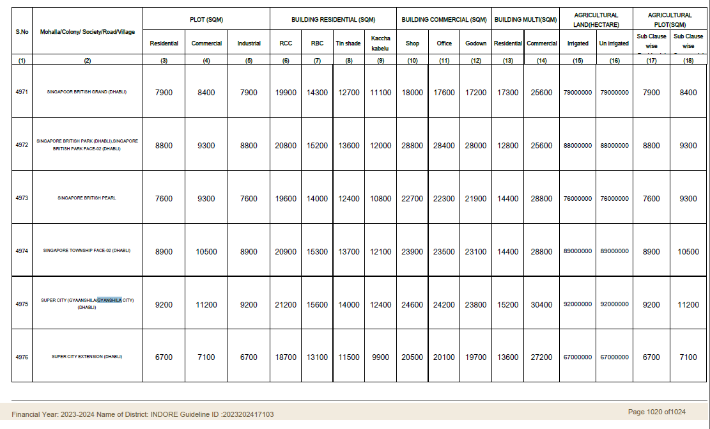

Considering various parameters recorded herein above, existing economic scenario, and the information that is available with reference to the development of neighborhood and method selected for valuation, we are of the opinion that, the property premises can be assessed and valued for this particular purpose as follows -

Particulars | Fair Market Value In (`) | Realizable Value In (`) | Distress Sale Value In (`) | Insurable Value In (`)
Residential Row House | 43,77,000/- | 39,39,300/- | 35,01,600/- | 16,77,000/-

Place: Indore
Date: 22.09.2023

Manoj B. Chalikwar
Registered Valuer
Chartered Engineer (India)
Reg. No. CAT-I-F-1763

The undersigned has inspected the property detailed in the Valuation Report dated _______________________

on ____________________. We are satisfied that the fair and reasonable market value of the property is `_________________________ (Rupees ________________________________________________________

________________________________________only).

Date
Signature
(Name & Designation of the Inspecting Official/s)

Countersigned
(BRANCH MANAGER)

Enclosures
 | Declaration-cum-undertaking from the valuer (Annexure - I) | Attached
 | Model code of conduct for valuer - (Annexure - II) | Attached
(Annexure-I)

DECLARATION-CUM-UNDERTAKING

I, Manoj Chalikwar son of Shri. Baburao Chalikwar hereby solemnly affirms and state that:

- I am a citizen of India.

- I will not undertake valuation of any assets in which I have a direct or indirect interest or become so interested at any time during a period of three years prior to my appointment as valuer or three years after the valuation of assets was conducted by me.

- The information furnished in my valuation report dated 22.09.2023 is true and correct to the best of my knowledge and belief and I have made an impartial and true valuation of the property.

- I/ my authorized representative has personally inspected the property on 21.06.2023. The work is not sub - contracted to any other valuer and carried out by myself.

- Valuation report is submitted in the format as prescribed by the bank.

- I have not been depanelled / delisted by any other bank and in case any such depanelment by other banks during my empanelment with you, I will inform you within 3 days of such depanelment.

- I have not been removed / dismissed from service / employment earlier.

- I have not been convicted of any offence and sentenced to a term of imprisonment

- I have not been found guilty of misconduct in my professional capacity.

- I have not been declared to be unsound mind

- I am not an undischarged bankrupt, or has not applied to be adjudicated as a bankrupt;

- I am not an undischarged insolvent.

- I have not been levied a penalty under section 271J of Income-tax Act, 1961 (43 of 1961) and time limit for filing appeal before Commissioner of Income-tax (Appeals) or Income-tax Appellate Tribunal, as the case may be has expired, or such penalty has been confirmed by Income-tax Appellate Tribunal, and five years have not elapsed after levy of such penalty

- I have not been convicted of an offence connected with any proceeding under the Income Tax Act 1961, Wealth Tax Act 1957 or Gift Tax Act 1958

- My PAN Card number as applicable is AERPC9086P

- I undertake to keep you informed of any events or happenings which would make me ineligible for empanelment as a valuer

- I have not concealed or suppressed any material information, facts and records and I have made a complete and full disclosure

- I have read the Handbook on Policy, Standards and procedure for Real Estate Valuation, 2011 of the IBA and this report is in conformity to the "Standards" enshrined for valuation in the Part - B of the above handbook to the best of my ability.

- I have read the International Valuation Standards (IVS) and the report submitted to the Bank for the respective asset class is in conformity to the "Standards" as enshrined for valuation in the IVS in "General Standards" and "Asset Standards" as applicable. The valuation report is submitted in the prescribed format of the bank.

- I abide by the Model Code of Conduct for empanelment of valuer in the Bank. (Annexure V - A signed copy of same to be taken and kept along with this declaration)

- I am valuer registered with Insolvency & Bankruptcy Board of India (IBBI)

- My CIBIL Score and credit worthiness is as per Bank's guidelines.

- I am Director of the company, who is competent to sign this valuation report.

- I will undertake the valuation work on receipt of Letter of Engagement generated from the system (i.e. LLMS / LOS) only.

- Further, I hereby provide the following information.

Sr.  No. | Particulars | Valuer comment
 | background information of the asset being valued; | The Residential land is owned by Shri. Baban Prasad Gaur S/o Shri. Ramuna Gaur, as per Sale Deed MP179092022A1856690 dated 22.08.2022, thereafter building is constructed.
 | purpose of valuation and appointing authority | As per the request from SVC Co-Operative Bank Ltd., MIG Branch to assess fair market value of the property for bank loan purpose.
 | identity of the valuer and any other experts involved in the valuation; | Sharadkumar B. Chalikwar – Regd. Valuer  Dinesh Kanere - Reginal Technical Manager  Akshay Kumar Trivedi – Valuation Engineer  Akhilesh Yadav – Technical Manager  Akshay Kumar Trivedi – Technical Officer
 | disclosure of valuer interest or conflict, if any; | We have no interest, either direct or indirect, in the property valued. Further to state that we do not have relation or any connection with property owner / applicant directly or indirectly. Further to state that we are an independent Valuer and in no way related to property owner / applicant
 | date of appointment, valuation date and date of  report; | Date of Appointment –21.06.2023  Valuation Date – 22.09.2023  Date of Report – 22.09.2023
 | inspections and/or investigations undertaken; | Physical Inspection done on 21.06.2023
 | nature and sources of the information used or relied upon; | - Market Survey at the time of site visit  - Ready Reckoner rates / Circle rates  - Online Price Indicators on real estate portals  - Enquiries with Real estate consultants
 | procedures adopted in carrying out the valuation and valuation standards followed; | Cost Approach (For building construction)  Comparative Sales Method / Market Approach (For Land component)
 | restrictions on use of the report, if any; | This valuation is for the use of the party to whom it is addressed and for no other purpose. No responsibility is accepted to any third party who may use or rely on the whole or any part of this valuation. The valuer has no pecuniary interest that would conflict with the proper valuation of the property.
 | major factors that were taken into account during the valuation; | current market conditions, demand and supply position, Residential Row House size, location, upswing in real estate prices, sustained demand for Residential Row House, all round development of commercial and residential application in the locality etc.
 | Major factors that were not taken into account during the valuation; | Nil
 | Caveats, limitations and disclaimers to the extent they explain or elucidate the limitations faced by valuer, which shall not be for the purpose of limiting his responsibility for the valuation report. | Attached

Assumptions, Disclaimers, Limitations & Qualifications

Value Subject to Change
The subject appraisal exercise is based on prevailing market dynamics as on 22nd September 2023 and does not take into account any unforeseeable developments which could impact the same in the future.

Our Investigations
We are not engaged to carry out all possible investigations in relation to the subject property. Where in our report we identify certain limitations to our investigations, this is to enable the reliant party to instruct further investigations where considered appropriate or where we recommend as necessary prior to reliance. Vastukala Consultants India Pvt. Ltd. (VCIPL) is not liable for any loss occasioned by a decision not to conduct further investigations

Assumptions
Assumptions are a necessary part of undertaking valuations. VCIPL adopts assumptions for the purpose of providing valuation advise because some matters are not capable of accurate calculations or fall outside the scope of our expertise, or out instructions. The reliant party accepts that the valuation contains certain specific assumptions and acknowledge and accept the risk of that if any of the assumptions adopted in the valuation are incorrect, then this may have an effect on the valuation.

Information Supplied by Others
The appraisal is based on the information provided by the client. The same has been assumed to be correct and has been used for appraisal exercise. Where it is stated in the report that another party has supplied information to VCIPL, this information is believed to be reliable but VCIPL can accept no responsibility if this should prove not to be so.

Future Matters
To the extent that the valuation includes any statement as to a future matter, that statement is provided as an estimate and/or opinion based on the information known to VCIPL at the date of this document. VCIPL does not warrant that such statements are accurate or correct.

Map and Plans
Any sketch, plan or map in this report is included to assist the reader while visualising the property and assume no responsibility in connection with such matters.

Site Details
Based on inputs received from Client and site visit conducted, we understand that the subject property is Residential Row House located on plot area admeasuring 900.00Sq. Ft. and structure thereof. in the name of Shri. Baban Prasad Gaur S/o Shri. Ramuna Gaur. At present, the property is Residential Row House and under Owner. Further, VCIPL has assumed that the subject property is free from any encroachment and is available as on the date of the appraisal.

Property Title
Based on our discussion with the Client, we understand that the subject property is owned by Shri. Baban Prasad Gaur S/o Shri. Ramuna Gaur. For the purpose of this appraisal exercise, we have assumed that the subject property has a clear title and is free from any encumbrances, disputes and claims. VCIPL has made no further enquiries with the relevant local authorities in this regard and does not certify the property as having a clear and marketable title. Further, no legal advice regarding the title and ownership of the subject property has been obtained for the purpose of this appraisal exercise. It has been assumed that the title deeds are clear and marketable.

Environmental Conditions
We have assumed that the subject property is not contaminated and is not adversely affected by any existing or proposed environmental law and any processes which are carried out on the property are regulated by environmental legislation and are properly licensed by the appropriate authorities.

Area
Based on the information provided by the Client, we understand that Residential Row House located on plot area admeasuring 900.00Sq. Ft. and structure thereof.

Condition & Repair
In the absence of any information to the contrary, we have assumed that there are no abnormal ground conditions, nor archaeological remains present which might adversely affect the current or future occupation, development or value of the property. The property is free from rat, infestation, structural or latent defect. No currently known deleterious or hazardous materials or suspect techniques will be used in the construction of or subsequent alteration or additions to the property and comments made in the property details do not purport to express an opinion about, or advise upon, the condition of uninspected parts and should not be taken as making an implied representation or statement about such parts

Valuation Methodology
The cost approach is a Real Property Valuation method which considers the value of a property as the cost of the land plus the replacement cost of the building (construction costs) minus the physical and functional depreciation.

Land cost can be estimated using the Sales Comparison Approach by studying recent sales of land close to the subject property, and these sales should be comparable in size and location with subject property.

There are different ways to estimate replacement costs, the most common being finding out the cost to build a square foot of comparable properties multiplied by the total square footage of the building. The cost approach is commonly used for Residential Bungalow, Residential Land and Buildings, independent buildings, Industrial Building and real estate properties that are not easily sold like schools, hospitals, government buildings. The property is a residential land and independent house thereof, we have adopted Cost approach / Land and Building Method for the purpose of valuation.
In case of inadequate recent transaction activity in the subject micro-market, the appraiser would collate details of older transactions. Subsequently, the appraiser would analyse rental / capital value trends in the subject micro-market in order to calculate the percentage increase / decrease in values since the date of the identified transactions. This percentage would then be adopted to project the current value of the same.
Where reliance has been placed upon external sources of information in applying the valuation methodologies, unless otherwise specifically instructed by Client and/or stated in the valuation, VCIPL has not independently verified that information and VCIPL does not advise nor accept it as reliable. The person or entity to whom the report is addressed acknowledges and accepts the risk that if any of the unverified information in the valuation is incorrect, then this may have an effect on the valuation.

Not a Structural Survey
We state that this is a valuation report and not a structural survey

Other
All measurements, areas and ages quoted in our report are approximate

Legal
We have not made any allowances with respect to any existing or proposed local legislation relating to taxation on realization of the sale value of the subject property. VCIPL is not required to give testimony or to appear in court by reason of this appraisal report, with reference to the property in question, unless arrangement has been made thereof. Further, no legal advice on any aspects has been obtained for the purpose of this appraisal exercise

Property specific assumptions
Based on inputs received from the client and site visit conducted, we understand that the subject property is Residential Row House located on plot area admeasuring 900.00Sq. Ft. and structure thereof.

ASSUMPTIONS, CAVEATS, LIMITATION AND DISCLAIMERS
1. We assume no responsibility for matters of legal nature affecting the property appraised or the title thereto, nor do we render our opinion as to the title, which is assumed to be good and marketable.
2. The property is valued as though under responsible ownership.
3. It is assumed that the property is free of liens and encumbrances.
4. It is assumed that there are no hidden or unapparent conditions of the subsoil or structure that would render it more or less valuable. No responsibility is assumed for such conditions or for engineering that might be required to discover such factors.
5. There is no direct/ indirect interest in the property valued.
6. The rates for valuation of the property are in accordance with the Govt. approved rates and prevailing market rates.
(Annexure - II)

MODEL CODE OF CONDUCT FOR VALUERS

Integrity and Fairness
- A valuer shall, in the conduct of his/its business, follow high standards of integrity and fairness in all his/its dealings with his/its clients and other valuers.
- A valuer shall maintain integrity by being honest, straightforward, and forthright in all professional relationships.
- A valuer shall endeavour to ensure that he/it provides true and adequate information and shall not misrepresent any facts or situations.
- A valuer shall refrain from being involved in any action that would bring disrepute to the profession.
- A valuer shall keep public interest foremost while delivering his services.

Professional Competence and Due Care
- A valuer shall render at all times high standards of service, exercise due diligence, ensure proper care and exercise independent professional judgment.
- A valuer shall carry out professional services in accordance with the relevant technical and professional standards that may be specified from time to time.
- A valuer shall continuously maintain professional knowledge and skill to provide competent professional service based on up-to-date developments in practice, prevailing regulations / guidelines and techniques.
- In the preparation of a valuation report, the valuer shall not disclaim liability for his/its expertise or deny his/its duty of care, except to the extent that the assumptions are based on statements of fact provided by the company or its auditors or consultants or information available in public domain and not generated by the valuer.
- A valuer shall not carry out any instruction of the client insofar as they are incompatible with the requirements of integrity, objectivity and independence.
- A valuer shall clearly state to his client the services that he would be competent to provide and the services for which he would be relying on other valuers or professionals or for which the client can have a separate arrangement with other valuers.

Independence and Disclosure of Interest
- A valuer shall act with objectivity in his/its professional dealings by ensuring that his/its decisions are made without the presence of any bias, conflict of interest, coercion, or undue influence of any party, whether directly connected to the valuation assignment or not.
- A valuer shall not take up an assignment if he/it or any of his/its relatives or associates is not independent in terms of association to the company.

- A valuer shall maintain complete independence in his/its professional relationships and shall conduct the valuation independent of external influences.
- A valuer shall wherever necessary disclose to the clients, possible sources of conflicts of duties and interests, while providing unbiased services.
- A valuer shall not deal in securities of any subject company after any time when he/it first becomes aware of the possibility of his / its association with the valuation, and in accordance with the Securities and Exchange Board of India (Prohibition of Insider Trading)Regulations,2015 or till the time the valuation report becomes public, whichever is earlier.
- A valuer shall not indulge in "mandate snatching" or offering "convenience valuations" in order to cater to a company or client's needs.
- As an independent valuer, the valuer shall not charge success fee.
- In any fairness opinion or independent expert opinion submitted by a valuer, if there has been a prior engagement in an unconnected transaction, the valuer shall declare the association with the company during the last five years.
Confidentiality
- A valuer shall not use or divulge to other clients or any other party any confidential information about the subject company, which has come to his / its knowledge without proper and specific authority or unless there is a legal or professional right or duty to disclose.

Information Management

- A valuer shall ensure that he/ it maintains written contemporaneous records for any decision taken, the reasons for taking the decision, and the information and evidence in support of such decision. This shall be maintained so as to sufficiently enable a reasonable person to take a view on the appropriateness of his /its decisions and actions.
- A valuer shall appear, co-operate and be available for inspections and investigations carried out by the authority, any person authorised by the authority, the registered valuers organisation with which he/it is registered or any other statutory regulatory body.
- A valuer shall provide all information and records as may be required by the authority, the Tribunal, Appellate Tribunal, the registered valuers organisation with which he/it is registered, or any other statutory regulatory body.
- A valuer while respecting the confidentiality of information acquired during the course of performing professional services, shall maintain proper working papers for a period of three years or such longer period as required in its contract for a specific valuation, for production before a regulatory authority or for a peer review. In the event of a pending case before the Tribunal or Appellate Tribunal, the record shall be maintained till the disposal of the case.

Gifts and hospitality:
- A valuer or his / its relative shall not accept gifts or hospitality which undermines or affects his independence as a valuer.
Explanation: For the purposes of this code the term 'relative' shall have the same meaning as defined in clause (77) of Section 2 of the Companies Act, 2013 (18 of 2013).
- A valuer shall not offer gifts or hospitality or a financial or any other advantage to a public servant or any other person with a view to obtain or retain work for himself / itself, or to obtain or retain an advantage in the conduct of profession for himself / itself.

Remuneration and Costs.
- A valuer shall provide services for remuneration which is charged in a transparent manner, is a reasonable reflection of the work necessarily and properly undertaken, and is not inconsistent with the applicable rules.
- A valuer shall not accept any fees or charges other than those which are disclosed in a written contract with the person to whom he would be rendering service.

Occupation, employability and restrictions.
- A valuer shall refrain from accepting too many assignments, if he/it is unlikely to be able to devote adequate time to each of his/ its assignments.
- A valuer shall not conduct business which in the opinion of the authority or the registered valuer organisation discredits the profession.
Miscellaneous
- A valuer shall refrain from undertaking to review the work of another valuer of the same client except under written orders from the bank or housing finance institutions and with knowledge of the concerned valuer.
- A valuer shall follow this code as amended or revised from time to time.

Manoj B. Chalikwar
Registered Valuer
Chartered Engineer (India)
Reg. No. CAT-I-F-1763

